What are the single points of failure?
This is sample content. Replace this file with your own document, keeping the same file name.

Architecture
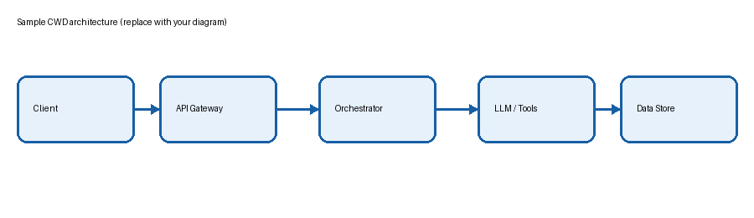

Trade-offs
Decision | Benefit | Cost | Mitigation
Async queue | Resilience | Complexity | Dead-letter queue
Cache | Lower latency | Stale data | TTL + invalidation
Persistence | Durability | Extra latency | Write-behind

Key takeaways
- Lead with the business problem
- Explain the design and the trade-offs
- Close with what you personally owned

