|  |
| --- |
| Gorica GROUP  POD  Invoice Auromation  SAISOFT ITC LTD.Process Manual |
| SAISOFT ITC LTD.SAISOFT ITC LTD. +971 585848052  Kishor.namburu@saisoftglobal.com  +971 585848052  Kishor.namburu@saisoftglobal.com |

 

## VERSION HISTORY:

|  |  |  |  |  |  |
| --- | --- | --- | --- | --- | --- |
| DATE | VERSION | AUTHOR | REVIEWER | REVIEWER ROLE | COMMENTS |
| 05th May 2023 | 1 | Soujanya Rongali & Mohamed Hasim | Kishor Namburu | Lead | Draft |

Table 1 Document Version History

## DOCUMENT APPROVAL HISTORY:

|  |  |  |  |  |
| --- | --- | --- | --- | --- |
| DATE | VERSION | NAME | ROLE | COMMENTS |
|  | 1 | Kishor Namburu | Lead |  |

Table 2 Document Approval History

## Abbreviations/Definitions

|  |  |  |
| --- | --- | --- |
| SR. NO. | ABBREVIATION/DEFINITIONS | DESCRIPTION |
|  | AS-IS Process | Defines how the user is currently executing the process |
|  | Assets | The credentials utilized by the job |
|  | .CSV | Comma Separated Value |
|  | SSFT | SAISOFT ITC Ltd. |
|  | Job | The software program that will execute the process |
|  | Logs | The execution information captured by the job while processing |
|  | NA | Not Applicable |
|  | NeoBots | Platform to manage and execute the job |
|  | Schedule | This is a functionality that the job utilizes to execute the process |
|  | Robot | It is a system on which a scheduled job will run. It is categorized into four types, namely Workstation, Laptop, Virtual Machine (VM), and Cloud Machine. |

Table 3 Abbreviations and Definitions

## INTRODUCTION

## OVERVIEW

## This manual is intended for the business users from MH warehouse Team who are responsible for performing the POD and GRV process. This manual is designed to explain the functionalities of the job and how to work with the automated Neobots process for various activities. The job function is divided into six distinct processes mentioned below:

* **Process 1 – OCR Reading & Splitting for POD**

This process handles the activity of performing OCR, grouping & splitting the documents by unique reference number such as Tax Invoice no for all the documents scanned for Proof of Delivery.

* **Process 2 – Upload the Metadata & Documents of POD to DMS**This process handles tagging meta data as part of file name of split documents, Uploads the spilt document to DMS
* **Process 3 – Exception Flow for POD**This process handles tagging meta data as part of file name of split documents, Uploads the spilt document to DMS
* **Process 4 – OCR Reading & Splitting documents for GRV**This process handles the activity of performing OCR, grouping & splitting the documents by unique reference number such as Tax Credit no for all the documents scanned for GRV.
* **Process 5 – Extract Meta Data & Upload Documents to DMS**This process handles tagging meta data as part of file name of split documents, Uploads the spilt document to DMS
* **Process 6 – Exception Flow for GRV**This process handles tagging meta data as part of file name of split documents, Uploads the spilt document to DMS

## PRE-REQUISITES

For the successful execution of the job below are the pre-requisites that have to be fulfilled.

1. Required folder structure to be available.
   1. C:\MH\TAXINVOICE\Unprocessed
   2. C:\MH\GRV\Unprocessed
2. Install NeoBots on every BOT machine.
3. Required Read/write privilege to the specific user where the bot is installed for all the folders under My documents and NeoBots.
4. Windows and system pop-ups should be disabled.
5. Install Ghostscript using this link : <https://ghostscript.com/releases/gsdnld.html>
6. Install Tesseract-ocr :
7. Declare environment variables:

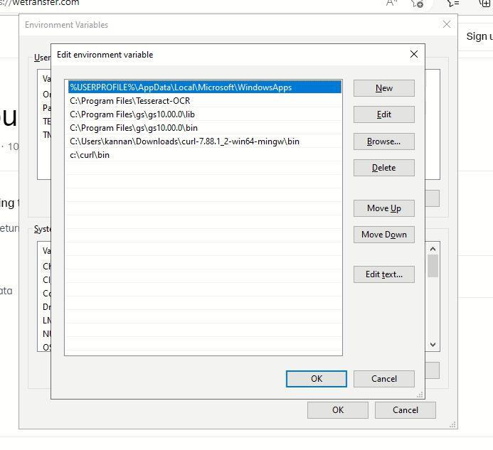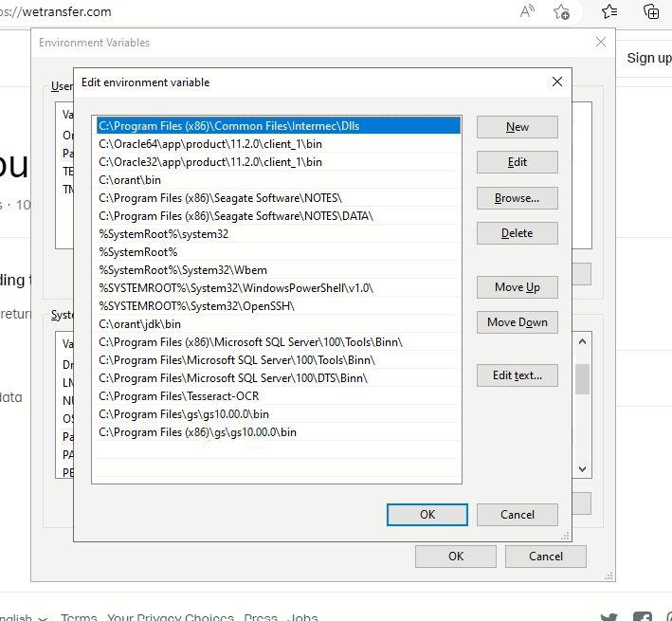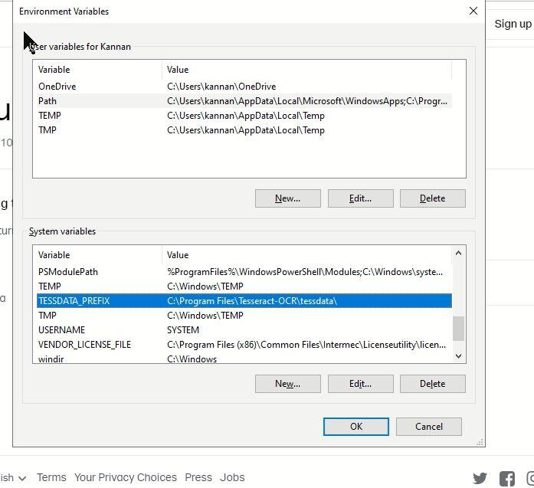

1. To perform the above installations, provide admin access to the given user in anydesk.
2. The bot domain user should have privilege to access all the mentioned folders for the execution and should be able to execute the neobots scripts.

## BOT STATION CONFIGURATION:

## RAM: 8 GB

## SYSTEM TYPE: 64-bit OS, x64-based processor

## Windows Specifications: Windows 10 or Higher

## Storage Required: 30 GB

## VM Type: SSD

## NUMBER OF BOT STATIONS REQUIRED: 6

## BOT CAPACITY: 1200 Page Document.

## FOLDER STRUCTURE

### DOCUMENTS

|  |  |  |  |  |
| --- | --- | --- | --- | --- |
| SR. NO. | DOCUMENT NAME | DOCUMENT TYPE | DESCRIPTION | FILE |
| 1. | TaxInvoice_ConsolidatedSheet | .xlsx | This excel file is under the TAXINVOICE folder for pod and contains the all the list of jobs completed in the past and respective status of the job |  |
| 2. | GRV_ConsolidatedSheet | .xlsx | This excel file is under the GRV folder for GRV and contains the all the list of jobs completed in the past and respective status of the job |  |
|  |  |  |  |  |

Table 4 Document list

**POD Process File Structure**

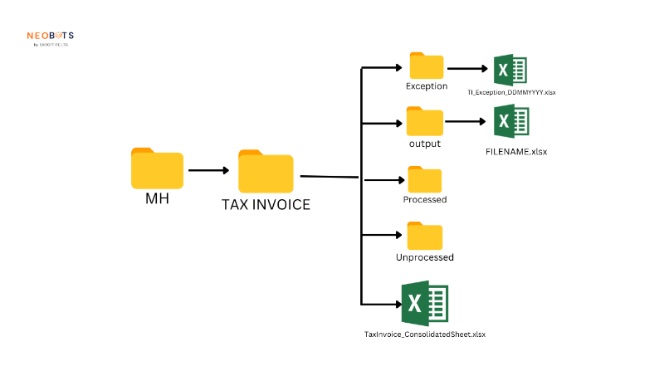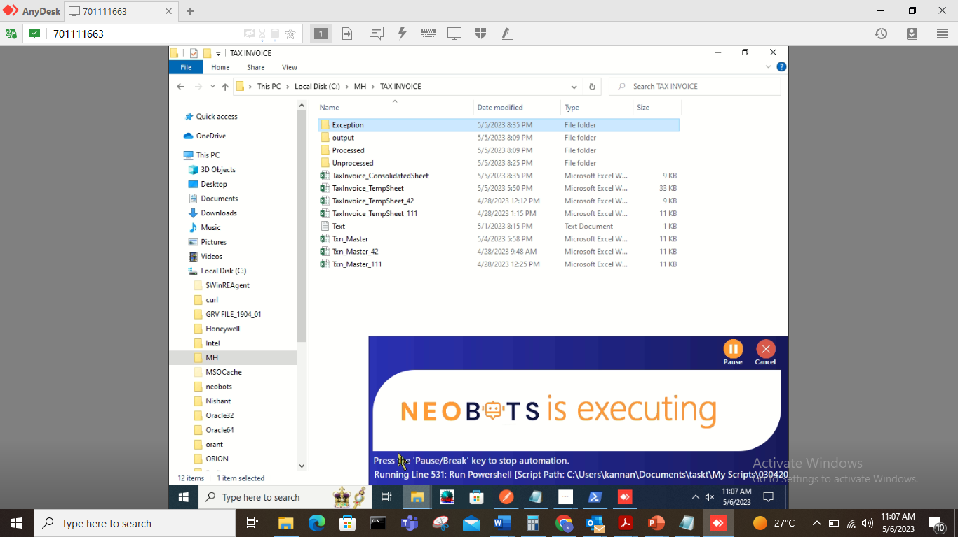

**GRV Process File Structure**

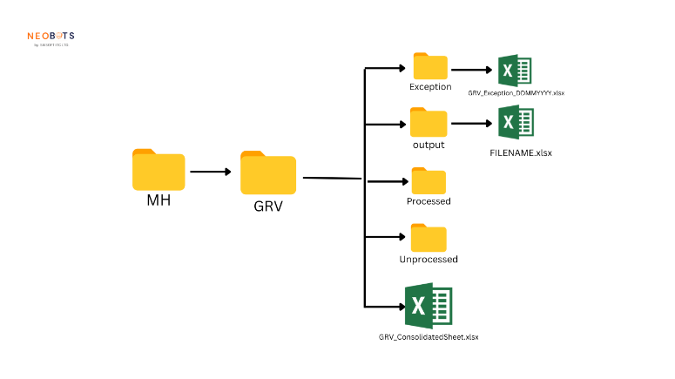 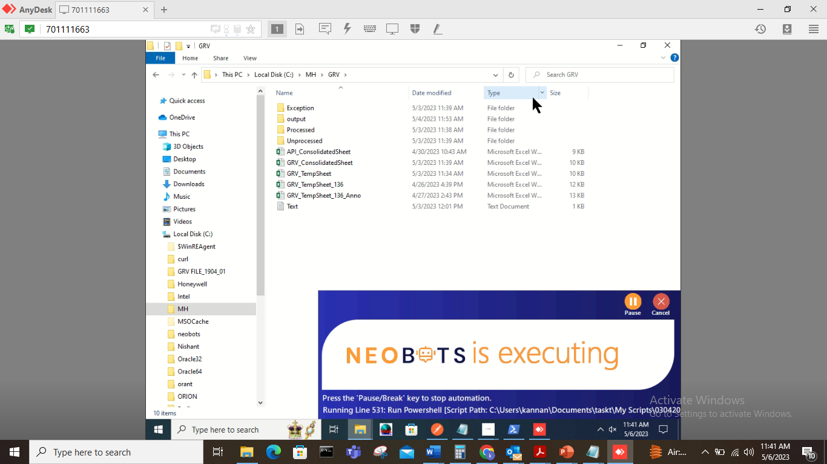e steps to take to amend them:

1. **TAXINVOICE_ConsolidatedSheet**  
   Contains the data of the PDF files received and processed, this file keeps log of all the activities.
2. **TAXINVOICE_TempSheet**  
   Contains the page wise details of the last executed job, this file is useful for analysis in case of any issues or exceptions, this file does not require to be reviewed by end user, however the IT team can use for analyzing received and processed, this file keeps log of all the activities.
3. **FILENAME.xlsx (Summary For POD)**  
   This is the summary file available in Output folder for the respective file processed contains the invoice number, stat page, end page, status and split file name, this sheet to be referred after every job completion.
4. **TI_Exception_DDMMYYY**

This is the exception file available in the Exception folder that lists all the possible exceptions caused during the job execution for respective file.

1. **GRV_ConsolidatedSheet**  
   Contains the data of the GRV scanned PDF files received and processed, this file keeps log of all the jobs executed.
2. **GRV_TempSheet**  
   Contains the page wise details of the last executed job of GRV, this file is useful for analysis in case of any issues or exceptions, this file does not require to be reviewed by end user, however the IT team can use for analyzing received and processed, this file keeps log of all the activities.
3. **FILENAME.xlsx (For GRV)**  
   This is the summary file available in Output folder for the respective file processed contains the Credit number, stat page, end page, status, annotation, Txn Code and split file name, this sheet to be referred after every job completion.

**Details for POD**

|  |  |  |  |  |
| --- | --- | --- | --- | --- |
| SRNO | SHEET NAME | COLUMN NAME | DESCRIPTION | USER ACTION |
| 1. | **TAXINVOICE_ConsolidatedSheet** | File Name | File name is the name of the PDF file placed in unprocessed folder for POD |  |
| 2. | **TAXINVOICE_ConsolidatedSheet** | Start Time | The time the job has started for POD Job for respective file |  |
| 3. | **TAXINVOICE_ConsolidatedSheet** | End Time | The time the job has ended for POD Job for respective file |  |
| 4. | **TAXINVOICE_ConsolidatedSheet** | Status | This describes the status of the job executed for POD, if the process is successful it will be “Processed” and if the job has any exception the status will be “Exception” | If any job is marked as exception, kindly refer to the exception sheet for respective job in Exception folder, look for the file TI_Exception_DDMMYYYY.xlsx |
| 5. | **TI_Exception_DDMMYYY** | Stage | Represents the stage where the exception has occurred, |  |
| 6. | **TI_Exception_DDMMYYY** | DateTime | Capture the Date & Time of the exception occurred during the job |  |
| 7. | **TI_Exception_DDMMYYY** | Exception | Capture the Details of the exception occurred during the job | Based on the error details mentioned, correct the details from Summary sheet available in Output folder |
| 8. | **TI_Exception_DDMMYYY** | FileName | Captures the original PDF file name that was used to process. |  |
| 9. | **FILENAME.xlsx (Summary For POD)** | Tax Invoice No | Represents the invoice number |  |
| 10. | **FILENAME.xlsx (Summary For POD)** | Start Page No | Start of the Page for respective Invoice number |  |
| 11. | **FILENAME.xlsx (Summary For POD)** | End Page No | End of the Page for respective Invoice number |  |
| 12. | **FILENAME.xlsx (Summary For POD)** | S & C Status | The status contains “P” or “E”, “P” represents for successfully processed invoice & respective split file, “E” represents issues while processing | In case of “E”, correct the details required either invoice number or Start Page No or End Page no, copy the corrected summary file in “output->Updated” folder and execute the exception flow from NeoBots. |
| 13. | **FILENAME.xlsx (Summary For POD)** | FilePath | Captures the full path of the split file created by invoice number. |  |

**Details for GRV**

|  |  |  |  |  |
| --- | --- | --- | --- | --- |
| SRNO | SHEET NAME | COLUMN NAME | DESCRIPTION | USER ACTION |
| 1. | **GRV_ConsolidatedSheet** | File Name | File name is the name of the PDF file placed in unprocessed folder for POD |  |
| 2. | **GRV_ConsolidatedSheet** | Start Time | The time the job has started for POD Job for respective file |  |
| 3. | **GRV_ConsolidatedSheet** | End Time | The time the job has ended for POD Job for respective file |  |
| 4. | **GRV_ConsolidatedSheet** | Status | This describes the status of the job executed for POD, if the process is successful it will be “Processed” and if the job has any exception the status will be “Exception” | If any job is marked as exception, kindly refer to the exception sheet for respective job in Exception folder, look for the file GRV_Exception_DDMMYYYY.xlsx |
| 5. | **GRV_Exception_DDMMYYY** | Stage | Represents the stage where the exception has occurred, |  |
| 6. | **GRV_Exception_DDMMYYY** | DateTime | Capture the Date & Time of the exception occurred during the job |  |
| 7. | **GRV_Exception_DDMMYYY** | Exception | Capture the Details of the exception occurred during the job | Based on the error details mentioned, correct the details from Summary sheet available in Output folder |
| 8. | **GRV_Exception_DDMMYYY** | FileName | Captures the original PDF file name that was used to process. |  |
| 9. | **FILE NAME.xlsx (Summary For GRV)** | Tax Credit No | Represents the invoice number |  |
| 10. | **FILENAME.xlsx (Summary For GRV)** | Start Page No | Start of the Page for respective Invoice number |  |
| 11. | **FILENAME.xlsx (Summary For GRV)** | End Page No | End of the Page for respective Invoice number |  |
| 12. | **FILENAME.xlsx (Summary For GRV)** | S & C Status | The status contains “P” or “E”, “P” represents for successfully processed invoice & respective split file, “E” represents issues while processing | In case of “E”, correct the details required either invoice number or Start Page No or End Page no, copy the corrected summary file in “output->Updated” folder and execute the exception flow from NeoBots. |
| 13. | **FILENAME.xlsx (Summary For GRV)** | FilePath | Captures the full path of the split file created by invoice number. |  |
| 14. | **FILENAME.xlsx (Summary For GRV)** | Anotation |  |  |
| 15. | **FILENAME.xlsx (Summary For GRV)** | Txn Code |  |  |

## JOB EXECUTION

## JOB DETAILS

|  |  |
| --- | --- |
| ITEMS | VALUE |
| Process 1 | C:\MH\Process\JOBS\TAXINVOICE_FLOW.xml |
| Process 2 | C:\MH\Process\JOBS\API.xml |
| Process 3 | C:\MH\Process\JOBS\TAXINVOICE_EXCEPTION_FLOW.xml |
| Process 4 | C:\MH\Process\JOBS\GRV_FLOW.xml |
| Process 5 | C:\MH\Process\JOBS\API.xml |
| Process 6 | C:\MH\Process\JOBS\GRV_EXCEPTION_FLOW.xml |
| Bot Station Name | MH Station 1 |

## JOB EXECUTION STEPS

## Below are the steps involved in the execution of the job:

## In case of POD process, end user has to ensure there is a Scanned PD file with the name “TAXINVOICE_POD_YYYYMMDD.pdf” under the respective “Unprocessed” folder of TAX INVOICES, Whenever there is a PDF file the BOT will auto identify and start processing.

1. **Process 1** – **OCR Reading & Splitting for POD**
   1. The job will check for new PDF file that starts with name as “TAXINVOICE_POD_YYYYMMDD.pdf” under the folder c:\MH\TAXINVOICE\Unprocessed,
   2. The job will read the PDF file using OCR and split the PDF files by the invoice number and respective supporting documents associated with it.
   3. The job will trigger Process 2.
2. **Process 2** – **Upload split documents to DMS** (will be auto-triggered by Process 1)
   1. The job will call the DMS API to upload all successfully split PDF’s
   2. The job will create the log file and sends the final summary file to MH team with output details after applying business rules on the data
3. **Process 3** – **Exception flow for POD (**grv_mh_exep.xml)
   1. Whenever there are any exceptions in identifying the information from the scanned PDF files or any issues in splitting the data in such cases the BOT marks such transactions to Error (E), In Summary sheet created under output folder (Eg TAXINVOICE_POD_YYYYMMDD.xlsx)
   2. Open neobots, click the open file and navigate to above mentioned Process3 flow file path and select the respective exception flow and click on “Save & run” option provided for initiating Exception Flow
   3. The job will trigger Process 2.

## In case of GRV process, end user have to ensure there is a Scanned PD file with the name “GRV_POD_YYYYMMDD.pdf” under the respective “Unprocessed” folder of GRV , Whenever there is a PDF file the BOT will auto identify and start processing.

1. **Process 4** – **OCR Reading & Splitting for GRV**
   1. The job will check for new PDF file that starts with name as “GRV_YYYYMMDD.pdf” under the folder c:\MH\TAXINVOICE\Unprocessed,
   2. The job will read the PDF file using OCR and split the PDF files by the invoice number and respective supporting documents associated with it.
   3. The job will trigger Process 2.
2. **Process 5** – **Upload split documents to DMS** (will be auto-triggered by Process 1)
   1. The job will call the DMS API to upload all successfully split PDF’s.
   2. The job will create the log file and sends the final summary file to MH team with output details after applying business rules on the data.
3. **Process 6** – **Exception flow for POD**
   1. Whenever there are any exceptions in identifying the information from the scanned PDF files or any issues in splitting the data in such cases the BOT marks such transactions to Error (E), In Summary sheet created under output folder (Eg GRV_YYYYMMDD.xlsx), End user have to copy the file to “output/updated” folder and then execute the exception flow.
   2. Open neobots, click the open file and navigate to above mentioned Process3 flow file path and select the respective exception flow and click on “Save & run” option provided for initiating Exception Flow
   3. The job will trigger Process 5.

## PROCESS FLOW DIAGRAMS:

## 

## 

## 

## 

## 

## 

## 

## 

## Exception Flow Assumption:

## Manual Step:

## The User has to correct the exceptions in the output folder and has to place the corrected sheet in the Output\Updated folder. The bot picks the corrected sheet from the updated folder.

## The Bot Assumes that the sheet placed in Updated folder is already corrected and splits as per the data in the Corrected output sheet.

## JOB PARAMETERS

## The below table contains the parameters that are configured for each process. Each of these parameters contains values that are utilized by the job during the execution. These parameters should contain valid values wherever user input is required.

|  |  |  |  |  |
| --- | --- | --- | --- | --- |
| **Name** | **Description** | **Default Value** | **User Action** | **Process Name** |
| **vOutPutFldr** | This is to define the folder to place the split PDF files | C:\MH\TAXINVOICE\output | NA | TAXINVOICE_FLOW |
| **vProcessFolder** | This is to place all processed files | C:\MH\TAXINVOICE\Processed | NA | TAXINVOICE_FLOW |
| **vUnpFloder** | This is to place the unprocessed files | C:\NH\TAXINVOICE\Unprocesssed | NA | TAXINVOICE_FLOW |
| **vOutPutFldr** | This is to define the folder to place the split PDF files | C:\MH\GRV\output | NA | GRV_FLOW |
| **vProcessFolder** | This is to place all processed files | C:\MH\GRV\Processed | NA | GRV_FLOW |
| **vUnpFloder** | This is to place the unprocessed files | C:\NH\GRV\Unprocesssed | NA | GRV_FLOW |

## 

## UPDATING THE PARAMETERS

## The below navigation screen can be used to update the parameters in case when required.

## Click on Neobots, open the respective process file and click on “Options” in the tool bar and click on “Variable Manager”

## 

## Expand the My Task Variables node displayed in the below screen

## 

## Select respective parameter and update the value of the parameter.

## 

## Manual Initiation of the Job

The user can manually trigger the ‘TAXINVOICE_FLOW (Process 1) from the Neobots as required. Below are the steps involved in manual execution of the job from the NeoBots:

Note: Same procedure is applied for all other jobs.

## 

## 

## 

## 

## Manually Stopping a Job

## Any job can be stopped manually by clicking on the “Cancel” button on NeoBots Job window or either it can be paused by clickin on “Pause” , once its clicked on Pause it turns to resume so whener user wishes to continue can click on resume.

## 

## 

## Schedule the process

## 

## 

## 

## 

## LOGS

The job logs all the important activities during the process and these logs can be accessed through the file folders. The user can follow the below steps to view and download the logs

1. Navigate to “ My Documents\neobots\My Logs”
2. Click on “neobots Engine LogsYYYYMMDD_{seq}.txt”
3. Review the most latest log file generated which will provide both error and success logs.

