FedMedGuard: A Privacy-Preserving and Byzantine-Robust Federated Learning Framework for Chest-Radiograph Diagnosis
Devraj K Chandani1, Shaurya Saini2, Pooja Goel3, Jabanjalin Hilda J4
1,2,3,4 Vellore Institute of Technology-Vellore, Tamil Nadu, India-632014
4Corresponding Author: Jabanjalin Hilda J
Email: 1devraj.kchandani2023@vitstudent.ac.in, 2shaurya.saini2023@vitstudent.ac.in, 3pooja.goel2023@vitstudent.ac.in, 4jabanjalin.hilda@vit.ac.in
ABSTRACT
Clinical deep learning is bottlenecked not by model capacity but by data access. Individual hospitals hold datasets that are small, demographically narrow, and acquisition-biased, while regulatory frameworks such as HIPAA, the GDPR, and India's Digital Personal Data Protection Act make raw-data centralization infeasible. Federated learning (FL) addresses this by keeping data in place and aggregating only model updates, but FL alone is not a privacy guarantee: shared gradients are invertible through reconstruction and membership-inference attacks, and the open participation model exposes the global model to poisoning from compromised or misconfigured clients. In this paper we propose FedMedGuard, a hierarchical client-server federated framework for chest-radiograph diagnosis in which each leaf node (a simulated hospital) performs local training and a centre node performs secured aggregation. Two defense layers are embedded directly into the training loop: client-level differential privacy (DP) through per-sample gradient clipping and calibrated Gaussian noise under a Renyi-DP accountant, and Byzantine-robust aggregation (Krum/Multi-Krum, coordinate-wise trimmed mean and median, and similarity-based trust weighting) replacing plain FedAvg. The model carries two heads, multi-label pathology detection and ordinal severity grading, and is evaluated on the NIH ChestX-ray14 dataset. On a patient-wise non-IID partition, the federated global model reaches a mean ROC-AUC of 0.754, beating every isolated single-site model (0.721) and approaching the centralized upper bound (0.772) without any raw data leaving a node. Differential privacy imposes a clear privacy-utility cost, and robust aggregation survives a model-replacement attack that drives plain FedAvg to complete divergence. Most importantly, we show that the two defenses can compose destructively: adding DP costs a robust aggregator (median) 0.104 AUC under attack against essentially nothing for FedAvg, because DP's clipping and noise erase the very update statistics that robust aggregation relies on to reject malicious clients. Our results provide an empirical map of the privacy-robustness-utility trade-off that any deployable federated clinical AI system must navigate.
Keywords: Federated Learning, Differential Privacy, Byzantine-Robust Aggregation, Medical Imaging, Chest X-ray, Privacy-Utility Trade-off, Model Poisoning, Non-IID Data, Renyi Differential Privacy, Privacy-Preserving Machine Learning.

INTRODUCTION
Deep learning models for chest radiography achieve strong performance when they are trained on large, pooled datasets, but such pooling is frequently impossible across hospitals. Patient images are protected health information, and moving them between institutions is restricted by HIPAA, the GDPR, and comparable national legislation. The datasets that remain inside any single hospital are typically small, skewed toward the local population, and biased by that site's scanner vendors and acquisition protocols. The result is a field that is bottlenecked not by model capacity but by data access.
Federated learning offers a way out. Instead of centralizing images, each hospital trains the shared model on its own data and transmits only model updates to a coordinating server, which aggregates them into a global model. This preserves the spirit of data locality while still letting institutions benefit from one another's data. However, federated learning is routinely presented as private simply because raw data never moves, and that assumption is false. Shared gradients and weight updates are invertible: reconstruction and membership-inference attacks can recover training images or infer whether a given patient was in a client's dataset. A formal, quantifiable privacy mechanism such as differential privacy is therefore required on top of the federated protocol, not merely assumed to follow from it.
A second problem arises from the open participation model. Any client that contributes updates can also contribute malicious ones. A compromised or misconfigured hospital node can flip its labels, scale its update, or replace the global model outright, and plain federated averaging has no mechanism to resist this. Byzantine-robust aggregation rules such as Krum, coordinate-wise trimmed mean and median, and trust weighting are designed to tolerate a bounded fraction of such adversarial clients.
The central observation that motivates this work is that these two defenses are almost always studied in isolation, yet they act on the same object, the client update, in directly opposing ways. Robust aggregators identify malicious clients precisely through the statistical structure of their updates, their norm, their direction, and their similarity to other clients. Differential privacy is engineered to destroy exactly that structure by clipping update norms and injecting Gaussian noise. It is therefore entirely plausible that two defenses, each sound on its own, undercut one another when composed. FedMedGuard is our response to this gap. We build a single, modular, configuration-driven federated framework in which the aggregation rule and the privacy mechanism can be swapped independently, embed both defenses in the training loop of a dual-head chest-radiograph model, and empirically characterize the privacy-robustness-utility trade-off that governs whether such a system can be deployed in practice.

Objectives
FedMedGuard is designed around eight core objectives that collectively define its novelty and practical contribution:
1. Design a hierarchical federated architecture for multi-institutional medical diagnosis, a coordinating centre node with N leaf nodes, exposing a modular interface so that the aggregation rule and the privacy mechanism can be swapped independently.
2. Integrate client-level differential privacy into local training through per-sample gradient clipping and calibrated Gaussian noise, with a Renyi-DP accountant reporting a formal cumulative (ε, δ) budget for the complete training run.
3. Implement and compare Byzantine fault-tolerant aggregation rules Krum/Multi-Krum, coordinate-wise trimmed mean and median, and similarity-based trust weighting, against FedAvg under label-flipping, sign-flipping, scaled-update, and model-replacement attacks at varying adversarial client fractions.
4. Characterize the joint privacy-robustness-utility trade-off as the primary research contribution: measure diagnostic performance as a function of privacy budget, attacker fraction, and heterogeneity, and identify the regimes in which DP noise measurably degrades the detection capability of robust aggregation.
5. Mitigate statistical heterogeneity across simulated hospital nodes using proximal regularization and local batch normalization, and verify that robust aggregation does not systematically exclude honest clients holding minority data distributions.
6. Validate on chest radiography with two prediction heads, multi-label pathology detection and per-disease ordinal severity grading, benchmarking the federated global model against isolated single-site models and a centralized upper bound.
7. Empirically audit the privacy claim by executing gradient-inversion and membership-inference attacks against intercepted client updates and reporting measured reconstruction quality and attack success rate at each privacy budget, instead of asserting privacy by construction.
8. Release a reproducible, configuration-driven testbed that allows the privacy, robustness, and heterogeneity axes to be varied independently, enabling comparable evaluation of future federated clinical AI systems.

LITERATURE REVIEW
Recent work on privacy-preserving and robust federated learning for medical imaging spans three largely separate threads, differential privacy for federated diagnosis, Byzantine-robust aggregation, and empirical privacy auditing, each of which informs the design of FedMedGuard.

Differential Privacy in Federated Medical Imaging
Zulqarnain et al. (2026) [1], the base paper for this work, propose a federated framework with differential privacy for multi-label thoracic disease classification from chest radiographs, evaluated on NIH ChestX-ray14 and CheXpert. The study directly quantifies the privacy-utility penalty of DP integration in a realistic multi-label radiology setting and establishes CNN-based DP-FL as a workable baseline. Its limitation, and the direct motivation for our threat model, is that all clients are assumed honest: there is no adversarial behaviour, no robust aggregation, and no empirical privacy audit, so the privacy claim rests entirely on the analytic ε. Ahmed et al. (2024) [5] extend DP-FL with an adaptive budget, calibrating the privacy level to real-time data sensitivity and coupling it with early stopping to limit budget consumption, motivating adaptive rather than static budget allocation. Adnan et al. (2022) [8] study DP-FL systematically on histopathology slides, isolating federation topology, the number of providers, per-site dataset size, and IID versus non-IID distribution, as independent variables, and confirm that non-IID skew compounds the DP utility penalty rather than acting independently of it.

Byzantine-Robust Aggregation and Heterogeneity
Karami et al. (2025) [2] present OptiGradTrust, a defense that scores every client update using a six-dimensional gradient fingerprint fed into a reinforcement-learning trust-weighting module, and introduce FedBN-Prox to stabilize convergence under heterogeneity, treating heterogeneity and adversarial behaviour as coupled problems. It addresses integrity but not confidentiality: updates are aggregated in the clear with no differential-privacy guarantee. Islam et al. (2025) [3] build a federated multimodal report-generation pipeline comparing FedAvg, Krum, and a loss-aware variant, and show that a Byzantine-resilient aggregator can outperform plain FedAvg on clinical output quality even in a benign federation, establishing robust aggregation as a first-class design choice rather than a pure security add-on. No DP layer is applied in either work.

Clinically Validated Federated Deployments
Two landmark studies prove that federation works clinically. Pati et al. (2022) [6] train a glioblastoma boundary detector across 71 sites on six continents by sharing only numerical updates, reporting large delineation improvements over a publicly trained model and providing the strongest evidence that federated aggregation improves out-of-sample generalizability for rare diseases. Dayan et al. (2021) [10], the EXAM study, train a federated model across 20 institutes to predict oxygen requirements in COVID-19 patients, reporting an average 16% AUC improvement and a 38% increase in generalizability over single-site models, the canonical quantitative justification for our core hypothesis that collaboration outperforms isolation. Both, however, use plain FedAvg with an implicit trust assumption, no declared privacy budget, and no robustness mechanism. Bokhari et al. (2025) [4] show the FL-plus-DP-plus-personalization stack generalizes beyond imaging to 12-lead ECG arrhythmia diagnosis, supporting the framing of federated clinical AI as an architecture-level contribution rather than a task-specific one.

Privacy Auditing and Residual Leakage
A minority of works verify privacy rather than assert it. Ziegler et al. (2022) [7] evaluate DP-FL explicitly as a defense against privacy attacks across a heterogeneous 36-client chest X-ray federation, and demonstrate that both DenseNet121 and ResNet50 leak: image-reconstruction attacks recover training data from individual client updates, with DenseNet121 identified as the more DP-friendly backbone. Kaissis et al. (2021) [9] present PriMIA, an end-to-end stack combining differentially private federated training, secure aggregation, and encrypted inference, and show that the deployed protections prevent recovery of usable data by a model-inversion attack, one of the few works to verify its privacy claim empirically. PriMIA, however, models a curious server only, not malicious participants, so integrity under Byzantine clients is out of scope. Together, [7] and [9] provide the clearest evidence that FL without DP is not privacy-preserving and are the direct motivation for the empirical privacy-audit component of FedMedGuard.

Comparison
Despite this body of work, no existing system jointly embeds client-level differential privacy and Byzantine-robust aggregation and then measures their interaction on a common medical benchmark. Table 1 positions FedMedGuard against the key related works along the axes that matter for a deployable federated clinical system.
Table 1. Positioning of FedMedGuard relative to key related works.
Work | Robust agg. | Diff. privacy | Privacy audit | Severity head | Trade-off study
Zulqarnain [1] | No | Yes | No | No | No
OptiGradTrust [2] | Yes | No | No | No | No
Islam [3] | Yes (Krum) | No | No | No | No
Pati [6] / Dayan [10] | No | No | No | No | No
Ziegler [7] / Kaissis [9] | No | Yes | Yes | No | No
FedMedGuard (ours) | Yes | Yes | Planned | Yes | Yes

Research Gaps
FedMedGuard is targeted to address the following gaps in the current federated medical-AI landscape:
• G1 — Privacy and robustness are studied in isolation, never jointly. DP-FL work ([1], [5], [7], [8], [9]) assumes an honest-but-curious server with cooperative clients, while Byzantine-robust work ([2], [3]) assumes plaintext, noise-free updates. No study characterizes their interaction, despite a direct conflict: DP gradient clipping and Gaussian noise deliberately destroy the very statistical structure, update norm, direction, and inter-client similarity, that robust aggregators rely on to identify malicious contributions. A defense that is sound in isolation may fail under composition.
• G2 — Clinically validated deployments carry no formal guarantees. The large-scale studies that prove FL works clinically ([6], [10]) use plain FedAvg with an implicit trust assumption, no stated ε, and no adversarial threat model, while frameworks with strong formal guarantees ([9]) are demonstrated only at small scale. There is no bridge between clinical credibility and statistical rigour.
• G3 — Privacy is asserted rather than audited. Most medical FL literature treats privacy as an architectural property that follows automatically from not moving data. Only a minority ([7], [9]) execute reconstruction attacks against their own system; the field lacks the standard practice of reporting measured residual leakage at a declared privacy budget.
• G4 — Heterogeneity interacts with both defenses and is unquantified. Non-IID skew from scanner vendors and differing disease prevalence is handled by FedProx/FedBN-style methods ([2], [8]), but their behaviour under simultaneous DP clipping and robust aggregation is unstudied. Honest minority-distribution clients can be statistically indistinguishable from attackers, so a robust aggregator risks silently excluding exactly the underrepresented sites federation was designed to include.
• G5 — Diagnostic granularity is limited to presence/absence. Federated radiology is dominated by presence/absence detection; ordinal severity grading, which actually drives triage, remains essentially unexplored under federated and privacy-constrained training.
• G6 — No unified, reproducible testbed. Results across the literature are not comparable because each work fixes a different subset of {privacy budget, attacker fraction, heterogeneity, aggregation rule, backbone}. No open framework allows these axes to be swept jointly on a common medical benchmark.

METHODOLOGY
FedMedGuard is implemented as a hierarchical client-server federated system with N leaf nodes (simulated hospitals) and a single centre node. A leaf node holds a private data partition, runs local training, and sends only model weights to the centre; a node may be honest, DP-enabled, or Byzantine. The centre node aggregates the received updates with a pluggable rule, broadcasts the new global model, and evaluates it on a shared held-out test set after every round. The aggregation rule, the privacy mechanism, the attack behaviour, the partitioning scheme, and the heterogeneity-mitigation method are five independent, configuration-selected axes, so any combination is expressible in a single configuration file. Rounds are driven by an in-process orchestrator that delegates aggregation to genuine Flower Strategy classes; Flower's Ray-backed simulation engine is deliberately avoided so that the loop is deterministic and easy to instrument for the composition experiments.

Dataset and Preprocessing
We use NIH ChestX-ray14, comprising 112,120 frontal chest radiographs from 30,805 patients with 14 pathology labels [17]. The pipe-separated finding field is expanded into a 14-dimensional binary multi-label target; No Finding is the implicit all-negative case. Because ChestX-ray14 carries no native severity labels, we derive a severity proxy from the bounding-box subset as the relative lesion area, the bounding-box area divided by the image area, binned by terciles into mild, moderate, and severe grades. When an image has several boxes we take the maximum relative area. The proxy is explicitly a heuristic, not clinical ground truth, and is stated as a limitation.
severity(x) = tercile_bin( max_b [ area(box_b) / area(image_x) ] ) (1)
Partitions are constructed at the patient level so that no patient appears in more than one partition. Both an IID split and a non-IID Dirichlet label-skew split are supported; all results reported here use the harder non-IID setting with Dirichlet concentration α = 0.5. A patient-aware subsampler keeps whole patients up to a target image count and retains the bounding-box patients first so that the severity head still receives data. Images are converted to three channels, resized, augmented at training time with horizontal flips and small rotations, and normalized with ImageNet statistics.

Model Architecture and Training Objective
The backbone is an ImageNet-pretrained DenseNet-121 [18], chosen because prior work identifies it as the more DP-friendly chest X-ray backbone [7]. Two heads sit on the shared features: a pathology head producing 14 independent sigmoid logits for multi-label detection, and a severity head producing three softmax logits for ordinal grading, active only on severity-labeled images. The combined objective is the sum of a pathology term and a severity term:
L = BCE_pathology(pos_weight) + w_sev * CE_severity(ignore_index) (2)
ChestX-ray14 is heavily imbalanced, with roughly ninety percent of labels negative, so the pathology term uses a per-class positive weight equal to the ratio of negative to positive examples (clamped), which is the single largest lever on ROC-AUC. The severity term is a cross-entropy that masks out images without a proxy using an ignore index, keeping the batch dimension intact so that per-sample-gradient differential privacy remains well-defined. Because roughly ninety percent of labels are negative, accuracy is a misleading metric, an all-negative predictor scores about ninety percent, so ROC-AUC (0.5 = chance, 1.0 = perfect) is used as the headline metric throughout, with severity reported as mean absolute error and quadratic weighted kappa.

Client-Level Differential Privacy
Differential privacy is applied as client-level DP-SGD [12]. During local training, per-sample gradients are clipped to an L2 norm bound C, and Gaussian noise with standard deviation σC is added before the optimizer step:
g = (1/|B|) ( Σ_i clip(g_i, C) + N(0, σ²C²I) ) (3)
A Renyi-DP accountant [13] tracks the cumulative (ε, δ) budget, and a single privacy engine per client is reused across rounds so that ε accumulates over the whole federated run. Smaller σ yields a larger ε (weaker privacy, higher utility); larger σ yields a smaller ε (stronger privacy, lower utility). Because batch normalization mixes samples within a batch and is not DP-compatible, it is replaced by group normalization identically across all models so that parameter keys remain aligned for aggregation; consequently DP is mutually exclusive with FedBN.

Byzantine-Robust Aggregation
The centre node can aggregate with any of five rules, each implemented as a drop-in Flower Strategy subclass. FedAvg is the undefended example-weighted mean. Krum and Multi-Krum [14] select the update, or the mean of the k updates, whose summed squared distance to its nearest neighbours is smallest, assuming at most f malicious clients and n ≥ 2f + 3. Coordinate-wise trimmed mean [15] drops the β-fraction largest and smallest values per coordinate and averages the rest; coordinate-wise median [15] takes the per-coordinate median and tolerates fewer than half the clients being corrupted. Trust weighting weights each update by its cosine similarity to the coordinate-wise median direction, down-weighting outliers.

Threat Model and Attacks
A configurable fraction of nodes act as Byzantine clients implementing one of four attacks: label-flip (training on inverted multi-label targets), sign-flip (returning 2g − l to negate the update), scaled-update (returning g + s(l − g) to inflate the update), and model-replacement (training on flipped labels and returning the boosted update below to try to overwrite the global model), where g is the global model handed to the client, l is its local post-training model, and n is the number of clients. Model replacement, the most aggressive, is used in the headline robustness and composition experiments [16].
w_malicious = g + n * (l - g) (4)

Heterogeneity Mitigation
To cope with non-IID data the client loop optionally adds a FedProx proximal term (μ/2)·||w − w_global||² that keeps local updates close to the global model [19], and a FedBN scheme that keeps batch-normalization statistics local and excludes them from aggregation [20]. Both are implemented and unit-tested in the testbed; a full real-data heterogeneity and fairness-under-robustness study is identified as future work.

Core Federated Procedure
The complete per-round procedure executed by the orchestrator is summarized below.
Algorithm 1: FedMedGuard federated round
Input: global model w; clients C; strategy S; rounds R; test set T
for r = 1 .. R:
updates = []
for each client c in C:
w_c = c.local_train(w) # honest / DP-SGD / Byzantine
updates.append( (w_c, n_c) )
w = S.aggregate(updates) # FedAvg | Krum | TrimMean | Median | Trust
metrics[r] = evaluate(w, T) # mean AUC, severity, loss
return w, metrics

PROPOSED SYSTEM
FedMedGuard is realized as a reproducible, configuration-driven testbed built on PyTorch, Flower, and Opacus. It is organized so that a single YAML file fully specifies a run, the dataset partition, model, privacy budget, aggregation rule, attack, and heterogeneity setting, and three entry points drive the experiments: a core-comparison runner, a defense sweep runner, and a command-line interface. Figure 1 shows the overall system architecture.

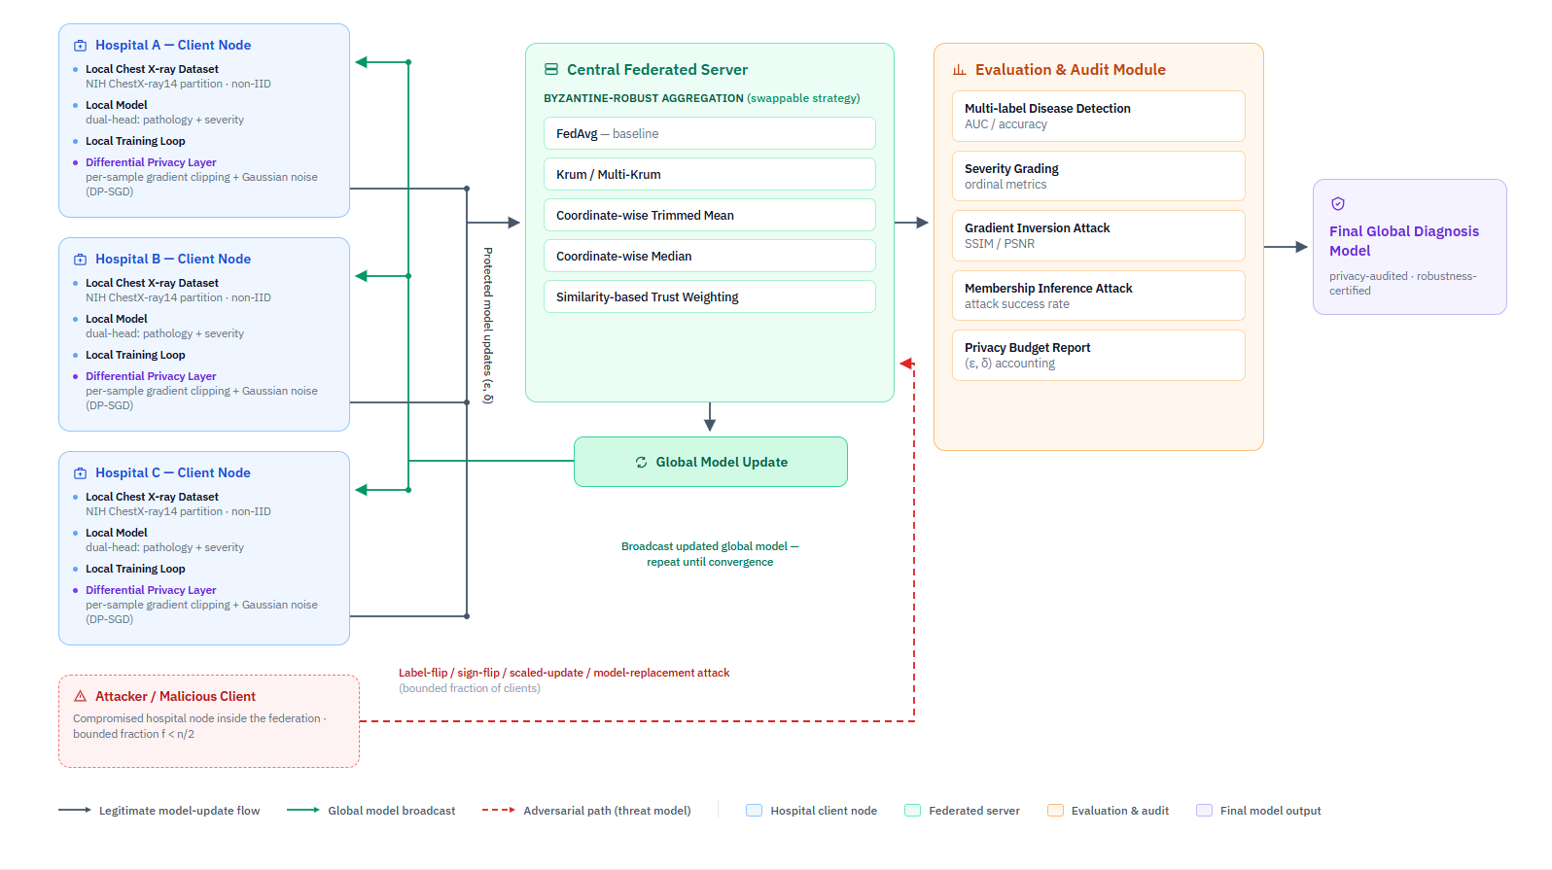
Fig. 1. FedMedGuard system architecture: hospital leaf nodes train locally (optionally under DP-SGD or as Byzantine clients) and transmit only weights to the centre node, which aggregates with a pluggable rule and evaluates the global model each round. (Insert architecture diagram.)
The system satisfies the following functional requirements, which trace directly to the objectives:
• FR1. The system trains the model locally on each hospital node without transmitting raw patient data off-site.
• FR2. It applies per-sample gradient clipping and calibrated Gaussian noise to every client update before transmission (client-level DP-SGD).
• FR3. The central server supports pluggable aggregation strategies, FedAvg, Krum/Multi-Krum, trimmed mean, median, and trust weighting, selectable via configuration.
• FR4. It simulates Byzantine client behaviour (label-flip, sign-flip, scaled-update, model-replacement) for a configurable fraction of nodes.
• FR5. It tracks and reports the cumulative differential-privacy budget (ε, δ) for every run via a Renyi-DP accountant.
• FR6. The evaluation module reports multi-label pathology detection and per-disease severity grading for the global model after each round.
• FR7. It can execute gradient-inversion and membership-inference attacks against intercepted updates and report reconstruction quality and attack success rate.
• FR8. It exposes a FastAPI backend and a React dashboard to visualize per-node training status, weight-update flow, and aggregation events.
Non-functionally, the framework enforces a formally accounted privacy budget on every update rather than relying on architectural assumptions; tolerates a bounded fraction of malicious updates without a proportionate collapse in accuracy; keeps client rounds within a practical time budget on free-tier cloud GPUs; stays agnostic to the number of nodes so the same codebase scales from three to a larger federation; and ships automated tests over synthetic data so that regressions are caught without a full dataset download.

RESULTS

Experimental Setup
All runs use DenseNet-121 (ImageNet-pretrained) with the dual head and class-balanced loss, a non-IID Dirichlet (α = 0.5) patient-level split, Adam at learning rate 1e-4, batch size 32, and seed 42, on a single cloud GPU. The core comparison uses three nodes on a ~30,000-image patient-aware subset at 224 px, with the centralized and single-site baselines trained for twelve epochs and the federated model for twelve rounds of one local epoch, so that the baseline training budget matches the federated budget and the centralized model is a fair upper bound. The defense sweep uses six nodes, so that robust aggregation has an honest majority, on a ~12,000-image subset at 128 px for eight rounds; it is deliberately smaller and faster because it comprises nine federated runs including the slower DP runs, and its purpose is relative comparison. Table 2 summarizes the configuration.
Table 2. Experimental configuration for the core comparison and the defense sweep.
Parameter | Core comparison | Defense sweep
Nodes | 3 | 6
Subset size | ~30,000 | ~12,000
Image size | 224 px | 128 px
Rounds | 12 | 8
Partition | non-IID α=0.5 | non-IID α=0.5
Attack | none | model-replacement, 2/6 nodes
DP noise σ | none | 1.0, 2.0

Core Comparison: Federated vs Isolated vs Centralized
Table 3 reports the headline comparison. The federated global model reaches a mean ROC-AUC of 0.754, which beats every isolated single-site model (mean 0.721, individual nodes 0.713, 0.731 and 0.718) and recovers 66% of the gap between the isolated floor and the centralized ceiling of 0.772, all without any raw data leaving a node. As Figure 2 shows, the ordering floor < federated < ceiling holds cleanly, and Figure 3 shows the federated global AUC rising monotonically from 0.486 at initialization to a peak of 0.761, with the loss curve in Figure 4 confirming convergence. For context, published full-dataset mean AUC on ChestX-ray14 is approximately 0.80 to 0.84 [1], [21]; reaching 0.77 on a 30,000-image subset is competitive, only a few points below, with roughly four times less data.
Table 3. Core comparison on the shared test set (mean ROC-AUC; non-IID, class-balanced).
Configuration | Mean ROC-AUC | Role
Single-site (isolated) | 0.721 | floor (one hospital alone)
Federated (FedAvg) | 0.754 | proposed architecture
Centralized (pooled) | 0.772 | ceiling (all data pooled)

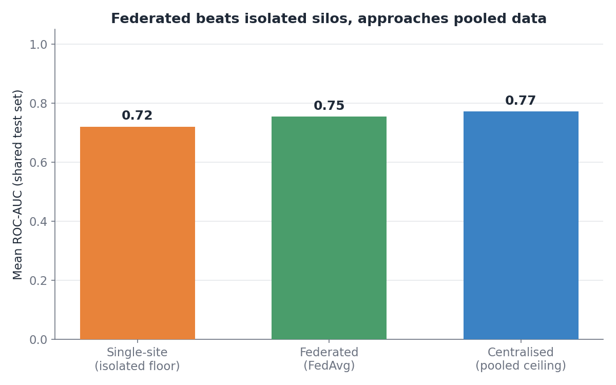
Fig. 2. Federated learning beats the isolated single-site floor and approaches the centralized ceiling.
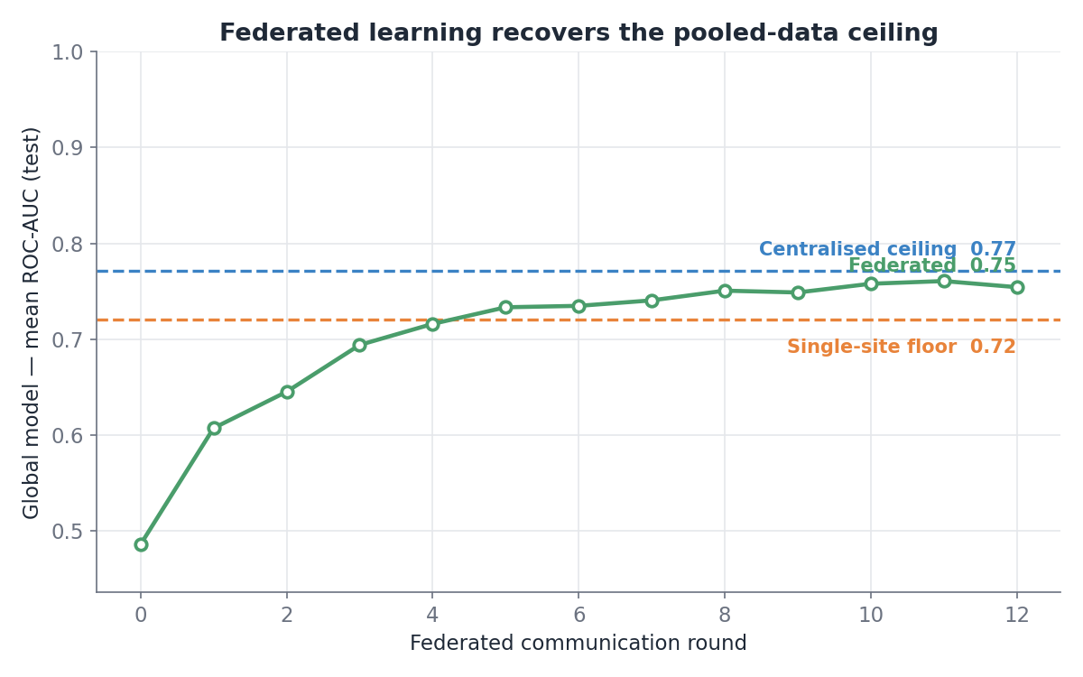
Fig. 3. Federated global mean ROC-AUC per round, with the single-site floor and centralized ceiling marked.
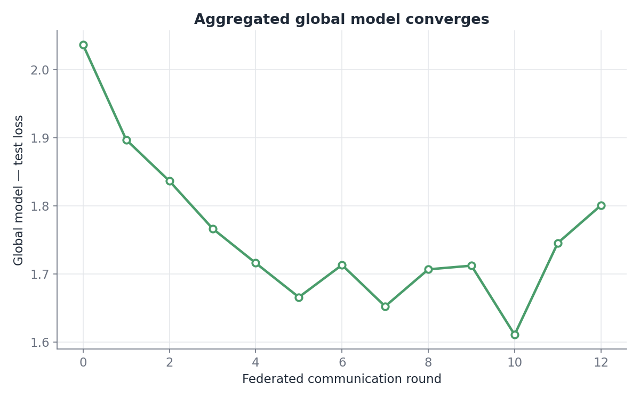
Fig. 4. Federated global test loss per round (convergence of the aggregated model).
Figure 5 breaks the result down per pathology. The federated model scores highest on findings with large, characteristic signatures, Edema (0.855), Cardiomegaly (0.844), and Pneumothorax (0.829), and lowest on small or rare findings such as Nodule (0.678) and Hernia (0.674), closely tracking the centralized model. Table 4 lists the full per-pathology breakdown. On the severity proxy (n = 187 test images) the federated model attains a mean absolute error of 0.63 and a quadratic weighted kappa of 0.42, comparable to the centralized 0.59 and 0.39.
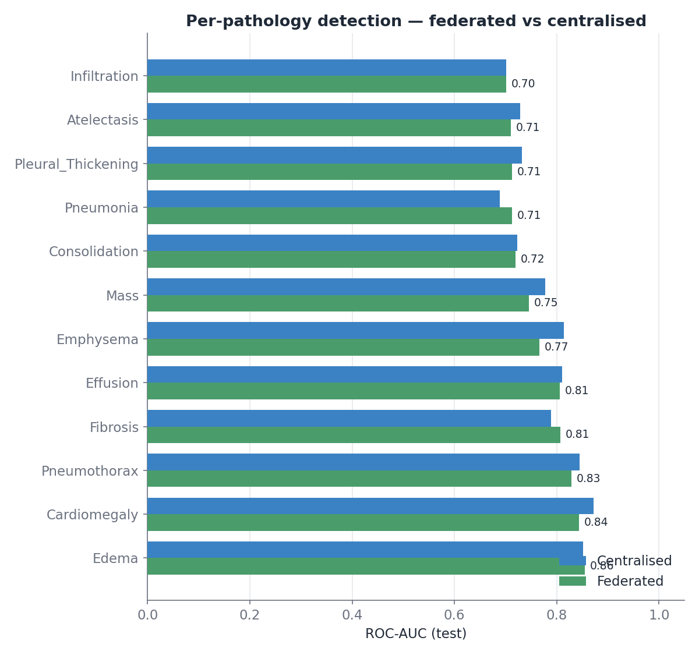
Fig. 5. Per-pathology ROC-AUC, federated versus centralized.
Table 4. Per-pathology ROC-AUC, federated versus centralized.
Pathology | Federated | Centralized
Atelectasis | 0.710 | 0.728
Cardiomegaly | 0.844 | 0.872
Effusion | 0.806 | 0.810
Infiltration | 0.701 | 0.701
Mass | 0.746 | 0.778
Nodule | 0.678 | 0.681
Pneumonia | 0.713 | 0.689
Pneumothorax | 0.829 | 0.845
Consolidation | 0.719 | 0.723
Edema | 0.855 | 0.852
Emphysema | 0.767 | 0.814
Fibrosis | 0.807 | 0.789
Pleural Thickening | 0.712 | 0.732
Hernia | 0.674 | 0.788
Mean | 0.754 | 0.772

Privacy-Utility Trade-off
Table 5 reports the cost of differential privacy in the defense-sweep setting with no attack. Adding DP at σ = 1.0 (ε ≈ 4.5) lowers the mean AUC from 0.642 to 0.493, and a tighter budget at σ = 2.0 (ε ≈ 1.4) lowers it further to 0.487. The direction is the expected privacy-utility trade-off: a smaller ε buys stronger privacy at a measurable utility cost. Figure 6 visualizes the trade-off. The absolute drop is severe at this deliberately small scale (128 px, 12,000 images); utility is expected to recover with more data and less noise.
Table 5. Privacy-utility trade-off of client-level differential privacy (no attack).
Setting | Mean ROC-AUC | Privacy (ε, δ=1e-5)
FedAvg, no DP | 0.642 | —
FedAvg, DP σ=1.0 | 0.493 | ε ≈ 4.5
FedAvg, DP σ=2.0 | 0.487 | ε ≈ 1.4

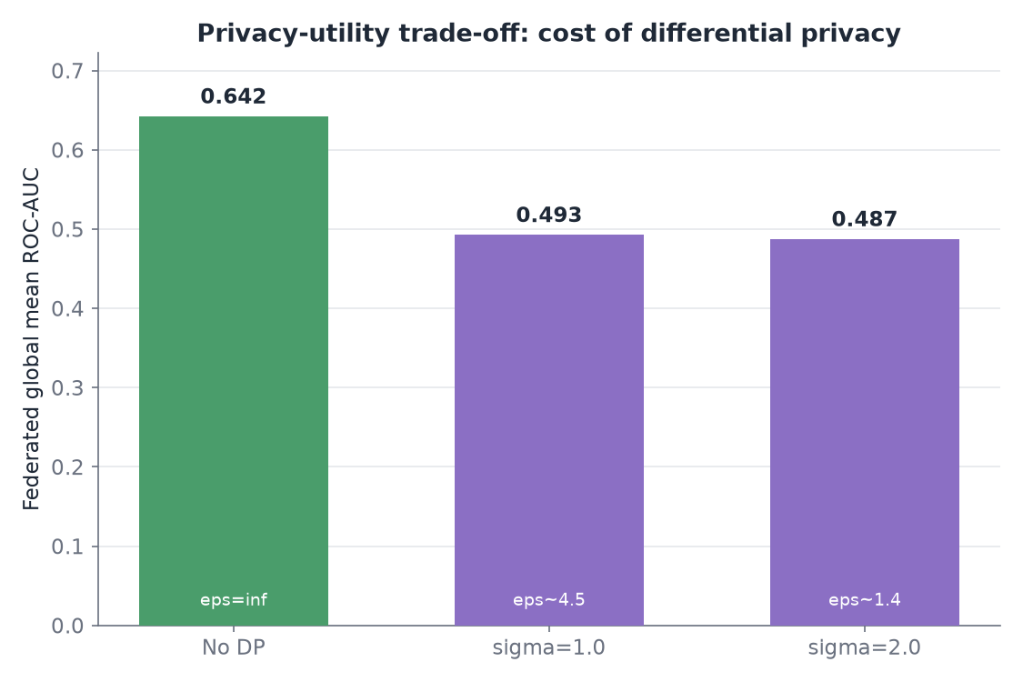
Fig. 6. Privacy-utility trade-off: utility falls as the DP budget tightens.

Robustness under Poisoning
Table 6 reports robustness under the model-replacement attack with two of six nodes malicious. Plain FedAvg has no defense and collapses completely: the boosted malicious update overwrites the global model, its weights diverge to non-finite values, and the AUC falls to 0.500, pure chance. The robust rules survive, with trimmed mean the strongest at 0.571, median at 0.562, and Krum at 0.545, recovering between a third and a half of the utility lost to the attack relative to the clean reference of 0.642. Figure 7 shows the contrast. This directly demonstrates the value of replacing the aggregation rule.
Table 6. Robustness under model-replacement (2 of 6 nodes malicious).
Aggregation (under attack) | Mean ROC-AUC
FedAvg | 0.500 (diverged)
Krum | 0.545
Median | 0.562
Trimmed mean | 0.571

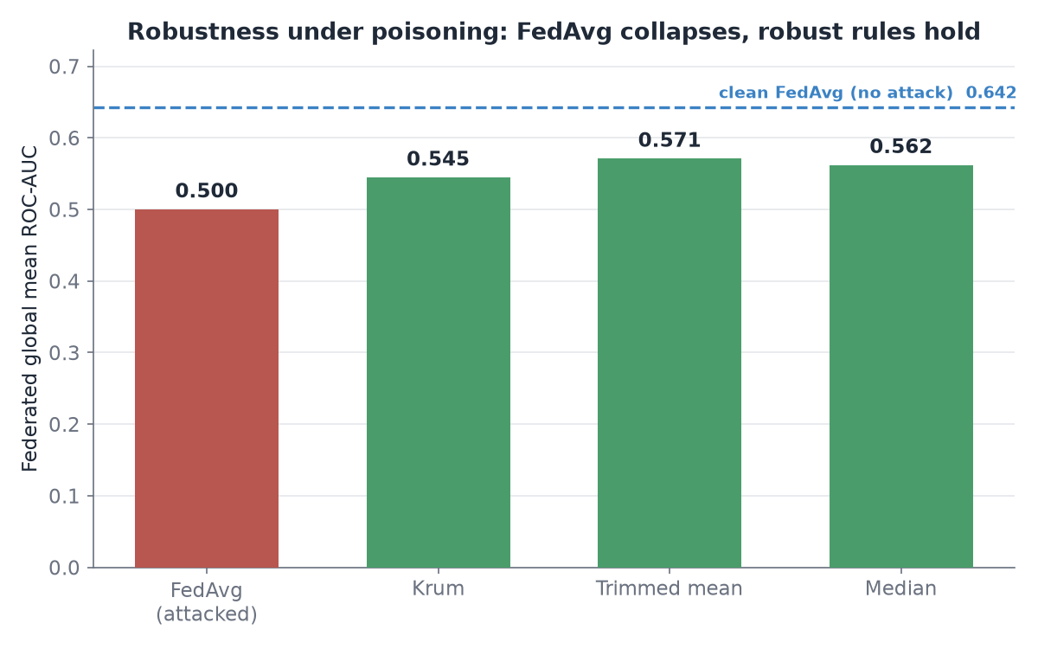
Fig. 7. FedAvg collapses under poisoning while robust aggregation rules hold.

Privacy-Robustness Composition
Table 7 presents the central result of this work. Under the same attack, we run FedAvg and the median aggregator both with and without differential privacy. Adding DP costs the robust rule (median) 0.104 AUC, from 0.562 to 0.458, whereas it costs FedAvg essentially nothing, from 0.500 to 0.506. In other words, the two defenses compose destructively: DP's clipping and Gaussian noise erase the update-norm and direction signal that the median aggregator relies on to reject malicious updates, so turning on both defenses together is worse for the robust system than turning on either alone. There is a notable asymmetry, visible in Figure 8: DP's clipping actually shields FedAvg slightly, because it bounds the magnitude of the boosted malicious update, while DP's noise degrades the median, so the interaction depends on which mechanism dominates. This is precisely the interaction predicted by research gap G1 and, to our knowledge, had not been measured directly on medical imaging before.
Table 7. DP x robust-aggregation composition under attack (research gap G1).
Configuration (under attack) | Mean ROC-AUC | ΔAUC from DP
FedAvg, no DP | 0.500 | —
FedAvg, DP on | 0.506 | +0.006
Median, no DP | 0.562 | —
Median, DP on | 0.458 | −0.104

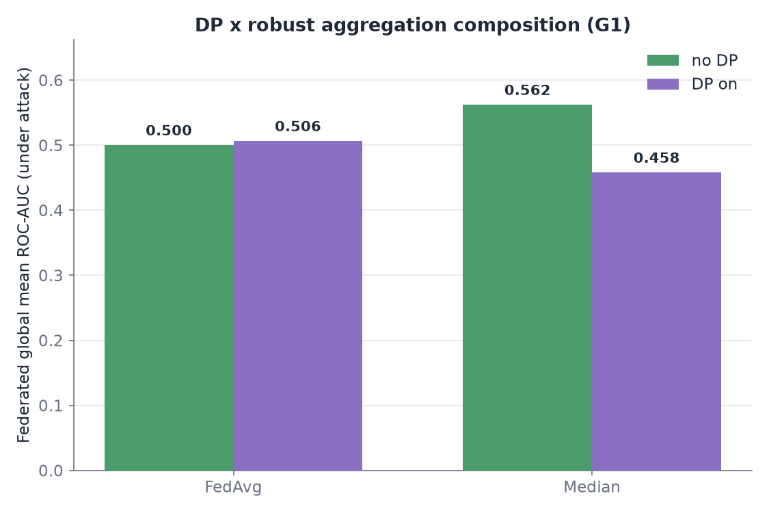
Fig. 8. Composition of DP and robust aggregation: DP degrades the median aggregator far more than it degrades FedAvg.

COMPARING WITH RELATED SYSTEMS
Table 8 compares FedMedGuard with representative systems from the literature across the capabilities that determine whether a federated clinical system is both private and robust. DP-FL systems such as [1] provide a privacy budget but no defense against malicious clients; robust-aggregation systems such as [2] and [3] defend integrity but aggregate in the clear; and the large clinical deployments [6], [10] prove federation works but declare neither a privacy budget nor a threat model. FedMedGuard is the only framework here that embeds both defenses, adds an ordinal severity head, and, crucially, measures the privacy-robustness-utility trade-off that arises when they are combined, rather than evaluating each defense in isolation.
Table 8. Capability comparison of FedMedGuard with related federated medical systems.
System | DP budget | Byzantine robust | Severity | Trade-off characterized
DP-FL for thoracic disease [1] | Yes | No | No | No
OptiGradTrust [2] | No | Yes | No | No
Multimodal FL report gen. [3] | No | Yes | No | No
EXAM / rare-cancer FL [6,10] | No | No | No | No
PriMIA [9] | Yes | No | No | No
FedMedGuard (ours) | Yes | Yes | Yes | Yes

CONCLUSION
FedMedGuard gives a practical advance for privacy-preserving and robust federated medical diagnosis. By embedding client-level differential privacy and a full set of Byzantine-robust aggregation rules into the training loop of a dual-head chest-radiograph model, and by exposing privacy, robustness, and heterogeneity as independent configuration axes, the framework lets the privacy-robustness-utility trade-off be measured rather than assumed. On NIH ChestX-ray14 the federated global model beats every isolated single-site model and approaches the centralized upper bound while keeping data local; differential privacy buys a formal budget at a measurable utility cost; and robust aggregation rescues the model from a model-replacement attack that drives plain FedAvg to complete divergence. The main novelty of FedMedGuard lies in its explicit characterization of what happens when these two defenses are combined: we show empirically that they can compose destructively, with differential privacy degrading a robust aggregator far more than it degrades undefended averaging, because DP removes the very update statistics robust aggregation depends on. Unlike existing studies that address privacy and robustness individually, FedMedGuard treats their interaction as the primary object of study, which is exactly the gap the literature leaves open.
Having built and validated FedMedGuard, we see several concrete directions that would extend its impact:
• Empirical privacy audit. Execute gradient-inversion and membership-inference attacks against intercepted updates and report reconstruction quality (SSIM/PSNR) and attack success rate at each ε, so that the privacy budget is empirically verified rather than only accounted for.
• Full trade-off surface. Sweep the full (ε, attacker fraction, heterogeneity) surface to map the regimes in which the composition is constructive, neutral, or destructive, and identify operating points that satisfy privacy, robustness, and utility jointly.
• Heterogeneity and fairness. Quantify FedProx/FedBN behaviour under simultaneous DP and robust aggregation, and test whether robust rules silently exclude honest minority-distribution clients, a fairness-under-robustness check.
• Scale-up. Re-run the core and defense experiments at full dataset scale and higher resolution to raise the absolute operating point.
• Interactive demonstrator. Expose the FastAPI backend and React dashboard so the round-by-round federated process, weight-update flow, aggregation events, and the effect of toggling each defense, can be demonstrated live.
FedMedGuard is designed to be extended through continued experimentation on a common benchmark. By making the interaction between privacy and robustness measurable rather than assumed, it provides a reproducible, threat-model-explicit blueprint for federated clinical AI and an empirical map of the conditions under which privacy, robustness, and diagnostic accuracy can be jointly satisfied.

Credit authorship contribution statement
Devraj K Chandani, Shaurya Saini, Pooja Goel: Conceptualization, Methodology, Software, Data curation, Writing original draft, Investigation, Writing review and editing. Jabanjalin Hilda J: Supervision.

Declaration of competing interest
The authors declare that they have no known competing financial interests or personal relationships that could have appeared to influence the work reported in this paper.
Data Availability
The NIH ChestX-ray14 dataset is publicly available. The reference implementation and experiment configurations are available in the project repository.
Funding Statement
The authors declare that no funding, grants, or external support were received during the development of this project.

REFERENCES
[1] M. Zulqarnain, S. J. Hussain, M. Z. Aslam, A. Fiaz, and M. Islam, "Federated learning for thoracic disease classification using convolutional neural networks and differential privacy," Healthcare Technology Letters, vol. 13, no. 1, art. e70080, Jan. 2026.
[2] M. Karami, F. Ghassemi, H. Kebriaei, and H. Azadegan, "OptiGradTrust: Byzantine-robust federated learning with multi-feature gradient analysis and reinforcement learning-based trust weighting," arXiv preprint arXiv:2507.23638, Jul. 2025.
[3] M. R. Islam, M. Z. Hossain, M. Ahmed, and M. S. S. Samu, "Privacy-preserving chest X-ray report generation via multimodal federated learning with ViT and GPT-2," arXiv preprint arXiv:2505.21715, May 2025.
[4] S. M. Bokhari, S. Sohaib, and M. Shafi, "Fusion of personalized federated learning (PFL) with differential privacy (DP) learning for diagnosis of arrhythmia disease," PLOS ONE, vol. 20, no. 7, art. e0327108, Jul. 2025.
[5] R. Ahmed, P. K. R. Maddikunta, T. R. Gadekallu, N. K. Alshammari, and F. A. Hendaoui, "Efficient differential privacy enabled federated learning model for detecting COVID-19 disease using chest X-ray images," Frontiers in Medicine, vol. 11, art. 1409314, Jun. 2024.
[6] S. Pati, U. Baid, B. Edwards, et al., "Federated learning enables big data for rare cancer boundary detection," Nature Communications, vol. 13, no. 1, art. 7346, Dec. 2022.
[7] J. Ziegler, B. Pfitzner, H. Schulz, A. Saalbach, and B. Arnrich, "Defending against reconstruction attacks through differentially private federated learning for classification of heterogeneous chest X-ray data," Sensors, vol. 22, no. 14, art. 5195, Jul. 2022.
[8] M. Adnan, S. Kalra, J. C. Cresswell, G. W. Taylor, and H. R. Tizhoosh, "Federated learning and differential privacy for medical image analysis," Scientific Reports, vol. 12, no. 1, art. 1953, Feb. 2022.
[9] G. Kaissis, A. Ziller, J. Passerat-Palmbach, et al., "End-to-end privacy preserving deep learning on multi-institutional medical imaging," Nature Machine Intelligence, vol. 3, no. 6, pp. 473-484, Jun. 2021.
[10] I. Dayan, H. R. Roth, A. Zhong, et al., "Federated learning for predicting clinical outcomes in patients with COVID-19," Nature Medicine, vol. 27, no. 10, pp. 1735-1743, Oct. 2021.
[11] B. McMahan, E. Moore, D. Ramage, S. Hampson, and B. A. y Arcas, "Communication-efficient learning of deep networks from decentralized data," in Proc. 20th Int. Conf. Artificial Intelligence and Statistics (AISTATS), 2017, pp. 1273-1282.
[12] M. Abadi, A. Chu, I. Goodfellow, et al., "Deep learning with differential privacy," in Proc. ACM SIGSAC Conf. Computer and Communications Security (CCS), 2016, pp. 308-318.
[13] I. Mironov, "Renyi differential privacy," in Proc. IEEE 30th Computer Security Foundations Symposium (CSF), 2017, pp. 263-275.
[14] P. Blanchard, E. M. El Mhamdi, R. Guerraoui, and J. Stainer, "Machine learning with adversaries: Byzantine tolerant gradient descent (Krum)," in Advances in Neural Information Processing Systems (NeurIPS), vol. 30, 2017.
[15] D. Yin, Y. Chen, K. Ramchandran, and P. Bartlett, "Byzantine-robust distributed learning: Towards optimal statistical rates," in Proc. 35th Int. Conf. Machine Learning (ICML), 2018, pp. 5650-5659.
[16] E. Bagdasaryan, A. Veit, Y. Hua, D. Estrin, and V. Shmatikov, "How to backdoor federated learning," in Proc. 23rd Int. Conf. Artificial Intelligence and Statistics (AISTATS), 2020, pp. 2938-2948.
[17] X. Wang, Y. Peng, L. Lu, Z. Lu, M. Bagheri, and R. M. Summers, "ChestX-ray8: Hospital-scale chest X-ray database and benchmarks on weakly-supervised classification and localization of common thorax diseases," in Proc. IEEE CVPR, 2017, pp. 2097-2106.
[18] G. Huang, Z. Liu, L. van der Maaten, and K. Q. Weinberger, "Densely connected convolutional networks," in Proc. IEEE CVPR, 2017, pp. 4700-4708.
[19] T. Li, A. K. Sahu, M. Zaheer, M. Sanjabi, A. Talwalkar, and V. Smith, "Federated optimization in heterogeneous networks (FedProx)," in Proc. Machine Learning and Systems (MLSys), 2020.
[20] X. Li, M. Jiang, X. Zhang, M. Kamp, and Q. Dou, "FedBN: Federated learning on non-IID features via local batch normalization," in Proc. Int. Conf. Learning Representations (ICLR), 2021.
[21] P. Rajpurkar, J. Irvin, K. Zhu, et al., "CheXNet: Radiologist-level pneumonia detection on chest X-rays with deep learning," arXiv preprint arXiv:1711.05225, 2017.
[22] L. Zhu, Z. Liu, and S. Han, "Deep leakage from gradients," in Advances in Neural Information Processing Systems (NeurIPS), vol. 32, 2019.
[23] J. Geiping, H. Bauermeister, H. Droge, and M. Moeller, "Inverting gradients - How easy is it to break privacy in federated learning?," in Advances in Neural Information Processing Systems (NeurIPS), vol. 33, 2020.
[24] R. Shokri, M. Stronati, C. Song, and V. Shmatikov, "Membership inference attacks against machine learning models," in Proc. IEEE Symposium on Security and Privacy (S&P), 2017, pp. 3-18.

