**CS518**

**Computer Vision**

**Assignment 1**

**Name: Pooja Goyal**

**Entry Number: 2020CSB1108**

**QUESTION 1**

**Canny Edge Detection**

Canny Edge Detection is an edge detection operator that uses a multi-stage algorithm to detect a wide range of edges in images. The stages in Canny Edge Detector are as follows:

* Noise Reduction
* Gradient calculation
* Non-maximum suppression
* Double threshold
* Edge Tracking by Hysteresis

**Step1: Noise Detection**

Gaussian filtering is used here to get rid of the noise in the image. The kernel for gaussian blur of size (2k+1)*(2k+1) is given by the following equation:

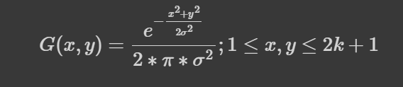

**Step2: Gradient Calculation**

Sobel filters:

kx = [[-1, 0, 1], [-2, 0, 2], [-1, 0, 1]]

ky = [[1, 2, 1], [0, 0, 0], [-1, -2, -1]]

Using these two, gradient magnitude and theta is calculated as:

|G| = sqrt(square(Ix)+square(Iy))

theta = arctan(Iy/Ix)

**Step3: Non Maximum Suppression**

To make the edges thinner, the algorithm goes through all the points on the gradient intensity matrix and finds the pixels with the maximum value in the edge directions

**Step4: Double Threshold**

Identifying 3 types of pixels depending on the intensity value of each pixel.

1. Strong
2. Weak
3. Irrelevent

**Step5: Hysteresis**

Tracking the edges by seeing if there are any strong pixels surrounding the chosen one.

**Deciding low and high threshold values.**

As the threshold is different per image so I had to vary the values. In my implementation I found it helpful to choose a threshold ratio instead of a specific value and multiply that by the maximum pixel value in the image.



Threshold values are chosen such that we can get the Structural Similarity Index Metric (SSIM) between the outputs of Skimage’s Canny Edge Detector and myCannyEdgeDetector() as large as possible and observing the output of various threshold values. Output should be as close to Skimage’s Canny Edge Detector as possible.

I choose the **low_threshold as 0.05 and high_threshold as 0.15**

For example: Output is as shown below for few pair of threshold values.

**Low_threshold: 0.1 and High_threshold = 0.4**

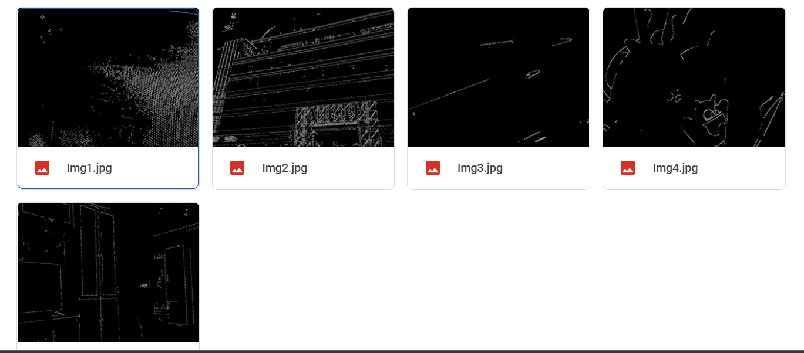

**Low_threshold: 0.05, High_threshold: 0.15**

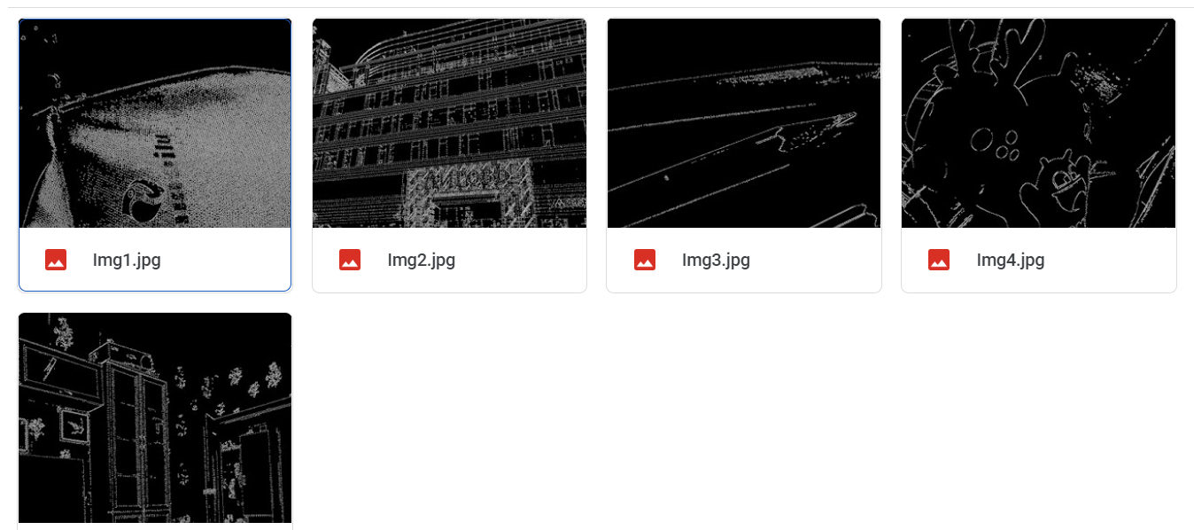

**Skimage’s Canny Edge Detector Results**

