POWER ANALYSIS AND BATTERY SELECTION
ESP-12F Temperature / Humidity Monitoring Node with 5-Minute MQTT Transmission
Engineering project article — design calculation, battery sizing and low-power operating strategy
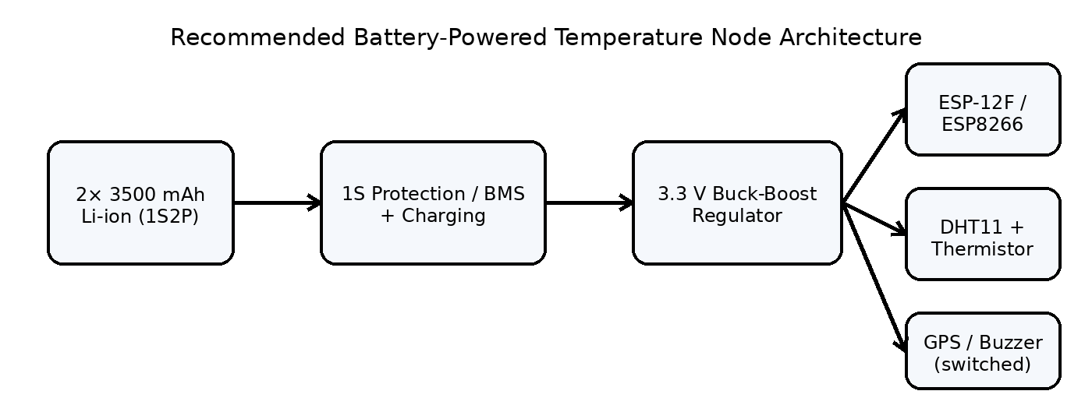
Figure 1. Recommended power architecture for the battery-powered temperature node.

1. System Definition
The proposed node uses an ESP-12F/ESP8266 as the wireless controller. A DHT11 measures ambient temperature and relative humidity, while an external thermistor provides an additional temperature measurement through an analogue divider. The GPS receiver is not a continuous sensing load: it is used only during initialization to obtain the node location, after which the location can be stored and the GPS powered off. The measured data are transmitted to the MQTT server once every 5 minutes.
For a long-life battery design, the ESP8266 should not remain connected to Wi-Fi continuously. The recommended operating sequence is: wake from deep sleep, read the sensors, connect to Wi-Fi, publish one MQTT message, disconnect, and return to deep sleep for approximately 300 s.
Parameter | Design value
MQTT transmission interval | 5 min (300 s)
MQTT messages per hour | 12
MQTT messages per day | 288
Battery arrangement | 1S2P — two 3500 mAh cells in parallel
Nominal battery voltage | 3.6–3.7 V
Nominal battery capacity | 7000 mAh
Nominal stored energy | 25.90 Wh
Regulated electronics rail | 3.3 V
GPS operation | Initialization only; OFF during normal monitoring

2. Component Power Data and Design Assumptions
The calculation uses manufacturer/datasheet values where available. Because the exact Wi-Fi association time, RF transmit duty cycle, thermistor resistance, and GPS model were not specified, a conservative engineering case is also included. The conservative case should be used for battery sizing.
Load | Value used | Basis
ESP8266 active/Wi-Fi interval | 100 mA for 5 s per cycle | Conservative design assumption; actual RF current varies
ESP8266 deep sleep | 20 µA | Espressif datasheet value
DHT11 measurement | 0.3 mA | DHT11 specification
DHT11 standby | 60 µA | DHT11 specification
Thermistor divider | 0.165 mA | 10 kΩ + 10 kΩ assumed at 3.3 V
3.3 V converter efficiency | 90% | Conservative engineering assumption
Converter quiescent current | 25 µA | Representative TPS63031 typical value

Espressif specifies an average operating current of about 80 mA for the ESP8266EX and reports 20 µA in deep sleep. Its RF section can draw substantially higher instantaneous current during transmission; the datasheet gives typical TX values of 120–170 mA depending on 802.11 mode. Espressif also gives a directly relevant example in which a temperature sensor sleeps for 300 s and then wakes to connect to the access point, with an overall average ESP8266 current below 1 mA.

3. Battery Configuration
Two 3500 mAh single-cell Li-ion batteries are selected in parallel, not in series. This produces a 1S2P pack: the voltage remains approximately 3.6–3.7 V nominal while the capacity becomes approximately 7000 mAh.
C_pack = 3500 mAh + 3500 mAh = 7000 mAh
E_pack ≈ 7.0 Ah × 3.7 V = 25.9 Wh
A protected 3500 mAh 18650 is a suitable cell class for this design. If unprotected Samsung INR18650-35E cells are used instead, a dedicated 1S protection/BMS circuit is mandatory. Cells connected in parallel should be matched, at similar state of charge, and from the same cell type/batch where practical. The protection and charging circuit must be designed for a 1S Li-ion pack with a 4.2 V charge limit.

4. Five-Minute MQTT Power Calculation

4.1 ESP8266 average current
Assume the ESP8266 is active for 5 s during each 300 s cycle at 100 mA. For the remaining 295 s it is in deep sleep at 20 µA = 0.020 mA.
I_ESP,avg = [(100 mA × 5 s) + (0.020 mA × 295 s)] / 300 s = 1.686 mA

4.2 DHT11 average current
The DHT11 is assumed to spend 1 s in its measurement state during each 5-minute cycle and to remain in its specified standby state for the rest of the interval.
I_DHT,avg = [(0.3 mA × 1 s) + (0.060 mA × 299 s)] / 300 s = 0.061 mA

4.3 Thermistor divider current
A 10 kΩ thermistor with a 10 kΩ fixed resistor is assumed for the analogue divider. At 3.3 V, the divider current is approximately:
I_divider = 3.3 V / (10 kΩ + 10 kΩ) = 0.165 mA

4.4 Total 3.3 V load
I_3V3,avg = 1.686 + 0.061 + 0.165 = 1.912 mA
The buzzer is assumed to be OFF during normal operation. The GPS is also excluded from the continuous load because it is powered only during location initialization.

4.5 Battery-side current through a buck-boost converter
A single-cell Li-ion battery cannot be regulated to 3.3 V over its complete discharge range by a simple AMS1117 LDO without losing usable battery capacity. A buck-boost converter is therefore recommended. For the calculation, 90% conversion efficiency is used.
I_bat,avg = (3.3 V × 1.912 mA) / (3.7 V × 0.90) + 0.025 mA = 1.920 mA

5. Battery Runtime
A practical design should not assume that every last milliamp-hour of the nominal battery capacity is usable. An 80% usable-capacity factor is applied to account for converter cutoff, cell voltage limits, temperature, ageing, and capacity tolerance.
C_usable = 7000 mAh × 0.80 = 5600 mAh
Runtime = 5600 mAh / 1.920 mA = 2917 h ≈ 121.5 days
Operating assumption | Average battery current | Estimated runtime
Conservative design case: 5 s active / 295 s deep sleep | 1.920 mA | 121.5 days
Espressif-style <1 mA ESP average + sensor loads | 1.240 mA | 188.2 days
No deep sleep; Wi-Fi maintained, ~15 mA modem-sleep baseline | 15.11 mA | 15.4 days

The large difference between the first and third cases is the key design result. Reducing the MQTT interval alone is not sufficient if the ESP8266 remains awake. The major battery-life improvement comes from putting the ESP8266 into deep sleep between measurements.

6. Daily Energy and Data Transmission
Quantity | Result
Messages per day | 288
Conservative average battery current | 1.920 mA
Approx. battery charge consumed per day | 46.1 mAh/day
Approx. nominal battery energy | 25.90 Wh
Approx. daily battery energy consumption | 0.170 Wh/day

At one MQTT message every 5 minutes, the node generates 12 messages per hour and 288 messages per day. This is generally adequate for environmental monitoring and reduces wireless activity by a factor of 300 compared with a one-message-per-second schedule.

7. GPS Initialization Energy
The GPS receiver is not part of the continuous power budget because it is used only to initialize the node location. As an engineering example, if a GPS receiver draws 50 mA for 60 s during initial acquisition, the one-time consumption is:
E_GPS,initial ≈ 50 mA × 1 h/60 = 0.83 mAh
This is negligible compared with a 7000 mAh battery. The exact GPS energy should nevertheless be recalculated using the selected receiver's datasheet and actual time-to-first-fix.

8. Regulator and Power-Path Recommendation
The existing AMS1117-3.3 arrangement should not be the preferred final power stage for a single-cell Li-ion battery. An LDO wastes the voltage difference as heat and, more importantly, cannot maintain 3.3 V once the cell voltage falls below the regulator's required headroom.
A buck-boost converter such as the TI TPS63031 is a suitable design reference because it accepts 1.8–5.5 V input, provides a fixed 3.3 V option, supports up to 500 mA in boost operation at 3.3 V, and has a typical quiescent current of 25 µA. The exact regulator should be selected after checking component availability, PCB layout requirements, and the ESP-12F's peak-current demand.
Power-stage item | Recommended implementation
Battery | 2 × 3500 mAh Li-ion, 1S2P, 3.6–3.7 V nominal
Protection | 1S Li-ion protection/BMS with overcharge, over-discharge and over-current protection
Regulator | 3.3 V buck-boost, ≥500 mA output capability preferred
ESP supply | 3.3 V regulated rail with local bulk + ceramic decoupling
DHT11 | 3.3 V supply; power-gate if further optimization is required
Thermistor | 10 kΩ divider; preferably switch divider power during deep sleep
GPS | Load-switched; ON only during initialization
Buzzer | Normally OFF
MQTT interval | 300 s
ESP sleep mode | Deep sleep between transmissions

9. Peak Current and Hardware Margin
Battery capacity determines runtime, but it does not guarantee reliable operation. The ESP8266 can draw much higher instantaneous current during Wi-Fi transmission than its long-term average. The power rail must therefore be designed for the peak load, not only the calculated average.
The ESP8266EX datasheet lists typical Wi-Fi TX currents of 120 mA for 802.11n, 140 mA for 802.11g, and 170 mA for 802.11b under specified test conditions. The regulator and PCB decoupling network should therefore provide adequate transient response. A practical design target is a regulated 3.3 V rail capable of at least 500 mA, with the exact margin verified experimentally.

10. Practical Battery-Life Optimization
• Use deep sleep rather than keeping the Wi-Fi association alive between MQTT transmissions.
• Power the GPS only during the initialization procedure and store the acquired location in non-volatile memory.
• Switch off the thermistor divider during deep sleep if the firmware/hardware permits it; this removes the continuous 0.165 mA divider current.
• Use a buck-boost regulator instead of AMS1117-3.3 for the final single-cell design.
• Avoid indicator LEDs that remain continuously powered; their current can become significant relative to the deep-sleep load.
• Place low-ESR bulk capacitance and ceramic decoupling close to the ESP-12F power pins to handle Wi-Fi current transients.
• Use matched cells in the 1S2P battery pack and provide proper 1S protection and charging.
• Validate the theoretical runtime using an ammeter/data logger because Wi-Fi retry time and access-point signal strength can dominate the actual wake energy.

11. Engineering Conclusion
For the proposed temperature-monitoring node, changing the MQTT interval to 5 minutes and using two 3500 mAh cells in a 1S2P arrangement gives a 7 Ah, approximately 25.9 Wh nominal battery pack. With deep sleep between transmissions, the calculated conservative battery-side average current is approximately 1.92 mA, giving an estimated runtime of about 122 days after applying an 80% usable-capacity factor. The actual runtime can be higher or lower depending primarily on Wi-Fi connection time, RF retries, regulator efficiency, sensor powering strategy, and battery condition.
If the ESP8266 is kept awake instead of using deep sleep, the same battery is expected to last only on the order of 15 days under the simplified 15 mA modem-sleep baseline. Therefore, deep sleep is the principal design requirement for achieving a genuinely long-lasting 5-minute MQTT node.

