Lab Sheet 6: MongoDB Basic commands

- Create a database called ‘vehicles’ and write a MongoDB query to select database as
“vehicles”.
- Write a MongoDB query to display all the databases.
- Create a collection called ‘two_wheelers’. (use capping) and Create a collection called
‘four_wheelers’.
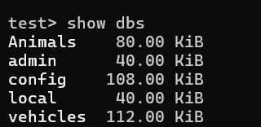

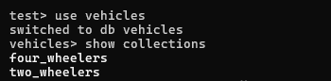

- Write a MongoDB query to display all documents available in two_wheelers and
four_wheelers
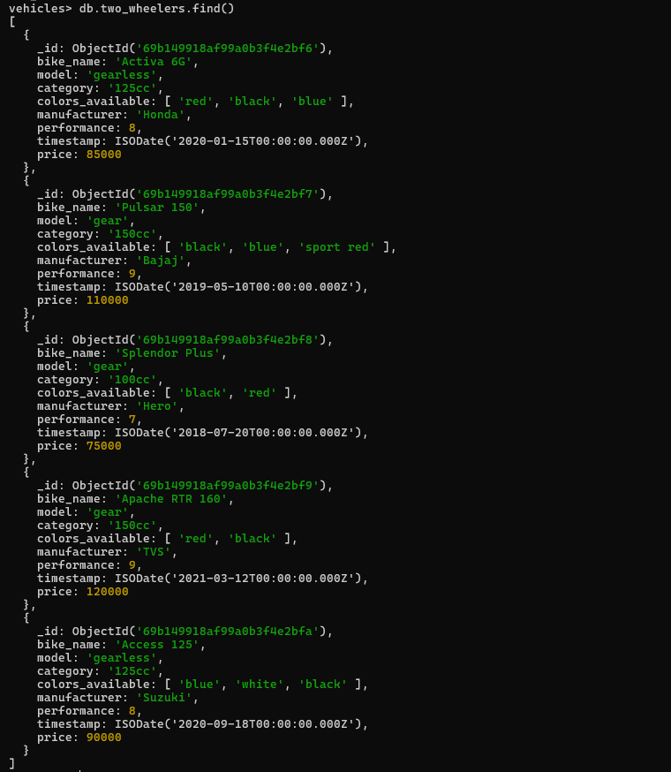

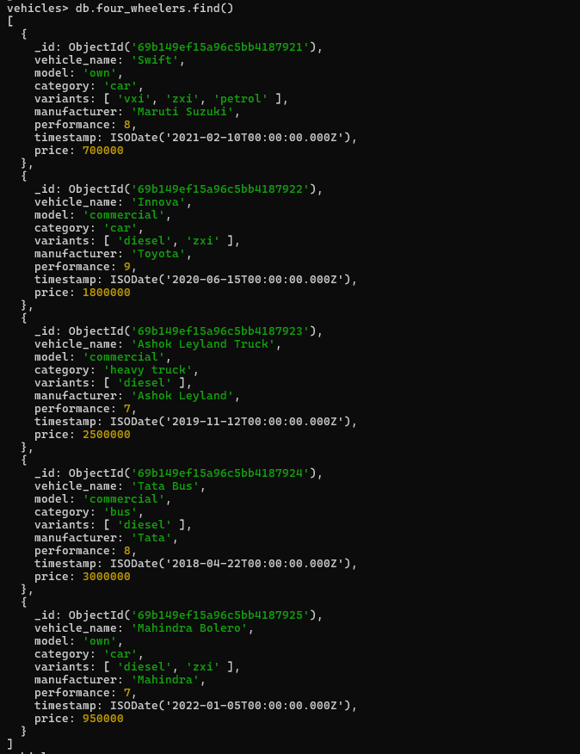

- Write a MongoDB query to display only vehicle name and price in all the collection of
the database
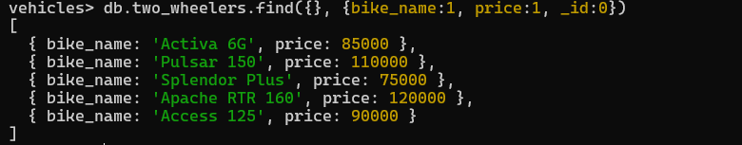
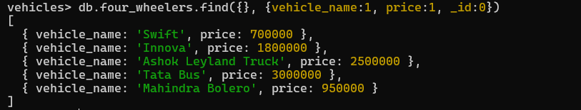

- Write a MongoDB query to display two_wheelers from a particular company
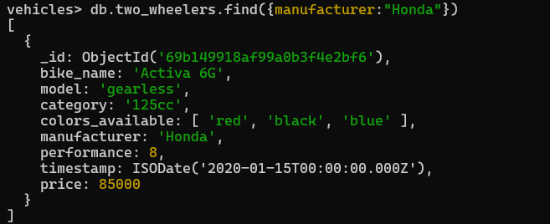

- Write a MongoDB query to display four_wheelers available in diesel variants
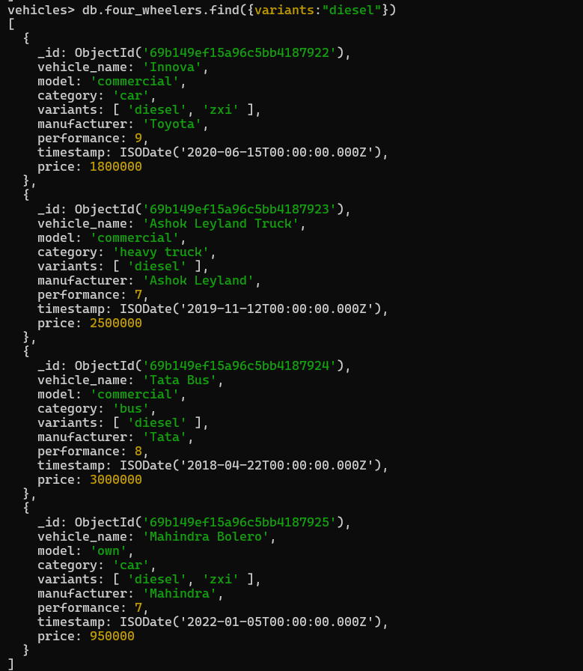

- Write a MongoDB query to display vehicles name, category and manufacturer details
whose rating is more than 5.
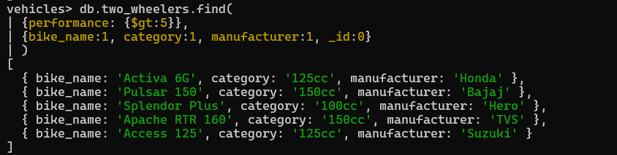
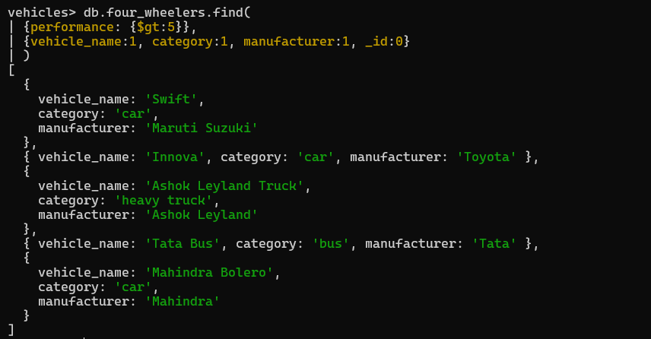

2.
- Create a database called ‘animal’ and write a MongoDB query to select database as
‘animal’.
- Write a MongoDB query to display all the databases.
- Create a collection called ‘wild_animals’.(use capping) and Create a collection called
‘domestic_animals’.


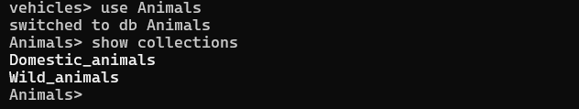

- Write a MongoDB query to display all documents available in wild_animals and domastic_animals.
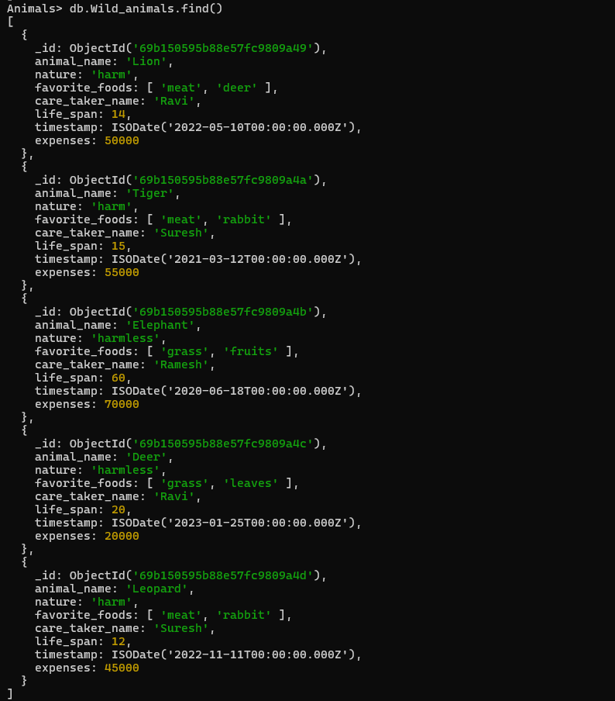
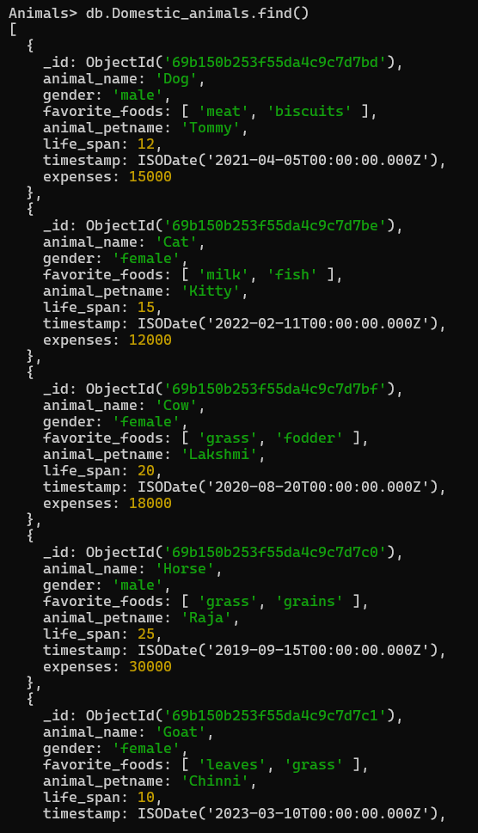
- Write a MongoDB query to display only animal name and expenses in all the collection of the database

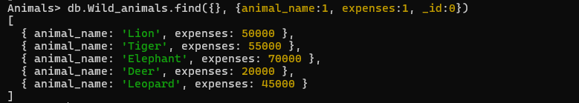
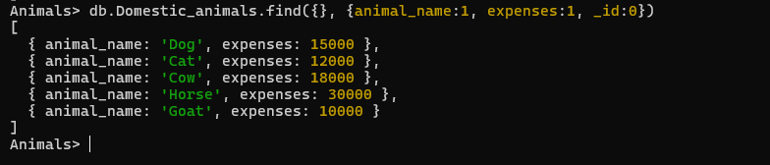

- Write a MongoDB query to display domestic_animals whose life is a particular year
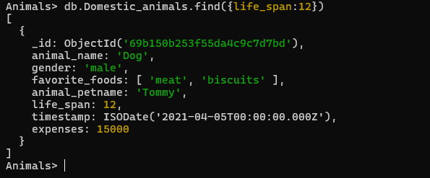

- Write a MongoDB query to display wild_animals available under a particular
care_taker
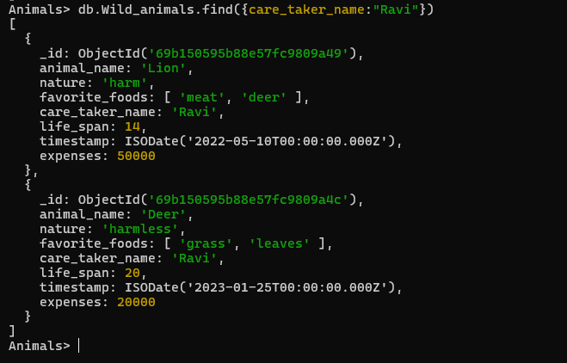

- Write a MongoDB query to display animal name, favorite_foods and expenses details whose lifespan is more than 5 years.
