

Project Data Narrative

The Report



Pooja Nakar

C0727416

Term 3

**Abstract**

The Health of Women and Girls Determines the Health and Well-Being of Our Modern World:

This report says about the health and care of the women and girls in a remote area of the countries. As per the survey from 2005 and 2015, the system is failing to provide proper health and care schemes to the women and girls in the remote areas.

Women and girls have specific health needs, and health systems around the world are failing them ([World Health Organization [WHO], 2009](https://www.ncbi.nlm.nih.gov/pmc/articles/PMC3703826/#R41)). The WHO states that today women’s health has become an urgent priority, yet the data surrounding this issue are limited and often unreliable ([WHO, 2009](https://www.ncbi.nlm.nih.gov/pmc/articles/PMC3703826/#R41)). It is ICOWHI’s aim to improve the health, health, care and well-being of women worldwide.

 The WHO estimates that women remain at a disadvantage in securing paid jobs, however, due to pervading sociocultural attitudes, minimal options for balancing work and family responsibilities, and challenges in birth control.

**Skilled Staff during child birth (Total %):**

As per the survey taken from 2005 to 2015, it has been known that the skilled staff during the birth is still not provided in many remote localities of various countries such as India, Ethiopia, Yemen, Libya etc.

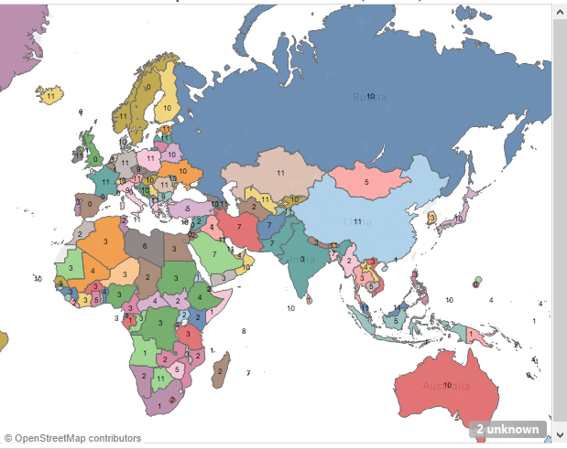

In the above visuals, it shows In Suadia Arabia, 7% of the total child birth lacks the skilled staff, doctors and proper medical facilities as compared in the cities.

Similarly, we can see, Uzbekistan, Bulgaria also have a high total percentage of skilled staff lacking during child birth.

Though India, Australia, Russia being a develop country as term of economy and technology it still shows certain % in lack of medical facilities.

Central and Southern Asia has shown the greatest rate of progress from 40 per cent coverage in the 2000-2005 period to 77 percent in the 2012-2017 period. Sub-Saharan Africa has also shown progress over the same period, and by 2012-2017 over 50% of births were attended by skilled health personnel.

**Teenage Pregnancy (Total %):**

Without proper sex education, it lead to teenage pregnancy which was a major cause of the death during child birth for the mother as well as the child.

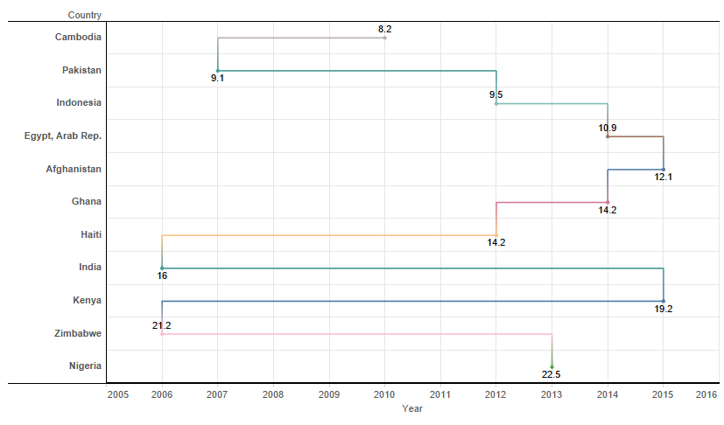

Here we can see, India having 16% of teenage mothers of the total, while Kenya has 19.2% of teen mothers in 2015.

The teen pregnancy rate (which includes pregnancies that end in a live birth and those that end in termination or miscarriage) has declined by 51 percent since 1991 – from 116.9 to 57.4 pregnancies per 1,000 teenage girls ages 15 to 19

[In 2015, a total of 229,715 babies were born to women ages 15 to 19, for a birth rate of 22.3 per 1,000 women in this age group](https://www.webmd.com/baby/teen-pregnancy-medical-risks-and-realities), an 8-percent drop from 2014.

In 2013, the teen pregnancy rate reached a new low. It declined by 63 percent from 1990 to 2013, from 118 to 43 pregnancies per 1,000 females ages 15 to 19—the lowest rate reported since estimates began in 1972. Among females younger than 15, there was a 78 percent decline from 1990 to 2013 (from 3.4 to 0.7 pregnancies per 1,000 females).

Over the same period, rates for teens ages 15 to 17 declined by 72 percent, from 75 to 21 pregnancies per 1,000 females; the rates for teens ages 18 to 19 declined by 56 percent, from 173 to 76

**Conclusion**

United Nations officials marked World Population Day on 11 July by spotlighting the issue of adolescent pregnancy, and calling on Governments to take measures to enable girls to make responsible life choices and realize their potential.

About 16 million girls under age 18 give birth each year, according to the UN Population Fund (UNFPA), which noted that another 3.2 million undergo unsafe abortions.

The vast majority – 90 per cent – of the pregnant adolescents in the developing world are married. The need to get girls into primary school and enable them to receive a good education through their adolescence. Providing comprehensive sexual and reproductive health services, as well as the maternal health services that women need should be stressed.

The government should provide all the facilities even in the remote areas for the under developed rural cities. A women’s health is always important for the development locality and environment. There should be proper education given to the women pre and post pregnancy.

Proper funding and provision of clinics, hospitals, medical utilities, doctors, nurses need to be provided by the government even in the remote localities.