FINSIGHT
Business Financial Intelligence Dashboard
A beginner-friendly, six-day MERN development blueprint

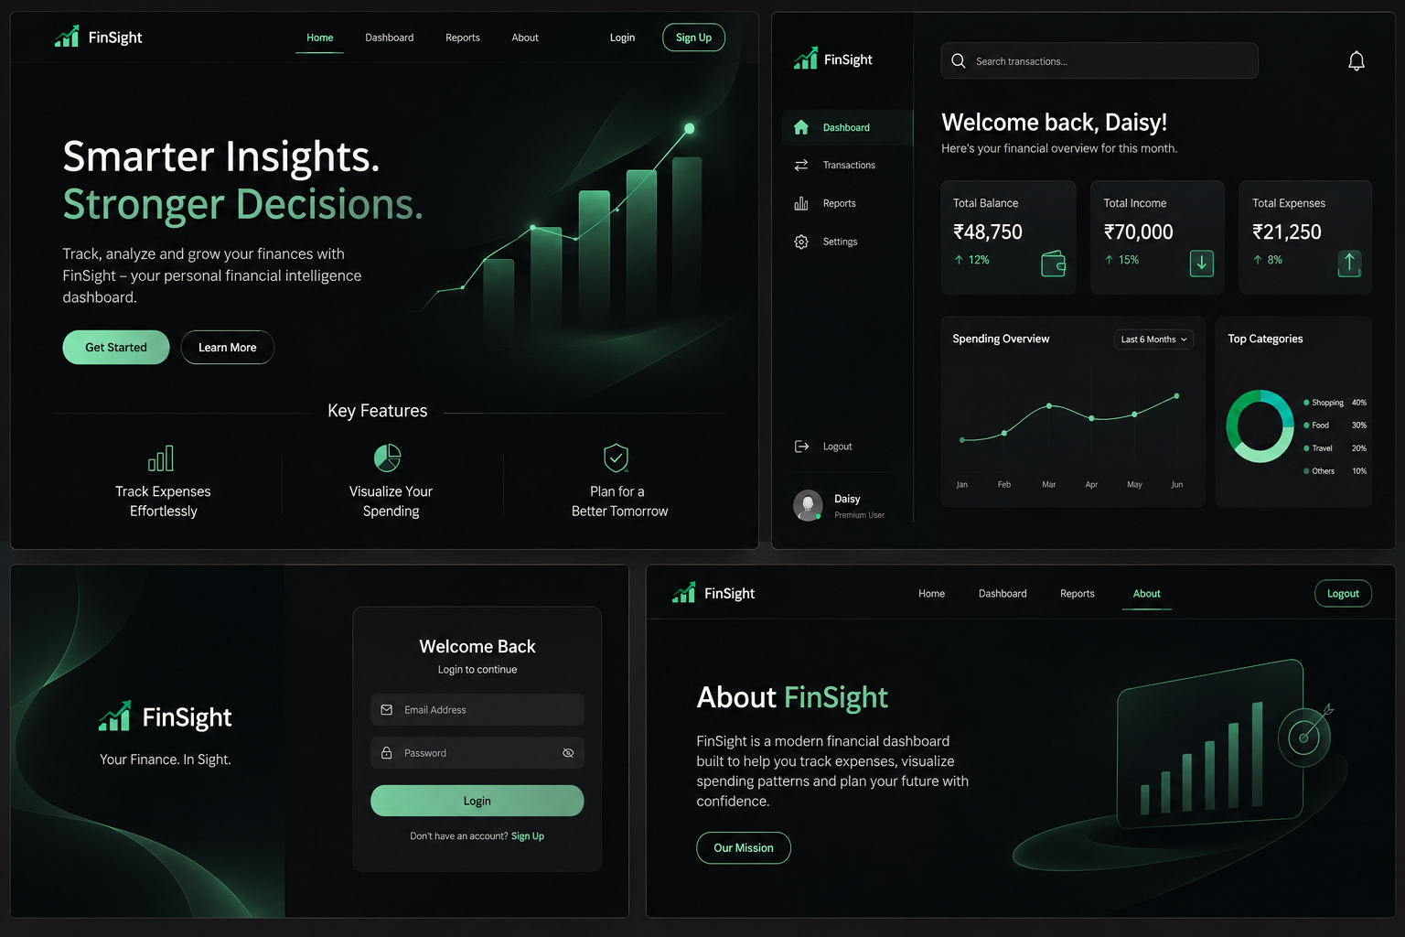
Visual direction: charcoal-black interface, restrained emerald accents and premium minimal styling.

PROJECT 2 • MERN STACK • SIX-DAY ACADEMIC PROTOTYPE

1. Project overview
FinSight is a financial management dashboard for small businesses and independent entrepreneurs. A logged-in user can record income and expenses, organize transactions, and view calculated summaries such as total revenue, total expenses, net profit and profit margin. Monthly charts help users understand financial trends, and a print-friendly report summarizes a selected period.

The problem it solves
Small businesses may track money in separate spreadsheets or notebooks. This makes it harder to see their overall financial position or notice monthly changes. FinSight brings basic record keeping and visual summaries into one place.

Main user workflow
- Register or log in.
- Open the dashboard and review the financial summary.
- Add an income or expense record with amount, date, category and description.
- Edit or delete an incorrect record.
- Filter records by type, category or date range.
- Review monthly charts and print a report.

2. Visual design direction
Use a dark, minimal and luxurious visual style. The interface should feel like a premium financial SaaS product: clean typography, generous spacing, subtle borders, restrained green highlights and no unnecessary decoration.
UI element | Suggested colour | Usage
Main background | #101411 | App canvas
Sidebar | #151B17 | Navigation area
Cards | #1B241E | Summary cards and panels
Primary accent | #39B879 | Primary buttons, active states, positive values
Secondary accent | #91B99D | Muted chart elements and supporting details
Main text | #F0F3EF | Headings and key figures
Secondary text | #929C94 | Labels and helper text
Borders | #2A352D | Subtle separators

Design rule
Use green sparingly for important numbers, buttons, active navigation and positive financial indicators. Avoid adding many accent colours or decorative gradients.

Screens to build
Screen | Main contents
1. Landing page | FinSight introduction, navigation, call-to-action and feature highlights.
2. Login / Signup | Registration and login forms, validation and authentication.
3. Dashboard | Revenue, expenses, net profit, profit margin, monthly chart and recent transactions.
4. Transactions | Transaction table, search, filters, edit and delete actions.
5. Add/Edit Transaction | Type, amount, category, date, description and save action.
6. Reports & Analytics | Monthly charts, selected-period summary and print-friendly report.
7. About | Project purpose, objectives, features and technology information.

3. Technology stack
Layer / tool | Technology | What it does in FinSight
Frontend | React.js | Builds pages, reusable components, forms and dashboard.
Build tool | Vite | Creates and runs the React development project.
Backend runtime | Node.js | Runs JavaScript outside the browser.
Backend framework | Express.js | Creates REST API endpoints and handles requests.
Database | MySQL | Stores user accounts and financial records.
ODM | Mongoose | Defines schemas and communicates with MongoDB.
Authentication | JWT + bcryptjs | Token-based authentication and password hashing.
HTTP client | Axios | Sends requests from React to Express.
Routing | React Router DOM | Navigates between frontend pages.
Charts | Chart.js + react-chartjs-2 | Displays monthly financial trends.
API testing | Postman | Tests backend routes before frontend integration.
Development | nodemon, dotenv, cors | Restarts server, loads environment variables and enables cross-origin requests.

How the technologies connect
- React displays the interface in the browser.
- Axios sends HTTP requests to the Express REST API.
- Express routes requests to controller functions.
- Controllers validate data, check authentication and use Mongoose models.
- MySQL stores the user's records and returns the requested data.
- Express sends JSON responses; React updates the screen.

4. Application architecture
Layer | Responsibilities | Example
React frontend | Pages, forms, tables, charts and UI state | Dashboard.jsx
API communication | HTTP requests and JSON responses | services/api.js
Express backend | Routes, middleware and business logic | server.js, routes/
Database layer | Schemas, queries and persistent data | models/
Authentication | Password hashing, JWT generation and verification | authController.js, authMiddleware.js

Example: Add an expense
The user submits an expense form in React. Axios sends a POST request. Express verifies the JWT and validates the input. Mongoose saves the record with the authenticated user's ID. The backend returns the saved record, and React refreshes the list and dashboard summary.

5. Database design
The academic prototype needs two MongoDB collections.

Collection A: users
Field | Type | Example / purpose
_id | ObjectId | MongoDB-generated identifier
name | String | Daisy
email | String | daisy@example.com; unique
passwordHash | String | bcrypt hash; never plain-text password
createdAt | Date | Account creation date

Collection B: financialRecords
Field | Type | Example / purpose
_id | ObjectId | MongoDB-generated identifier
userId | ObjectId | Reference to the owning user
type | String | income or expense
amount | Number | 50000; must be positive
category | String | Sales, Rent, Marketing, Salaries
description | String | October product sales
date | Date | Transaction date
createdAt | Date | Created automatically
updatedAt | Date | Updated automatically

Ownership and privacy
Every financial record must contain userId. Backend queries must use the authenticated user's ID so one user cannot read, edit or delete another user's records. Do not trust a userId sent by the browser.

6. REST API plan
Area | Method | Endpoint | Purpose
Auth | POST | /api/auth/register | Register a user
Auth | POST | /api/auth/login | Log in and return token
Auth | GET | /api/auth/me | Get current authenticated user
Records | POST | /api/records | Create a financial record
Records | GET | /api/records | List current user's records
Records | GET | /api/records/:id | Get one owned record
Records | PUT | /api/records/:id | Update an owned record
Records | DELETE | /api/records/:id | Delete an owned record
Dashboard | GET | /api/dashboard/summary | Return financial totals
Dashboard | GET | /api/dashboard/monthly | Return monthly income and expense totals

CRUD meaning
Operation | Meaning | HTTP method
Create | Add a transaction | POST
Read | View transactions | GET
Update | Edit a transaction | PUT
Delete | Remove a transaction | DELETE

7. Financial calculations
Calculate totals from the user's saved records for the selected date period.
Metric | Calculation
Total revenue | Sum of all income records
Total expenses | Sum of all expense records
Net profit | Total revenue − Total expenses
Profit margin | (Net profit ÷ Total revenue) × 100; if revenue is zero, show 0% or Not available

JavaScript example
const income = [50000, 30000, 20000];
const expenses = [10000, 15000, 15000];
const totalRevenue = income.reduce(
(sum, amount) => sum + amount, 0
);
const totalExpenses = expenses.reduce(
(sum, amount) => sum + amount, 0
);
const netProfit = totalRevenue - totalExpenses;
const profitMargin = totalRevenue === 0
? 0
: (netProfit / totalRevenue) * 100;
console.log("Revenue:", totalRevenue);
console.log("Expenses:", totalExpenses);
console.log("Net Profit:", netProfit);
console.log("Profit Margin:", profitMargin);
Implementation note
This is a standalone learning example. In the application, calculate using records retrieved from MongoDB, preferably in backend controller logic. The dashboard should not rely on hardcoded sample totals.

8. Recommended project folder structure
FINSIGHT/
├── client/
│ ├── public/
│ └── src/
│ ├── assets/
│ ├── components/
│ │ ├── Navbar.jsx
│ │ ├── Sidebar.jsx
│ │ ├── SummaryCard.jsx
│ │ ├── TransactionTable.jsx
│ │ └── ProtectedRoute.jsx
│ ├── pages/
│ │ ├── Home.jsx
│ │ ├── Login.jsx
│ │ ├── Register.jsx
│ │ ├── Dashboard.jsx
│ │ ├── Transactions.jsx
│ │ ├── AddTransaction.jsx
│ │ ├── Reports.jsx
│ │ └── About.jsx
│ ├── context/
│ │ └── AuthContext.jsx
│ ├── services/
│ │ └── api.js
│ ├── App.jsx
│ ├── main.jsx
│ └── index.css
│
├── server/
│ ├── config/db.js
│ ├── models/
│ │ ├── User.js
│ │ └── FinancialRecord.js
│ ├── controllers/
│ │ ├── authController.js
│ │ ├── recordController.js
│ │ └── dashboardController.js
│ ├── routes/
│ │ ├── authRoutes.js
│ │ ├── recordRoutes.js
│ │ └── dashboardRoutes.js
│ ├── middleware/authMiddleware.js
│ ├── .env
│ ├── server.js
│ └── package.json
│
└── README.md

Folder responsibilities
Folder | Responsibility
components | Reusable interface elements shared across pages.
pages | Complete website screens.
context | Shared authentication state.
services | Axios configuration and API functions.
config | Database connection setup.
models | Mongoose schemas and models.
controllers | Request handling and business logic.
routes | API endpoint definitions.
middleware | JWT verification and request checks.

DAY 1 — Setup, React, Express and authentication
Daily target
Goal: Get the development foundation running.

Implementation steps
- Check Node.js and npm with node -v and npm -v.
- Create the FINSIGHT root folder, then client and server folders.
- Create React with Vite inside client and install frontend dependencies.
- Initialize the backend with npm init -y and install Express, Mongoose, dotenv, cors, bcryptjs and jsonwebtoken.
- Create a basic Express server and verify it in the browser.
- Create a MongoDB Atlas deployment, database user and network access rule; put the connection string in server/.env.
- Create the User model, registration route, login route and JWT verification middleware.
- Test registration and login using Postman.

End-of-day checklist
- ☐ React app runs locally
- ☐ Express server responds
- ☐ MongoDB connects
- ☐ User model created
- ☐ Registration works
- ☐ Login returns JWT
- ☐ Passwords are hashed

DAY 2 — Financial model and CRUD APIs
Daily target
Goal: Complete the backend financial record workflow.

Implementation steps
- Create the FinancialRecord Mongoose model with userId, type, amount, category, description and date.
- Implement POST /api/records to create a record using the authenticated user's ID.
- Implement GET /api/records to list only the authenticated user's records.
- Implement GET /api/records/:id to fetch one owned record.
- Implement PUT /api/records/:id to update an owned record.
- Implement DELETE /api/records/:id to delete an owned record.
- Validate positive amounts, required fields and allowed type values.
- Test all endpoints in Postman using a JWT.

End-of-day checklist
- ☐ FinancialRecord model created
- ☐ Create, read, update and delete APIs work
- ☐ JWT protects routes
- ☐ Records are isolated by user

DAY 3 — React dashboard and API integration
Daily target
Goal: Build the main interface and connect it to real data.

Implementation steps
- Create reusable components: Sidebar, Navbar, SummaryCard, TransactionTable and TransactionForm.
- Build the dashboard shell with navigation, welcome text, summary-card placeholders and recent transactions.
- Build the add/edit transaction form with type, amount, category, date and description.
- Configure Axios in services/api.js and attach the JWT to protected requests.
- Fetch records with useEffect and store them in React state with useState.
- Render records in a table and implement add, edit and delete interactions.
- Add loading, empty and error states.

End-of-day checklist
- ☐ Dashboard layout built
- ☐ Transaction form works
- ☐ Axios connected
- ☐ Records load from MongoDB
- ☐ Add/edit/delete work

DAY 4 — Calculations, filters and search
Daily target
Goal: Make the dashboard respond to actual financial data.

Implementation steps
- Create GET /api/dashboard/summary for revenue, expenses, net profit and margin.
- Calculate totals from the logged-in user's records.
- Support a selected date period so cards and reports use consistent date boundaries.
- Connect API results to the summary cards.
- Add transaction-type filter: All, Income and Expense.
- Add category and date-range filters.
- Add search by description or category.
- Refresh or refetch the summary after create, update and delete operations.

End-of-day checklist
- ☐ Summary API works
- ☐ Four financial metrics are correct
- ☐ Type/category/date filters work
- ☐ Search works
- ☐ Dashboard updates after CRUD

DAY 5 — Charts, reports and visual polish
Daily target
Goal: Finish the main visual features.

Implementation steps
- Create GET /api/dashboard/monthly to return monthly income and expense totals.
- Display a monthly income-versus-expenses bar chart using Chart.js.
- Add a simple doughnut chart or category breakdown if time allows.
- Build a print-friendly report with date range, revenue, expenses, profit and margin.
- Add a Print Report button using window.print().
- Use print CSS to hide navigation and buttons and switch to a readable print layout.
- Polish spacing, typography, table styling, responsive layout and empty/error states.
- Attempt CSV import only if all core features are stable.

End-of-day checklist
- ☐ Monthly chart works
- ☐ Report page works
- ☐ Print/PDF flow works
- ☐ Dark luxury styling consistent

DAY 6 — Testing, debugging and presentation
Daily target
Goal: Stabilize the app and prepare the demo.

Implementation steps
- Test registration, duplicate email, invalid password, login, logout and protected routes.
- Test create, read, update and delete for both income and expense records.
- Test invalid amounts and missing required fields.
- Verify calculations with known test data.
- Create two accounts and verify that each user can only access their own records.
- Add 15–20 realistic demo transactions across several months.
- Fix bugs and check the interface at desktop and mobile widths.
- Write README setup instructions, feature list, API routes and demo credentials if appropriate.
- Practise the end-to-end demonstration.

End-of-day checklist
- ☐ Authentication tested
- ☐ CRUD tested
- ☐ Calculations verified
- ☐ User isolation verified
- ☐ Demo data ready
- ☐ README ready
- ☐ Presentation practised

9. Day 1 starter commands
Run commands in the correct folder. Keep the frontend and backend running in separate VS Code terminals.

Create the React frontend
cd FINSIGHT
mkdir client
cd client
npm create vite@latest . -- --template react
npm install
npm install axios react-router-dom react-icons chart.js react-chartjs-2
npm run dev

Create the Express backend
cd FINSIGHT
mkdir server
cd server
npm init -y
npm install express mongoose dotenv cors bcryptjs jsonwebtoken
npm install -D nodemon

Basic Express server
const express = require("express");
const cors = require("cors");
const app = express();
app.use(cors());
app.use(express.json());
app.get("/", (req, res) => {
res.send("FinSight API is running");
});
app.listen(5000, () => {
console.log("Server running on port 5000");
});

Environment variables
PORT=5000
MONGO_URI=your_mongodb_connection_string
JWT_SECRET=your_long_random_secret
Keep secrets private
Do not commit .env to GitHub. Add it to .gitignore. Never place MongoDB credentials or JWT secrets in frontend code.

10. What to know before coding
Area | Beginner concepts to review
HTML | Forms, inputs, tables and semantic elements.
CSS | Flexbox, Grid, spacing, positioning and responsive design.
JavaScript | Functions, arrays, objects, map, filter, reduce, promises and async/await.
React | Components, JSX, props, state, useEffect, forms and React Router.
Node.js | npm, modules and package.json.
Express | Routes, middleware, request and response.
MongoDB/Mongoose | Database, collection, documents, schema, model and CRUD.
REST APIs | GET, POST, PUT and DELETE.
Authentication | Password hashing, JWT and protected routes.

11. Scope control: features to leave out
For a six-day beginner build, do not implement these features:
- Bank account linking or automatic synchronization
- Online payments
- GST, tax filing or professional accounting
- Invoice generation
- Stock-market analysis or investment recommendations
- AI financial recommendations
- Multi-company accounting
- Real-time collaboration and chat
Scope rule
Finish the must-have end-to-end workflow before attempting optional features. CSV import is a stretch feature, not a requirement.

12. Testing data and expected calculations
Transaction | Type | Amount
Product sales | Income | ₹50,000
Service revenue | Income | ₹30,000
Office rent | Expense | ₹20,000
Marketing | Expense | ₹10,000

Metric | Expected result
Total revenue | ₹80,000
Total expenses | ₹30,000
Net profit | ₹50,000
Profit margin | 62.5%

Use this small dataset to verify the summary calculation before adding more demo transactions.

13. Final demonstration script
- Open the FinSight landing page and explain the problem it solves.
- Register and log in to demonstrate authentication.
- Open the dashboard and explain the four summary metrics.
- Add an income record and an expense record.
- Edit one record and delete another to demonstrate CRUD.
- Show how the summary updates after the changes.
- Filter transactions by type, category and date.
- Show the monthly chart and explain the trend.
- Open the printable report and use the browser print dialog.
- Briefly explain the React, Express, MongoDB and JWT architecture.

14. Quality and security checklist
- ☐ Passwords are hashed; never store plain-text passwords.
- ☐ Protected API routes verify JWTs on the backend.
- ☐ Every record query checks ownership using the authenticated user's ID.
- ☐ Amounts are stored as numbers and must be positive.
- ☐ Forms validate required fields and display useful error messages.
- ☐ Frontend handles loading, empty and error states.
- ☐ Environment variables store database credentials and JWT secrets.
- ☐ The README explains setup, features, API routes and demo credentials where applicable.
- ☐ The final demo follows one complete end-to-end workflow.

15. Project boundaries and academic note
FinSight is a simplified financial tracking and management prototype. Its summaries are intended for demonstration and basic management visibility. It is not a substitute for accounting software, tax calculations or professional financial advice.
The six-day plan is a focused academic target. Prioritize authentication, financial record CRUD, calculations, frontend integration, validation and a working dashboard. Add CSV import or extra refinements only after the core application is stable.

END OF GUIDE • BUILD ONE WORKING FEATURE AT A TIME

