**DEVICE AUTOMATED TEST BENCH**

***Features:***

1. Under standard testing conditions, per cycle only one unit can be tested.
2. Dynamic test server code.
3. More usage of configuration files and log files.
4. Test reports are sent to concerned people automatically via email.
5. Less man power required
6. Customized to suit product definition
7. Less probability of missing previous test cases or earlier designed test cases are easily adaptable to test bench environment.
8. Effective stress test on the firmware part of the device.
9. Tester friendly HTML user interface for more effective monitoring.

***Testing guidelines:***

***Pre-requisites:***

1. Before the server starts, tester should update the iterationNumber (number of iterations field) in noOfIterations.json file for stress test or sending multiple requests to device.
2. In the same file, tester can add or remove email addressed in toAddress field, to whom the report emails should be sent or not.

***Actual test guidelines:***

1. Once the server is started, Only two clients can be connected at a time per one test cycle.

***Steps to be followed***

1. First refresh the HTML client page, when connected message pops, then page is connected to server.
2. After HTML client is connected, switch on the device.
3. Wait until device communication LED starts glowing continuously, ie, device gets connected to test server.
4. Once both HTML client and device is connected, PLEASE DO NOT REFRESH HTML CLIENT/RESTART DEVICE.

***Steps to be followed while using HTML client:***

1. Enter device ID of the device in field (1), which is to be tested.
2. Enter your name (Tester Name) in filed (2).
3. Click On submit button as shown in field (3).
4. Click On get client ID button (field (4)), to obtain client ID for user.
5. Click On get device current info shown in field (5), to obtain information directly from device.
6. In field (6), Enter T for timer mode, M for manual mode to change mode from one to another by clicking submit button next to it.
7. When mode is in T, Tester can enter timer details in HHMMDDRE format, in the field (7), where H is Hour, M is Minute of timer start, D is duration of timer and R is repeat, E is enable.

For example, to set timer at 10:30 for 5 minutes enter 10300511 in field (7).

1. Enter either action no 104 to set timesheet or 105 to give fresh timer, at a given point of time in field (8).
2. Steps 7 and 8 can be repeated for action 105 also.
3. Then click submit button to set timer.
4. If device is in manual mode
   1. Enter 1 in field (9), to switch on solenoid. Either in field (10) Enter duration of water flow from sensor or in field (11) enter amount of water flow in liters.
   2. Please enter either field (10) or (11), any one of information not both at a time, or else enter 0 in other field
5. Enter 0 in field (9), to switch off solenoid (also you can enter 0 in 10/11 fields)

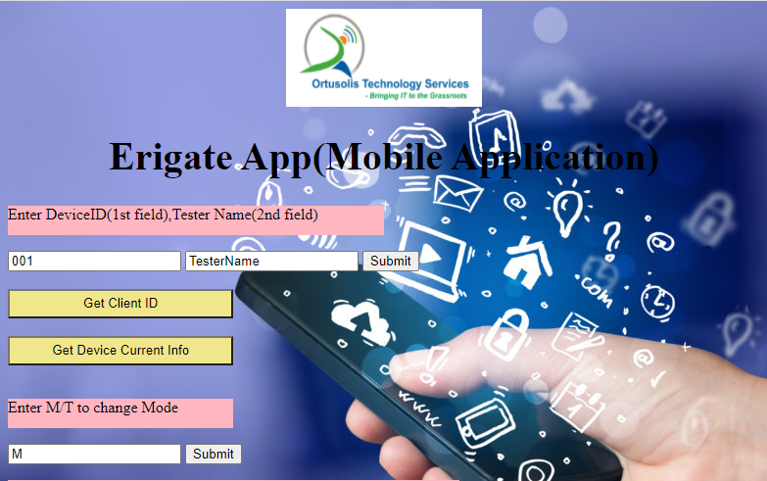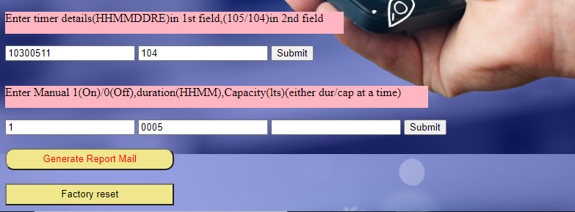

**13**

**11**

**100**

**12**

**9**

**8**

**7**

**5**

**6**

**4**

**3**

**2**

**1**

***Note:***

Tester can repeat procedures from Step 5 to step 12 any number of time.

Also tester can refer to <https://docs.zoho.com/file/l3lt0c4a303bd6904454db5a01839c7f812dd> for more test cases, related to E-rigate light project.

***Post test cycle steps to be followed:***

1. After all testing done, Click on generate report mail, field (12), to send report E-mail.(Note that once you click on mail button, all previous contents will be erased.)
2. Please operate this button at last and only once at the end of cycle.
3. Press factory reset button, field (13), to erase all stored the contents of the associated device before next round of test.