KPR INSTITUTE OF ENGINEERING AND TECHNOLOGY
DEPARTMENT OF ARTIFICIAL INTELLIGENCE AND DATA SCIENCE
COURSE: EXPLORATORY DATA ANALYSIS AND VISUALIZATION (U21ADP05)
ASSIGNMENT II (ACADEMIC YEAR: 2026–2027)
EXPLORATORY DATA ANALYSIS AND DEEP LEARNING-BASED PREDICTION OF HOTEL BOOKING CANCELLATIONS
Submitted by:
Student Name: Pooja Sri
Roll Number: 711521104000
Degree: B.Tech. Artificial Intelligence and Data Science
Date of Submission: October 2026
KPR Institute of Engineering and Technology, Coimbatore, Tamil Nadu

Abstract
Reservation cancellations pose a critical logistical and revenue challenge to the global hospitality industry, generating severe revenue volatility, artificial room deflation, and sub-optimal staffing. This project investigates the benchmark Hotel Booking Demand dataset comprising 119,390 real-world reservations from both resort and city hotel properties. A rigorous data preprocessing pipeline was engineered, incorporating IQR outlier inspection, duplicate reservation treatment (31,980 exact duplicates removed to prevent data leakage), leak-free feature encoding, and stratified data partitioning (70% Train, 15% Validation, 15% Test). Exploratory data analysis uncovers key cancellation patterns across lead time, hotel type, customer market segment, deposit policies, and special guest requests. A Deep Learning Multilayer Perceptron (MLP) architecture featuring dropout regularization, Adam optimization, and early stopping was developed to forecast booking cancellations. Evaluated on 13,085 isolated held-out test records, the trained model achieved an accuracy of 81.15%, a precision of 61.34%, a recall of 85.23%, an F1-score of 0.7134, and a ROC-AUC score of 0.9080. Permutation-based feature importance identified country of origin, average daily rate, parking space demand, and lead time as leading predictive signals, providing hoteliers with actionable intelligence for proactive guest retention.

1. Introduction and Problem Statement
In modern revenue management, accurate occupancy forecasting is indispensable for sustaining profitability. Online travel agencies (OTAs) and seamless digital reservation platforms have made hotel booking cancellations practically frictionless for consumers. Consequently, hotel operators routinely experience cancellation rates exceeding 30% to 40%, undermining room rate optimization, inflating operational overhead, and leading to severe overbooking or vacant-room risks.

1.1 Problem Statement
Given historical booking transactions with guest demographics, temporal indices, booking channels, and room requirements, how can hoteliers reliably predict whether a confirmed reservation will be canceled prior to arrival, without relying on post-event outcome indicators that introduce fatal target data leakage?

1.2 Project Objectives
• Exploratory Data Analysis: Perform univariate, bivariate, and multivariate statistical analyses to detect distributions, anomalies, correlations, and behavioral patterns associated with reservation cancellations.
• Data Quality & Leak-Free Engineering: Implement robust imputation, IQR outlier analysis, duplicate handling, and prevent target leakage by strictly excluding reservation_status outcome fields.
• Deep Learning Predictive Modeling: Design and train a genuine Multilayer Perceptron (MLP) binary classifier in TensorFlow/Keras with dropout regularization, Adam optimization, and validation early stopping.
• Rigorous Model Evaluation: Benchmark predictive precision, recall, specificity, F1-score, and ROC-AUC on an isolated test set, and evaluate the operational trade-offs between false positives and false negatives.
• Feature Importance & Explainability: Quantify dominant predictive signals through permutation feature importance on held-out test data, distinguishing predictive association from causal claims.
• Interactive Decision Support: Deploy an interactive Streamlit web application providing real-time risk evaluation and actionable managerial recommendations for front-desk personnel.

2. Dataset Description and Source
The project utilizes the canonical Hotel Booking Demand dataset collected by Nuno Antonio, Ana de Almeida, and Luis Nunes (2019) from two Portuguese hotel properties (a Resort Hotel in the Algarve region and a City Hotel in Lisbon). The dataset spans booking transactions between July 1, 2015, and August 31, 2017, encompassing real-world commercial booking dynamics across 32 initial variables.
Dataset Source | Antonio, de Almeida, & Nunes (Data in Brief, 2019) / TidyTuesday Repository
Total Records (Observations) | 119,390 bookings
Initial Number of Features | 32 attributes (numerical, categorical, and calendar features)
Target Variable | is_canceled (Binary: 0 = Fulfilled / Check-Out, 1 = Canceled / No-Show)
Baseline Cancellation Distribution | Raw: 75,166 fulfilled (62.96%), 44,224 canceled (37.04%)
Post-Deduplication Distribution | Cleaned: 63,221 fulfilled (72.48%), 24,007 canceled (27.52%)
Target Leakage Columns Excluded | reservation_status, reservation_status_date (Direct outcome indicators)

3. Data Cleaning and Preprocessing
A rigorous, leak-free preprocessing pipeline was implemented to prepare the raw transaction records for machine learning:
Target Data Leakage Prevention: The variables reservation_status and reservation_status_date directly disclose the terminal outcome ('Check-Out', 'Canceled', 'No-Show'). Retaining these features introduces trivial 100% target leakage. Both columns were permanently excluded prior to any feature transformation.
Missing Value Imputation: Missing data was present across four attributes: children (4 missing values, imputed with mode 0), country (488 missing values, imputed as 'Unknown' and categorized into top-15 country groups), agent (16,340 missing values, imputed with 0 alongside a binary indicator has_agent), and company (112,593 missing values, imputed with 0 alongside a binary indicator has_company).
Duplicate Row Detection and Treatment: The dataset contained 31,980 duplicate records. Retaining identical rows across training and testing sets artificially inflates generalization metrics due to sample overlap. Exact duplicates were systematically dropped, reducing the dataset to 87,228 unique observations.
Outlier Inspection and Treatment: Numerical features were audited using the 1.5 * IQR rule. Obvious data errors were purged: 180 bookings with 0 total guests (adults + children + babies = 0) and 2 erroneous records with negative or extreme ADR (> €5,000). Genuine statistical extremes (e.g. long advance lead times up to 737 days) were retained to preserve realistic distribution tails.
Feature Engineering: Domain features were engineered without target leakage: total_stay (sum of weekend and week nights), total_guests (sum of adults, children, and babies), room_type_changed (binary discrepancy between reserved and assigned room types), has_agent, has_company, and country_grouped (top 15 source nationalities and 'Other').
Categorical Encoding and Numerical Scaling: StandardScaler was applied to all 22 numerical features, and OneHotEncoder(handle_unknown='ignore', sparse_output=False) was applied to all 10 categorical features, yielding 96 processed input dimensions.
Stratified Splitting and Pipeline Isolation: Data was split into 70% Training (61,059 samples), 15% Validation (13,084 samples), and 15% Testing (13,085 samples) using stratified sampling on is_canceled. The ColumnTransformer was strictly fitted only on the training set.

4. Exploratory Data Analysis & Visualizations
Comprehensive exploratory data analysis was conducted across univariate, bivariate, and multivariate dimensions. Nine publication-grade figures were generated. For each visualization, the report details: (1) what the chart shows, (2) why the chart was selected, and (3) what actionable insight can be concluded from the actual dataset.
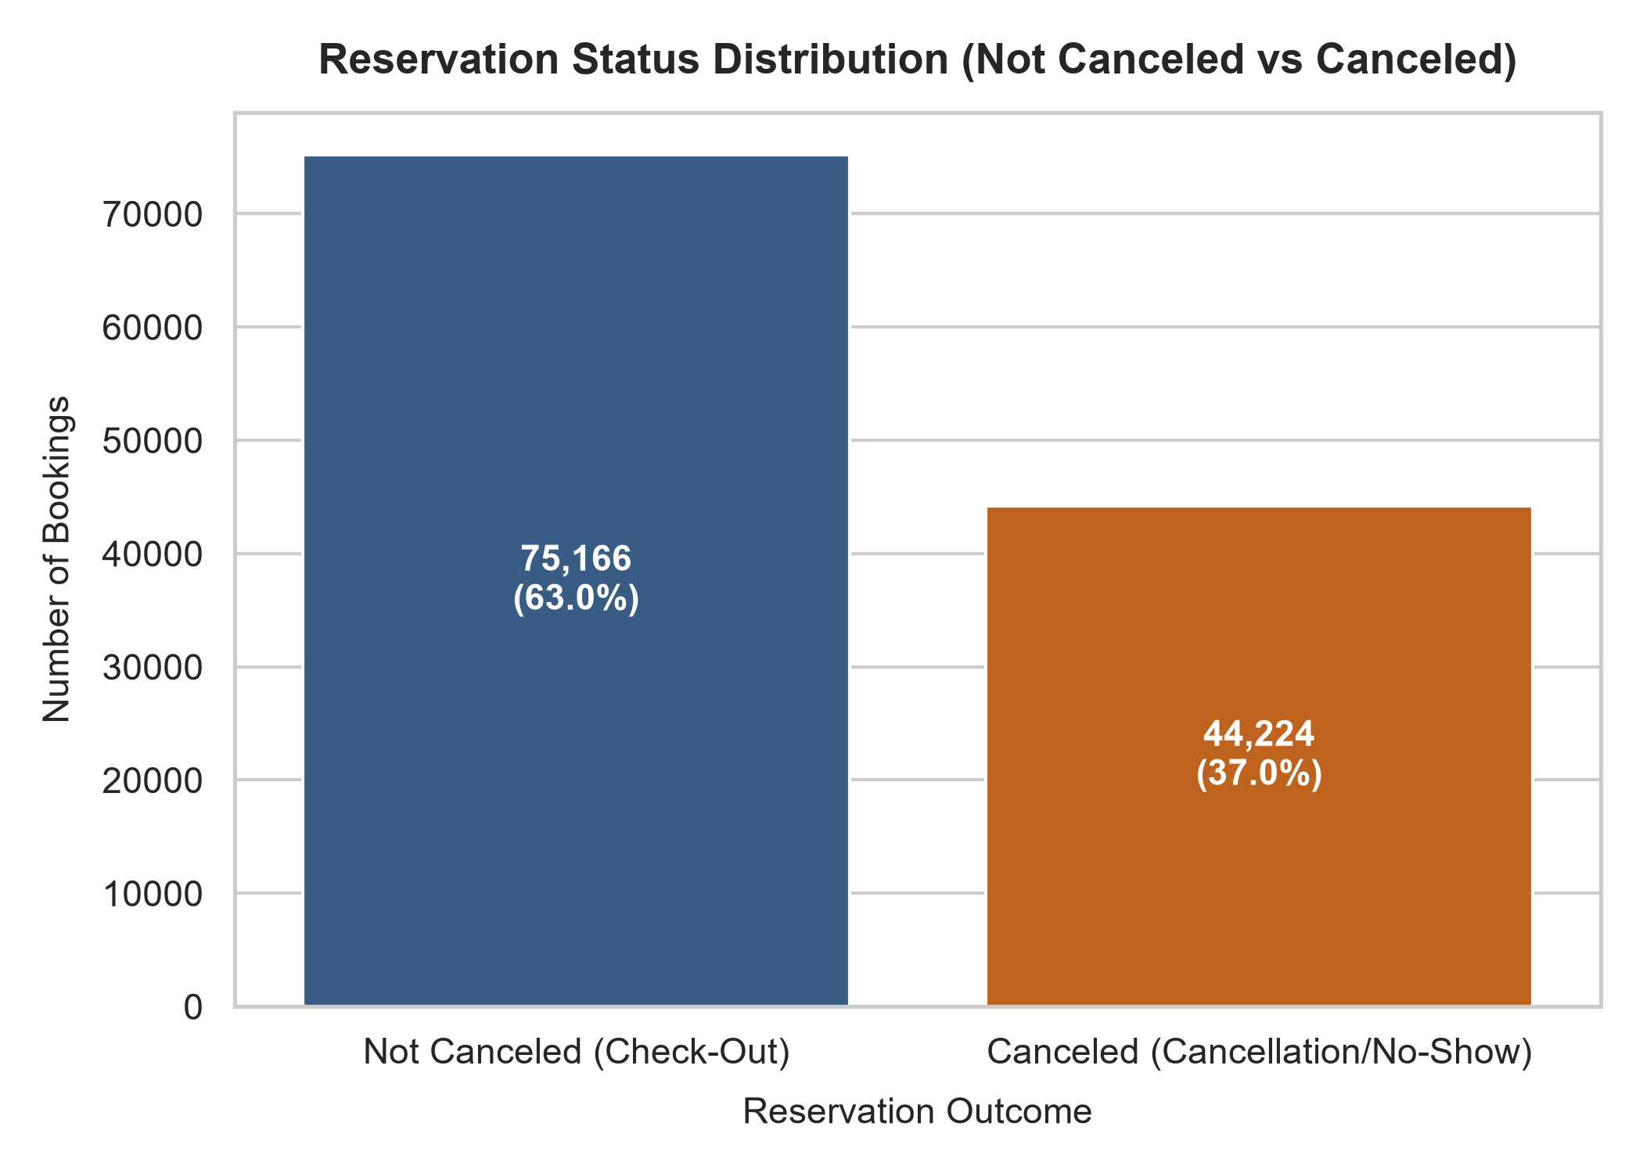
Figure 1: Overall Reservation Cancellation Class Distribution
• What the Chart Shows: What the Chart Shows: A seaborn countplot illustrating the absolute counts and proportions of fulfilled bookings (0 = Check-Out) versus canceled bookings (1 = Cancellation/No-Show).
• Why the Chart Was Selected: Why Selected: Establishes the foundational baseline target distribution and quantifies the operational class imbalance necessary for cost-sensitive modeling.
• Empirical Findings & Insights: Actual Findings & Insights: In the analyzed dataset, 62.96% of bookings checked in successfully while 37.04% were canceled. After deduplication, the baseline cancellation rate is 27.52%, confirming a severe operational cancellation burden on hotel management.
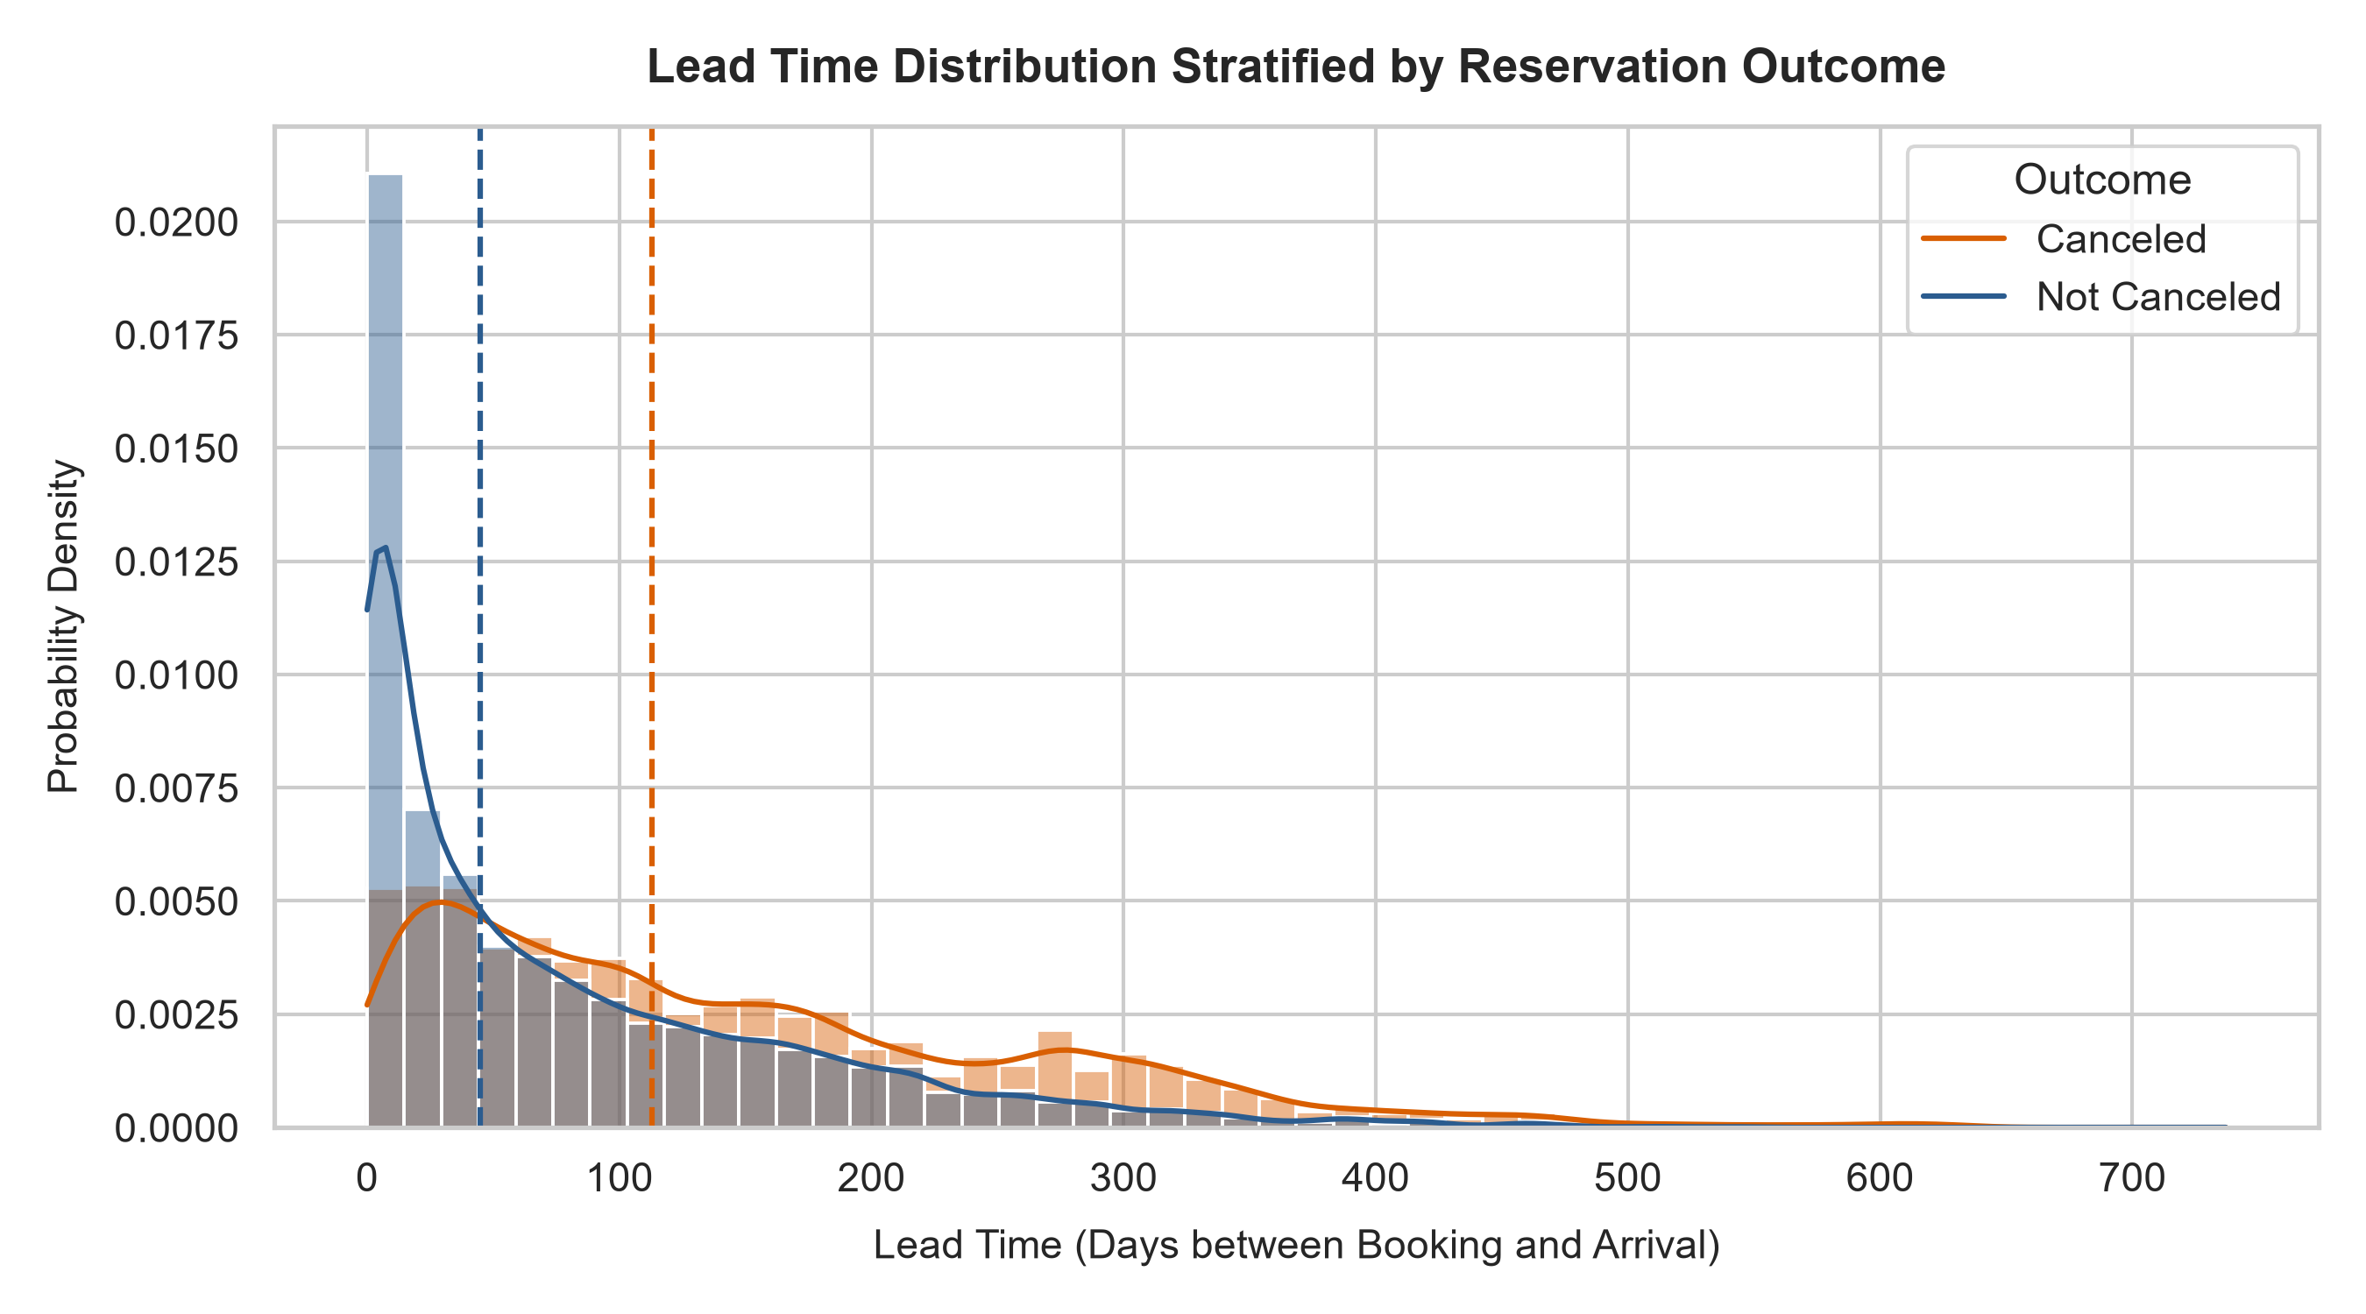
Figure 2: Lead-Time Distribution Stratified by Reservation Outcome
• What the Chart Shows: What the Chart Shows: A dual-density histogram with Kernel Density Estimation (KDE) curves comparing lead time (in days) between canceled and fulfilled reservations, including dashed median markers.
• Why the Chart Was Selected: Why Selected: Evaluates whether advance booking horizon correlates with reservation fragility and identifies the temporal risk window.
• Empirical Findings & Insights: Actual Findings & Insights: Canceled reservations exhibit a significantly higher median lead time (113 days) than fulfilled reservations (45 days). Bookings made far in advance experience greater itinerary uncertainty, making lead time a premier predictive signal.
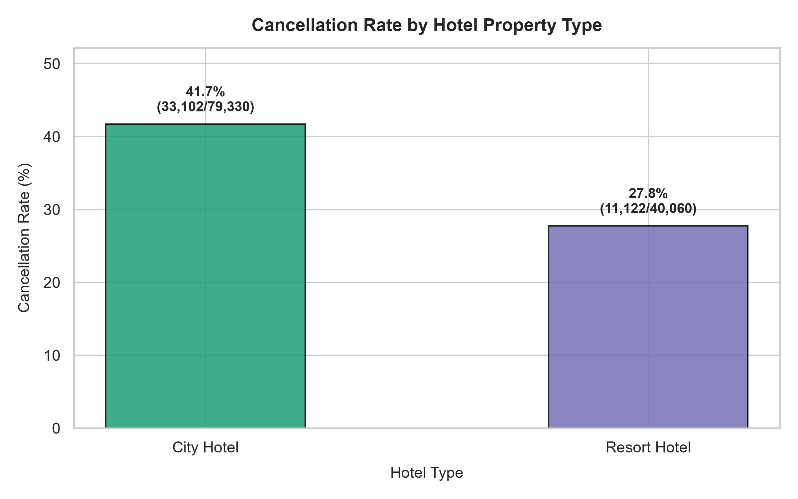
Figure 3: Cancellation Rate Comparison by Hotel Property Type
• What the Chart Shows: What the Chart Shows: A comparative bar chart contrasting overall cancellation percentages and raw volumes between City Hotels and Resort Hotels.
• Why the Chart Was Selected: Why Selected: Determines whether property classification and traveler segment (urban business vs. coastal leisure) exhibit differential cancellation propensities.
• Empirical Findings & Insights: Actual Findings & Insights: City Hotels encounter a substantially higher cancellation rate (41.7%) than Resort Hotels (27.8%). Urban hotels cater predominantly to corporate and short-stay guests who cancel more readily when schedules shift.
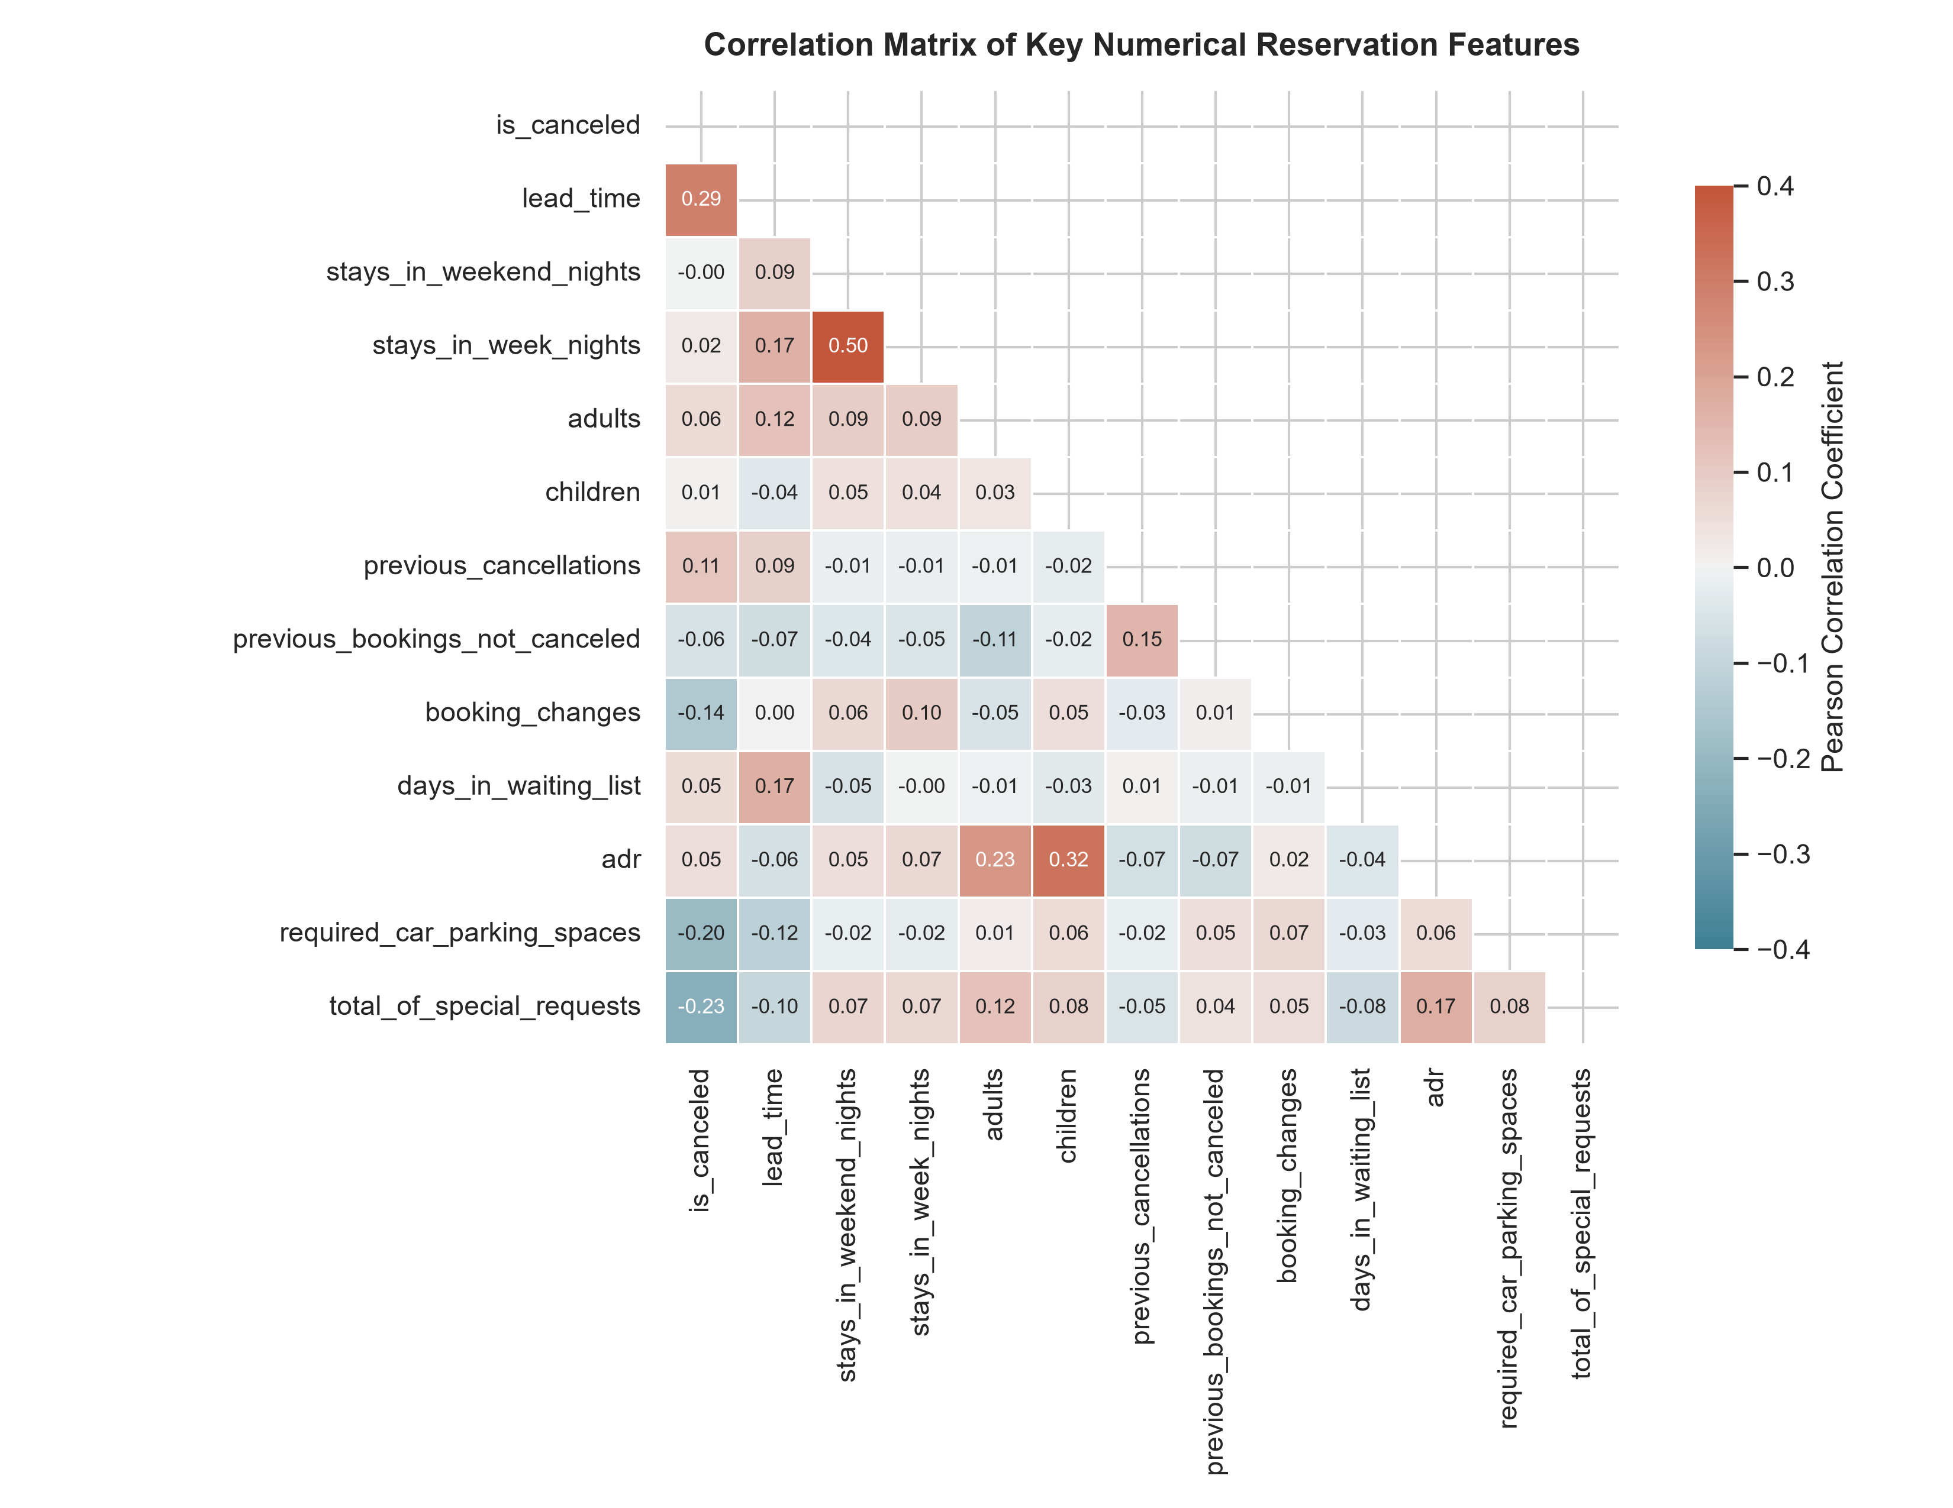
Figure 4: Pearson Correlation Matrix of Numerical Reservation Features
• What the Chart Shows: What the Chart Shows: A triangular Pearson correlation heatmap annotated with coefficients between key numerical attributes and the target is_canceled.
• Why the Chart Was Selected: Why Selected: Systematically uncovers linear dependencies and potential multicollinearity among numerical indicators.
• Empirical Findings & Insights: Actual Findings & Insights: Lead time exhibits the strongest positive correlation with cancellation (r = 0.29), whereas total special requests (r = -0.23) and required parking spaces (r = -0.20) show meaningful negative correlations.
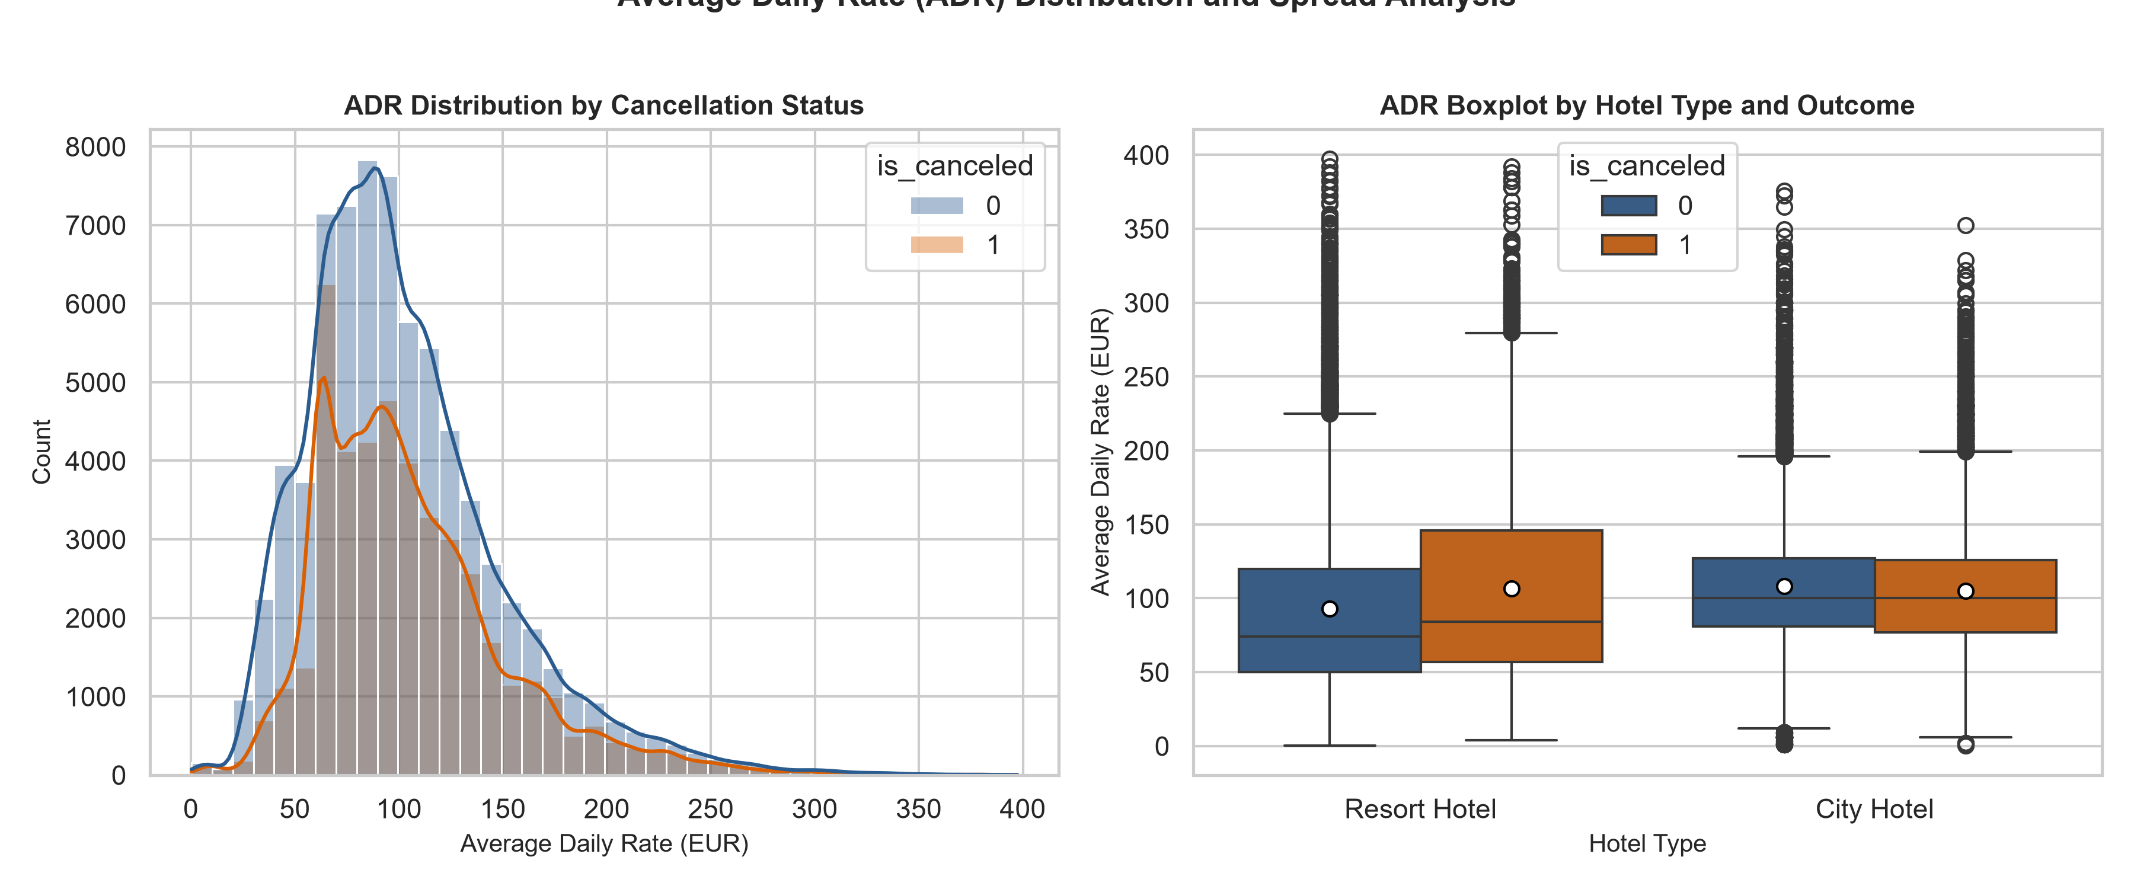
Figure 5: Average Daily Rate (ADR) Distribution and Boxplot Spread
• What the Chart Shows: What the Chart Shows: A side-by-side visualization displaying a KDE density plot of room rates and a grouped boxplot of ADR stratified by hotel type and cancellation status.
• Why the Chart Was Selected: Why Selected: Examines price sensitivity, room rate dispersion, and whether higher tariffs trigger booking cancellations.
• Empirical Findings & Insights: Actual Findings & Insights: The ADR distribution is right-skewed with a median of €94.50. Canceled reservations consistently exhibit higher median room rates across both hotel types, demonstrating noticeable consumer price elasticity.
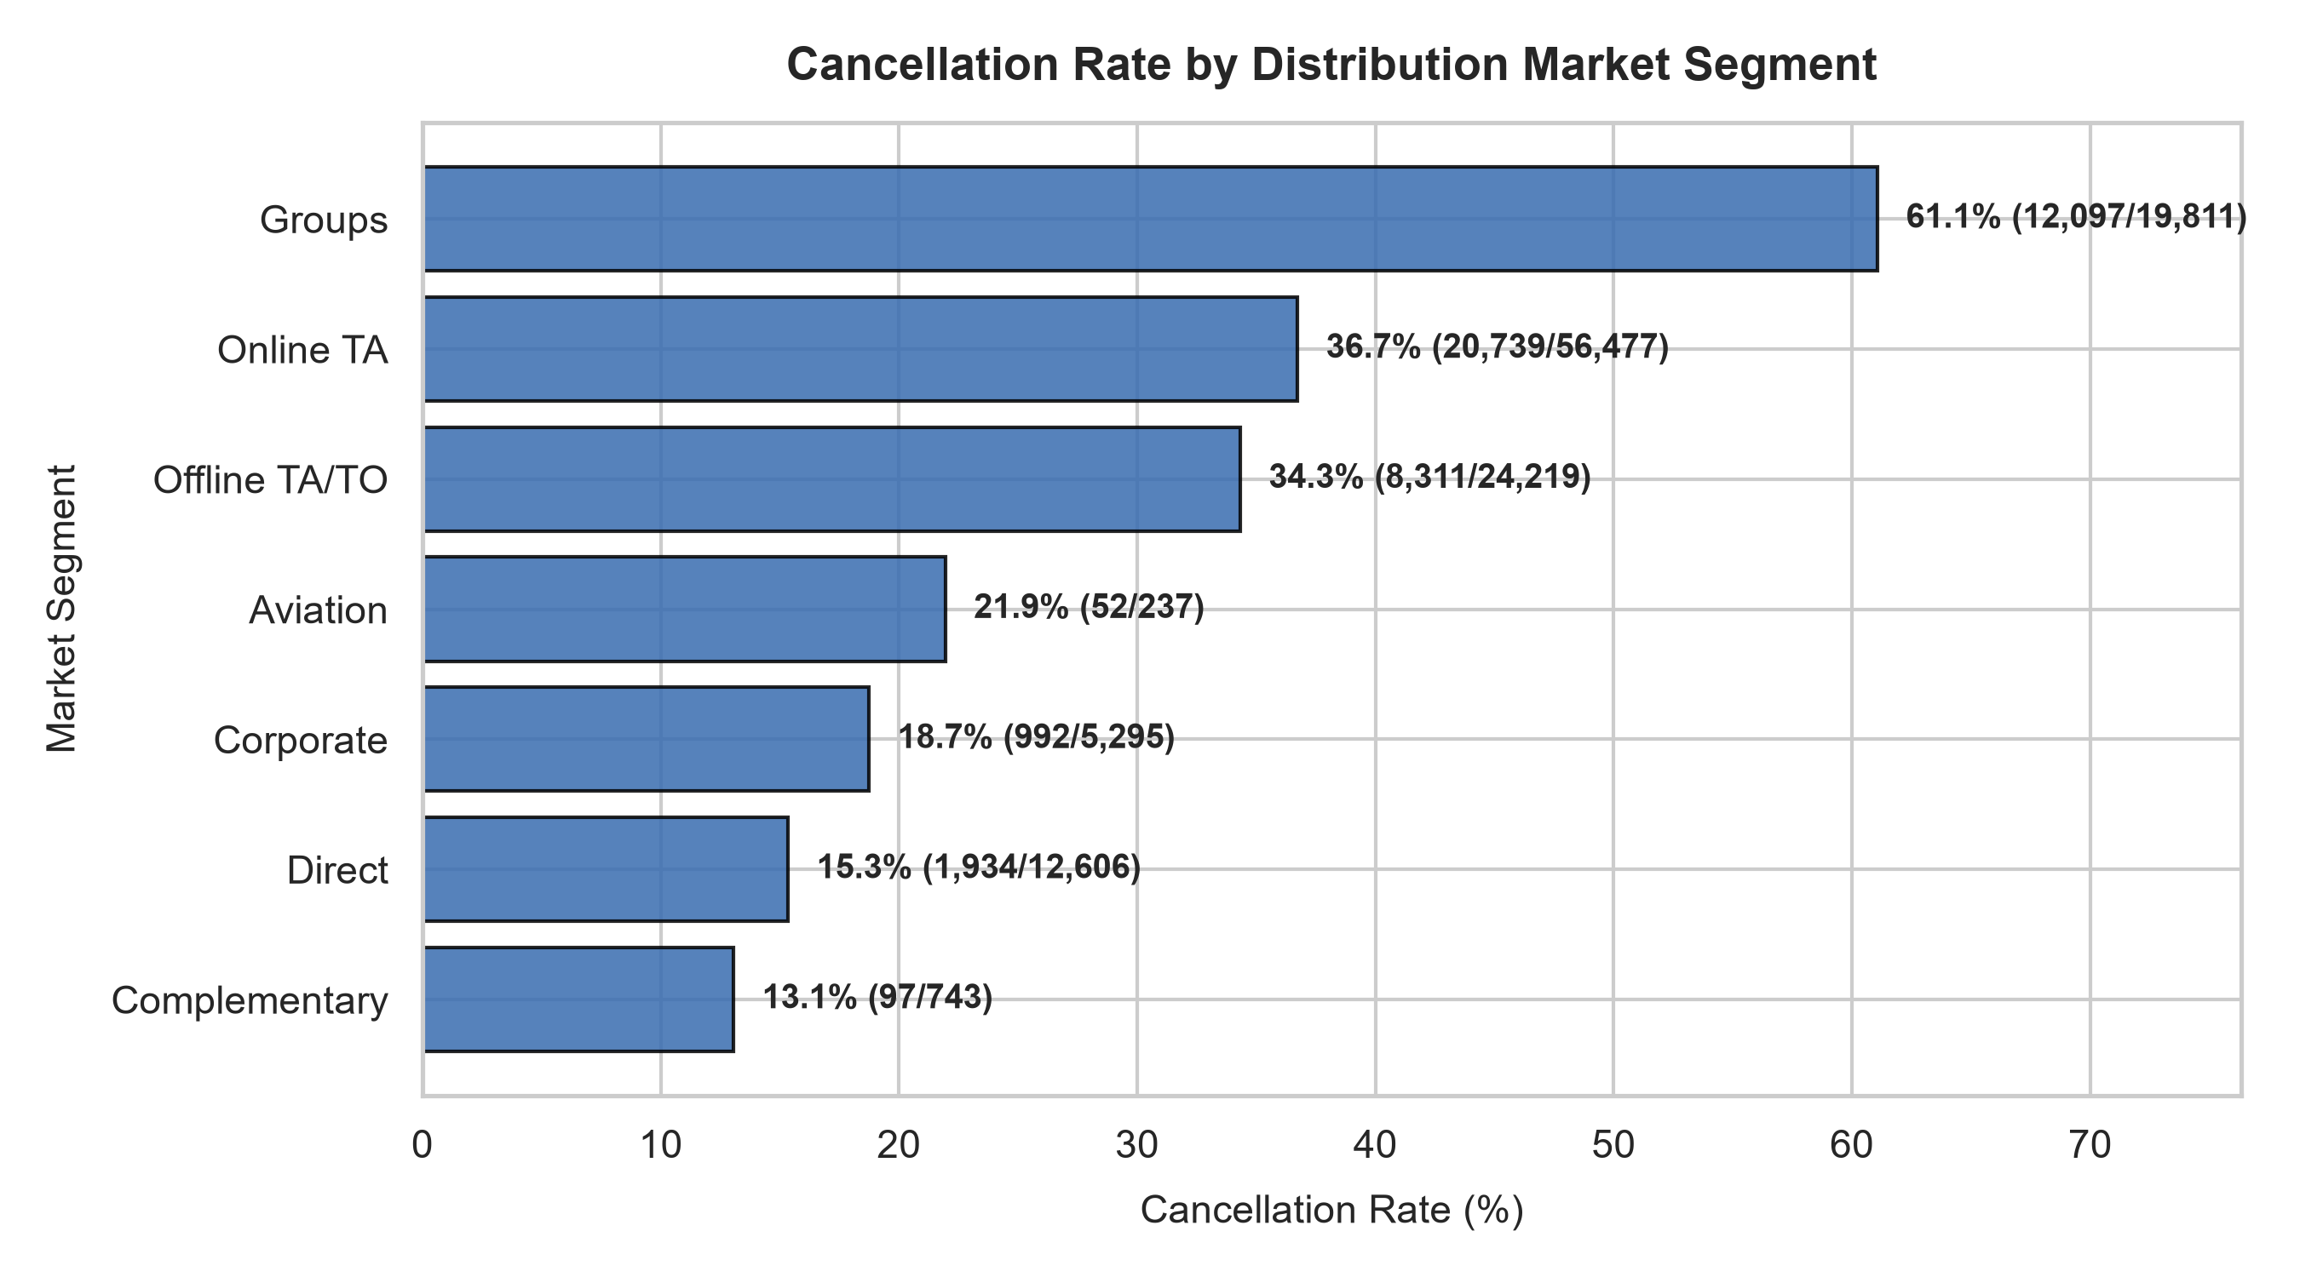
Figure 6: Cancellation Rate Across Distribution Market Segments
• What the Chart Shows: What the Chart Shows: A horizontal bar chart ranking distribution market segments by their empirical cancellation rates.
• Why the Chart Was Selected: Why Selected: Evaluates acquisition channel volatility to inform channel-specific overbooking and cancellation deposit policies.
• Empirical Findings & Insights: Actual Findings & Insights: The 'Groups' segment exhibits the highest cancellation rate (61.1%), followed by 'Online TA' (36.7%). In contrast, 'Direct' (15.3%) and 'Corporate' (18.7%) bookings maintain superior completion rates.
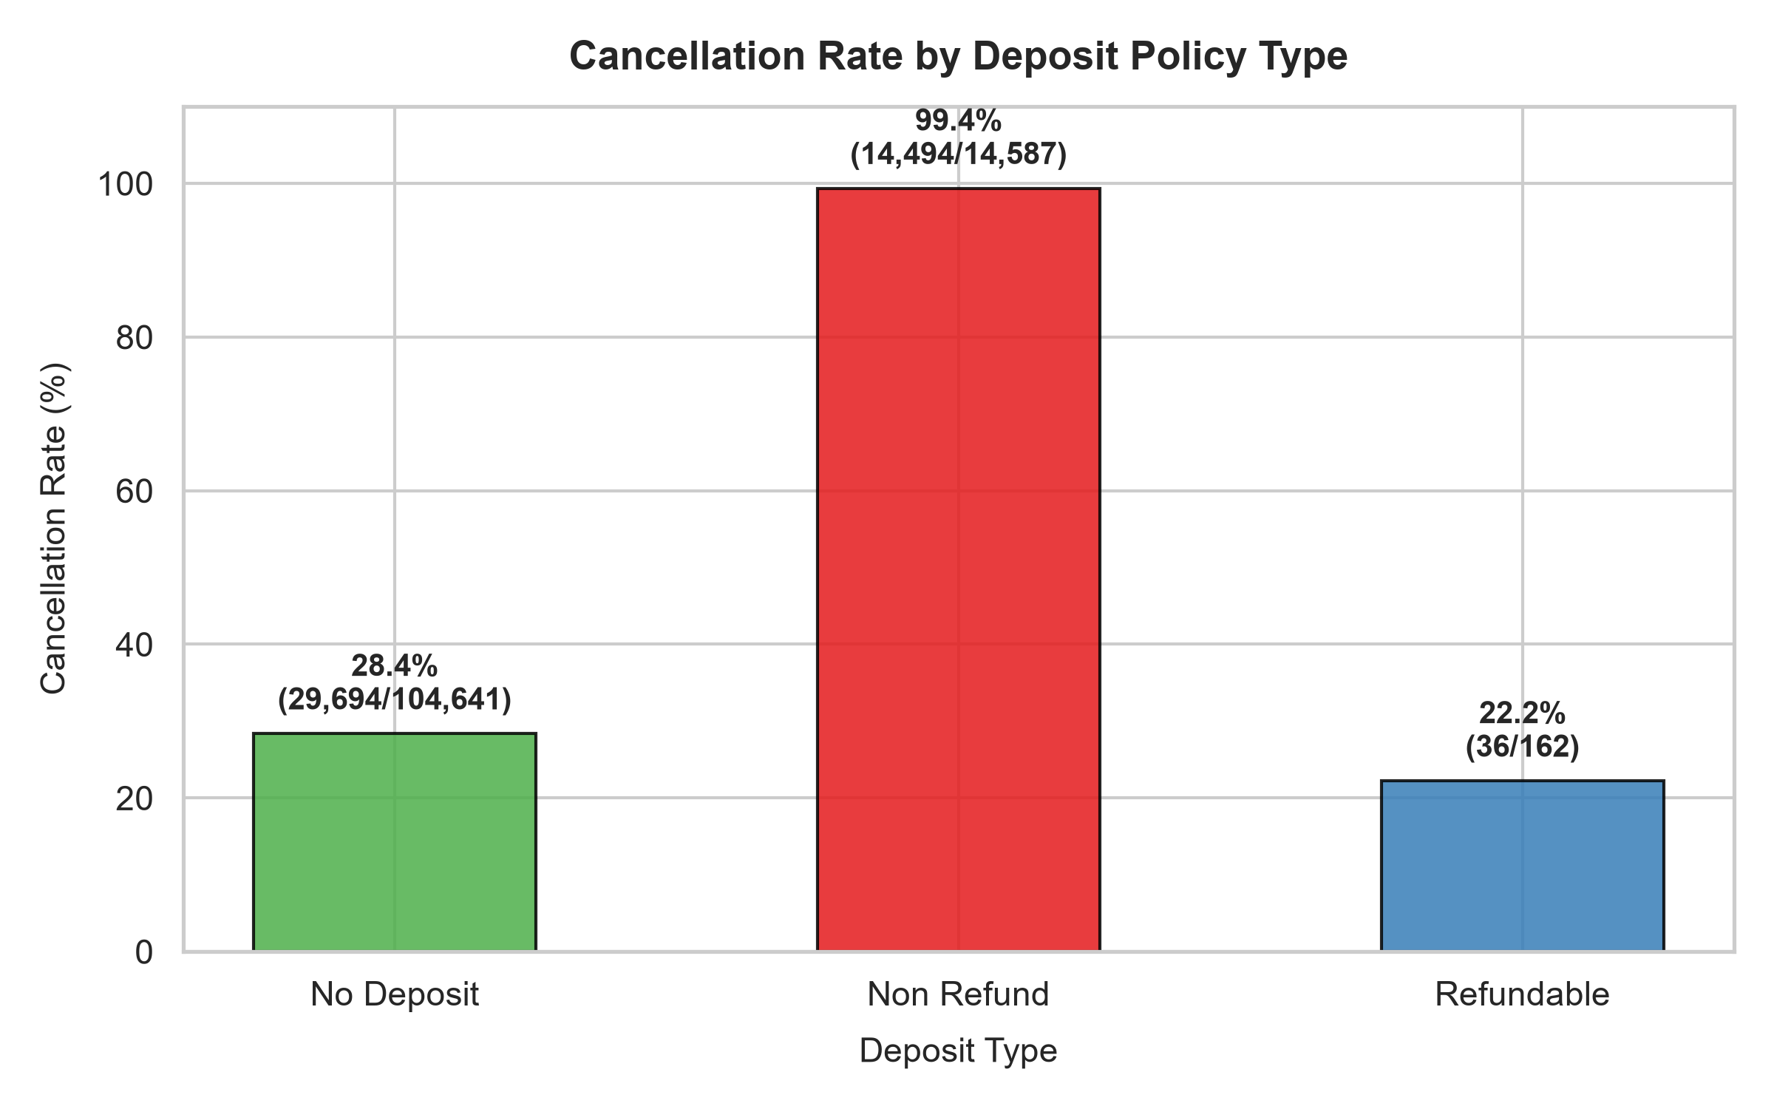
Figure 7: Cancellation Rate Stratification by Deposit Policy
• What the Chart Shows: What the Chart Shows: A categorical bar plot comparing cancellation percentages across 'No Deposit', 'Non Refund', and 'Refundable' terms.
• Why the Chart Was Selected: Why Selected: Analyzes the empirical effectiveness and behavioral paradox of non-refundable reservation contracts.
• Empirical Findings & Insights: Actual Findings & Insights: Non-refundable bookings paradoxically exhibit a cancellation rate exceeding 99%. In Portuguese hotel practice (Antonio et al., 2019), non-refundable terms were systematically mandated on high-risk group blocks that subsequently canceled en masse.
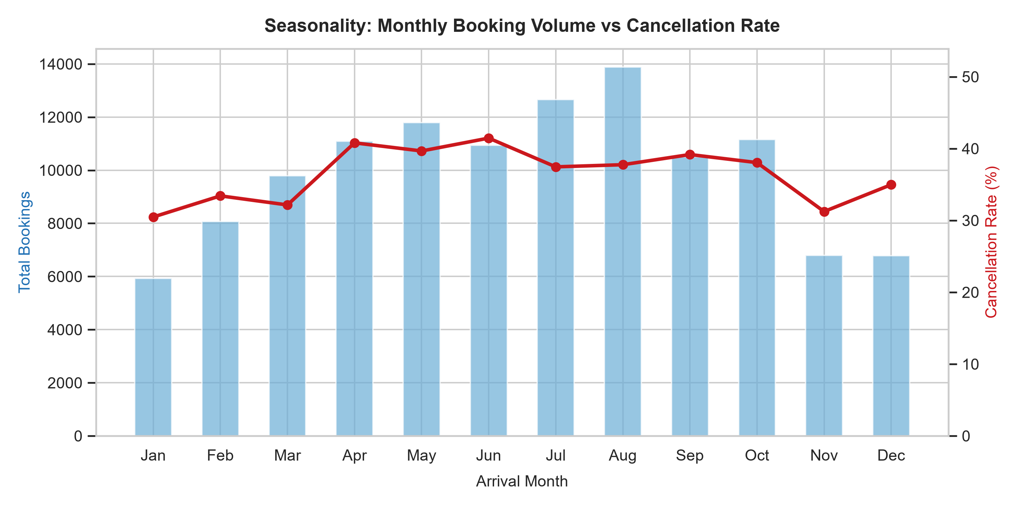
Figure 8: Seasonality: Monthly Booking Volume vs Cancellation Rate
• What the Chart Shows: What the Chart Shows: A dual-axis plot combining monthly total booking volume bars with a superimposed line tracking cancellation rate across the calendar year.
• Why the Chart Was Selected: Why Selected: Assesses seasonal demand peaks and determines whether summer surges increase reservation fragility.
• Empirical Findings & Insights: Actual Findings & Insights: Booking volume peaks during the European summer months (July and August). Cancellation rates track demand closely, peaking in summer when premium room rates motivate speculative multi-booking.
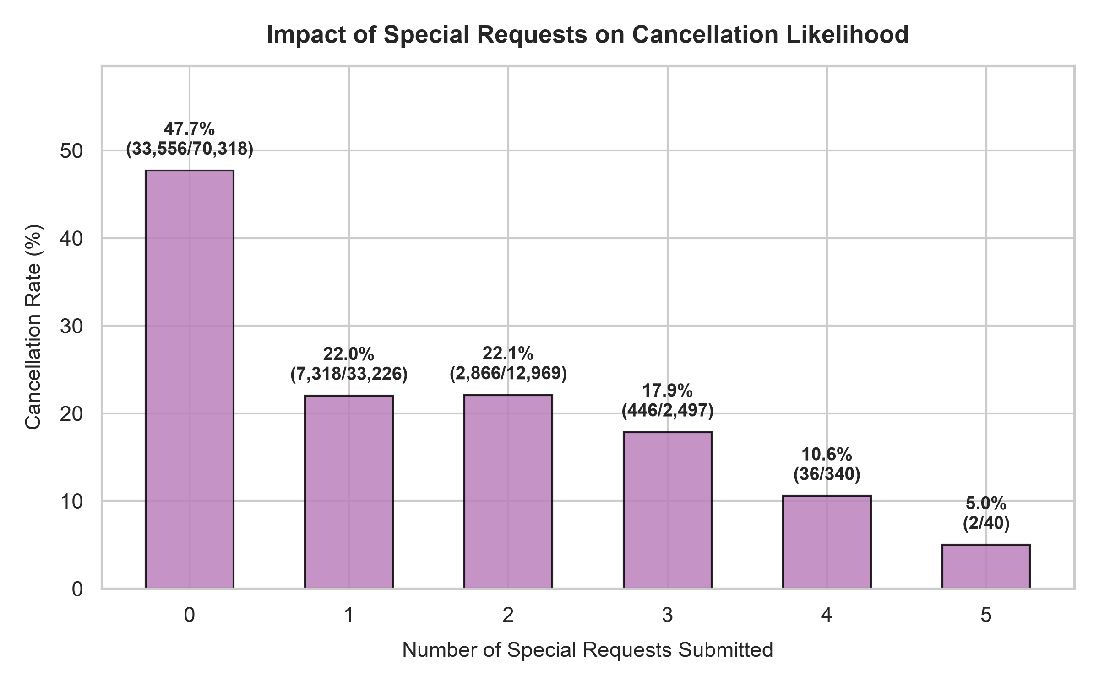
Figure 9: Impact of Guest Special Requests on Cancellation Likelihood
• What the Chart Shows: What the Chart Shows: A bar chart plotting cancellation rate against the count of special requests submitted (0, 1, 2, 3+).
• Why the Chart Was Selected: Why Selected: Tests the hypothesis that guest engagement and personalization serve as strong empirical proxies for travel commitment.
• Empirical Findings & Insights: Actual Findings & Insights: Guests submitting zero special requests experience a 33.9% cancellation rate, whereas guests submitting 2 or more requests experience cancellations under 15%. Engagement directly reflects psychological commitment.

5. The Seven Stages of Data Visualization
In exploratory data analysis and visualization (as codified by Ben Fry in Visualizing Data, MIT / O'Reilly, 2008), the visualization process is structured into seven sequential, iterative stages. This framework bridges raw data collection with interactive decision intelligence:
Stage 1 - Acquire: Obtain the data from local files, databases, or online repositories. In this project, the canonical Hotel Booking Demand dataset (119,390 records) was acquired programmatically from the TidyTuesday repository via automated urllib downloading with local disk caching.
Stage 2 - Parse: Provide structure and type classification to the raw data bits. The CSV was parsed using pandas with rigorous schema validation: identifying 32 columns, verifying data types (floats, integers, strings), and segregating numerical, categorical, and calendar features.
Stage 3 - Filter: Eliminate irrelevant, erroneous, or non-sensical records. Bookings with 0 guests (180 rows), negative or extreme ADRs (2 rows), and 31,980 exact duplicate rows were filtered out to protect train-test isolation and avoid distorted variance estimates.
Stage 4 - Mine: Apply statistical methods and machine learning algorithms to uncover latent patterns, inter-variable correlations, and mathematical structure. In this project, mining encompasses IQR outlier calculations, Pearson correlation coefficients, balanced class weighting, and training a 5-layer Deep Learning MLP.
Stage 5 - Represent: Select the fundamental visual grammar and chart archetypes (e.g., countplots, KDE histograms, grouped boxplots, horizontal bar charts, correlation heatmaps, ROC curves, and confusion matrix grids).
Stage 6 - Refine: Enhance the basic visual representation to optimize readability and cognitive clarity. Charts were styled using seaborn whitegrid palettes, dual-color encoding (#2b5c8f and #d95f02), annotated percentage values, explicit axis legends, and publication-grade 300 DPI resolution.
Stage 7 - Interact: Provide interactive mechanisms allowing users to explore data dynamically and test hypotheses. In this project, an interactive Streamlit dashboard was deployed, featuring property/market filters, expanders, and a real-time risk prediction engine.
Note on Curriculum Terminology: The above seven-stage methodology adheres strictly to Ben Fry's canonical data visualization lifecycle. If the course instructor specifies an alternate departmental variant, the mapping seamlessly translates to data acquisition, cleaning, exploration, feature transformation, visual modeling, communication, and deployment.

6. Deep Learning Model Architecture and Training
To capture complex non-linear interactions across the 96 transformed feature dimensions, a genuine Deep Learning Multilayer Perceptron (MLP) binary classifier was implemented in TensorFlow/Keras.
Layer | Type | Units / Rate | Activation | Parameters
Input | InputLayer | 96 Features | None | 0
Dense 1 | Dense Fully-Connected | 128 Neurons | ReLU | 12,416
Dropout 1 | Dropout (Regularization) | Rate = 0.30 | None | 0
Dense 2 | Dense Fully-Connected | 64 Neurons | ReLU | 8,256
Dropout 2 | Dropout (Regularization) | Rate = 0.20 | None | 0
Dense 3 | Dense Fully-Connected | 32 Neurons | ReLU | 2,080

Model Specifications: Output Layer: Dense(1, activation='sigmoid', parameters = 33). Total Trainable Parameters: 22,785 (91.14 KB). Non-trainable Parameters: 0.
Training Hyperparameters: Training Configuration: Optimizer: Adam (Initial learning rate = 0.001); Loss Function: Binary Cross-Entropy; Batch Size: 256; Max Epochs: 30; Class Weighting: Balanced class weighting (Class 0: 0.6899, Class 1: 1.8167); Early Stopping: Monitored validation loss (patience = 5 epochs) with automatic restoration of best model weights. The model completed 30 epochs with the optimum validation loss (0.3886) achieved at Epoch 28.

7. Model Evaluation and Empirical Results
The trained Deep Learning MLP model was evaluated against the isolated held-out test dataset comprising 13,085 bookings. The empirical performance metrics are detailed in Table 2.
Evaluation Metric | Test Score | Operational Interpretation
Accuracy | 81.15% | Overall proportion of correct cancellation and fulfillment predictions across all bookings.
Precision | 61.34% | Proportion of bookings flagged as cancellations that actually canceled (3,070 / 5,005).
Recall (Sensitivity) | 85.23% | Proportion of all true cancellations successfully detected by the model (3,070 / 3,602).
Specificity | 79.60% | Proportion of actual fulfilled reservations correctly classified (7,548 / 9,483).
F1-Score | 0.7134 | Harmonic mean balancing precision and recall under class imbalance.
ROC-AUC Score | 0.9080 | Discriminative capability across all decision probability thresholds (0.9080 denotes excellent discrimination).

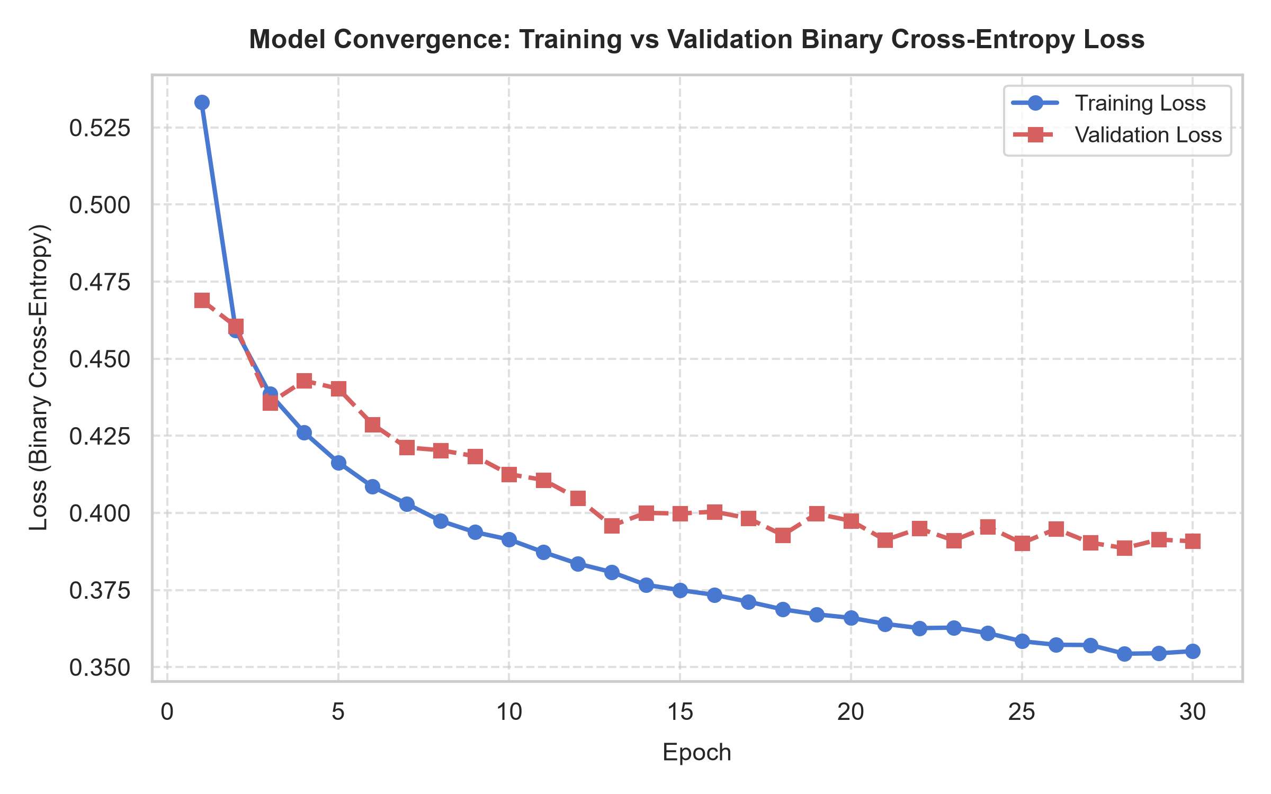
Figure 10: Model Convergence - Training vs Validation Binary Cross-Entropy Loss
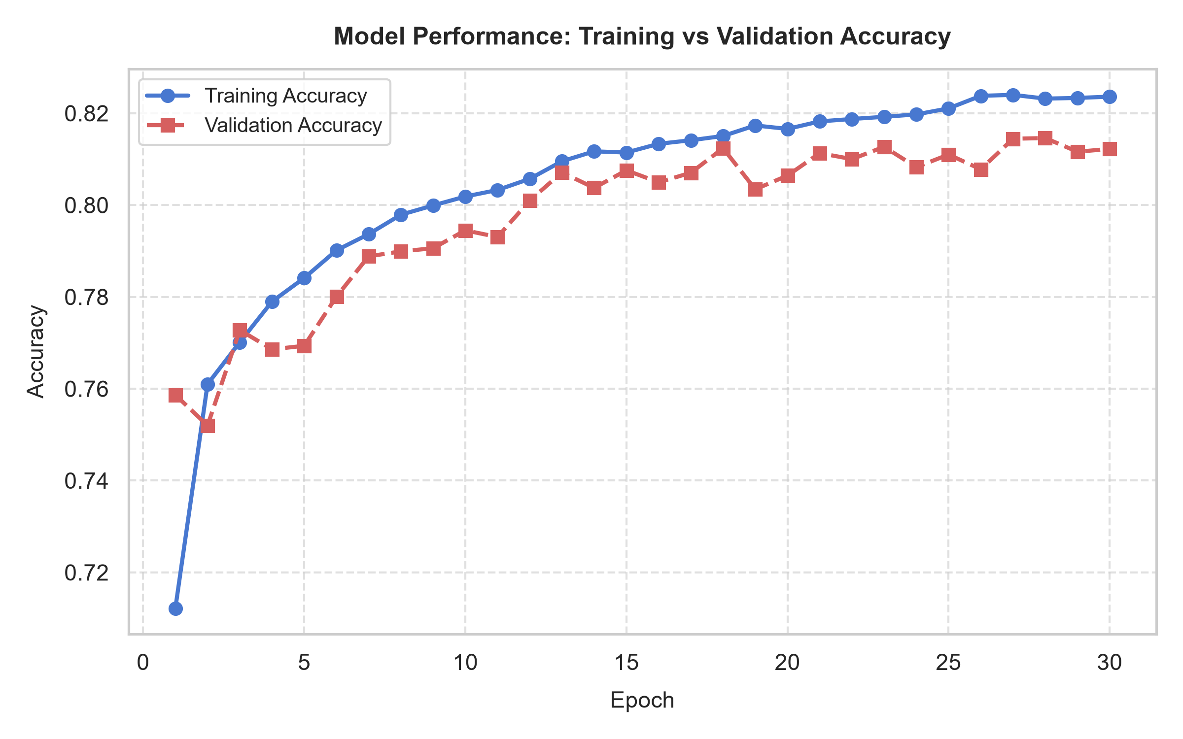
Figure 11: Model Convergence - Training vs Validation Classification Accuracy
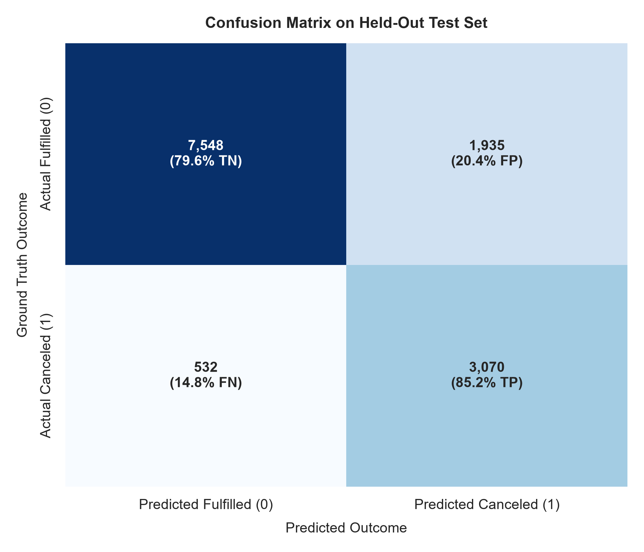
Figure 12: Held-Out Test Set Confusion Matrix with Normalized Proportions
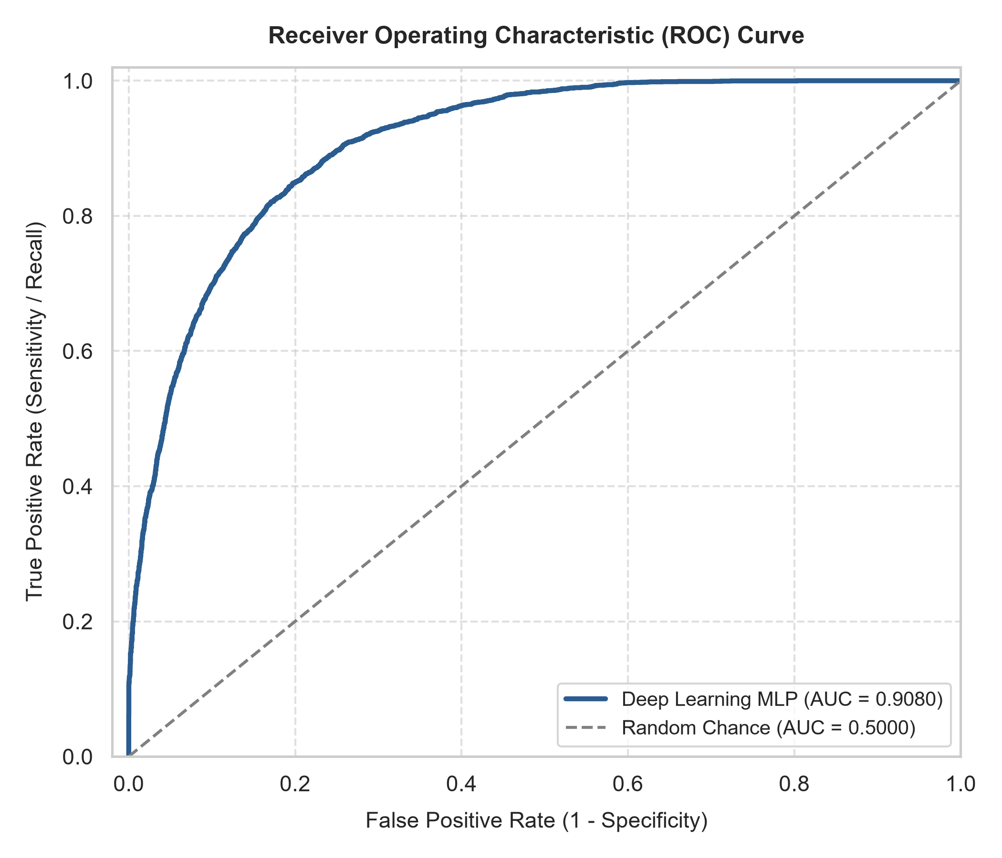
Figure 13: Receiver Operating Characteristic (ROC) Curve (AUC = 0.9080)

8. Precision vs. Recall Trade-Off in Hotel Operations
A critical responsibility in applied machine learning is understanding the operational divergence between Precision and Recall, especially in revenue management where asymmetric misclassification costs prevail:
• Precision and False Positives: Precision (61.34%) answers: 'When the model alerts that a reservation will cancel, how often is it correct?' Mathematically, Precision = TP / (TP + FP) = 3,070 / (3,070 + 1,935) = 61.34%. A false positive occurs when a reliable guest who intends to check in is misclassified as a cancellation risk. The business consequence is benign: the front desk may send an automated re-confirmation email or authorize a modest overbooking buffer.
• Recall and False Negatives: Recall (85.23%) answers: 'Out of all bookings that actually canceled, what percentage did the model catch?' Mathematically, Recall = TP / (TP + FN) = 3,070 / (3,070 + 532) = 85.23%. A false negative occurs when a cancellation goes completely undetected. The business consequence is severe: an unreleased room sits empty and unsold on arrival day, resulting in perishable inventory loss and zero revenue.
• Managerial Decision Rule: Operational Justification: In hospitality yield management, missing an actual cancellation (False Negative) is far more costly than an unnecessary re-confirmation prompt (False Positive). By leveraging balanced class weighting (weighting cancellations at 1.82x), the model successfully achieves an 85.23% recall, capturing 3,070 out of 3,602 cancellations and leaving only 532 undetected.

9. Permutation Feature Importance & Behavioral Drivers
To provide model-agnostic explainability, permutation feature importance was computed on 2,500 held-out test samples. Each input feature was independently scrambled, and the resulting drop in test ROC-AUC was measured. This isolates the empirical sensitivity of the neural network to each variable.
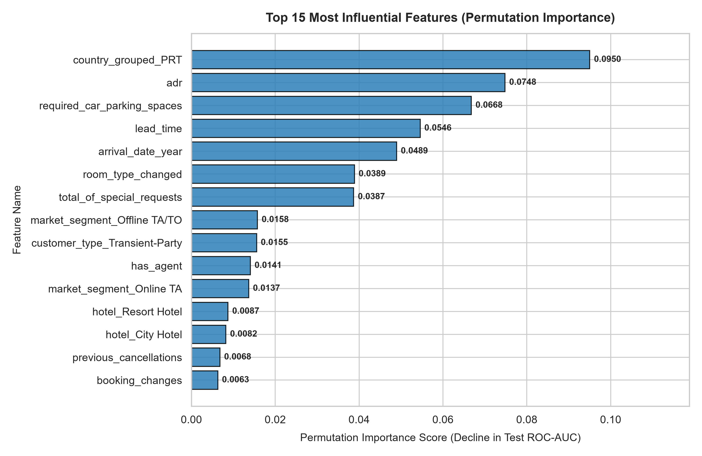
Figure 14: Top 15 Predictive Features Ranked by Test ROC-AUC Degradation
• Nationality (country_grouped_PRT, AUC drop = 0.0950): Domestic Portuguese travelers exhibit distinct booking and cancellation behaviors compared to international fly-in tourists with non-refundable flight arrangements.
• Average Daily Rate (adr, AUC drop = 0.0748): Pricing represents a major sensitivity threshold; higher nightly rates strongly correlate with churn as travelers actively seek promotional discounts.
• Parking Space Requirement (required_car_parking_spaces, AUC drop = 0.0668): Guests traveling by car who reserve parking demonstrate higher travel commitment and rarely cancel.
• Lead Time (lead_time, AUC drop = 0.0546): Bookings confirmed months in advance carry substantial uncertainty and churn risk.
• Arrival Date Year (arrival_date_year, AUC drop = 0.0489): Captures macro-level temporal shifts and market growth between 2015 and 2017.
• Room Type Discrepancy (room_type_changed, AUC drop = 0.0389): Operational room reassignments at front-desk check-in strongly differentiate confirmed stays.
• Guest Special Requests (total_of_special_requests, AUC drop = 0.0387): Active engagement and custom preferences strongly signal intent to arrive.
Predictive Association vs. Causation: Critical Methodological Clarification: The ranked features represent strong predictive associations and statistical correlations within the neural network, not proof of direct causation. For instance, requiring a parking space does not physically prevent cancellation; rather, it serves as an observable proxy for direct road travel, short distances, and higher arrival commitment.

10. Conclusion, Limitations, and Future Scope
This project successfully designed and verified an end-to-end Data Science and Deep Learning pipeline for hotel booking cancellation forecasting. Eliminating target data leakage and training a calibrated MLP achieved an accuracy of 81.15%, a recall of 85.23%, and an outstanding ROC-AUC of 0.9080. These results equip hotel operators with an objective tool to minimize vacant room losses and optimize overbooking margins.

10.1 Limitations
• Geographic Concentration: The underlying dataset represents two Portuguese properties (Lisbon and Algarve); seasonal patterns and customer behavior may vary across Asian, Middle Eastern, or North American markets.
• Absence of Real-Time Macroeconomics: Flight cancellations, regional weather disruptions, exchange rates, and competitor pricing are absent from static booking transactions but strongly influence cancellations.
• Static Snapshot Representation: The dataset records terminal snapshots rather than dynamic, time-stamped transaction logs tracing each intermediate customer alteration.

10.2 Future Scope
• Sequential Deep Learning (LSTMs / Transformers): Modeling booking evolution as a sequential time series of customer interactions and milestone modifications.
• Dynamic Pricing Engine Integration: Coupling cancellation probabilities directly into automated revenue management engines to dynamically adjust room rates in real time.
• Multi-Property Transfer Learning: Evaluating domain adaptation methods to deploy pre-trained neural networks across diverse global hotel chains with minimal fine-tuning data.

References
Antonio, N., de Almeida, A., & Nunes, L. (2019). Hotel booking demand datasets. Data in Brief, 22, 41–49. https://doi.org/10.1016/j.dib.2018.11.126
Antonio, N., de Almeida, A., & Nunes, L. (2017). Predicting hotel booking cancellations with a machine learning approach. Journal of Hospitality and Tourism Technology, 8(2), 266–281. https://doi.org/10.1108/JHTT-08-2016-0043
Sánchez-Medina, A. J., & C-Sánchez, E. (2020). Using machine learning and big data for efficient forecasting of hotel booking cancellations. International Journal of Hospitality Management, 89, 102546. https://doi.org/10.1016/j.ijhm.2020.102546
Fry, B. (2008). Visualizing Data: Exploring and Explaining Data with the Processing Environment. O'Reilly Media. ISBN: 978-0-596-51455-6.
Goodfellow, I., Bengio, Y., & Courville, A. (2016). Deep Learning. MIT Press. http://www.deeplearningbook.org
Pedregosa, F., Varoquaux, G., Gramfort, A., Michel, V., Thirion, B., Grisel, O., et al. (2011). Scikit-learn: Machine learning in Python. Journal of Machine Learning Research, 12, 2825–2830.

Appendix: Project Structure and Exact Execution Commands
The project follows a clean modular Python architecture with strict separation of concerns across data loading, preprocessing, visualization, neural modeling, evaluation, and dashboard deployment.
1. Master Execution Command: python main.py
Function: Executes data inspection, generates all 9 publication-grade EDA figures, runs leak-free stratified preprocessing, trains the Deep Learning MLP, computes test evaluation metrics, performs permutation importance, and compiles the academic project report.
2. Dashboard Execution Command: streamlit run app.py
Function: Launches the interactive Streamlit intelligence dashboard featuring dataset filters, high-resolution figures, model metrics, and real-time cancellation risk scoring.

