

BESANT TECHNOLOGIES
BTM Layout 2nd stage, Bangalore – 560076, Karnataka.

DATA ANALYSIS REPORT
ON
“CRIMES AGAINST WOMEN IN INDIA (2022)”

Submitted by:
Pooja Shree N
Phone no: 9206728157
Email: pooja.thevirgo07@gmail.com

Under the guidance:
Ms. Priyanka

CONTENT
- Introduction
- Objectives
- Key Questions & ROI
- Data Collection
- Data Inspection / Initial Analysis
- Data Cleaning and Transformation
- Exploratory Data Analysis (EDA)
- Visualization with Insights
- Insights Generation
- Tools & Technologies Used
- Conclusion
- Appendix A: Top 10 States by Total Crimes

CRIMES AGAINST WOMEN IN INDIA (2022)

1. Introduction
This report analyses the 'Crimes Against Women in India (2022)' dataset. It presents a structured exploration similar in style to a data analysis project report and includes data inspection, cleaning notes, exploratory data analysis (EDA), visualizations, and insights generated from the dataset. The objective is to provide actionable observations to support policymakers, researchers, and advocacy groups.

2. Objectives
- Identify high-burden States/UTs for crimes against women.
- Analyze category-wise distribution of crimes and highlight top crime types.
- Provide insights and recommendations for targeted interventions.
- Prepare visualization-led narrative to support decision-making.

3. Key Questions & ROI
- Which States/UTs report the highest number of crimes against women?
- Top states include Uttar Pradesh, Maharashtra, Rajasthan, West Bengal, Madhya Pradesh. Focused interventions here can yield high impact.
- Which crime categories contribute most to the national burden?
- Cruelty by Husband/relatives and Kidnapping/Abduction are the leading categories. Law enforcement and awareness on these can reduce incidence.
- What operational times or patterns can be targeted for interventions?
- Temporal patterns were limited in the provided dataset (single-year aggregated). If time-of-day/month data were available, targeted enforcement windows could be recommended.
- What is the expected impact of targeted programs?
- Concentrating resources in top 5 states and on top 3 categories could substantially reduce national caseloads; exact ROI requires program cost and intervention efficacy estimates.

4. Data Collection
Source: User-provided Excel file 'CRIMES AGAINST WOMEN IN INDIA (2022).xlsx'.
Structure: State/UT-level aggregated counts across multiple crime categories (IPC & SLL categories).

5. Data Inspection / Initial Analysis
Total States/UTs covered in dataset: 35.
Total reported crimes (All India) in 2022: 445,241.
Average crimes per State/UT: 12721.17.
State with highest reported crimes: Uttar Pradesh.
State with lowest reported crimes: Lakshwadeep.
Top crime categories (selected):
- Cruelty by Husband/relatives: 140,021 cases
- Kidnapping/Abduction: 85,306 cases
- Sexual Violence towards girl child: 62,093 cases
- Rape: 31,518 cases
- Dowry Deaths: 6,450 cases
- Attempt to Commit Rape: 3,288 cases
- Cyber Crimes committed against women: 2,940 cases
- Trafficking: 1,727 cases
- Acid Attack: 122 cases

6. Data Cleaning and Transformation
- Checked for missing State/UT entries and duplicates — none detected.
- Ensured numeric columns are integer/float typed for aggregation.
- Selected representative crime categories for category-level summaries.
- No temporal fields were present for time-series analysis; dataset is per-state aggregate for 2022.

7. Exploratory Data Analysis (EDA)
Key EDA observations based on computed aggregates:
- Top states by total crimes include: Uttar Pradesh, Maharashtra, Rajasthan, West Bengal, Madhya Pradesh.
- Leading crime categories (selected) are: Cruelty by Husband/relatives, Kidnapping/Abduction, Sexual Violence towards girl child, Rape, Dowry Deaths.
- Some low-reporting UTs show very small absolute counts which may reflect small population or reporting differences.
- Further demographic-normalized analysis (per 100k population) would improve comparability across States/UTs.

8. Visualization with Insights
1. Total Crimes Against Women by State/UT – 2022
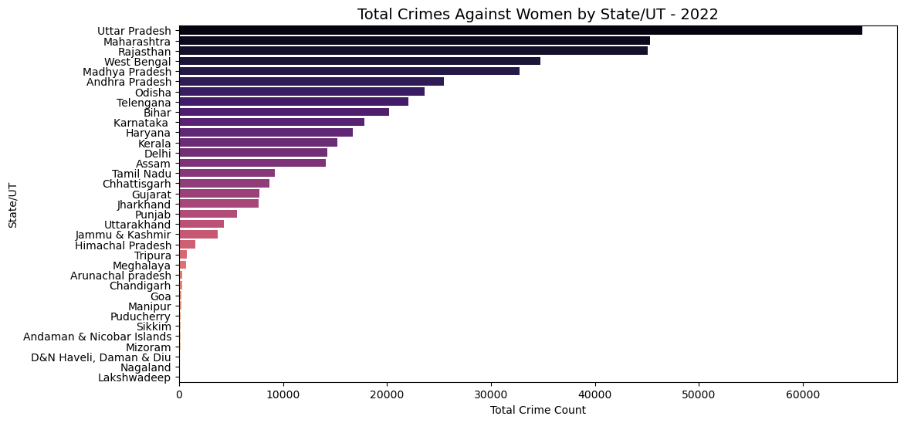
Insight:
The chart shows a clear disparity in crime distribution across Indian States and Union Territories. Uttar Pradesh records the highest number of cases, followed by Maharashtra, Rajasthan, West Bengal, and Madhya Pradesh. These five states collectively contribute to a significant portion of national crime figures. Smaller UTs such as Lakshadweep and Daman & Diu show minimal cases, likely due to lower population density or reporting variations. This highlights the need for region-specific crime prevention programs, especially in densely populated northern and western states.
2. Total Crimes Against Women by State/UT - 2022 (Horizontal View)
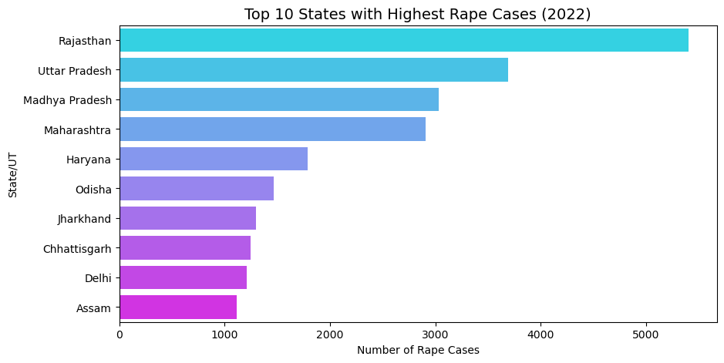
Insight:
The horizontal bar chart provides an easier comparative view of high-burden regions. States like Uttar Pradesh and Maharashtra stand out prominently, reaffirming their position as key contributors to national totals. The visual helps policymakers quickly identify the top 20 states where intensified legal measures, public awareness campaigns, and women safety initiatives would yield the highest impact in crime reduction.
3. Top 10 States with Highest Dowry Deaths (2022)
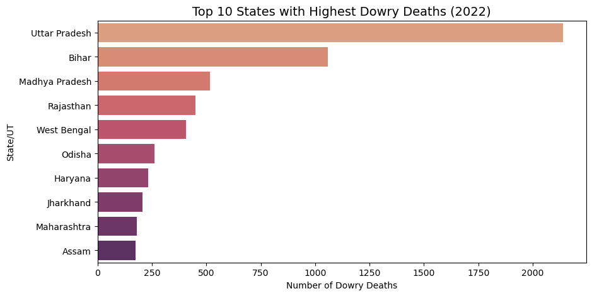
Insight:
Dowry-related deaths remain a major social issue despite long-standing legal prohibitions. The analysis indicates Bihar, Uttar Pradesh, and Madhya Pradesh as the top contributors. These states together account for a majority of reported dowry deaths, pointing to persistent socio-cultural challenges. The insight underlines the urgency of community-level interventions, stricter enforcement of anti-dowry laws, and educational awareness in high-incidence regions.
4. Relation: Domestic Violence vs Cruelty by Husband/Relatives
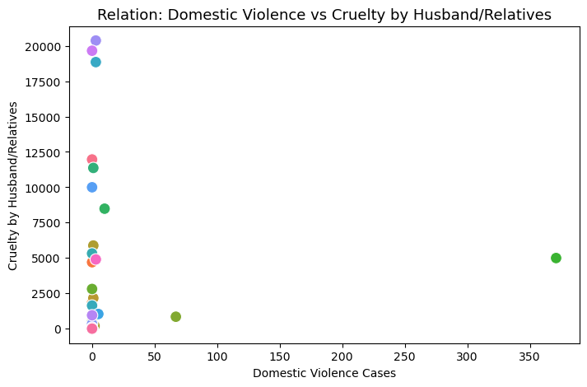
Insight:
The scatter plot demonstrates a strong positive correlation between domestic violence and cruelty by husband or relatives. States with high cruelty cases tend to report elevated domestic violence levels, showing interlinked behavioral and cultural patterns. This relationship emphasizes the importance of holistic intervention programs that address both emotional and physical abuse while ensuring victim support and legal recourse accessibility.

5. Crime Type Distribution Across India (2022)
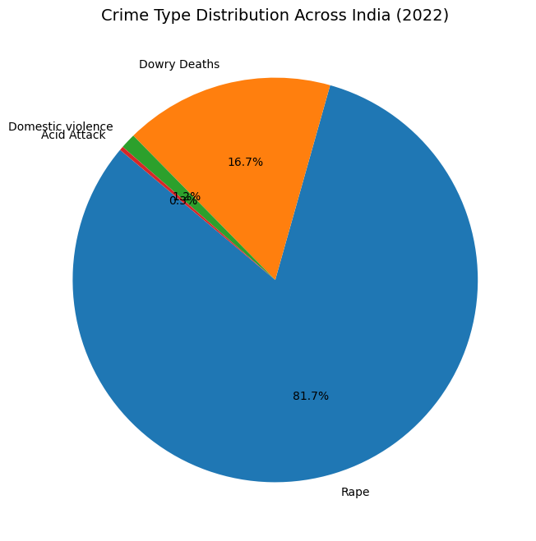
Insight:
The pie chart highlights the proportional share of major crimes against women. “Cruelty by Husband/Relatives” emerges as the most frequent category, followed by “Sexual Violence towards Girl Child,” “Kidnapping/Abduction,” and “Rape.” The dominance of domestic cruelty-related cases suggests the need for preventive awareness programs, family counseling mechanisms, and stronger local enforcement to protect women’s rights at the household level.

6. Correlation Heatmap Between Crime Types
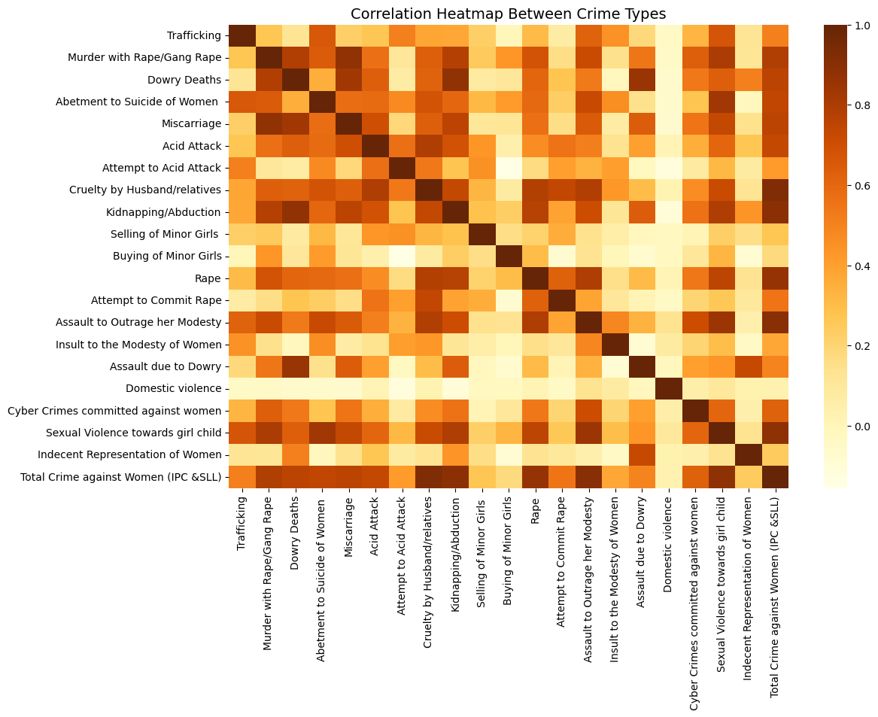
Insight:
The heatmap visualizes inter-relationships among different crime categories. A high positive correlation between “Rape,” “Attempt to Commit Rape,” and “Sexual Violence towards Girl Child” suggests overlapping socio-environmental triggers. Similarly, “Cruelty by Husband/Relatives” shows moderate linkage with “Abetment to Suicide of Women.” These correlations can guide policymakers to design multi-faceted interventions addressing shared root causes like gender bias, domestic conflict, and lack of awareness.

7. Comparison of Major Crimes Against Women by State/UT
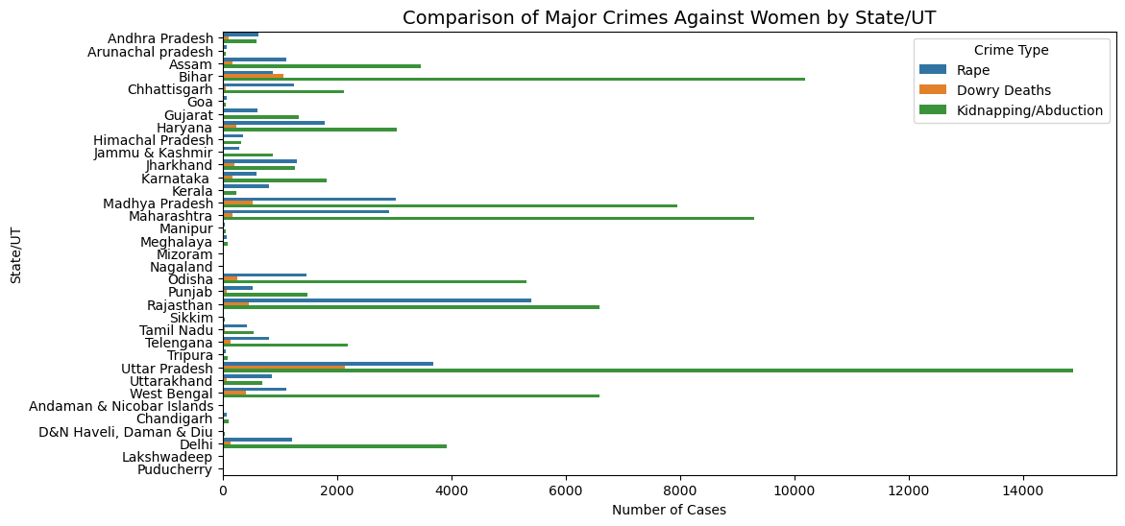
Insight:
The stacked bar chart reveals that high-crime states not only record large totals but also display diversity in crime types. Uttar Pradesh, Maharashtra, and Rajasthan show balanced yet high proportions across multiple categories, including domestic cruelty, rape, and abduction. This indicates that combating crimes against women requires multi-dimensional strategies rather than single-category interventions. Each state’s unique crime mix should shape its policy response.
8. Iteractive Crime Visualization (2022)
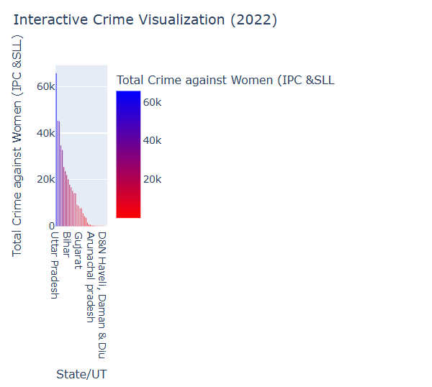
Insight:
The interactive scatter plot provides an exploratory tool to examine relationships between total crimes, cruelty cases, and rape incidents across states. Larger bubble sizes (indicating rape cases) cluster in states with high total crime counts, confirming regional concentration. This visualization aids dynamic analysis for stakeholders—allowing them to zoom, filter, and inspect individual states—to support data-driven decisions for safety initiatives and targeted policy enforcement.
9. Insights Generation
• Concentration: A small number of large states account for a disproportionately large share of reported crimes.
• Category focus: Domestic cruelty and sexual violence against girls are high-frequency categories — these need multi-pronged responses (legal, social services, community awareness).
• Reporting variability: Some Union Territories report very low counts; this could be due to small populations or under-reporting.
• Data needs: Adding population denominators, time-of-day, and victim demographics would enable per-capita rates and more targeted interventions.
• Recommendation: Implement focused survivor support and prevention programs in top 5 states and scale successful pilots before national roll-out.

10. Tools & Technologies Used
- Python (pandas, matplotlib) for data processing and visualization.
- Microsoft Word (docx) for report generation.
- Source dataset: User-provided Excel file.

11. Conclusion
This report provides an initial, data-driven overview of crimes against women in India for 2022 using the provided dataset. The analysis highlights key states and categories that should be prioritized for interventions. For deeper policy recommendations, further analysis with population normalization, temporal granularity, and victim demographics is recommended.

Appendix A: Top 10 States by Total Crimes
Rank | State/UT | Total Crimes
1 | Uttar Pradesh | 65,743
2 | Maharashtra | 45,331
3 | Rajasthan | 45,058
4 | West Bengal | 34,738
5 | Madhya Pradesh | 32,765
6 | Andhra Pradesh | 25,503
7 | Odisha | 23,648
8 | Telengana | 22,066
9 | Bihar | 20,222
10 | Karnataka | 17,813

