**DAILY ONLINE ACTIVITIES SUMMARY**

|  |  |  |  |  |  |  |  |  |
| --- | --- | --- | --- | --- | --- | --- | --- | --- |
| **Date:** | **11/07/2020** | | | | | **Name:** | **MHASKE POOJA** | |
| **Sem & Sec** | **VI & A sec** | | | | | **USN:** | **4AL17CS050** | |
| **Online Test Summary** | | | | | | | | |
| **Subject** | | **Operating System** | | | | | | |
| **Max. Marks** | | **-** | | **Score** | | | **-** | |
| **Course Summary** | | | | | | | | |
| **Course** | **Blockchain Basics** | | | | | | | |
| **Certificate Provider** | | | **Coursera** | | **Duration** | | | **2 hrs** |
| **Coding Challenges** | | | | | | | | |
| **Problem Statement:**  **1.Write a C program to check whether the given character is a Vowel or a Consonant**  Write a C program to check whether the given character is a Vowel or a Consonant  1.  Write a C program to check whether the given character is a Vowel or a Consonant     |  |  | | --- | --- | |  |  |  |  |  | | --- | --- | |  |  | | | | | | | | | |
| **Status: completed** | | | | | | | | |
| **Uploaded the report in Github** | | | | | **Yes** | | | |
| **If yes Repository name** | | | | | [https://github.com/Pooja-mhaske354/Daily-Status](https://github.com/maheksa1234/Daily-Status) | | | |
| **Uploaded the report in slack** | | | | | **Yes** | | | |

**Operating System:**

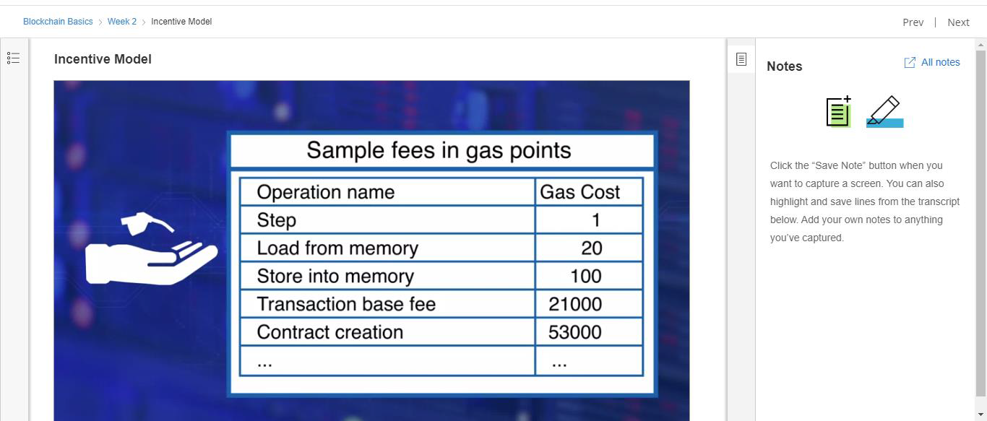

**Online Certification Course Details:**

Today I completed week 2 (Ethereum Blockchain) and took quiz on this.

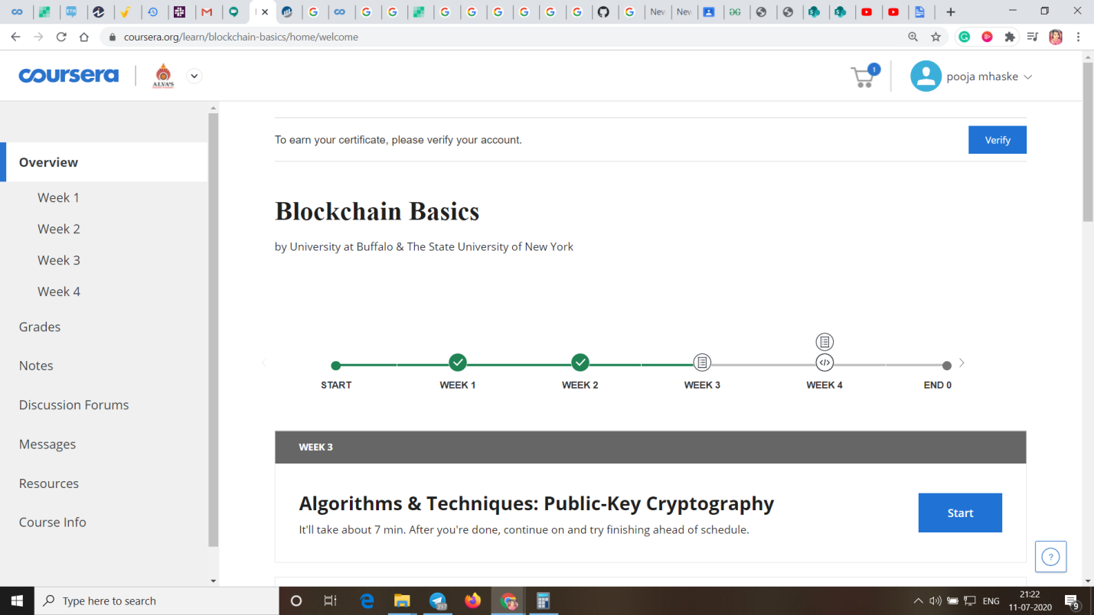

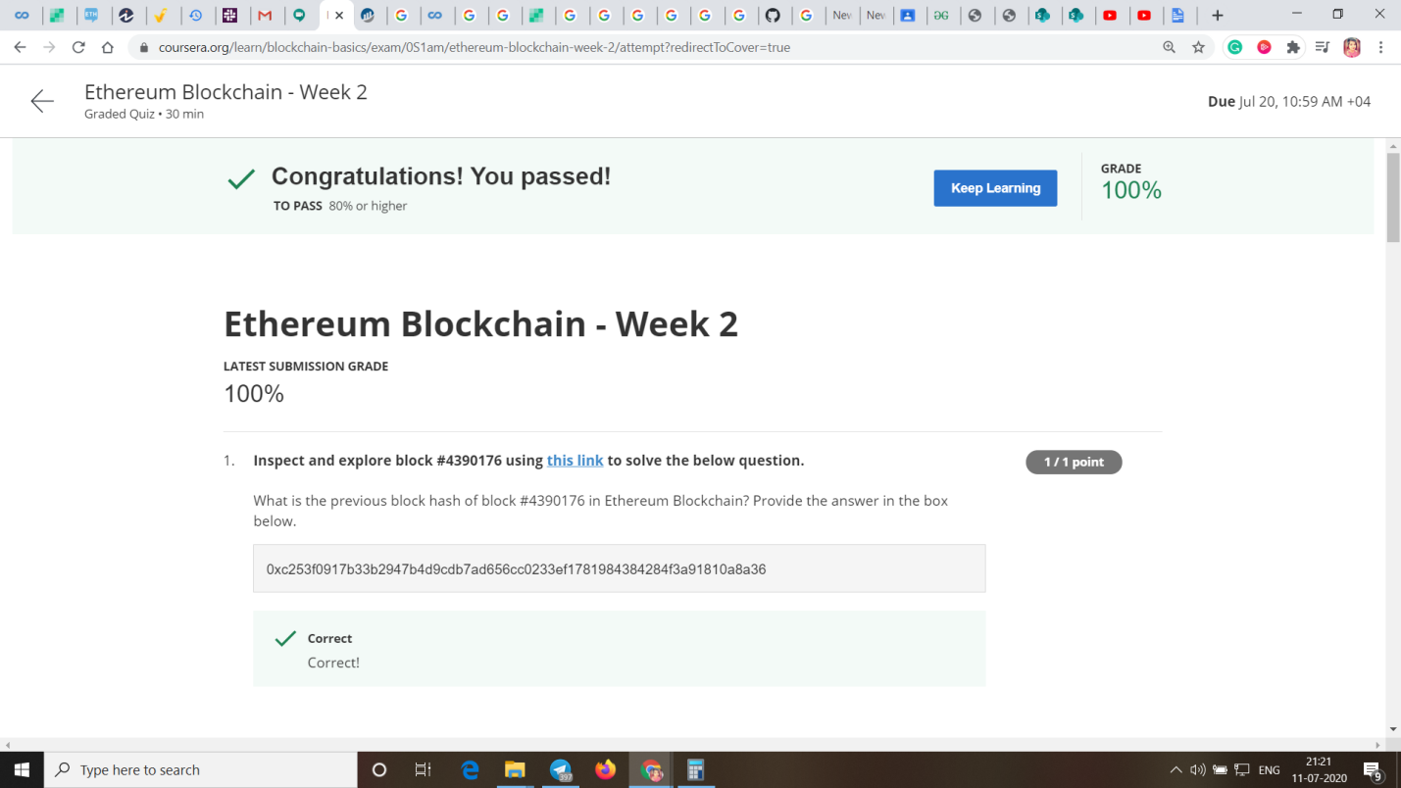

**Coding Challenges Details:**

<https://github.com/Pooja-mhaske354/Daily-Status/tree/master/Online%20Coding/11-7-2020>

The same report is also available in :

[https://github.com/Pooja-mhaske354/Daily-Status/tree/master/Online%20Coding](https://github.com/maheksa1234/Daily-Status/tree/master/Online%20Coding)