**DAILY ONLINE ACTIVITIES SUMMARY**

|  |  |  |  |  |  |  |  |  |
| --- | --- | --- | --- | --- | --- | --- | --- | --- |
| **Date:** | **16/06/2020** | | | | | **Name:** | **MHASKE POOJA** | |
| **Sem & Sec** | **VI & A sec** | | | | | **USN:** | **4AL17CS050** | |
| **Pre placement training Summary** | | | | | | | | |
| **Pre placement training** | | **9:15 am to 11:20 am - Programming in C**  **11:20 am to 1:30pm - Applications of python in DA and ML** | | | | | | |
| **Max. Marks** | | **20** | | **Score** | | | **14** | |
| **Course Summary** | | | | | | | | |
| **Course** | **1.** **Python for Data Science**  **2.Workshop exercise solving** | | | | | | | |
| **Certificate Provider** | | | **JOSEPH** | | **Duration** | | | **2 hrs** |
| **Coding Challenges** | | | | | | | | |
| **Problem Statement:**   1. **Write a Python program to check whether a given a binary tree is a valid binary search tree (BST) or not?** 2. **Write a C Program to perform the following operations on Triply Linked List (TLL)**      |  |  | | --- | --- | |  |  |  |  |  | | --- | --- | |  |  | | | | | | | | | |
| **Status: completed** | | | | | | | | |
| **Uploaded the report in Github** | | | | | **Yes** | | | |
| **If yes Repository name** | | | | | <https://github.com/Pooja-mhaske354/Daily-Status> | | | |
| **Uploaded the report in slack** | | | | | **Yes** | | | |

**Programming in C**

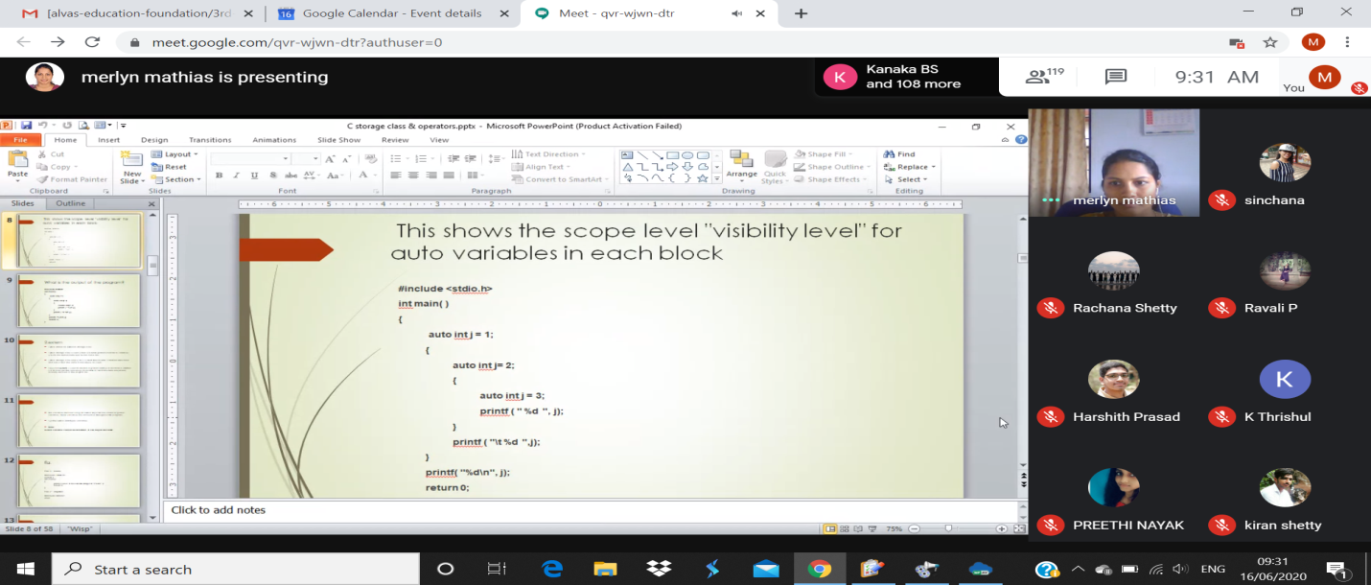

**Quiz Snapshots:**

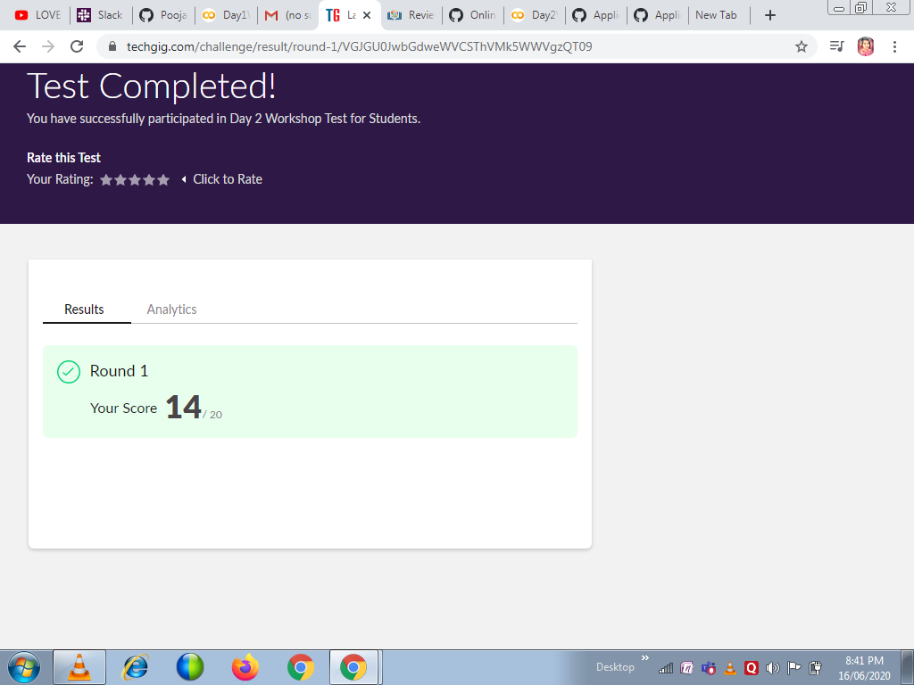

**Applications of python in DA and ML**

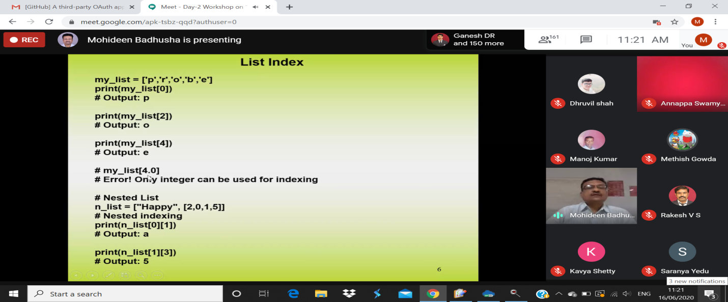

**Certification Course Details:**

Refer GitHub account for Detailed information:

<https://github.com/Pooja-mhaske354/Daily-Status>

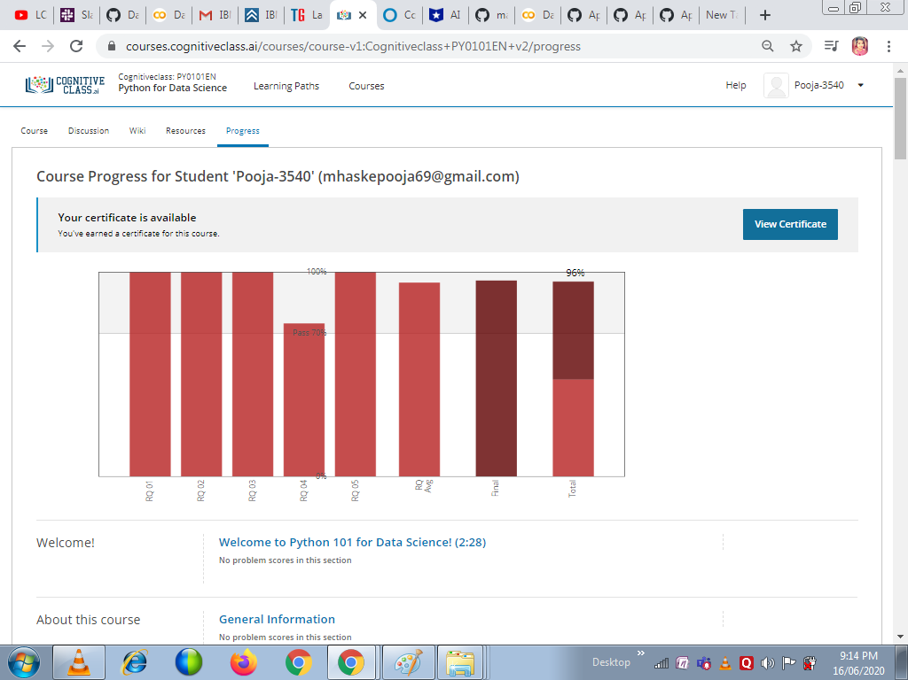

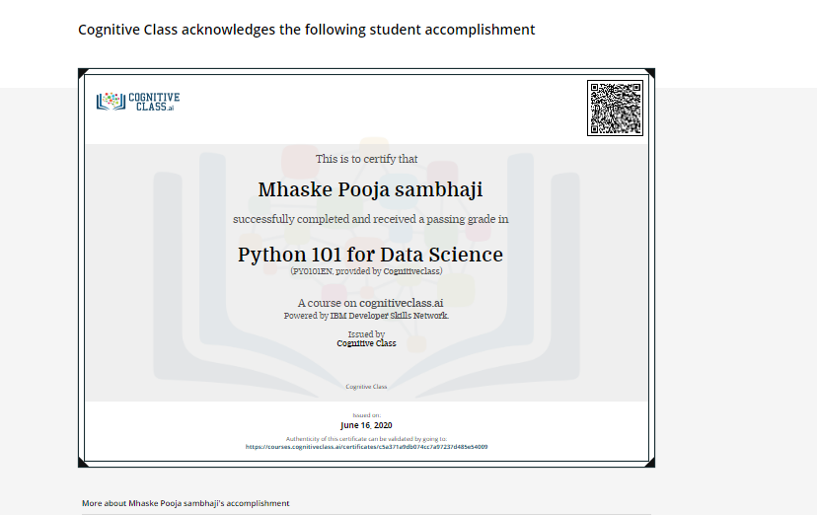

Refer the github link for example programs and exercise programs:

<https://github.com/Pooja-mhaske354/Applications-Of-Python-Programming-in-DL-and-ML>

**Coding Challenges Details:**

<https://github.com/maheksa1234/Daily-Status/tree/master/Online%20Coding/16-6-2020>

The same report is also available in :

<https://github.com/Pooja-mhaske354/Daily-Status/tree/master/Online%20Coding>