**DAILY ONLINE ACTIVITIES SUMMARY**

|  |  |  |  |  |  |  |  |  |
| --- | --- | --- | --- | --- | --- | --- | --- | --- |
| **Date:** | **17/06/2020** | | | | | **Name:** | **MHASKE POOJA** | |
| **Sem & Sec** | **VI & A sec** | | | | | **USN:** | **4AL17CS050** | |
| **Online Test Summary** | | | | | | | | |
| **Pre placement training** | | **Programming in C** | | | | | | |
| **Max. Marks** | | **15** | | **Score** | | | **12** | |
| **Certification Course Summary** | | | | | | | | |
| **Course** | **Workshop on ”Application Of Python Programming in DA And ML”** | | | | | | | |
| **Certificate Provider** | | | **-** | | **Duration** | | | **-** |
| **Coding Challenges** | | | | | | | | |
| **Problem Statement:**  **1.Java program to find the row, column position of a specified number**  **(row, column ,position) in a given 2-dimensional array**  **2.Find the smallest positive integer value that cannot be represented as sum of any**  **subset of a given array sorted in ascending order**     |  |  | | --- | --- | |  |  |  |  |  | | --- | --- | |  |  | | | | | | | | | |
| **Status: executed** | | | | | | | | |
| **Uploaded the report in Github** | | | | | **Yes** | | | |
| **If yes Repository name** | | | | | <https://github.com/Pooja-mhaske354/Daily-Status> | | | |
| **Uploaded the report in slack** | | | | | **Yes** | | | |

**Online Test Details:**

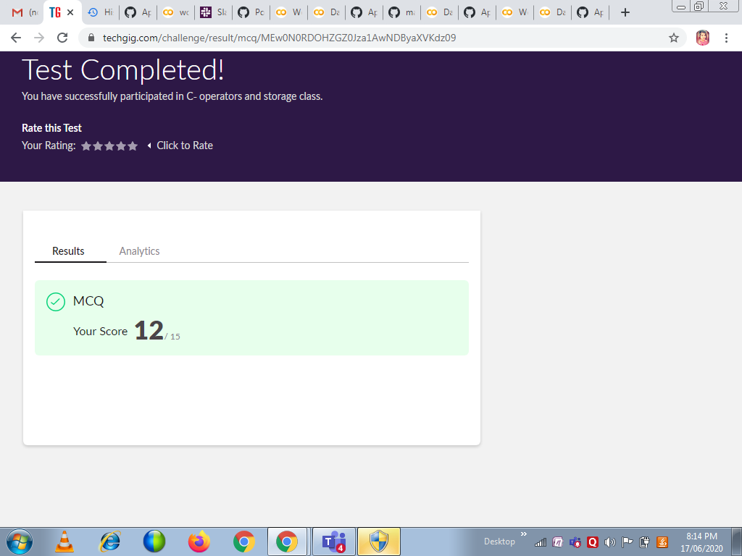

**Programming in C:**

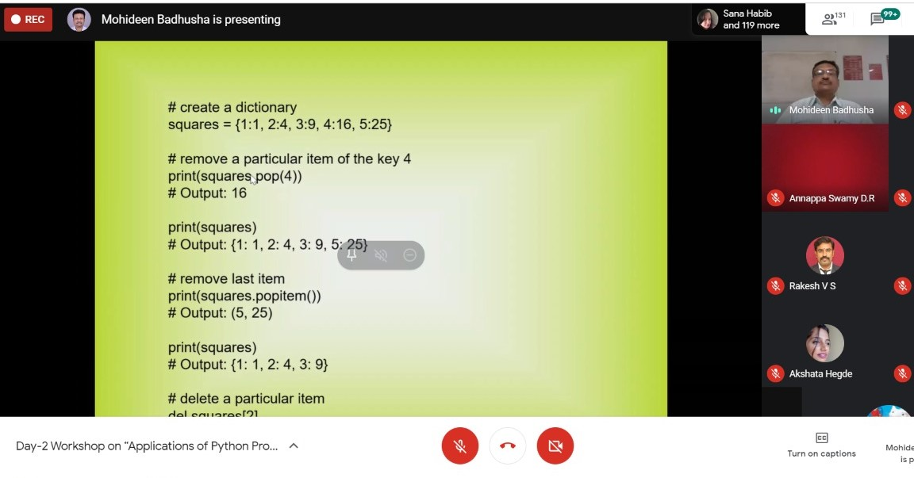

**Workshop Details:**

**Applications of python in DA and ML**



Refer the github link for example programs and exercise programs:

<https://github.com/Pooja-mhaske354/Applications-Of-Python-Programming-in-DL-and-ML>

**Coding Challenges Details:**

<https://github.com/Pooja-mhaske354/Daily-Status/tree/master/Online%20Coding/17-6-2020>

The same report is also available in :

<https://github.com/Pooja-mhaske354/Daily-Status/tree/master/Online%20Coding>