**DAILY ONLINE ACTIVITIES SUMMARY**

|  |  |  |  |  |  |  |  |  |
| --- | --- | --- | --- | --- | --- | --- | --- | --- |
| **Date:** | **19/06/2020** | | | | | **Name:** | **MHASKE POOJA** | |
| **Sem & Sec** | **VI & A sec** | | | | | **USN:** | **4AL17CS050** | |
| **Online test Summary** | | | | | | | | |
| **Pre placement training** | |  | | | | | | |
| **Max. Marks** | | **-** | | **Score** | | | **-** | |
| **Pre-Placement Training Summary** | | | | | | | | |
| **Course** | **9:15 am to 10:55 am - Programming in C**  **11:00 am to 1:30pm - Applications of python in DA and ML** | | | | | | | |
| **Certificate Provider** | | | **Ms.Shilpa**  **Dr.MohideenBadusha** | | **Duration** | | | **4 hrs** |
| **Coding Challenges** | | | | | | | | |
| **Problem Statement:**  **1.Write a C Program to rotate a Matrix by 90 Degree in Clockwise or Anticlockwise Direction**  **2.Swap 2 numbers using pointers**  **3.Write a Java program to create a doubly linked list of n nodes and display it in reverse order**     |  |  | | --- | --- | |  |  |  |  |  | | --- | --- | |  |  | | | | | | | | | |
| **Status: executed** | | | | | | | | |
| **Uploaded the report in Github** | | | | | **Yes** | | | |
| **If yes Repository name** | | | | | <https://github.com/Pooja-mhaske354/Daily-Status> | | | |
| **Uploaded the report in slack** | | | | | **Yes** | | | |

**Online Test Details:**

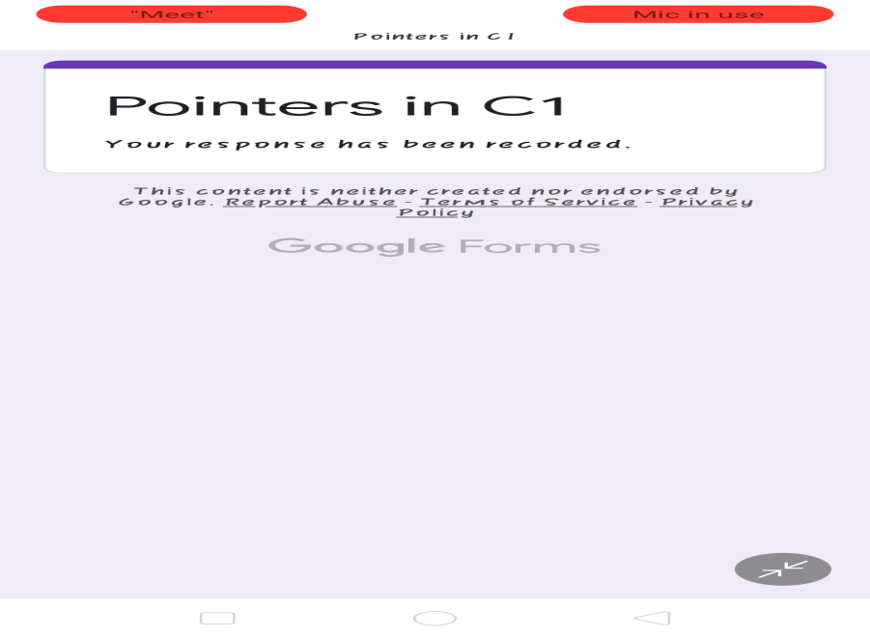

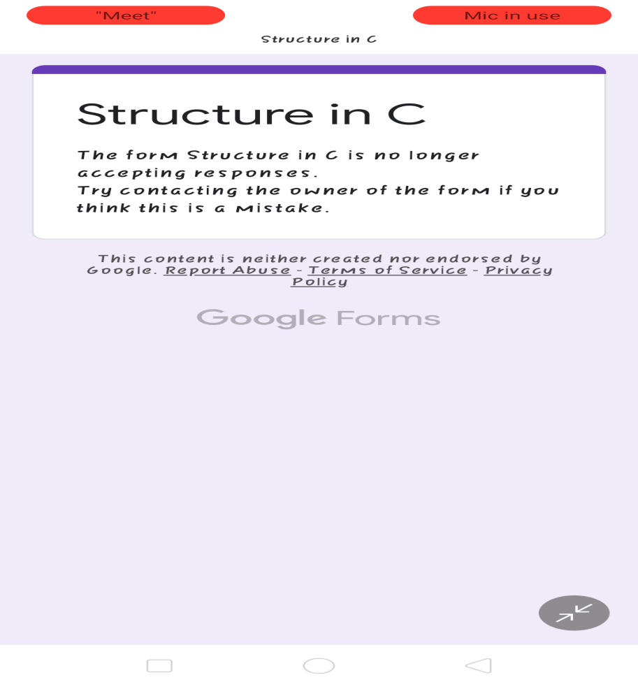

**Programming in C:**

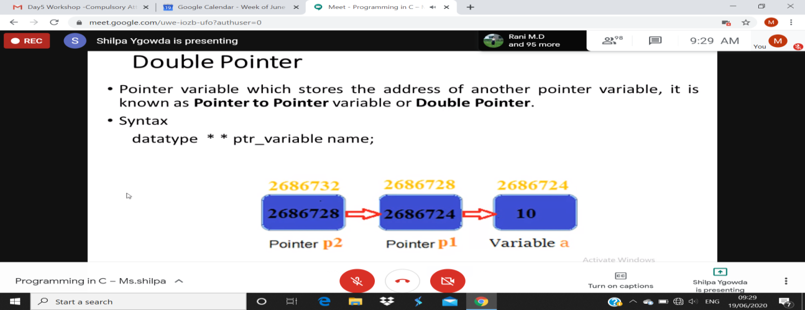

**Workshop Details:**

**Applications of python in DA and ML**

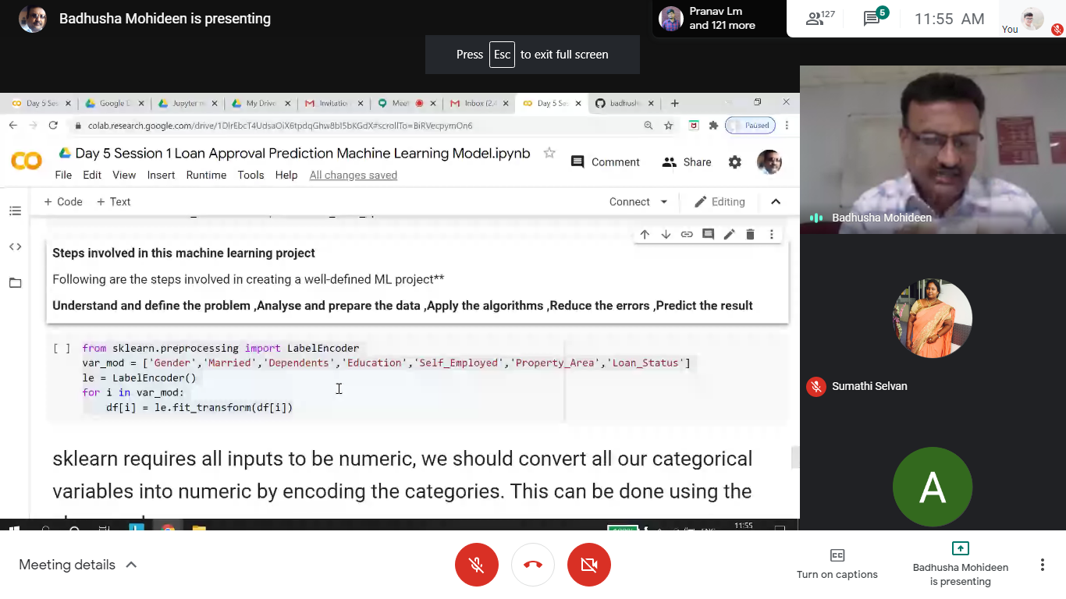

Refer the github link for example programs and exercise programs:

<https://github.com/Pooja-mhaske354/Applications-Of-Python-Programming-in-DL-and-ML>

**Coding Challenges Details:**

[https://github.com/Pooja-mhaske354/Daily-Status/tree/master/Online%20Coding/19-6-2020](https://github.com/Pooja-mhaske354/Daily-Status/tree/master/Online%20Coding/18-6-2020)

The same report is also available in :

<https://github.com/Pooja-mhaske354/Daily-Status/tree/master/Online%20Coding>