**DAILY ONLINE ACTIVITIES SUMMARY**

|  |  |  |  |  |  |  |  |  |
| --- | --- | --- | --- | --- | --- | --- | --- | --- |
| **Date:** | **20/06/2020** | | | | | **Name:** | **MHASKE POOJA** | |
| **Sem & Sec** | **VI & A sec** | | | | | **USN:** | **4AL17CS050** | |
| **Online test Summary** | | | | | | | | |
| **Pre placement training** | | **Programming in C++** | | | | | | |
| **Max. Marks** | | **-** | | **Score** | | | **-** | |
| **Pre-Placement Training Summary** | | | | | | | | |
| **Course** | **Programming in C++** | | | | | | | |
| **Certificate Provider** | | | **Ms.Ankitha shetty**  **Mr.Pradeep Nayak** | | **Duration** | | | **4 hrs** |
| **Coding Challenges** | | | | | | | | |
| **Problem Statement:**  **1. Write a C Program to rotate an array by K positions.**  **2. Write a Java Program to find area of Square, Rectangle and Circle using Method Overloading**     |  |  | | --- | --- | |  |  |  |  |  | | --- | --- | |  |  | | | | | | | | | |
| **Status: executed** | | | | | | | | |
| **Uploaded the report in Github** | | | | | **Yes** | | | |
| **If yes Repository name** | | | | | <https://github.com/Pooja-mhaske354/Daily-Status> | | | |
| **Uploaded the report in slack** | | | | | **Yes** | | | |

**Quiz Snapshots:**

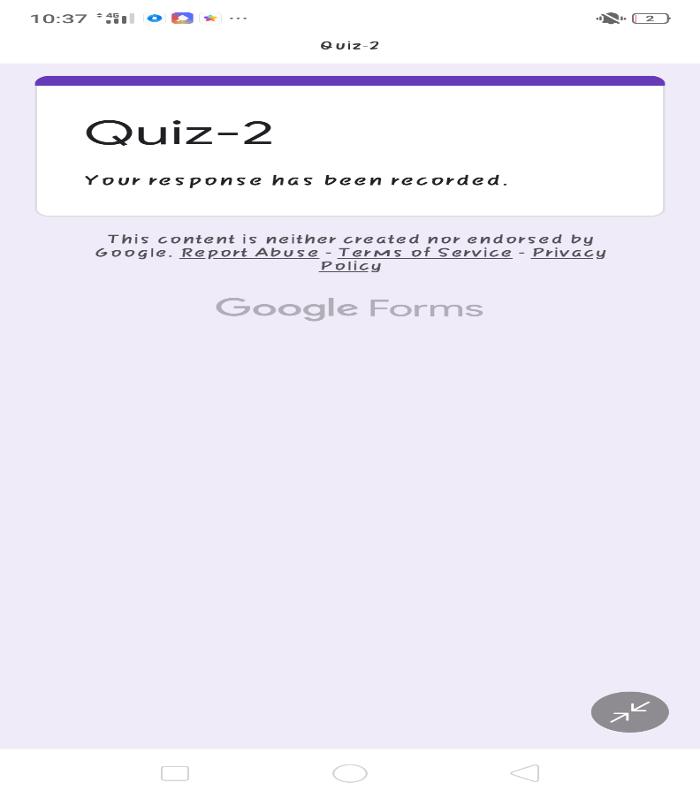

**Programming in C** ++**:**

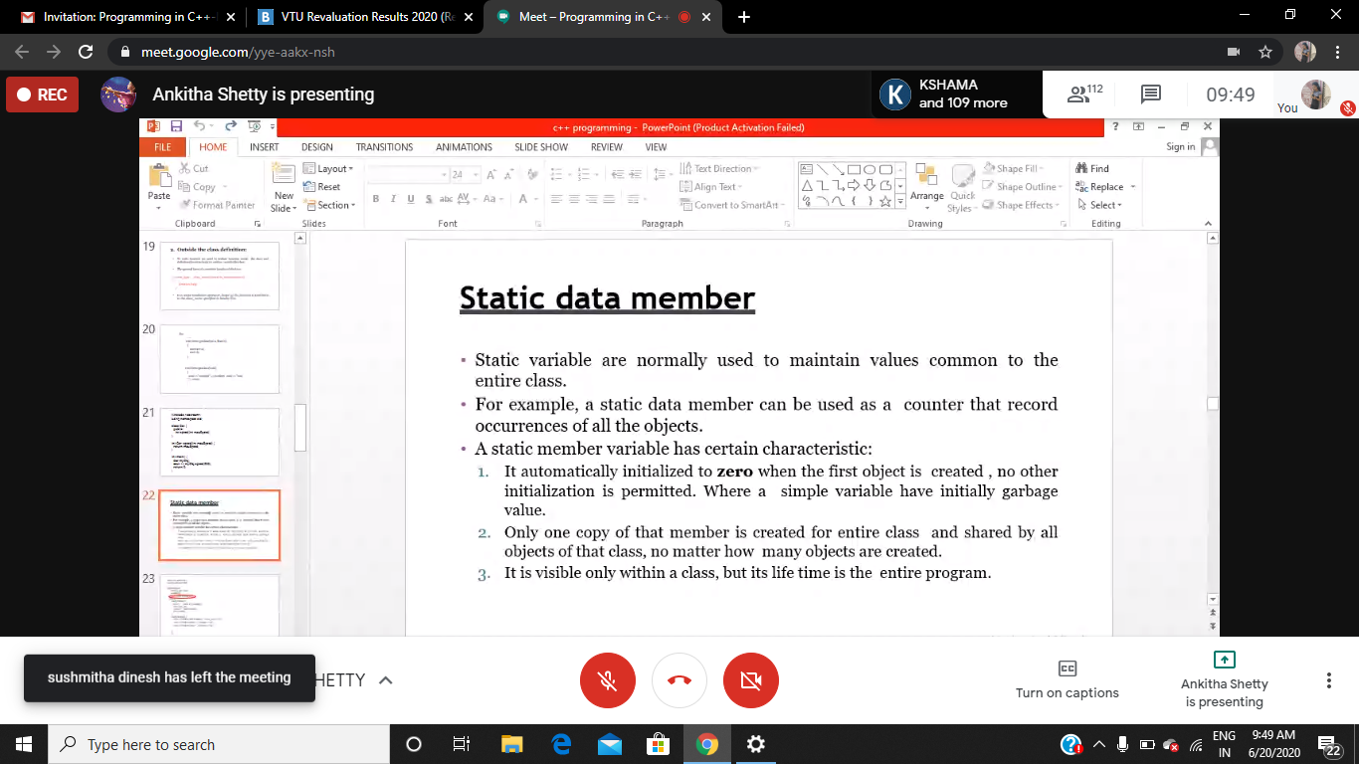

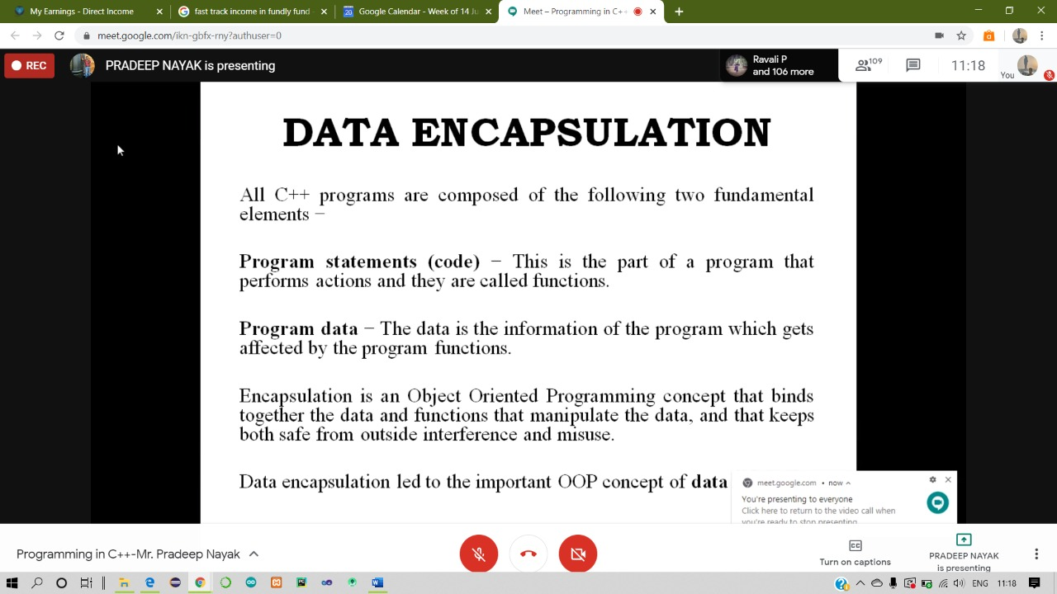

**Today I have learnt data encapsulation and several examples where explained.**

**Coding Challenges Details:**

<https://github.com/Pooja-mhaske354/Daily-Status/tree/master/Online%20Coding/20-6-2020>

The same report is also available in :

<https://github.com/Pooja-mhaske354/Daily-Status/tree/master/Online%20Coding>