**DAILY ONLINE ACTIVITIES SUMMARY**

|  |  |  |  |  |  |  |  |
| --- | --- | --- | --- | --- | --- | --- | --- |
| **Date:** | **18/05/2020** | | | | **Name:** | **MHASKE POOJA** | |
| **Sem & Sec** | **VI ,A sec** | | | | **USN:** | **4AL17CS050** | |
| **Online Test Summary** | | | | | | | |
| **Subject** | | **OR-1** | | | | | |
| **Max. Marks** | | **30** | | **Score** | | **30** | |
| **Certification Course Summary** | | | | | | | |
| **Course** | **MACHINE LEARNING WITH PYTHON** | | | | | | |
| **Certificate Provider** | | | **Saeed Aghabozorgi** | **Duration** | | | **12 hrs** |
| **Coding Challenges** | | | | | | | |
| **Problem Statement:**  **1.We have a Letter or a word then we need add some letters to it and need to find out shortest palindrome**  **2.Write a simple code to identify given linked list is palindrome or not by using stack. First take a Stack. Traverse through each node of the linked list and push each node value to**  **Stack** | | | | | | | |
| **Status:completed** | | | | | | | |
| **Uploaded the report in Github** | | | | **Yes** | | | |
| **If yes Repository name** | | | | <https://github.com/Pooja-mhaske354/Daily-Status> | | | |
| **Uploaded the report in slack** | | | | **Yes** | | | |

**Online Test Details:**

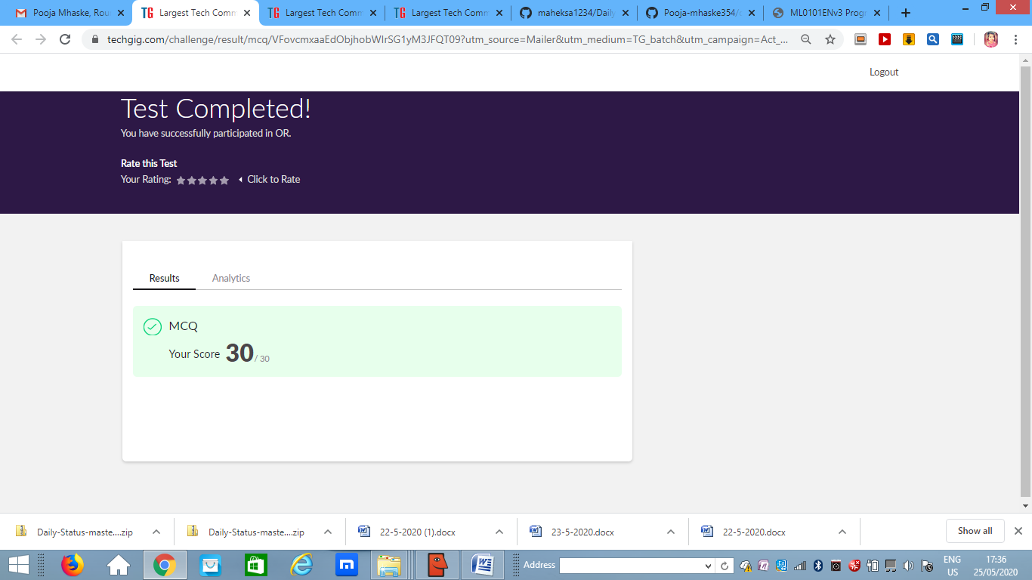**Certification Course Details:**

Refer GitHub account for Detailed information:

<https://github.com/Pooja-mhaske354/Daily-Status>

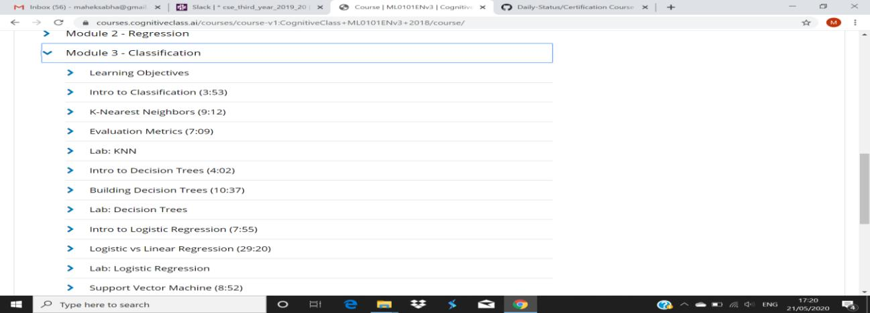

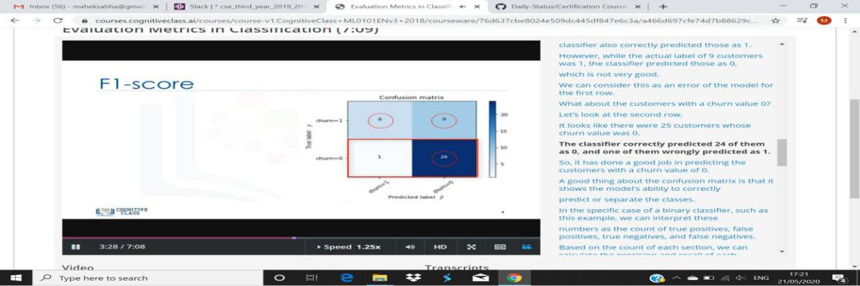

**Coding Challenges Details:**

<https://github.com/Pooja-mhaske354/Daily-Status/tree/master/Online%20Coding/22-5-2020>

The same report is also available in :

<https://github.com/Pooja-mhaske354/Daily-Status/tree/master/Online%20Coding>