**DAILY ONLINE ACTIVITIES SUMMARY**

|  |  |  |  |  |  |  |  |  |
| --- | --- | --- | --- | --- | --- | --- | --- | --- |
| **Date:** | **23/06/20** | | | | | **Name:** | **MHASKE POOJA** | |
| **Sem & Sec** | **VI & A sec** | | | | | **USN:** | **4AL17CS050** | |
| **Online test Summary** | | | | | | | | |
| **Subject** | | **Java & J2EE , Data Structure With C And PAP Assignment 4** | | | | | | |
| **Max. Marks** | | **-** | | **Score** | | | **-** | |
| **Pre-Placement Training Summary** | | | | | | | | |
| **Course** | **Placement Training** | | | | | | | |
| **Certificate Provider** | | | **Mr.Sharan L Pai**  **Mrs.Merlyn Melita** | | **Duration** | | | **4 hrs** |
| **Coding Challenges** | | | | | | | | |
| **Problem Statement:**  **1.Write a C Program to Sort a stack using a temporary stack.**  **2.Write a Java Program to traverse a binary tree using PreOrder traversal without**  **Recursion.**       |  |  | | --- | --- | |  |  |  |  |  | | --- | --- | |  |  | | | | | | | | | |
| **Status: executed** | | | | | | | | |
| **Uploaded the report in Github** | | | | | **Yes** | | | |
| **If yes Repository name** | | | | | <https://github.com/Pooja-mhaske354/Daily-Status> | | | |
| **Uploaded the report in slack** | | | | | **Yes** | | | |

**Online Test Details:**

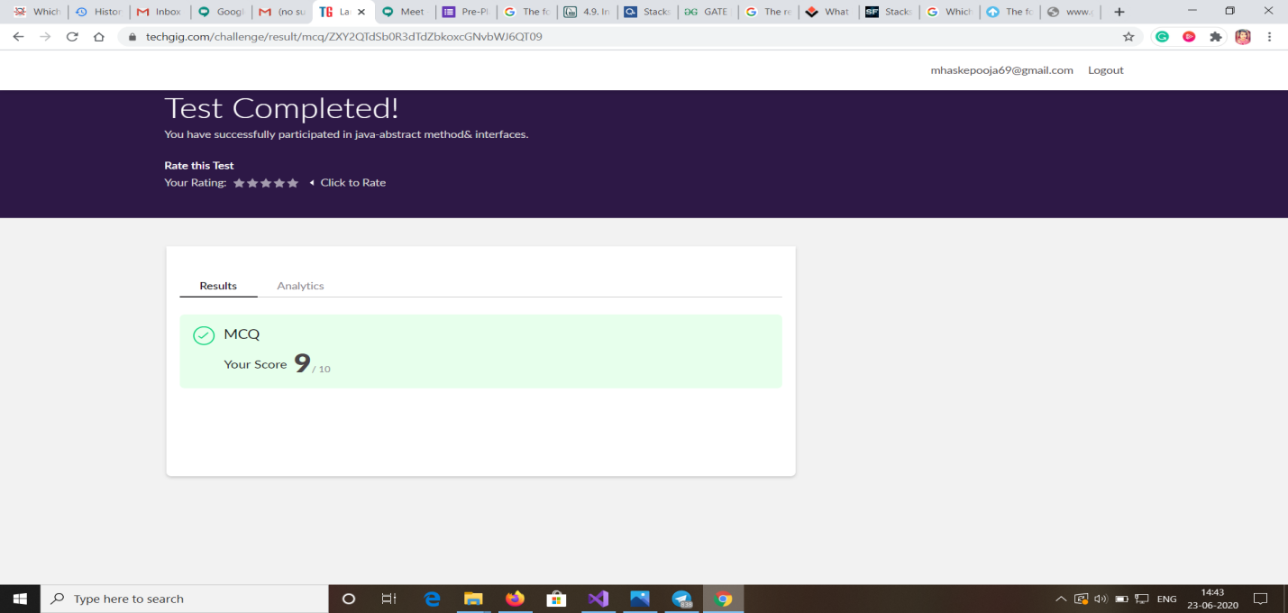

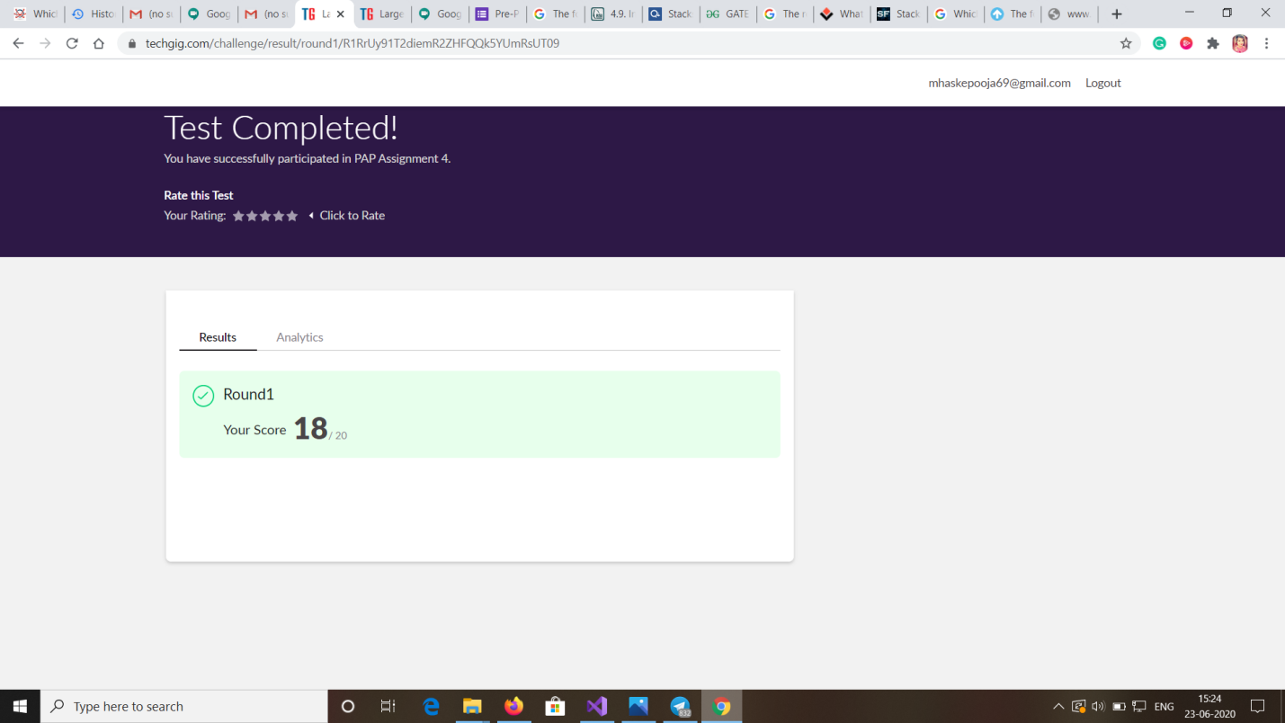

**Quiz Snapshots:**

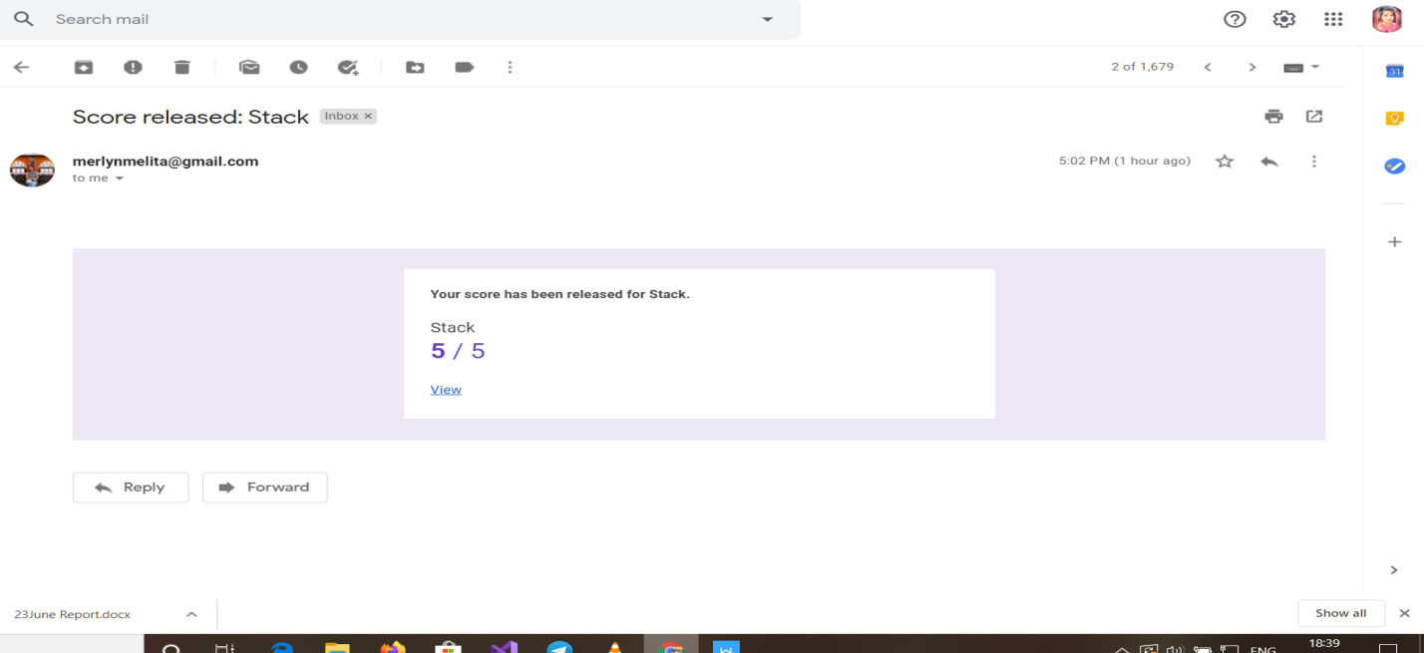

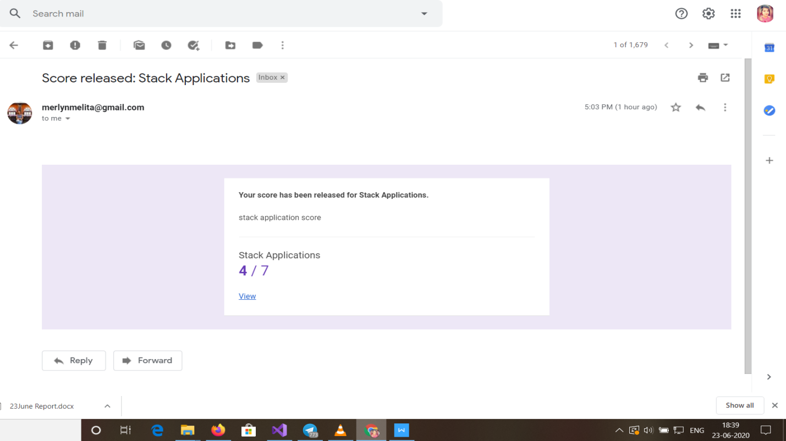

**JAVA & J2EE:**

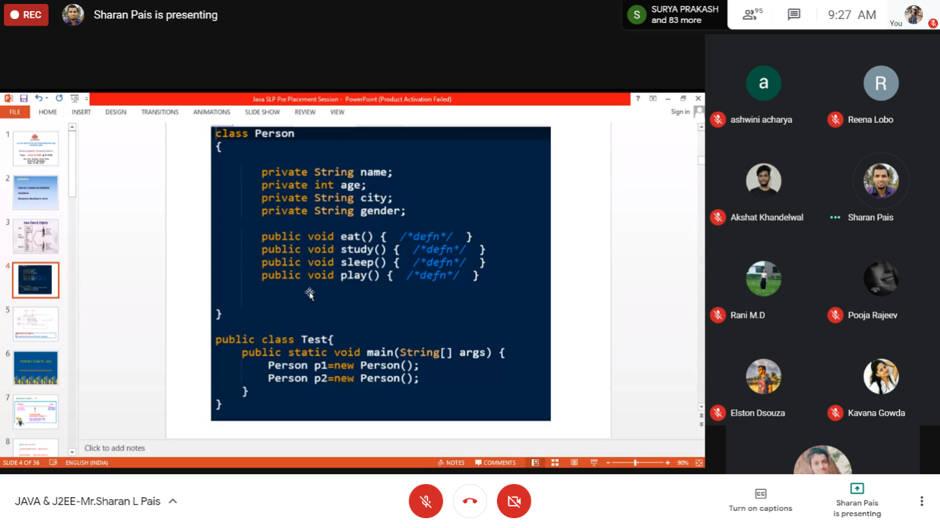

**Data Structures With C:**

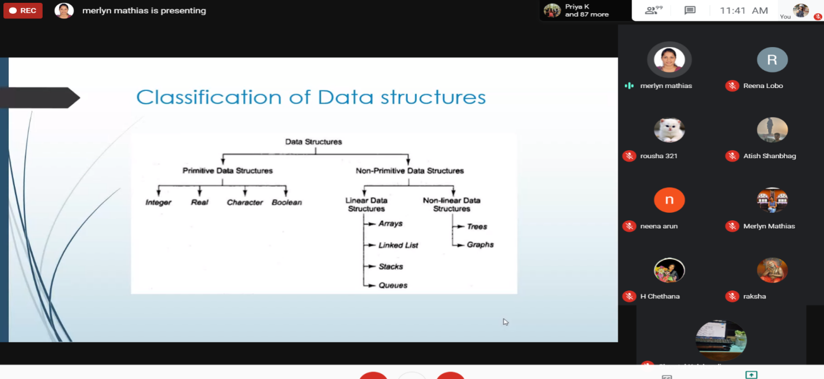

**Coding Challenges Details:**

<https://github.com/Pooja-mhaske354/Daily-Status/tree/master/Online%20Coding/23-6-2020>

The same report is also available in :

<https://github.com/Pooja-mhaske354/Daily-Status/tree/master/Online%20Coding>