**DAILY ONLINE ACTIVITIES SUMMARY**

|  |  |  |  |  |  |  |
| --- | --- | --- | --- | --- | --- | --- |
| **Date:** | **24/06/2020** | | | **Name:** | **MHASKE POOJA** | |
| **Sem & Sec** | **VI & A sec** | | | **USN:** | **4AL17CS050** | |
| **Online Test Summary** | | | | | | |
| **Subject** | **Java**  **Data Structures in C** | | | | | |
| **Max. Marks** | **-** | **Score** | | | **-** | |
| **Pre-Placement Training Summary** | | | | | | |
| **Topic** | **Placement training** | | | | | |
| **Certificate Provider** | **Ms.Shilpa**  **Mr.Venkatesh Bhat** | | **Duration** | | | **4 hrs** |
| **Coding Challenges** | | | | | | |
| **Problem Statement:**  **1.Create a class named 'Shape' with a method to print "This is This is shape". Then create two other classes named 'Rectangle', 'Circle' inheriting the Shape class, both having a method to print "This is rectangular shape" and "This is circular shape" respectively. Create a subclass 'Square' of 'Rectangle' having a method to print "Square is a rectangle". Now call the method of 'Shape' and 'Rectangle' class by the object of 'Square' class.**     |  |  | | --- | --- | |  |  |  |  |  | | --- | --- | |  |  | | | | | | | |
| **Status: completed** | | | | | | |
| **Uploaded the report in Github** | | | **Yes** | | | |
| **If yes Repository name** | | | [https://github.com/Pooja-mhaske354/Daily-Status](https://github.com/maheksa1234/Daily-Status) | | | |
| **Uploaded the report in slack** | | | **Yes** | | | |

**Quiz Snapshots:**

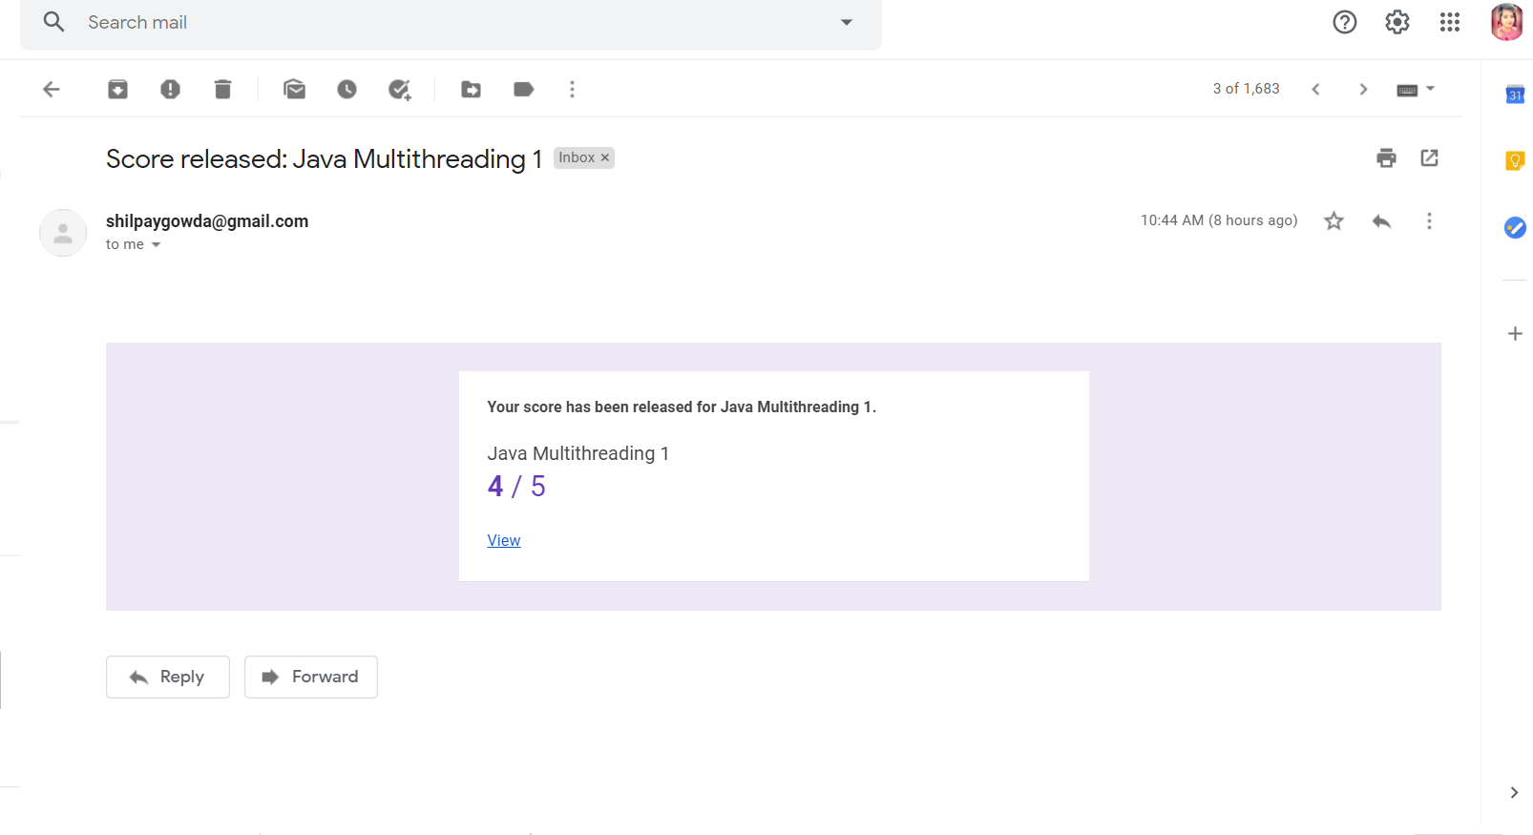

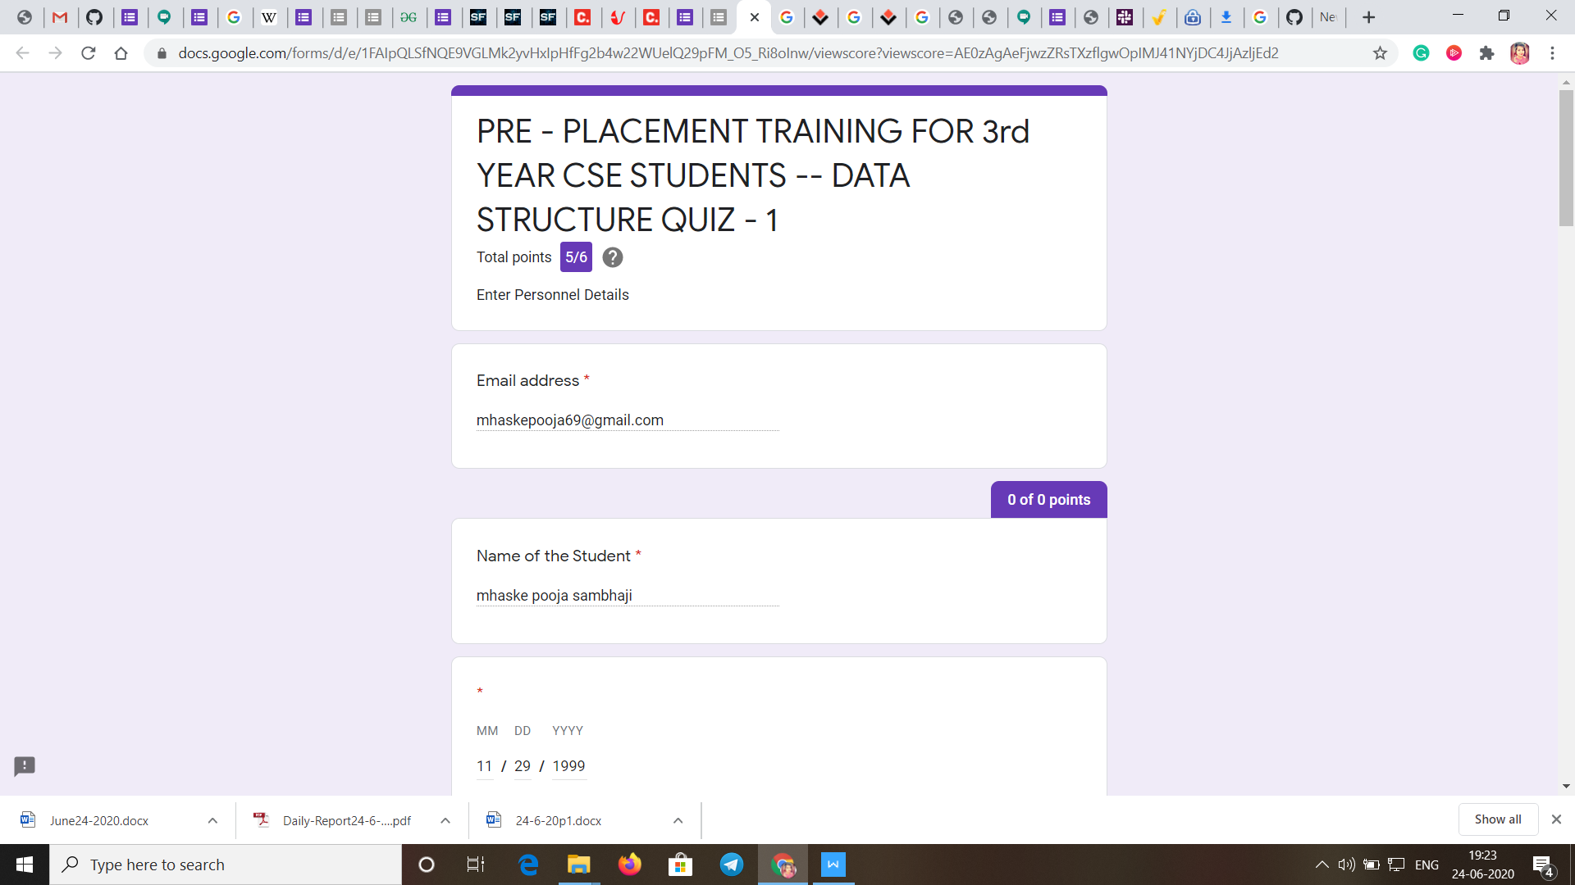

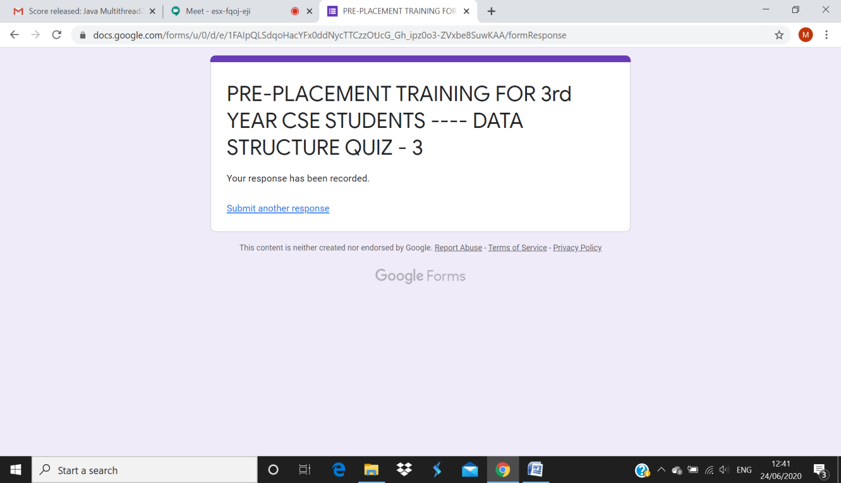

**Java (session 1):**

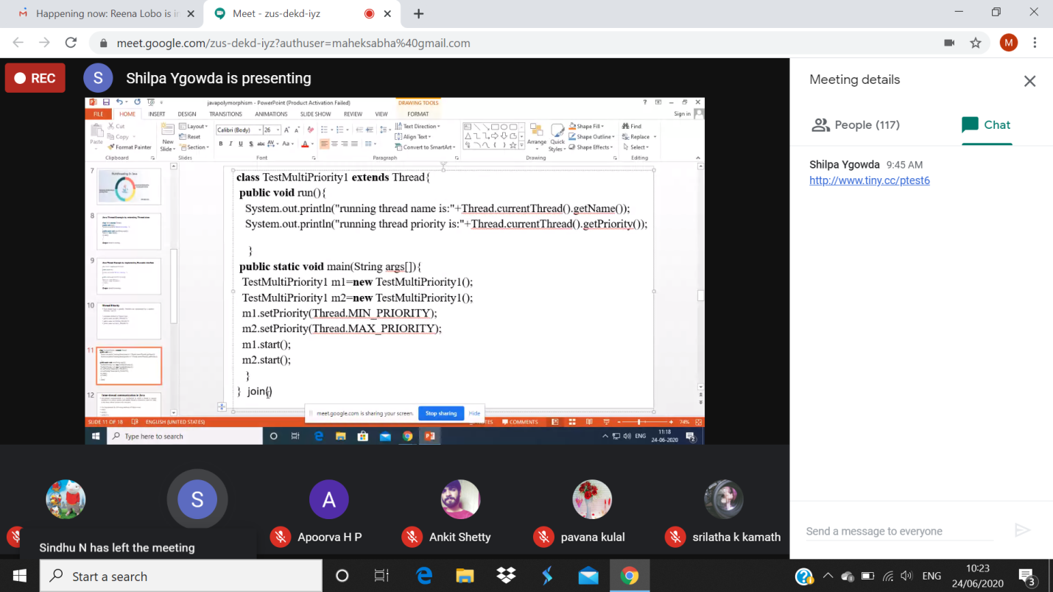

**Data Structure in C (session 2):**

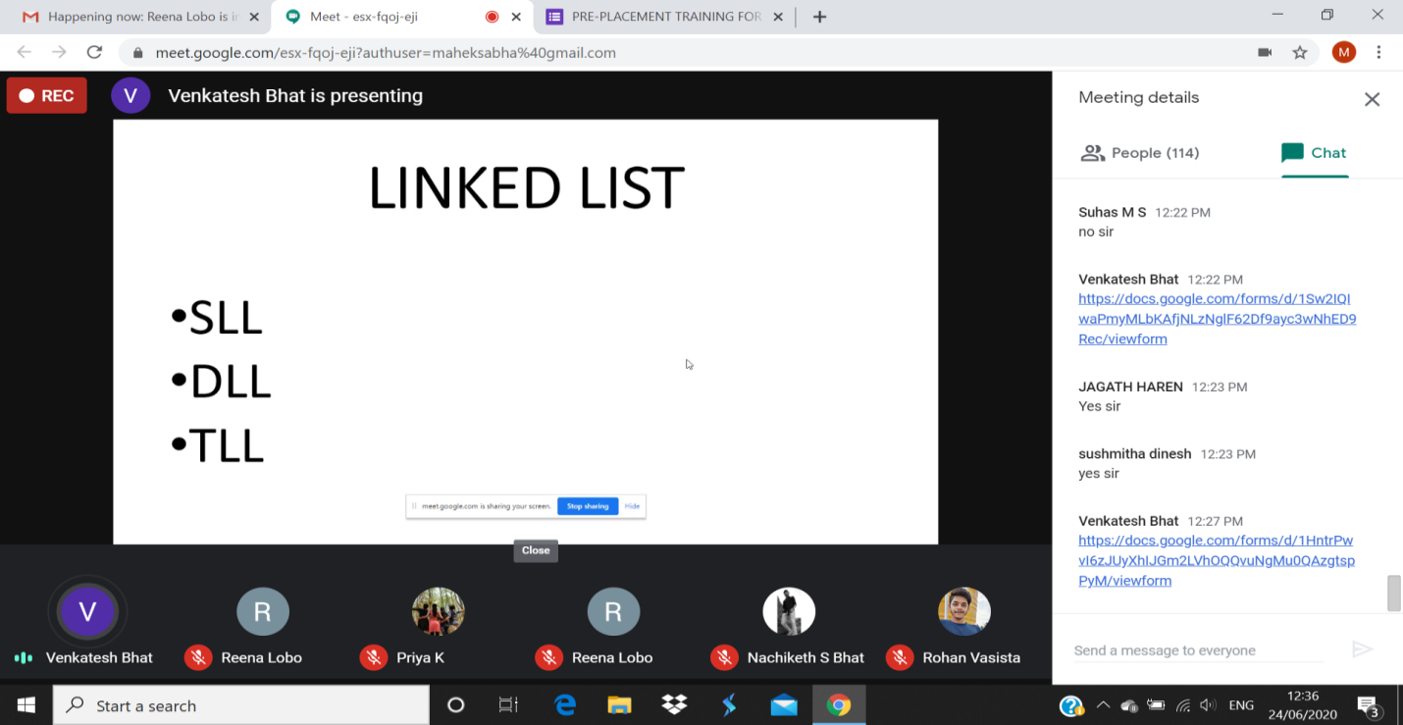

**Coding Challenges Details:**

<https://github.com/Pooja-mhaske354/Daily-Status/tree/master/Online%20Coding/24-6-2020>

The same report is also available in :

[https://github.com/Pooja-mhaske354/Daily-Status/tree/master/Online%20Coding](https://github.com/maheksa1234/Daily-Status/tree/master/Online%20Coding)