**DAILY ONLINE ACTIVITIES SUMMARY**

|  |  |  |  |  |  |  |  |
| --- | --- | --- | --- | --- | --- | --- | --- |
| **Date:** | **27/06/2020** | | | | **Name:** | **MHASKE POOJA** | |
| **Sem & Sec** | **VI & A sec** | | | | **USN:** | **4AL17CS050** | |
| **Online Test Summary** | | | | | | | |
| **Subject** | **DBMS And JDBC** | | | | | | |
| **Max. Marks** | **-** | | **Score** | | | **-** | |
| **Pre placement training Summary** | | | | | | | |
| **Course** | **Placement training** | | | | | | |
| **Certificate Provider** | | **Mr. Hemanth K**  **Mr. Sayeesh** | | **Duration** | | | **4 hrs** |
| **Coding Challenges** | | | | | | | |
| **Problem Statement:**  **1. Write a program to print all permutations of a given string.**  **2. Python Program to Read the Contents of a File in Reverse Order**     |  |  | | --- | --- | |  |  |  |  |  | | --- | --- | |  |  | | | | | | | | |
| **Status: completed** | | | | | | | |
| **Uploaded the report in Github** | | | | **Yes** | | | |
| **If yes Repository name** | | | | <https://github.com/Pooja-mhaske354/Daily-Status> | | | |
| **Uploaded the report in slack** | | | | **Yes** | | | |

**Quiz Snapshots:**

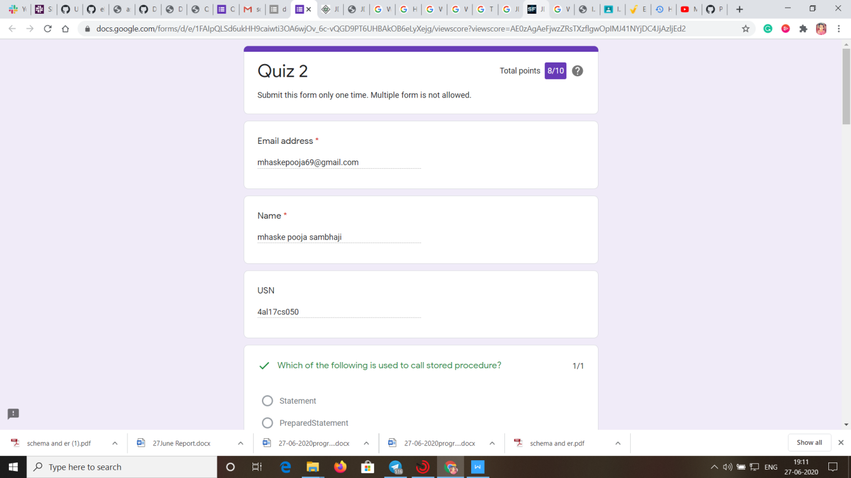

**DBMS (session 1):**

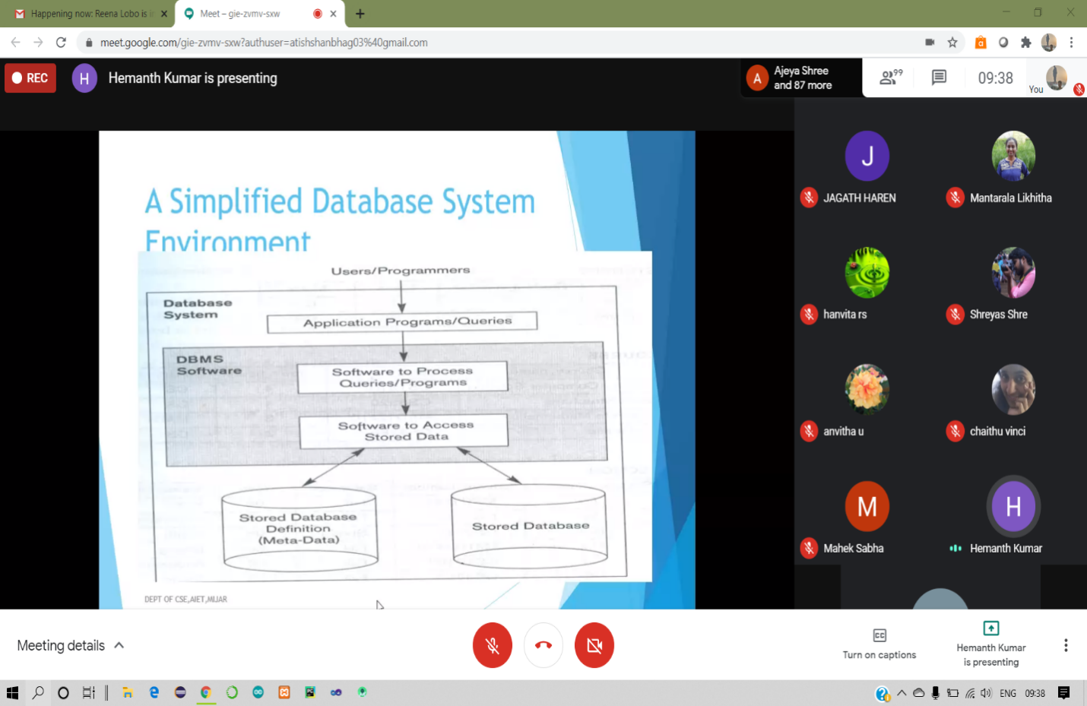

**JDBC (session 2):**

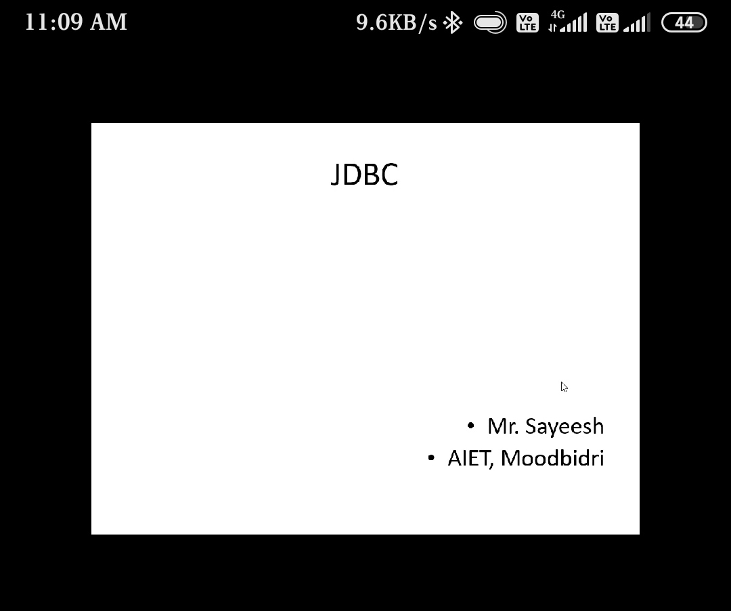

**Coding Challenges Details:**

<https://github.com/Pooja-mhaske354/Daily-Status/tree/master/Online%20Coding/27-6-2020>

The same report is also available in :

<https://github.com/Pooja-mhaske354/Daily-Status/tree/master/Online%20Coding>