**DAILY ONLINE ACTIVITIES SUMMARY**

|  |  |  |  |  |  |  |  |
| --- | --- | --- | --- | --- | --- | --- | --- |
| **Date:** | **30/06/2020** | | | | **Name:** | **MHASKE POOJA** | |
| **Sem & Sec** | **VI & A sec** | | | | **USN:** | **4AL17CS050** | |
| **Online Test Summary** | | | | | | | |
| **Subject** | **JAVA** | | | | | | |
| **Max. Marks** | **-** | | **Score** | | | **-** | |
| **Pre placement training Summary** | | | | | | | |
| **Course** | **Placement training** | | | | | | |
| **Certificate Provider** | | **Mr.Sharan Pias** | | **Duration** | | | **2 hrs** |
| **Coding Challenges** | | | | | | | |
| **Problem Statement:**  **1. Write a Java Program to determine whether one string is a rotation of another.**  **2.Write a C Program to generate first n Ugly Numbers**     |  |  | | --- | --- | |  |  |  |  |  | | --- | --- | |  |  | | | | | | | | |
| **Status: completed** | | | | | | | |
| **Uploaded the report in Github** | | | | **Yes** | | | |
| **If yes Repository name** | | | | [https://github.com/Pooja-mhaske354/Daily-Status](https://github.com/maheksa1234/Daily-Status) | | | |
| **Uploaded the report in slack** | | | | **Yes** | | | |

**Quiz Snapshots:**

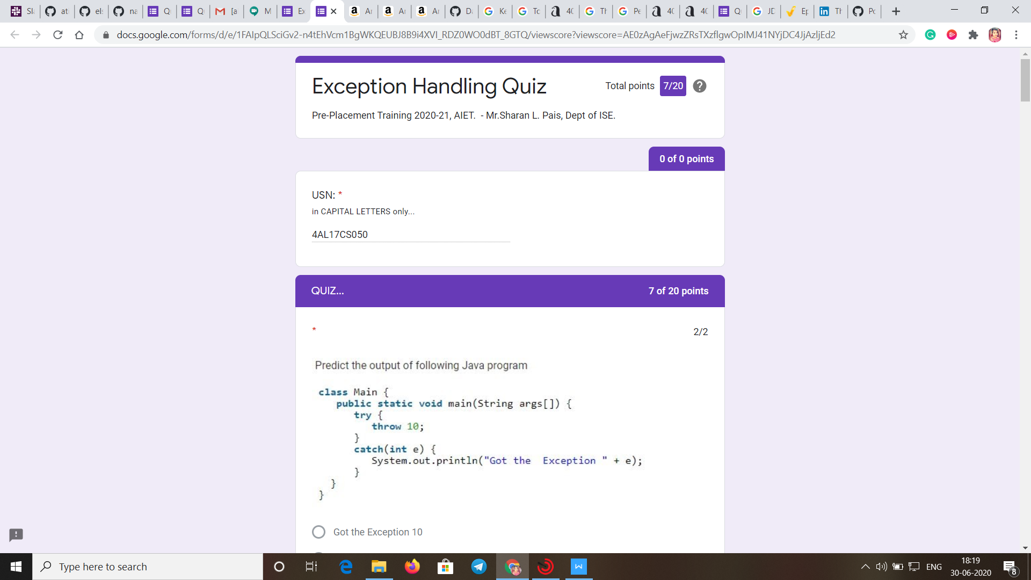

**JAVA(session 1):**

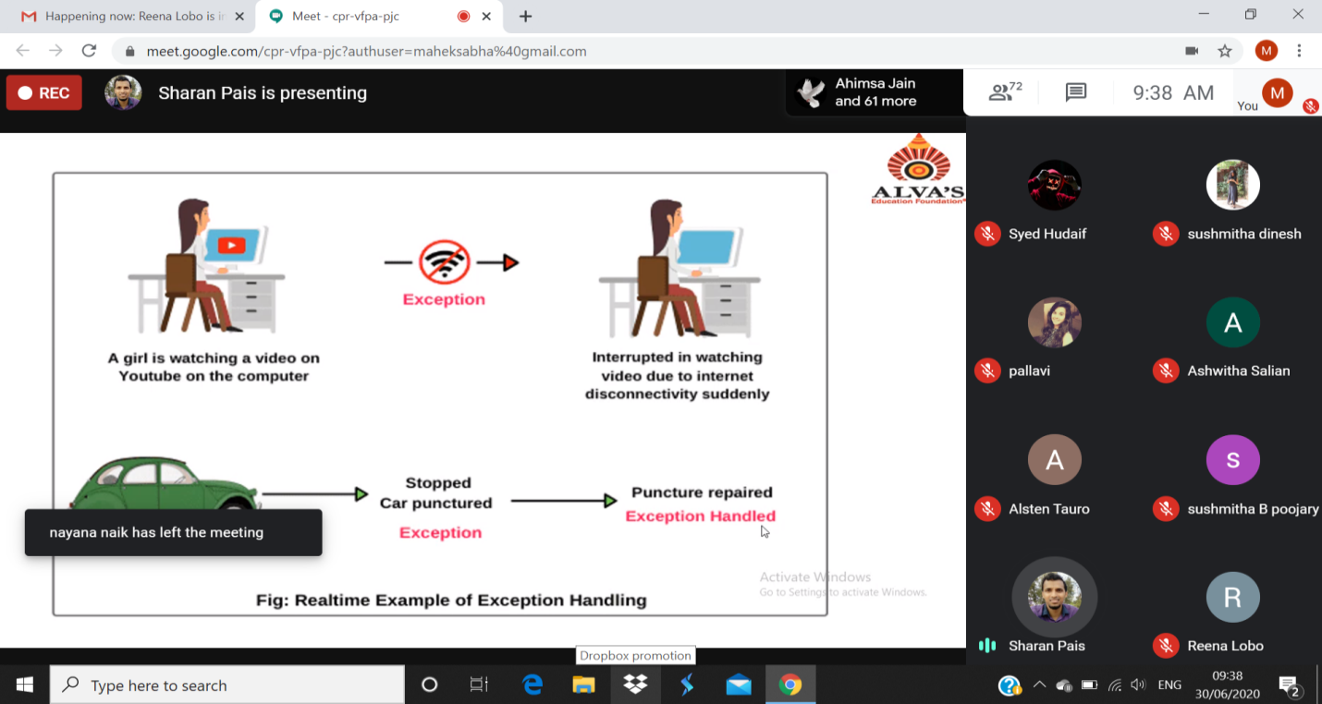

**Coding Challenges Details:**

<https://github.com/Pooja-mhaske354/Daily-Status/tree/master/Online%20Coding/30-6-2020>

The same report is also available in :

[https://github.com/Pooja-mhaske354/Daily-Status/tree/master/Online%20Coding](https://github.com/maheksa1234/Daily-Status/tree/master/Online%20Coding)