DAILY ONLINE ACTIVITIES SUMMARY
Date: | 22/06/2020 |  |  |  |  | Name: | MHASKE POOJA
Sem & Sec | VI & A sec |  |  |  |  | USN: | 4AL17CS050
Online test Summary
Pre placement training
Max. Marks |  | - |  | Score |  |  | -
Pre-Placement Training Summary
Course | 9:00 am to 11:00 am - Programming in C++  11:00 am to 1:00pm - Programming in C++
Certificate Provider |  |  | Ms.Shilpa  Ms.Ankitha Shetty |  | Duration |  |  | 4 hrs
Coding Challenges
Problem Statement:
1.Write a Java program to find maximum repeated words from a file.

Status: executed
Uploaded the report in Github |  |  |  |  | Yes
If yes Repository name |  |  |  |  | https://github.com/Pooja-mhaske354/Daily-Status
Uploaded the report in slack |  |  |  |  | Yes

Quiz Snapshots:
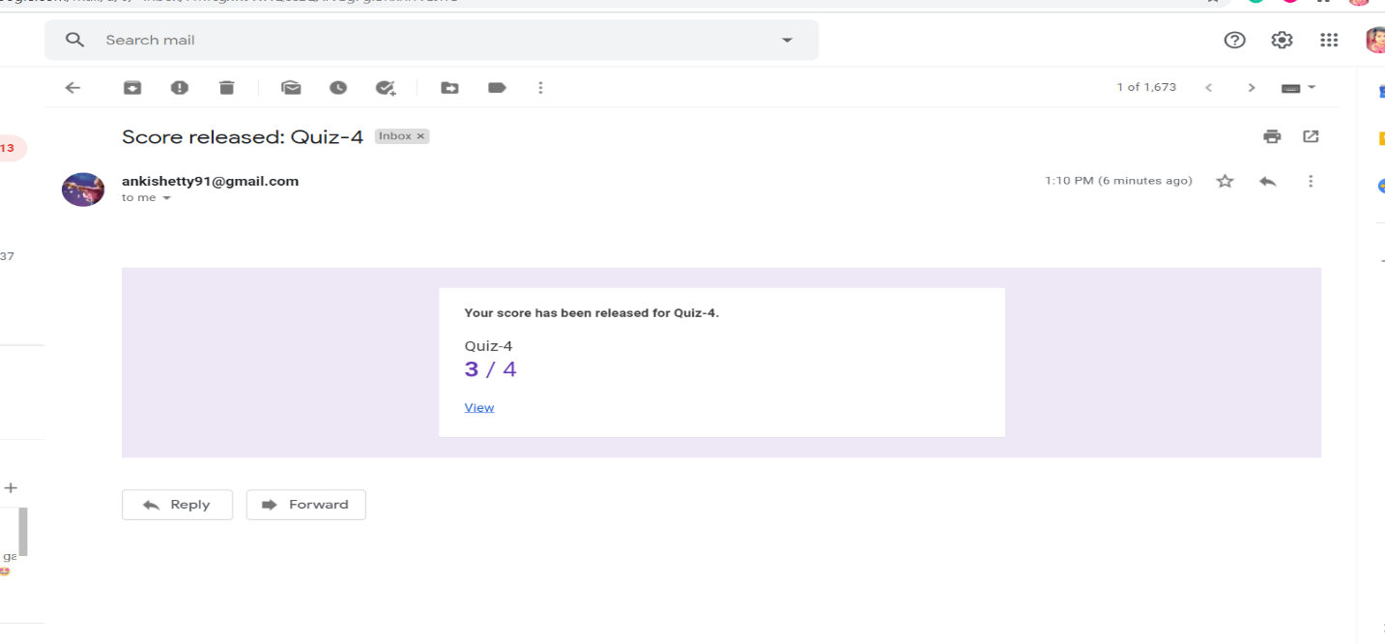

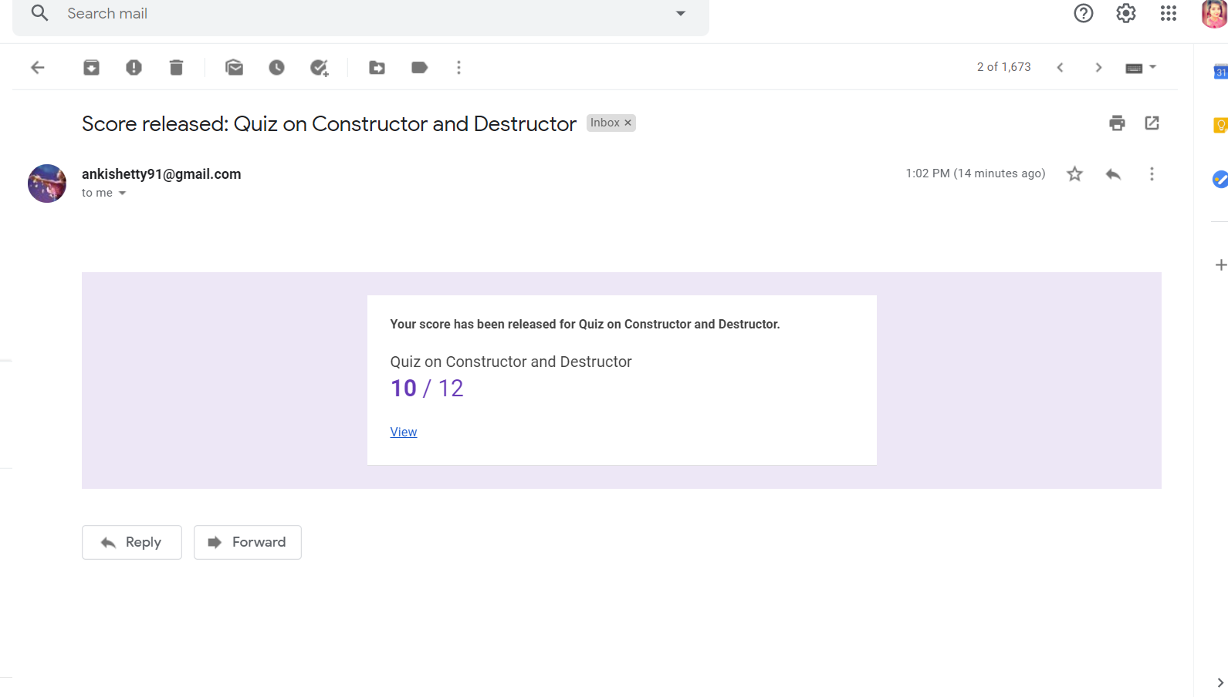

Programming in C ++:

Coding Challenges Details:
https://github.com/Pooja-mhaske354/Daily-Status/tree/master/Online%20Coding/22-6-2020
The same report is also available in :
https://github.com/Pooja-mhaske354/Daily-Status/tree/master/Online%20Coding

