LOGISTICS DATA ANALYSIS
Exploratory Data Analysis (EDA) using Python
Prepared by: Pooja Pandey
Dataset: dynamic supply-chain logistics data

1. Objective
The objective is to explore logistics and supply-chain indicators, summarize their distributions, examine relationships between variables, visualize potential operational risks, and recommend areas for further investigation. The analysis uses Python, pandas, and Matplotlib.

2. Dataset overview
The working file contains 32,065 rows and 38 columns. The timestamp field spans 2021-01-01 to 2024-08-29. Fields include shipping costs, lead time, ETA variation, traffic congestion, fuel consumption, warehouse inventory, demand, delay probability, delivery-time deviation, and risk classification.
Important limitation: the source units and definitions should be verified against the original dataset documentation. The dataset is being treated as a hypothetical/illustrative logistics dataset for this assignment. The charts describe recorded values; they do not by themselves prove that one factor causes delays or costs.

3. Methodology
- Loaded the CSV file with pandas and parsed timestamp values as dates.
- Reviewed dataset dimensions, data types, missing values, and exact duplicate rows.
- Calculated mean, median, standard deviation, minimum, maximum, and quartiles for key numeric variables.
- Used histograms to inspect distributions, a correlation heatmap to inspect linear relationships, a bar chart to compare risk labels, and a monthly line chart to inspect lead-time trends.
- Kept the original operational fields for interpretation; normalized columns were not used as replacements for the original units.
Data quality check: 0 missing cells across the loaded file; 0 exact duplicate rows detected. Missing values should be handled according to column meaning rather than automatically filling every field.

4. Descriptive statistics
Metric | Mean | Median | Std. dev. | Minimum | Maximum
lead_time_days | 5.23 | 3.30 | 4.52 | 1.00 | 15.00
shipping_costs | 459.37 | 389.00 | 312.18 | 100.00 | 1000.00
eta_variation_hours | 2.89 | 3.88 | 2.27 | -2.00 | 5.00
delay_probability | 0.70 | 0.84 | 0.32 | 0.00 | 1.00
delivery_time_deviation | 5.18 | 6.11 | 4.16 | -2.00 | 10.00
traffic_congestion_level | 4.99 | 4.98 | 3.53 | 0.00 | 10.00
fuel_consumption_rate | 8.01 | 5.64 | 4.26 | 5.00 | 20.00
Mean describes the average; median is the middle observation and is less affected by extreme values. Standard deviation indicates how spread out the values are. Compare mean and median and inspect histograms before deciding whether a metric is strongly skewed.

5. Visualizations and interpretation

Figure 1. Lead-time distribution
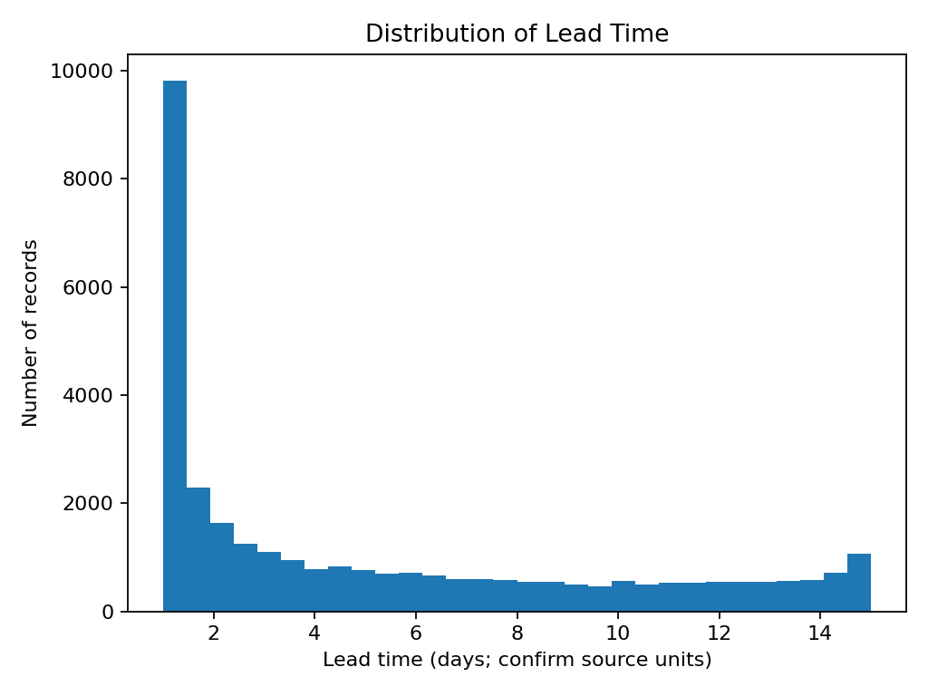
Why this chart: a histogram shows common lead-time ranges and whether the distribution has a long tail. Use it to identify unusually long lead times for follow-up. Confirm the field's units before interpreting the values.

Figure 2. Shipping-cost distribution
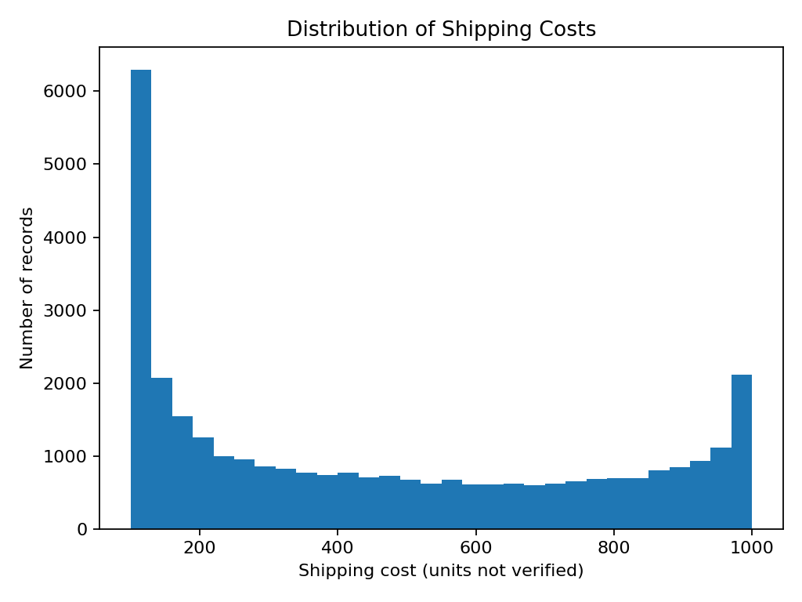
Why this chart: a histogram reveals the spread of shipping costs and possible high-cost records. High values may reflect longer routes, special handling, or data issues; these explanations must be checked rather than assumed.

Figure 3. Correlation heatmap
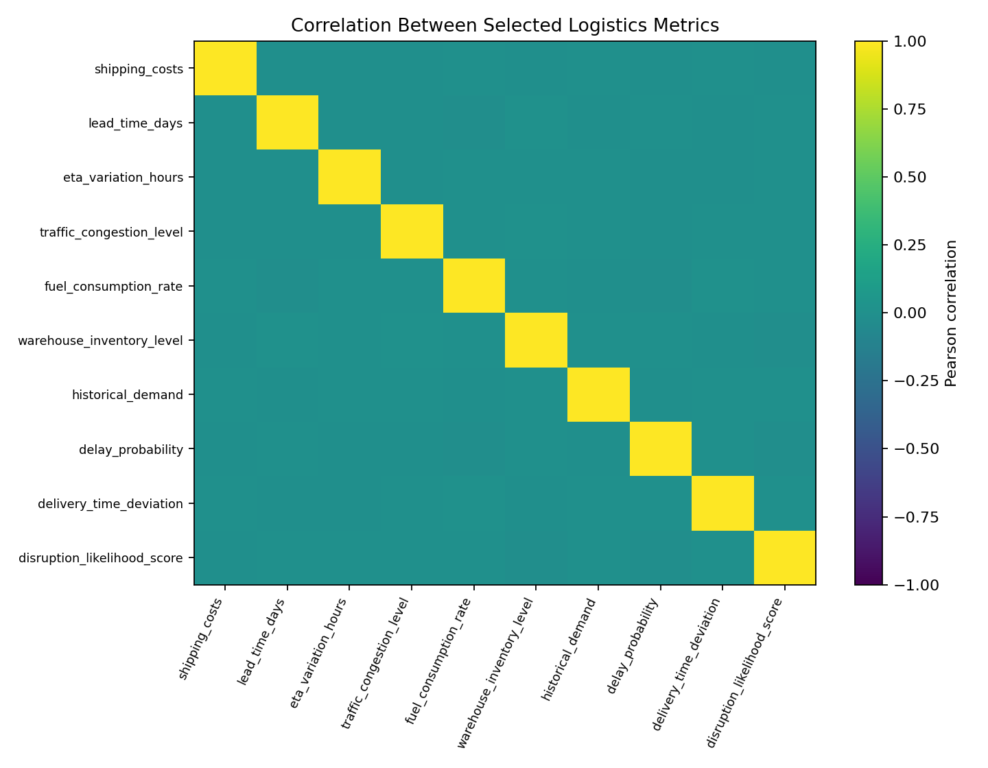
Why this chart: correlation coefficients range from -1 to +1. Values near +1 indicate a positive linear association; values near -1 indicate a negative association; values near 0 indicate little linear association. Correlation does not establish causation, and correlations may be affected by synthetic data or unusual values.

Figure 4. Risk-classification counts
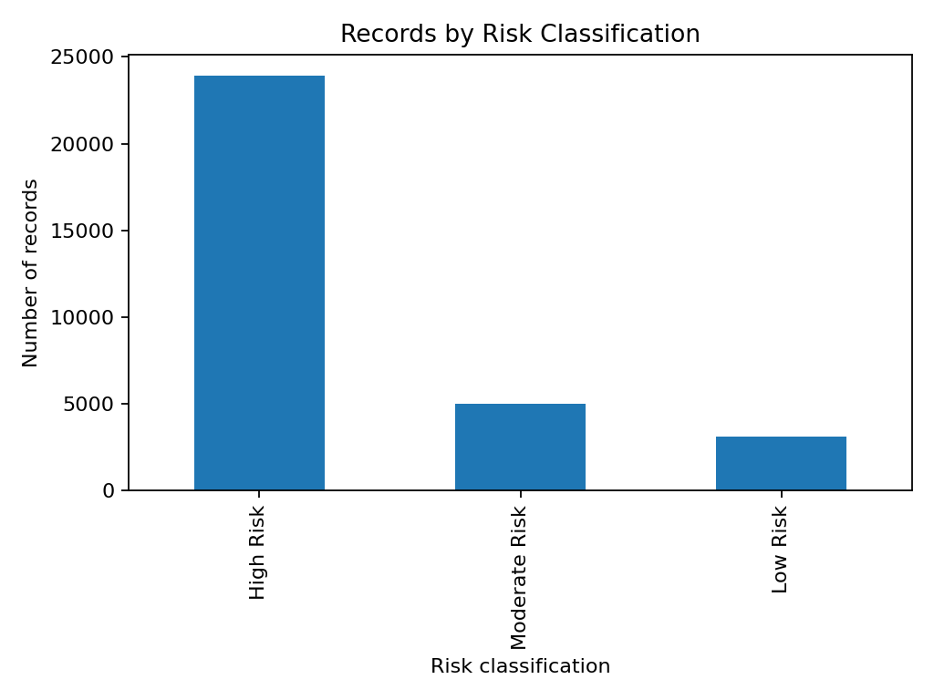
Why this chart: a bar chart makes it easy to compare the number of records assigned to each risk class. If one class dominates, check whether the dataset is imbalanced and whether the classification rule is documented.

Figure 5. Monthly average lead time
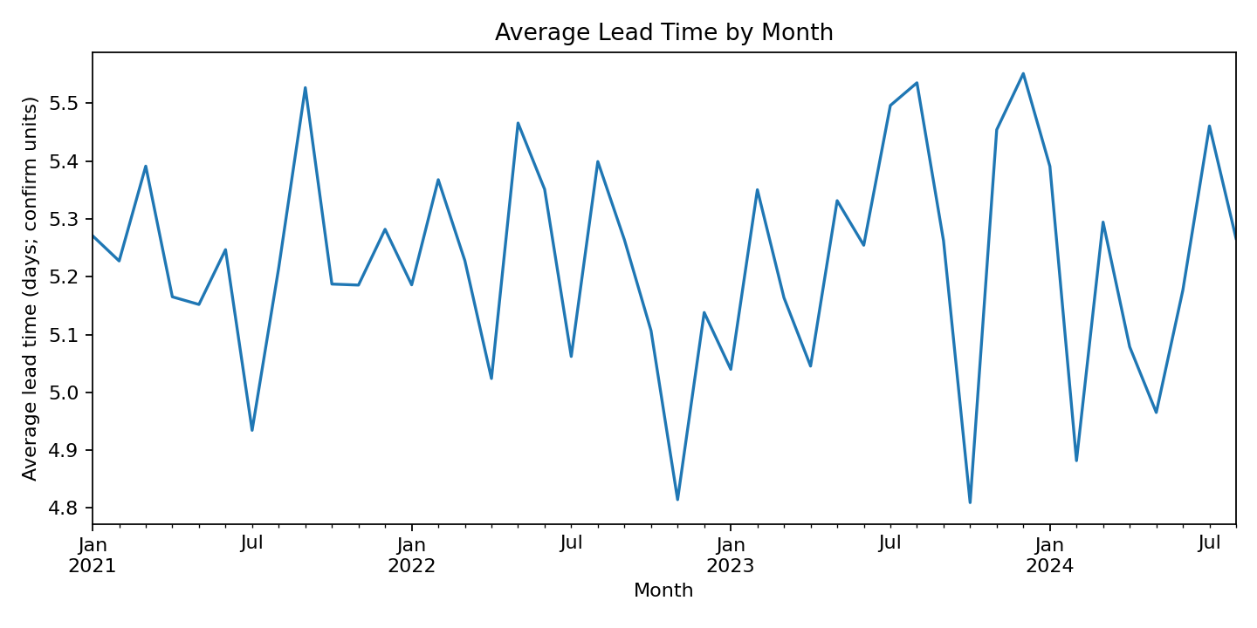
Why this chart: a line chart highlights changes over time and possible periods that deserve investigation. A visible rise or fall is a signal to investigate; it is not proof of a real operational change without validated source data.

6. Correlation findings to review
The following pairs have the largest absolute Pearson correlations in this dataset. Treat these as associations for investigation, not causal findings.
- fuel_consumption_rate and delay_probability: correlation = -0.014
- warehouse_inventory_level and disruption_likelihood_score: correlation = -0.014
- lead_time_days and fuel_consumption_rate: correlation = -0.013
- fuel_consumption_rate and delivery_time_deviation: correlation = 0.012
- lead_time_days and warehouse_inventory_level: correlation = 0.012

7. Recommendations
- Investigate records with unusually high lead time, shipping cost, or delivery-time deviation; confirm whether each is a valid event or a data-quality issue.
- Compare delay probability and delivery-time deviation with traffic, ETA variation, fuel use, and disruption indicators. Validate patterns against real operational knowledge.
- Monitor monthly lead time and shipping cost in a dashboard, and annotate known disruptions before drawing conclusions.
- Check inventory and historical demand together to identify periods that may require replenishment planning; validate field meanings first.
- Confirm source, licence, units, and definitions. Do not publish or redistribute the dataset unless its licence allows it.
- Repeat the analysis on verified real operational data before making business decisions.

8. Python tools and reproducibility
The companion file logistics_eda.py reproduces the core analysis and saves charts in a logistics_charts folder. It also writes descriptive statistics, a correlation matrix, and a short text summary.
How to run: (1) Put logistics_eda.py and cleaned_logistics_data.csv in the same folder. (2) Open a terminal in that folder. (3) Install packages using: pip install pandas matplotlib. (4) Run: python logistics_eda.py. (5) Open the logistics_charts folder and inspect the output images.

9. Conclusion
EDA provides a structured first look at logistics performance by summarizing typical values, highlighting unusual observations, and showing relationships over time and between metrics. The analysis can help prioritize questions about delays, costs, inventory, and risk. Conclusions should remain provisional until dataset definitions and source quality are confirmed.

Appendix A. Code excerpt
import pandas as pd
import matplotlib.pyplot as plt
df = pd.read_csv("cleaned_logistics_data.csv")
df["timestamp"] = pd.to_datetime(df["timestamp"], errors="coerce")
print(df[["lead_time_days", "shipping_costs",
"delay_probability"]].describe())
df["lead_time_days"].dropna().plot(
kind="hist", bins=30, title="Distribution of Lead Time")
plt.xlabel("Lead time (days; verify units)")
plt.ylabel("Number of records")
plt.tight_layout()
plt.show()

