

2018

Group Member: Huan Wang

Group Member :

Group Member :

6/3/2018

**Assessment of Bank Loan Application**



PERTH – AUSTRALIA

University of Western Australia

*Figure:* *Loan application*

*Source: Retrieved from https://www.bellevuedowntown.com/go/the-commerce-bank-of-washington*

* Set inference rules

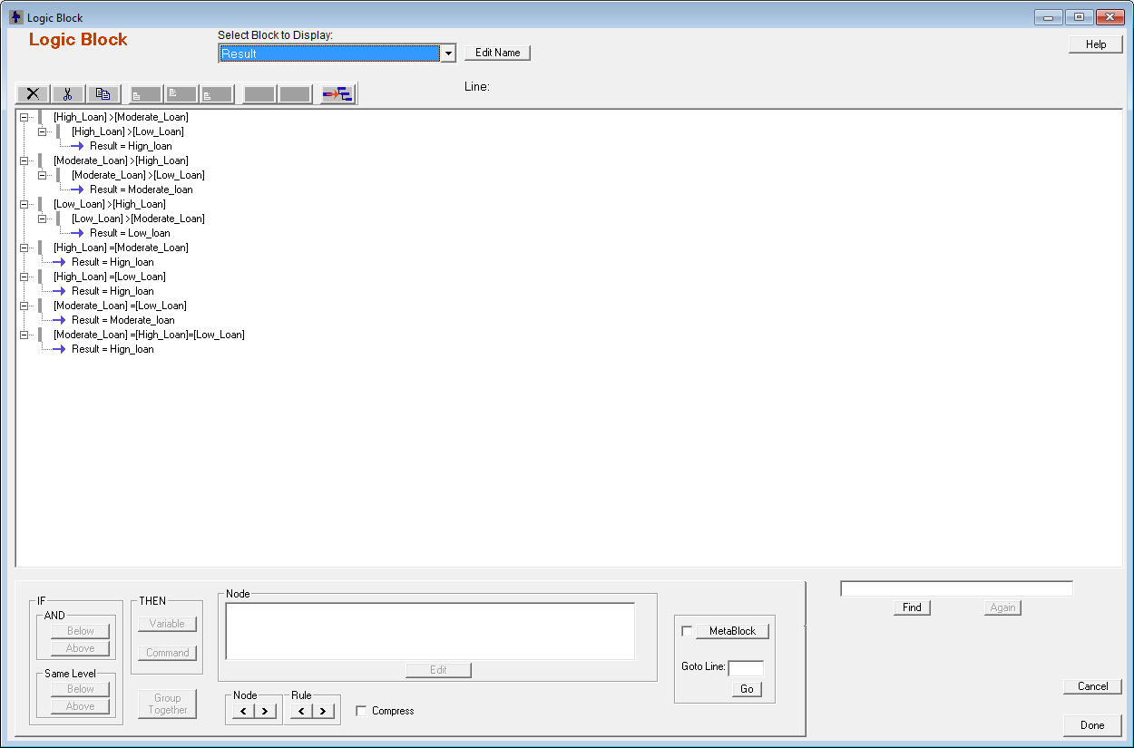

* Command block

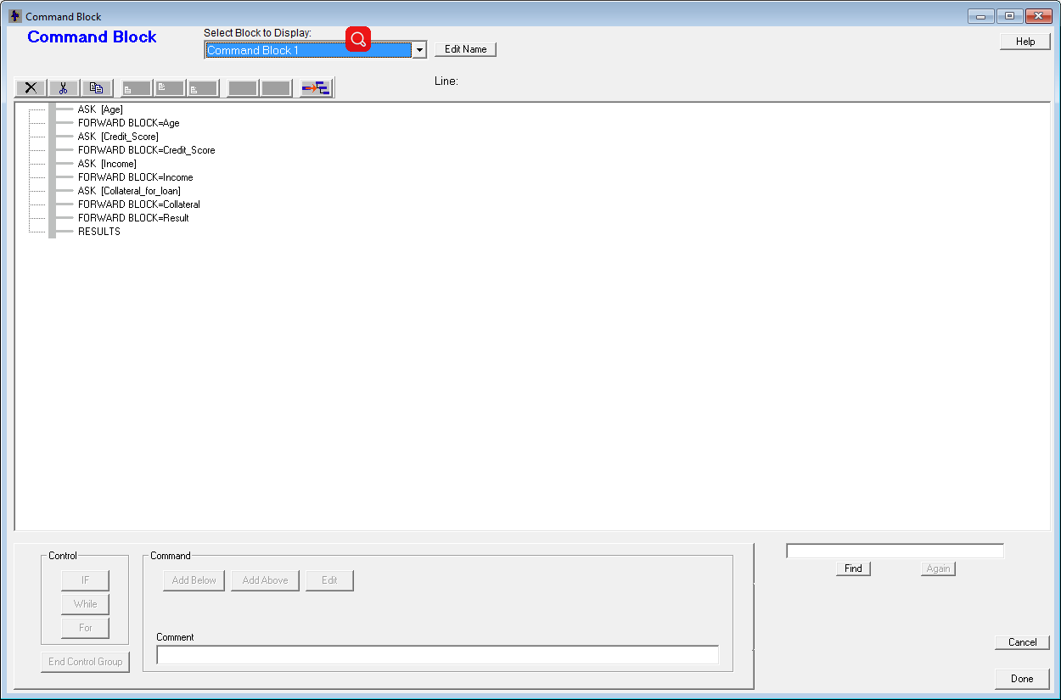

* Static variables

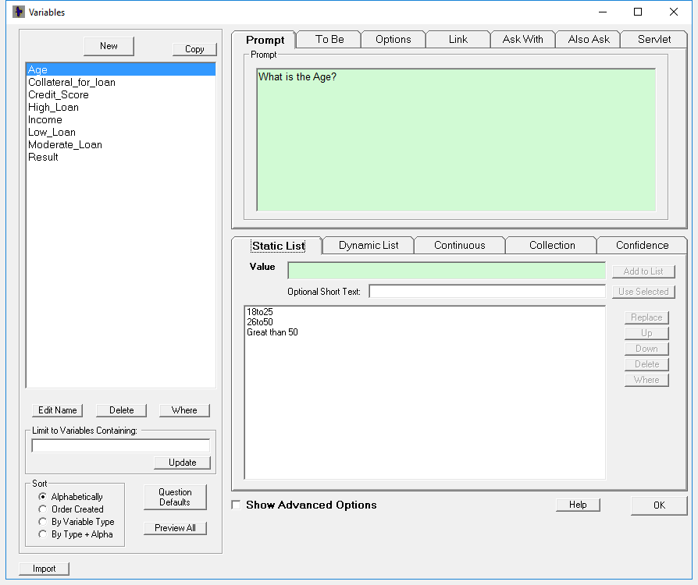

* Logic block

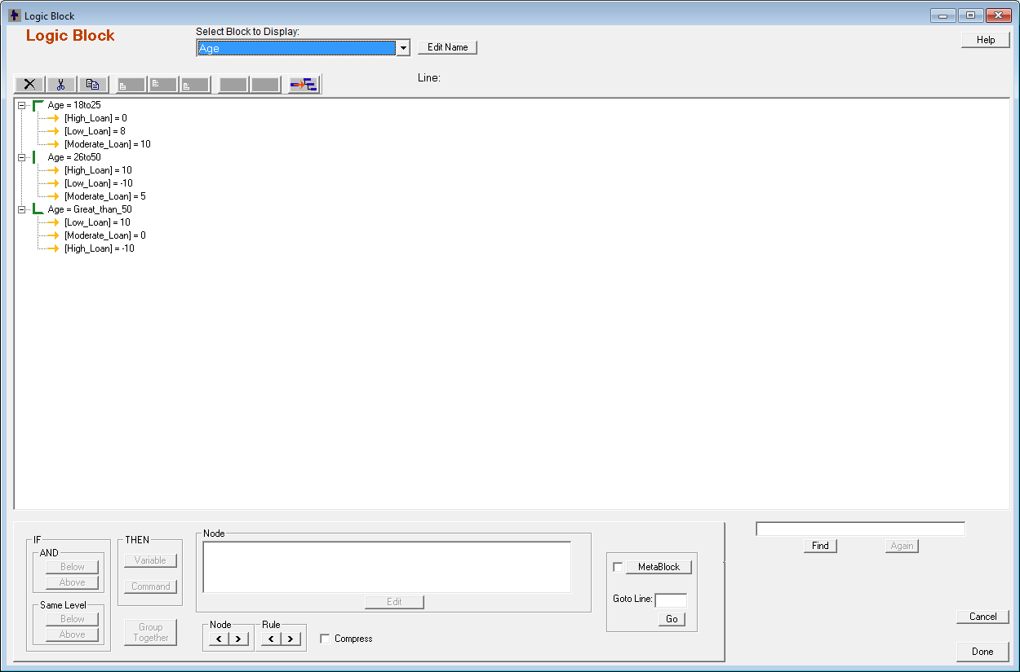

* Collateral

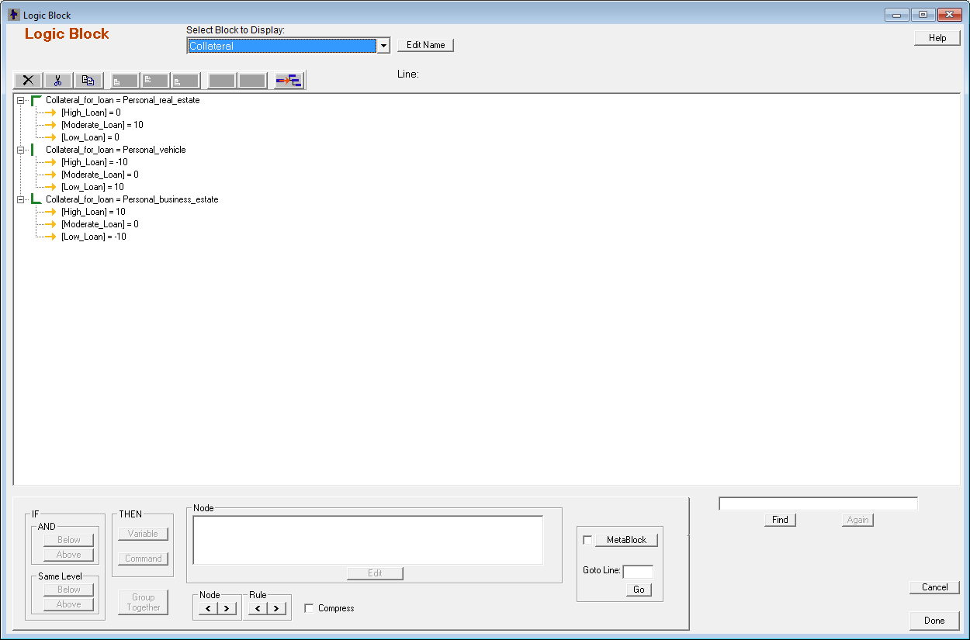

# 

* Credit_Score

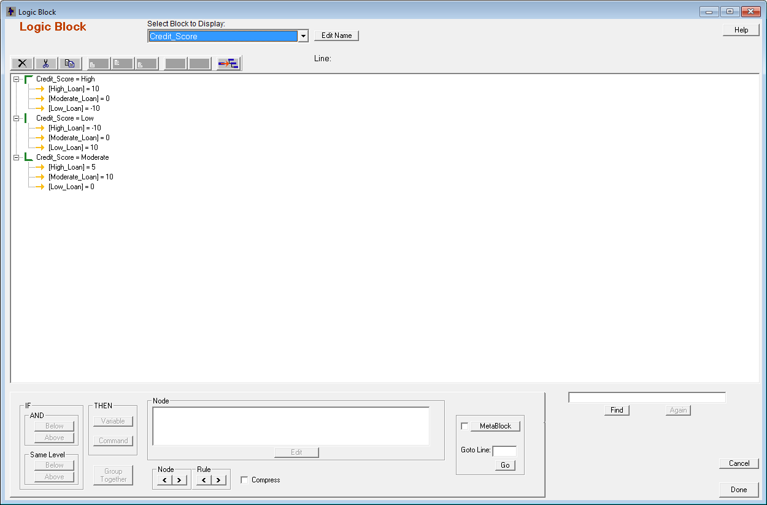

* Income

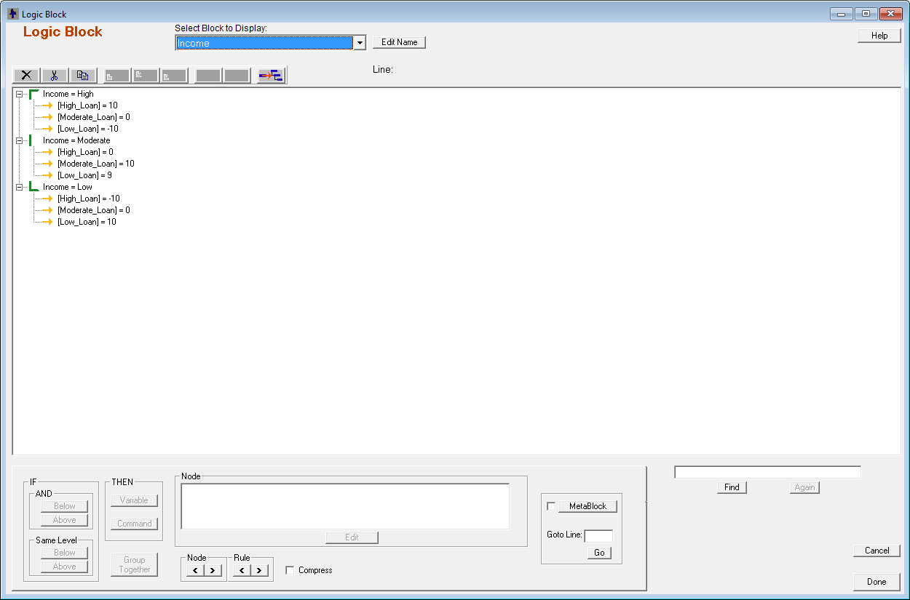



Results:

