

Drupal

REPORT SUBTITLE

Name | Course Title | Date

# Setup new proj with work folder

* C:\xampp\apache\conf\httpd.conf

Change line 245 and 246

* DocumentRoot "C:/work/sites"
* <Directory "C:/work/sites">
* C:\xampp\apache\conf\extra\httpd-vhosts.conf

<VirtualHost *:80>

DocumentRoot "C:/work/sites/demo"

ServerName demo.local

ErrorLog "logs/demo.local-error.log"

<Directory "C:/xampp/htdocs/demo">

AllowOverride All

Require all granted

</Directory>

</VirtualHost>

* C:\Windows\System32\drivers\etc\hosts

127.0.0.1 ldu538old.local

127.0.0.1 ldu545.local

127.0.0.1 wpdemo.local

127.0.0.1 yasisland.local

127.0.0.1 mam006.local

#10.160.179.5 mubadala.com www.mubadala.com

10.160.179.6 careers.mubadala.com

10.160.179.7 www.mubadalacompliance.ae

# ‘Views as page’ link in menus

* Create a menu title in “menu settings” section of “view as page”.
* Get it into “main menu” and change the parent to “navigation menu”.

## Heading 2

You might like the photo on the cover page as much as we do, but if it’s not ideal for your report, it’s easy to replace it with your own.

Just delete the placeholder picture. Then, on the Insert tab, click Picture to select one from your files.

# Search issue

* Configuration -> search settings.
* Select “Node” in “ACTIVE SEARCH MODULES”
* Re-index site
* Run cron (cron maintenance task in “INDEXING THROTTLE” )

# Cron

Setting up cron is an important step in the installation of the website and assists in the maintenance of the site's assets for search results, checking for updates to Drupal core and modules, and removing temporary files.

* A properly configured cron job can manage a variety of tasks:
* The Search module that indexes the website's content.
* The Aggregator module's that retrieves feeds.
* The Ping module that notifies other sites of updates.
* The System module that performs routine maintenance tasks, such as pruning of logs.

<http://drupal.stackexchange.com/questions/59079/adding-fields-to-user-registration-form>

Drupal uses **_drupal_exception_handler ($exception)** function to handle the errors in the site. These errors will not be enclosed in a try/catch block. The script won't execute the function when an exception handler exits.

The code for **_drupal_exception_handler** will be shown as below:

function _drupal_exception_handler($exception) {

require_once DRUPAL_ROOT . '/includes/errors.inc';

try {

// display the error message in the log and return the error messages to the user

_drupal_log_error(_drupal_decode_exception($exception), TRUE);

}

catch (Exception $excp2) {

// Another uncaught exception was thrown while handling the first one.

// If we are displaying errors, then do so with no possibility of a further uncaught exception being thrown.

if (error_displayable()) {

print '<h1>Additional uncaught exception thrown while handling exception.</h1>';

print '<h2>Original</h2><p>' . _drupal_render_exception_safe($exception) . '</p>';

print '<h2>Additional</h2><p>' . _drupal_render_exception_safe($excp2) . '</p><hr />';

}

}

}

# Errors fixing while setup

## Too big file (php.ini)

* upload_max_filesize=52M
* post_max_size=128M

## Execution error (php.ini)

* max_execution_time=3000

## Mysql has gone away (my.ini)

* max_allowed_packet=24M

## Innobdb (my.ini)

* innodb_log_file_size = 124M

## Allocated mem eror (php.ini)

* memory_limit=520M

# Password reset hash

require_once DRUPAL_ROOT . '/includes/password.inc'; in index.html of ur drupal project

echo user_hash_password('admin1234');

die();

see the password and replace in users table of ur db

# Translation with core modules

Enable ***locale*** and ***content translation*** module

Enable Enabled, with ***translation*** in content type and add content

# Caching

## boost

* Install boost module <https://www.drupal.org/project/boost>
* Go to config/system/boost ***BOOST CACHE TYPE SETTINGS*** html settings
* Enable both checkboxes in ***cache expiration*** tab
* ***File system*** tab in ***Root cache directory*** set path ***sites/cache***
* Go to .***HTACCESS*** tab in that .***htaccess generation*** tab copy the code and paste in ur .htaccess file (make a copy of it as a safe) in line 107 below ***# RewriteBase /drupal***
* Comment this code in htaccess (else it won’t allow u to save anything)
* RewriteCond %{REQUEST_METHOD} !^(GET|HEAD)$ [OR]

RewriteCond %{REQUEST_URI} (^/(admin|sites/cache|misc|modules|sites|system|openid|themes|node/add|comment/reply))|(/(edit|user|user/(login|password|register))$) [OR]

RewriteCond %{HTTPS} on [OR]

RewriteCond %{HTTP_COOKIE} DRUPAL_UID [OR]

RewriteCond %{ENV:REDIRECT_STATUS} 200

RewriteRule .* - [S=2]

* Hit the page and hit it without login. It should create html file in ***sites/cache/..***
* Now when u make changes to node it won’t show u the changes. For this u need extra module ***Boost clear cache*** <https://www.drupal.org/project/boost_cache_clear>
* Enable it and go to the content type and edit -> in ***Boost clear cache settings*** -> enable ***Enable*** ***Boost Clear Cache*** and add * in **Clear Boost cache for specific pages while node is creat/edit in Complex**

# Ck editor for internal links

* Install ckeditor_link module <https://www.drupal.org/project/ckeditor_link>
* go to config -> text formats -> add format 'link format'
* config -> wysiyg profiles -> check ***link*** and ***ckeditor_link*** -> select from drop down in textarea field of ur content

# Svg in drupal 7

## svg patch for any image field in any ct

* <https://www.drupal.org/files/issues/drupal-add_basic_svg_support-2539478-3-D7.patch>
* <https://www.drupal.org/node/2539478>
* Add svg in allowed list of image field

## svg logo

* Go to appearance-> default theme -> logo -> svg path
* In logo add img tag and src as svg path

## svg menu for **other facilities, Explore and brochure link**

* Download module ***menuimage*** <https://www.drupal.org/project/menuimage>
* Upload svg and get the path and add in src attr of img tag

Node save – clear all cache

<https://drupal.stackexchange.com/questions/85338/when-saving-an-updated-node-does-the-update-operation-clear-all-caches>

<https://drupal.stackexchange.com/questions/100346/whenever-i-edit-update-a-node-all-the-page-caches-for-anonymous-user-are-lost>

# Disable captcha while login on local

# 

[SELECT](http://localhost/phpmyadmin/url.php?url=http://dev.mysql.com/doc/refman/5.5/en/select.html) * FROM `mez_captcha_points`  
make **module and captcha_type** column values blank for **form_ids** column values:

user_login, user_login_block, user_pass

Disable module google_recaptcha

[UPDATE](http://localhost/phpmyadmin/url.php?url=http://dev.mysql.com/doc/refman/5.5/en/update.html) mez_system [SET](http://localhost/phpmyadmin/url.php?url=http://dev.mysql.com/doc/refman/5.5/en/set.html) status='0' WHERE name='google_recaptcha'

# Recaptcha for webform

* Download captcha module and enable
* Create webformand download webform captcha_webform module and enable
* Add recaptcha module and enable
* Go to config people captcha .. select recaptcha for particular webform
* Config->admin->people->captcha go to recaptcha tab and add keys generated using ur local url on this <https://www.google.com/recaptcha/admin>

# Drush installation on windows using composer

* <https://modulesunraveled.com/drush/installing-drush-windows>
* If u get No **Drupal site found, only 'drush' cache was cleared. [warning]** then **export PATH=/c/xampp/mysql/bin/:$PATH** enter command and check drush cc all

## drush 8 n 7

<https://ayesh.me/drush-8-windows-7-8-10>

1. Download compose exe file from <https://getcomposer.org/download/>
2. Check in cmd or git bash **composer –V**
3. Install drush - **composer global require drush/drush:8.\***
4. Check in cmd or git bash **drush version**
5. Go to drupal8project and open git bash – **drush cache re-build**
6. Got to drupal7project and open git bash – **drush cc all**

(throws error – drupal not found

Add in PATH user environment variables - C:\xampp\mysql\bin\

Or

export PATH=/c/xampp/mysql/bin/:$PATH (temporary – it will go after restarting machine)

)

1. Restart your machine

# Feeds

## Feeds for node

* Create content type and fields 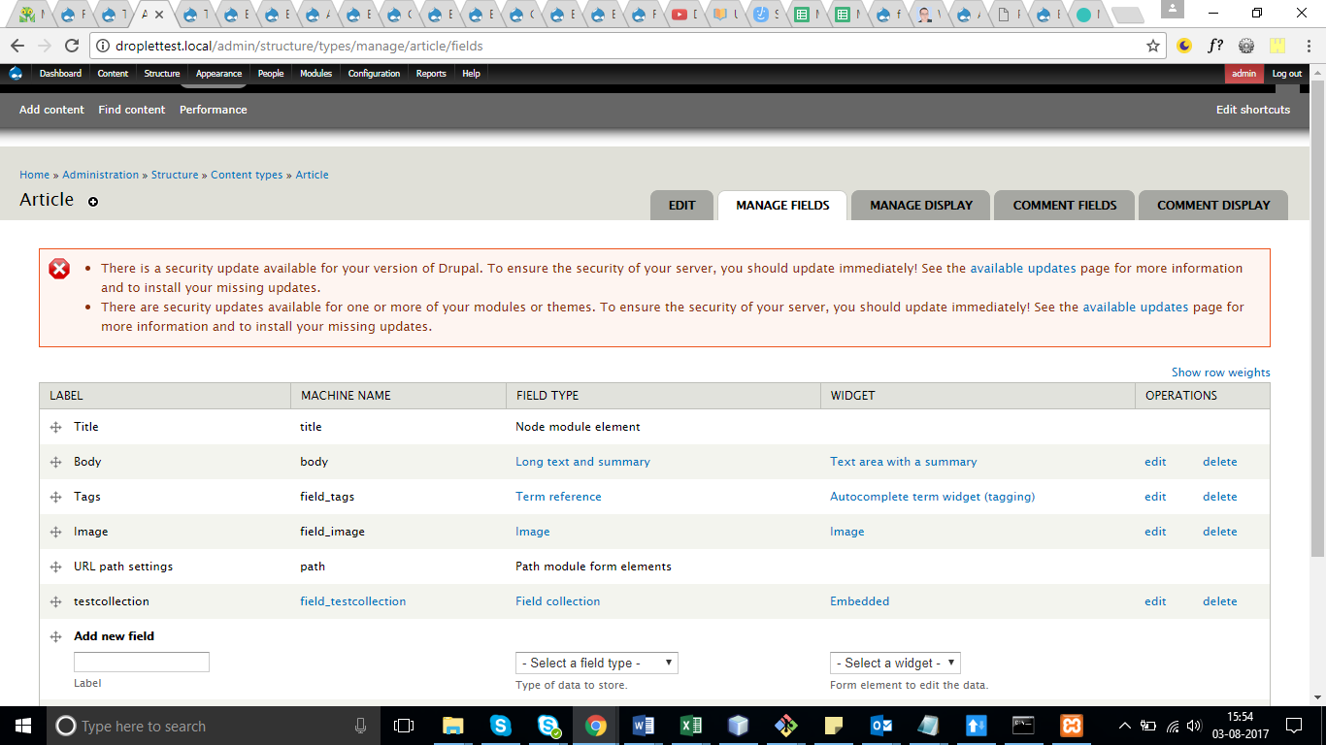
* Download feeds module
* Structure -> Feeds importers -> Add importer
* **Import on submission**

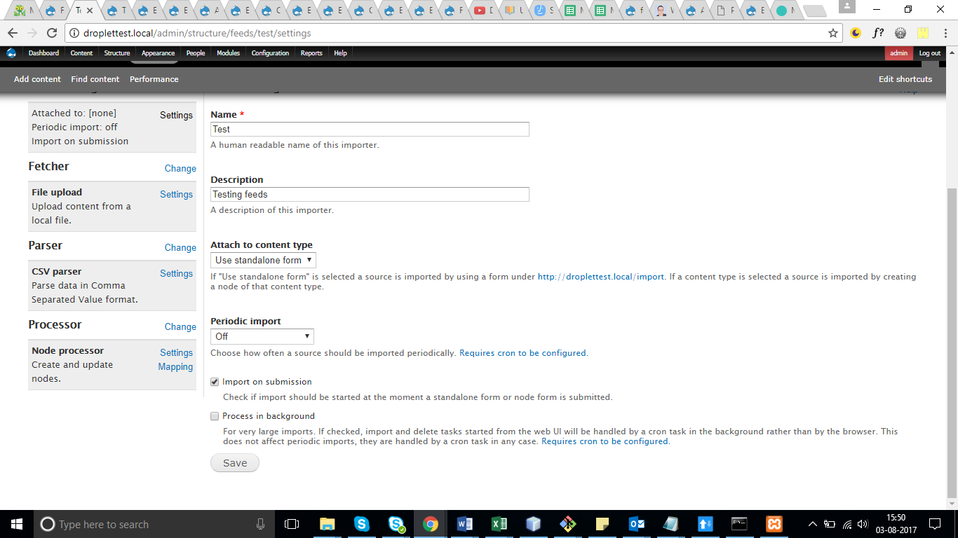

* Fetcher : file upload
* File upload as it is (chk csv)
* Parser : csv parser
* Csv parser : coma
* Processor : Node processor
* 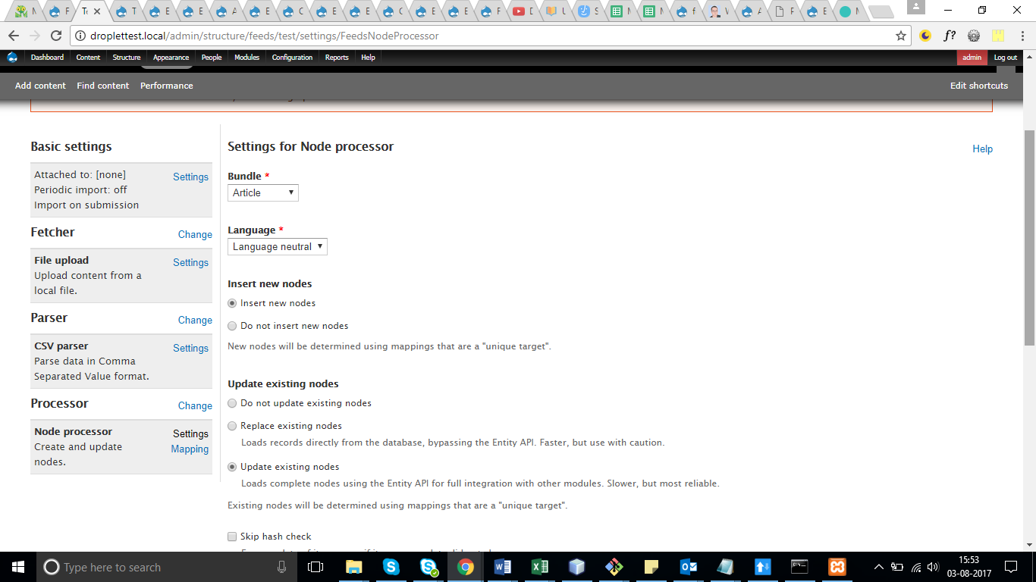
* 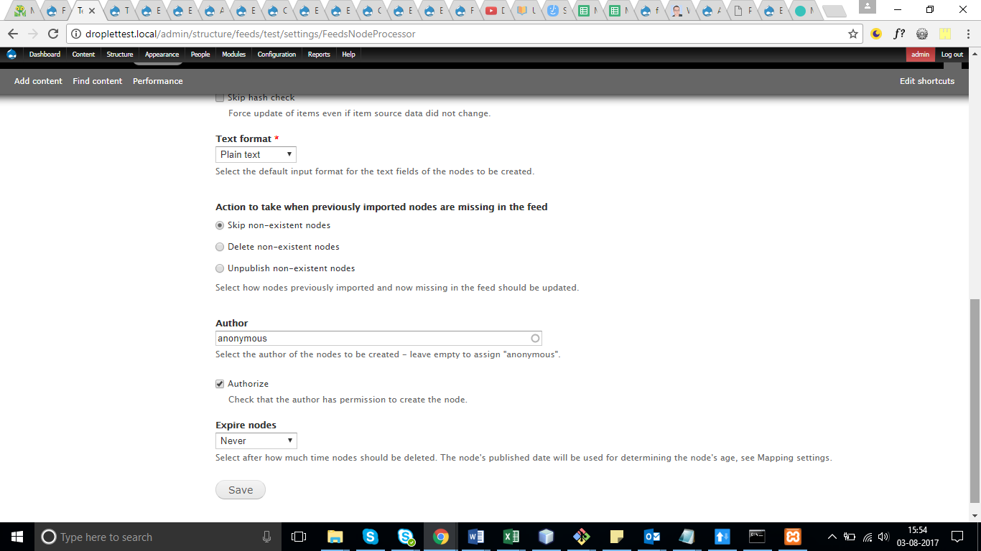
* 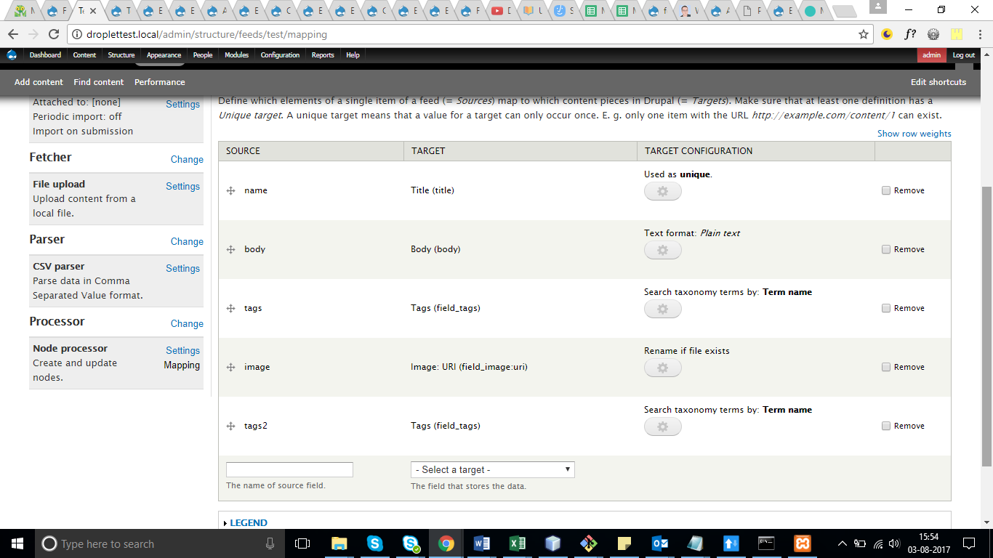
* Create csv file 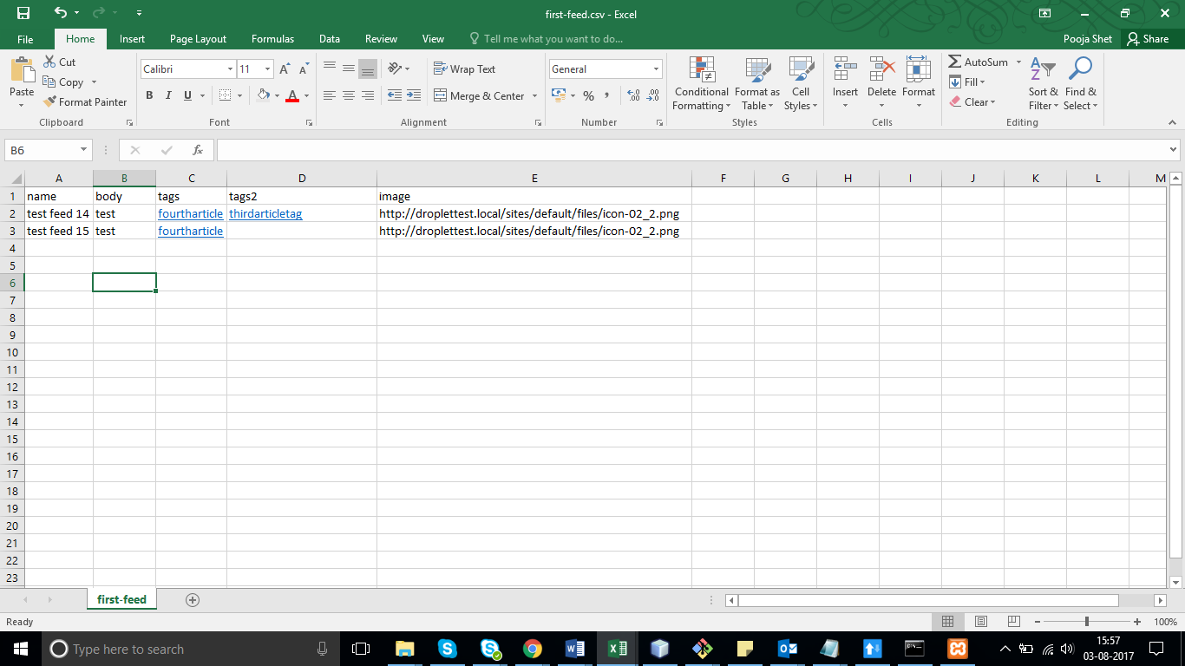
* <http://droplettest.local/import> -> Test -> upload the csv file

For multiple image in Tamper

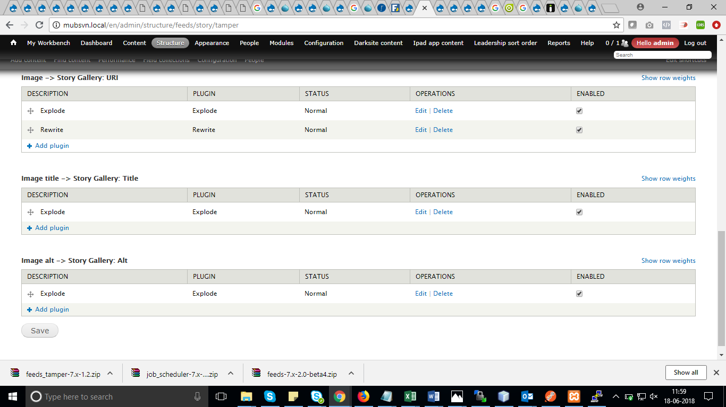

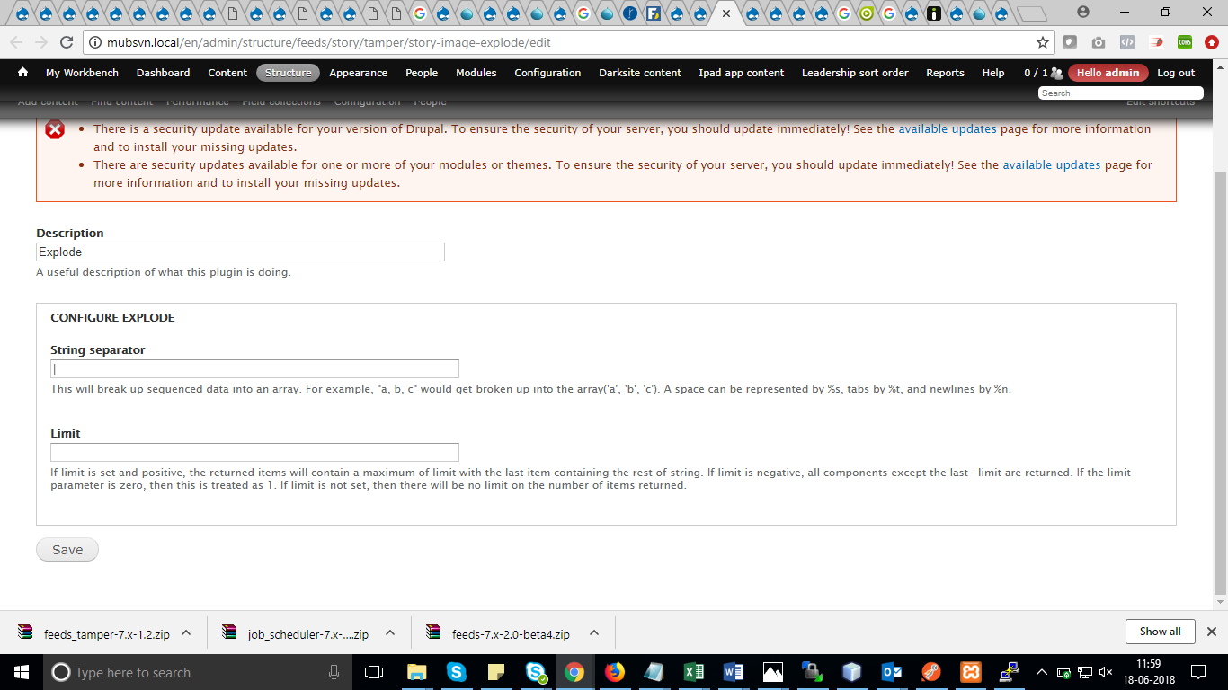

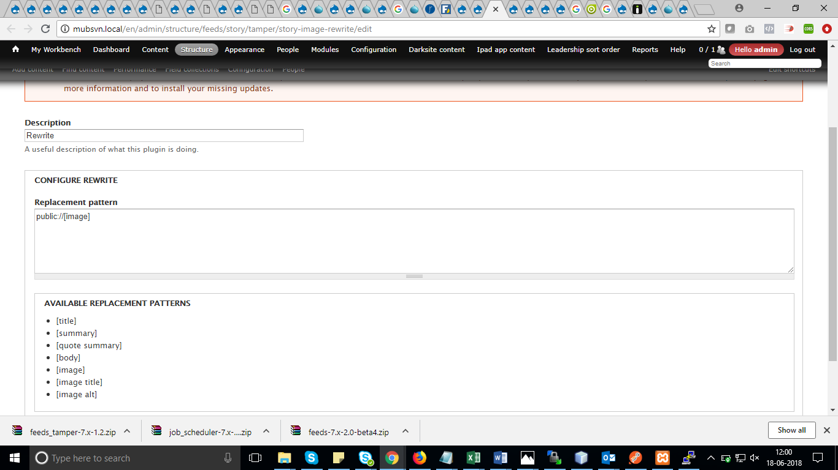

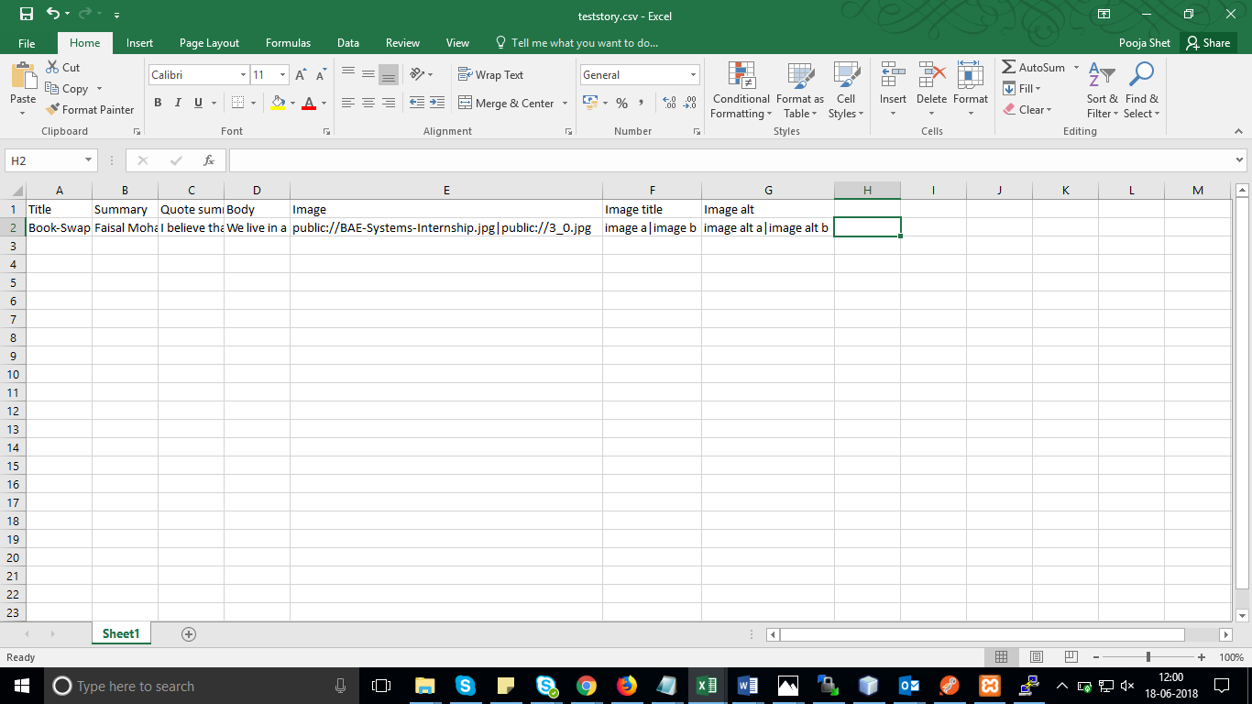

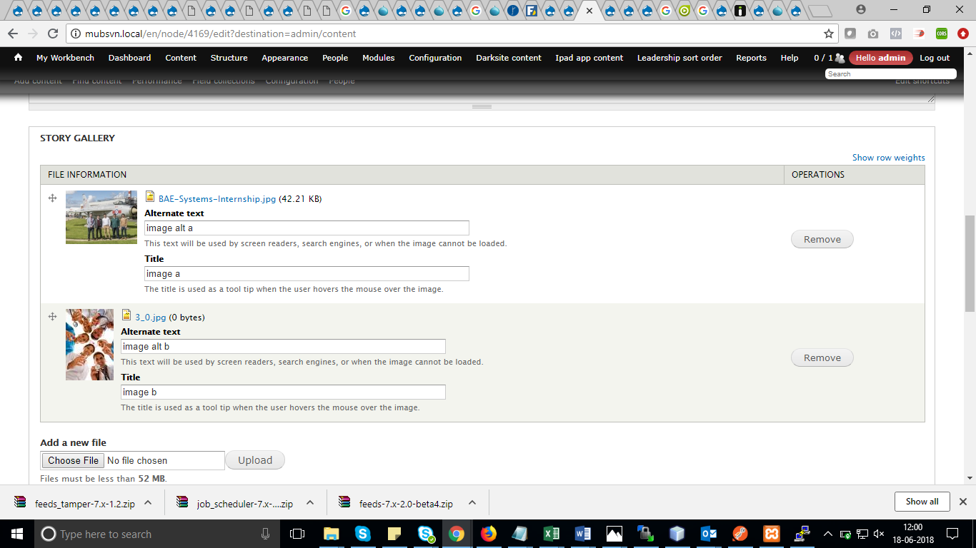

## Feeds for field collection

* Create field collection items 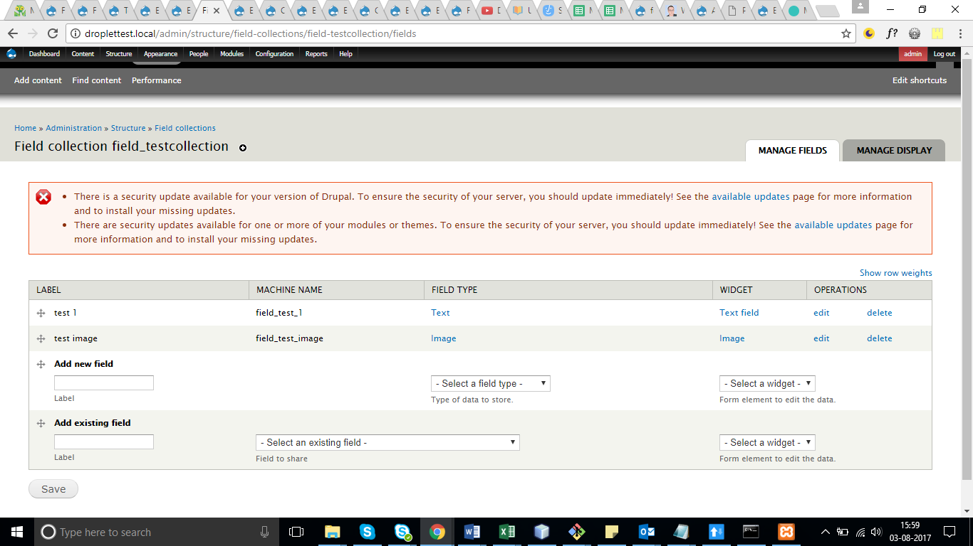
* Download field_collection_feeds module and enable it
* Structure -> Feed importers -> Add importers 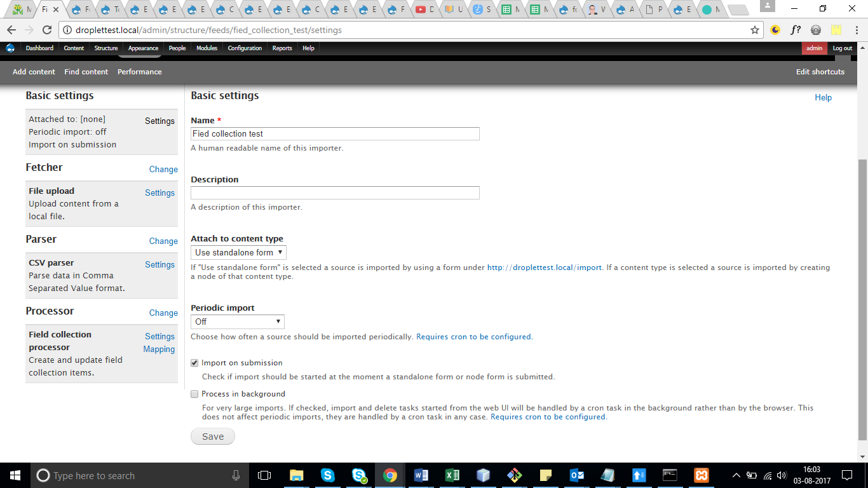
* Fetcher : file upload
* File upload as it is (chk csv)
* Parser : csv parser
* Csv parser : coma
* Processor : Field collection processor
* 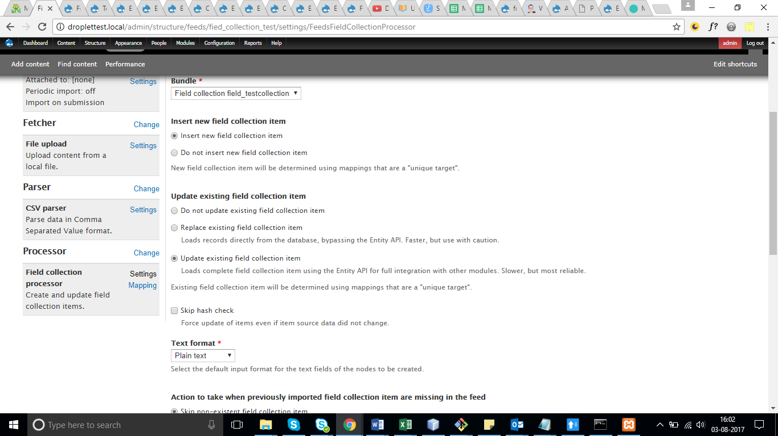
* 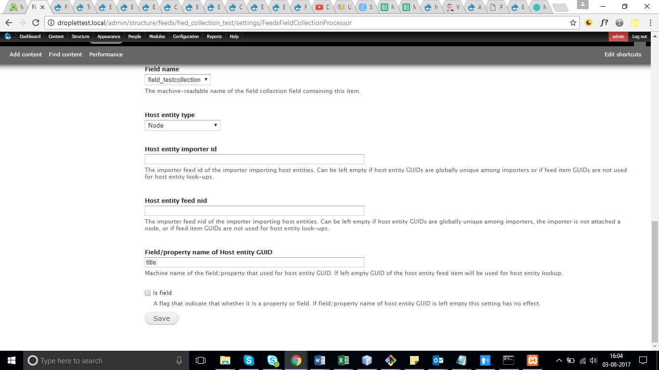
* Is field keep it uncheck if u using title or nid as host entity guid
* 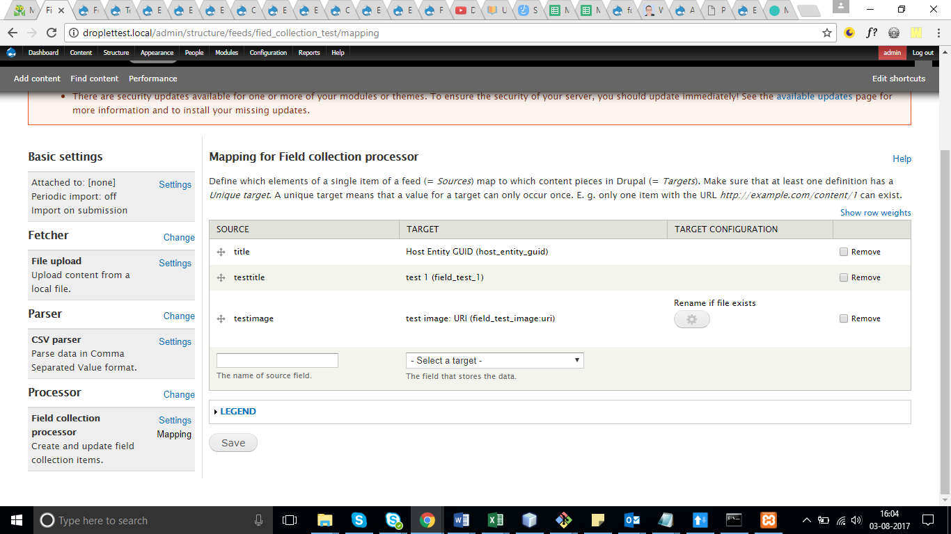
* 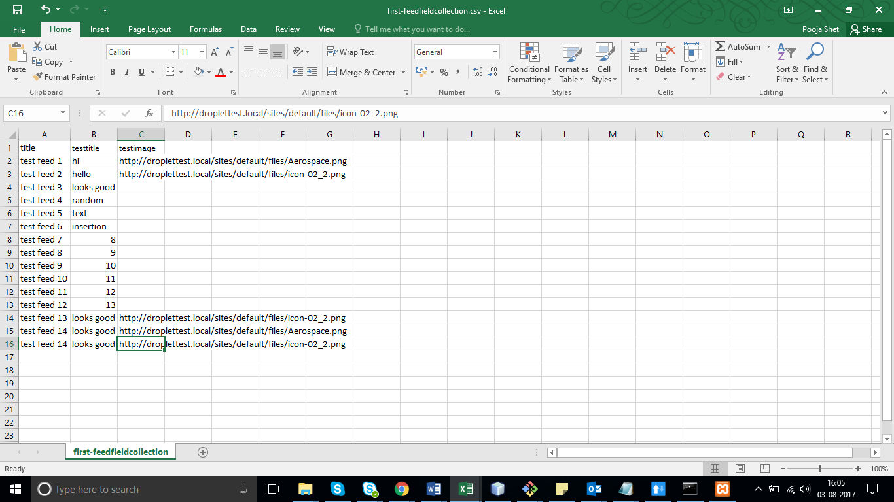
* <http://droplettest.local/import> -> Field collection test -> upload the csv and check

## Feeds for field collection for unlimited (corporate structure)changes

* Download field_collection_feeds module and enable it
* Field collection processor –select “ Do no update “
* Host entity type – select “content” (node was not available)
* 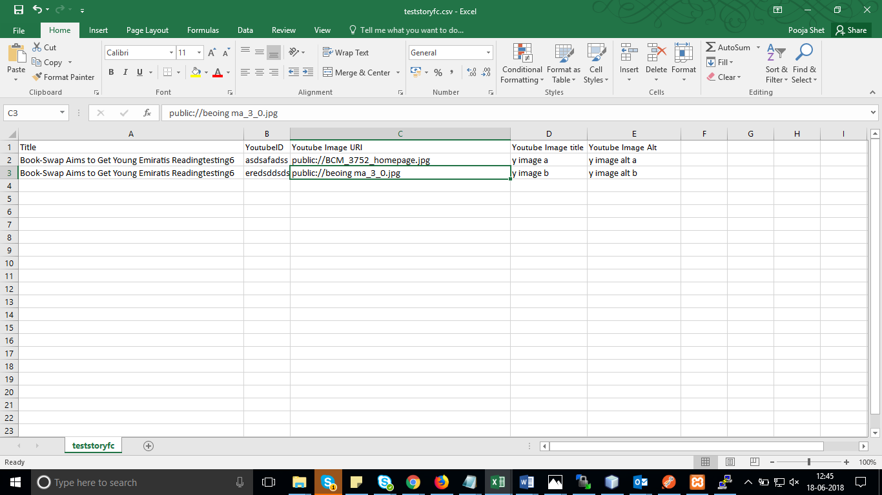
* 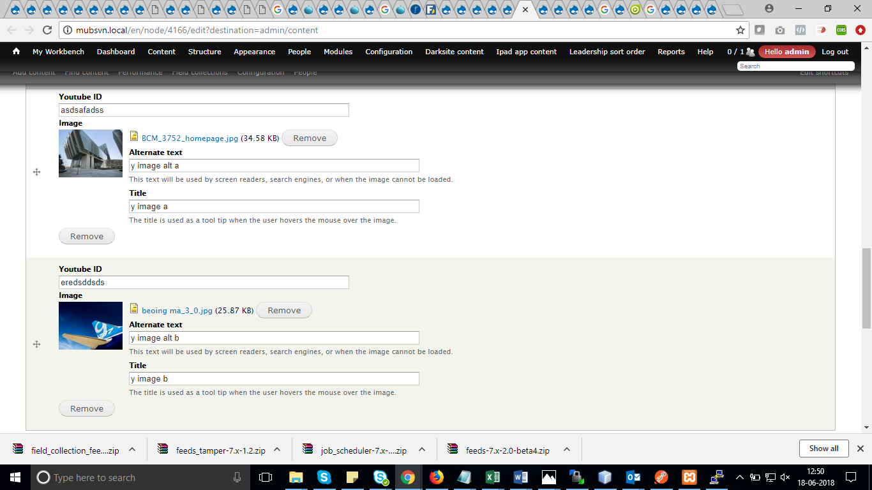

## Notes

upload image from external link

multiple taxonomies

multiple field collection

-----------------

notes

keep unique title

import on submission

field collection

<https://www.drupal.org/node/1831004>

keep as field checkbox uncheck

**Note: csv are kept in documents/feeds csv folder**

# For arabic

Take guid as tnid for both content (en & ar) same nid for both and imprt it will get imported as separate node with same guid in feeds_item table in sql. To make the connection , run the below query

**UPDATE mub_node n, mub_feeds_item lng1, mub_feeds_item lng2 SET n.tnid = lng1.entity_id WHERE ( n.nid = lng1.entity_id OR n.nid = lng2.entity_id ) AND lng1.id='story' AND lng2.guid=lng1.guid AND lng2.id='story'**

[UPDATE](http://pma.dxb.cloud.flip.me/url.php?url=https://dev.mysql.com/doc/refman/5.5/en/update.html) mub_node n, mub_field_data_field_translation_nid lng1, mub_field_data_field_translation_nid lng2 [SET](http://pma.dxb.cloud.flip.me/url.php?url=https://dev.mysql.com/doc/refman/5.5/en/set.html) n.tnid = lng1.entity_id WHERE ( n.nid = lng1.entity_id [OR](http://pma.dxb.cloud.flip.me/url.php?url=https://dev.mysql.com/doc/refman/5.5/en/logical-operators.html#operator_or) n.nid=lng2.entity_id ) [AND](http://pma.dxb.cloud.flip.me/url.php?url=https://dev.mysql.com/doc/refman/5.5/en/logical-operators.html#operator_and) lng1.bundle='weyana_story' [AND](http://pma.dxb.cloud.flip.me/url.php?url=https://dev.mysql.com/doc/refman/5.5/en/logical-operators.html#operator_and) lng2.field_translation_nid_value=lng1.field_translation_nid_value [AND](http://pma.dxb.cloud.flip.me/url.php?url=https://dev.mysql.com/doc/refman/5.5/en/logical-operators.html#operator_and) lng2.bundle='weyana_story'

Football Player

update mub_node nc, mub_node n, mub_field_data_field_common c set nc.tnid = n.nid where ( n.title = c.field_common_value and nc.nid = c.entity_id ) and c.bundle = 'football_player'

print_r(db_query("update mub_node nc, mub_node n, mub_field_data_field_common c set nc.tnid = n.nid where ( n.title = c.field_common_value and nc.nid = c.entity_id ) and c.bundle = 'football_player'")->rowCount());

update mub_node nc, mub_node n set nc.tnid = n.tnid where nc.nid = n.tnid and nc.type = 'football_player'

print_r(db_query("update mub_node nc, mub_node n set nc.tnid = n.tnid where nc.nid = n.tnid and nc.type = 'football_player'")->rowCount());

update mub_node nc, mub_node n, mub_field_data_field_common c set nc.tnid = n.nid where ( n.title = c.field_common_value and nc.nid = c.entity_id ) and c.bundle = 'football_team'

update mub_node nc, mub_node n set nc.tnid = n.tnid where nc.nid = n.tnid and nc.type = 'football_team'

update mub_node nc, mub_node n, mub_field_data_field_common c set nc.tnid = n.nid where ( n.title = c.field_common_value and nc.nid = c.entity_id ) and c.bundle = 'football_group'

update mub_node nc, mub_node n set nc.tnid = n.tnid where nc.nid = n.tnid and nc.type = 'football_group'

[update](http://pma.dxb.cloud.flip.me/url.php?url=https://dev.mysql.com/doc/refman/5.5/en/update.html) mub_node nc, mub_node n, mub_field_data_field_common c [set](http://pma.dxb.cloud.flip.me/url.php?url=https://dev.mysql.com/doc/refman/5.5/en/set.html) nc.tnid = n.nid where ( n.title = c.field_common_value [and](http://pma.dxb.cloud.flip.me/url.php?url=https://dev.mysql.com/doc/refman/5.5/en/logical-operators.html#operator_and) nc.nid = c.entity_id) [and](http://pma.dxb.cloud.flip.me/url.php?url=https://dev.mysql.com/doc/refman/5.5/en/logical-operators.html#operator_and) c.bundle = 'football_match_schedule'

update mub_node nc, mub_node n set nc.tnid = n.tnid where nc.nid = n.tnid and nc.type = 'football_match_schedule'

print_r(db_query("UPDATE `mub_node` SET `status` = '0' WHERE `mub_node`.`nid` = 106;")->rowCount());

**Mub_feeds_itm replace to** mub_field_data_field_translation_nid

Guid to field_translation_nid_value

[**https://drupal.stackexchange.com/questions/69763/using-feeds-to-import-multiple-languages**](https://drupal.stackexchange.com/questions/69763/using-feeds-to-import-multiple-languages)

# Excel sheet formula for unlimited images explode by |

=CONCATENATEMULTIPLE(B1:B6,"|")

# Modules

IMCE upload images media files

/imce

# Drupal standards – code sniffer

<http://www.tothenew.com/blog/how-to-install-and-setup-drupal-code-sniffer/>

# Theme suggestion - **Corporate structure**

Corporate structure(content title) – basic page (content type)

Template(field) in basic page **corporate_structure**

For corporate structure –

Page—**corporate-structure.**tpl.php

*In template.php*

**if ($vars['node']->type != "") {**

**if(isset($vars['node']->field_template["und"][0]["value"])) {**

**$vars['theme_hook_suggestions'][] = 'page__'.$vars['node']->field_template["und"][0]["value"];**

**}**

**}**

# Excel sheet compare A-B

=IF(COUNTIF($B:$B,$A1)=0,"No match in B","")

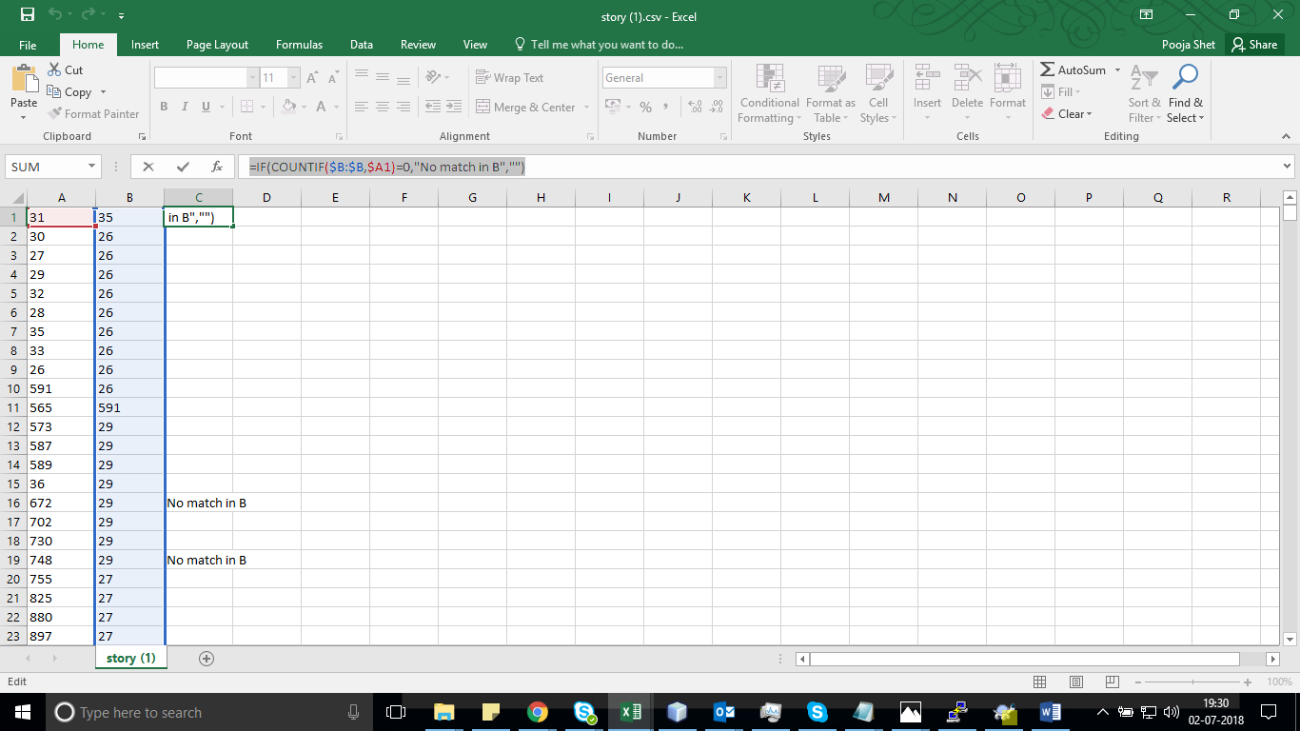

# Excel sheet combine metatags

=VLOOKUP(A:A,Sheet2!A:B,2,FALSE)

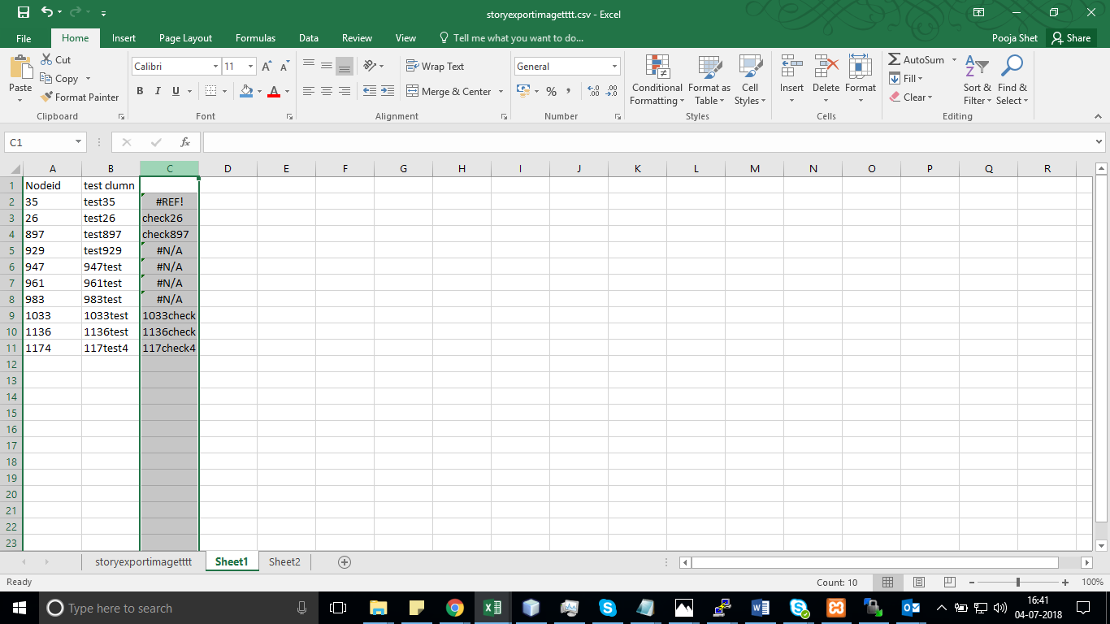

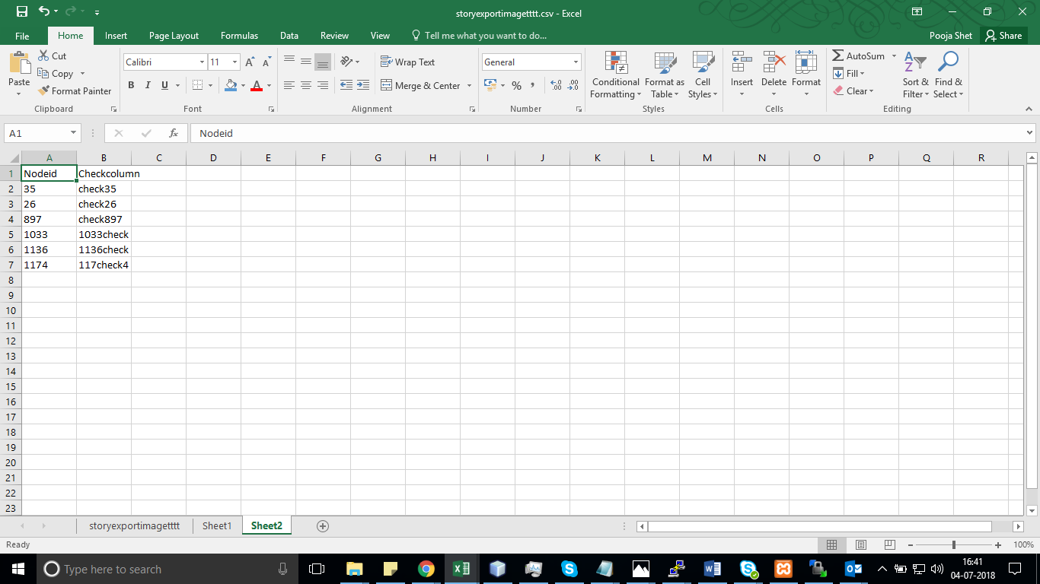

# Add node ref field in basic page – field_leaders

**In** Page—**corporate-structure.**tpl.php - print render($node_content['field_leaders']);/ print render($page['content']);

Manage displays in basic page for node reference – referenced node (teaser)

Changes in node ref ct change tpl

C:\work\sites\mub170\sites\all\themes\whippy_new\templates\nodes\alternative\node--leadership--teaser.tpl.php

# Fields tpl override with view mode

In template.php

$vars['theme_hook_suggestions'][] = 'field__' . $vars['element']['#field_name'] . '__' . $vars['element']['#bundle'] . '__' . $vars['element']['#view_mode'];

all/themes/whippy_new/templates/fields/alternative/field--field-category--leadership--teaser.tpl.php

all/themes/whippy_new/templates/fields/alternative/field--field-image--leadership--teaser.tpl.php

**changed files**

M all/themes/whippy_new/template.php

? all/themes/whippy_new/templates/fields/alternative/field--field-category--leadership--teaser.tpl.php

? all/themes/whippy_new/templates/fields/alternative/field--field-image--leadership--teaser.tpl.php

? all/themes/whippy_new/templates/nodes/alternative/node--leadership--teaser.tpl.php

? all/themes/whippy_new/templates/pages/page--corporate-structure.tpl.php

different approach - backend display usage

feeds

bundle copy

custom formatters

imce

themekey

boost

=====

multilingual

multisite

varnish

apache solr

gaurangi.sambhoo@abmindia.com

https://www.youtube.com/watch?v=HFM3fjZWpMw

https://www.youtube.com/watch?v=Z96KMymDHkQ

----

https://www.youtube.com/watch?v=ZyFDNryHF4U

=====

gallery

http://www.bestjquery.com/?A3S1mxDt

-----------

future

250000

30

75000

thursday working last in month

----------

arq

my recommendation -> short term,intraday

fundamental -> long term

intraday

10k to 40k

18% per annum after todays

40 times

15 times

====

450 + gst

kra = 36.80

power of etrny = 50 rs

====

<?php echo 'Terms of Use'; ?>

<https://www.youtube.com/watch?v=3DhDgZ211EU>

<table style="margin: 0 auto; border-collapse: collapse; border: none; border-color: transparent;" border="0" width="640" cellspacing="0" cellpadding="0">

<tbody>

<tr>

<td style="border-color: #000;" valign="top">

<table style="border-collapse: collapse; border: none; border-color: #000;" border="0" width="100%" cellspacing="0" cellpadding="0" bgcolor="#000">

<tbody>

<tr>

<td>

<table style="border-collapse: collapse; border: none;" border="0" width="100%" cellspacing="0" cellpadding="0" bgcolor="#000">

<tbody>

<tr>

<td width="70"></td>

<td style="text-align: center;" width="500"><img title="Diet Smart" src="http://dietsmartdubai.com/wp-content/themes/dietsmart/images/logo.svg" alt="Diet Smart" width="200" height="130" /></td>

<td width="70"></td>

</tr>

</tbody>

</table>

</td>

</tr>

</tbody>

</table>

</td>

</tr>

<tr>

<td>

<table style="border-collapse: collapse; border: none;" border="0" width="100%" cellspacing="0" cellpadding="0">

<tbody>

<tr>

<td width="70"></td>

<td width="500">

<div style="height: 40px;"><img src="http://dietsmartdubai.com/wp-content/themes/dietsmart/images/spacer.gif" width="500" height="40" /></div>

<span style="font-family: Arial, Helvetica, sans-serif; color: #1e252b; font-size: 32px; font-weight: bold;">Smart Diet Goals</span>

&nbsp;

<span style="font-family: Arial, Helvetica, sans-serif; color: #545b61; line-height: 20px; font-size: 14px;">Dear [ninja_forms_field id=1],</span>

Thank you for contacting us. Our representative will contact you shortly.

Thanks for contacting us.

Diet Smart Team</td>

<td width="70"></td>

</tr>

</tbody>

</table>

</td>

</tr>

<tr>

<td colspan="2" height="40">

<div style="height: 40px;"><img src="http://dietsmartdubai.com/wp-content/themes/dietsmart/images/spacer.gif" width="580" height="40" /></div></td>

</tr>

<tr>

<td bgcolor="#333">

<table style="border-collapse: collapse; border: none;" border="0" width="100%" cellspacing="0" cellpadding="0" bgcolor="#333">

<tbody>

<tr>

<td width="30"></td>

<td width="580">

<table style="border-collapse: collapse; border: none;" border="0" width="100%" cellspacing="0" cellpadding="0" bgcolor="#333">

<tbody>

<tr>

<td colspan="2" height="40">

<div style="height: 40px;"><img src="http://dietsmartdubai.com/wp-content/themes/dietsmart/images/spacer.gif" width="580" height="40" /></div></td>

</tr>

<tr>

<td><span style="font-family: Arial, Helvetica, sans-serif; color: #686d72; line-height: 20px; font-size: 13px;">Diet Smart by Maria Aspioti Monem © 2016</span></td>

</tr>

<tr>

<td colspan="2" height="40">

<div style="height: 40px;"><img src="http://dietsmartdubai.com/wp-content/themes/dietsmart/images/spacer.gif" width="580" height="40" /></div></td>

</tr>

</tbody>

</table>

</td>

<td width="30"></td>

</tr>

</tbody>

</table>

</td>

</tr>

</tbody>

</table>

# Drupal Arrays

<https://stackoverflow.com/questions/8347565/difference-between-mysql-fetch-array-and-mysql-fetch-row>

<?php

$query=mysql_connect("localhost","root","");

mysql_select_db("tobby",$query);

?>

**mysql_fetch_row()**

Fetch a result row as an numeric array

<html>

<?php

include('db.php');

$query=mysql_query("select * from tb");

$row=mysql_fetch_row($query);

echo $row[0];

echo $row[1];

echo $row[2];

?>

</html>

Result

1 tobby tobby78$2

**mysql_fetch_object()**

Fetch a result row as an object

<html>

<?php

include('db.php');

$query=mysql_query("select * from tb");

$row=mysql_fetch_object($query);

echo $row->id;

echo $row->username;

echo $row->password;

?>

</html>

Result

1 tobby tobby78$2

**mysql_fetch_assoc()**

Fetch a result row as an associative array

<html>

<?php

include('db.php');

$query=mysql_query("select * from tb");

$row=mysql_fetch_assoc($query);

echo $row['id'];

echo $row['username'];

echo $row['password'];

?>

</html>

Result

1 tobby tobby78$2

**mysql_fetch_array()**

Fetch a result row as an associative array, a numeric array and also it fetches by both associative & numeric array.

<html>

<?php

include('db.php');

$query=mysql_query("select * from tb");

$row=mysql_fetch_array($query);

echo $row['id'];

echo $row['username'];

echo $row['password'];

<span style="color: #993300;">/* here both associative array and numeric array will work. */</span>

echo $row[0];

echo $row[1];

echo $row[2];

?>

</html>