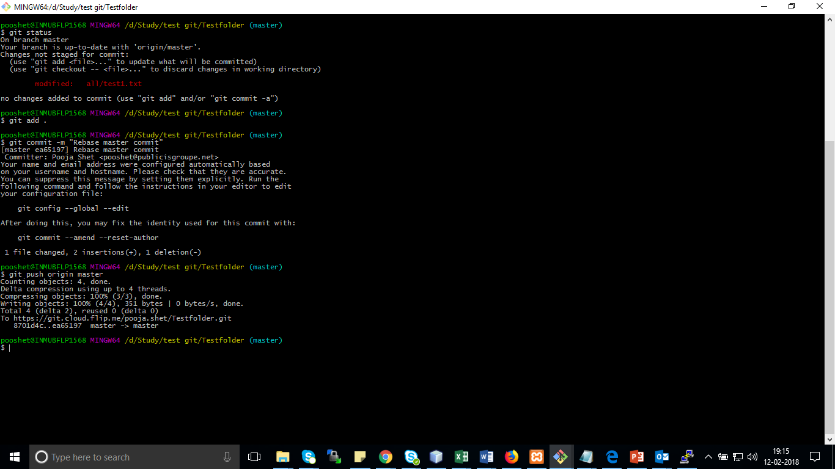

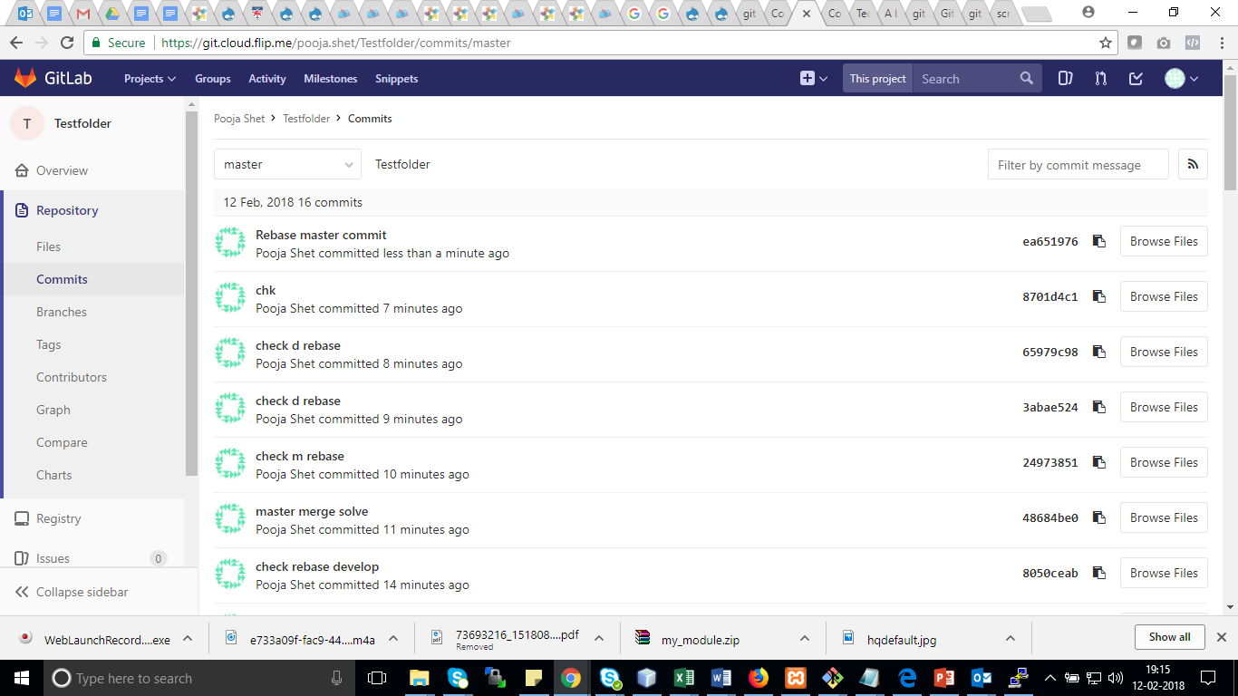

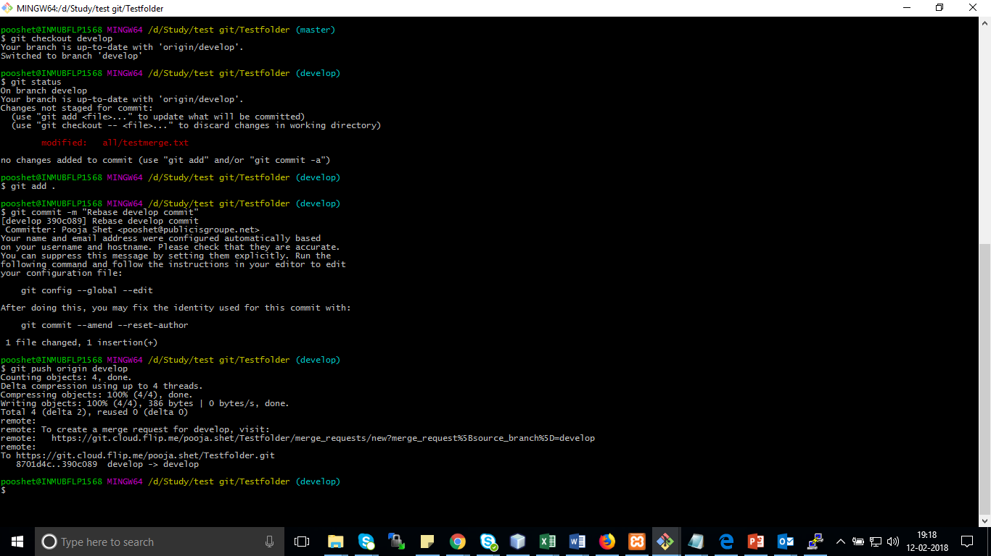

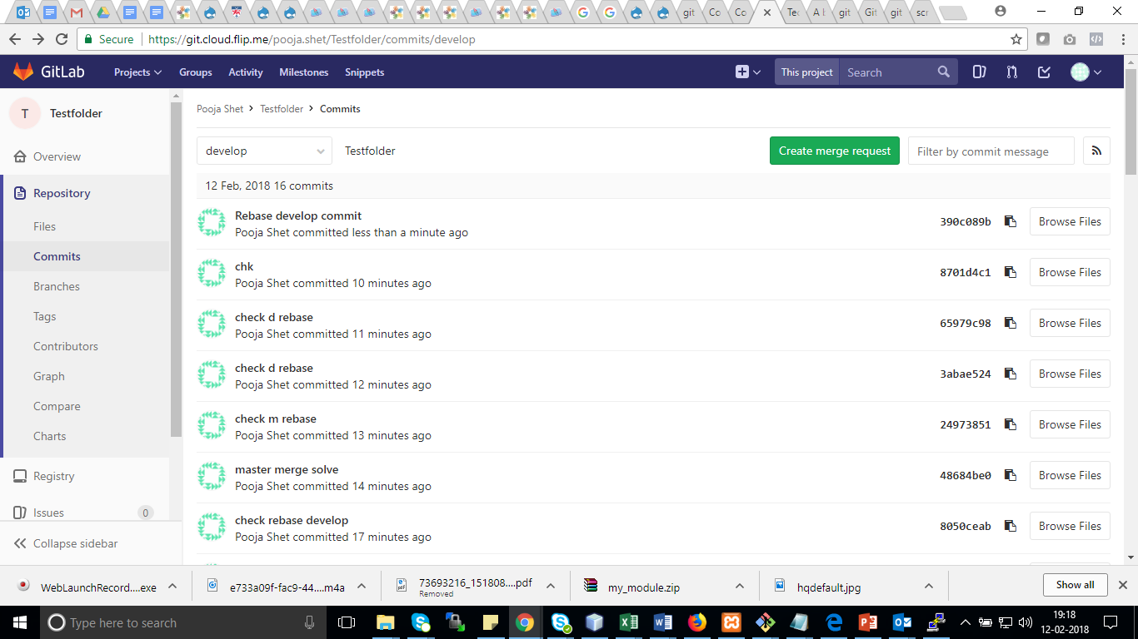

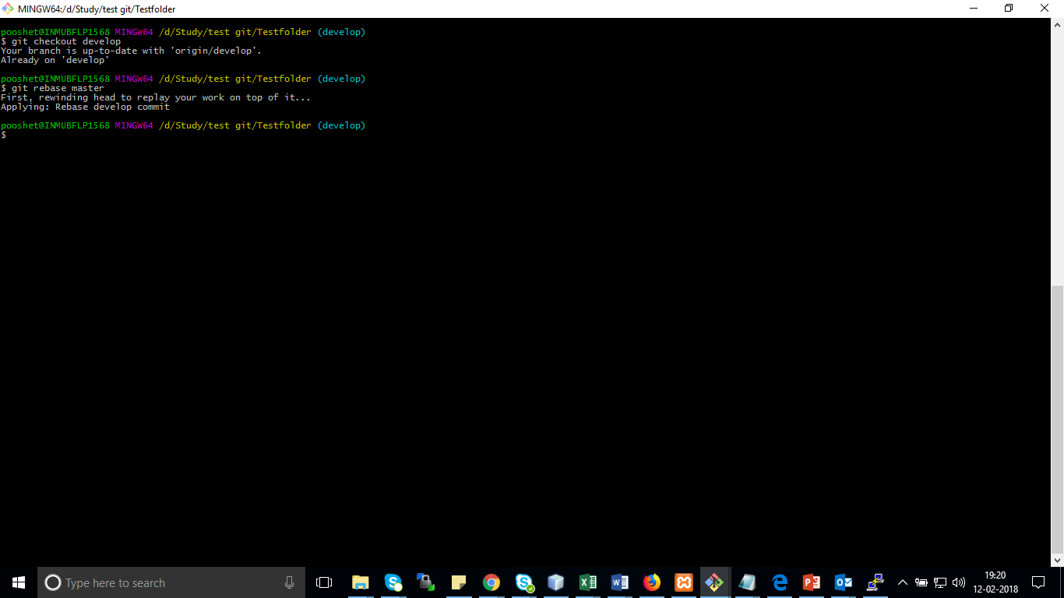

pooshet@INMUBFLP1568 MINGW64 /d/Study/test git/Testfolder (develop)

$ git push -f origin develop

Counting objects: 4, done.

Delta compression using up to 4 threads.

Compressing objects: 100% (4/4), done.

Writing objects: 100% (4/4), 388 bytes | 0 bytes/s, done.

Total 4 (delta 2), reused 0 (delta 0)

remote:

remote: To create a merge request for develop, visit:

remote: https://git.cloud.flip.me/pooja.shet/Testfolder/merge_requests/new?merge_request%5Bsource_branch%5D=develop

remote:

To https://git.cloud.flip.me/pooja.shet/Testfolder.git

+ 390c089...237b052 develop -> develop (forced update)

