***A Mini Project Synopsis on***

**FinTrack- Personal Finance Tracker**

**S.E. – Computer Science and Engineering-Data Science**

**Submitted By**

**Ekta Panchal 21107049**

**Aryan Palaspagar 21107040**

**Aditi Yadav 21107018**

**Hrithik Singh 21107059**

**Under The Guidance Of**

**Prof. Sheetal Jadhav**



**DEPARTMENT OF CSE-DATA SCIENCE**

A.P.SHAH INSTITUTE OF TECHNOLOGY

G.B. Road, Kasarvadavali, Thane (W), Mumbai-400615

UNIVERSITY OF MUMBAI

**Academic year : 2023-24**

**CERTIFICATE**

This to certify that the Mini Project report on **Personal Finance Tracker** has been submitted by Ekta Panchal(21107049), Aryan Palaspagar(21107040), Aditi Yadav(21107018) and Hrithik Singh(21107059) who are a Bonafede students of A. P. Shah Institute of Technology, Thane, Mumbai, as a partial fulfilment of the requirement for the degree in **Computer Science and Engineering(Data Science)**, during the academic year **2023-2024** in the satisfactory manner as per the curriculum laid down by University of Mumbai.

Prof. Sheetal Jadhav

Guide

Prof. Anagha Aher Dr. Uttam D. Kolekar

Head Department of CSE-Data Science Principal

External Examiner(s)

1.

2.

Place: A. P. Shah Institute of Technology, Thane

Date:

**TABLE OF CONTENTS**

1. Introduction.......................................................................................................... 4
   1. Purpose..................................................................................................... 5
   2. Objectives................................................................................................. 6
   3. Scope........................................................................................................ 9
2. Problem Definition………………….................................................................... 10
3. Proposed System………....................................................................................... 12
   1. Features and Functionality………………………………………………….12
4. Project Outcomes.................................................................................................. 15
5. Software Requirements ........................................................................................ 16
6. Project Design........................................................................................................18
7. Project Scheduling..................................................................................................23
8. Conclusion..............................................................................................................25

References.........................................................................................................................26

Acknowledgement............................................................................................................27

**CHAPTER 1**

**INTRODUCTION**

In the hustle and bustle of modern life, managing our finances has become increasingly crucial. Finance Tracker is designed to help individuals and businesses monitor and manage their spending. It provides a systematic way to record, categorize, and analyze expenses, allowing users to gain insights into their financial habits and make more informed decisions about their spending. Finance tracking is important in creating a budget for your small business. Tracking expenses can help you stay on top of your cash flow and prepare you for tax season.

Tracking finances may seem like a no-brainer, but it can easily fall by the wayside for time-crunched small business owners. That can be disastrous for your business both now and in the future. Finance tracking reduces the time it takes to prepare for taxes and allows you to identify potential issues quickly, which keeps employees honest. Financial tracking is vital to identifying profitable growth opportunities, creating an exit strategy for businesses that aren’t performing well and managing expenses. Over time, financial tracking will give you a clear picture of how cash is moving in and out of your business, enabling you to increase cash flow, forecast your finances, find ways to slash business costs and identify growth opportunities. It can also help you apply for a business loan, curtail employee fraud and prevent you from scrambling at tax time.

The Finance Tracker tracks all the expenses and helps the user to manage his/her expenses so that the user is the path of financial stability. It is used to track the daily expenses of the user. It is like digital record keeping which keeps the records of expenses done by a user. The application keeps the track of the Income and Expenses both of user on a day-to-day basis.

# 1.1 PURPOSE:

The main purpose of an expense tracker is to help users better understand their financial habits, control their spending, and make informed decisions about their finances. It often includes features like budgeting, visualization of spending patterns, and alerts to help users stay on top of their expenses. A finance tracker helps users understand their financial habits, patterns, and behaviors. By tracking income and expenses, users can see exactly where their money is going, allowing them to identify areas of overspending or potential savings.

Whether it's saving for a vacation, purchasing a home, or building an emergency fund, finance trackers assist users in setting and tracking financial goals. The tool provides insights on progress toward these goals, encouraging consistent and focused savings. One of the primary purposes of a finance tracker system is to track and categorize expenses. This allows users to establish budgets for different spending categories, ensuring that they can manage their finances within their means. Finance trackers assist in achieving financial goals by providing insight into spending patterns. Users can allocate funds more effectively toward their goals, whether it's saving for a vacation, an emergency fund, or debt repayment.

With finance trackers, users can track expenses in real time, offering an accurate and up-to-date overview of their financial situation. This empowers individuals to make informed decisions based on their current financial status. Ultimately, the purpose of a finance tracker is to contribute to improved financial health. Users who actively manage their finances through tracking are more likely to achieve financial stability, reduce debt, build savings, and work towards their aspirations. It serves as a centralized platform that helps users gain better control over their finances by offering various features and benefits:

* Financial Awareness
* Budgeting and Expense Management
* Goal Achievement
* Data-Driven Decision Making
* Debt Management

**1.2 OBJECTIVES:**

The main objectives of a finance tracker are to help users manage their personal or business finances effectively. The objective is to provide individuals and businesses with a comprehensive platform for managing their financial activities in a streamlined and efficient manner. This system aims to empower users by offering tools to track expenses, manage income, set budgets, and monitor financial goals It offers various features and functions that assist users in tracking, analyzing, and optimizing their financial activities. The aim is to empower users with the tools and insights they need to manage their money effectively, achieve financial goals, and improve their overall financial well-being. The finance tracker system enables users to gain a deeper understanding of their financial health. Ultimately, it seeks to enhance financial literacy, promote sound financial decision-making, and contribute to the overall financial well-being of its users.

Here are some of the main objectives of a finance tracker:

* Expense Tracking: It allows users to input and categorize their expenses. This helps users understand where their money is going and identify areas where they can cut back or make adjustments.
* Income Management: Users should be able to input their various sources of income. This could include salaries, freelance work, investments, and more. Tracking income helps users assess their overall financial health.
* Budgeting: A finance tracker should enable users to set up budgets for different categories of spending. It can provide real-time updates on how well users are adhering to their budgets.
* Financial Goal Setting: Users can set specific financial goals, such as saving for a vacation, buying a house, or paying off debt. It can allow users to track their progress toward these goals.
* User-Friendly Interface: It has an intuitive and user-friendly interface that makes it easy for users to input, track, and manage their financial information.

Future Expense Prediction Using Linear Regression Algorithm:

Linear regression is a powerful statistical method for modeling and analyzing the relationship between a dependent variable and one or more independent variables. In the context of a finance tracker, it can be used to predict future expenses based on historical spending patterns. The primary steps involved in implementing future expense prediction using a Linear Regression algorithm are as follows:

1. Data Collection and Preparation:

* Historical Expense Data: Gather historical expense data for the user. This data should include past expenses categorized by type (e.g., groceries, utilities, entertainment).
* Feature Selection: Select relevant features (independent variables) that may influence future expenses. These can include income, past expenses, and any other factors that are significant in predicting future spending.

2. Data Preprocessing:

* Data Cleaning: Clean the data to handle missing values, outliers, and inconsistencies.
* Feature Engineering: Create additional features if necessary. For example, you might create features to represent seasonality or financial events.
* Data Split: Divide the data into training and testing sets. The training set will be used to build the regression model, while the testing set is used to evaluate its performance.

3. Linear Regression Model:

* Model Selection: Choose the appropriate form of linear regression, such as simple linear regression (with one independent variable) or multiple linear regression (with multiple independent variables).
* Model Training: Fit the linear regression model to the training data. The model learns the relationships between the selected features and historical expenses.
* Model Evaluation: Assess the model's performance on the testing data using appropriate metrics, such as Mean Absolute Error (MAE), Mean Squared Error (MSE), or R-squared (R²). The goal is to ensure the model accurately predicts future expenses.

4. Future Expense Prediction:

* Once the linear regression model is trained and validated, it can be used to make predictions for future expenses.

5. Visualization:

To visualize the predicted future expenses alongside historical data. A graph can be created to compare the two, making it easy for users to understand their financial trajectory. Here's how the graph can be designed:

X-axis: Category

Y-axis: Amount

**1.3 SCOPE:**

The scope of a finance tracker is expansive, encompassing a wide array of functionalities tailored to help individuals and businesses navigate their financial landscapes with precision. It involves meticulously recording and categorizing expenses, enabling users to gain profound insights into their spending behaviors. Moreover, the scope extends to managing income sources comprehensively, aiding in a holistic understanding of financial inflows.

The finance tracker's prowess lies in its capacity to facilitate prudent budget creation and management, empowering users to proactively plan their financial journey. Beyond these core functions, the scope embraces the strategic setting, tracking, and accomplishment of financial goals, instilling a sense of purpose into financial decisions. The system's automated transaction categorization, insightful visualizations, and informative reports provide a panoramic view of one's financial standing. In today’s busy and expensive life, we are in a great rush to make moneys, but at the end of the month we broke off. As we are unknowingly spending money on title and unwanted things. So, we have come over with the plan to follow our profit. Here user can define their own categories for expense type like food, clothing, rent and bills where they have to enter the money that has been spend and likewise can add some data in extra data to indicate the expense.

Monitoring your everyday expenses can set aside you cash, yet it can likewise help you set your monetary objectives for what’s to come. On the off chance that you know precisely where your sum is going much of a stretch see where a few reductions and bargains can be made. Finance Tracker project is for keeping our day-to-day expenditures will helps us to keep record of our money daily. The project what we have created is work more proficient than the other income and expense tracker. The project effectively keeps away from the manual figuring for trying not to ascertain the pay and cost each month.

**CHAPTER 2**

**PROBLEM DEFINITION**

The problem definition in a finance tracker project involves identifying the challenges or issues that users face in managing their finances and how the application aims to address those challenges.

Many individuals and households struggle with effectively managing their finances, leading to financial stress, overspending, and a lack of clarity about their financial health. Tracking income, expenses, and financial goals can be time-consuming and error-prone, making it difficult to make informed financial decisions and achieve financial stability. Additionally, the absence of real-time insights and user-friendly tools often contributes to this problem.

In today's fast-paced world, the complexity of financial transactions and the sheer volume of data generated can overwhelm individuals. The traditional pen-and-paper or spreadsheet-based methods are often inadequate for keeping up with daily expenses, categorizing transactions, and understanding spending patterns. This leads to confusion about where money is going and how to allocate resources effectively.

Furthermore, the lack of financial education exacerbates the problem. Many individuals struggle to understand fundamental financial concepts, such as budgeting, saving, investing, and managing debt. Without access to educational resources and tools, they may make uninformed decisions that hinder their financial progress.

Moreover, the dynamic nature of personal finance, with income fluctuations, changing expenses, and evolving financial goals, makes it challenging to maintain a clear financial picture. Traditional banking apps or standalone budgeting tools often lack the depth and flexibility required to adapt to these changing circumstances.

The Finance Tracker project aims to solve these issues by providing a comprehensive and user-friendly solution. It seeks to simplify financial management, enhance financial literacy, and empower users to take control of their finances through efficient expense and income tracking, budget management, goal setting, and real-time data visualization. By addressing these challenges, the project aims to promote responsible financial practices and improve users' overall financial well-being.

The Finance Tracker project recognizes these multifaceted challenges and seeks to provide a holistic solution. By offering a user-friendly interface, educational resources, real-time tracking, and powerful analysis tools, the project aims to empower users to regain control of their finances, reduce financial stress, and work toward their financial goals with confidence. Through data-driven insights and tailored financial guidance, the Finance Tracker project aspires to improve users' financial well-being and enhance their overall quality of life.

Below are the several common problems emerging:

* Disorganized Financial Data: Many individuals struggle to maintain organized records of their financial transactions. They may have receipts scattered across different locations, making it challenging to accurately track income and expenses.
* Difficulty in Expense Categorization: Manually categorizing expenses can be time-consuming and error-prone. Users often find it challenging to allocate expenses to the correct categories consistently.
* Budget Overspending: Without real-time tracking and budget management tools, users may exceed their budget limits, leading to financial strain and unpredictability.
* Lack of Financial Insights: Traditional financial management methods often lack the ability to provide users with meaningful insights into their spending habits, savings opportunities, or investment performance.

To address these problems, the Finance Tracker project offers several solutions:

* Data Visualization: Utilize interactive charts and graphs to visually represent financial data, making it easier for users to grasp their financial situation at a glance.
* Advanced Analytics: Develop advanced analytics and reporting tools that generate insights into users' financial patterns. This can include spending trends, savings opportunities, and investment performance analysis.
* Smart Expense Categorization: Utilize machine learning algorithms to suggest expense categories based on past transactions, reducing the burden of manual categorization

**CHAPTER 3**

**PROPOSED SYSTEM**

The proposed system for a finance tracker project aims to provide a comprehensive and user-friendly solution for managing personal finances efficiently. The proposed system aims to provide users with a comprehensive tool to manage their personal finances efficiently, gain insights into their financial habits, and improve their overall financial well-being.

**3.1 FEATURES AND FUNCTIONALITY:**

A finance tracker project includes a range of features and functionalities designed to help individuals manage their personal finances effectively. Here are common features and functionalities:

1. Income and Expense Tracking: Users can input their daily income and expenses, including descriptions, date, time, accounts and amounts. Categorize expenses into different categories (e.g., groceries, entertainment, utilities). Users can create and manage custom expense and income categories, allowing for flexibility in tracking their finances. Users can see how expenses are distributed among different categories and compare spending patterns. User can track income trends and growth. User can compare spending patterns over time. Categorization provides a clear and organized view of financial transactions. Users can easily distinguish between different types of income and expenses.
2. Budgeting: Set up budget limits for different expense categories (e.g., food, transportation, utilities). Users can set spending limits for different expense categories and receive notifications if they're approaching or exceeding their budget. User can check their limit, spent and remaining. Budget limits encourage responsible spending and discourage impulsive purchases. Users are more likely to think twice about their expenses, leading to better financial discipline. By defining budget limits for different categories, users become more aware of their spending patterns. They can identify areas where they tend to overspend and make adjustments accordingly. Setting aside a portion of the budget for savings or investments ensures that users prioritize their financial future.
3. Reports and Analytics: User can generate visual reports and graphs to gain insights into spending patterns and financial health. Generate detailed monthly reports summarizing income and expenses. It also includes insights and trends based on historical data. Reports categorize expenses and income, making it easy for users to see where their money is going. This categorization helps identify areas where they may need to adjust spending.
4. Data Visualization: Financial data is presented in various chart and graph formats, including pie charts, bar graphs, and line charts by offering interactive dashboards with real-time updates. Financial data is presented in charts and graphs, making it easier to understand and analyze spending patterns and trends. Charts and graphs provide a visual representation of complex financial data, making it easier for users to interpret and understand. Visual cues and patterns become immediately apparent.
5. Live Daily Records: The application provides an interface for users to input daily transactions. Charts and graphs are updated instantly to reflect new data. In the daily live records user can view date, time, category, amount and accounts. Daily live records ensure that every expense, no matter how small or frequent, is captured in real-time. This accuracy is essential for understanding where money is being spent. By recording expenses daily, users can immediately see when they are approaching their budget limits for specific categories. This awareness helps prevent overspending and reduces the risk of financial stress.
6. Power BI Integration: Integrating Power BI dashboard to provide statistical analysis of each expense and income category. The Power BI integration enhances the user experience by providing advanced data analytics and visualization capabilities. It generates interactive charts and graphs based on user data. It helps in visualize spending trends, patterns, and comparisons. User can choose particular category and get the whole data analysis immediately on the dashboard, which makes user friendly interface. Visual representations make it easier for users to interpret complex financial data. Graphs and charts simplify the understanding of spending patterns, income sources, and budget adherence.
7. Future Expense Prediction: This feature leverages Linear Regression, a statistical modeling technique, to predict future expenses based on historical financial data. It helps users gain insights into their upcoming financial obligations and make informed financial decisions.

Functionality:

* Data Collection: Users input their historical financial data, including income and past expenses, into the finance tracker.
* Feature Selection: The system selects relevant features from the data, which may include income, past expenses, and other factors impacting spending patterns.
* Data Preprocessing: Data is cleaned and prepared to handle missing values and outliers. Additionally, new features may be created to capture trends, seasonality, or special financial events.
* Linear Regression Model: A Linear Regression model is chosen and trained using the historical data. This model learns the relationships between the selected features and past expenses.

1. Expense Spending Graph: This feature provides users with a graphical representation of the user daily expense spending.

**CHAPTER 4**

**PROJECT OUTCOMES**

1. Expense and Income Tracking: Users can efficiently input their daily expenses and incomes, enabling them to maintain a comprehensive record of their financial transactions. This feature empowers users to better understand their financial patterns and make informed decisions.
2. Power-BI Dashboard Integration: Integration with Power-BI allows users to visualize their financial data in an engaging and insightful way through pie charts and graphs. This not only enhances the user experience but also provides valuable insights into their spending and earning habits.
3. Budget Management: Users can set budget limits for specific expense categories. The application provides visual cues by changing the color of bar graphs to red when the budget limit is exceeded and green when the budget is within limits. This feature encourages users to stay within their budget and manage their finances effectively.
4. Expense Prediction: By using linear regression algorithms on historic expense data, the application provides users with a scatter graph displaying predicted future expenses. This feature equipsusers with the ability to anticipate their financial commitments and make proactive financial decisions.
5. Monthly Income and Expense Reports: Users can generate monthly income and expense reports in Excel format. This feature streamlines financial reporting and facilitates comprehensive analysis of their financial status over time.
6. Daily Expense Visualization: The application provides users with bar graphs to visually represent their daily expenses. This visual representation allows users to quickly assess their spending patterns and make adjustments as needed.

**CHAPTER 5**

**SOFTWARE REQUIREMENTS**

1. Backend:

* Django web framework for handling the server-side logic.
* SQLite database to store user data.

1. Frontend:

* HTML, CSS, and JavaScript for building the user interface.
* Integration with Power-BI for the dashboard.

1. Third-party Libraries and APIs:

* Integration with data visualization libraries for charts and graphs.
* Integration with Excel exporting libraries for report generation.
* Power-BI Integration: The application will establish an ODBC connection with Power BI for data extraction.
* The ODBC connection setup will include the configuration of connection parameters such as server address, authentication, and data refresh frequency.

1. Server and Hosting:

* Hosting environment capable of handling web traffic.
* Server setup for the Django application.

1. Machine Learning:

* Environment for running the linear regression algorithm for expense prediction.

Table 1: System Requirements

|  |  |  |
| --- | --- | --- |
| **COMPONENTS** | **SUB-COMPONENTS** | **SPECIFICATION** |
| Operating System | Windows | Windows 11 |
| Languages | HTML | HTML5 |
| CSS | CSS3 |
| JavaScript | ECMAScript 6 (ES6) |
| Python | Python 3.6 |
| Backend | Django Framework | Django 3.7 |
| Database | SQLite | SQLite 3.43.0 |
| IDE | Visual Studio Code | Visual Studio Code 17.7 |
| Libraries | sklearn (scikit-learn) | Scikit-learn 1.3 |
| matplotlib | matplotlib 3.8.0 |

**CHAPTER 6**

**PROJECT DESIGN**

* 1. User Login

Table 2: Login

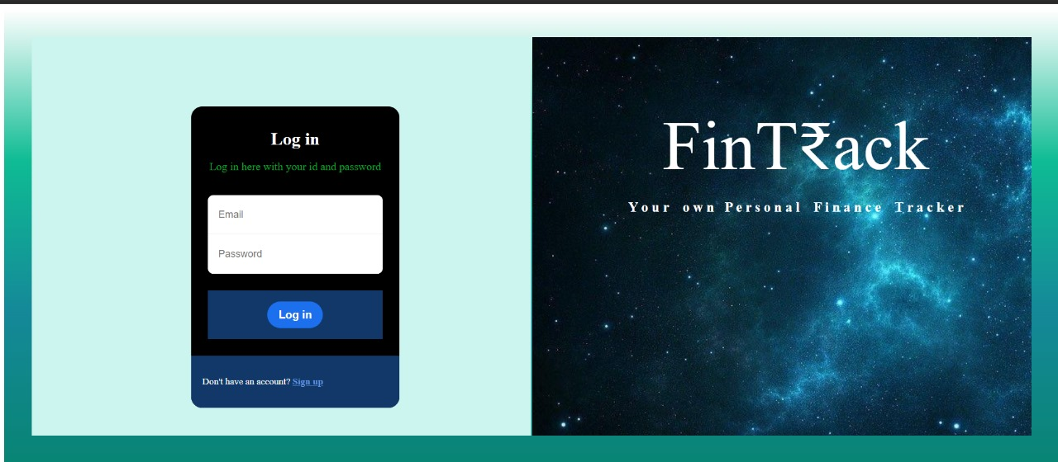

1. User Registration

Table 3: Register

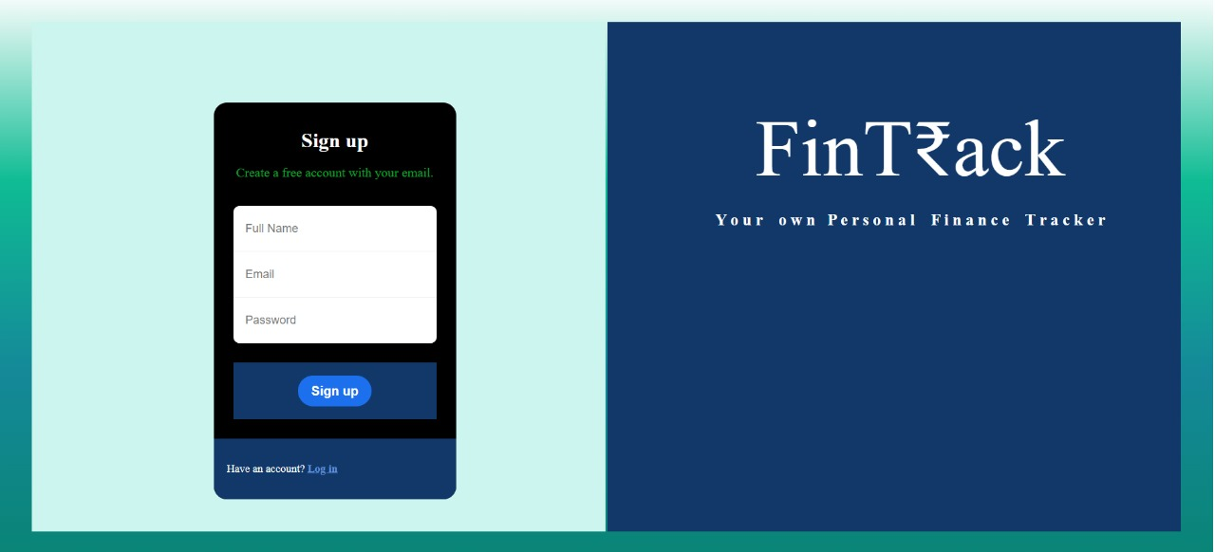

1. Dashboard:

Table 4: Dashboard

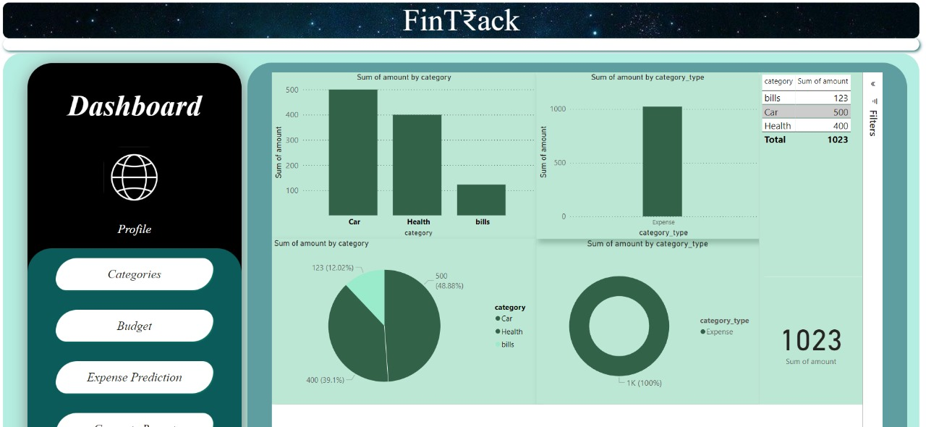

1. Input Expense and Income:

Table 5: Add Income and Expense

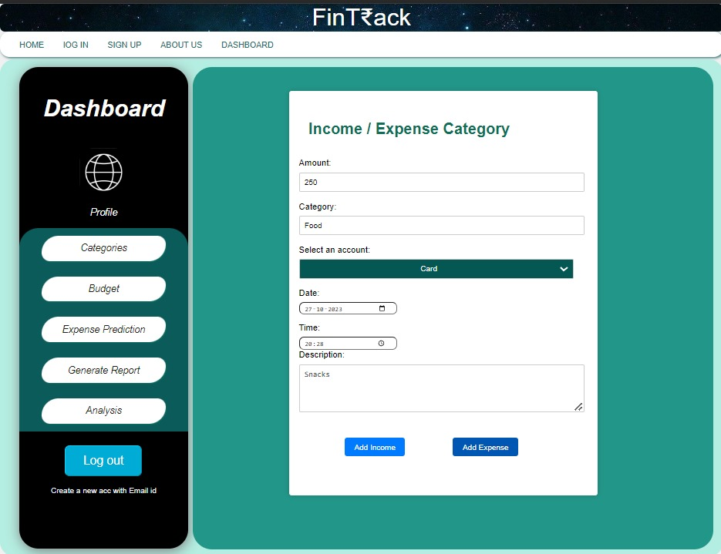

1. Income and Expense Record Table:

Table 6: Income and Expense Record

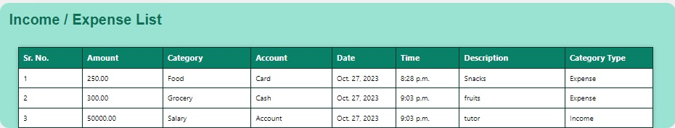

1. Budget:

Table 7: Set Budget

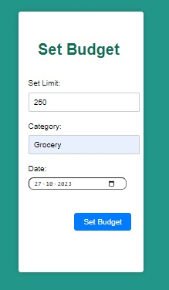

1. Budget Alert:

Table 8: Budget Alert Graph

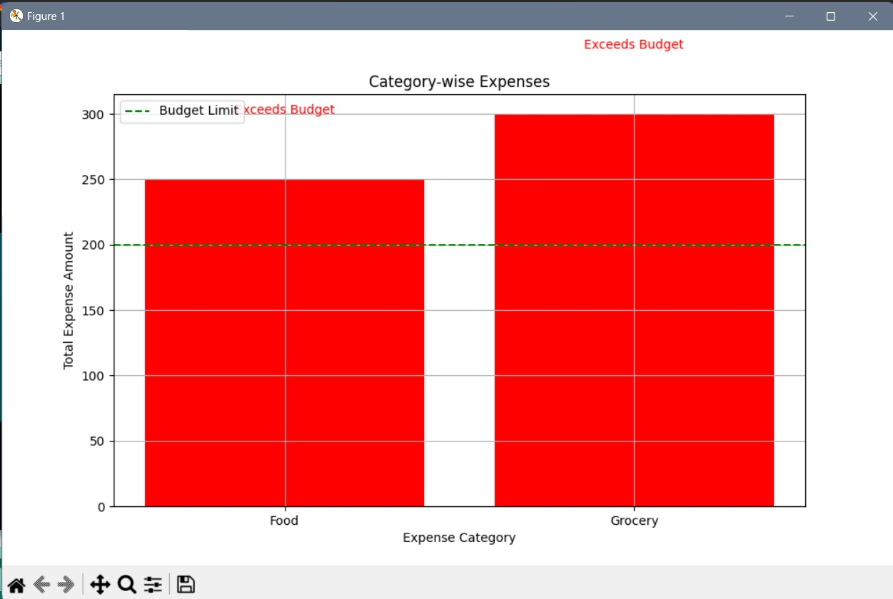

1. Expense Prediction:

Table 9: Expense Prediction Page

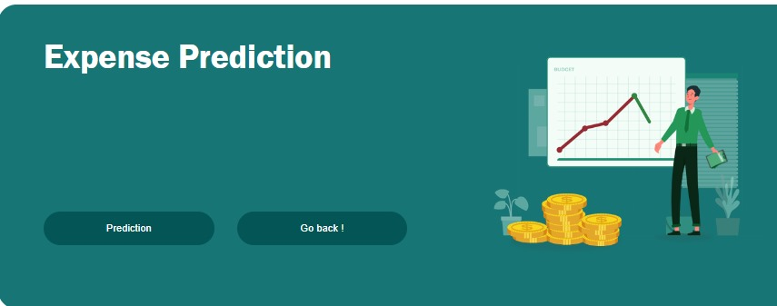

1. Expense Prediction using Linear Regression:

Table 10: Expense Prediction using Linear Regression

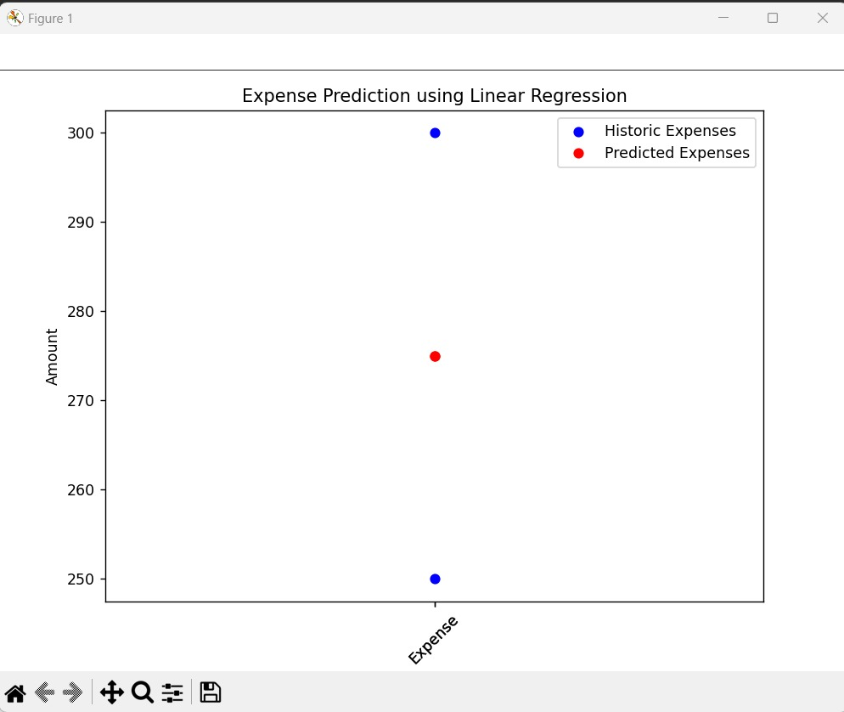

1. Generate Monthly Report:

Table 11: Monthly Report

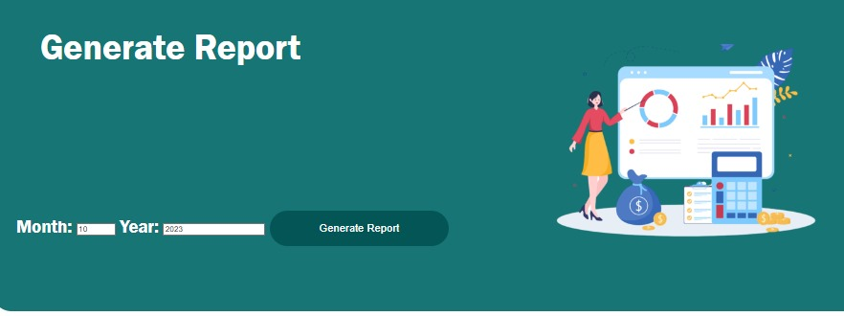

Table 12: Monthly Report: Excel Format

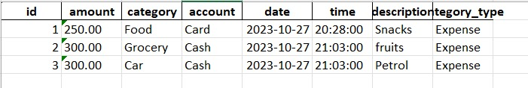

**CHAPTER 7**

**PROJECT SCHEDULING**

Table 13: Project Scheduling

|  |  |  |  |
| --- | --- | --- | --- |
| **Sr. No** | **Group Member** | **Time Duration** | **Work to be done** |
| 1. | Ekta Panchal  Aryan Palaspagar  Aditi Yadav  Hrithik Singh | **1st week of August** | Group formation and Topic finalization. Identifying the scope and objectives of the Mini Project. |
| Discussing the project topic with the help of a paper prototype. |
| 2. | Ekta Panchal  Aryan Palaspagar | **3rd week of August** | Identifying the functionalities of the Mini Project. |
| Designing the Graphical User Interface (GUI). |
| 3. | Aditi Yadav  Hrithik Singh | **2nd week of September** | Database Design |
| 4. | Aditi Yadav | **1st week of October** | Database Connectivity of all modules. |
| 5. | Ekta Panchal | **Last week of October** | Integration of all modules and  Report Writing. |

Table 14: Gantt Chart

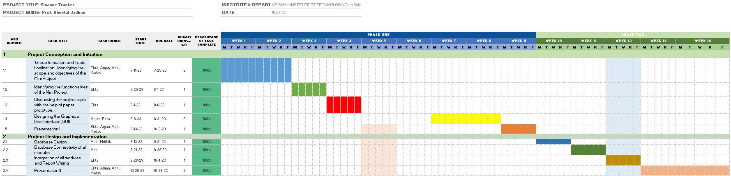

**CHAPTER 4**

**CONCLUSION**

In the development of the Finance Tracker web-based application, we have successfully created a comprehensive financial management solution that empowers users to gain control over their daily income and expenses. The project has been executed with meticulous attention to detail and adherence to software requirements. The Finance Tracker application not only serves as a practical tool for financial management but also has educational value. Through its data visualization capabilities and predictive features, users can gain insights into their financial behavior and better understand patterns and trends. This knowledge can be empowering, enabling users to make informed decisions and improve their financial literacy.

The Finance Tracker web-based application represents a significant step forward in personal finance management. Its comprehensive features, intuitive user interface, and data-driven insights empower users to take control of their finances. By addressing financial tracking, budgeting, predictive analysis, and reporting in a single platform, the application simplifies the complexities of personal finance. As we move forward, the project team remains committed to ongoing improvement, user engagement, and the delivery of a valuable tool that will continue to assist users in their journey toward financial well-being. With adaptability and an unwavering focus on user needs, the Finance Tracker project looks to the future with the potential to make an even more significant impact on the financial lives of its users.

In summary, the Finance Tracker project represents a significant step forward in personal finance management. By harnessing technology, data analysis, and collaboration, it offers a practical and educational solution for individuals seeking financial well-being and control. The commitment to scalability, security, community contributions, and user support positions the project for long-term success and impact. The journey continues, and the Finance Tracker project remains dedicated to assisting users in their pursuit of financial prosperity.

**REFERENCES**

1. <https://nevonprojects.com/daily-expense-tracker-system/>
2. <https://devfolio.co/projects/finance-tracker>
3. <https://pythongeeks.org/python-expense-tracker/>
4. <https://en.wikipedia.org/wiki/Expense_management>
5. <https://en.wikipedia.org/wiki/Personal_budget>
6. <https://www.youtube.com/watch?v=HTD86h69PtE>
7. <https://www.indeed.com/career-advice/career-development/project-expense-tracking>
8. <https://www.slideshare.net/RashnaMaharjan2/daily-expense-tracker>
9. <https://www.ijitee.org/wp-content/uploads/papers/v9i1/A4720119119.pdf>
10. <https://www.analyticsvidhya.com/blog/2021/06/linear-regression-in-machine-learning/#:~:text=Linear%20regression%20is%20a%20fundamental,make%20predictions%20for%20new%20inputs>.

**ACKNOWLEDGEMENT**

This project would not have come to fruition without the invaluable help of our **guide Prof. Sheetal Jadhav**. Expressing gratitude towards our HoD, **Prof. Anagha Aher**, and the Department of Computer Science and Engineering (Data Science) for providing us with the opportunity as well as the support required to pursue this project. We would also like to thank our teachers who gave us her valuable suggestions and ideas when we were in need of them. Lastly, we would like to thank our peers and colleagues for their helpful suggestions, discussions, and feedback, which enhanced the quality of our work.