CHAPTER 1
INTRODUCTION

1.1 INTRODUCTION TO THE PROJECT
Agriculture is the practice of cultivating natural resources to sustain human life. It combines the creativity, imagination, and skill involved in planting crops with modern production methods and new technologies. For thousands of years, agriculture has played an important role in everyday life. Before agriculture, hunting and gathering enabled humans to survive. It wasn’t until the transition to the planned sowing and harvesting of crops that humans began to thrive. Humans developed tools and practices to improve agricultural output with more efficient means of sustaining themselves. Today, the importance of agriculture in everyday life can’t be minimized. Advanced farming equipment and the increased use of fertilizers and pesticides have resulted in higher crop yields. At the same time, they’ve impacted the environment, contributing to soil and water pollution and climate change. NASA projects a 24% decline in corn crop yields by 2030, thanks to climate change. However, ensuring a healthy biodiversity can help mitigate the impact. Through sustainable agricultural practices, farmers and ranchers help ensure the profitability of their land while improving soil fertility, helping promote sound environmental practices, and minimizing environmental impacts through climate action. From temperature- and moisture-sensing devices to GPS technologies for land surveys to robots, agriculture technology can result in higher crop yields, less chemical runoff, and lower impact on natural resources.
Managing the decision-making processes of farming has always been complex because there are so many different limiting factors that aren’t within a farmer’s control. There is a concentrated effort to modernize the agriculture industry, and data-driven weather intelligence is the key to sustainability. The vision of sustainable agriculture involves people in a variety of capacities throughout the industry. In the past, agriculture focused on taking full advantage of available land and yielding as many crops as possible. There was no focus on sustainable crop production or land preservation. By adopting sustainable practices, farmers will reduce their reliance on nonrenewable energy, reduce chemical use and save scarce resources. Keeping the land healthy and replenished can go a long way. Today, there is an opportunity to develop agricultural practices from a pure production standpoint, and sustainable agriculture is the route with the most opportunity.
Weeds are one of the most important factors affecting agricultural production. The waste and pollution of farmland ecological environment caused by full-coverage chemical herbicide spraying are becoming increasingly evident. Precise spraying depends on accurately identifying and locating weeds and crops. By using precision agricultural technologies and practices, farmers can target their inputs (such as seeds, fertilizers, and pesticides) to specific areas of the field that need them the most, rather than applying them uniformly across the entire field. An imaging sensor is a key component of almost any weed detection and classification system and methods of using them are various. Individual plant classification has been successfully demonstrated with either spectral or color imaging. The spatial resolutions of spectral systems are typically not adequate for accurate individual plant or leaf detection. Then again, color-imaging methods with higher spatial resolution do not offer the important additional information the spectral data provides. Caltrans sprays roadside plant material with herbicide to prevent the weeds from becoming a fire hazard during the summer. A system that could make use of the spatial distribution information in real-time and apply only the necessary amounts of herbicide to the weed-infested area would be much more efficient and minimize environmental damage. Therefore, a high spatial resolution, real-time weed infestation detection system seems to be the solution for site-specific weed management.

1.2. STATEMENT OF THE PROBLEM
- Scope of the Problem
The need for precision agriculture is growing as farmers seek targeted, efficient, and sustainable methods for weed and pest management. Implementing real-time detection systems can significantly reduce chemical usage, mitigating environmental impact and promoting more sustainable farming practices. Efficient, targeted application through real-time detection technologies has the potential to reduce costs by optimizing the use of resources, including chemicals and fuel. Implementing effective real-time detection and pest-spraying systems can contribute to higher crop yields by addressing threats promptly and precisely.
- Intent to address the Problem.
By implementing a real-time weed detection system, we intend to empower farmers with the ability to identify and address weeds. By minimizing the overapplication of herbicides and pesticides, our system intends to reduce operational costs for farmers. Our intent is to address the multifaceted challenges posed by weed and pest management in agriculture by developing an innovative, technology-driven solution. By doing so, we aim to not only increase the efficiency and productivity of farming operations but also contribute to a more sustainable agricultural.

1.3. SYSTEM SPECIFICATIONS
HARDWARE AND SOFTWARE REQUIREMENTS SOFTWARE REQUIREMENTS:
GOOGLE COLAB:
Google Colab, short for Google Colaboratory, is a cloud-based platform provided by Google that enables users to write and execute code in a collaborative environment. It is particularly popular among data scientists, machine learning practitioners, and researchers for its convenience and accessibility. Key features and characteristics of Google Colab:
Google Colab provides a cloud-based interactive computing environment through Jupyter Notebooks. Users can create, edit, and run Python code in a web-based environment, eliminating the need for local installations. One of the standout features of Google Colab is the free access to Graphics Processing Units (GPUs) and Tensor Processing Units (TPUs). This is particularly beneficial for computationally intensive tasks, such as training machine learning models, without the need for dedicated hardware. Colab supports real-time collaboration, allowing multiple users to work on the same notebook simultaneously. Users can share their notebooks just like Google Docs, making it easy for collaboration in research or educational projects. Colab is tightly integrated with Google Drive. Users can save their notebooks directly to Google Drive, making it convenient for version control and sharing across devices.
Google Colab comes with many popular Python libraries pre-installed, including TensorFlow, PyTorch, OpenCV, and more. This reduces the setup time for users who want to start working on machine learning or data science projects immediately. Colab supports Markdown cells, allowing users to include formatted text, images, and links along with code. This makes it easy to create comprehensive and well documented notebooks. Colab supports various extensions and add-ons that enhance its functionality. Users can install additional libraries or extensions to customize their working environment. Colab integrates seamlessly with popular data visualization libraries like Matplotlib and Seaborn, enabling users to create interactive charts and graphs within their notebooks. Google Colab provides an accessible and powerful platform for individuals and teams to collaborate, experiment with code, and leverage machine learning resources in the cloud without the need for significant infrastructure setup.
PYTHON
Python is a versatile, high-level, interpreted programming language known for its simplicity, readability, and extensive support for libraries and frameworks. Here's a brief description of Python, Python is a general-purpose programming language, meaning it can be used for a wide range of applications, from web development and data analysis to artificial intelligence and scientific computing. Python's syntax is designed to be clear and readable, emphasizing code readability and reducing the cost of program maintenance. The use of indentation instead of braces contributes to a clean and visually consistent code structure. Interpreted and Interactive: Python is an interpreted language, allowing developers to run code line by line, making it highly interactive. This makes it suitable for both quick prototyping and development as well as for learning purposes. Python has a rich ecosystem of libraries and frameworks that cover various domains, including web development (Django, Flask), data science and machine learning (NumPy, Pandas, TensorFlow, PyTorch), and more. These libraries simplify complex tasks and accelerate development. Python has a large and active community of developers worldwide. This community contributes to the language's growth, shares knowledge through forums, and creates a wealth of resources for learning and troubleshooting. Python is cross-platform, meaning Python code can run on different operating systems without modification. This portability is advantageous for developing applications that need to run on various platforms. Python supports objectoriented, imperative, and functional programming paradigms. This flexibility allows developers to choose the most suitable approach for their projects. Python is a dynamically typed language, meaning the type of a variable is interpreted at runtime. This simplifies coding and increases flexibility but requires careful attention to variable types during development. Python is an open-source language, and its interpreter and standard libraries are freely available. This fosters collaboration, transparency, and the development of a large and diverse set of tools.
Python abstracts many low-level programming tasks, making it easier to focus on solving problems rather than dealing with system-specific details. This high-level nature contributes to the language's simplicity and expressiveness. Overall, Python's combination of readability, versatility, and a vast ecosystem of libraries has contributed to its popularity and widespread use across various industries and domains. It is an excellent choice for both beginners and experienced developers.
PUTTY
PuTTY is a free, open-source terminal emulator application that supports several network protocols, including SSH (Secure Shell), Telnet, and SCP (Secure Copy Protocol). Developed by Simon Tatham, PuTTY is widely used on Windows operating systems to establish secure remote connections to other devices over a network.
PuTTY serves as a terminal emulator, allowing users to interact with remote systems through a command-line interface. It provides a text-based console to execute commands and manage files on remote servers. Secure Shell (SSH) is a cryptographic network protocol for secure data communication. PuTTY supports SSH, enabling users to establish encrypted connections to remote servers securely. This is commonly used for remote administration and secure file transfers. PuTTY also supports the Telnet protocol, which allows for communication between computers over a network. However, Telnet is less secure compared to SSH, as it does not encrypt data during transmission. PuTTY includes tools like PSCP (PuTTY Secure Copy) and PSFTP (PuTTY Secure File Transfer Protocol) for secure file transfers between local and remote systems. PuTTY can be used as a serial console client, allowing users to connect to and manage devices like routers, switches, and other network equipment through serial ports. PuTTY allows users to save and manage connection settings through profiles. This makes it easy to store configurations for different servers and quickly connect to them without entering details each time. PuTTY supports X11 forwarding, allowing users to run graphical applications on a remote server and display them on a local machine. PuTTY is a portable application that does not require installation. Users can run it directly from the executable file or use a standalone executable for USB drives. PuTTY has a straightforward and user-friendly interface. It's lightweight, easy to configure, and provides essential features for remote access.
PuTTY is distributed under the MIT License, making its source code available for inspection and modification by the community. PuTTY is a popular choice for system administrators, network engineers, and anyone who needs to access remote systems securely. Its simplicity, reliability, and broad protocol support contribute to its widespread use in the IT industry.
VNC VIEWER
VNC Viewer is a graphical desktop-sharing system that allows users to remotely access and control the graphical desktop of another computer or server. The term "VNC" stands for Virtual Network Computing, and it's a protocol that enables users to view and interact with the graphical desktop environment of a remote machine over a network connection. VNC Viewer is one of the clients that can be used to connect to VNC servers. Overall, VNC Viewer is a widely used tool for remote desktop access and administration, providing a convenient way for users to control remote machines over a network.
RASPBIAN OS
Raspbian is an operating system specifically designed for the Raspberry Pi, a popular single-board computer developed by the Raspberry Pi Foundation. It is the official operating system for Raspberry Pi devices, and it is based on the Debian Linux distribution. Raspbian has been widely adopted by the Raspberry Pi community due to its performance optimizations and compatibility with the hardware. Here are some key features and characteristics of Raspbian, Raspbian is built upon the Debian operating system, a popular and widely used Linux distribution. It inherits many of Debian's features and package management tools. Raspbian is tailored to run efficiently on the Raspberry Pi's hardware architecture. It includes specific optimizations to make the most of the limited resources available on the Raspberry Pi. Raspbian typically comes with the lightweight LXDE (Lightweight X11 Desktop Environment) as the default desktop environment. This provides a graphical user interface (GUI) for users to interact with the system. Raspbian includes a variety of preinstalled software, including a web browser, text editor, file manager, and programming tools. This makes it easier for users to start working with their Raspberry Pi right out of the box. Raspbian includes the raspiconfig tool, a command-line utility that allows users to configure various system settings, including overclocking, expanding the filesystem, enabling/disabling hardware features, and more.

HARDWARE REQUIREMENTS:
RASPBERRY PI
The Raspberry Pi is a series of small, affordable, single-board computers developed by the Raspberry Pi Foundation, a UK-based charity organization. It was created with the goal of promoting computer science education and providing a low-cost computing platform for various projects. Since its introduction in 2012, the Raspberry Pi has gained immense popularity and has been widely adopted for educational, hobbyist, and industrial purposes. Here are some key features and characteristics of the Raspberry Pi, One of the defining features of the Raspberry Pi is its low cost. The boards are designed to be affordable, making them accessible to a wide range of users, including students and hobbyists. The Raspberry Pi is a credit card-sized computer with a compact form factor. Despite its small size, it includes all the essential components of a computer, such as a CPU, RAM, GPU, USB ports, HDMI output, and more. Over the years, the Raspberry Pi Foundation has released several models, each offering different specifications and capabilities. These models include the Raspberry Pi 1, 2, 3, 4, and more.
Newer models typically feature improvements in processing power, memory, and connectivity. The Raspberry Pi has a vibrant and active community of users and developers. This community contributes to a vast ecosystem of software, projects, tutorials, and support forums. The Raspberry Pi Foundation provides extensive documentation and resources for users. The Raspberry Pi was originally created to serve as an educational tool for teaching computer science and programming. It is widely used in schools and learning institutions to introduce students to computing concepts and coding. The Raspberry Pi includes a set of General-Purpose Input/Output (GPIO) pins, which allow users to connect the board to external hardware and electronics. This feature makes the Raspberry Pi suitable for various DIY and maker projects. The Raspberry Pi supports various operating systems, with Raspbian (now called Raspberry Pi OS) being the official and recommended operating system. However, other Linux distributions and even some versions of Windows 10 can run on Raspberry Pi. The Raspberry Pi can be used for a wide range of applications, including desktop computing, media centers, retro gaming consoles, home automation, robotics, IoT (Internet of Things) projects, and much more. Most Raspberry Pi models come with an HDMI output, allowing users to connect the board to a monitor or television for display. This makes it suitable for multimedia and entertainment applications. The Raspberry Pi ecosystem includes a variety of accessories and add-ons, such as cases, power supplies, cameras, sensors, and HATs (Hardware Attached on Top), which expand the capabilities of the board. Overall, the Raspberry Pi has played a significant role in democratizing access to computing and fostering innovation in various fields. Its versatility, low cost, and community support make it a popular choice for a diverse range of projects and applications.
PI CAMERA
The "Pi Camera" typically refers to the official camera modules developed by the Raspberry Pi Foundation for use with Raspberry Pi single-board computers.
➢ Specifications:
- Resolution: 5 megapixels
- Video: 1080p at 30 frames per second (fps)
- Still Image: 2592 x 1944 pixels
- Fixed focus lens
- Connection: Ribbon cable to the camera serial interface (CSI) port on the Raspberry Pi board
➢ Features:
• Compact design
• Suitable for various applications, including photography, video recording, and computer vision projects.
• Often used in hobbyist and educational projects.

MOTOR DRIVER
A motor driver is an electronic device or circuit that controls and powers an electric motor. Its primary function is to manage the flow of electrical energy from a power source to the motor, allowing for precise control of the motor's speed, direction, and other operational parameters. Motor drivers are commonly used in various applications, including robotics, automation, electric vehicles, and industrial machinery. The power stage of a motor driver is responsible for delivering the necessary electrical power to the motor. The control circuitry interprets external signals and user commands to generate the appropriate signals for the power stage. Motor drivers typically include built-in protection features, such as overcurrent protection, overvoltage protection, and thermal protection, to ensure the motor and the driver itself are not damaged during operation. In modern applications, motor drivers are designed to be compact and energy efficient, suitable for integration into space-constrained environments such as mobile devices, drones, and small-scale robotics.
DC MOTOR
A DC (direct current) motor is an electromechanical device that converts electrical energy into mechanical motion. It operates on the principle of electromagnetic induction, utilizing the interaction between magnetic fields and current-carrying conductors. DC motors are widely used in various applications, ranging from household appliances and robotics to industrial machinery and automotive systems. DC motors find applications in a wide range of devices, including power tools, fans, electric vehicles, conveyor systems, printers, and more. Their adaptability, reliability, and ease of control contribute to their widespread use. DC motors are known for their efficiency in converting electrical energy into mechanical energy. Brushless DC motors are valued for their higher efficiency, reduced maintenance needs, and longer lifespan compared to brushed counterparts. DC motors offer easy speed control by adjusting the applied voltage or using pulse-width modulation (PWM) techniques. This flexibility makes them suitable for various applications requiring variable speeds. DC motors have specific voltage and current ratings that dictate their operating parameters. The voltage supplied to the motor determines its speed, and the current influences its torque.
LI-ON BATTERY
A Li-ion (Lithium-ion) battery is a type of rechargeable battery that has become widely used in various electronic devices due to its high energy density, long cycle life, and relatively lightweight design. Li-ion batteries operate based on the movement of lithium ions between the positive and negative electrodes during the charging and discharging cycles. Li-ion batteries incorporate various safety features to prevent overheating, overcharging, and other potential issues. These may include thermal controls, voltage monitoring, and protective circuits. Li-ion batteries are widely used in portable electronic devices such as smartphones, laptops, tablets, and cameras. They are also increasingly popular in electric vehicles, renewable energy storage systems, and various other applications requiring a rechargeable power source.
JUMPER WIRES
Jumper wires are electrical wires used to create connections between various components on a breadboard or in electronic circuits. They are essential tools for prototyping, testing, and creating temporary connections during the development of electronic projects. Jumper wires come in various lengths, colors, and styles to accommodate diverse needs in circuit building. Jumper wires are reusable, making them a cost-effective and practical solution for temporary connections in electronic projects. They can be disconnected and reconnected multiple times without significant wear. Jumper wires are widely used in electronics prototyping, educational settings, and hobbyist projects. They provide a convenient means for quickly experimenting with and testing electronic circuits. Jumper wires are generally flexible, allowing them to be easily bent and routed as needed in a circuit. This flexibility aids in organizing and managing the layout of components on a breadboard.
ROBOTIC CHASSIS
A robotic chassis is the structural framework or body of a robot that provides the foundation for attaching various components, sensors, actuators, and other necessary elements to create a functional robot. The chassis serves as the main support structure and determines the overall shape and mobility of the robot. Different types of robotic chassis are designed to suit specific applications, environments, and functions. Robotic chassis can be constructed from various materials, including metals (such as aluminum or steel), plastics, composites, or a combination of materials. The choice of material depends on factors like weight, strength, and environmental conditions.
MODULES USED
OpenCV
OpenCV is an open source (see http://opensource.org) computer vision library available from http://SourceForge.net/projects/opencvlibrary. Th e library is written in C and C++ and runs under Linux, Windows and Mac OS X. Th ere is active development on interfaces for Python, Ruby, Matlab, and other languages. OpenCV was designed for computational effi ciency and with a strong focus on realtime applications. OpenCV is written in optimized C and can take advantage of multicore processors. If you desire further automatic optimization on Intel architectures [Intel], you can buy Intel’s Integrated Performance Primitives (IPP) libraries [IPP], which consist of low-level optimized routines in many diff erent algorithmic areas. OpenCV automatically uses the appropriate IPP library at runtime if that library is installed. One of OpenCV’s goals is to provide a simple-to-use computer vision infrastructure that helps people build fairly sophisticated vision applications quickly. Th e OpenCV library contains over 500 functions that span many areas in vision, including factory product inspection, medical imaging, security, user interface, camera calibration, stereo vision, and robotics. Because computer vision and machine learning oft en go hand-inhand, OpenCV also contains a full, general-purpose Machine Learning Library (MLL). Th is sublibrary is focused on statistical pattern recognition and clustering. Th e MLL is highly useful for the vision tasks that are at the core of OpenCV’s mission, but it is general enough to be used for any machine learning problem.
CHAPTER 2
2. LITERATURE SURVEY

- “Revolutionizing Weed Detection in Agriculture through the Integration of IoT, Big Data, and Deep Learning with Robotic Technology”, by “Nafil Khalid”

The author here has employed an existing model that implemented the YOLO algorithm for object detection. YOLO, or "You Only Look Once," is a neural network-based algorithm that divides an image into grids, predicting class probabilities and bounding boxes for each grid cell. They have configured the Darknet framework for GPU and OpenCV usage, then downloaded and processed a dataset from Kaggle. This dataset comprised 1300 images depicting various types of sesame and weed, serving as the training data for a custom object detector based on the YOLO algorithm. This study was to create a weed detection and classification method suitable for incorporation into agricultural robotic weed control systems. The methodology harnessed image processing algorithms based on deep learning to distinguish between crops and weeds by analyzing their distinctive features. By employing the state-of-the-art real-time object detection system, YOLOv4, the model exhibited efficient performance, showcasing superiority over other classifier-based systems in terms of both accuracy and speed.

- “Detecting Crops and Weeds in Fields using YOLOv6 and Faster R-CNN Object Detection Models”, by “Srikanth Bhat K”.

The dataset includes 1300 classifications for photos of various weed kinds and sesame crops. The size of each image is 512 x 512 in color. YOLO format is used for image labels. This data set was gathered through Kaggle. The data flow initiates with input sources, primarily composed of images. Prior to inputting the data into the object detection models, a pre-processing stage is undertaken. Pre-processing activities may encompass tasks such as data augmentation, standardization, and scaling to enhance the quality and suitability of the input data. The pre-processed data is then directed into the YOLOv6 and Faster R-CNN models for object detection. These models analyse the input data and generate output, including confidence scores and bounding boxes for each identified object. Subsequently, post-processing steps are executed on the output from both models. This post-processing stage is crucial for refining the results and involves extracting confidence scores, labels, and bounding boxes for each detected object. The final output results encompass comprehensive information, incorporating confidence scores, object labels, and the precise coordinates of bounding boxes, thereby providing a detailed and accurate depiction of the detected crops and weeds in the input images. Based on the experiment results, YOLOv6 demonstrated superior speed compared to Faster R-CNN, and both algorithms exhibited successful detection and classification of crops and weeds with a high level of accuracy.

- “CNN Based Identification of weeds in Tomato Farm”, by “Kavyapriya V K”.

An open access image dataset, “Early crop weed dataset”, provided by Agricultural University of Athens, available on GitHub includes field images of early-stage tomato, cotton, velvetleaf, and black nightshade was used. In this research, two versions of YOLO object classification algorithms, namely YOLOv5 and YOLOv7, are investigated to classify crops and weed in a tomato cultivated field. The algorithm is based on PyTorch, and the training epoch was set to 200. An F1 score of 98.89 was obtained for YOLOv5 and 96.41 for YOLOv7. YOLOv7 is computationally intensive, making it difficult to run in real-time. Considering the conclusions, it can be said that YOLOv5 stands out over real-time identification on an integrated system because it can be built into an agricultural precision sprayer.

- “Advancing Weed Detection in Agricultural Landscapes using Computer Vision”, by “Bei Ren Tan”.

This study investigates the necessity for weed detection in agricultural environments, where the presence of weeds poses substantial challenges to crop productivity. The dataset utilized in this study was sourced from the Kaggle repository. It encompasses a collection of 1300 labels assigned to photos depicting a diverse range of weeds and sesame crops. The dimensions of each image are 512 pixels by 512 pixels. To address this concern, computer vision techniques are employed to develop an accurate weed detection algorithm specifically designed to identify weed patches within images of agricultural fields. To ensure robust model evaluation, the dataset is divided into training and testing subsets, subsequently utilized in training the YOLOv3 model. The YOLOv3 model exhibits commendable precision, achieving an average precision of 66.4% for crop regions and a notable 92.5% precision in detecting weeds. These outcomes underscore the potential of artificial intelligence-driven weed detection techniques to enhance crop management practices and promote sustainable agriculture in the contemporary era.

- “A YOLOv3-based Framework for Weed Detection in Agricultural Fields”, by “Mingyu Tang”.

This paper employs the YOLOv3 network model as the central component to achieve the detection of weeds in agricultural fields, with crops as the designated target. The author used the open-source dataset CARD on Kaggle, which contains 1300 images of crops and different types of weeds, each with a label. Each image is a 512 X 512 color image. The image labels are in YOLO format. The author presents a YOLOv3-based weed detection framework, emphasizing real-time capability and crops as the primary detection objective. An enhanced YOLOv3 network model is trained, boasting improved recognition accuracy and faster processing speed. Through practical scenarios of crop weed detection, the efficacy of our target detection model is demonstrated, validated by comparisons with other high-performing target detection models. The experimental results affirm that the YOLOv3-based weed detection framework outlined in this paper not only fulfills practical application requirements but also surpasses the detection speed of other convolutional neural network target detection algorithms.

- “A Novel Approach to Weed Detection Using Segmentation and Image Processing Techniques by “Shafina Charania”.

The objective is the management of weeds, which compete with crops for essential resources like nutrients, water, and light, consequently diminishing crop yield. To train the model, we utilized an open-source Sugar beets dataset available online, comprising 1,300 images depicting both vegetation and weeds. The dataset spans various crop growth stages, ranging from sowing to maturity. For testing purposes, we selected 1,300 images from this extensive dataset, focusing on crop sizes ranging between two to five centimetres. Additionally, we applied augmentation techniques to expand the dataset size from 1,300 to 3,900 images. This paper introduces a hybrid approach that integrates semantic segmentation and the YOLO (You Only Look Once) algorithm to differentiate between plants and unwanted vegetation. The proposed model achieved an accuracy of 93% in distinguishing between crops and weeds, showcasing the effectiveness of the hybrid methodology.

- “Real time Agricultural Monitoring with Deep Learning using Wireless Sensor Framework”, by “Dibya Rup Mukherjee”

The proposed solution outlined in this paper involves the implementation of a technology-driven approach for crop monitoring and weed management. The system comprises wireless sensor nodes strategically placed across the field, coupled with a mobile unit designed for weed detection and targeted weedicide spraying. This innovative unit is integrated into an autonomous vehicle equipped with a camera module, transferring image data to a Deep Learning model hosted on a local machine via Wi-Fi. The Deep Learning model's results are then utilized for precise weedicide spraying. The Wireless Sensor Network (WSN) gathers physical information about the field, contributing to smart irrigation practices. This data-driven system not only helps in regulating the indiscriminate use of weedicides but also enables remote monitoring of the fields by farmers. Consequently, farmers can efficiently irrigate their fields, preventing soil degradation and promoting sustainable agriculture practices. From the data acquired after training the 3 deep learning models. The Xception model delivered the best accuracy but the time to train the model and get an output was significantly longer. The CNN model took less time than RESNET 50 and accuracy was also better.

- “AI-based Maize and Weeds Detection on the Edge with Corn Weed Dataset” by “Naeem Iqbal”.

This paper focuses on the Faster R-CNN version for object detection. Utilizing a convolutional neural network (CNN) as the backbone, this version identifies feature maps that are subsequently processed by a region proposal network and a detection network. The study explores the performance of multiple object detectors, including one-stage detectors (RetinaNet, FCOS, YOLO), a two-stage detector (Faster R-CNN), and a transformer-based detector (DINO), in the context of agricultural applications on various edge systems. Through experimentation with a dedicated dataset, the study reveals that the YOLOv5 object detector excels in detecting maize and performs reasonably well in identifying small objects such as tiny weeds. Other neural networks exhibit characteristics such as lower accuracy in detecting small objects, a common challenge in agricultural perception tasks. Across all networks, the YOLOv5 models achieve the highest performance, with mAP50 and mAP50:95 values of 85.4 and 53.9, respectively.

- “Accurate Detection and Precision Spraying of Corn and Weeds Using the Improved YOLOv5 Model” by “BAOJU WANG”.

This paper introduces a lightweight model based on the improved YOLOv5s and implements a precision spraying robot. A comparative analysis is conducted among YOLOv5s, YOLOv5l, YOLOv5m, and YOLOv5x, revealing that YOLOv5s strikes a balance between real-time performance and accuracy, making it more deployable on edge devices. To enhance real-time performance, the paper introduces the C3-Ghost-bottleneck module. The implemented precision spraying robot, when compared with the original model, demonstrates a 3.2% increase in the map@0.5 value, a reduction of 3.6 MB in the model file size, an increase in the Average Precision (AP) value for corn from 93.2% to 96.3%, and an increase in the AP value for weeds from 85.6% to 88.9%. Subsequently, precision spraying experiments on weeds are conducted. The results indicate an 83% recognition accuracy for weeds, an 81% probability of the spraying robot correctly identifying and accurately spraying weeds, and a detection speed of 30ms/f. These experimental outcomes confirm the feasibility of precision spraying weeding and validate the effectiveness of the improved model, offering valuable insights for the engineering application of precision weeding.

- “A lightweight model based on YOLOv8n in wheat spike detection”, by “Xuyang BAN”.

This paper employs the Global Wheat Head Detection (GWHD) dataset and compares YOLOv5, YOLOv7, and YOLOv8. YOLOv8, identified as superior in both model size and accuracy, is selected as the baseline, and a variant with reduced model depth and convolution channels (n-model) is chosen. Given the dense and small nature of wheat ears in the dataset, the paper addresses issues related to feature loss and difficulty in detecting small targets in the P5 layer with lower resolution. As a solution, the P5 feature layer is removed, and the P3 and P4 feature layers, containing more target information with less down sampling, are utilized for feature extraction. The proposed method achieves an average accuracy (mAP@0.5) of 94.3%, with the model size, number of parameters, and Frames Per Second (FPS) reaching 3.19 MB, 6.2 GFLOPs, and 300, respectively. Notably, this improved method effectively reduces the model size, decreases the number of parameters, and enhances model detection speed without compromising accuracy.

CHAPTER 3
3. SYSTEM ANALYSIS

3.1. EXISTING SYSTEM
Traditional weed removal methods often involve manual labor and basic tools. One of the simplest methods is to manually pull weeds from the soil. This method is effective for small areas or gardens. Using a hoe to cut weeds just below the soil surface. This disrupts the roots and prevents the weeds from regrowing or the use of hand tools or animal-drawn implements like plows to disturb the soil and uproot weeds. Controlled burning is used in some traditional agricultural practices to clear fields and control weed growth. However, this method requires caution and adherence to safety regulations. While they may be considered traditional, some are still widely used today, especially in smaller-scale farming and gardening.

3.2. LIMITATIONS OF EXISTING SYSTEM
While traditional weed removal methods have been used for generations and can be effective in certain situations, they also come with several disadvantages: Many traditional methods, such as hand pulling, hoeing, and manual digging, require significant manual labor. This can be time-consuming and physically demanding, especially for large areas. Traditional methods may lack precision, leading to potential damage to desirable plants or crops in the process of weed removal. Burning as a weed removal method can have environmental consequences, releasing pollutants into the air and potentially causing soil degradation. Traditional methods such as cultivation or hoeing may be weather-dependent. Wet or unfavorable weather conditions can limit the effectiveness of these methods. Traditional methods like hand pulling or manual digging may be physically demanding, requiring individuals to be physically fit to carry out the task. To address these disadvantages, modern agriculture and landscaping often incorporate a combination of traditional and advanced weed management techniques, embracing integrated approaches that consider the specific needs of the environment, crops, and desired outcomes.

3.3. PROPOSED SYSTEM
An automatic weed detection and pest spraying system is proposed in this project as it is an innovative approach to streamline agricultural processes and enhance crop management. Employ Pi camera to capture images of the agricultural field and Implement image processing and machine learning algorithms to analyze the captured images and identify the presence of weeds. Convolutional Neural Networks (CNNs) and other deep learning models can be trained to recognize different weed species. Once the weed is detected, an automated pest control system that includes sprayers capable of precisely targeting and spraying herbicides or pesticides on the detected weeds.

3.4. ADVANTAGES OF THE PROPOSED SYSTEM
The system enables precision agriculture by targeting specific areas with weed infestations, reducing the overall use of herbicides, and minimizing environmental impact. Automation enhances efficiency by automating the time-consuming tasks of manual weed detection and spraying, allowing farmers to focus on other essential aspects of crop management. Automated systems can potentially reduce labor costs associated with manual weeding and spraying. By accurately targeting only the areas with weed infestations, the system minimizes the environmental impact of herbicide use, promoting sustainable and eco-friendly agriculture. The system can provide real-time monitoring and feedback, allowing farmers to make informed decisions based on the current state of the field.

CHAPTER 4

4. SYSTEM DESIGN

4.1 HIGH LEVEL DESIGN (ARCHITECTURAL)

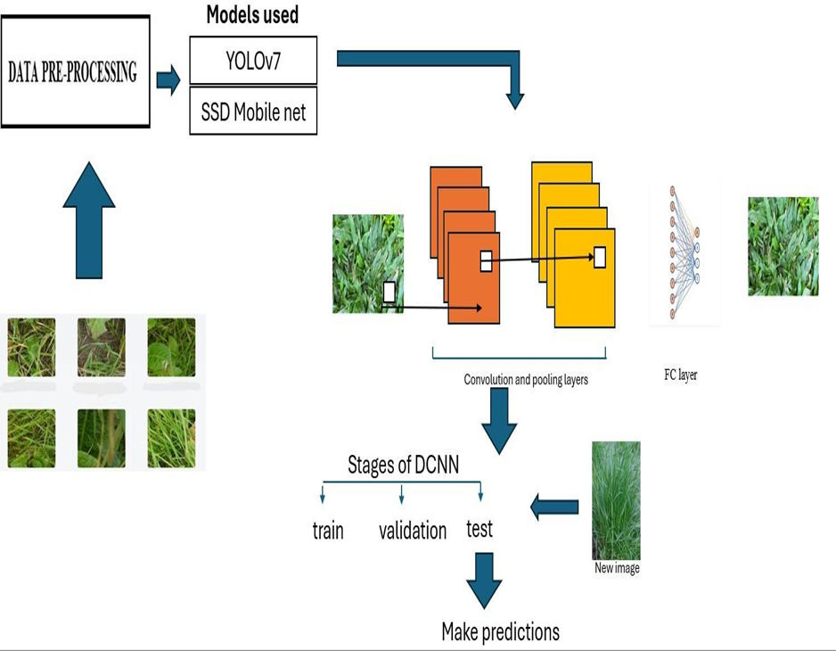

Fig 1: System design for real time weed detection using CNN

4.2 LOW LEVEL DESIGN

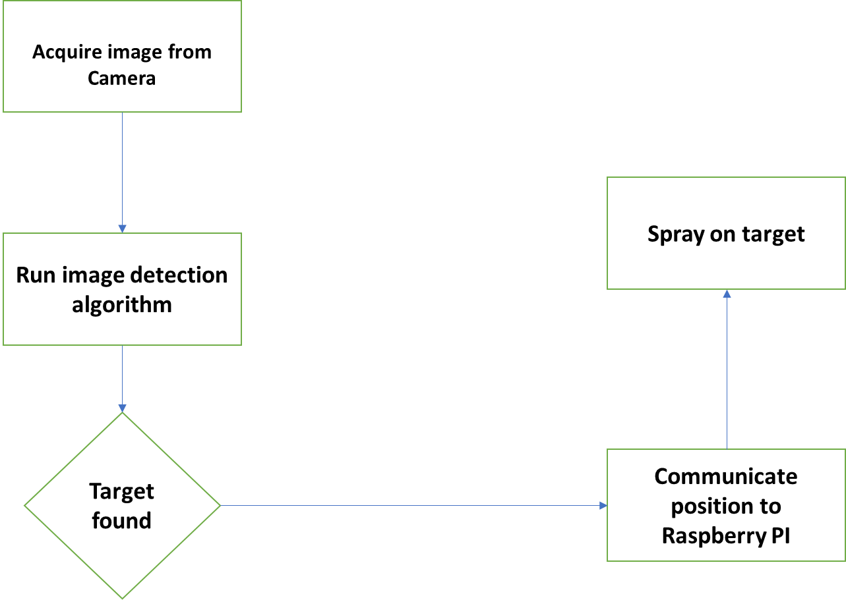
Fig.2 Block diagram representing weed detection and automatic herbicide sprayer

CHAPTER 5
- DATA COLLECTION AND PREPARATION

5.1 DATA SOURCES
Images of grass and weeds growing in various places were acquired using either a smartphone camera or a hand-held digital camera. Dataset is prepared for model building. Image labelling and annotation is done by roboflow. The dataset consists of 1793 images that are split into training, test, and validation sets.

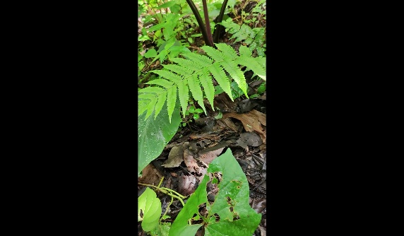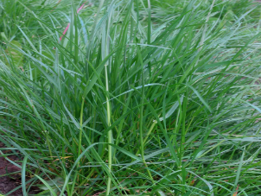
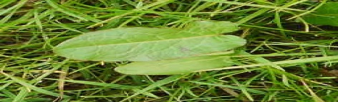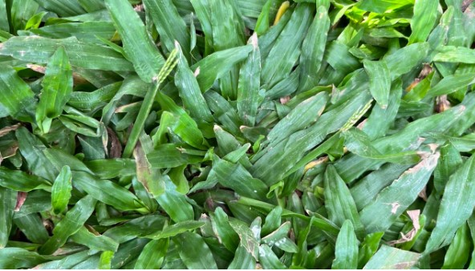
Fig 3. Images from dataset

5.2 DATA PROFILING

The images were saved in .jpeg format. Images were captured from different view angles, under natural field light conditions. All the images are of the same size 256*256.The images in the dataset are labelled with a class name “grass”. By using the YOLOv7 PyTorch export, we export the suitable version of our dataset from the roboflow after annotations. Then, the model is initially trained on a portion of the COCO dataset.

CHAPTER 6
6.METHODOLOGY

6.1 DATA MODELS
OBJECT DETECTION
Object classification is typically performed using machine learning techniques, where a model is trained on a labelled dataset of images and their associated class labels. The trained model can then be used to classify new images by assigning them a class label based on their learned features.
Object detection is a computer vision task that deals with identifying and locating objects of certain pre-defined classes within input images. With the development of deep learning, object detection has achieved very promising results. There are several algorithms and models, such as R-CNN, Faster R-CNN, YOLO, and SSD, that have been developed for object detection. These algorithms and models are being used in various applications.
A convolutional neural network (CNN) is a category of machine learning model, namely a type of deep learning algorithm well suited to analyzing visual data. CNNs -- sometimes referred to as convnets -- use principles from linear algebra, particularly convolution operations, to extract features and identify patterns within images. Although CNNs are predominantly used to process images, they can also be adapted to work with audio and other signal data.CNN architecture is inspired by the connectivity patterns of the human brain -- in particular, the visual cortex, which plays an essential role in perceiving and processing visual stimuli.CNNs use a series of layers, each of which detects different features of an input image. Depending on the complexity of its intended purpose, a CNN can contain dozens, hundreds or even thousands of layers, each building on the outputs of previous layers to recognize detailed patterns.The process starts by sliding a filter designed to detect certain features over the input image, a process known as the convolution operation (hence the name "convolutional neural network"). The result of this process is a feature map that highlights the presence of the detected features in the image. This feature map then serves as input for the next layer, enabling a CNN to gradually build a hierarchical representation of the image. In the final layers of a CNN, the model makes a final decision -- for example, classifying an object in an image -- based on the output from the previous layers.The convolutional layer is the fundamental building block of a CNN and is where the majority of computations occur. This layer uses a filter or kernel -- a small matrix of weights -- to move across the receptive field of an input image to detect the presence of specific features.
The process begins by sliding the kernel over the image's width and height, eventually sweeping across the entire image over multiple iterations.This transforms the input image into a set of feature maps or convolved features, each of which represents the presence and intensity of a certain feature at various points in the image.
CNNs often include multiple stacked convolutional layers. Through this layered architecture, the CNN progressively interprets the visual information contained in the raw image data. In the earlier layers, the CNN identifies basic features such as edges, textures or colors. Deeper layers receive input from the feature maps of previous layers, enabling them to detect more complex patterns, objects and scenes.The pooling layer of a CNN is a critical component that follows the convolutional layer.The pooling layer aims to reduce the dimensionality of the input data while retaining critical information, thus improving the network's overall efficiency. This is typically achieved through downsampling: decreasing the number of data points in the input.
For CNNs, this typically means reducing the number of pixels used to represent the image. The most common form of pooling is max pooling, which retains the maximum value within a certain window (i.e., the kernel size) while discarding other values.The term fully connected means that each neuron in one layer is connected to each neuron in the subsequent layer.
The fully connected layer integrates the various features extracted in the previous convolutional and pooling layers and maps them to specific classes or outcomes. Each input from the previous layer connects to each activation unit in the fully connected layer, enabling the CNN to simultaneously consider all features when making a final classification decision.

Not all layers in a CNN are fully connected. Because fully connected layers have many parameters, applying this approach throughout the entire network would create unnecessary density, increase the risk of overfitting and make the network very expensive to train in terms of memory and compute. CNNs have fundamentally changed our approach towards image recognition as they can detect patterns and make sense of them. They are considered the most effective architecture for image classification, retrieval and detection tasks as the accuracy of their results is very high. They have broad applications in real-world tests, where they produce high-quality results and can do a good job of localizing and identifying where in an image a person/car/bird, etc., are. This aspect has made them the go-to method for predictions involving any image as an input.

There are several metrics commonly used to evaluate the performance of object detection models:
1. Mean Average Precision (mAP): The precision of a model is defined as the number of true positives divided by the number of true positives plus false positives. The mAP metric takes into account both the precision and recall of the model and is calculated as the mean of the average precision for each class. A higher mAP value indicates a better performance of the model.
2. Average Precision (AP): It is a measure of the precision of the model at different recall levels. The precision is defined as the number of true positives divided by the number of true positives plus false positives. The recall is defined as the number of true positives divided by the number of true positives plus false negatives. AP is calculated as the area under the precision-recall curve. A higher AP value indicates a better performance of the model.

6.2 MODEL SELECTION
Model selection in a weed detection project involves choosing a machine learning or computer vision model that can effectively identify and classify weeds in images. The choice of the model depends on various factors such as the characteristics of the dataset, the complexity of the task, available computational resources, and the desired level of accuracy. Models like ResNet, MobileNet, or EfficientNet are often used for transfer learning. Convolutional Neural Networks (CNNs) are commonly used for image classification tasks.Architectures like YOLO (You Only Look Once) or Faster R-CNN for object detection if precise localization of weeds is required.

YOLO
YOLO is used to implement real-time object detection algorithms. The YOLO v7 model was authored by WongKinYiu and Alexey Bochkovskiy (AlexeyAB). For instance, you could use YOLO to detect cars in a video, or people walking on a street. The YOLO (You Only Look Once) v7 model is the latest in the family of YOLO models. YOLO models are single stage object detectors. In a YOLO model, image frames are featured through the backbone. These features are combined and mixed in the neck, and then they are passed along to the head of the network YOLO predicts the locations and classes of objects around which bounding boxes should be drawn.One of the main advantages of YOLO v7 is its speed. It can process images at a rate of 155 frames per second, much faster than other state-of-the-art object detection algorithms. Even the original baseline YOLO model was capable of processing at a maximum rate of 45 frames per second. This makes it suitable for sensitive real-time applications such as surveillance and self-driving cars, where higher processing speeds are crucial. YOLO conducts a post-processing via non-maximum suppression (NMS) to arrive at its final prediction. YOLO models were used widely by the computer vision and machine learning communities for modelling object detection because they were small, nimble, and trainable on a single GPU.
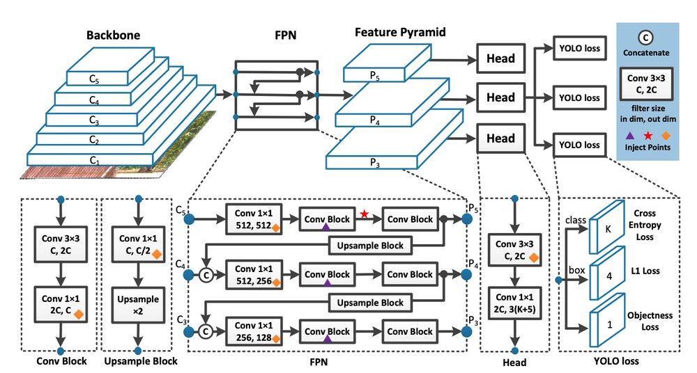fig.4 YOLO network architecture

SINGLE SHOT OBJECT DETECTION (SSD)
Single-shot object detection is a type of object detection algorithm that is able to detect objects within an image or video in a single pass without the need for multiple stages or region proposals.
Single-shot object detectors, such as YOLO (You Only Look Once) and SSD (Single Shot MultiBox Detector), use a single convolutional neural network (CNN) to directly predict the class labels and bounding boxes of objects within an image or video. These models are trained end-to-end using a large dataset of labeled images and their associated object-bounding boxes.
Single-shot object detection is considered faster and more efficient than two-shot object detection methods, as it eliminates the need for multiple stages and can be run in real time on even low-powered devices. However, it may not have the same level of accuracy as the multi-stage methods.The SSD (Single Shot Multibox Detector) approach relies on a feed-forward convolutional network that generates a fixed-size set of bounding boxes and associated scores indicating the presence of object class instances within those boxes. Subsequently, a non-maximum suppression step is employed to yield the final detections. The initial layers of the network adhere to a standard architecture commonly used for high-quality image classification. These initial layers are truncated before any classification layers, and we refer to this as the base network. To enhance the network for object detection, we introduce additional structure, including:
1. multi-scale feature maps for detection: We extend the base network by appending convolutional feature layers to its truncated end. These added layers progressively decrease in size, enabling the prediction of detections at multiple scales. Unlike other approaches such as Overfeat and YOLO, which operate on a single-scale feature map, our method utilizes distinct convolutional models for predicting detections on each feature layer.
2. Convolutional Predictors for Detection: Each additional feature layer, or optionally an existing feature layer from the base network, contributes to generating a predefined set of detection predictions through a series of convolutional filters. These filters are visually represented on the SSD network architecture in Figure 2. Consider a feature layer with dimensions m × n and p channels; the fundamental component for predicting parameters of a potential detection is a 3 × 3 × p small kernel. This kernel yields either a category score or a shape offsets concerning the default box coordinates. At every location within the m × n grid where the kernel is applied, it generates an output value. The output values for bounding box offsets are expressed relative to a default box position corresponding to each feature map location, as opposed to YOLO's architecture that utilizes an intermediate fully connected layer instead of a convolutional filter for this purpose.
3. Default Boxes and Aspect Ratios: Each feature map cell, across multiple feature maps at the network's top, is associated with a set of default bounding boxes. These default boxes systematically tile the feature map, ensuring a fixed position relative to each corresponding cell. For every feature map cell, we predict offsets relative to the default box shapes within the cell, along with per-class scores indicating the presence of a class instance in each box. Specifically, for each out of k boxes at a given location, we calculate c class scores and 4 offsets relative to the original default box shape. This results in a total of (c + 4)k filters applied around each location in the feature map, generating (c + 4)kmn outputs for an m × n feature map. Refer to Figure 1 for an illustration of default boxes. Our approach to default boxes resembles the anchor boxes in Faster R-CNN, but we apply them across various feature maps with different resolutions. This allows us to efficiently discretize the space of potential output box shapes.
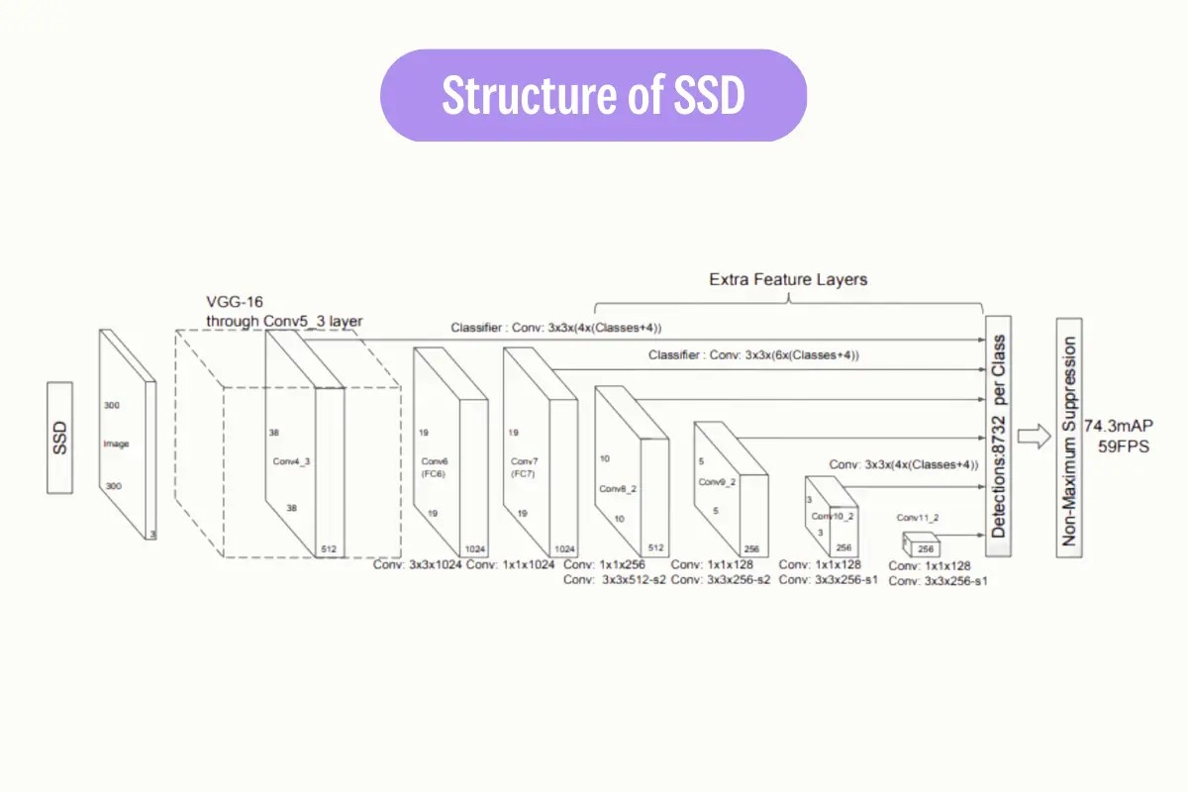
Fig.5 Structure of SSD

6.3 MODEL BUILDING
To train our dataset we take the following steps: • Install YoloV7 dependency. • Load custom dataset from Roboflow in YoloV7 format. • Run YoloV7 training. • Evaluate YoloV7 performance. • Run YoloV7 inference on test images.
Roboflow: Developers use Roboflow to build better computer vision models quickly and accurately. Many developers use Roboflow for (automatic) annotation (because the model can’t learn anything, so to make our model understand anything we need to annotate the data), convert the dataset formats (like YOLOv7), train, deploy, and improve their datasets/models.
To use YOLOv7 efficiently, we need to convert our datasets into a specific format that the YoloV7 model can understand.
• Input format capability: YoloV7 expects to input data in a specific format, which includes images and corresponding annotation files. The annotation contains the information and class of objects within the images.
• Standardization: Using a standardized format like YoloV7 helps maintain consistency and capability within the computer vision community. The researchers and developers working with YoloV7 can readily understand and work with datasets in this format.
• Preprocessing: Resizing and normalizing bounding box coordinates helps to prepare the data for training the model.
Git clone is used to copy an existing Git repository into a new local directory. The Git clone command will create a new local directory for the repository, copy all the contents of the specified repository, and all the required packages are installed using pip install command. By using the YOLOv7 PyTorch export, we export the suitable version of our dataset from the roboflow after annotations. Then, the model is initially trained on a portion of the COCO dataset. This pre-training is typically done on a large-scale dataset because it helps the model learn general features and representations that are useful for various computer vision tasks. Train the modified YOLOv7 model on our dataset while keeping the pretrained weights fixed for the initial layers. This process is known as fine-tuning. Before training, the script loads and prepares the training data. The data is often split into training and validation sets. Our dataset is split in 90% training set and 10% validation set. The main part of the train.py script is the training loop. In this loop, the YOLOv7 model is trained on the training data. During each iteration, the model makes predictions on the training data, computes loss functions, and updates the model’s weights through backpropagation. Then the YOLOv7 framework uses the detect.py command to apply the trained model to new data for inference. detect.py analyzes the content of the images or frames of the video and identifies objects, along with their class labels and bounding box coordinates.
We use 'ssd_mobilenet_v1_fpn_640x640_coco17_tpu-8'. This model is pre-trained on the COCO (Common Objects in Context) dataset and uses the Single Shot Multibox Detector (SSD) with MobileNet as its base architecture. We have separate directories for scripts, models, annotations, images, etc., to keep the project well-organized. We ensure that the required directories specified in the paths dictionary exist, and if not, it creates them by using -mkdir command as our operating system is windows. We Make sure to check the system requirements and dependencies for TensorFlow Object Detection API installation based on your operating system. We are preparing the environment by downloading a pre-trained model and creating a label map for a custom object detection task, here we use only one label as weed and ensure that the necessary dependencies are installed. We convert the images into xml file as it is a suitable format for our model and save it in a zipped file. The contents of the zip file are then extracted using the -tar command and split into training and test set for model training and evaluation. Once the model training is done we evaluate by passing random images to make our predictions.

6.4 RESULTS

In a comparative evaluation between YOLOv7 and SSD MobileNet for weed detection, SSD MobileNet demonstrated exceptional accuracy, achieving a perfect score of 100%, while YOLOv7 exhibited a slightly lower accuracy of 94.4%. The accuracy of SSD MobileNet suggests its robust capability to precisely identify weeds across various conditions and environments. On the other hand, YOLOv7, though slightly less accurate, still performed admirably with a 94.4% accuracy rate. The choice between the two models may depend on specific project requirements, computational efficiency, or deployment constraints. Both models showcase advanced object detection capabilities, and the decision to use one over the other should consider a balance between accuracy and practical considerations in the context of our weed detection project.

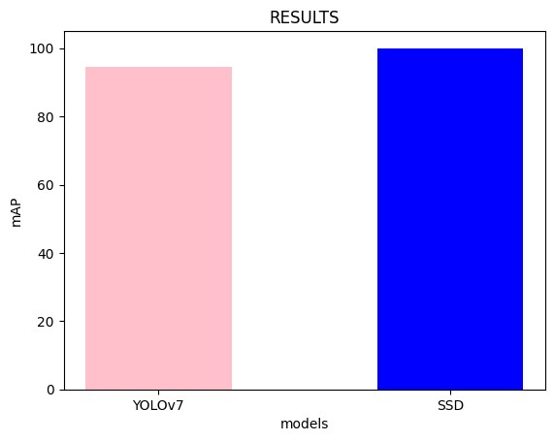
Fig.6 Accuracy of YOLOv7 and SSD

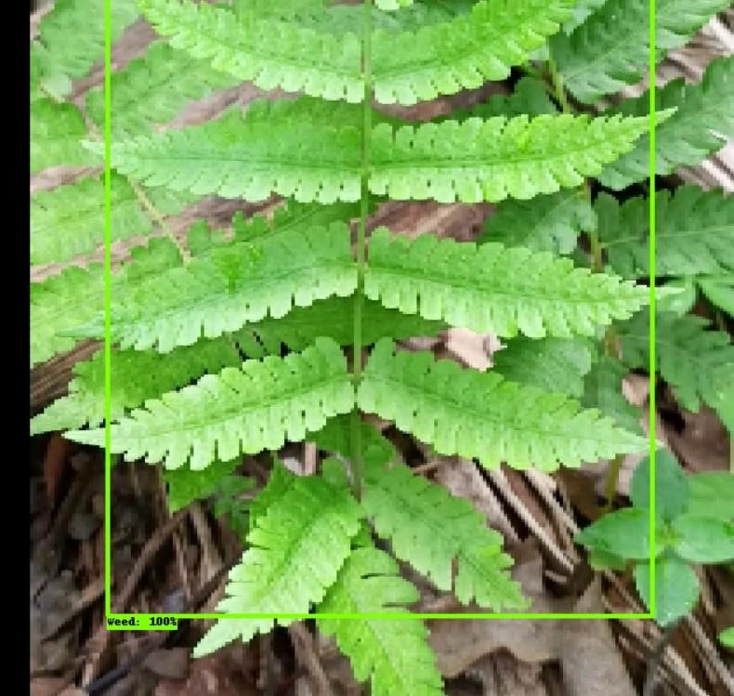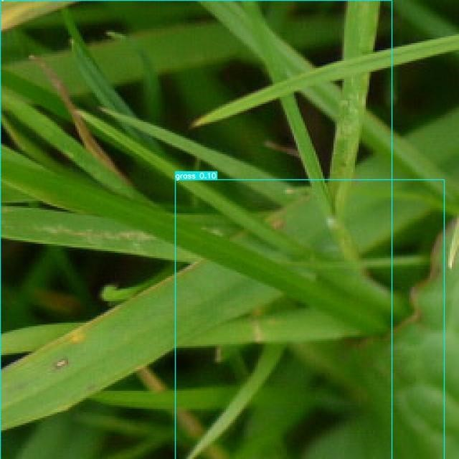
Fig.8 weed detection using SSD mobilenet fig.9 weed detection using YOLOv7
CHAPTER 7

7.TESTING

The box loss is associated with the accuracy of bounding box predictions. A decrease in box loss over epochs implies that the model is improving in accurately localizing and drawing bounding boxes around objects in the images. This is crucial for precise object detection and localization.Class loss is related to the accuracy of predicting object classes. As the class loss decreases over epochs, it indicates that the model is becoming more proficient at correctly identifying the classes of objects present in the images. This is essential for the model to distinguish between different categories of objects, such as weeds in the context of our weed detection project. A graph depicting the gradual decrease of both box loss and class loss with increasing epochs is a positive indicator in the context of training an object detection model, such as YOLO (You Only Look Once) or SSD (Single Shot Multibox Detector). The decreasing trends in box loss and class loss suggest that the model is converging and learning from the training data. It implies that the model is learning to accurately localize objects and classify them, key aspects for successful object detection in applications like our weed detection project.

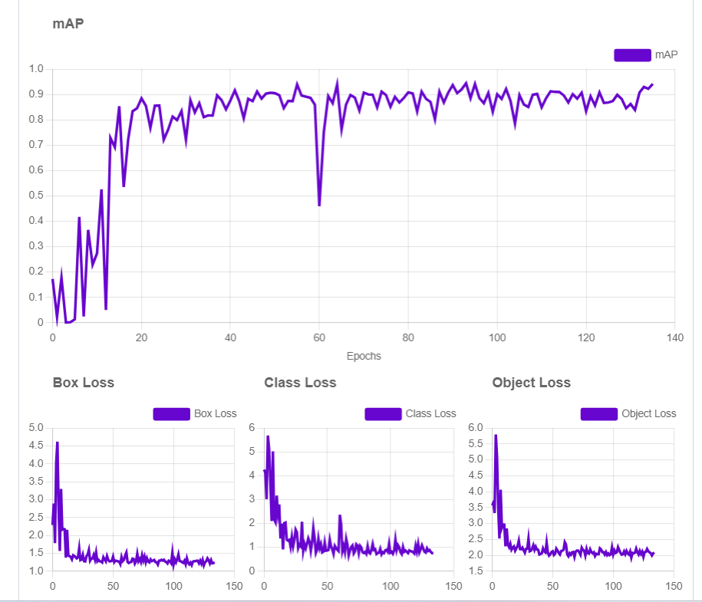
Fig 10. Training graphs
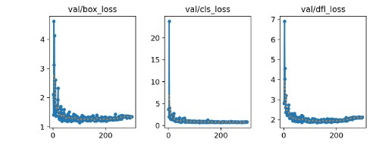
Fig.11 Validation graphs

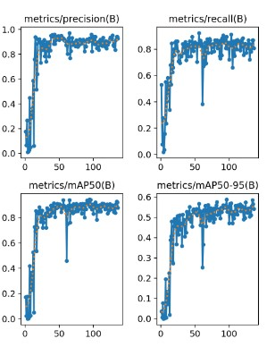Fig.12 Evaluation metrics YOLOv7

REAL TIME DEPLOYMENT USING RASPBERY Pi

We have deployed a system using a Raspberry Pi to efficiently run a weed detection model. The Raspberry Pi is powered by a 5W supply obtained from a portable power bank. The Pi camera captures images, and these images are transmitted to the Raspberry Pi for classification. The primary goal is to distinguish between weeds and plants in the captured images. Upon classification, if the detected object is identified as a weed, the Raspberry Pi triggers a signal to activate a power supply, providing 10W to the pump motor. This motor is responsible for spraying pesticide on the identified weed. Once the spraying process is complete, the power supply is halted. Simultaneously, a set of batteries is employed to power a DC motor, allowing it to move forward. This motion continues for a predefined number of iterations, in this case, 10, and can be adjusted as needed. If the classification indicates that the detected object is a plant, the Raspberry Pi refrains from triggering the pesticide spray. Instead, the DC motor moves forward, carrying out its designated task. In our project we have deployed our system in real time in the agricultural field (i.e. REVA krushi). We have classified beans as crops and grass as weed. The entire system is designed to be energy-efficient, with the Raspberry Pi managing the decision-making process based on image classification, thereby optimizing the use of resources, and minimizing unnecessary actions.

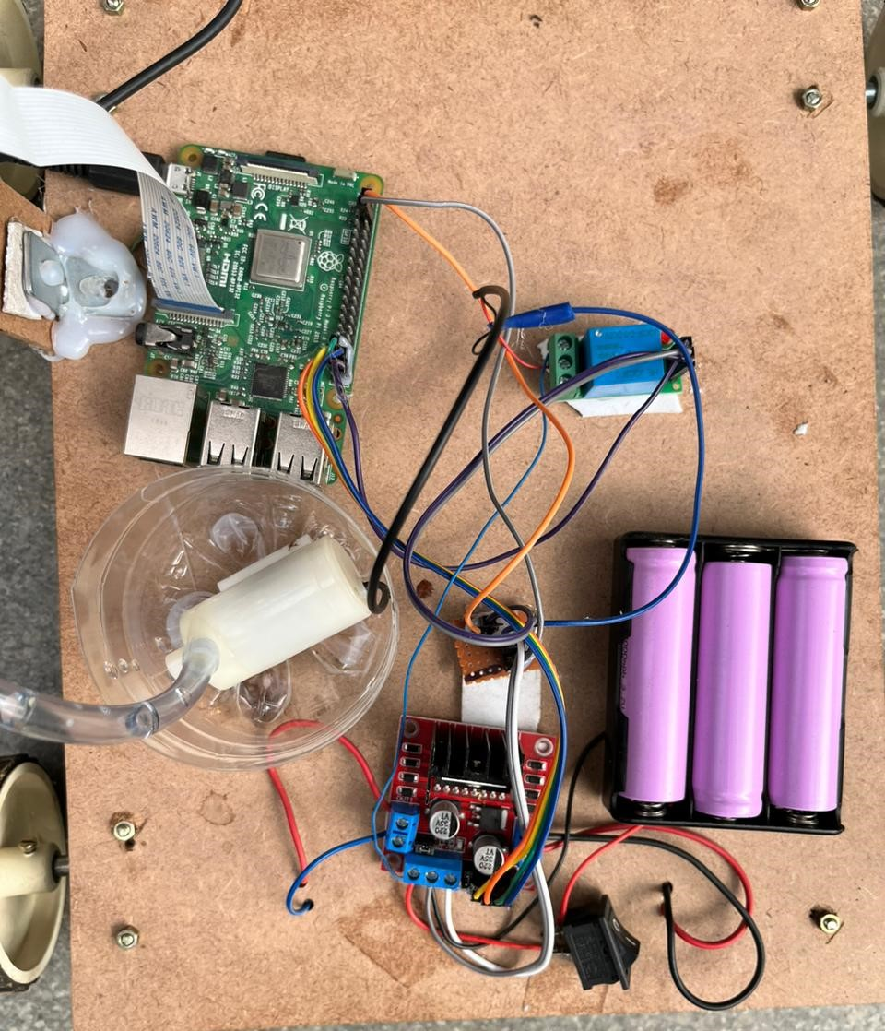
Fig.13 Weed detection and automatic herbicide sprayer device

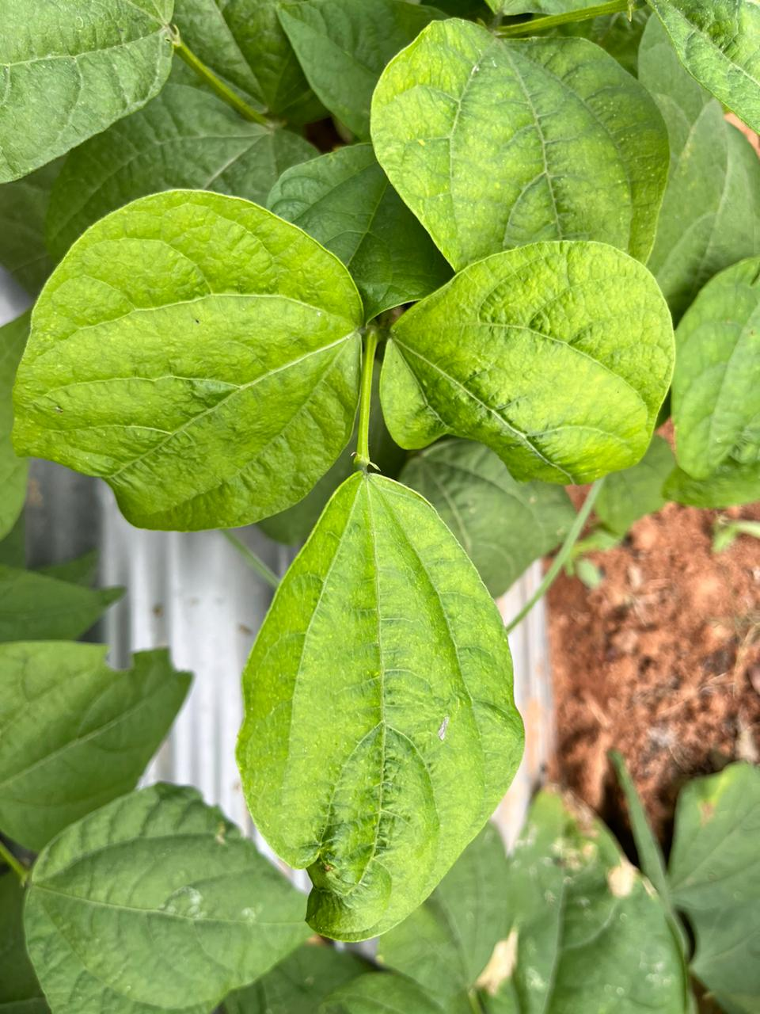
Fig.14 Beans plant used for classified as crop.

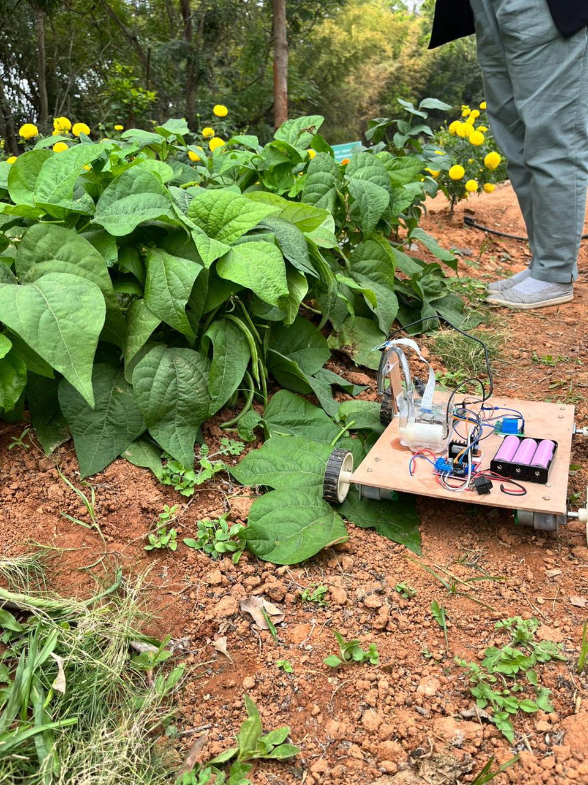
Fig.15 Real time weed detection and pest spraying in reva krushi.

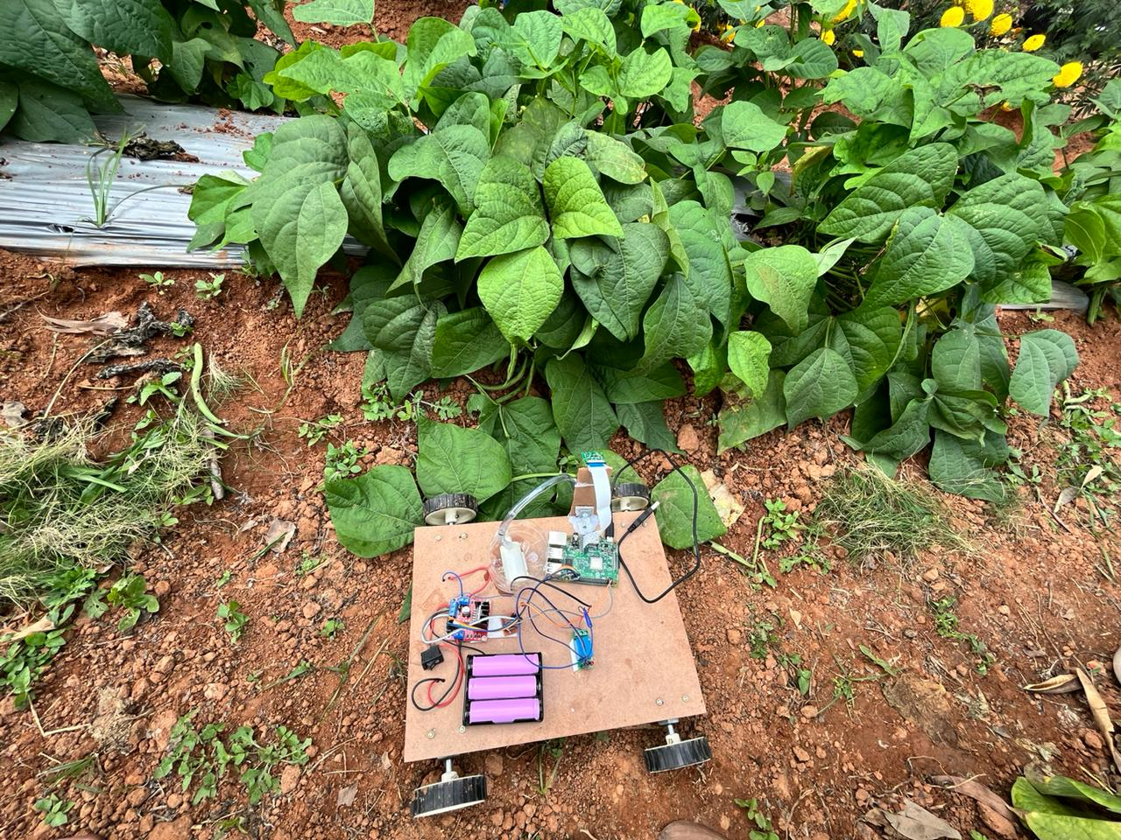
Fig.16 Real time weed detection and pest spraying in reva krushi.

FUTURE ENHANCEMENT
Implement advanced data augmentation techniques to artificially increase the size of your training dataset. This can include random rotations, flips, and changes in lighting conditions, making the model more robust. Consider building an ensemble of models, combining the strengths of YOLOv7 and SSD MobileNet. Ensemble models often provide improved accuracy and robustness by aggregating predictions from multiple models. This crop-weed identification mechanism could be further extended by adding sensors to our system.

CHAPTER 8

8.CONCLUSION

As a result of implementing our innovative system, we can discern and delineate areas within the crop where weeds have taken root. A cutting-edge, real-time in-row weed control strategy has been devised through the seamless integration of a state-of-the-art machine vision algorithm with a precision high-resolution micro-jet sprayer. The machine vision algorithm employs advanced crop signaling principles to effectively identify and categorize both weeds and crops within the agricultural landscape. This automated model or robotic system proves advantageous, particularly in the context of selective herbicide application, leading to a substantial reduction in overall herbicide usage across the field. This not only contributes to enhanced environmental sustainability but also serves as a proactive measure to mitigate potential health concerns associated with excessive herbicide exposure.

BIBILOGRAPHY

Journal Articles
[9] BAOJU WANG, et.al, (2023). “Accurate Detection and Precision Spraying of Corn and Weeds Using the Improved YOLOv5 Model”. Digital Object Identifier 10.1109/ACCESS.2023.3258439.

Conference papers:

[1] Nafil Khalid, et.al, (2023). “Revolutionizing Weed Detection in Agriculture through the Integration of IoT, Big Data, and Deep Learning with Robotic Technology”. 979-8-3503-2297-2/23/31.00 © 2023 IEEE.
[2] Srikanth Bhat K, et.al, (2023). “Detecting Crops and Weeds in Fields using YOLOv6 and Faster R-CNN Object Detection Models”. 979-8-3503-0663-7/23/$31.00 ©2023 IEEE.
[3] Kavyapriya V K, et.al, (2023). “CNN Based Identification of weeds in Tomato Farm”. IEEE – 56998.
[4] Bei Ren Tan, et.al, (2023). “Advancing Weed Detection in Agricultural Landscapes using Computer Vision”. 979-8-3503-0415-2/23/$31.00 ©2023 IEEE.
[5] Mingyu Tang, et.al, (2023). “A YOLOv3-based Framework for Weed Detection in Agricultural Fields”. 979-8-3503-0245-5/23/$31.00 ©2023 IEEE.
[6] Shafina Charania, et.al, (2023). “A Novel Approach to Weed Detection Using Segmentation and Image Processing Techniques”. 979-8-3503-1120-4/23/$31.00 ©2023 IEEE.
[7] Dibyarup Mukherjee, et.al, (2023). “Real time Agricultural Monitoring with Deep Learning using Wireless Sensor Framework”. 979-8-3503-0511-1/23/$31.00 ©2023 IEEE.
[8] Naeem Iqbal, et.al, (2023). “AI-based Maize and Weeds Detection on the Edge with CornWeed Dataset”. CFP2385N-ART ©2023, PTI.
[10] Xuyang BAN, et.al, (2023). “A lightweight model based on YOLOv8n in wheat spike detection”. 979-8-3503-0351-3/23/$31.00 ©2023 IEEE.

APPENDIX – Sample Source Code/Pseudo Code
SSD Mobilenet
from google.colab import drive
drive.mount('/content/drive')

import os

"""Importing from tensorflow zoo.
https://github.com/tensorflow/models/blob/master/research/object_detection/g3doc/tf2_detection_zoo.md

ssd_mobnet
"""

CUSTOM_MODEL_NAME = 'ssd_mobilenet'
PRETRAINED_MODEL_NAME = 'ssd_mobilenet_v1_fpn_640x640_coco17_tpu-8'
PRETRAINED_MODEL_URL = 'http://download.tensorflow.org/models/object_detection/tf2/20200711/ssd_mobilenet_v1_fpn_640x640_coco17_tpu-8.tar.gz'
TF_RECORD_SCRIPT_NAME = 'generate_tfrecord.py'
LABEL_MAP_NAME = 'label_map.pbtxt'

paths = {
'WORKSPACE_PATH': os.path.join('Tensorflow', 'workspace'),
'SCRIPTS_PATH': os.path.join('Tensorflow','scripts'),
'APIMODEL_PATH': os.path.join('Tensorflow','models'),
'ANNOTATION_PATH': os.path.join('Tensorflow', 'workspace','annotations'),
'IMAGE_PATH': os.path.join('Tensorflow', 'workspace','images'),
'MODEL_PATH': os.path.join('Tensorflow', 'workspace','models'),
'PRETRAINED_MODEL_PATH': os.path.join('Tensorflow', 'workspace','pre-trained-models'),
'CHECKPOINT_PATH': os.path.join('Tensorflow', 'workspace','models',CUSTOM_MODEL_NAME),
'OUTPUT_PATH': os.path.join('Tensorflow', 'workspace','models',CUSTOM_MODEL_NAME, 'export'),
'TFJS_PATH':os.path.join('Tensorflow', 'workspace','models',CUSTOM_MODEL_NAME, 'tfjsexport'),
'TFLITE_PATH':os.path.join('Tensorflow', 'workspace','models',CUSTOM_MODEL_NAME, 'tfliteexport'),
'PROTOC_PATH':os.path.join('Tensorflow','protoc')
}

files = {
'PIPELINE_CONFIG':os.path.join('Tensorflow', 'workspace','models', CUSTOM_MODEL_NAME, 'pipeline.config'),
'TF_RECORD_SCRIPT': os.path.join(paths['SCRIPTS_PATH'], TF_RECORD_SCRIPT_NAME),
'LABELMAP': os.path.join(paths['ANNOTATION_PATH'], LABEL_MAP_NAME)
}

for path in paths.values():
if not os.path.exists(path):
if os.name == 'posix':
!mkdir -p {path}
if os.name == 'nt':
!mkdir {path}

""" Download TF Models Pretrained Models from Tensorflow Model Zoo and Install TFOD"""

if os.name=='nt':
!pip install wget
import wget

if not os.path.exists(os.path.join(paths['APIMODEL_PATH'], 'research', 'object_detection')):
!git clone https://github.com/tensorflow/models {paths['APIMODEL_PATH']}

# Install Tensorflow Object Detection
if os.name=='posix':
!apt-get install protobuf-compiler
!cd Tensorflow/models/research && protoc object_detection/protos/*.proto --python_out=. && cp object_detection/packages/tf2/setup.py . && python -m pip install .

if os.name=='nt':
url="https://github.com/protocolbuffers/protobuf/releases/download/v3.15.6/protoc-3.15.6-win64.zip"
wget.download(url)
!move protoc-3.15.6-win64.zip {paths['PROTOC_PATH']}
!cd {paths['PROTOC_PATH']} && tar -xf protoc-3.15.6-win64.zip
os.environ['PATH'] += os.pathsep + os.path.abspath(os.path.join(paths['PROTOC_PATH'], 'bin'))
!cd Tensorflow/models/research && protoc object_detection/protos/*.proto --python_out=. && copy object_detection\\packages\\tf2\\setup.py setup.py && python setup.py build && python setup.py install
!cd Tensorflow/models/research/slim && pip install -e .

VERIFICATION_SCRIPT = os.path.join(paths['APIMODEL_PATH'], 'research', 'object_detection', 'builders', 'model_builder_tf2_test.py')
# Verify Installation
!python {VERIFICATION_SCRIPT}

import object_detection

!pip list

if os.name =='posix':
!wget {PRETRAINED_MODEL_URL}
!mv {PRETRAINED_MODEL_NAME+'.tar.gz'} {paths['PRETRAINED_MODEL_PATH']}
!cd {paths['PRETRAINED_MODEL_PATH']} && tar -zxvf {PRETRAINED_MODEL_NAME+'.tar.gz'}
if os.name == 'nt':
wget.download(PRETRAINED_MODEL_URL)
!move {PRETRAINED_MODEL_NAME+'.tar.gz'} {paths['PRETRAINED_MODEL_PATH']}
!cd {paths['PRETRAINED_MODEL_PATH']} && tar -zxvf {PRETRAINED_MODEL_NAME+'.tar.gz'}

"""Create Label Map"""

labels = [{'name':'Weed','id':1}]
with open(files['LABELMAP'], 'w') as f:
for label in labels:
f.write('item { \n')
f.write('\tname:\'{}\'\n'.format(label['name']))
f.write('\tid:{}\n'.format(label['id']))
f.write('}\n')

"""Create TF records"""

#For Collab
ARCHIVE_FILES = os.path.join(paths['IMAGE_PATH'], '/content/drive/MyDrive/archive.tar.gz')
if os.path.exists(ARCHIVE_FILES):
!tar -zxvf {ARCHIVE_FILES}

if not os.path.exists(files['TF_RECORD_SCRIPT']):
!git clone https://github.com/nicknochnack/GenerateTFRecord {paths['SCRIPTS_PATH']}

!python {files['TF_RECORD_SCRIPT']} -x {os.path.join(paths['IMAGE_PATH'], 'train')} -l {files['LABELMAP']} -o {os.path.join(paths['ANNOTATION_PATH'], 'train.record')}
!python {files['TF_RECORD_SCRIPT']} -x {os.path.join(paths['IMAGE_PATH'], 'test')} -l {files['LABELMAP']} -o {os.path.join(paths['ANNOTATION_PATH'], 'test.record')}

"""Copy Model Config to Training Folder"""

if os.name =='posix':
!cp {os.path.join(paths['PRETRAINED_MODEL_PATH'], PRETRAINED_MODEL_NAME, 'pipeline.config')} {os.path.join(paths['CHECKPOINT_PATH'])}
if os.name == 'nt':
!copy {os.path.join(paths['PRETRAINED_MODEL_PATH'], PRETRAINED_MODEL_NAME, 'pipeline.config')} {os.path.join(paths['CHECKPOINT_PATH'])}

"""Update Config For Transfer Learning"""

!pip install tensorflow==2.13.0

import tensorflow as tf
from object_detection.utils import config_util
from object_detection.protos import pipeline_pb2
from google.protobuf import text_format

config = config_util.get_configs_from_pipeline_file(files['PIPELINE_CONFIG'])

config

pipeline_config = pipeline_pb2.TrainEvalPipelineConfig()
with tf.io.gfile.GFile(files['PIPELINE_CONFIG'], "r") as f:
proto_str = f.read()
text_format.Merge(proto_str, pipeline_config)

pipeline_config.model.ssd.num_classes = len(labels)
pipeline_config.train_config.batch_size = 4
pipeline_config.train_config.fine_tune_checkpoint = os.path.join(paths['PRETRAINED_MODEL_PATH'], PRETRAINED_MODEL_NAME, 'checkpoint', 'ckpt-0')
pipeline_config.train_config.fine_tune_checkpoint_type = "detection"
pipeline_config.train_input_reader.label_map_path= files['LABELMAP']
pipeline_config.train_input_reader.tf_record_input_reader.input_path[:] = [os.path.join(paths['ANNOTATION_PATH'], 'train.record')]
pipeline_config.eval_input_reader[0].label_map_path = files['LABELMAP']
pipeline_config.eval_input_reader[0].tf_record_input_reader.input_path[:] = [os.path.join(paths['ANNOTATION_PATH'], 'test.record')]

config_text = text_format.MessageToString(pipeline_config)
with tf.io.gfile.GFile(files['PIPELINE_CONFIG'], "wb") as f:
f.write(config_text)

"""Train the model"""

TRAINING_SCRIPT = os.path.join(paths['APIMODEL_PATH'], 'research', 'object_detection', 'model_main_tf2.py')

command = "python {} --model_dir={} --pipeline_config_path={} --num_train_steps=2000".format(TRAINING_SCRIPT, paths['CHECKPOINT_PATH'],files['PIPELINE_CONFIG'])

print(command)

!{command}

"""Evaluate the Model"""

command = "python {} --model_dir={} --pipeline_config_path={} --checkpoint_dir={}".format(TRAINING_SCRIPT, paths['CHECKPOINT_PATH'],files['PIPELINE_CONFIG'], paths['CHECKPOINT_PATH'])

print(command)

!{command}

"""To view result in tensorboard
1. Open environment on cmd prompt
2. type cd Tensorflow\workspace\models\my_ssd_mobnet\train #for train result
3. type cd Tensorflow\workspace\models\my_ssd_mobnet\eval #for eval result
3. link will bge generated and visit the link

Load Train Model From Checkpoint
"""

import os
import tensorflow as tf
from object_detection.utils import label_map_util
from object_detection.utils import visualization_utils as viz_utils
from object_detection.utils import config_util

# Load pipeline config and build a detection model
from object_detection.builders import model_builder
configs = config_util.get_configs_from_pipeline_file(files['PIPELINE_CONFIG'])
detection_model = model_builder.build(model_config=configs['model'], is_training=False)

# Restore checkpoint
ckpt = tf.compat.v2.train.Checkpoint(model=detection_model)
ckpt.restore(os.path.join(paths['CHECKPOINT_PATH'], 'ckpt-1')).expect_partial()

@tf.function
def detect_fn(image):
image, shapes = detection_model.preprocess(image)
prediction_dict = detection_model.predict(image, shapes)
detections = detection_model.postprocess(prediction_dict, shapes)
return detections

import os
import tensorflow as tf

checkpoint_path = os.path.join("Tensorflow/workspace/models/ssd_mobilenet", "ckpt-0")

try:
# Attempt to restore the model
model = tf.keras.models.load_model(checkpoint_path)
print("Model loaded successfully.")

except (tf.errors.NotFoundError, OSError) as e:
print(f"Error loading model: {e}")

"""Detect from an Image"""

# Commented out IPython magic to ensure Python compatibility.
import cv2
import numpy as np
from matplotlib import pyplot as plt
# %matplotlib inline

category_index = label_map_util.create_category_index_from_labelmap(files['LABELMAP'])

IMAGE_PATH = os.path.join(paths['IMAGE_PATH'], 'test', '/content/Tensorflow/workspace/images/test/Spreadable_weed.2d54e6d5-fb66-11ec-ad57-9b670cf88ee4.jpg')
IMAGE_PATH

img = cv2.imread(IMAGE_PATH)
image_np = np.array(img)

input_tensor = tf.convert_to_tensor(np.expand_dims(image_np, 0), dtype=tf.float32)
detections = detect_fn(input_tensor)

num_detections = int(detections.pop('num_detections'))
detections = {key: value[0, :num_detections].numpy()
for key, value in detections.items()}
detections['num_detections'] = num_detections

# detection_classes should be ints.
detections['detection_classes'] = detections['detection_classes'].astype(np.int64)

label_id_offset = 1
image_np_with_detections = image_np.copy()

viz_utils.visualize_boxes_and_labels_on_image_array(
image_np_with_detections,
detections['detection_boxes'],
detections['detection_classes']+label_id_offset,
detections['detection_scores'],
category_index,
use_normalized_coordinates=True,
max_boxes_to_draw=5,
min_score_thresh=.4,
agnostic_mode=False)

YOLOv7

"source": [
"\n",
"\n",
"# Download YOLOv7 repository and install requirements\n",
"\n",
"# !git clone https://github.com/WongKinYiu/yolov7\n",
"# %cd yolov7\n",
"# !pip install -r requirements.txt\n",
"\n",
"# current version of YOLOv7 is not compatible with pytorch>1.12.1 and numpy>1.20.1\n",
"# until the appropriate changes get made to the main repository, we will be using a fork containing the patched code\n",
"# you can track the progress here: https://github.com/roboflow/notebooks/issues/27\n",
"!git clone https://github.com/SkalskiP/yolov7.git\n",
"%cd yolov7\n",
"!git checkout fix/problems_associated_with_the_latest_versions_of_pytorch_and_numpy\n",
"!pip install -r requirements.txt"

}
]

"source": [
"!pip install roboflow\n",
"\n",
"\n",
"from roboflow import Roboflow\n",
"rf = Roboflow(api_key=\"lMTi5Vip7Pq6pAuMyUBW\")\n",
"project = rf.workspace(\"deep-learning-minor-project\").project(\"real-time-weed-detection1\")\n",
"dataset = project.version(1).download(\"yolov7\")\n"

],

"source": [
"!pip install roboflow\n",
"\n",
"from roboflow import Roboflow\n",
"rf = Roboflow(api_key=\"lMTi5Vip7Pq6pAuMyUBW\")\n",
"project = rf.workspace().project(\"real-time-weed-detection1\")\n",
"model = project.version(1).model\n",
"\n"
]

{

"source": [
"# download COCO starting checkpoint\n",
"%cd /content/yolov7\n",
"!wget https://github.com/WongKinYiu/yolov7/releases/download/v0.1/yolov7_training.pt"
]
},

{
"# run this cell to begin training\n",
"%cd /content/yolov7\n",
"!python train.py --batch 16 --epochs 1 --data {dataset.location}/data.yaml --weights 'yolov7_training.pt' --device 0\n"

},

{
"source": [
"import torch\n",
"print(torch.cuda.is_available())"
]
},

{
"source": [
"# Run evaluation\n",
"!python detect.py --weights runs/train/exp/weights/best.pt --conf 0.1 --source {dataset.location}/test/images"
]
},

{
"source": [
"#display inference on ALL test images\n",
"\n",
"import glob\n",
"import matplotlib.pyplot as plt\n",
"from IPython.display import Image, display\n",
"\n",
"i = 0\n",
"limit = 1000 # max images to print\n",
"for imageName in glob.glob('/content/yolov7/runs/detect/exp/*.jpg'): #assuming JPG\n",
" if i < limit:\n",
" display(Image(filename=imageName))\n",
" print(\"\\n\")\n",
" i = i + 1"
]
},

