**Group Id:GD07 Project Report**

On

**ENHANCEMENT OF ATM SECURITY**

### SUBMITTED TO THE SAVITRIBAI PHULE PUNE UNIVERSITY, PUNE IN THE PARTIAL FULFILLMENT OF THE REQUIREMENTS FOR THE AWARD OF THE DEGREE

### BACHELOR OF ENGINEERING (COMPUTER ENGINEERING)

By

### Arya Sasidharan B190334207

### Sayali Gayachari B190334264

### Juilee Gayachari B190334283

### Shreepooja Yelugoti B190334476

Under the guidance of

### Prof Harshada Mhaske



## DEPARTMENT OF COMPUTER ENGINEERING

## Pimpri Chinchwad College of Engineering Nigdi, Pune-411044.

## affiliated to

## Savitribai Phule Pune University (Ac. Yr. 2022-2023)

## Pimpri Chinchwad Education Trust’s Pimpri Chinchwad College of Engineering Nigdi, Pune-411044.



## CERTIFICATE

This is to certify that the project report entitles

### Enhancement of ATM Security

Submitted by

### Arya Sasidharan B190334207 Sayali Bijutkar B190334264 Juliee Gayachari B190334283 Shreepooja Yelugoti B190334476

are bonafide students of this institute and the work has been carried out by them under the super- vision of Prof. Harshada Mhaske and it is approved for the partial fulfillment of the requirement of Savitribai Phule Pune University, for the award of the degree of Bachelor of Engineering (Com- puter Engineering).

Date: 12 May 2023 Place: Pune

Prof.Harshada Mhaske Dr.K.Rajeswari Prof. Dr. G.N. Kulkarni Guide, Head of the Department, Director,

Department of Computer Engineering

Department of Computer Engineering

Pimpri Chinchwad College of Engineering Pune – 44

## Acknowledgment

We express our sincere thanks to our Guide Prof. Harshada Mhaske for her constant encour- agement and support throughout our project, especially for the useful suggestions given during the course of project and having laid down the foundation for the success of this work.

We would also like to thank our Project Coordinator, Prof. Sushma R. Vispute for her assistance, genuine support and guidance from early stages of the project. We would like to thank Prof. Dr.

K. Rajeswari, Head of Computer Department for her unwavering support during the entire course of this project work. We are very grateful to our Director, Prof. Dr. G.N. Kulkarni for providing us with an environment to complete our project successfully. We also thank all the staff members of our college and technicians for their help in making this project a success.

We also thank all the web committees for enriching us with their immense knowledge. Finally, we take this opportunity to extend our deep appreciation to our family and friends, for all that they meant to us during the crucial times of the completion of our project.

### Arya Sasidharan BECOD402

### Sayali Bijutkar BECOD405

### Juilee Gayachari BECOD420

### Shreepooja Yelugoti BECOD461

**Abstract**

The surveillance systems have been widely used in automatic teller machines (ATMs), banks, convenient stores, etc. For example, when a customer uses the ATM, the surveillance systems will record his/her face information. The information will help us understand and trace who withdrew money. However, when criminals use the ATM to withdraw illegal money, they usually block their faces with something (now-a-days, criminals usually use safety helmets or masks to block their faces). That will degrade the purpose of the surveillance system. In this proposed system if the withdrawers face is covered, the user is being alerted to uncover his face and unless the user uncovers his face the transaction is kept on hold. The technology will help in reducing physical thefts and thereby assisting to find the culprit through CCTV footage.

**Contents**

1. Introduction 2
   1. Overview 3
   2. Motivation 4
   3. Problem Definition 4
   4. Goals and Objectives 4
   5. Scope of the work 5
   6. Existing Methods/Tools/Techniques 5
2. Literature Survey 6
   1. Literature Survey 6
3. Software Requirements Specification 11
   1. Project Scope 11
   2. Assumptions and Dependencies 11
   3. Functional Requirements 11
   4. External Interface Requirements 12
   5. Non Functional Requirements 12
   6. Performance Requirements 13
   7. Safety Requirements 13
   8. Security Requirements 13
   9. System Requirements 13
   10. Database Requirements 13
   11. Software Requirements 13
   12. Hardware Requirements 14
   13. Data Requirements 14
   14. Analysis model 14
4. Proposed System Architecture 15
   1. System Architecture 15
   2. Mathematical Model 15
   3. Algorithm 16
   4. UML Diagrams 17
5. Project Plan 22
   1. System Implementation plan 22
   2. Project Tasks 22
   3. Risk Identification 23
   4. Risk analysis 25
6. Project Implementation 27
   1. Machine Learning Model 27
   2. Tools and Technologies Used 27
7. Software Testing 29
   1. Test Cases 29
8. Results 33
   1. Outcomes 33
   2. Results found 33
9. Conclusion 37
   1. Conclusion and Future Work 37
   2. Applications 38
10. Abbreviations 39

**List of Tables**

6.1 Tools and Technologies Used 28

8.1 Results found for sentiment analysis 33

**List of Symbols, Abbreviations and Nomenclature**

### Symbol Details

NLP Natural language Processing

NlTK Natural language Toolkit

ML Machine Learning

IF Inverse Frequency

IDF Inverse Document Frequency

SVM Support Vector Machine

RNN Recurrent Neural Network

CNN Convolutional Neural Network

ANN Artificial Neural Network

NLU Natural Language Understanding NLG Natural Language Generation

AI Artificial Intelligence

BoW Bag of Words

BE Project Report Stock Price Prediction Incorporating Senitment Analysis

**Chapter 1 Introduction**

The Modern age is constantly changing and everything is at our fingertips because of constant up-gradation in technology. This technology is used from high medical demands to personal needs, one of the most effective usages is in ATM security to reduce ATM thefts and robberies. Within the present scenario, the majority of the population uses the ATM system to withdraw cash. At the same time, there are countless ATM thefts and robberies that have occurred in many localities of the city, although Closed-circuit Television(CCTV) cameras are installed within the ATM center, if a person enters with his face covered it becomes difficult to detect his face. A good way to abate these kinds of robberies is by means of the usage of smart and embellished technology. In the present ATM system, the use of the right PIN allows the user to withdraw the cash and have a successful transaction but when ATM cards are forgotten or stolen, an unauthorized person can use the card, which increased the crime and illegal access of the ATM cards which has become a severe danger to both the finance zone and to humans. The robbery related to ATMs primarily based on unauthorized access has accelerated hugely in current years about 90 percent.

In this proposed system if the withdrawers face is covered, the user is being alerted to uncover his face and unless the user uncovers his face the transaction is kept on hold. The technology will help in reducing physical thefts and thereby assisting to find the culprit through CCTV footage. Face recognition is a majorly used technology in many sectors because of its easy integrity and enhanced security, face recognition identifies the unique appearance of the human face after which it makes an analogy based totally on the present database of images. Sensors locate and perceive face shapes by the color of the iris, nostril form, and so on. figuring out the human face consists of focusing on certain particular functions, including the jaw, cheekbones, face shape, and so forth.

Department of Computer Engineering,PCCoE, Nigdi,Pune-411044. 1

Stock Price Prediction Incorporating Senitment Analysis

# Overview

Due to rapid development in science and technology, upcoming innovations are being built-up with strong security. But on the other hand, threats are also being posed to destroy this security level. Though enhancement in automation has made a positive impact overall, but various financial institutions like banks and applications like ATM are still subjected to thefts and frauds. The existing ATM model uses a card and a PIN which gives rise to increase in attacks in the form of stolen cards, or due to statically assigned PINs, duplicity of cards and various other threats. To overcome, hybrid model which consists of conventional features along with additional features like face recognition and one-time password (OTP) is used. Database holds information about a user's account details, images of his/her face and a mobile number which will improve security to a large extent.

First, the user will swipe the ATM card. A live image is captured automatically through a webcam installed on the ATM, which is compared with the images stored in the database. If it is unmasked , transaction in performed successfully otherwise, an OTP will be sent to the corresponding registered mobile number. This randomly generated code has to be entered by the user in the text box. If the user correctly enters the OTP, the transaction can proceed. Therefore, the combination of face recognition algorithm and an OTP drastically reduces the chances of fraud.

# Motivation

They considered the numerous security challenges encountered by Automated Teller Machines (ATM) and; given that the existing security in the ATM system has not been able to address these challenges, they saw the need to enhance the ATM security system to overcome these challenges.

The financial crime case rises repeatedly in recent years; many criminals tamper with the ATM terminal and steal user's credit card and password by illegal means. Once user's bank card is lost and the password is stolen, the criminal will draw all cash in the shortest time, which will bring enormous financial losses to customer.

Department of Computer Engineering,PCCoE, Nigdi,Pune-411044. 2

Stock Price Prediction Incorporating Senitment Analysis

# Problem Definition

Design and development of a system for enhancing ATM security with facial detection. This system provides an efficient way of reducing ATM robbery by using face detection and analyzes different parameters for ATM security.

# Goals and Objectives

Security: The primary goal of using face detection and OTP in ATMs is to enhance security. By using face detection to verify the user's identity and OTP to verify their phone number, the system can ensure that only the authorized user can access the ATM.

Fraud prevention: Another objective of using face detection and OTP in ATMs is to prevent fraud. The system can be programmed to detect and alert bank officials if someone tries to access the ATM using a fake or stolen identity.

# Scope of the work

* + 1. The scope is to enhance the existing ATM security. As, nowadays due to rapidly growing technology the threats to ATM is also increased.
    2. In this project, the ATM system warns the ATM user to show their full-face during transaction process because with masked face transaction will not be continued, this information will help Police to trace who withdrew the money.
    3. The scope is to enhance secure logins of ATM user in their respective accounts reducing the frauds

Department of Computer Engineering,PCCoE, Nigdi,Pune-411044. 3

Stock Price Prediction Incorporating Senitment Analysis

# Existing Methods/Tools/Techniques

There are various methods and tools available for face mask detection. Some of the commonly used ones are:

Convolutional Neural Networks (CNNs): CNNs are deep learning models that can be trained to detect face masks. They work by analyzing the features of the face and mask, and then classifying the image as either with or without a mask.

OpenCV: OpenCV is an open-source computer vision library that can be used to detect faces and facial features. It can be combined with other techniques to detect face masks, such as by analyzing the color of the mask.

Thermal cameras: Thermal cameras can be used to detect the temperature of a person's face. This can be combined with facial recognition software to determine if a person is wearing a mask or not.

Artificial intelligence-powered surveillance systems: Some companies have developed AI-powered surveillance systems that use machine learning algorithms to analyze video footage and detect if people are wearing face masks.

Mobile applications: Several mobile applications have been developed that can be used for face mask detection. These apps work by analyzing images or video feeds from a smartphone camera and alerting the user if someone is not wearing a mask.

It's worth noting that each of these methods has its strengths and weaknesses, and the most effective approach may vary depending on the specific use case and environment.

Department of Computer Engineering,PCCoE, Nigdi,Pune-411044. 4

BE Project Report Stock Price Prediction Incorporating Senitment Analysis

**Chapter 2 Literature Survey**

# 2.1 Literature Survey

A. IOT based ATM surveillance machine. In this proposed system a face spotting CCTV camera is used to capture bodily disturbances and is frequently used for physical thefts. The main purpose of the proposed machine is to ship an alert via social media like Facebook, twitter, and Gmail the usage of IOT and GSM community. It uses Liquidator chloroform to unfold the chloroform to make the thief unconscious. This device caters for realistic monitoring and manages maintaining the Integrity of the Specifications.

B. ATM- security using machine learning technique in IOT This project will give access to the user only after identifying the image of the user taken by the CCTV in the ATM and compare the identified image with the image of the user that was stored in the database created during the account creation which comes under the banking session of banks. In some cases the authorized user is not able to use the ATM for some emergency purposes, in such cases, the OTP is sent to the user's registered mobile number and the person who came instead of the authorized user has to enter the OTP that the authorized user received.

Department of Computer Engineering,PCCoE, Nigdi,Pune-411044. 5

Stock Price Prediction Incorporating Senitment Analysis

C. Design and Implementation Of ATM With Theft Detection, Prevention, Protection and Tracking. This project deals with prevention of ATM theft from robbery, so as to overcome the drawbacks found in existing technology in our society. In order to enter the ATM room, the user will have to show the ATM card having inbuilt RFID tag to the RFID reader attached to the ATM door .Once the card is read, the ATM door will open and the user will enter the room. Within 20 seconds the ATM door will close automatically. The movement of the ATM door is in turn controlled by a DC motor . If the ATM is tampered, the vibration sensor senses vibration produced from the ATM machine.

D. Face mask recognition system using CNN model This paper provides a simple way to achieve this objective utilizing some fundamental Machine Learning tools such as TensorFlow, Keras, OpenCV and Scikit-Learn. The suggested technique successfully recognizes the face in the image or video and then determines whether or not it has a mask on it. As a surveillance job performer, it can also recognize a face together with a mask in motion as well as in a video. The technique attains excellent accuracy.

E. ATM Theft Monitoring and Security System using Rasp- berry Pi2 Therefore, this study is going to suggest the method of rapid reaction and minimization of loss by detecting the ATM machine in real- time when it has been stolen. Whenever a robbery occurs, Vibration sensor is used here which senses vibration produced from ATM machines. This system uses Raspberry pi2 to process real time data collected using the vibration sensor. Once the vibration is sensed the beep sound will occur from the buzzer. DC Motor is used for closing the door and shutter of an ATM. Camera is always processing and sending video continuously to the PC and it will be saved on the computer.

Department of Computer Engineering,PCCoE, Nigdi,Pune-411044. 6

Stock Price Prediction Incorporating Senitment Analysis

|  |  |  |
| --- | --- | --- |
|  | Research paper No.1 | Research paper No.2 |
| Title of paper | Face Detection OpenCV Based ATM Security System | Enhanced security for ATM machine with OTP and Facial recognition features |
| Journal Name | International Journal for Modern Trends in Science and Technology | International Conference on Advanced Computing Technologies and Applications |
| Author Name | Praveena.P , Savithri.V . Saratha.R ,Monisha.M ,Ashwini.R | Mohsin Karovaliyaa , Saifali Karediab , Sharad Ozac , Dr.D.R.Kalbanded |
| Year of  Publication | 2021 | 2015 |
| Description | In this proposed system, Haar Cascade Classifier is used for face detection and analyzed the performance of various algorithms like PCA, LDA, Fisherfaces, CNN and hence proposed CNN has the highest accuracy.  To make use of biometrics for authentication instead of ATM card using face detection and recognition algorithm | The purpose of this paper is to reinforce security of the conventional ATM model which eliminates the chances of fraud due to theft and duplicity of ATM cards  In this proposed system, features like face recognition and One-Time  Password (OTP) are used with the help of PCA for the enhancement of security of accounts and privacy of users. This frees the user from remembering PINs as it itself acts as a PIN |

Figure 2.1: Research paper description

Department of Computer Engineering,PCCoE, Nigdi,Pune-411044. 7

Stock Price Prediction Incorporating Senitment Analysis

|  |  |  |
| --- | --- | --- |
|  | Research paper No.3 | Research paper No.4 |
| Title of paper | Face Recognition based New Generation ATM System | Facial recognition system using LBPH face recognizer for anti -theft and surveillance application based on drone technology. |
| Journal Name | European Journal of Molecular & Clinical Medicine | Sage Journal |
| Author Name | Dr S Sasipriya , Dr P. Mayil Vel Kumar , S. Shenbagadevi | Li Wang and Ali Akbar Siddique |
| Year of  Publication | 2020 | 2020 |
| Description | To improve the security of ATM transactions by using Local Binary Pattern and Haar Cascade  Haar-cascade and Local binary pattern (LBP) was utilized to extract the texture features of the face for recognition. If face is not recognized then OTP is sent to the authorized user to proceed the transaction. | To identify the criminal in the crowded area using LBPH Recognizer mounted on drone technology  This paper proposes a facial recognition system using Local Binary Patterns Histogram Face recognizer mounted on drone technology in order to find or identify the person within the crowd with the accuracy of approximately 89.1%. |

Figure 2.2: Research paper description

Department of Computer Engineering,PCCoE, Nigdi,Pune-411044. 8

Stock Price Prediction Incorporating Senitment Analysis

|  |  |
| --- | --- |
|  | Research paper No.5 |
| Title of paper | Design And Implementation Of ATM With Theft Detection, Prevention, Protection and Tracking |
| Journal Name | JETIR (Journal of Emerging Technologies and Innovative Research) |
| Author Name | Shayrub Iqbal, Hira Showkat, Huma wani, Asma manzoor |
| Year of  Publication | 2018 |
| Description | To develop a system which minimizes physical ATM thefts and to enhance the ATM security by using vibration sensor and GPS  This project deals with prevention of ATM thefts by making use of RFID reader, DC motor, vibration sensor, buzzer, GSM and GPS |

Figure 2.3: Research paper description

Department of Computer Engineering,PCCoE, Nigdi,Pune-411044. 9

BE Project Report Stock Price Prediction Incorporating Senitment Analysis

**Chapter 3**

**Software Requirements Specification**

# Project Scope

The surveillance systems have been widely used in automatic teller machines (ATMs), banks, convenient stores, etc. For example, when a customer uses the ATM, the surveillance systems will record his/her face information. The information will help us understand and trace who withdrew money. However, when criminals use the ATM to withdraw illegal money, they usually block their faces with something (in Taiwan, criminals usually use safety helmets or masks to block their faces). That will degrade the purpose of the surveillance system. In this proposed system if the withdrawer's face is covered, the user is being alerted to uncover his face and unless the user uncovers his face the transaction is kept on hold. The technology will help in reducing physical thefts and thereby assisting to find the culprit through CCTV footage.

# Assumptions and Dependencies

The successful implementation of face detection and OTP generation in atm is possible with integration of existing ATM system such as hardware and software as well as bank database and network.

The implementation of face detection and OTP in ATMs may raise concern about cost, it may involve additional cost such as hardware and software upgrades, maintenances, training.

Department of Computer Engineering,PCCoE, Nigdi,Pune-411044. 10

Stock Price Prediction Incorporating Senitment Analysis

# Functional Requirements

# .1 Functional Requirements of Face Mask Dataset:

1. The system must have an unbiased ‘with_mask’ dataset.
2. The dataset must have over 1500+ images in both ‘with_mask’ and ‘without_mask’ classes.
3. The dataset must not re-use the same images in training and testing phases.

# 3.3.2 Functional Requirements of Face Mask Detector:

1. The system must be correctly able to load the face mask classifier model.
2. The system must be able to detect faces in images or video stream.
3. The system must be able to extract each face’s Region of Interest (ROI).
4. There must not be any object between the system and the face of the user for successful face detection and hence the face mask detection.
5. The end position of the face must be fit inside the webcam frame and must be closer to the cameras
6. Correctly able to detect masks in ‘ png ’, ‘ jpg ’, ‘ jpeg ’, and ‘ gif ’ format images.
7. The system must be able to detect face masks on human faces on every frame in a live video.
8. The results must be viewed by showing the probability along with the output of ‘Mask’ or ‘No Mask’.

# External Interface Requirements

1. Front-end and Back-end technologies

Python Environment and Libraries

Stock prices dataset for Prediction and its taken from yahoo finance

Flask(API)

React(UI)

1. Communication Interfaces

This project supports all type of systems and is accessible through URL

Department of Computer Engineering,PCCoE, Nigdi,Pune-411044. 11

Stock Price Prediction Incorporating Senitment Analysis

# Non Functional Requirements:

# Product Opertaion:

# The face should be localized by detecting the facial landmarks and the background must be ignored.

# The system will be implemented in Python script with an accuracy of the model of over 90%.

# The user must not move his/her face out of camera’s sight in order to get correct results

# The background must not be too bright or too dark while detecting the face mask.

# Recommended camera settings:

# Quality: highest.

# Bitrate: maximum possible.

# Profile: maximum possible.

# I-frame interval (GOV): 50.

# Stream anti-aliasing: off.

# Exposure and brightness: ensuring that the face is clearly seen (if the camera faces the light source, the overexposed background is acceptable).

# Shutter speed: must not be too low (more than 1/50), because in such a case the blurring of moving objects will occur).

# Performance Requirements

The Software should be robust and the model should give good Accuracy.

Fast data retrieval and result generation

Fast Data retrieval

# Safety Requirements

The database must be Protected from Unauthorized access and system failure

# Security Requirements

The user can use the application only when they are logged in with a valid password.

Department of Computer Engineering,PCCoE, Nigdi,Pune-411044. 12

Stock Price Prediction Incorporating Senitment Analysis

# System Requirements

# Database Requirements

The database requirements for the system are our previous stock closing price from “Yahoo Fi- nance”.

# Software Requirements

Numpy to convert a list into the matrix i.e. to convert the closing price data into matrix form for easy computations.

Matplotlib.pyplot is used for plotting the graph of a time period of prediction

Pandas are used to read the data from a file.

pandas datareader to read the data from yahoo finance.

datetime is used to get the data from where to where the user will like to train its model

sklearn.preprocessing MinMaxScaler to bring all the closing price values under 0 and 1 for better predictions.

tensorflow.keras.models Sequential() is to run the API for building a neural network which will be specified.

tensorflow.keras.layers dropout, LSTM is used for prediction and optimizing the prediction.

Department of Computer Engineering,PCCoE, Nigdi,Pune-411044. 13

Stock Price Prediction Incorporating Senitment Analysis

# Hardware Requirements

# Working WebCam

# 4 GB RAM and above

# 1TB Hard disk

# 64-bit processor

# I5 processor

# Operating System

# Power Supply

# Data Requirements

Mask image Dataset: The main AI powered feature of the application is that we can identify images of users and check whether it is masked or not using masked and not masked images. Hence to train the model it is necessary to perform processing on the image datasets

# Analysis model

The model to be used is the Agile model.

Agile Methodology is used to adapt to changes fast and efficiently. Its main goal is to facilitate quick project completion. In the Agile model the requirements are decomposed into small parts that are developed incrementally. These are the following phases :

1.Concept

First is the concept phase. Here we determine the scope of the project. We discussed key requirements and prepared documentation to outline them, including what features will be supported and the proposed end results. We kept the requirements to a minimum as they can be added to in later stages. This detailed analysis helped us to decide whether or not a project is feasible.

2.Inception

Once the concept is outlined, we started with software development planning. We started the design process. We planned and drew some sample mockup user interface and build the project architecture. The inception stage helped us determine the product functionality.

Department of Computer Engineering,PCCoE, Nigdi,Pune-411044. 14

Stock Price Prediction Incorporating Senitment Analysis

3.Iteration

Next up is the iteration phase. It is the longest phase as the bulk of the work is carried out here. We will work on UX to combine all product requirements and turn the design into code. The goal is to build the bare functionality of the product by the end of the first iteration or sprint. Additional features and tweaks can be added in later iterations.

4.Release

The product is almost ready for release. But for quality assurance you need to perform some tests to ensure the software is fully functional. The team members will test the system to ensure the code is clean and if potential bugs or defects are detected, the developers will address them swiftly.

5.Maintenance

The software will now be fully deployed and made available to customers. This action moves it into the maintenance phase. During this phase, the software development team will provide ongoing support to keep the system running smoothly and resolve any new bugs

Department of Computer Engineering,PCCoE, Nigdi,Pune-411044. 15

BE Project Report Stock Price Prediction Incorporating Senitment Analysis

**Chapter 4**

**Proposed System Architecture**

# System Architecture

# Mathematical Model

* Input: Image
* Output:
* case 1: If mask is not detected the transaction process is continued
* case 2: If face mask of the user is detected warning is given to the user to unmask his/her face
* Algorithms: Convolutional neural networks Algorithm.
* Mathematical Formulation:
* System = {Train, Test, classification}
* Train = {pre-process, feature extract, classification}
* Test = {pre-process, feature extract, classification}
* Object detection = {checking whether the user is covering his face or not}}
* Success condition: If we train the model successfully on an unbiased dataset without any issues then we get accurate output. Thus the model will identify whether the user has covered his face or not.

Stock Price Prediction Incorporating Senitment Analysis



**Stock Price Prediction System**

LSTM

Output

Sentiment Analysis

RNN

Output

Top negative tweets

Top positive tweets

Figure 4.1: System Architecture

# Algorithm

Convolutional Neural Network, also known as convnets or CNN, is a well-known method in computer vision applications. It is a class of deep neural networks that are used to analyze visual imagery. This type of architecture is dominant to recognize objects from a picture or video. It is used in applications like image or video recognition, neural language processing, etc. A convolutional neural network for image classification is not very difficult to understand. An input image is processed during the convolution phase and later attributed a label.

**Step 1:** Import Dataset:

**Step 2:** Input layer:

This step reshapes the data. The shape is equal to the square root of the number of pixels. For instance, if a picture has 156 pixels, then the shape is 26×26. You need to specify if the picture has color or not. If yes, then you had 3 to the shape- 3 for RGB-, otherwise 1. input_layer = tf.reshape(tensor = features["x"],shape =[-1, 28, 28, 1])

Department of Computer Engineering,PCCoE, Nigdi,Pune-411044. 15

Stock Price Prediction Incorporating Senitment Analysis

**Step 3:** Convolutional layer

Next, you need to create the convolutional layers. You apply different filters to allow the network to learn important features. You specify the size of the kernel and the amount of filters.

conv1 = tf.layers.conv2d(

inputs=input_layer,

filters=14,

kernel_size=[5, 5],

padding="same",

activation=tf.nn.relu)

**Step 4:** Pooling layer

In the third step, you add a pooling layer. This layer decreases the size of the input. It does so by taking the maximum value of a sub-matrix. For instance, if the sub-matrix is [3,1,3,2], the pooling will return the maximum, which is 3.

pool1 = tf.layers.max_pooling2d(inputs=conv1, pool_size=[2, 2], strides=2)

**Step 5:** Add Convolutional Layer and Pooling Layer

In this step, you can add as much as you want conv layers and pooling layers. Google uses architecture with more than 20 conv layers.

**Step 6:** Dense layer

Step 6 flatten the previous to create fully connected layers. In this step, you can use different activation functions and add a dropout effect.

pool2_flat = tf.reshape(pool2, [-1, 7 * 7 * 36])

dense = tf.layers.dense(inputs=pool2_flat, units=7 * 7 * 36, activation=tf.nn.relu)

dropout = tf.layers.dropout(

inputs=dense, rate=0.3, training=mode == tf.estimator.ModeKeys.TRAIN)

**Step 7:** Logit Layer

The final step is the prediction.

logits = tf.layers.dense(inputs=dropout, units=10)

Department of Computer Engineering,PCCoE, Nigdi,Pune-411044. 15

Stock Price Prediction Incorporating Senitment Analysis

# UML Diagrams

Department of Computer Engineering,PCCoE, Nigdi,Pune-411044. 16

Stock Price Prediction Incorporating Senitment Analysis

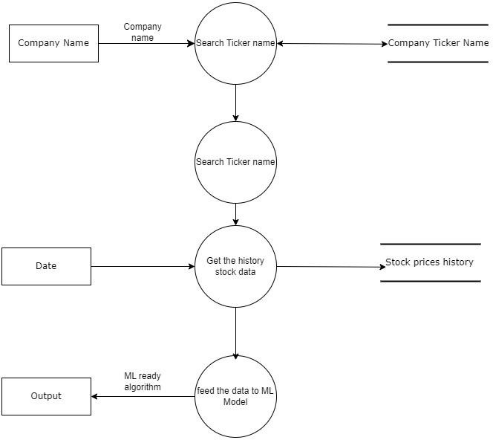

Figure 4.2: Data Flow Diagram

Department of Computer Engineering,PCCoE, Nigdi,Pune-411044. 17

Stock Price Prediction Incorporating Senitment Analysis

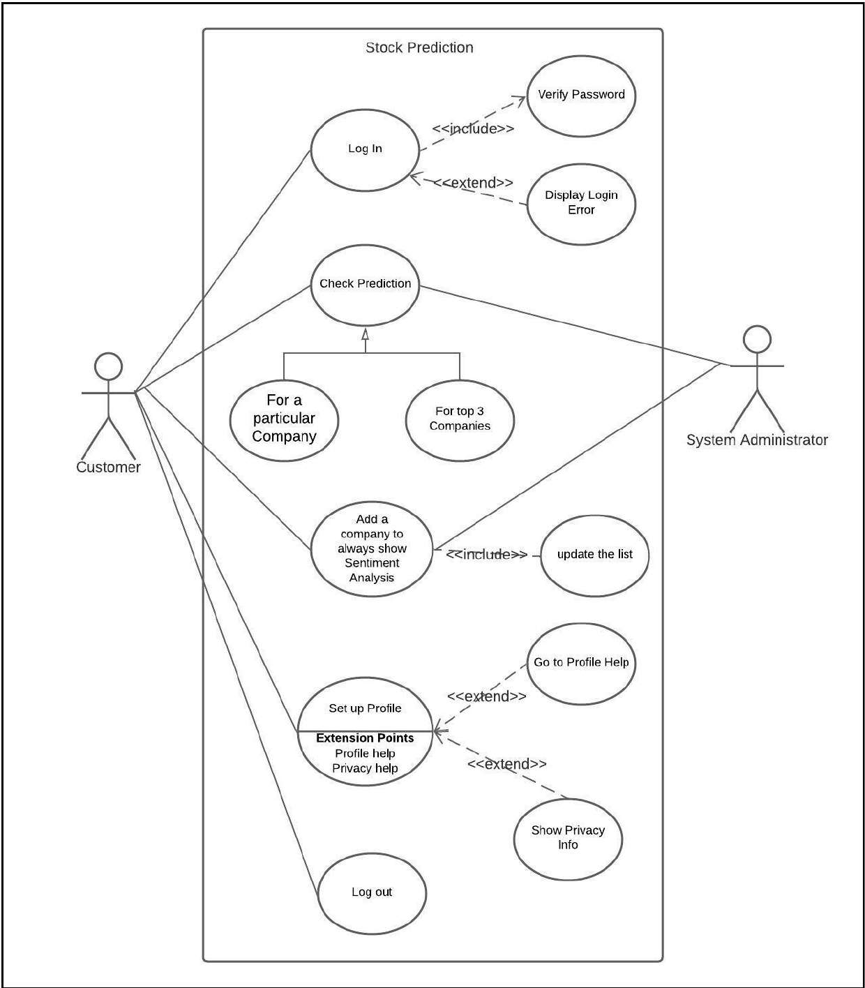

Figure 4.3: Use Case Diagram

Department of Computer Engineering,PCCoE, Nigdi,Pune-411044. 18

Stock Price Prediction Incorporating Senitment Analysis

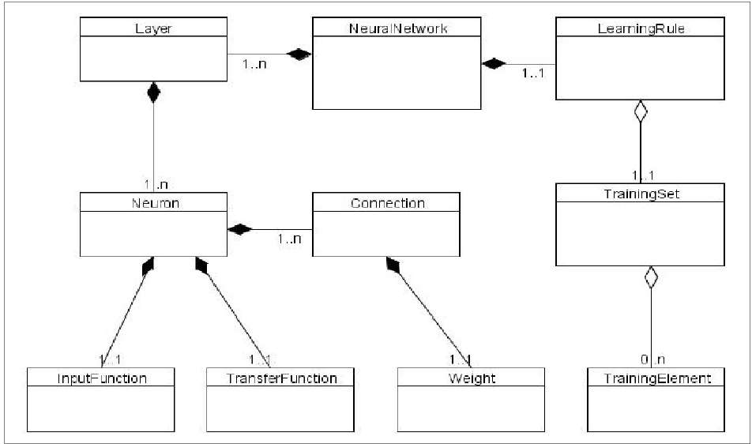

Figure 4.4: Model

Department of Computer Engineering,PCCoE, Nigdi,Pune-411044. 19

Stock Price Prediction Incorporating Senitment Analysis

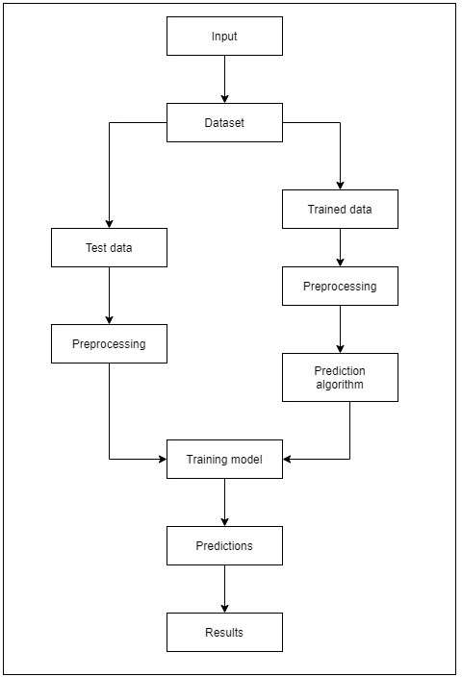

Figure 4.5: General Model

Department of Computer Engineering,PCCoE, Nigdi,Pune-411044. 20

BE Project Report Stock Price Prediction Incorporating Senitment Analysis

**Chapter 5 Project Plan**

# System Implementation plan

Initially the problem statement was framed

A literature survey was carried out to check through the existing algorithms and also iden- tified what shortcomings were in different implementations.

Stock market prediction can be done by either quantitative or the qualitative aspect.Most of the work was focussed on the qualitative aspect in which the historical prices of the stock market was considered to make the predictions.Also there were some implementations to implement the qualitative aspect by doing the sentiment analysis on twitter or the news headline.

There were also a few implementations involving both..So we decided to create a similar type of system whose performance and accuracy would try to enhance to get the most accurate results.

Then the algorithms were selected and an abstract view of the system was created.Further the technologies we wanted to use for the frontend were decided

# Project Tasks

All the identified tasks along with their priority and the task owner and the progress is given in the table.

Department of Computer Engineering,PCCoE, Nigdi,Pune-411044. 21

Stock Price Prediction Incorporating Senitment Analysis

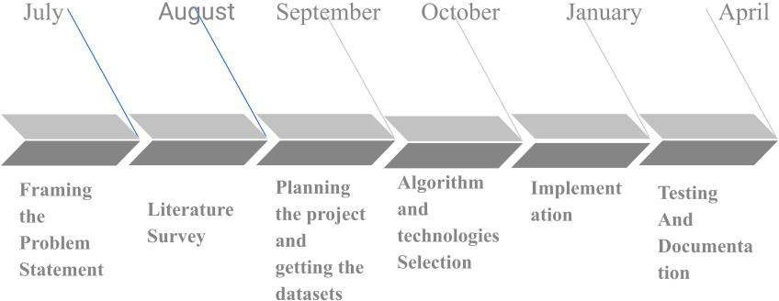

Figure 5.1: System Implementation plan

# Risk Identification

Economic risks: These include factors such as inflation, interest rates, GDP growth rates, and consumer confidence. Economic risks can have a significant impact on stock prices, as they affect the overall health of the economy and the profitability of companies.

Political risks: Political instability, changes in government policies, and geopolitical tensions can all impact the stock market. For example, trade tensions between countries can lead to market volatility and uncertainty, which can impact stock prices.

Company-specific risks: These include factors such as management changes, lawsuits, and product recalls. Company-specific risks can have a direct impact on the stock price of a particular company, and investors should be aware of these risks when making investment decisions.

Market risks: Market risks refer to the overall volatility of the stock market, and can include factors such as changes in market sentiment, market bubbles, and crashes. Market risks can be difficult to predict, but investors should be aware of the potential for sudden and dramatic price movements.

Department of Computer Engineering,PCCoE, Nigdi,Pune-411044. 22

Stock Price Prediction Incorporating Senitment Analysis

|  |  |  |  |  |
| --- | --- | --- | --- | --- |
| **Task Id** | **Task**  **Description** | **Priority** | **Task Owner** | **Status** |
| TS-01 | designing of LSTM model | Very Important | Aditya Singh Rajpurohit | Done |
| TS-02 | Designing of RNN model | Very Important | Nutan Dhamale | Done |
| TS-03 | Designing of sentiment  analysis model | Very Important | Pradnya Gaikwad | Done |
| TS-04 | Testing of historical price models | Important | Aditya Singh Rajpurohit & Nutan Dhamale | Done |
| TS-05 | Testing of sentiment models | Important | Pradnya Gaikwad & Shravani Ahirrao | Done |
| TS-06 | Design of front-end | Very Important | Shravani Ahirrao & Nutan Dhamale | Done |
| TS-07 | database  creation and linking with business layer | Urgent | Aditya Singh Rajpurohit | Done |
| TS-08 | Integration of business layer and front-end | Urgent | Shravani Ahirrao & Aditya Singh Rajpurohit | Done |
| TS-09 | Security model design | Important | Pradnya Gaikwad & Shravani Ahirrao | Done |
| TS-10 | Implementation of encryption | Important | Shravani Ahirrao & Nutan Dhamale | Done |
| TS-11 | Security testing | Very Important | Pradnya Gaikwad | Done |

Figure 5.2: Project Tasks

Department of Computer Engineering,PCCoE, Nigdi,Pune-411044. 23

Stock Price Prediction Incorporating Senitment Analysis

Technological risks: The impact of new technologies, such as artificial intelligence and au- tomation, can have a significant impact on the stock market. Companies that fail to adapt to new technologies or that are disrupted by new entrants to the market may see their stock prices decline.

Environmental risks: Environmental risks, such as climate change and natural disasters, can also impact the stock market. For example, companies that are heavily reliant on fossil fuels may face significant regulatory and financial risks as governments move towards renewable energy sources.

# Risk analysis

The risks identified along with their id,impact,severity,mitigation is provided in the table.

Department of Computer Engineering,PCCoE, Nigdi,Pune-411044. 24

Stock Price Prediction Incorporating Senitment Analysis

|  |  |  |  |  |  |  |
| --- | --- | --- | --- | --- | --- | --- |
| Risk Id | Risks description | Risk | | | status | Mitigation strategies |
|  |  | likeli hood | Im pac t | Severity |  |  |
| RP-01 | Economic risks: These include factors such as inflation, interest rates, GDP growth rates, and consumer confidence. | 4 | 4 | 8 | Closed | 1) By taking into consideration inflation. 2) This can be done by feeding the network with the current inflation rate decided by government |
| RP-02 | Political risks: Political instability, changes in government policies, and geopolitical tensions can all impact the stock market. | 3 | 4 | 7 | Closed | 1. By doing a proper sentiment analysis 2. Giving an weight to the Government policies for that particular sector |
| RP-03 | Company-specific risks: These include factors such as management changes, lawsuits, and product recalls. | 4 | 4 | 9 | Open | 1) By observing the public opinion on the company's new policies. 2) also by checking |
| RP-04 | Market risks: Market risks refer to the overall volatility of the stock market, and can include factors such as changes in market sentiment, market bubbles, and crashes. | 5 | 3 | 6 | Open | 1) Market is very volatile; it changes every minute. 2)model need to focus on the market opening, closing, high, low, upper circuit, lower circuit, 52 week high and low prices only and not all the minute or second changes |
| RP-05 | server crash due to overload: before opening of market in the morning traffic on site will be more the model should be able to predict efficiently | 2 | 5 | 9 | Closed | 1) heroku provides a type of service where according to traffic the resources are allocated here we only need to pay according to usage of resources. |

Figure 5.3: Risk analysis

Department of Computer Engineering,PCCoE, Nigdi,Pune-411044. 25

BE Project Report Stock Price Prediction Incorporating Senitment Analysis

**Chapter 6**

**Project Implementation**

# Machine Learning Model

The models used for the analysis of the historic prices are the LSTM AND RNN.Long Short Term Memory (LSTM) is a machine learning algorithm. It is a type of Recurrent Neural Network (RNN) algorithm.In this algorithm, the output of the previous computation is provided as an input to the current computation. The Recurrent Neural Network is streamlined in short-termed predictions. LSTM bridles the shortcomings of RNN by providing a systematized approach towards long term predictions. LSTM is efficient in retention of information for long tenures. It facilitates Classifi- cation, Prediction and Processing on the basis of time series data.For the sentiment analysis,SVM and Logistic Regression has been used.SVM is used for the problems corresponding to both re- gression and classification but it is mostly used for the classification problems.Logistic regression is in a way similar to linear regression but it is used for the analysis of the categorical data.

# Tools and Technologies Used

Department of Computer Engineering,PCCoE, Nigdi,Pune-411044. 26

Stock Price Prediction Incorporating Senitment Analysis

Table 6.1: Tools and Technologies Used

|  |  |  |
| --- | --- | --- |
| Sr. No. | Requirement Category | Roll No. |
| 1. | User Interface | ReactJs |
| 2. | Server | Flask |
| 3. | Prediction Model | Python, TenserFlow |
| 4. | Dataset | Yahoo Finance |
| 5. | Version Control System | Git |
| 6. | Operating System | Windows |
| 7. | Testing Software | Postman |
| 8. | Browser | Chrome, Edge, Mozilla Firefox |
| 9. | IDE | VSCode |

Department of Computer Engineering,PCCoE, Nigdi,Pune-411044. 27

BE Project Report Stock Price Prediction Incorporating Senitment Analysis

**Chapter 7 Software Testing**

# 7.1 Test Cases

Department of Computer Engineering,PCCoE, Nigdi,Pune-411044. 28

Stock Price Prediction Incorporating Senitment Analysis

|  |  |  |  |  |  |
| --- | --- | --- | --- | --- | --- |
| **Test Case Number** | **Test Case** | **Test Step Description** | **Expected Result** | **Actual Result** | **Testing Result** |
| T001 | Application is open successfully | Upon opening the application Home page should be visible | Application Home page should be visible on opening it | Application Home page is visible on opening it | Passed |
| T002 | Home page  content is discernible | The Home page content should be visible upon opening the Home page | The Home page content should be visible upon opening the Home page | The Home page content is visible upon opening the Home page | Passed |
| T003 | The logo is visible on the top left corner | The logo is visible on the top left corner upon opening the application | The logo should be visible on the top left corner upon opening the application | The logo is visible on the top left corner upon  opening the application | Passed |
| T004 | The Navigation Bar should be visible on top right corner and should be functional | The navigation bar is visible on the top right corner upon opening the application and should be functional | The navigation bar is visible on the top right corner upon opening the  application and  should be  functional | The navigation bar is visible on the top right corner upon  opening the application and is functional | Passed |
| T005 | About tab is functional | Upon clicking the About button on the Navigation bar About page should be opened | Upon clicking the About button on the Navigation bar About page should be opened | Upon clicking the About button on the Navigation bar About page is opened | Passed |
| T006 | Home tab is functional | Upon clicking the Home button on the Navigation bar Home page should be opened | Upon clicking the Home button on the Navigation bar Home page should be opened | Upon clicking the Home button on the Navigation bar Home page is opened | Passed |
| T007 | Predict tab is functional | Upon clicking the Predict button on the Navigation bar Predict page should be opened | Upon clicking the Predict button on the Navigation bar Predict page should be opened | Upon clicking the Predict button on the Navigation bar Predict page is opened | Passed |

Department of Computer Engineering,PCCoE, Nigdi,Pune-411044. 29

Stock Price Prediction Incorporating Senitment Analysis

|  |  |  |  |  |  |
| --- | --- | --- | --- | --- | --- |
| **Test Case Number** | **Test Case** | **Test Step Description** | **Expected Result** | **Actual Result** | **Testing Result** |
| T008 | Contact Us  tab is  functional | Upon clicking the Contact us button on the Navigation bar Contact us page should be opened | Upon clicking the Contact us button on the Navigation bar Contact us page should be opened | Upon clicking the Contact us button on the Navigation bar Contact us page is opened | Passed |
| T009 | About page  content is discernible | The About page content should be visible upon opening the About page | The About page content should be visible upon  opening the About page | The About page content is visible upon opening the About page | Passed |
| T010 | Predict page content is discernible | The Predict page content should be visible upon opening the Predict page | The Predict page content should be visible upon  opening the Predict page | The Predict page content is visible upon opening the Predict page | Passed |
| T011 | Contact Us page content is discernible | The Contact Us page content should be visible upon opening the Contact Us page | The Contact Us page content should be visible upon opening the Contact Us page | The Contact Us page content is visible upon  opening the Contact Us page | Passed |
| T012 | Ticker Name Box should be functional on the Predict Page | Ticker Name Box should accept the ticker name of the company | Ticker Name  Box should accept the ticker name of the company | Ticker Name Box accepts the ticker name of the company | Passed |
| T013 | Target Date Box should be functional on the Predict Page | Target Date Box should be functional on the Predict Page | Target Date Box should be functional on the Predict Page | Target Date Box is functional on the Predict Page | Passed |
| T015 | Submit button should be functional on the Predict Page | Submit button should save the input ticker name and target date on the Predict Page | Submit button  should be functional on the Predict Page | Submit button is functional on the Predict Page and it saves the target date and ticker name | Passed |

Department of Computer Engineering,PCCoE, Nigdi,Pune-411044. 30

Stock Price Prediction Incorporating Senitment Analysis

|  |  |  |  |  |  |
| --- | --- | --- | --- | --- | --- |
| **Test Case Number** | **Test Case** | **Test Step Description** | **Expected Result** | **Actual Result** | **Testing Result** |
| T016 | Predicted Price should be displayed upon clicking the Submit button | Predicted Price should be displayed upon clicking the Submit button | Predicted Price should be displayed upon clicking the Submit button | Predicted Price is displayed upon clicking the Submit button | Passed |
| T017 | The logo  should be displayed on the bottom of every page  and it  redirects to the Home page | The logo should be displayed on the bottom of every page and it redirects to the Home page | The logo should be displayed on the bottom of every page and it redirects to the Home page | The logo is displayed on the bottom of every page and it redirects to the Home page | Passed |
| T018 | The GD9 Workers button should be visible on the bottom of every page and it should redirect to the About page | The GD9 Workers button should be visible on the bottom of every page and it should redirect to the About page | The GD9  Workers button should be visible on the bottom of every page and it should redirect to the About page | The GD9 Workers button is visible on the bottom of every page and it should redirect to the About page | Passed |
| T019 | Name Box  should be functional on the Contact us Page | Name Box should be functional on the Contact us Page and should accept input value | Name Box  should be functional on the Contact us Page and should  accept input value | Name Box is functional on the Contact us Page and should accept input value | Passed |
| T020 | Message Box should be functional on the Contact us Page | Message Box should be functional on the Contact us Page and should accept input value | Message Box  should be functional on the Contact us Page and should  accept input value | Message Box is functional on the Contact us Page and should accept input value | Passed |

Department of Computer Engineering,PCCoE, Nigdi,Pune-411044. 31

BE Project Report Stock Price Prediction Incorporating Senitment Analysis

**Chapter 8 Results**

# Outcomes

Finding the overall sentiment of the market for a particular company.

Analysis of historic prices considered along with the sentiment analysis.

# Results found

Table 8.1: Results for the models

|  |  |  |
| --- | --- | --- |
| Sr. No. | Model | Results |
| 1. | SVM | Training accuracy: 94.423883543 |
|  |  | Testing accuracy: 78.6536248 |
| 2. | Logistic Regression | Training accuracy: 87.34270910436713 |
|  |  | Testing accuracy: 76.985040276 |

Department of Computer Engineering,PCCoE, Nigdi,Pune-411044. 32

Stock Price Prediction Incorporating Senitment Analysis

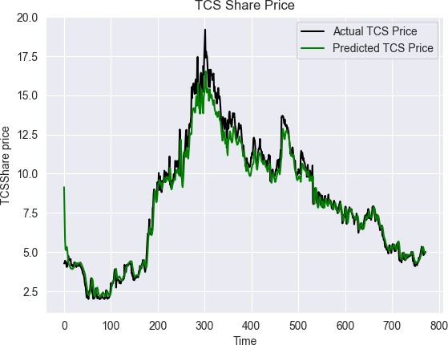 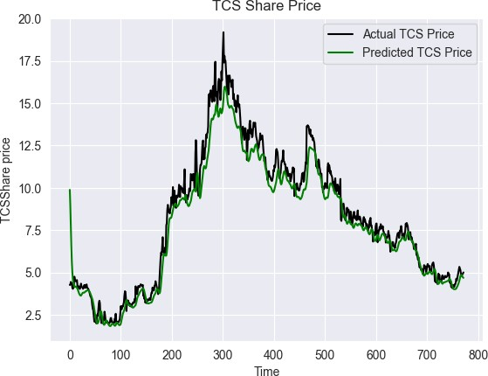

Case 1: Upon instantiating the epochs and batch size of 32 on the preprocessed data and wielding dropouts in the hidden layer, we could procure paramount accuracy.

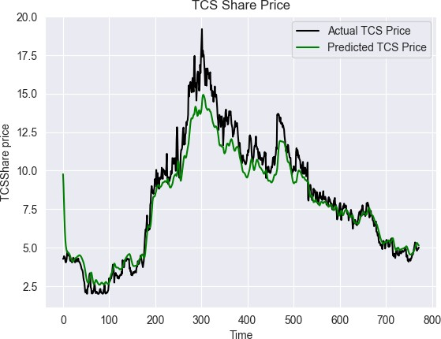

Case 2: The preprocessed data yielded inaccurate results,furthermore the next day’s prediction curve lacks precision.

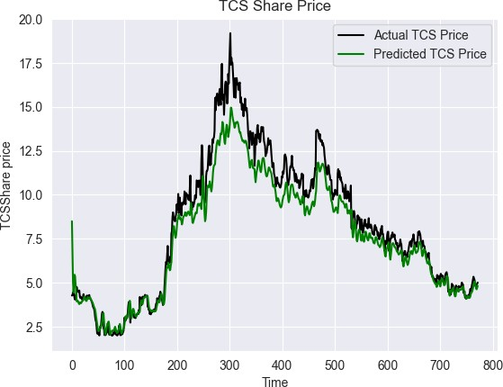

Case 3:The taken epoch and batch size, reverberates inaccuracy, nevertheless it facilitates to efficiently predict the meticulous next day curve.

Case 4: It took tenacious efforts to train the model with the given size.Notwithstanding it procured the same accuracy with epoch size and batch size of 32 respectively. Withal, there had been a slight delay in prediction, leading to inexactitude.

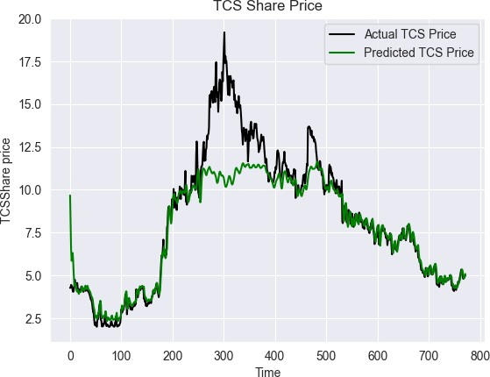

Case 5: Only preprocessed data no dropout, epoch, batchsize

Figure 8.1: Different cases considered and their observations

Department of Computer Engineering,PCCoE, Nigdi,Pune-411044. 33

Stock Price Prediction Incorporating Senitment Analysis

Figure 8.2: Observations Found

|  |  |  |  |  |
| --- | --- | --- | --- | --- |
| **Cases** | **Epoch Size** | **Batch Size** | **Description** | **r2 score** |
| 1 | 32 | 32 | Upon instantiating the epochs and batch size of  32 on the preprocessed data and wielding dropouts in the hidden layer, we could procure paramount accuracy. | 0.96 |
| 2 | 10 | 100 | The preprocessed data yielded inaccurate results,furthermore the next day’s prediction curve lacks precision. | 0.95 |
| 3 | 100 | 10 | The taken epoch and batch size, reverberates inaccuracy, nevertheless it facilitates to efficiently predict the meticulous next day curve. | 0.84 |
| 4 | 100 | 100 | It took tenacious efforts to train the model with the given size.Notwithstanding it procured the same accuracy with epoch size and batch size of 32 respectively. Withal, there had been a slight delay in prediction, leading to inexactitude. | 0.84 |
| 5 | No  epoch | No  Batch size | Only preprocessed data no dropout, epoch, batchsize | 0.81 |

Department of Computer Engineering,PCCoE, Nigdi,Pune-411044. 34

Stock Price Prediction Incorporating Senitment Analysis

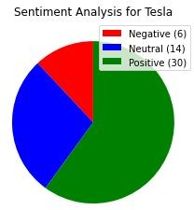

Figure 8.3: The number of positive, negative and neutral tweets found using textblob

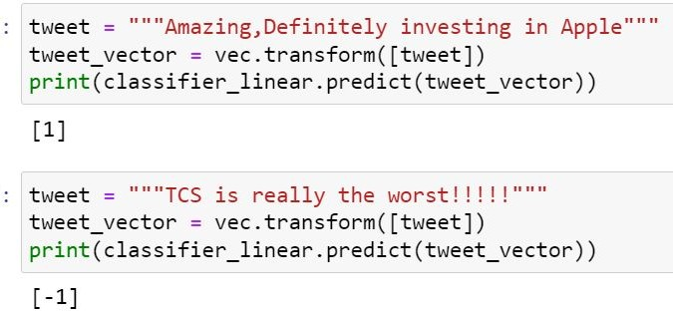

Figure 8.4: Checking for the polarity of the tweets

Department of Computer Engineering,PCCoE, Nigdi,Pune-411044. 35

BE Project Report Stock Price Prediction Incorporating Senitment Analysis

**Chapter 9 Conclusion**

# Conclusion and Future Work

Stock market is the current buzzword in the market wherein people are curious to learn about it and how to effectively invest, in order to benefit themselves. Right investments have led people to earn enormous profit whereas some had to face tremendous losses in the market. The risk factor in the stock market has always feared the new investors and also the experienced ones, with the evolving technologies it is now easy to make predictions about the stocks taking into account the performance of the company in the past and also the overall opinion of the people about the com- pany. For the stock price prediction model we have taken the historic prices of the company TCS and calculated its accuracy for different epochs and batch sizes and have also taken the tweets related to it and checked the accuracy for the model. Sentiment analysis on the tweets enabled to understand the mood of the market towards the TCS company and their willingness to invest in the company.

We plan to develop an application which shall predict the stock prices of the companies incor- porating sentiment analysis. The precise advance prediction of the stock prices would enable the companies to adapt to the changing market scenario in an efficient way. This would aid the com- panies to amend and adopt necessary policies which would stabilize and boost their stock prices. The system would predict the stock prices with minimum or zero errors.This platform provides the investors assured data which would facilitate them to invest better.

Department of Computer Engineering,PCCoE, Nigdi,Pune-411044. 36

Stock Price Prediction Incorporating Senitment Analysis

# Applications

Predicting the overall sentiment of the market.

Using it we can provide one stop spot for the investors to understand what other investors sentiment is,instead of going through a lot of research on different platforms.

Aalyze opinions of the people for a particular company.

It shall help traders and investors who participate in the stock market.

It shall enable us to consider various parameters while predicting the price like high, low, opening, close.

It shall facilitate proficient machine learning model training and building

It shall enable improved and efficient results

Department of Computer Engineering,PCCoE, Nigdi,Pune-411044. 37

BE Project Report Stock Price Prediction Incorporating Senitment Analysis

**Chapter 10 Abbreviations**

The same is given in the beginning of the report

### Symbol Details

NLP Natural language Processing

NlTK Natural language Toolkit

ML Machine Learning

IF Inverse Frequency

IDF Inverse Document Frequency

SVM Support Vector Machine

RNN Recurrent Neural Network

CNN Convolutional Neural Network

ANN Artificial Neural Network

NLU Natural Language Understanding NLG Natural Language Generation

AI Artificial Intelligence

BoW Bag of Words

Department of Computer Engineering,PCCoE, Nigdi,Pune-411044. 38

BE Project Report Stock Price Prediction Incorporating Senitment Analysis

**Bibliography**

* + 1. Rubi Gupta, Min Chen, “Sentiment Analysis for Stock Price Prediction”,*IEEE-Institute of Electrical and Electronics Engineers,2020*
    2. Eka Miranda ,Eka Miranda ,Ricky Hariyanto,Ricky Hariyanto,“Sentiment Analysis using Sen- tiwordnet and Machine Learning Approach ” *IEEE-Institute of Electrical and Electronics Engineers.,2020*
    3. Pranjal Chakraborty, Ummay Sani Pria, Md. Rashad Al Hasan Rony, Mahbub Alam Majum- dar,“Predicting Stock Movement using Sentiment Analysis of Twitter feed ” *IEEE-Institute of Electrical and Electronics Engineers.,2020*
    4. Yichuan Xu,Vlado Keselj,“Stock Prediction using Deep Learning and Sentiment Analysis”

*IEEE-Institute of Electrical and Electronics Engineers.,2019*

* + 1. Zhaoxia Wang,Seng-Beng Ho ,Zhiping Lin , “Stock Market Prediction Analysis by Incorpo- rating Social and News Opinion and Sentiment ”,*IEEE-Institute of Electrical and Electronics Engineers,2018*
    2. Saloni Mohan,Sahitya Mullapudi, Sudheer Sammeta, Parag Vijayvergia, David C. Anastasiu

,“Stock Price Prediction Using News Sentiment Analysis” *IEEE-Institute of Electrical and Electronics Engineers.,2019*

* + 1. Masoud Makrehchi,Sameena Shah ,Wenhui Liao ,“Stock Prediction Using Event-Based Sen- timent Analysis” *IEEE-Institute of Electrical and Electronics Engineers.,2013*
    2. Mehar Vijh , Deeksha Chandola, Vinay Anand Tikkiwal, Arun Kumar,“Stock Closing Price Prediction using Machine Learning Techniques” *International Conference on Computational Intelligence and Data Science,2019*
    3. Yongqiang Zhu, “Stock price prediction using the RNN model”, *International Conference on Applied Physics and Computing, 2020.*

Department of Computer Engineering,PCCoE, Nigdi,Pune-411044. 39

Stock Price Prediction Incorporating Senitment Analysis

* + 1. Aditya Bhardwaja, Yogendra Narayanb , Vanrajc , Pawana , Maitreyee Duttaa, “Sentiment Analysis for Indian Stock Market Prediction Using Sensex and Nifty”, *4th International Con- ference on Eco-friendly Computing and Communication Systems, 2015.*
    2. LI Bing, Keith C.C. Chan, Carol OU, “Public Sentiment Analysis in Twitter Data for Pre- diction of A Company’s Stock Price Movements”, *IEEE 11th International Conference on e-Business Engineering, 2014.*
    3. Gang KOU, Xiangrui CHAO, Yi PENG , Fawaz E. ALSAADI, Enrique HERRERA-VIEDMA, “Machine Learning methods for systematic risk analysis in financial sectors”, *Technological and Economic Development of Economy , 2019*
    4. Troy J. Strader, ”Machine Learning Stock Market Prediction Studies:Review and Research Directions”, *International Technology and Information Management, 2020.*
    5. Hiransha M, ”NSE stock market prediction using deep learning models,” *International Con- ference on Computational Intelligence and Data Science, 2018.*
    6. Priyanka Srivastava; P K Mishra, “Stock Market Prediction Using RNN LSTM”, *IEEE, 01-03 October 2021.*

Department of Computer Engineering,PCCoE, Nigdi,Pune-411044. 40