SEVA – The food donation app

“Seva” is a food donation application which helps users to donate food to local charities, old age homes, animal shelters, slums and NGOs. This is done by connecting the food donor with these organizations by posting their food online on this platform. If interested the organization will accept this food and both the parties can thus interact and help each other.

User flow:

There are 2 main users of this app:

1. Donor
2. Collector

Donor side user flow –

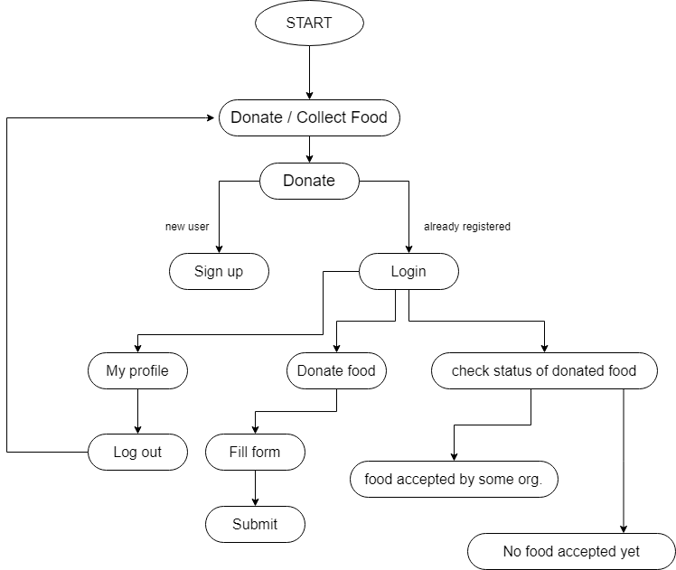

Collector side user flow –

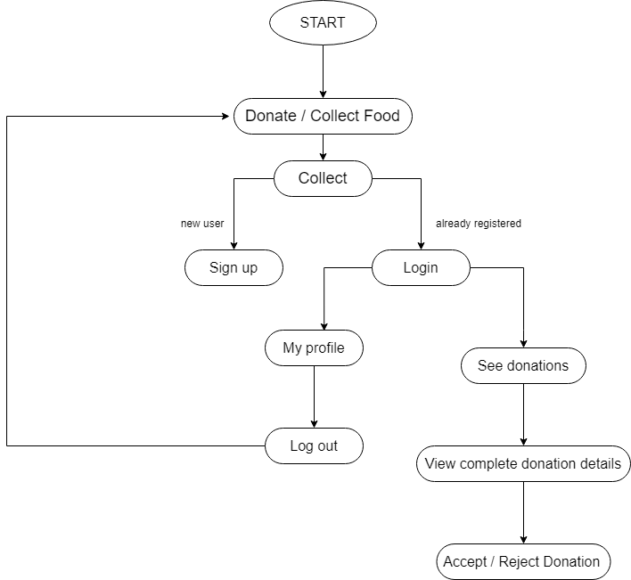

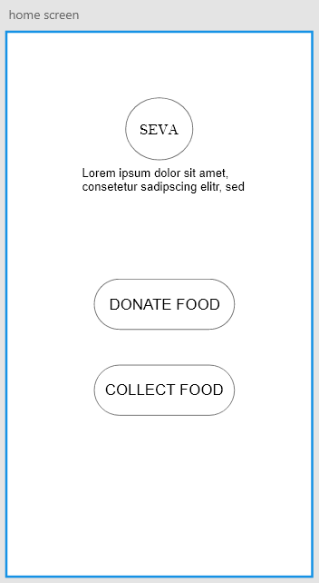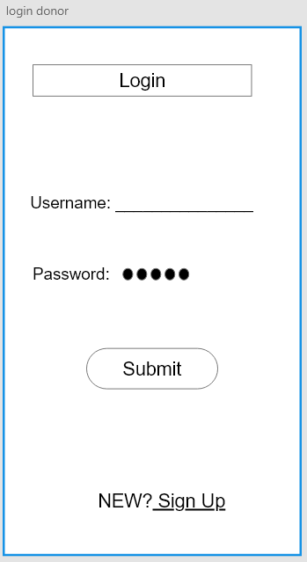Wireframe – Digital

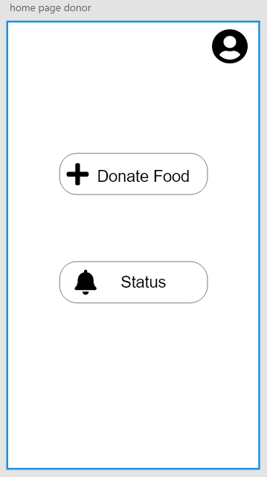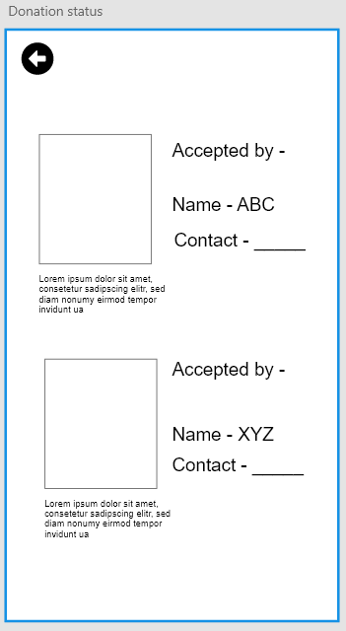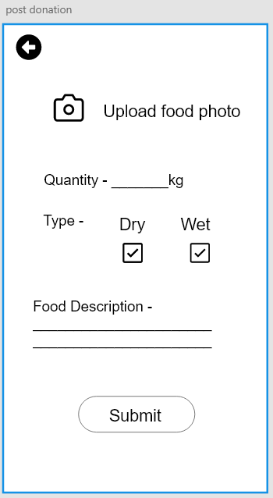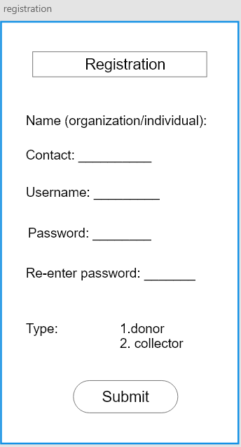

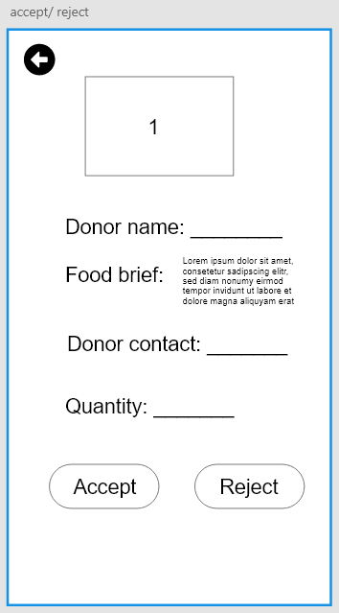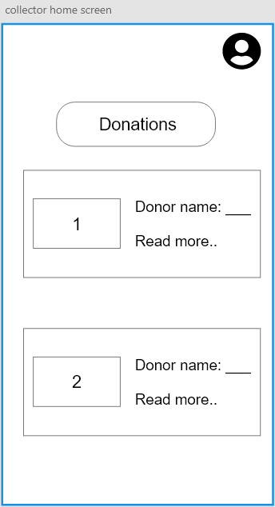

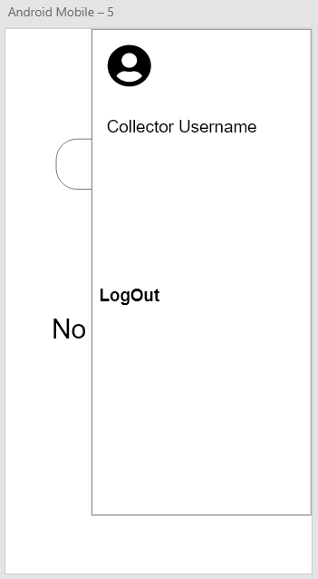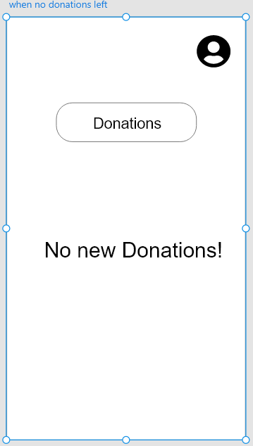

Wireframe link (made using Adobe Xd) - <https://xd.adobe.com/view/cac20857-1264-4e95-4d72-f133def26828-bcf3/>