**Pooja Kore.**

**PG-DAC**

**Concepts of operating System**

**Assignment – 1**

**Problem 1.**

1. Navigate and List :

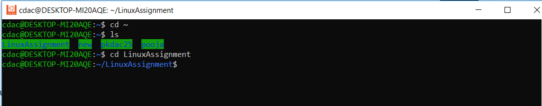

1. File management :

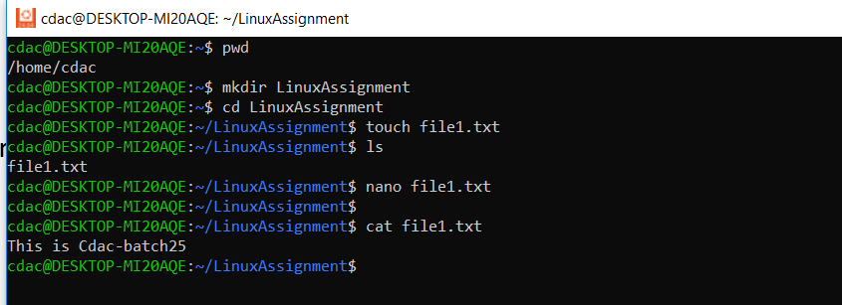

1. Directory Management :

**cdac@DESKTOP-MI20AQE:~/LinuxAssignment$ mkdir docs**

1. Copy and move files :

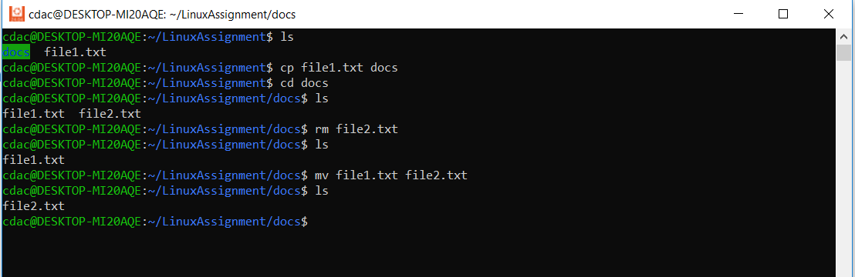

1. Permissions and Ownership :



1. Final checklist :

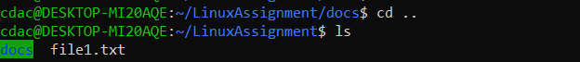



1. File searching :

a.

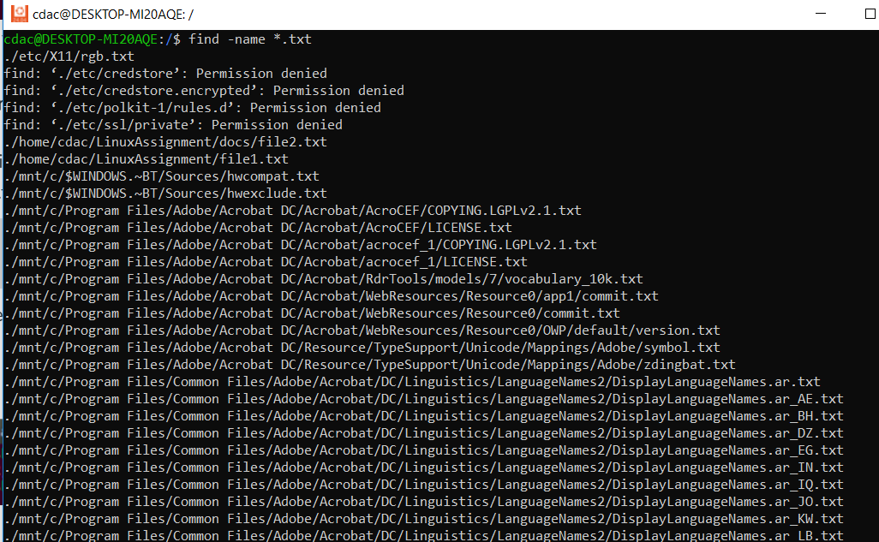

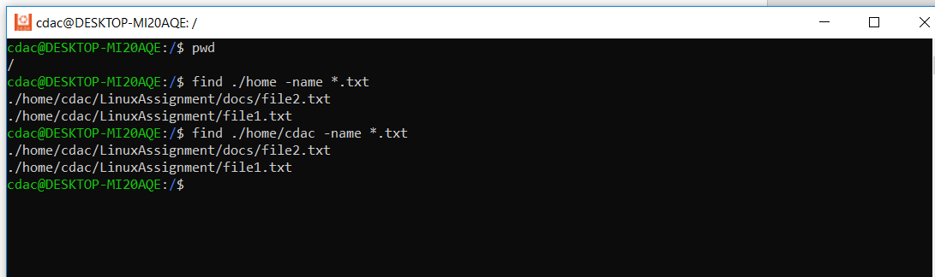

b.

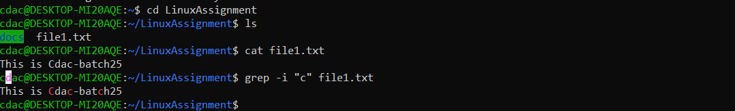

1. Display current date and time :

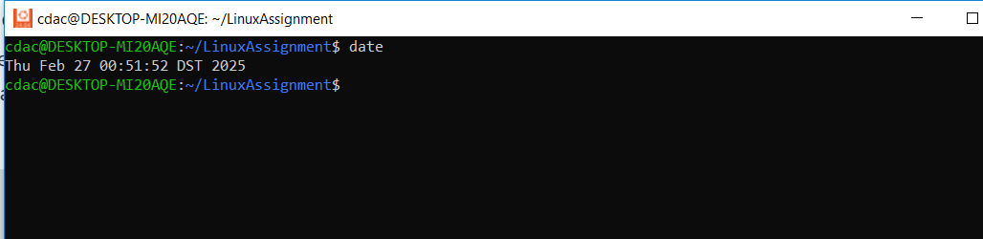

1. Networking :

a. Display the IP address of the system

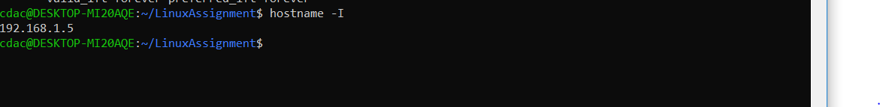

b. Ping a remote server to check connectivity (provide a remote server address to ping).

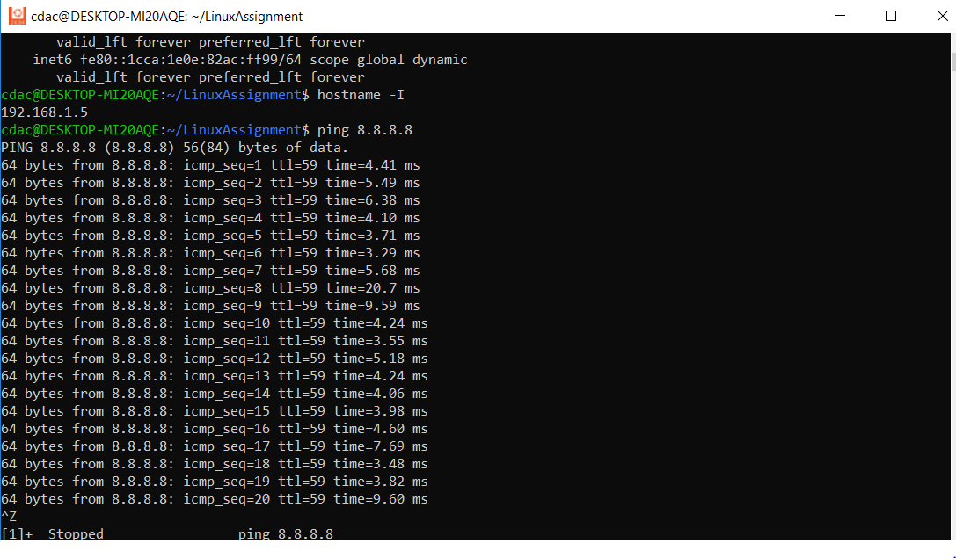

j) File Compression:

a. Compress the "docs" directory into a zip file.



b. Extract the contents of the zip file into a new directory

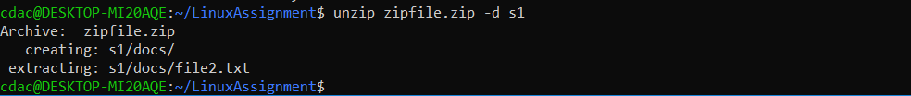

K. File Editing :

a. Open the "file1.txt" file in a text editor and add some text to it.

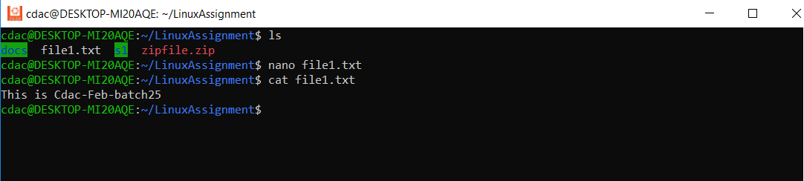

b. Replace a specific word in the "file1.txt" file with another word (provide the original word and the word to replace it with).

