

Bachelor of Computer Applications Semester – V
Business Analytics Experiment No.: 02

Title: Power BI Sales Performance Dashboard

Submitted By:
Poojashree H
Reg. No.: 2411021240046
Date: 30/08/2026

Submitted To:
Faculty Name: Mr. Aman Kumar Sharma

Department of Computer Application Alliance University
Chandapura - Anekal Main Road, Anekal Bengaluru – 562106

AUGUST 2026

Experiment No.: 02

Power BI Sales Performance Dashboard (Sample Superstore Dataset)

Github Link : https://github.com/Pooja27-web/Bussiness-Analytics
Dataset Link : https://www.kaggle.com/datasets/naveenkumar20bps1137/sample-superstore

Problem Statement
Management wanted a clear, visual way to understand how sales and profit are performing across products, categories, and regions. Using the Sample Superstore dataset, the goal was to build a set of Power BI visualizations that could reveal key business patterns which categories and regions drive revenue, where profitability is weak, and how performance has trended over time.

Step 1: Data Collection

- Imported the Sample Superstore CSV dataset into Power BI using Get Data → Text/CSV.
- Reviewed the dataset structure, which included Order details, Customer details, Product
details (Category, Sub-Category, Product Name), and transaction metrics (Sales, Quantity, Discount, Profit).
- Verified in Power Query Editor that the dataset was already clean, with no missing values or duplicate records.
- Corrected data types where needed: Sales, Discount, and Profit set to Fixed Decimal Number for accurate currency representation; Quantity kept as Whole Number; Order Date and Ship Date confirmed as Date type.

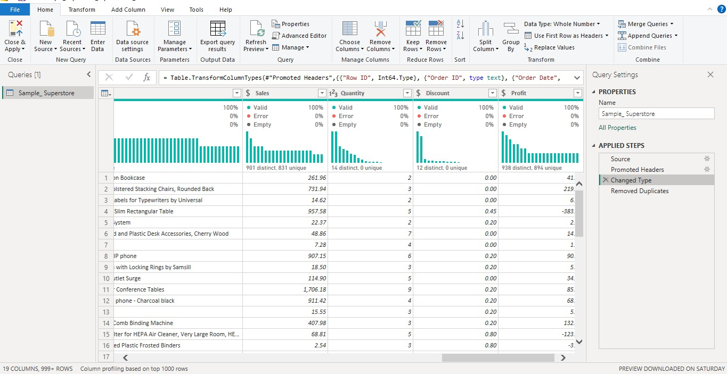

Step 2: Building a Calendar Table

- Created a dedicated Calendar table using DAX to support proper time-based analysis: Calendar = CALENDAR(MIN(Sample_Superstore[Order Date]), MAX(Sample_Superstore[Order Date]))

- Added supporting columns for Year, Month, and MonthNumber, along with a combined MonthYear column sorted chronologically, to ensure trend charts displayed in correct time order rather than alphabetical order.

- Linked the Calendar table to the main sales table via a one-to-many relationship on the date field, enabling accurate time-intelligence calculations.

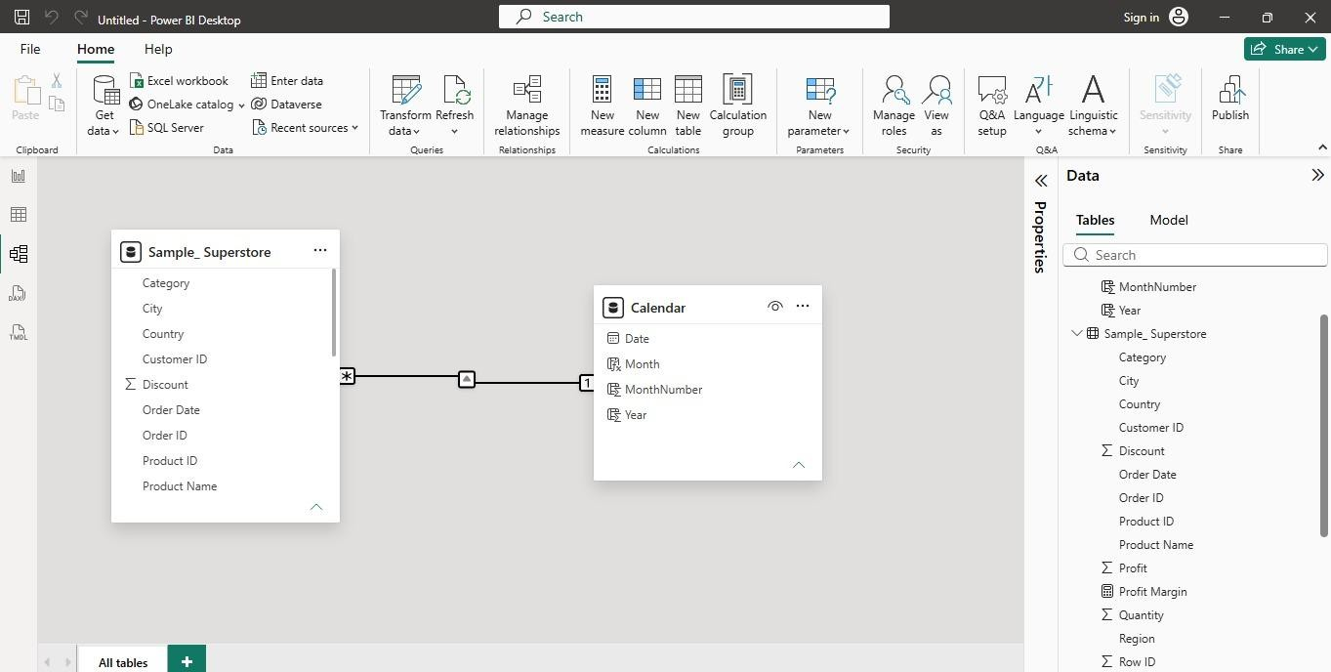

Step 3: DAX Measures

Created the following measures to quantify business performance:

Total Sales = SUM(Sample_Superstore[Sales])
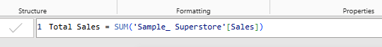

Total Profit = SUM(Sample_Superstore[Profit])
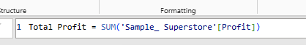

Total Orders = DISTINCTCOUNT(Sample_Superstore[Order ID])
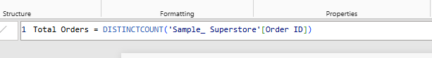

Total Quantity = SUM(Sample_Superstore[Quantity])
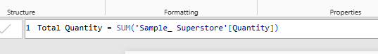

Profit Margin = DIVIDE([Total Profit],[Total Sales])
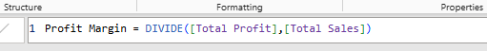

Average Order Value = DIVIDE([Total Sales],[Total Orders])
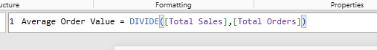

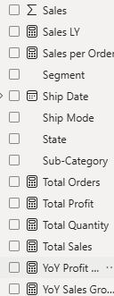
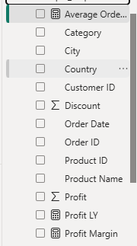

Step 4: Dashboard Page 1 — Executive Overview

Built a summary page giving a quick snapshot of overall performance:
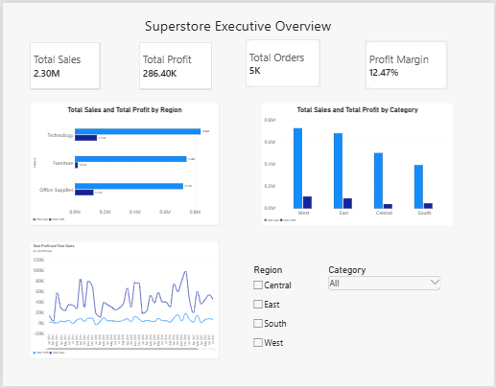

- KPI cards for Total Sales, Total Profit, Total Orders, and Profit Margin.
- A monthly sales and profit trend line chart, using the sorted MonthYear field to correctly show performance across the full multi-year period.
- A bar chart comparing Sales and Profit across Categories, highlighting that some categories generate strong revenue without matching profit.
- A column chart comparing Sales and Profit across Regions, showing which regions perform strongest.
- Region and Category slicers were added to make the page interactive, letting users filter the entire view dynamically.

Step 5: Dashboard Page 2 — Business Drivers

Built a second page focused on deeper, sub-category and segment-level analysis using varied visual types:
  - A bar chart showing Sales and Profit by Sub-Category.
  - A donut chart showing each sub-category's contribution to total profit revealing that Copiers and Phones together account for over 32% of total profit, while sub-categories like Labels and Art contribute comparatively little.

  - A treemap showing Sales by Customer Segment, sized proportionally, making it easy to see Consumer as the leading segment.
  - A map visual plotting Sales by State and Region, giving a geographic view of where revenue is concentrated.
  - Added a written insight summary at the bottom of the page tying the visuals together into a business takeaway.
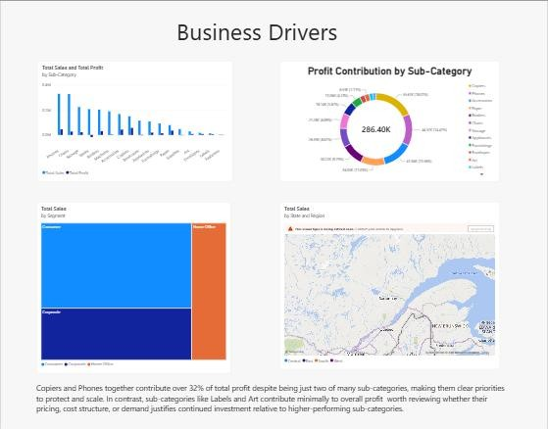

Key Insights
  - Copiers and Phones are the strongest profit contributors despite being a small share of all sub-categories, making them priorities to protect and scale.
  - Sub-categories like Labels and Art generate comparatively little profit, suggesting a need to review their pricing or cost structure.
  - The Consumer segment drives the largest share of total sales, followed by Corporate, with Home Office contributing the least.
  - Sales are geographically concentrated in specific states, visible through the map visual, which could inform regional focus for marketing or inventory decisions.

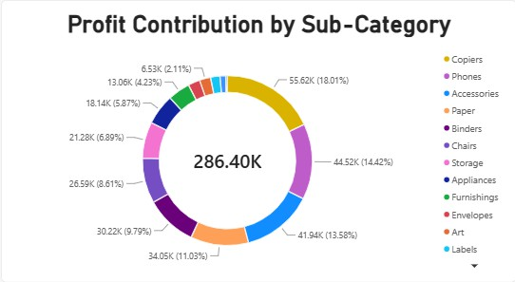

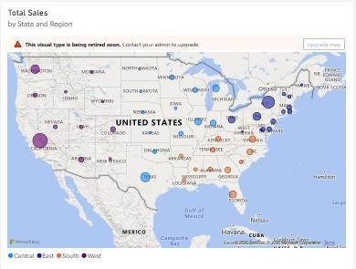

  - Some categories with high sales volume (such as Furniture) show comparatively weaker profit margins than Technology, pointing to a possible pricing or discounting issue worth investigating further.

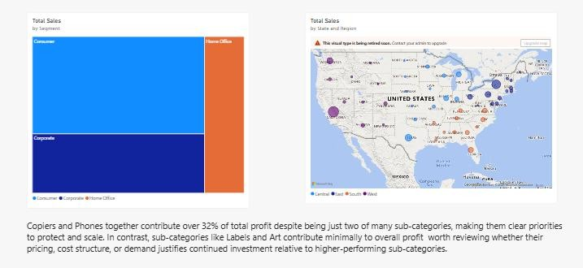

Conclusion

This assignment involved building a two-page, interactive Power BI dashboard using the Sample Superstore dataset to analyze sales performance across products, categories, and regions. A
proper calendar table and time-intelligence-ready data model were established, DAX measures were created to summarize key metrics, and a range of visual types line charts, bar charts, a
donut chart, a treemap, and a map were used to present the data clearly and avoid repetitive chart types. The resulting dashboard highlights not just what is happening in the business, but where
the strongest opportunities and weakest areas of profitability lie, giving management a practical tool for data-driven decisions.

Learning Outcomes

- Learned to import and clean a real-world business dataset in Power Query, including correcting data types for accurate reporting.
- Learned to build a custom Calendar table using DAX and connect it properly to enable time-based analysis.
- Learned to write DAX measures for core business KPIs, including profit margin and average order value.
- Learned how to build a multi-page, structured dashboard that moves from a high-level overview to more detailed business drivers.
- Learned to use varied visual types (line, bar, donut, treemap, map) to avoid repetitive charts and better match each visual to the type of insight it needed to convey.
- Learned to identify and communicate business insights directly from dashboard visuals, rather than just presenting raw numbers.

