

Project-10

Bachelor of Computer Application – Data science
Semester – V

Sub: Deep Learning

Topic: Overfitting and Underfitting Analysis

By
Name: Poojashree H
Reg no: 2411021240046

Faculty Name: Nagasri.P

Faculty Signature: _______________

Department of Computer Application
Alliance University
Chandapura - Anekal Main Road, Anekal
Bengaluru - 562 106

October 2026

Objective

The objective of this project is to understand how model complexity affects performance. Three neural networks of different sizes are trained on the same Iris data, and their training and test results are compared to identify underfitting, good fitting, and overfitting. Methods to fix the overfitting are then applied and evaluated.

Dataset Description

The Iris dataset has 150 samples of iris flowers from three species (Setosa, Versicolor, Virginica), each with four features: sepal length, sepal width, petal length, and petal width. The data was split 80/20 into 120 training and 30 test samples (stratified), and features were standardized using StandardScaler. All models use this same split.

Methodology

Model Architectures (Task 1)

Model | Hidden Layers | Activation | Trainable Parameters
Simple | 1 neuron | tanh | 11
Medium | 8 neurons | ReLU | 67
Complex | 3 layers x 128 neurons | ReLU | 34,051

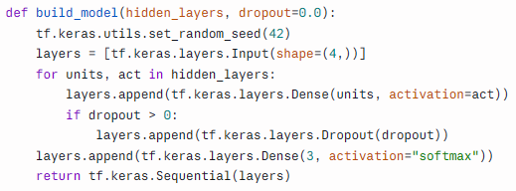

Training and Evaluation (Task 2)
All three models were trained under identical settings so only model complexity differs:

Setting | Value
Optimizer | Adam (learning rate 0.01)
Batch size | 16
Epochs | 100
Loss | Sparse categorical cross-entropy

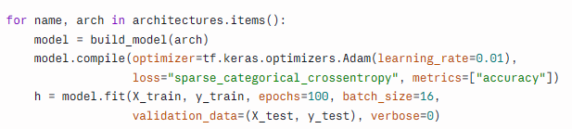

Diagnosis and Improvement (Task 3)
Fitting quality was diagnosed by comparing training and test accuracy and by plotting training loss against test loss over the epochs. To fix the overfitting model, the same complex architecture was retrained with Dropout (0.3) and Early Stopping (patience of 10 epochs, restoring the best weights).
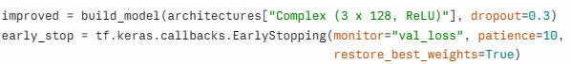
Results
Model Comparison
Model | Train Acc | Test Acc | Train Loss | Test Loss
Simple (1 neuron) | 67.50% | 66.67% | 0.4711 | 0.4704
Medium (8 neurons) | 98.33% | 96.67% | 0.0352 | 0.0709
Complex (3 x 128) | 100.00% | 93.33% | 0.0001 | 0.5399

Diagnosis

Model | Diagnosis | Evidence
Simple | Underfitting | Low accuracy on both train and test; loss curves overlap and stay high
Medium | Good fit | High accuracy on both with a small gap; loss curves settle close together
Complex | Overfitting | Perfect training score but weaker test score; test loss rises while train loss falls

For the complex model, test loss reached its lowest value of 0.025 at epoch 28, then climbed to 0.540 by epoch 100 while training loss fell to nearly zero. The model kept memorizing the training data after it stopped learning useful patterns.
After Improvement

Model | Epochs Run | Train Acc | Test Acc | Train Loss | Test Loss
Complex (overfit) | 100 | 100.00% | 93.33% | 0.0001 | 0.5399
Complex + Dropout + Early Stopping | 17 | 95.00% | 100.00% | 0.1670 | 0.0410

Test loss dropped from 0.540 to 0.041, and training stopped after only 17 epochs. Train and test loss are now close together.

Loss Curves

The plot (fitting_analysis.png) shows train vs test loss for all four models side by side:
- Simple: both curves overlap and flatten at a high value.
- Medium: both curves fall smoothly and stay close together.
- Complex: train loss goes to zero while test loss spikes and then steadily rises.
- Improved: both curves stay low and close together.

Discussion

Underfitting happens when a model lacks the capacity (or training) to learn the pattern, so it performs poorly on both the training and test data. Fixes include adding neurons or layers, training longer, or tuning the learning rate.

Overfitting happens when a model is so flexible that it memorizes the training data, including its noise, and fails to generalize. Fixes include dropout, early stopping, a smaller network, L2 regularization, or more training data.

Loss shows overfitting more clearly than accuracy. The complex model’s accuracy gap (100% vs 93.3%) looks modest, but its test loss rose to more than 20 times its best value. On a small dataset, the model’s growing overconfidence on wrong predictions shows up in the loss before it shows up in accuracy.

Limitations:

- The test set has only 30 samples, so accuracy differences of a few percentage points correspond to one or two predictions.
- Early stopping used the test set to decide when to stop, so the improved model’s 100% test accuracy is slightly optimistic. A stricter setup would use a separate validation set and keep the test set untouched.
- The simple model’s loss was still slowly falling at epoch 100. Iris is an easy dataset, so even a 1-neuron model improves with many more epochs. Under the same settings as the other models, though, its limited capacity clearly shows.

Conclusion
Training three networks of different complexity on the same Iris data showed all three outcomes: the 1-neuron model underfit, the 8-neuron model fit well, and the 3 x 128 model overfit, with its test loss rising sharply after epoch 28. Applying Dropout and Early Stopping to the overfitting model reduced its test loss from 0.54 to 0.04 and stopped training after 17 epochs. The key lesson is that model complexity should match the problem, and comparing training performance against test performance is the way to detect when it doesn’t.

