

Project-12

Bachelor of Computer Application – Data science
Semester – V

Sub: Deep Learning

Topic: Understanding Convolution and Pooling

By
Name: Poojashree H
Reg no: 2411021240046

Faculty Name: Nagasri.P

Faculty Signature: _______________

Department of Computer Application
Alliance University
Chandapura - Anekal Main Road, Anekal
Bengaluru - 562 106

October 2026

Introduction

Convolution and pooling are the two core operations in a Convolutional Neural Network (CNN). Convolution slides a small filter (kernel) over an image to detect features such as edges, producing a feature map. Pooling then shrinks the feature map by keeping only a summary of each small region, which reduces size and keeps the strongest signals. This project implements both from scratch in Python and shows their effect on a real image.

Task 1: Load a Sample Image

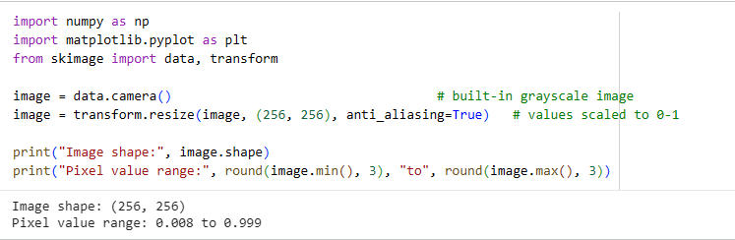

Task 2: Apply Convolution Filters and Pooling

Convolution
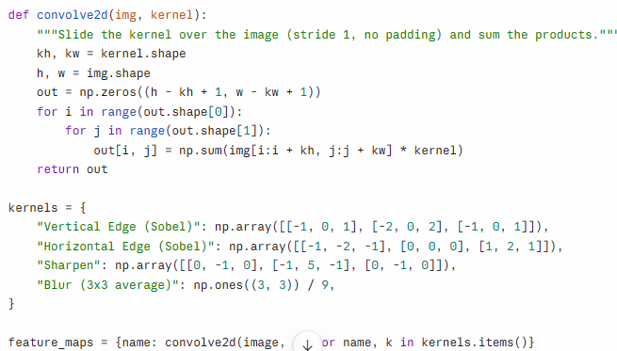
Pooling
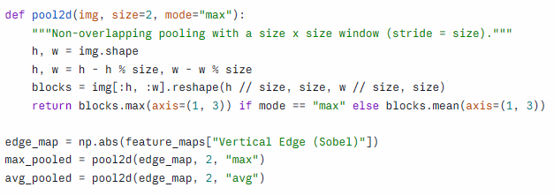
Pooling is applied to the vertical-edge feature map. Absolute values are used so strong edges count whether they go from dark to light or light to dark.

Task 3: Visualize and Compare
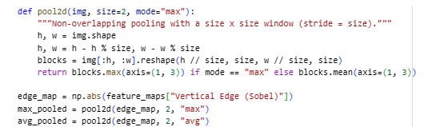
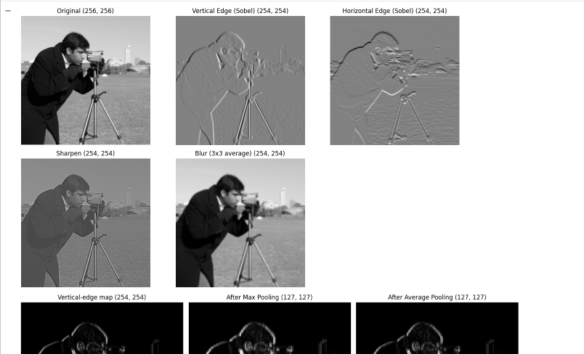

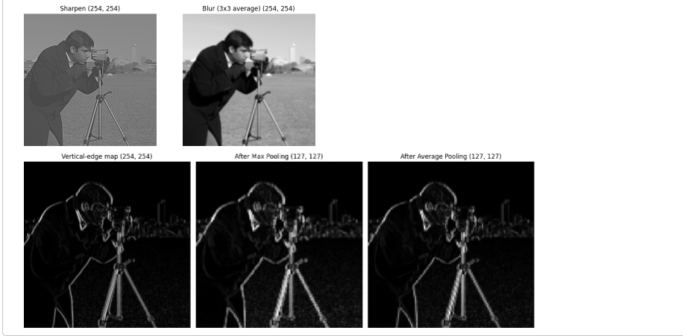

Different filters respond to different features, which is the idea behind CNNs: each filter acts as a feature detector.
Pooling:
- Both pooling types cut each side in half, from 254 x 254 to 127 x 127, so the feature map holds 4 times fewer values.
- The main edges stay clearly visible after pooling, so the important information survives the shrinking.
- Max pooling keeps the strongest response in each block, so edges stay bright and sharp.
- Average pooling blends each block, so edges look dimmer and smoother.

Conclusion
This project showed how a CNN extracts features. Convolution filters respond to specific patterns such as vertical edges, horizontal edges, sharpness, or smoothness, and each produces its own feature map. Pooling then reduces the size of those maps by 4 times while keeping the important features, with max pooling preserving the strongest responses and average pooling giving a smoother result. In a real CNN, the filter values are not hand-picked like these; they are learned during training so the network finds the most useful features for its task.

