

Project-05
Bachelor of Computer Application – Data science Semester – V

Sub: Deep Learning

Topic: Activation Functions Using Python

By
Name: Poojashree H
Reg no: 2411021240046

Faculty Name: Nagasri.P Faculty Signature:
Department of Computer Application Alliance University
Chandapura - Anekal Main Road, Anekal Bengaluru - 562 106

September 2026

Project 5: Activation Functions Using Python

Introduction

Activation functions introduce non-linearity into neural networks, allowing them to learn complex patterns instead of just linear relationships. This project implements three commonly used activation functions Sigmoid, ReLU, and Tanh in Python, generates their outputs for a range of input values, and visualizes their behavior for comparison.

Task 1: Python Implementation

import numpy as np
import matplotlib.pyplot as plt

def sigmoid(x):
return 1 / (1 + np.exp(-x))

def relu(x):
return np.maximum(0, x)

def tanh(x):
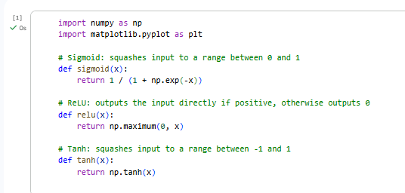
return np.tanh(x)

Task 2: Outputs for Different Input Values inputs = np.array([-5, -2, -1, 0, 1, 2, 5], dtype=float) sigmoid_outputs = sigmoid(inputs)

relu_outputs = relu(inputs) tanh_outputs = tanh(inputs)

print(f"{'Input':>8} | {'Sigmoid':>10} | {'ReLU':>8} | {'Tanh':>10}") print("-" * 45)
for x, s, r, t in zip(inputs, sigmoid_outputs, relu_outputs, tanh_outputs): print(f"{x:8.1f} | {s:10.4f} | {r:8.1f} | {t:10.4f}")

Output:
Input | Sigmoid | ReLU | Tanh

-5.0 | | 0.0067 | | 0.0 | | -0.9999
-2.0 | | 0.1192 | | 0.0 | | -0.9640
-1.0 | | 0.2689 | | 0.0 | | -0.7616
0.0 | | 0.5000 | | 0.0 | | 0.0000
1.0 | | 0.7311 | | 1.0 | | 0.7616
2.0 | | 0.8808 | | 2.0 | | 0.9640
5.0 | | 0.9933 | | 5.0 | | 0.9999
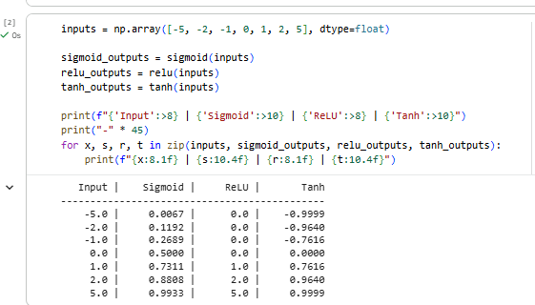

Task 3: Visualization and Comparison

x_range = np.linspace(-10, 10, 400)

plt.figure(figsize=(8, 5))
plt.plot(x_range, sigmoid(x_range), label="Sigmoid", color="#1f77b4", linewidth=2) plt.plot(x_range, relu(x_range), label="ReLU", color="#2ca02c", linewidth=2)
plt.plot(x_range, tanh(x_range), label="Tanh", color="#d62728", linewidth=2)

plt.axhline(0, color='gray', linewidth=0.6) plt.axvline(0, color='gray', linewidth=0.6)
plt.title("Comparison of Activation Functions") plt.xlabel("Input (x)")
plt.ylabel("Output f(x)") plt.legend()
plt.grid(alpha=0.3) plt.tight_layout()
plt.savefig("activation_functions_plot.png", dpi=200)
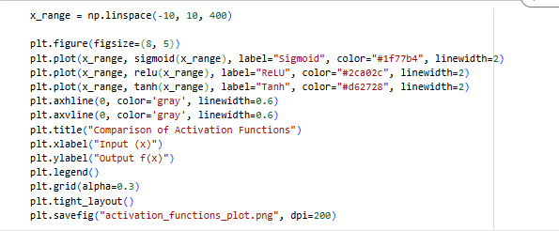

Resulting plot:
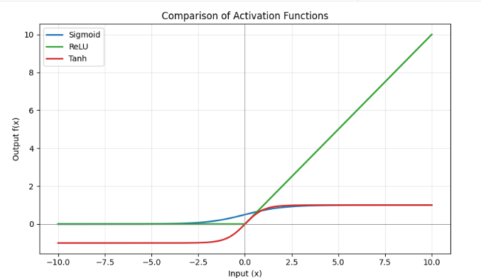

Comparison:

- Sigmoid squashes any input into a range between 0 and 1, giving it an S-shaped curve. It's smooth and interpretable as a probability, but it saturates for large positive or negative inputs, causing very small gradients (vanishing gradient problem) and slowing down learning in deep networks.
- ReLU outputs 0 for any negative input and passes positive inputs unchanged. This makes it computationally cheap and helps avoid the vanishing gradient problem for positive values, which is why it's the default choice in most modern deep networks. Its main drawback is that neurons can "die" (get stuck outputting 0) if they consistently receive negative inputs.
- Tanh is similar to Sigmoid but squashes inputs to a range between -1 and 1, making it zero-centered. This often helps optimization converge faster than Sigmoid, but it still suffers from saturation and vanishing gradients at extreme input values.

Conclusion

Sigmoid and Tanh are smooth, bounded functions best suited for output layers or situations needing probability-like values, but both suffer from vanishing gradients at extreme inputs. ReLU avoids this saturation problem for positive inputs and is computationally efficient,
making it the most commonly used activation function in hidden layers of modern deep neural networks.

