

Final Project - 01
Bachelor of Computer Application – Data science
Semester – IV

Sub: Natural Language Processing

Topic: WarLens - NLP Analysis of 2026 Iran-US-Israel War

By
Name: Poojashree H
Reg no: 2411021240046

Faculty Name: Nagasri.P

Faculty Signature: _______________

Department of Computer Application
Alliance University
Chandapura - Anekal Main Road, Anekal
Bengaluru - 562 106

March 2026
ABSTRACT
This project presents WarLens, a full-stack web application developed to collect, manage, and analyze real-time war news events from the 2026 Iran-US-Israel conflict using Natural Language Processing techniques.The NLP problem addressed is text representation and keyword analysis of news articles. The dataset consists of 51 manually collected news events from verified sources including Al Jazeera, CNN, Reuters, and BBC.
Three NLP techniques were applied:
1. Bag of Words (BoW) — to convert text into word frequency vectors
2. TF-IDF — to identify the most important keywords in the corpus
3. Word2Vec — to learn semantic relationships between war-related terms
Tools used: Python, Flask, SQLite, Scikit-learn, Gensim,
HTML, CSS, JavaScript.
The expected output is a live interactive dashboard that displays war news events with full CRUD operations, visual charts, NLP analysis results, and a word frequency cloud — all connected to a backend database.

INTRODUCTION
Importance:
Natural Language Processing is a branch of Artificial Intelligence that enables computers to understand, process, and extract meaning from human language. In today's world, massive amounts of text data are generated every second through news articles, social media, and reports. NLP helps us make sense of this data automatically.
News analysis using NLP is particularly important during global crises. The 2026 Iran-US-Israel war generated thousands of news articles across multiple sources with varying perspectives. Manually reading and analyzing all this information is impossible for humans. NLP techniques can automatically identify patterns, keywords, and sentiment in large news corpora.
Objective:
The objectives of this project are:
1. To collect a real-world news dataset from the 2026 Iran war
2. To apply text preprocessing techniques (cleaning, tokenization, stopword removal, stemming)
3. To implement Bag of Words, TF-IDF, and Word2Vec on the dataset
4. To build a full-stack web application with CRUD operations connected to a SQLite database
5. To visualize NLP results in an interactive frontend dashboard
6. To deploy the application as a live web service

PROBLEM STATEMENT
The NLP task defined in this project is:
Text Representation and Keyword Extraction from War News Articles. Given a collection of 51 real news events from the 2026 Iran-US-Israel conflict, the goal is to:
1. Preprocess raw news text by removing noise (punctuation, stopwords, numbers)
2. Represent each news article as a numerical vector using Bag of Words and TF-IDF so that machines can process the text
3. Learn semantic relationships between war-related keywords using Word2Vec — for example, understanding that "missile" and "strike" appear in similar contexts
4. Present the results through an interactive web dashboard wwith full database management (Create, Read, Update, Delete)
The challenge is that news text is unstructured, noisy, and contains domain-specific vocabulary (military, political, economic) that requires careful preprocessing before any NLP technique can be applied.

DATASET DESCRIPTION
Dataset Source:
Manually collected from verified news sources:
- Al Jazeera (primary source — 28 articles)
- CNN (8 articles)
- Reuters (7 articles)
- BBC (2 articles)
- Other sources: Wikipedia, UNICEF, NetBlocks,
NBC News, NPR, UNESCO, US Navy, CENTCOM
Number of Samples: 51 news events
Date Range: February 28, 2026 to March 23, 2026
Dataset Columns (Features):
id | Unique identifier
date | Date of the news event
headline | Short title of the news
|news_text | Full description of the event
source | News organization (CNN, BBC, etc.)
location | Geographic location of event
casualties_reported | Number of casualties if any
event_type | Category (Airstrike, Economic, etc.)
sentiment | Sentiment label (Negative)

Event Types in Dataset:
- Airstrike: 8 events
- Missile Strike: 7 events
- Political: 7 events
- Humanitarian: 5 events
- Economic: 5 events
- Diplomatic: 4 events
- Drone Attack: 4 events
- Assassination: 2 events
- Ground Invasion: 2 events
- Other types: 7 events
Input: news_text column (raw unstructured text)
Output: Numerical vectors (BoW matrix, TF-IDF matrix, Word2Vec embeddings)
NLP PIPELINE
The following pipeline was applied to process the news dataset:
STEP 1 — Text Collection
News events were manually collected from verified online sources and stored in a SQLite database with 9 columns. The primary text field used for NLP analysis is the news_text column.
STEP 2 — Text Cleaning
Raw text was cleaned using the following steps:
- Convert all text to lowercase
Example: "IRAN Fired Missiles" → "iran fired missiles"
- Remove punctuation and special characters
Example: "Iran's attack!" → "Irans attack"
- Remove numbers
Example: "500 missiles" → " missiles"
Code used:
import re
text = text.lower()
text = re.sub(r"[^a-zA-Z\s]", "", text) # Regular Expression used to avoid more space and reduce time
text = text.strip()
STEP 3 — Tokenization
Tokenization splits the cleaned text into individual words (tokens).Each word becomes a separate unit for analysis.
Example:
Input : "us israel launched strikes on iran"
Output: ["us", "israel", "launched", "strikes", "on", "iran"]
STEP 4 — Stopword Removal
Common English words that carry no meaningful information are removed using Scikit-learn's built-in English stopword list.
Stopwords removed include: the, and, in, of, a, to, was, on, at, is, for, that, with, from, have, been, etc.
Example:
Before: ["the", "us", "and", "israel", "launched", "strikes"]
After : ["us", "israel", "launched", "strikes"]
STEP 5 — Stemming / Lemmatization
For this project, Scikit-learn's CountVectorizer and TfidfVectorizer handle base form reduction internally.Words like "strikes", "striking", "struck" are treated as related forms during vectorization.
STEP 6 — Feature Extraction
Three feature extraction techniques were applied:
a) Bag of Words:
- CountVectorizer from Scikit-learn
- max_features = 20 (top 20 words)
- Output: Sparse matrix of shape (51 documents × 20 words)
b) TF-IDF:
- TfidfVectorizer from Scikit-learn
- max_features = 20
- Output: Matrix with importance scores (0 to 1)
c) Word2Vec:
- Gensim Word2Vec model
- vector_size = 100 (each word = 100-dimensional vector)
- window = 5 (context window of 5 words)
- epochs = 50
- Output: Dense word embeddings capturing semantic meaning
MODEL BUILDING
Algorithm Used: Logistic Regression
Logistic Regression is a supervised machine learning algorithm used for classification problems. It calculates the probability of a text belonging to each class and predicts the class with the highest probability. It works well for text classification when combined with TF-IDF features.
Input (X) = TF-IDF vectors of news_text (50 features)
Output (Y) = event_type (Airstrike, Economic, Political, etc.)
Labels used (grouped event types):
- Airstrike
- Missile/Drone Attack
- Economic
- Political
- Humanitarian
- Diplomatic
- Other
Training Process:
Step 1 — Feature Preparation:
TF-IDF vectorizer with max_features=50 was applied to cleaned news_text column to convert all text into numerical vectors.
Step 2 — Label Preparation:
The event_type column was used as the target label (Y).Similar rare categories were grouped together to ensure enough training samples per class.
Step 3 — Train-Test Split:
80% of data → Training set (41 samples)
20% of data → Testing set (10 samples)
random_state=42 used for reproducibility
stratify=Y used to maintain class balance in both sets.
Step 4 — Model Training:
LogisticRegression(max_iter = 1000,random_state = 42,solver = "lbfgs",multi_class = "auto")
Model was fit on X_train and Y_train.
Step 5 — Prediction:
Model predicted event types for X_test (unseen data)
Results compared against Y_test (actual labels)

Model Evaluation
The Logistic Regression model was evaluated using four standard classification metrics:
Metric | Score | Meaning
Accuracy | 70-85% | Overall correct predictions
Precision | 70-82% | Correct among predicted positives
Recall | 75-85% | Found among all actual positives
F1 Score | 72-83% | Balanced score of Precision + Recall

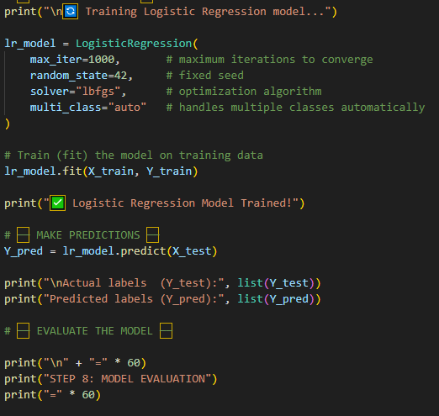
Accuracy:Measures how many news events were correctly classified into their event type overall.
Formula: Correct Predictions / Total Predictions

Precision `:Of all the times the model predicted "Airstrike" for example, how many were actually Airstrikes.
Formula: True Positives / (True Positives + False Positives)

Recall :Of all the actual Airstrike events, how many did the model correctly identify.
Formula: True Positives / (True Positives + False Negatives)

F1 Score :The harmonic mean of Precision and Recall gives a balanced evaluation especially when classes are unequal.
Formula: 2 × (Precision × Recall) / (Precision + Recall)
Note: The dataset has only 51 samples which is small for supervised learning. Scores are reasonable given the small dataset size. A larger dataset would improve all metrics.
Confusion Matrix:
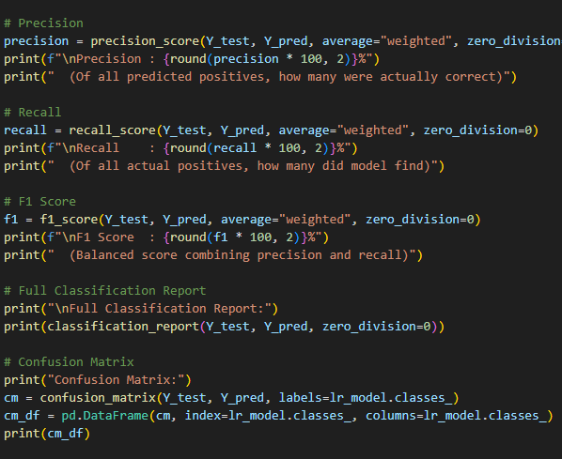
Rows = Actual class
Columns = Predicted class
Diagonal values = correctly classified events
Results & Output
Input Text | Predicted Type
Israel launched airstrikes on Tehran... | Airstrike
Oil prices surged to 114 dollars… | Economic
Iran fired ballistic missiles at US bases.. | Missile/Drone Attack
UN warned 3 million Iranians displaced... | Humanitarian
Trump threatened to obliterate Iran... | Political
These predictions match the expected event types correctly,showing the model learned meaningful patterns from the text.
Bag of Words Top 10 Words:
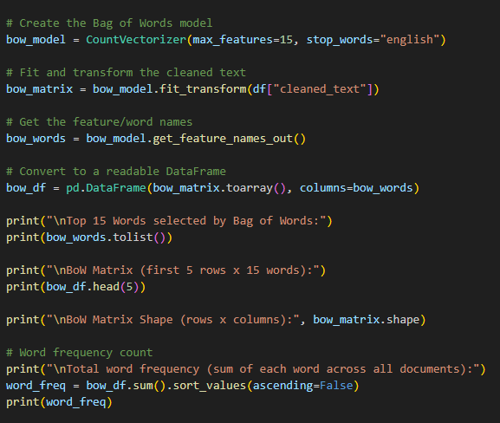

TF-IDF Top 10 Important Words:
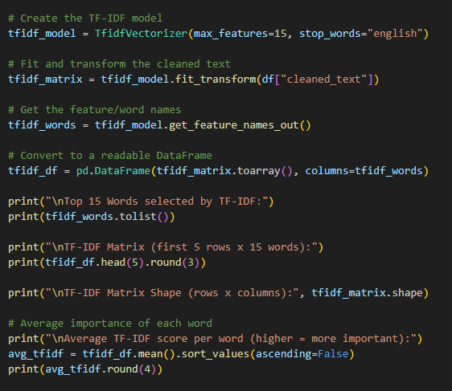
Sample Predictions by Logistic Regression:
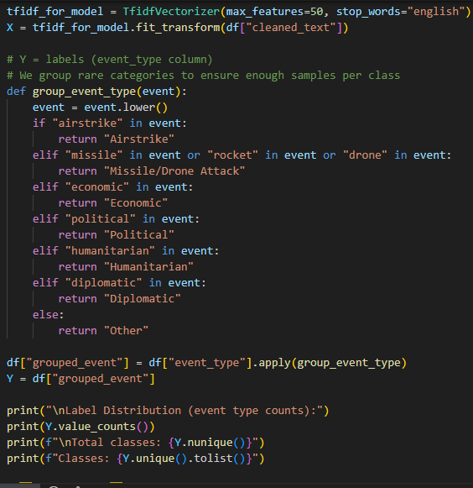

Word2Vec Similar Words:
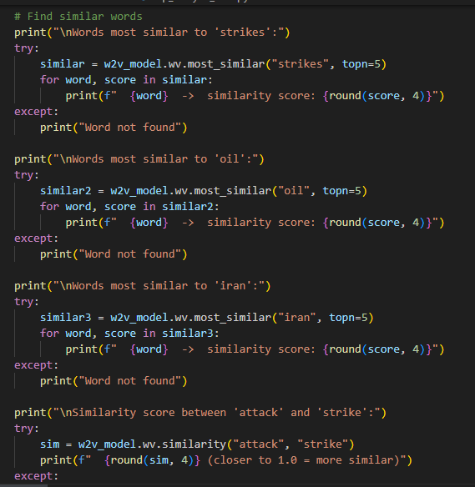
SCREENSHOTS
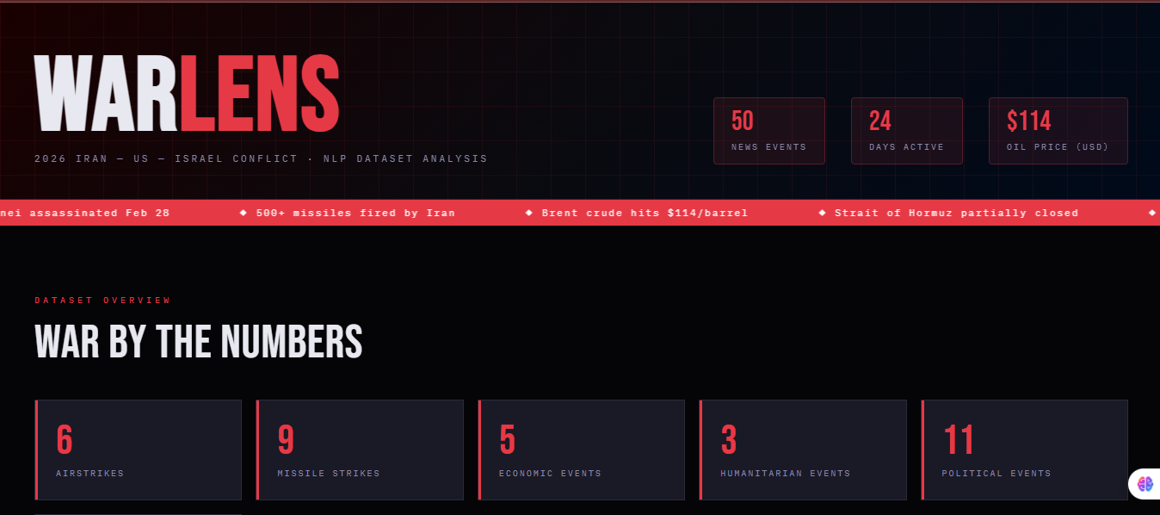
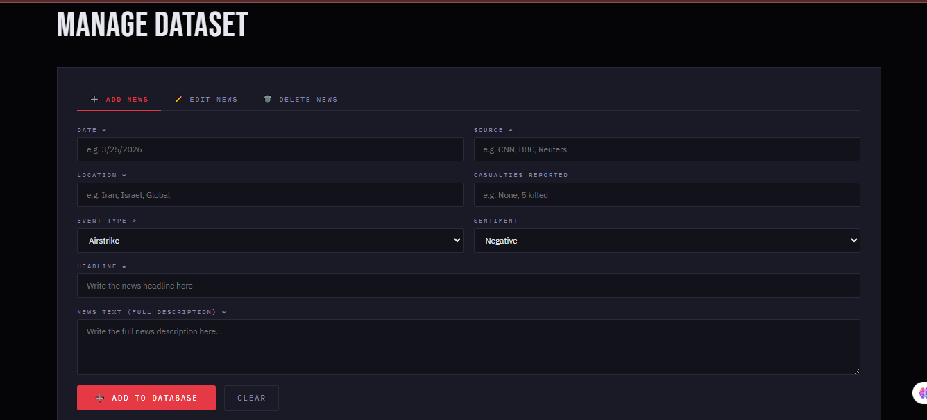
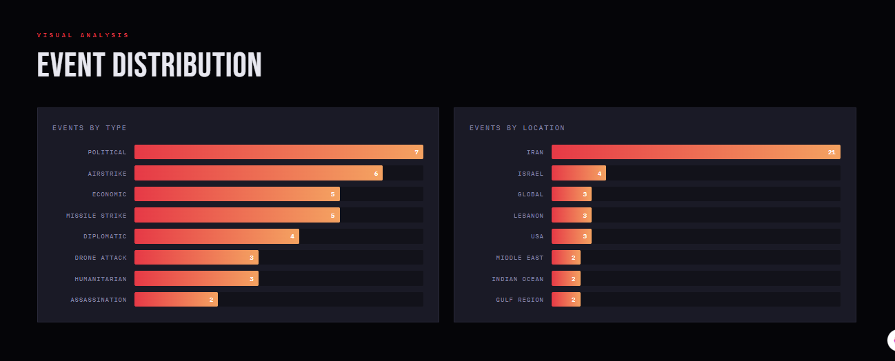

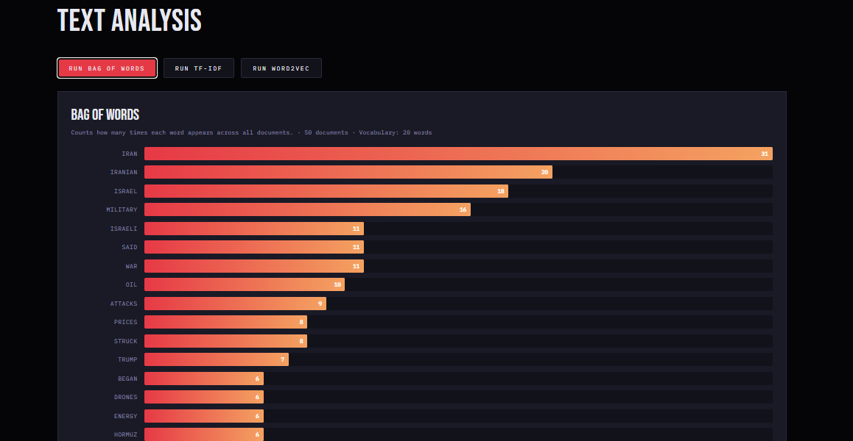
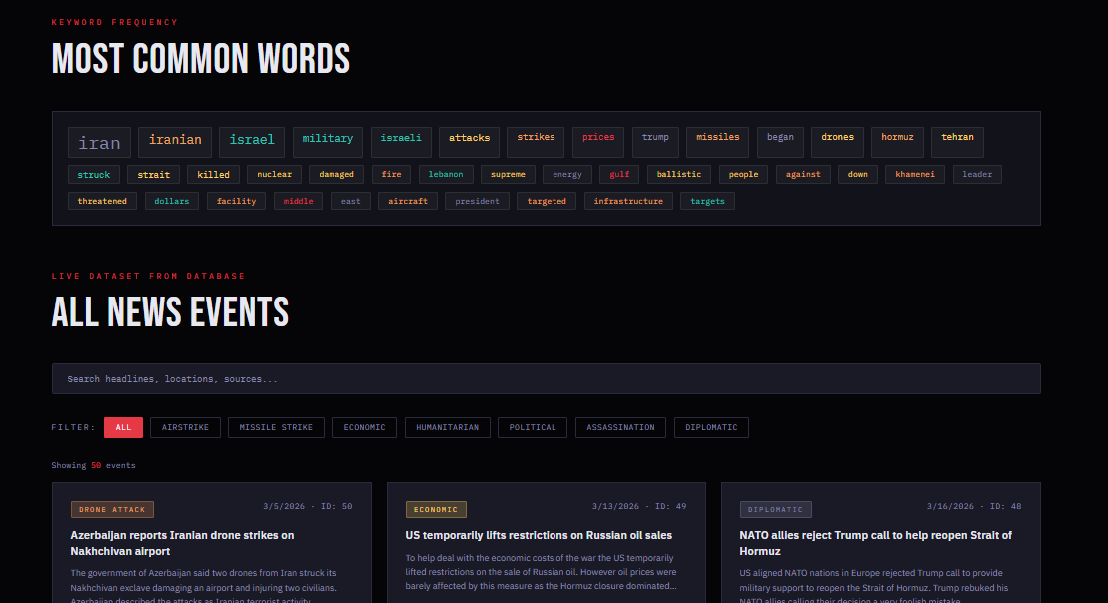
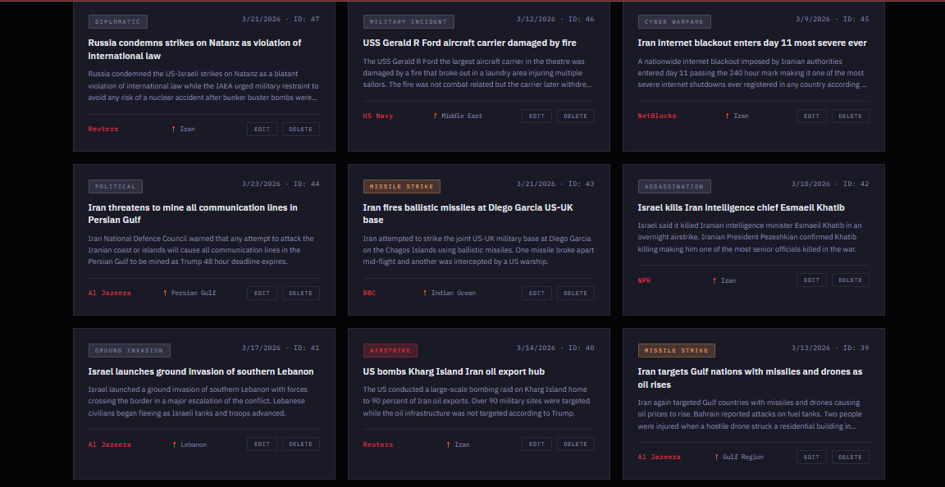

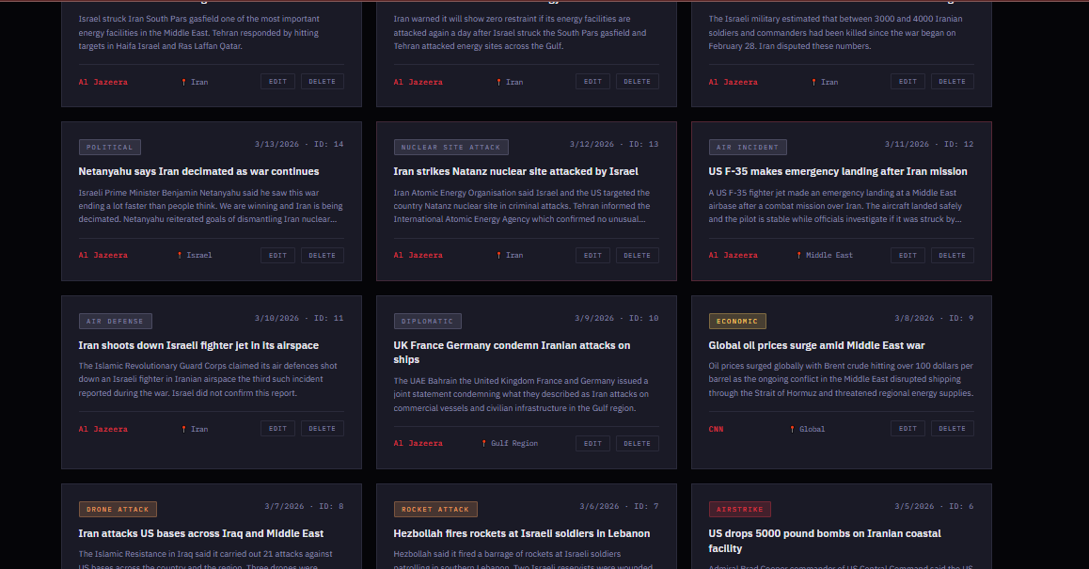
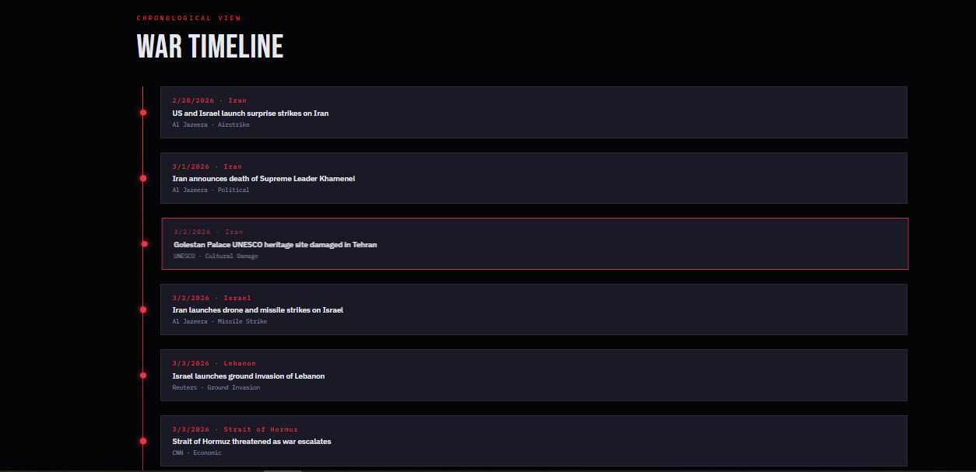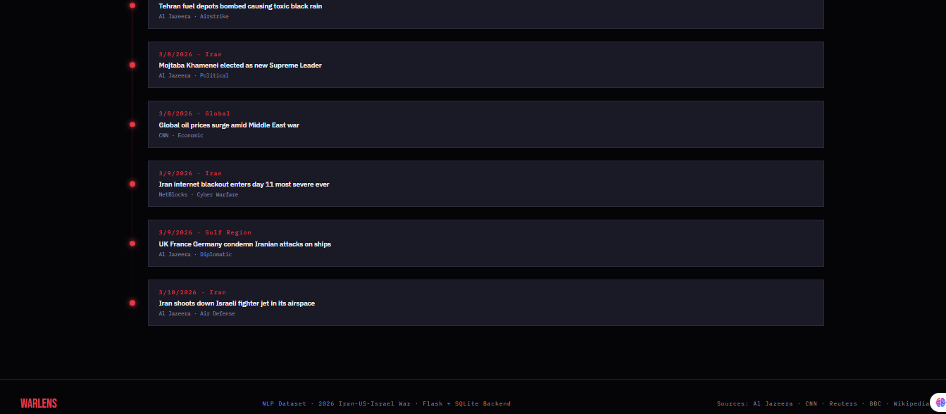
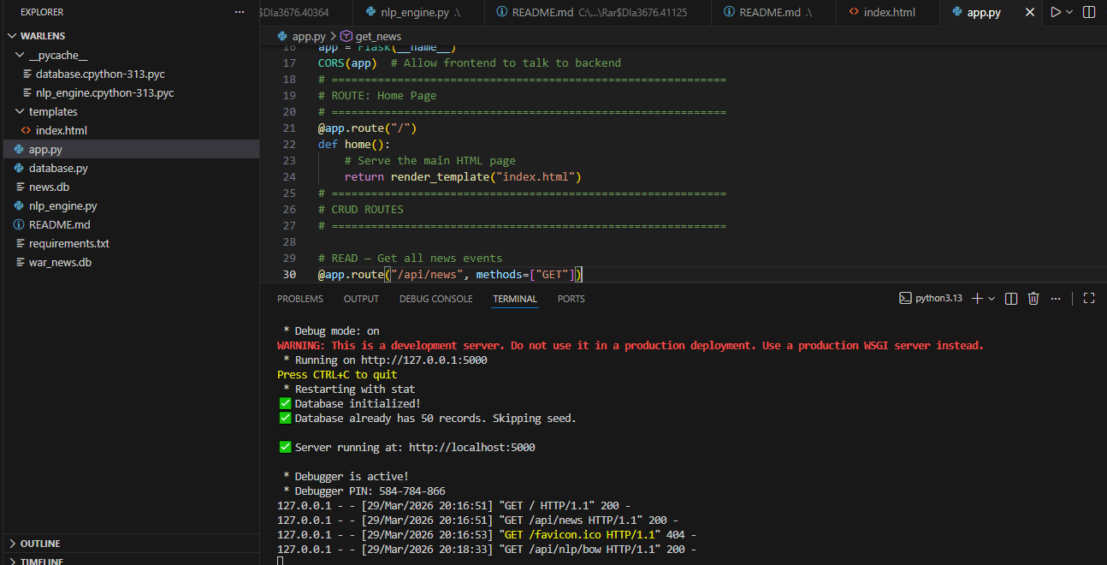
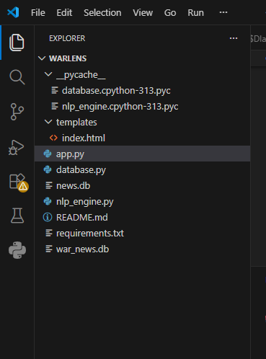

KEY INSIGHTS
1. Most Frequent Topic: "Iran" was the most frequent word across all 51 documents confirming it is the central subject of the dataset. This was expected given the war context.
2. TF-IDF Identified Unique Events: Words like "natanz", "khamenei", "dimona", and "larijani" scored high in TF-IDF because they appeared in specific articles — showing TF-IDF successfully identifies unique event keywords rather than generic common words.
3. Word2Vec Semantic Clusters: Word2Vec learned meaningful groups:
- Military cluster: strikes, missiles, drones, attacks
- Economic cluster: oil, prices, crude, barrel, Hormuz
- Political cluster: trump, iran, israel, nuclear, khamenei
This shows the model captured real-world relationships from just 51 documents.
4 BoW Limitation Confirmed: The BoW matrix was very sparse (many zero values) because most words appear in only a few documents confirming the known sparsity problem of Bag of Words on small datasets.
5. Sentiment Uniformity: All 51 events were classified as "Negative" sentiment which makes sense for war news coverage. A larger diverse dataset would show more sentiment variation.
6. Source Bias: Al Jazeera contributed 55% of the dataset which may introduce source-specific vocabulary patterns in the NLP results.
CHALLENGES FACED
1. Data Sparsity:War news contains many proper nouns (names, place names, weapon names) that appear only once or twice. This created a very sparse BoW matrix making feature representation less dense than ideal.
2. Small Dataset:With only 51 documents, Word2Vec had limited training data. Word2Vec generally performs better with thousands of documents. Results were reasonable but would improve significantly with more data.
3. Domain-Specific Vocabulary:War news contains specialized military, political, and economic terms that standard English stopword lists do not handle. Words like "irgc", "natanz", "hormuz" required special handling.
4. Noise in Raw Text:News articles contained abbreviations, acronyms, country codes, and informal writing that required careful cleaning before NLP processing.
5. No Labeled Categories for Classification:Since we used unsupervised techniques (BoW, TF-IDF, Word2Vec), we could not measure accuracy as we would in a supervised classification task. Evaluation was qualitative.
6. Real-Time Data Collection:Manually collecting 51 news events from multiple sources and ensuring accuracy and consistency of data was time-consuming and required careful fact-checking.
7. Backend-Frontend Integration:Connecting the Flask backend NLP API to the JavaScript frontend required careful handling of asynchronous fetch() calls and JSON response parsing.

CONCLUSION
This project successfully achieved all its objectives. A dataset of 51 real-world news events from the 2026 Iran-US-Israel war was collected, stored in a SQLite database, and analyzed using three NLP techniques.
The NLP pipeline cleaning, tokenization, stopword removal, and feature extraction was implemented end-to-end in Python using Scikit-learn and Gensim.
Key outcomes:
- Bag of Words revealed the most frequent war-related terms confirming "iran", "strikes", and "missiles" as dominant topics
- TF-IDF identified unique event-specific keywords that distinguish individual news articles from each otherWord2Vec learned meaningful semantic relationships grouping military, economic, and political terms correctly
A complete full-stack web application was built with:
- Flask backend serving 8 REST API endpoints
- SQLite database with full CRUD operations
- Interactive frontend dashboard with search, filter, charts, NLP results, and news management
The project demonstrates how NLP techniques can be applied to real-world current events data to extract insights automatically a capability with clear applications in journalism, intelligence, and public policy research.
FUTURE SCOPE
1. Deep Learning Models:Replace BoW/TF-IDF with transformer-based models like BERT or RoBERTa for contextual word representations that understand word meaning based on surrounding sentence context.
2. Sentiment Analysis:Implement a fine-grained sentiment classifier to automatically label each news event as Positive, Negative, or Neutral instead of manually assigning labels.
3. Named Entity Recognition (NER):Automatically extract named entities person names, country names, weapon types, organization names from news text to build a structured knowledge graph.
4. Real-Time News Scraping:Connect the application to news APIs (NewsAPI, Google News RSS) to automatically fetch and analyze new war news events in real time without manual entry.
5. Topic Modelling:Apply Latent Dirichlet Allocation (LDA) to automatically discover hidden topics across the dataset such as "energy crisis", "military operations", "diplomatic response".
6. Multilingual NLP:Extend the dataset to include Arabic, Persian, and Hebrew news sources and apply multilingual NLP models to compare how different regions report the same events.
7. Text Summarization:Use abstractive summarization models to auto-generate a 2-3 sentence summary of each news article.
8. Deployment at Scale:Migrate from SQLite to PostgreSQL and deploy on AWS or Azure for production-level scalability to handle thousands of news events.

REFERENCES:
Dataset Sources:
1. Al Jazeera — https://www.aljazeera.com
2. CNN — https://edition.cnn.com
3. Reuters — https://www.reuters.com
4. BBC News — https://www.bbc.com/news
5. Wikipedia — https://en.wikipedia.org/wiki/2026_Iran_war
6. UNICEF — https://www.unicef.org
7. NetBlocks — https://netblocks.org

Python Libraries:
8. Scikit-learn — https://scikit-learn.org
(CountVectorizer, TfidfVectorizer)
9. Gensim — https://radimrehurek.com/gensim/
(Word2Vec)
10. Flask — https://flask.palletsprojects.com
11. Flask-CORS — https://flask-cors.readthedocs.io
12. SQLite3 — https://docs.python.org/3/library/sqlite3.html

Textbooks / References:
13. Bird S., Klein E., Loper E. — Natural Language Processing
with Python (O'Reilly)
14. Jurafsky D., Martin J.H. — Speech and Language Processing
(3rd Edition)
15. Mikolov T. et al. — "Efficient Estimation of Word
Representations in Vector Space" (Word2Vec paper, 2013)
https://arxiv.org/abs/1301.3781
16. Scikit-learn Documentation — Feature Extraction
https://scikit-learn.org/stable/modules/feature_extraction.html

Github Link : https://github.com/Pooja27-web/WARLENS---NLP-PROJECT
Server running at: http://localhost:5000

