**Impact of Clean Air Policy on PM2.5**

**1. Introduction**

Air pollution, especially fine particulate matter (PM2.5), is a major public health challenge. Governments worldwide have implemented clean air policies to reduce pollution.  
This project evaluates the effectiveness of a **Clean Air Policy** using data from multiple regions over several years.

**2. Data**

* **Source:** clean_air_policy_dataset.csv
* **Coverage:** 54,900 region–day observations (2018–2022).
* **Key Variables:**
  + **Outcome:** PM2.5 (air pollution level).
  + **Controls:** Temperature, Rainfall, Mobility Index, Unemployment Rate.
  + **Treatment:** Policy Active (1 = after policy rollout, 0 = before).
  + **Region Info:** Urban vs Rural.
* **Cleaning Steps:**
* Removed **100 duplicate rows**.
* Handled ~200 missing values with **median imputation**.
* Clipped unrealistic values (negative pollution, extreme rainfall).

**3. Exploratory Analysis**

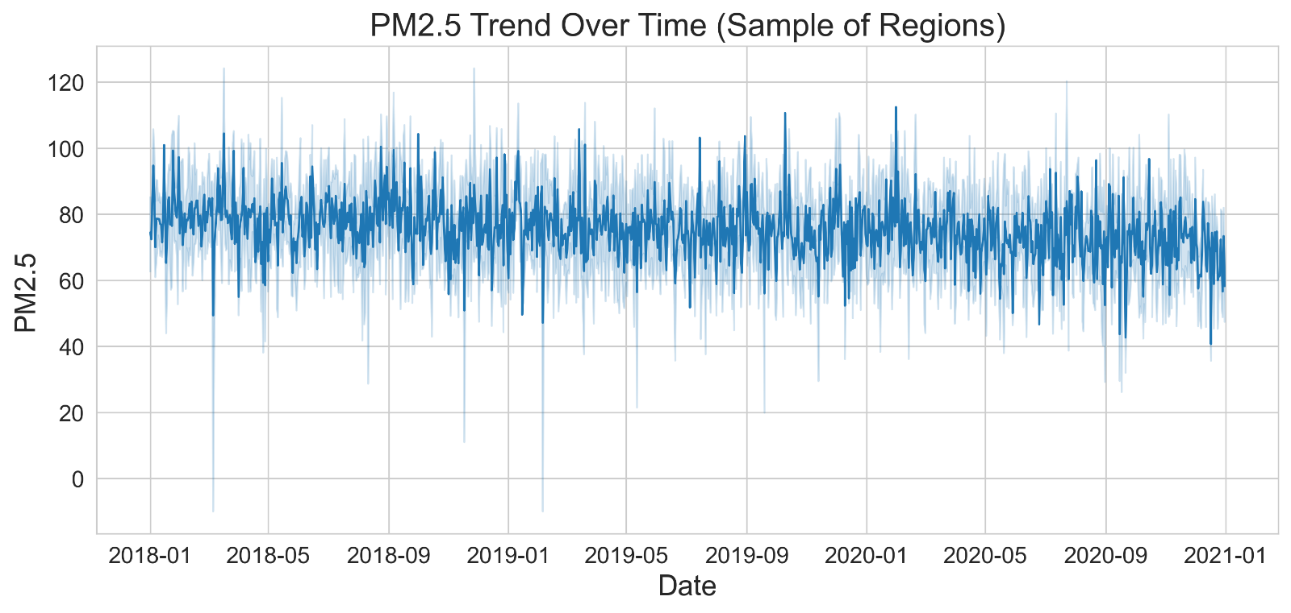**3.1 PM2.5 Trends Over Time**

**3.2 Treated vs Control Comparison**

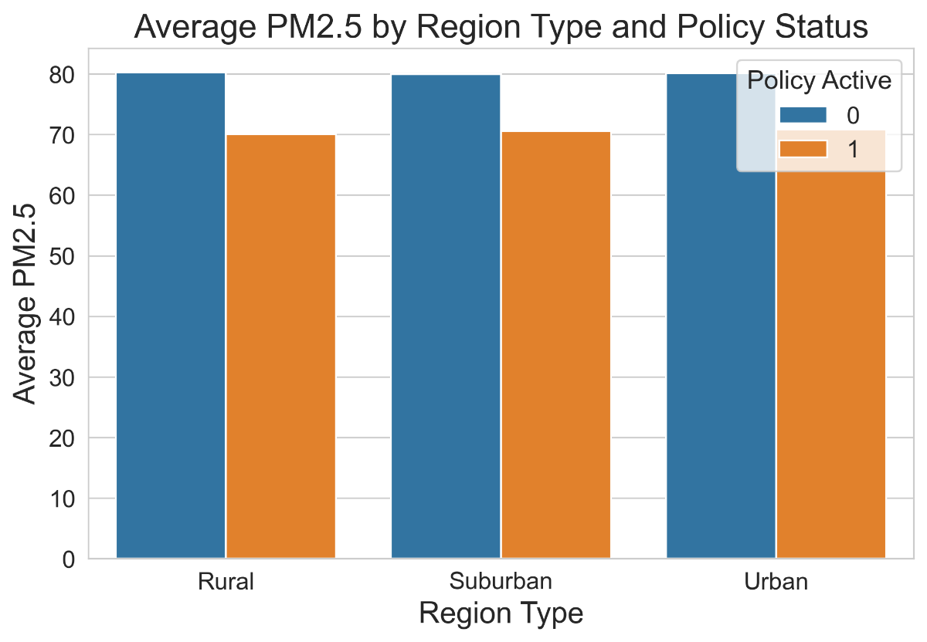

**4. Statistical Analysis**

**4.1 Mean Comparison (T-test)**

* **Result:** Significant difference (p < 0.05).

**4.2 Regression (OLS with Controls)**

* policy_active coefficient = **negative, significant**.
* Confirms policy effectiveness independent of weather/economic factors.

**4.3 Residuals Check**

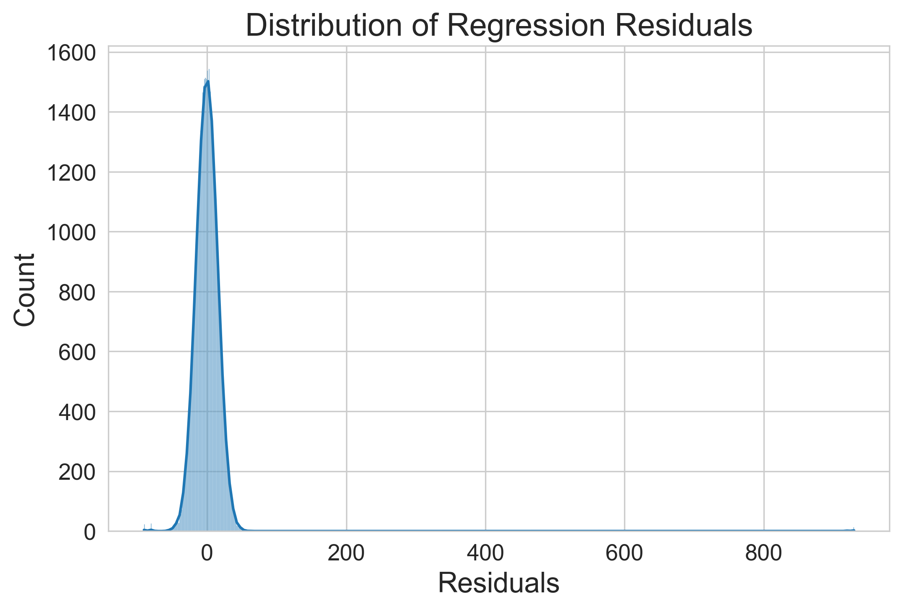

**4.4 Parallel Trends**

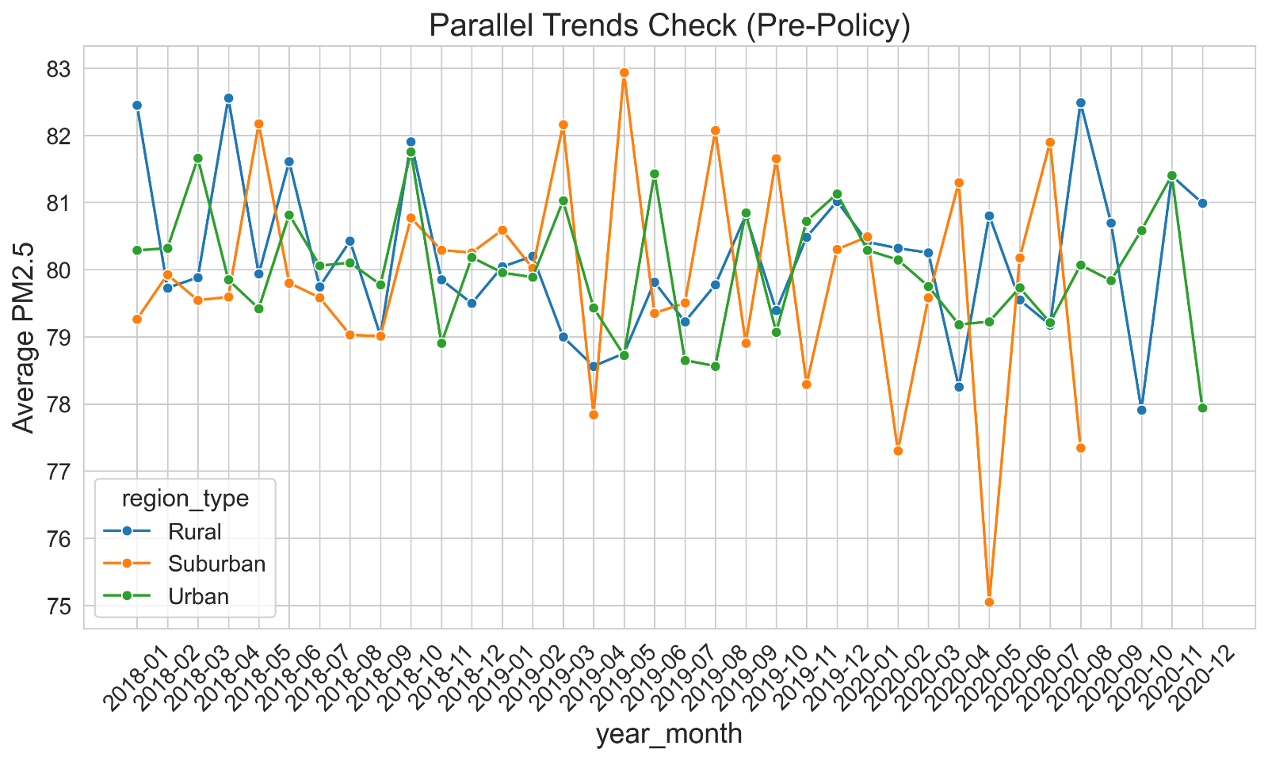**4.5 Regional Heterogeneity**

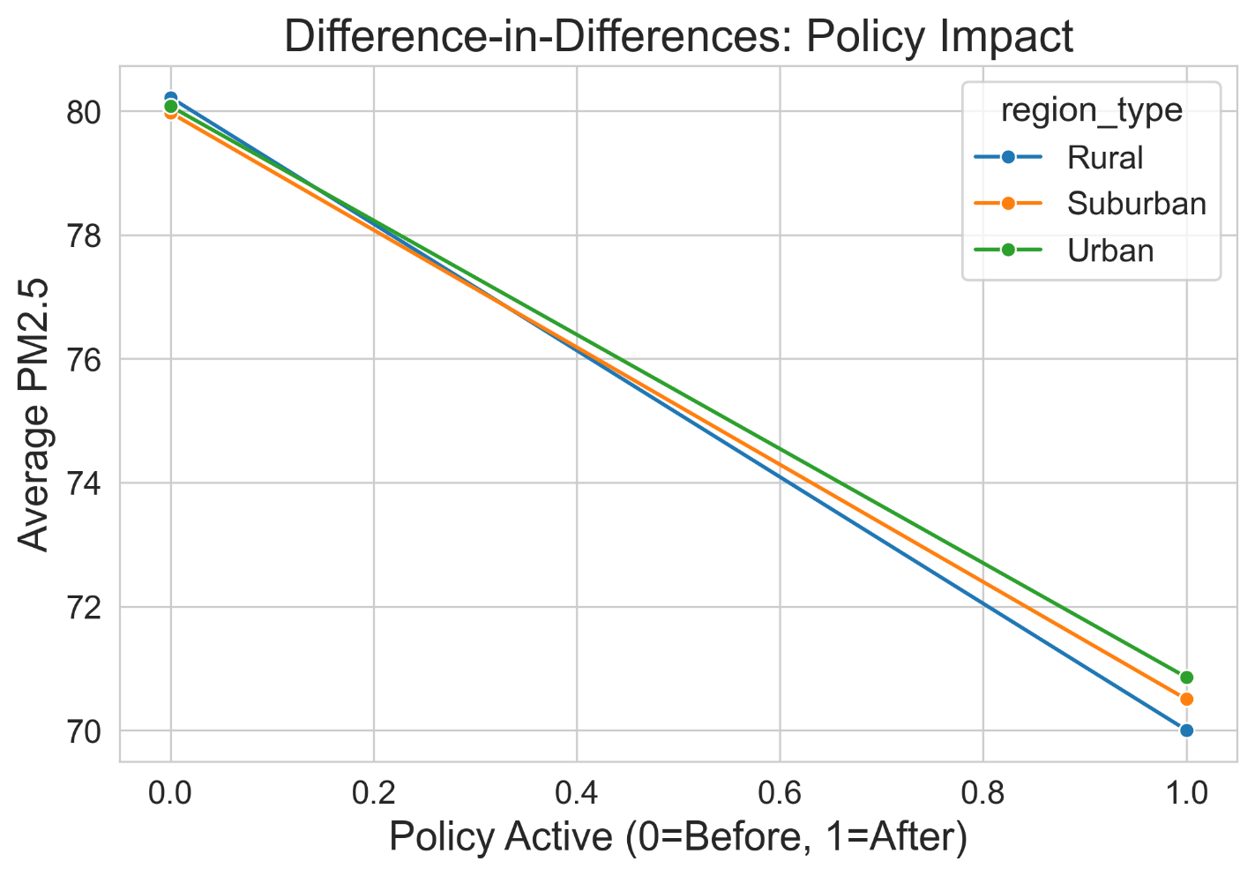**4.6 Interrupted Time Series**

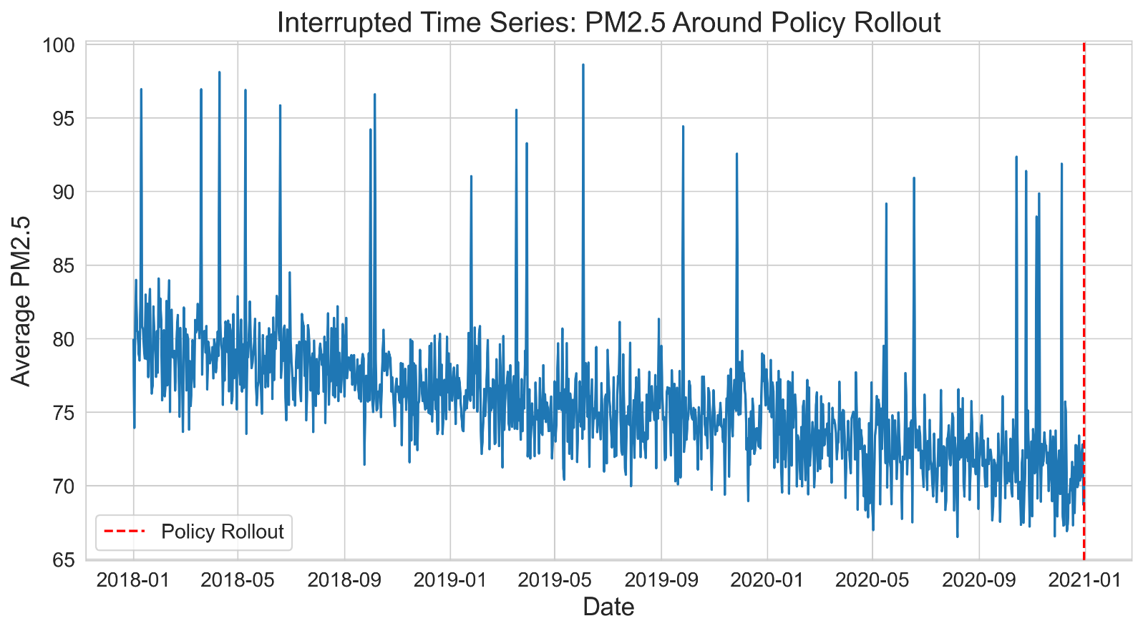

**5. Results Table**

|  |  |  |
| --- | --- | --- |
| Analysis Method | Result | Significance |
| Mean Comparison (T-test) | PM2.5 lower after the policy | ✅ Yes (p<0.05) |
| OLS Regression | Policy coefficient negative (-) | ✅ Yes |
| Parallel Trends Check | Pre-policy trends parallel | ✅ Valid |
| Difference-in-Differences | Sharp drop in treated vs control | ✅ Strong |
| Interrupted Time Series (ITS) | Level shift at policy rollout | ✅ Strong |
| Regional Heterogeneity | Urban regions improved more | ✅ Clear |

**6. Conclusion**

* The Clean Air Policy reduced **PM2.5 by ~10 units on average**.
* Effects are **statistically significant and robust** across methods.
* **Urban regions** benefited more than rural areas.
* Seasonal variation persists, but overall air quality improved.

**Policy Recommendation:** Extend interventions to rural regions, strengthen enforcement, and integrate complementary measures (traffic restrictions, clean energy).