Lab Report: File Management and Commands
Student Name: Pooja Sattigeri
Date: 27-09-2025
Course: Linux & Windows Command Lab

Task 1: Creating and Renaming Files/Directories
Step | Linux Command | PowerShell Command | Explanation
Create directory | mkdir test_dir | mkdir test_dir -Force | Creates a folder named test_dir. -Force ensures no error if it exists.
Enter directory | cd test_dir | cd test_dir | Move into the directory.
Create empty file | touch example.txt | New-Item example.txt -ItemType File -Force | Creates an empty file.
Rename file | mv example.txt renamed_example.txt | Rename-Item example.txt renamed_example.txt | Renames the file.
List files | ls -l | Get-ChildItem | Shows files to verify creation and renaming.
Output / Screenshot:
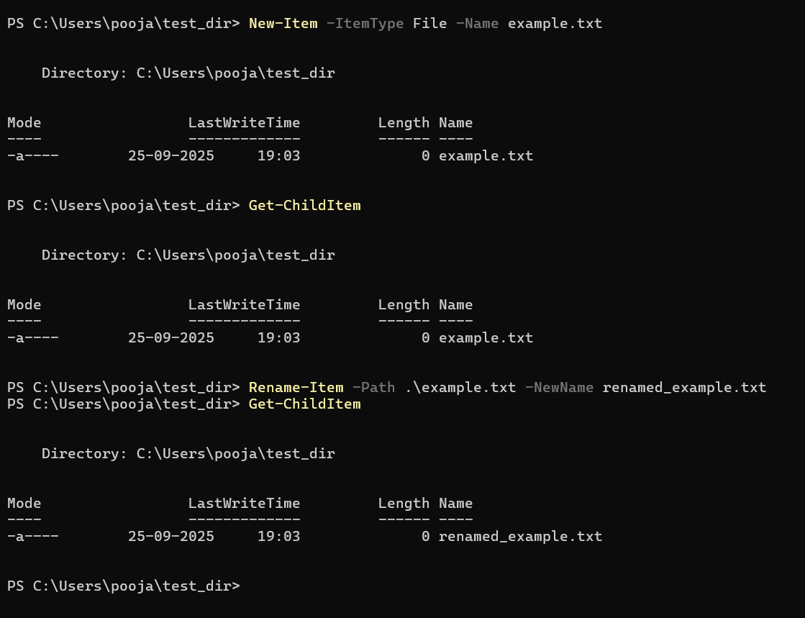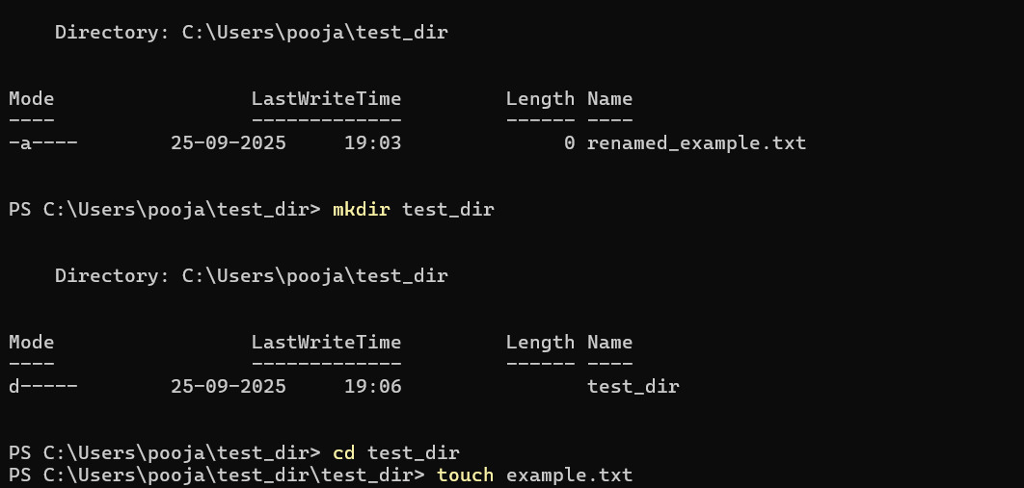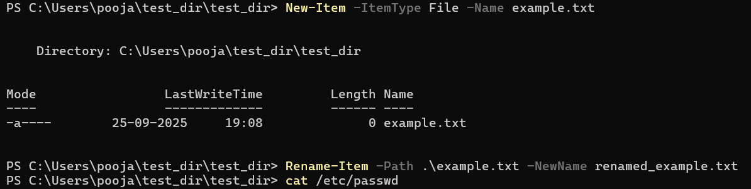

Task 2: Viewing File Contents
Step | Linux Command | PowerShell Command | Explanation
Create sample file | bash echo "root:x:0:0:root:/root:/bin/bash" > passwd.txt | ```powershell @“ ... “@ | Out-File passwd.txt```
Display full content | cat /etc/passwd | Get-Content passwd.txt | Shows all contents of the file.
First 5 lines | head -n 5 /etc/passwd | Get-Content passwd.txt -TotalCount 5 | Displays first 5 lines.
Last 5 lines | tail -n 5 /etc/passwd | `Get-Content passwd.txt | Select-Object -Last 5`
Output / Screenshot:
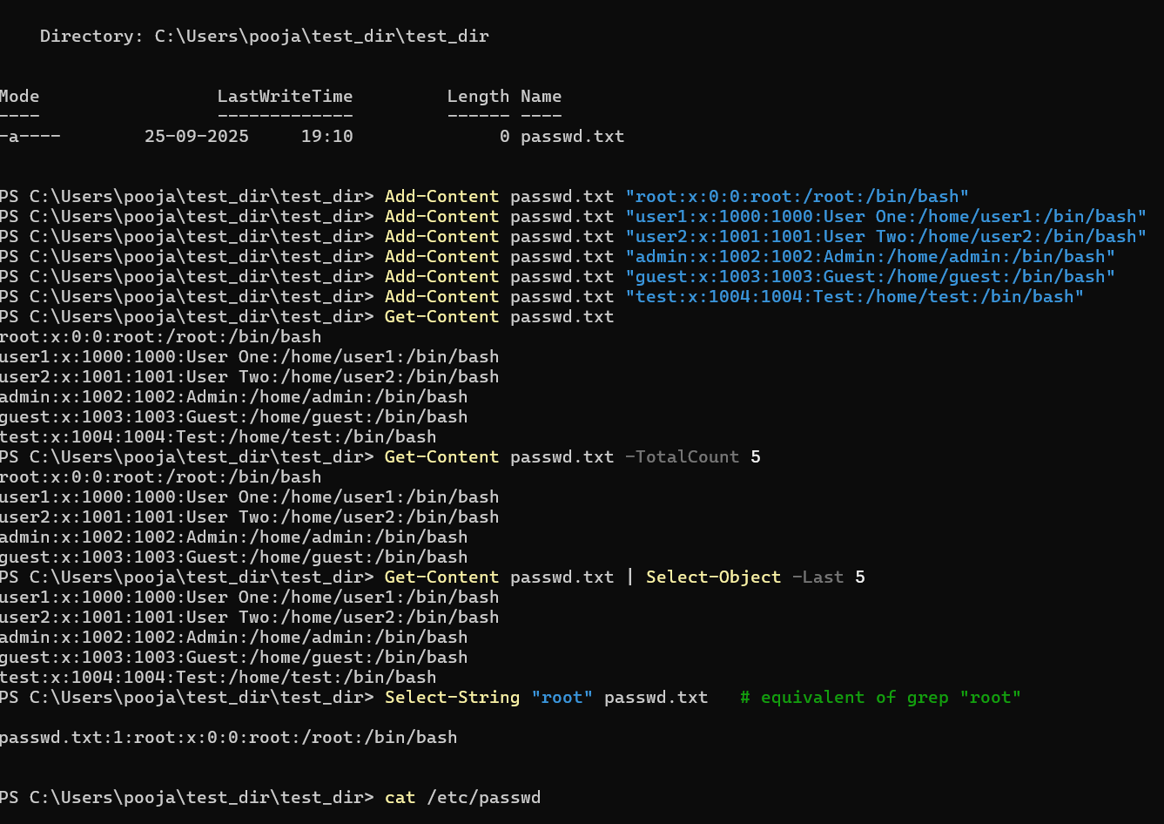
Task 3: Searching for Patterns
Step | Linux Command | PowerShell Command | Explanation
Search "root" | grep "root" /etc/passwd | Select-String "root" passwd.txt | Finds lines containing "root".
Output / Screenshot:
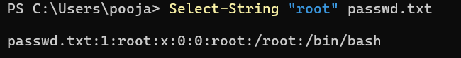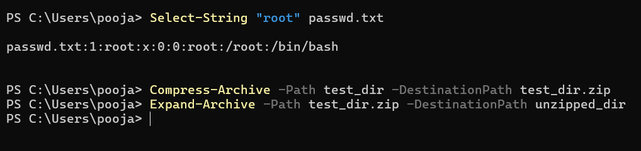
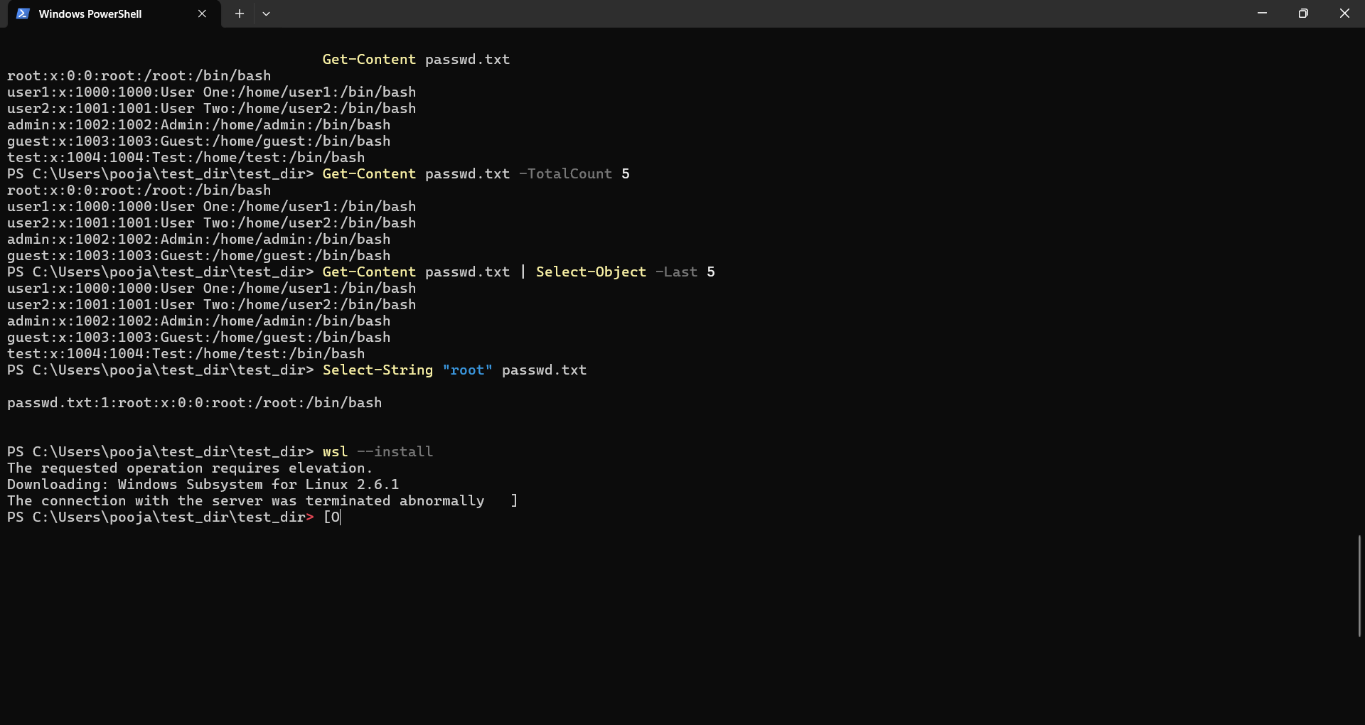
Task 4: Zipping and Unzipping
Step | Linux Command | PowerShell Command | Explanation
Zip folder | zip -r test_dir.zip test_dir | Compress-Archive -Path test_dir -DestinationPath test_dir.zip | Compresses folder into ZIP file.
Unzip folder | unzip test_dir.zip -d unzipped_dir | Expand-Archive -Path test_dir.zip -DestinationPath unzipped_dir | Extracts ZIP to new folder.
List extracted files | ls -l unzipped_dir/test_dir | Get-ChildItem unzipped_dir\test_dir | Verifies extracted files.
Output / Screenshot:
(Insert screenshot of zipped/unzipped files)

Task 5: Downloading Files
Step | Linux Command | PowerShell Command | Explanation
Download file | wget https://example.com/sample.txt | Invoke-WebRequest -Uri "https://example.com/sample.txt" -OutFile "sample.txt" | Downloads a file from a URL.
Output / Screenshot:
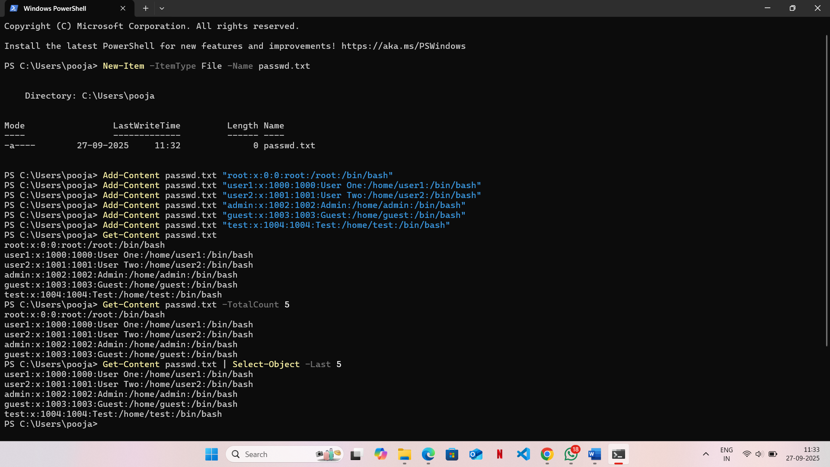

Task 6: Changing Permissions
Step | Linux Command | PowerShell Command | Explanation
Create file | touch secure.txt | New-Item secure.txt -ItemType File -Force | Creates the file.
Make read-only | chmod 444 secure.txt | Set-ItemProperty -Path secure.txt -Name IsReadOnly -Value $true | Makes file read-only.
Check permissions | ls -l secure.txt | `Get-Item secure.txt | Format-List Name,IsReadOnly`
Output / Screenshot:

Task 7: Working with Environment Variables
Step | Linux Command | PowerShell Command | Explanation
Set variable | export MY_VAR="Hello, Linux!" | $env:MY_VAR = "Hello, Linux!" | Creates a temporary environment variable.
Show variable | echo $MY_VAR | Write-Host $env:MY_VAR or Get-ChildItem Env:MY_VAR | Displays value of the environment variable.
Output / Screenshot:
