**Sports Dashboard Application**

**Overview**

This project is a simple application that retrieves sports data from an external API, stores it in a MongoDB database, and displays it in a user-friendly interface using React.

**Project Structure**

Backend (server.js): Handles API requests, interacts with MongoDB, and fetches data from the sports API.

Frontend (src/components/SportsList.js): Displays the sports data retrieved from the backend.

**Setup Instructions:**

Prerequisites:

* Node.js
* MongoDB

**Backend Setup**

1. Clone the Repository

git clone https://gitlab.com/Pooja575/sports.git

cd sports_app_backend

1. Install Dependencies

npm install

1. Start MongoDB

Make sure MongoDB is running on the default port (27017).

1. Run the Backend Server

node server.js

The server will start on [**http://localhost:5000**](http://localhost:5000)

**Frontend Setup**

1. Navigate to the Frontend Directory

cd sports_app_frontend

1. Install Dependencies

npm install

1. Run the React Application

npm start

The application will be available at **http://localhost:3000**

**API Endpoints**

**Fetch Sports Data**

* Endpoint: GET /fetch-sports
* Description: Retrieves sports data from the external API and saves it to the MongoDB database.

**Get Sports Data**

* Endpoint: GET /get-sports
* Description: Retrieves sports data from the MongoDB database and returns it in JSON format.

**Usage**

Open the frontend application in your browser (http://localhost:3000).

The sports data will be fetched and displayed on the page.

**Additional Features**

Basic interactivity: The UI displays a list of sports fetched from the backend.

Error handling: Includes error messages for failed data fetching and server issues.

Testing

Basic tests can be implemented using tools like Jest. Ensure that the backend APIs are working as expected and that the frontend is displaying data correctly.

**Documentation**

Code Comments: Inline comments are provided for key parts of the code.

Setup Instructions: Detailed setup instructions are included above.

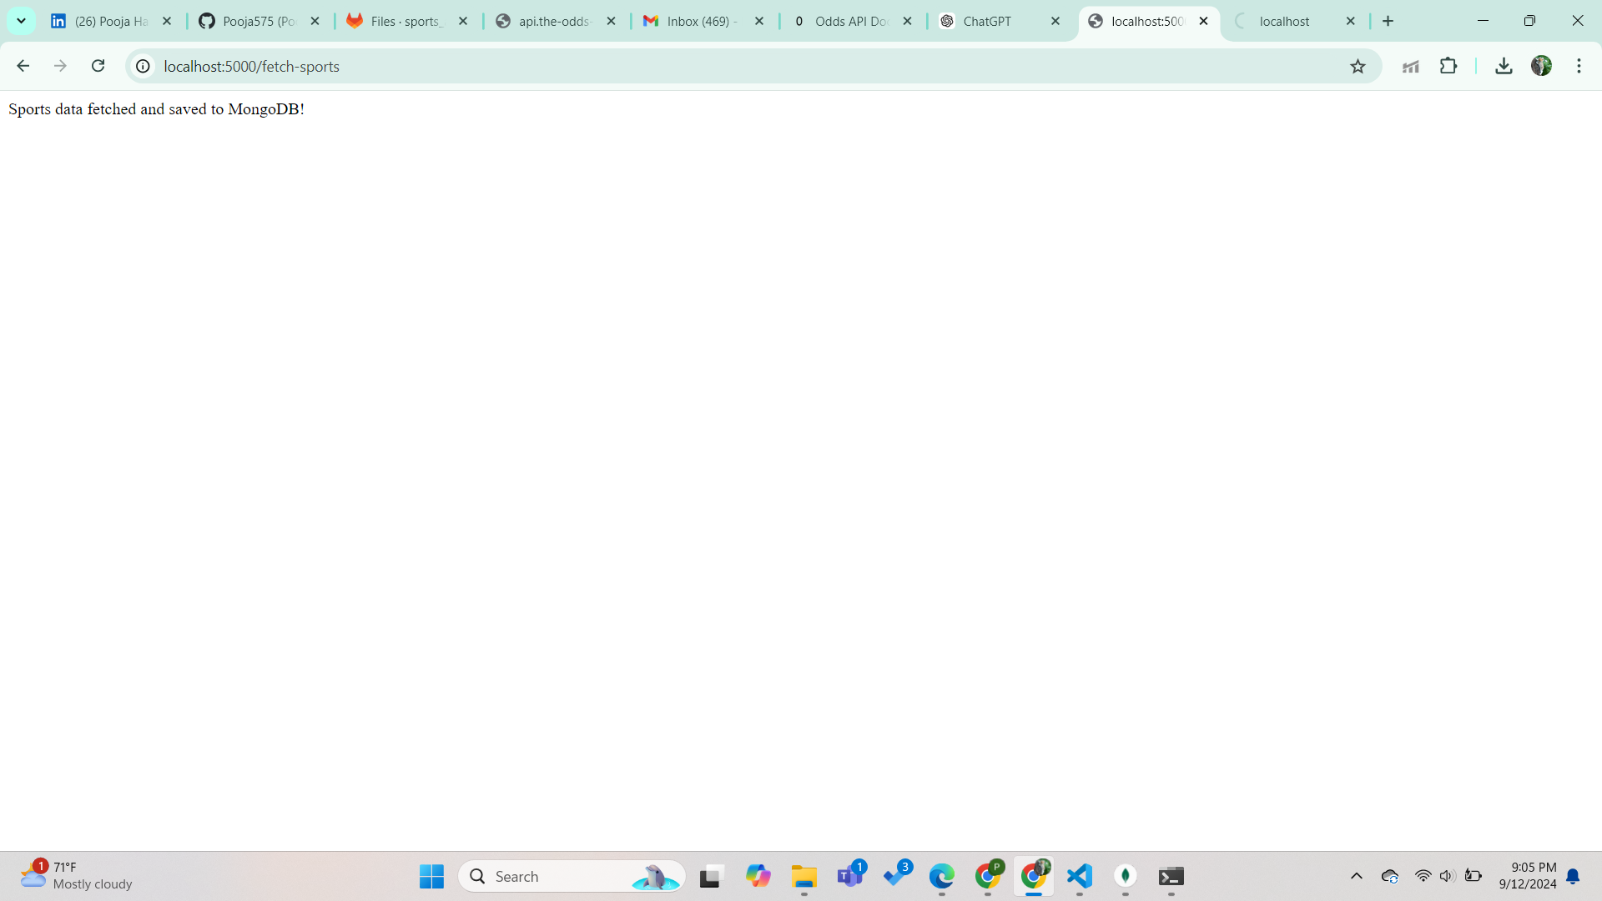

Fig: localhost:5000/fetch-sports

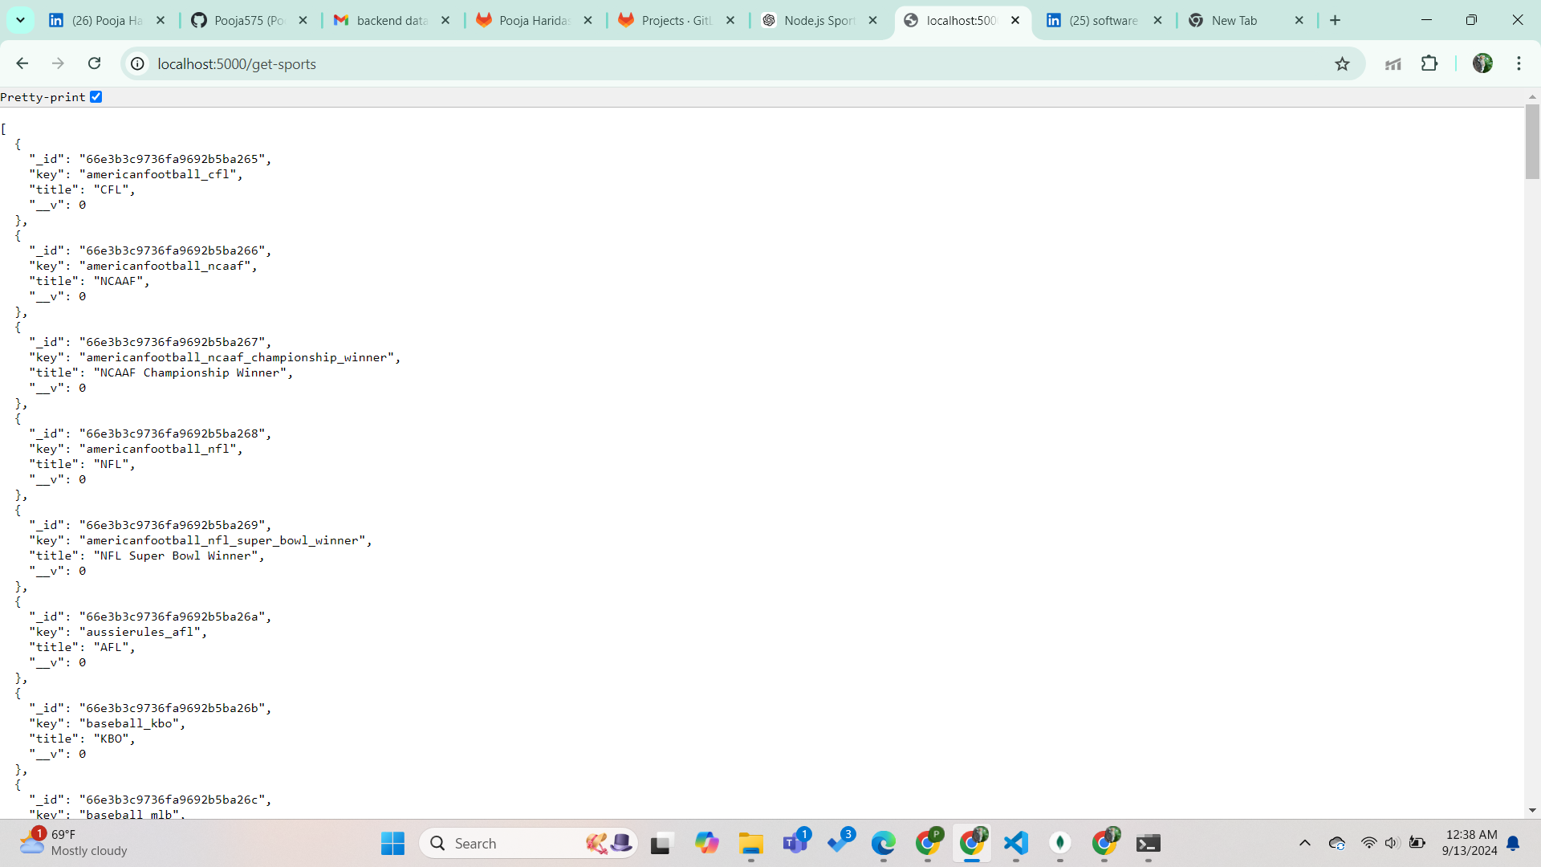

Fig: localhost:5000/get-sports

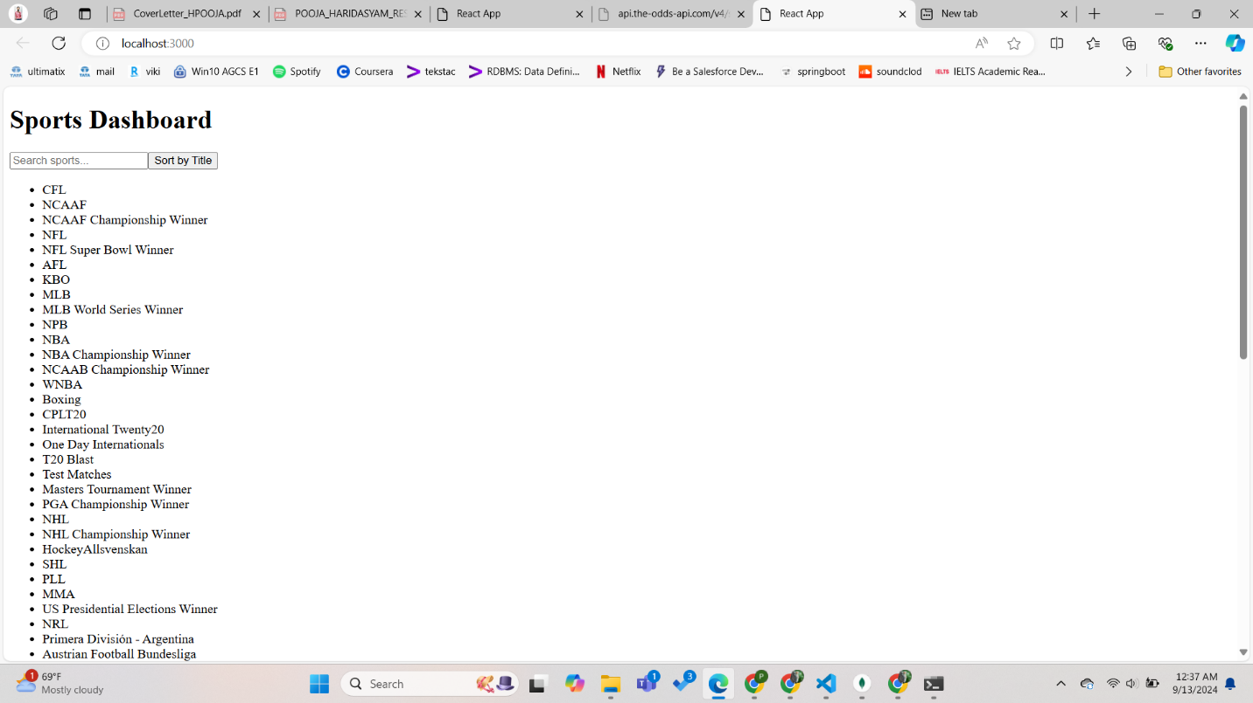

Fig: localhost:3000