Sabaragamuwa University of Sri Lanka



Assignment

Title | Cloud-Based Customer Churn Prediction and Retention Analytics on AWS
Course Title | Business Intelligence
Course Code
Student Name | [INSERT NAME]
Index Number | [INSERT INDEX NUMBER]

DEPARTMENT OF DATA SCIENCE
FACULTY OF COMPUTING

12 October 2026
Table of Contents
List of Figures 2
List of Tables 2
Abstract 3
1. Introduction 3
1.1 Background and Problem Statement 3
1.2 Objectives 3
1.3 Dataset and Team Scope 4
2. System Architecture and Cloud Design 4
2.1 Architecture Overview 4
2.2 Design Decisions 5
2.3 Security 5
3. Data Exploration and Preprocessing 5
3.1 Exploratory Findings 5
3.2 Cleaning and Encoding 6
4. Machine Learning and Evaluation 6
4.1 Experimental Design 6
4.2 Candidate Models 7
4.3 Results 7
4.4 Deployment and Holdout Scoring 8
5. Business Analytics with Amazon Athena 9
5.1 Data Catalogue and Queries 9
5.2 Findings 9
5.3 Recommended Actions 10
6. Discussion, Limitations and Future Work 11
7. Conclusion 11
References 11
Appendices 12
Appendix A: Key Implementation Excerpts 12
Appendix B: Evaluation Reproduction Notes 13

List of Figures
Figure 1 End-to-end AWS architecture of the churn prediction system. 5
Figure 2 Churn class distribution and strongest correlations with churn (training data). 6
Figure 3 ROC curve and confusion matrix of the champion model on the held-out test set. 8
Figure 4 Permutation feature importance and observed churn rate by predicted-risk decile (test set). 8
Figure 5 Churn risk by handset age and handset condition: model prediction (left) and observed training data (right). 10

List of Tables
Table 1 Pipeline stages, artefacts and the S3 prefixes that each stage’s IAM policy allows it to read and write. 4
Table 2 Data cleaning and encoding operations (58 raw columns become 69 cleaned columns). 6
Table 3 Test-set performance of the candidate models (n = 10,196; decision threshold 0.5). 7
Table 4 Risk-tier profile of the 20,000 scored holdout customers. 9
Table 5 The five service areas with the most high-risk customers, plus the two highest predicted churn rates among the top 15 areas. 10

Abstract
Customer churn is one of the costliest problems in mobile telecommunications. This report documents an end-to-end, cloud-native churn prediction system built on Amazon Web Services (AWS) using the Cell2Cell dataset: 51,047 labelled training customers and 20,000 unlabelled holdout customers described by 58 raw attributes. Raw CSV files are ingested into Amazon S3, cleaned by leakage-free Python, AWS Lambda and AWS Glue jobs, used to train a class-weighted HistGradientBoosting classifier, and scored in batch and through a Lambda inference handler. The scored customers are exposed to Amazon Athena for SQL-based business analytics, and every stage is governed by least-privilege IAM policies. On an independent 20% test split the champion model reaches ROC-AUC 0.673, recall 0.614 and F1 0.483, and its highest-risk decile contains 53.6% churners against a 28.7% base rate (1.87× lift). Scoring the holdout places 2,382 customers (11.9%) in the High-Risk tier, representing $134,975 of monthly revenue (about $1.62 million a year). Handset age, tenure, usage level and recent usage change are the strongest drivers. The report recommends pre-emptive handset upgrades, proactive retention, concierge contact for high-value accounts and score calibration.

1. Introduction

1.1 Background and Problem Statement
Customer churn, the loss of subscribers to a competitor, is expensive for mobile operators because lost recurring revenue must be replaced through costly acquisition. Predictive models let a provider rank customers by risk and target retention spending, but they create value only inside a reliable data pipeline whose output is translated into business decisions [1]. This project builds such a pipeline on Amazon Web Services (AWS): it ingests raw customer records, prepares them without information leakage, trains and deploys a churn classifier, and exposes the scored customers to SQL analytics.

1.2 Objectives
The specific objectives of the project are to:
- design a zoned Amazon S3 data lake with event-driven ingestion, serverless processing and CloudWatch logging;
- clean the Cell2Cell data using preprocessing parameters learned from training data only;
- train and compare classifiers under a 2.47 : 1 class imbalance, selecting the champion by cross-validated ROC-AUC;
- score 20,000 unlabelled customers, segment them into Low, Medium and High risk tiers and publish them as an Athena table;
- derive retention recommendations with quantified revenue exposure, securing every stage with least-privilege IAM policies.

1.3 Dataset and Team Scope
The Cell2Cell telecom dataset [2] describes each subscriber with 58 attributes covering usage, billing, handset, demographics and retention-contact behaviour. The training file holds 51,047 labelled customers (28.8% churned). The holdout file holds 20,000 customers whose Churn label is withheld, so model quality is measured on a split of the training data and the holdout is used only for deployment-style scoring. The work was divided into four stages (Table 1). The scripts for Stage 1 were not part of the submitted repository, so that stage is described from the project design; Stages 2–4 are documented from their delivered code and outputs, and every figure reported below was recomputed from those artefacts.
Table 1 Pipeline stages, artefacts and the S3 prefixes that each stage’s IAM policy allows it to read and write.
Stage | Responsibility and principal artefacts | S3 read | S3 write
1. Ingestion | S3 bucket churnpredictionaws-team-2026; event-triggered validation Lambda; CloudWatch logging | source CSVs | raw/real/
2. Preprocessing | EDA script, Cell2CellPreprocessor, Lambda handler, Glue job, boto3 command-line pipeline | raw/* | processed/*
3. Machine learning | Training notebook, batch inference, cloud pipeline, Lambda inference handler | processed/* | models/*, output/predictions/*
4. Analytics | Athena DDL, seven SQL queries, analytics engine, executive report | processed/*, output/predictions/* | output/reports/*, athena-results/*

2. System Architecture and Cloud Design

2.1 Architecture Overview
Figure 1 shows the data flow. Raw CSV files land under raw/real/ in the S3 bucket [3], where an ObjectCreated event invokes a validation Lambda that logs to Amazon CloudWatch. The preprocessing stage reads the validated files and writes cleaned, schema-aligned files to processed/real/. The machine-learning stage reads these, stores the serialised model in models/ and writes scored customers to output/predictions/. Finally, an Athena external table over that prefix, registered in the AWS Glue Data Catalog, supports the SQL analytics whose outputs are written to output/reports/.
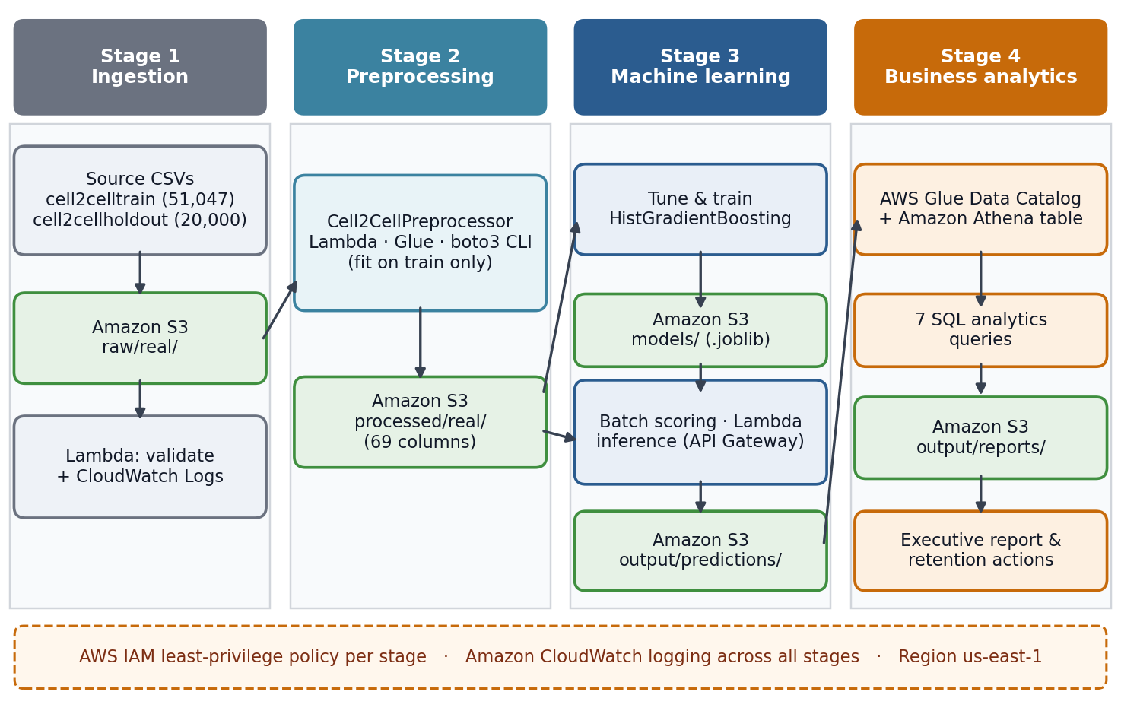
Figure 1 End-to-end AWS architecture of the churn prediction system.

2.2 Design Decisions
Three decisions shape the implementation. First, the bucket is zoned by prefix (raw, processed, models, output), so each stage has a single writable location and no stage can overwrite its own input. Second, every Python stage offers a local and a cloud mode, so identical code is tested offline and then run against S3 with boto3. Third, preprocessing is available in three interchangeable forms (an AWS Lambda handler, an AWS Glue job and a command-line pipeline) [4], and inference is available as a batch pipeline and as a Lambda handler that serves either S3-event batches or JSON requests from API Gateway. The inference handler downloads the model from S3 once and caches it in memory across warm invocations, avoiding repeated cold-start cost.

2.3 Security
Each stage has its own IAM policy [5] that grants only the S3 prefixes listed in Table 1, a prefix-conditioned s3:ListBucket permission and CloudWatch log-write actions. Two weaknesses remain and are discussed in Section 6: the delivered scripts can load credentials from a key file, and the Athena and Glue statements of the analytics policy use a wildcard resource.

3. Data Exploration and Preprocessing

3.1 Exploratory Findings
The target is imbalanced: 14,711 of 51,047 training customers churned (28.8%), a ratio of 2.47 : 1 (Figure 2). Fourteen columns contain missing values, but none exceeds 1.8% (AgeHH1 and AgeHH2: 909 rows; PercChangeMinutes and PercChangeRevenues: 367; six usage and billing fields: 156 each; ServiceArea: 24). No single feature correlates strongly with churn. The largest absolute Pearson coefficient is 0.104 (CurrentEquipmentDays), followed by RetentionCalls (+0.065) and TotalRecurringCharge (−0.061), which suggests that churn is the product of many weak and probably non-linear signals. Observed churn rises steadily with handset age, from 22.9% for handsets under six months old to 36.1% beyond two years, and customers who had phoned the retention team churned at 45.0% compared with 28.2% for those who had not.
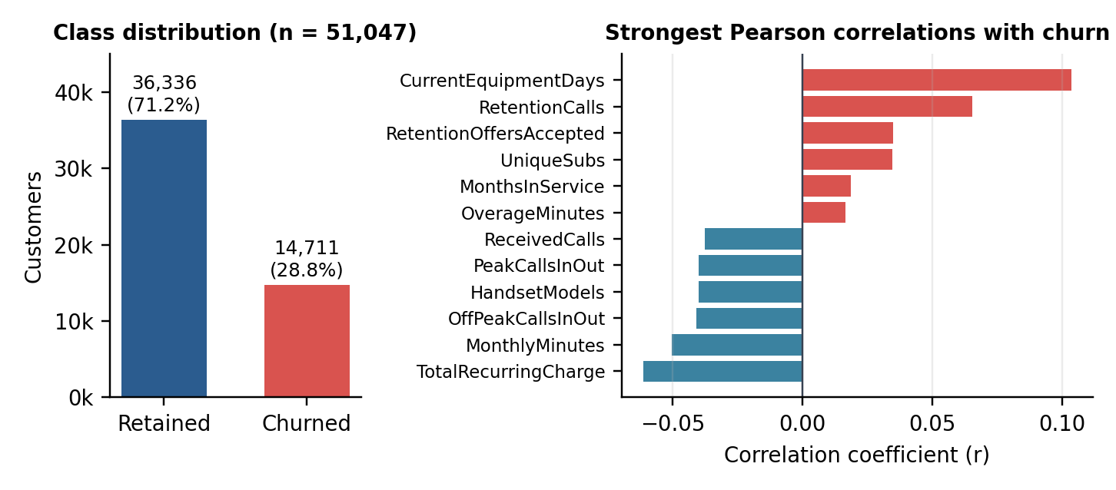
Figure 2 Churn class distribution and strongest correlations with churn (training data).

3.2 Cleaning and Encoding
A Cell2CellPreprocessor class learns every parameter from the training file only and applies it unchanged to the holdout, which prevents leakage (Table 2). Customer identifiers and ServiceArea are preserved for Athena joins. Both outputs share an identical 69-column schema, and the pipeline asserts this together with the absence of nulls in the cleaned data (the holdout Churn column is intentionally empty).
Table 2 Data cleaning and encoding operations (58 raw columns become 69 cleaned columns).
Issue | Treatment | Columns affected
Missing numeric values | Training-set median, reused on the holdout | 13 columns (e.g. AgeHH1/2, PercChange*)
Missing service area | Constant “UNKNOWN”; key kept for SQL joins | ServiceArea (24 rows)
Mixed-type field | “Unknown” to missing, then median (US$60) | HandsetPrice
Yes/No flags | Mapped to 1/0 | 15 columns
Ordinal rating | 1-Highest … 7-Lowest mapped to 1 … 7 | CreditRating
Nominal categories | One-hot (4 + 8 + 3 = 15 dummies); Homeownership dropped | PrizmCode, Occupation, MaritalStatus

4. Machine Learning and Evaluation

4.1 Experimental Design
Features were screened on the training portion only. After removing 68 customers whose service area occurs once (50,979 remain), the labelled data were split 80/20, stratified by ServiceArea (random_state = 42), giving 40,783 training and 10,196 test customers with near-identical churn prevalence (28.9% and 28.7%). One-way ANOVA F-tests on 34 numeric features and chi-square tests on 33 categorical or binary features, each at p < 0.05, retained 45 features. A scikit-learn [7] pipeline imputes medians and standardises numeric inputs, and one-hot encodes ServiceArea. To counter the class imbalance [6], every candidate uses class-weighted learning, and hyper-parameters were tuned by randomised search with stratified five-fold cross-validation on ROC-AUC.

4.2 Candidate Models
Logistic regression served as a linear baseline, a random forest [10] as a bagged-tree reference, and histogram-based gradient boosting [8], [9] as the boosted-tree candidate. The boosting model was selected and exported as a single joblib pipeline. Its tuned settings were a learning rate of 0.1445, maximum depth 5, 17 leaf nodes and at least 60 samples per leaf; early stopping halted training at 120 of a maximum 766 iterations. Table 3 compares the models on the identical test split; the notebook did not store the logistic-regression and random-forest search results, so those rows are untuned reference configurations re-run for this report, while the boosting row evaluates the saved champion.
Table 3 Test-set performance of the candidate models (n = 10,196; decision threshold 0.5).
Model | Configuration | ROC-AUC | Precision | Recall | F1
Logistic regression | Class-weighted, C = 1 (untuned) | 0.599 | 0.350 | 0.559 | 0.430
Random forest | 300 trees, min. leaf 10 (untuned) | 0.660 | 0.394 | 0.597 | 0.475
HistGradientBoosting | Tuned, class-weighted (champion) | 0.673 | 0.398 | 0.614 | 0.483

4.3 Results
On the held-out test set the champion reaches a ROC-AUC of 0.673 [11] (training AUC 0.755), accuracy of 62.2%, recall of 61.4% and precision of 39.8%, which is 1.4 times the 28.7% base rate (Figure 3). It therefore finds roughly six of every ten churners at the cost of 2,723 false alarms among 7,267 retained customers. Its value lies in ranking: the highest-risk decile contains 53.6% churners (1.87× lift) and the lowest only 8.7%, and the top 30% of customers captures 46.0% of all churners (Figure 4). Permutation importance [12] on the test set ranks CurrentEquipmentDays (AUC drop 0.052), MonthsInService (0.038), MonthlyMinutes (0.036) and PercChangeMinutes (0.032) highest, in line with the exploratory findings. Tenure matters despite a near-zero linear correlation (r = 0.019) because its effect is non-monotonic: observed churn is 26.6% in the first year, peaks at 30.8% in the second year and falls to 27.3% beyond three years.
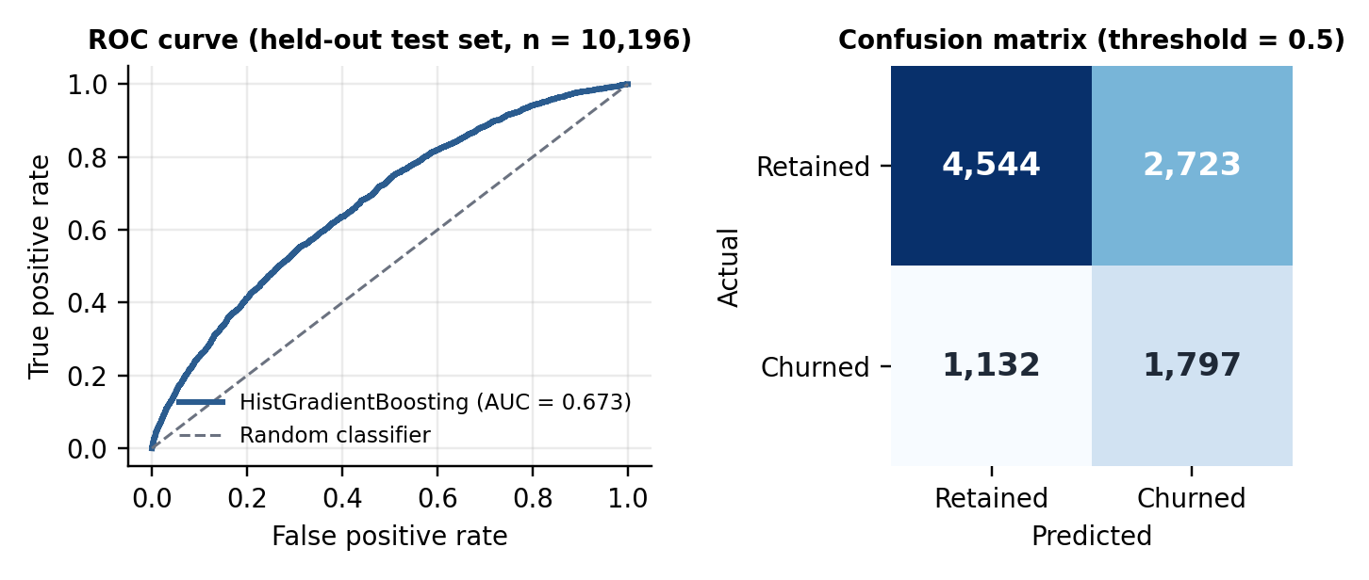
Figure 3 ROC curve and confusion matrix of the champion model on the held-out test set.
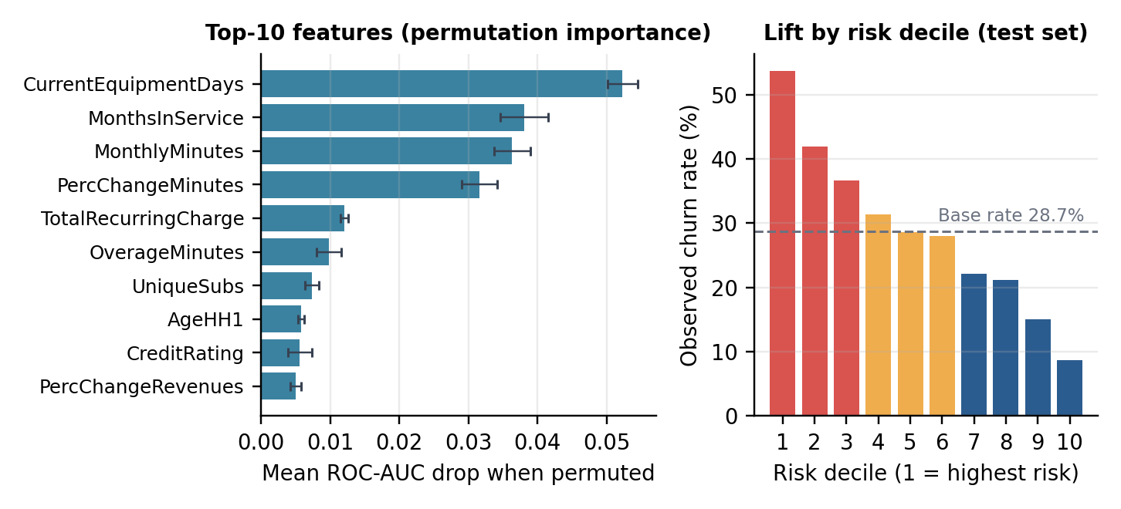
Figure 4 Permutation feature importance and observed churn rate by predicted-risk decile (test set).

4.4 Deployment and Holdout Scoring
The champion classifies customers at a 0.5 threshold and produces a probability-like score, rounded to four decimals, that is bucketed into Low (up to 0.35), Medium (0.35 to 0.65) and High (above 0.65) risk. Applied to the 20,000 holdout customers it predicts 8,884 churners (44.4%) and places 2,382 customers (11.9%) in the High tier (Table 4). The predicted churn rate exceeds the 28.8% training base rate because class weighting pushes scores upward (the mean score is 0.47), so the score should be read as a ranking signal rather than a calibrated probability (Section 6).

5. Business Analytics with Amazon Athena

5.1 Data Catalogue and Queries
The 72-column scored file (69 cleaned attributes plus prediction, score and tier) is exposed as the external table churn_db.customer_predictions over output/predictions/ [13], and the DDL column order matches the file exactly. Seven SQL queries cover risk distribution, usage profile, service areas, handset age, retention-team behaviour, credit rating and a high-value target list. The delivered outputs were produced by running the same SQL locally in SQLite; recomputing all seven queries from the predictions file reproduced every result.

5.2 Findings
Risk tiers. High-risk customers (Table 4) are not heavy users facing large bills. Compared with the Low-Risk tier they use 41% fewer minutes (389 against 656), pay 27% lower recurring charges and hold handsets 2.3 times older (466 against 202 days), although their average overage is 45% higher. They represent $134,975 of monthly revenue, about $1.62 million a year and 11.5% of the portfolio’s $1.18 million monthly revenue.
Table 4 Risk-tier profile of the 20,000 scored holdout customers.
Tier | Customers | Share | Mean score | Monthly revenue | Avg. minutes | Recurring charge | Handset age (days)
High | 2,382 | 11.9% | 71.9% | $134,975 | 389 | $39.63 | 466
Medium | 12,926 | 64.6% | 50.0% | $745,089 | 503 | $45.62 | 428
Low | 4,692 | 23.5% | 26.0% | $297,304 | 656 | $54.30 | 202
Total | 20,000 | 100% | 47.0% | $1,177,368 | — | — | —

Handset age. Model-predicted risk rises from 36.8% for original handsets under six months old to 56.0% beyond two years, and refurbished handsets carry 1.5 to 8.9 percentage points more risk in every age bracket (Figure 5, left). The labelled training data confirm the pattern independently (right): observed churn climbs from 20.6% to 36.0% for original handsets and is 3.9 points higher overall for refurbished ones (32.2% against 28.3%).
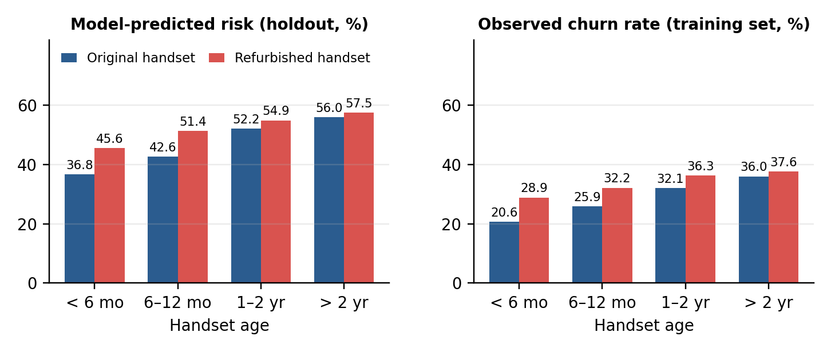
Figure 5 Churn risk by handset age and handset condition: model prediction (left) and observed training data (right).
Service areas. High-risk counts largely follow market size (Table 5). NYCBRO917 has the most high-risk customers (83) but a moderate predicted churn rate of 43.7%, while smaller markets such as SFRSCL408 (61.7%) and DENDEN303 (58.8%) show the highest rates among the top 15 areas, so rates are the better guide for regional offers.
Table 5 The five service areas with the most high-risk customers, plus the two highest predicted churn rates among the top 15 areas.
Service area | Customers | Predicted churners | Churn rate | High-risk customers | Mean score
NYCBRO917 | 670 | 293 | 43.7% | 83 | 45.9%
NYCMAN917 | 466 | 227 | 48.7% | 54 | 47.9%
HOUHOU281 | 601 | 224 | 37.3% | 52 | 45.3%
APCFCH703 | 327 | 171 | 52.3% | 47 | 49.5%
DALDAL214 | 542 | 208 | 38.4% | 45 | 45.6%
SFRSCL408 | 180 | 111 | 61.7% | 36 | 52.3%
DENDEN303 | 165 | 97 | 58.8% | 25 | 50.7%

Retention behaviour. Only 673 holdout customers (3.4%) had contacted the retention team, yet their mean score is 61.9% against 46.5% for the rest. In the labelled data, callers who accepted at least one offer churned less (41.1%, n = 881) than callers who accepted none (49.1%, n = 864), but still more than non-callers (28.2%). Retention contact therefore appears to be reactive: customers call when they have already decided to leave. This association is not proof of causation, but it favours earlier, score-driven outreach.

5.3 Recommended Actions
- Pre-emptive handset refresh. Offer upgrades before handsets reach one year of age, when risk steps up, prioritising owners of refurbished handsets.
- Proactive retention. Contact High-Risk customers before they call the retention team and make offers they can accept, since acceptance is associated with about eight points lower churn.
- Concierge outreach for high-value accounts. The 50 highest-revenue High-Risk accounts ($176 to $508 a month each, $12,159 in total, 9.0% of High-Risk revenue) merit personal contact.
- Regional and usage actions. Target loyalty bundles at the areas with the highest churn rates, and send overage alerts because High-Risk customers incur 45% more overage minutes.
The dataset contains no offer costs or uplift measurements, so return on investment cannot be estimated and should be tested in a controlled pilot.

6. Discussion, Limitations and Future Work
- Modest discrimination. An AUC of 0.673 reflects the weak individual signals seen in Section 3.1, and the gap to the training AUC (0.755) shows some overfitting. Richer features, more behavioural history and a threshold chosen from real retention costs could improve precision.
- Uncalibrated scores. The mean score of 0.47 is far above the 28.7% base rate. Scores should be calibrated, for example by Platt scaling or isotonic regression [14], before conversion into expected revenue loss; the “revenue at risk” reported here is exposure, not expected loss.
- No ground truth for the holdout. Business findings rest on predicted risk. They were cross-checked against labelled training data where possible, but campaign outcomes should be tracked to confirm them.
- Cloud validation. The analytics ran locally rather than on Athena; running them there over partitioned Parquet files would confirm the results, and the missing Stage 1 scripts should be added to the repository.
- Security and operations. Replace key-file credentials with IAM roles, scope Athena and Glue permissions to named resources, encrypt the bucket, and add orchestration, drift monitoring and scheduled retraining.

7. Conclusion
The project delivers a working, secured AWS pipeline that carries the Cell2Cell data from raw files to risk-ranked customers and business recommendations. The champion HistGradientBoosting model reaches a ROC-AUC of 0.673 with a 1.87× lift in the top risk decile, and scoring the holdout identifies 2,382 High-Risk customers worth about $1.62 million in annual revenue. Handset age, tenure and usage are the main levers. With score calibration, a controlled retention pilot and the security hardening described above, the system is a sound basis for production use.

References
All references follow IEEE style. Web documents were not dated; add access dates after final verification.
- J. Burez and D. Van den Poel, “Handling class imbalance in customer churn prediction,” Expert Syst. Appl., vol. 36, no. 3, pp. 4626–4636, Apr. 2009.
- Teradata Center for Customer Relationship Management, Duke University, “Cell2Cell customer churn dataset (cell2celltrain.csv and cell2cellholdout.csv),” distributed with the project repository.
- Amazon Web Services, “Amazon S3 User Guide.” [Online]. Available: https://docs.aws.amazon.com/AmazonS3/latest/userguide/
- Amazon Web Services, “AWS Lambda Developer Guide.” [Online]. Available: https://docs.aws.amazon.com/lambda/latest/dg/
- Amazon Web Services, “Security best practices in IAM.” [Online]. Available: https://docs.aws.amazon.com/IAM/latest/UserGuide/best-practices.html
- H. He and E. A. Garcia, “Learning from imbalanced data,” IEEE Trans. Knowl. Data Eng., vol. 21, no. 9, pp. 1263–1284, Sep. 2009.
- F. Pedregosa et al., “Scikit-learn: Machine learning in Python,” J. Mach. Learn. Res., vol. 12, pp. 2825–2830, Oct. 2011.
- J. H. Friedman, “Greedy function approximation: A gradient boosting machine,” Ann. Statist., vol. 29, no. 5, pp. 1189–1232, Oct. 2001.
- G. Ke et al., “LightGBM: A highly efficient gradient boosting decision tree,” in Proc. Adv. Neural Inf. Process. Syst., 2017, pp. 3146–3154.
- L. Breiman, “Random forests,” Mach. Learn., vol. 45, no. 1, pp. 5–32, Oct. 2001.
- T. Fawcett, “An introduction to ROC analysis,” Pattern Recognit. Lett., vol. 27, no. 8, pp. 861–874, Jun. 2006.
- A. Altmann, L. Toloşi, O. Sander, and T. Lengauer, “Permutation importance: A corrected feature importance measure,” Bioinformatics, vol. 26, no. 10, pp. 1340–1347, May 2010.
- Amazon Web Services, “Amazon Athena User Guide.” [Online]. Available: https://docs.aws.amazon.com/athena/latest/ug/
- A. Niculescu-Mizil and R. Caruana, “Predicting good probabilities with supervised learning,” in Proc. 22nd Int. Conf. Mach. Learn., 2005, pp. 625–632.

Appendices

Appendix A: Key Implementation Excerpts
Critical segments of the delivered code, shown for reproducibility. Full listings are in the project repository.
A.1 Leakage-free fit and transform (Member 02, preprocess.py; lightly reformatted)
def fit(self, train_df):
handset_numeric = pd.to_numeric(
df['HandsetPrice'].replace('Unknown', np.nan), errors='coerce')
self.medians['HandsetPrice'] = float(handset_numeric.median())
num_cols = df.select_dtypes(include=[np.number]).columns.drop(['CustomerID'], errors='ignore')
for col in num_cols:
self.medians[col] = float(df[col].median()) # learned on training data only
self.modes['ServiceArea'] = 'UNKNOWN'

def transform_holdout(self, holdout_df):
cleaned_holdout = self._transform_core(holdout_df, is_train=False)
return cleaned_holdout[self.final_columns] # identical 69-column schema
A.2 Champion model search (Member 03, main.ipynb; lightly reformatted)
hgb_pipe = Pipeline([
('preprocessor', dense_preprocessor),
('clf', HistGradientBoostingClassifier(
class_weight='balanced', early_stopping=True, random_state=42))])
hgb_params = {
'clf__learning_rate': loguniform(0.01, 0.3), 'clf__max_iter': randint(200, 800),
'clf__max_depth': [None, 3, 5, 7, 10], 'clf__max_leaf_nodes': randint(15, 63),
'clf__min_samples_leaf': randint(10, 100), 'clf__l2_regularization': loguniform(1e-3, 10)}
search = RandomizedSearchCV(hgb_pipe, hgb_params, n_iter=25, scoring='roc_auc',
cv=StratifiedKFold(n_splits=5, shuffle=True, random_state=42),
n_jobs=-1, random_state=42, refit=True)
A.3 Athena table and Query 1 (Member 04, athena_ddl.sql and queries.sql; DDL abridged)
CREATE EXTERNAL TABLE IF NOT EXISTS churn_db.customer_predictions (
CustomerID INT, ServiceArea STRING, MonthlyRevenue DOUBLE, MonthlyMinutes DOUBLE,
... /* remaining feature columns */ ..., Churn STRING,
ChurnPrediction INT, ChurnProbability DOUBLE, RiskSegment STRING)
ROW FORMAT DELIMITED FIELDS TERMINATED BY ','
STORED AS TEXTFILE
LOCATION 's3://churnpredictionaws-team-2026/output/predictions/'
TBLPROPERTIES ("skip.header.line.count"="1");

SELECT RiskSegment, COUNT(*) AS CustomerCount,
ROUND(COUNT(*) * 100.0 / SUM(COUNT(*)) OVER(), 2) AS PercentageOfTotal,
ROUND(AVG(ChurnProbability) * 100, 2) AS AvgChurnProbabilityPct,
ROUND(SUM(MonthlyRevenue), 2) AS TotalMonthlyRevenueAtRisk
FROM churn_db.customer_predictions
GROUP BY RiskSegment ORDER BY AvgChurnProbabilityPct DESC;

Appendix B: Evaluation Reproduction Notes
The test metrics, decile lift and permutation importance in Section 4 were produced by re-creating the notebook’s split (labelled rows with a service area occurring at least twice; 80/20 split stratified by ServiceArea; random_state = 42) and evaluating the saved champion pipeline with scikit-learn 1.8.0; the saved pipeline needed a one-line compatibility shim for an internal SimpleImputer attribute, applied in memory only. Permutation importance used ROC-AUC with five repeats (seed 42). The logistic-regression and random-forest reference models used the same preprocessing and split, and the business analytics were recomputed from datasets/predictions/cell2cellholdout_predictions.csv.

