SENTIMENT ANALYSIS OF McDONALD'S CUSTOMER REVIEWS
Final Report
DS4110 Aritificial Intelligence



Submitted by
Pooja Anbalagan
Index No: 22CDS0412

DEPARTMENT OF DATA SCIENCE
FACULTY OF COMPUTING
SABARAGAMUWA UNIVERSITY OF SRI LANKA
August, 2026

Table of Contents

Chapter 1: Introduction 3
Chapter 2: Background and Problem Domain 3
Chapter 3: Methodology 3
3.1 Dataset 3
3.2 Labeling Pipeline 3
3.3 Preprocessing Steps 4
3.4 Feature Engineering & Models 5
3.4b Train / Test Split 5
3.5 Evaluation Metrics 5
Chapter 4: Results, Insights and Discussion 5
4.1 Model Comparison 5
4.2 Per-Class Performance — Linear SVM 6
4.3 Human-Labeling Validation (Gold Test, n=150) 7
4.4 VADER Lexicon Baseline 7
4.5 Full Per-Class Metrics — All Supervised Models 8
Chapter 5: Limitations and Future Work 8
5.1 Future Enhancements 9
5.2 Deployment Note 9
Chapter 6: Conclusion 9
References 9

Chapter 1: Introduction
This project builds and evaluates a sentiment-classification system for McDonald's Google Maps customer reviews, comparing supervised machine-learning models (Logistic Regression, Linear SVM, Naive Bayes) against a lexicon-based VADER baseline. Objectives were to construct a labelled sentiment dataset validated through human annotation, train and compare classifiers using a class-imbalance-robust metric, and report the champion model's performance; scope covers data acquisition through model evaluation, excluding production deployment and multi-domain generalisation.

Chapter 2: Background and Problem Domain
Sentiment analysis classifies text polarity (Negative/Neutral/Positive); customer reviews are short, informal, and often rating-anchored, making rating-derived labels a natural but imperfect proxy for true sentiment — a 3-star review, for instance, may carry strongly negative wording that a star count alone would miss. Lexicon methods such as VADER require no training data but struggle with domain-specific and mixed-sentiment language, while supervised models require labelled data but generally achieve higher accuracy once trained; both approaches are therefore compared in this project against a human-verified ground truth.

Chapter 3: Methodology

3.1 Dataset
33,396 Google Maps reviews of McDonald's outlets were scraped and cleaned to 22,366 usable free-text reviews (5,167 auto-generated placeholder "reviews" were identified and excluded to prevent label leakage). Each record contains the review text, a 1–5 star rating, and outlet metadata.

3.2 Labeling Pipeline
Ground-truth labels were originally rating-derived (1–2→Negative, 3→Neutral, 4–5→Positive). To validate this proxy, three annotators independently labelled a stratified 1,000-review pilot from text alone (blind to rating). Inter-annotator agreement was substantial (Fleiss' κ = 0.629; 66.4% full agreement). The resolved human labels were compared against the rating-derived proxy: accuracy 0.789, Cohen's κ 0.654, macro-F1 0.694 — below the pre-set 0.80 acceptance bar, so the rating proxy alone was not adopted.
A hybrid pseudo-labeling approach was used instead. The 1,000 human labels were split 700/150/150 (train/validation/gold-test). A TF-IDF (1–2-gram) + Logistic Regression model (C=2.0, class_weight='balanced') was tuned on the validation split and evaluated once on the untouched gold-test set: accuracy 0.707, macro-F1 0.599. This model was refit on all 850 human train+validation rows and used to pseudo-label the remaining 21,371 reviews (9,522 of these, 44.5%, fell below a 0.60 confidence threshold and were flagged needs_human_review).
Methodological caveat: the final training/test pool is therefore 995 human-verified labels (4.4%) plus 21,371 model-generated pseudo-labels (95.6%). Downstream model accuracy in Section 3.2 is measured mostly against pseudo-labels, not independent human ground truth, and should be read alongside the smaller gold-test figures above, which are the only fully human-verified evaluation in this project.
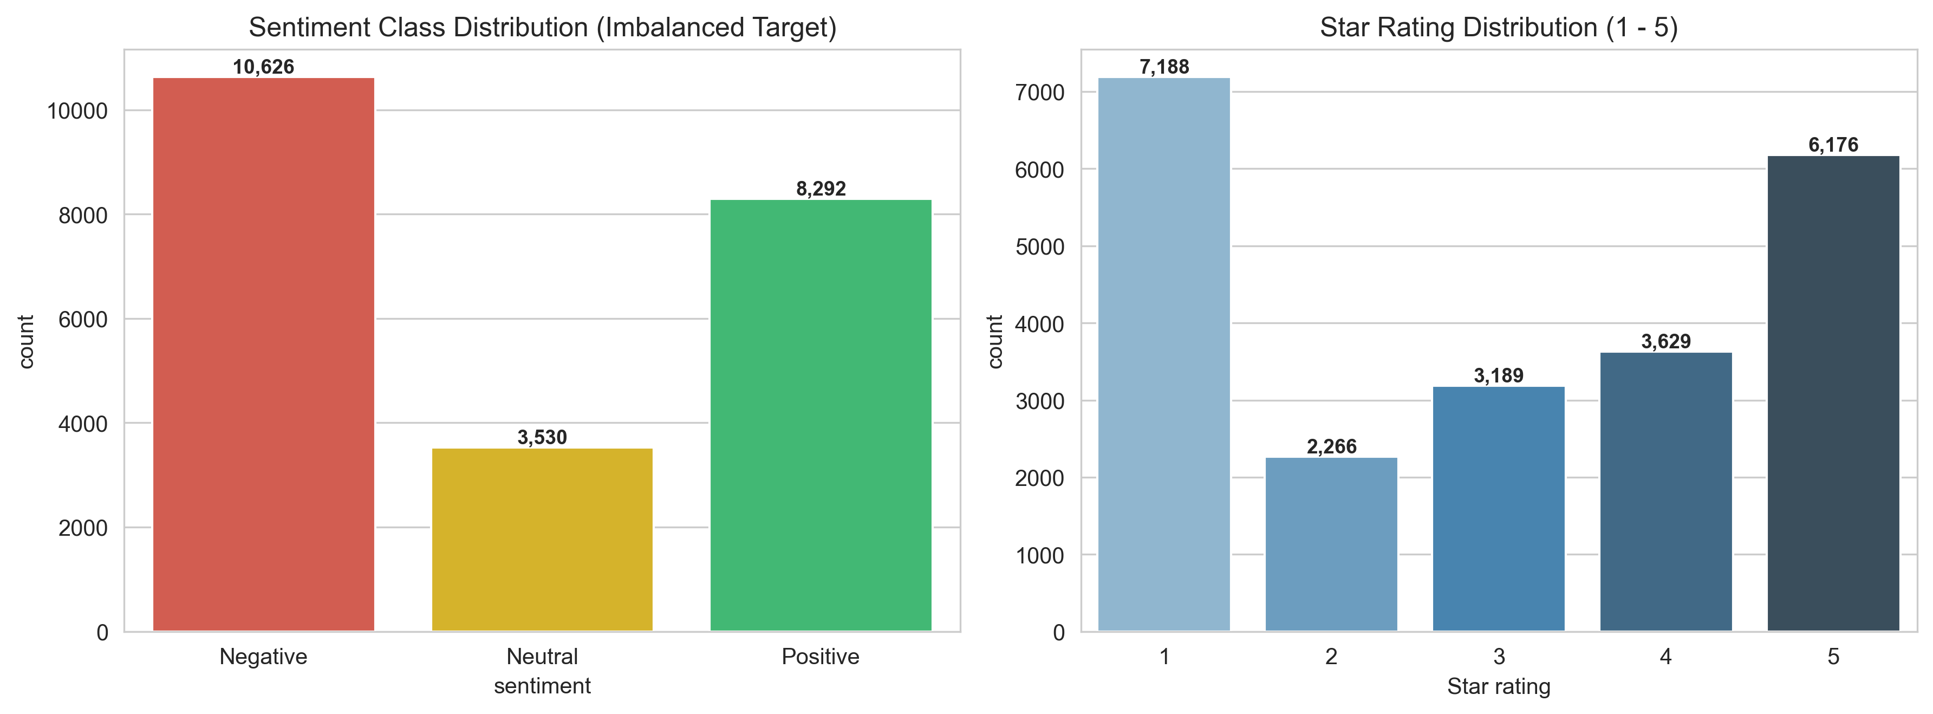
Figure A: Sentiment class distribution after rating-derived labelling (22,366 reviews).

3.3 Preprocessing Steps
Step | Detail
Noise removal | Strip URLs, emojis, HTML artefacts, non-alphabetic tokens
Normalisation | Lower-casing; expand contractions
Auto-tag filtering | Remove 5,167 platform-generated placeholder reviews
Tokenisation | Negation-preserving word tokeniser (keeps "not_good" as one unit)
Stopword handling | Domain stopword list; sentiment-bearing negators retained
Vectorisation | TF-IDF, 1–3-grams, 20,000 features, min_df=3, sublinear TF
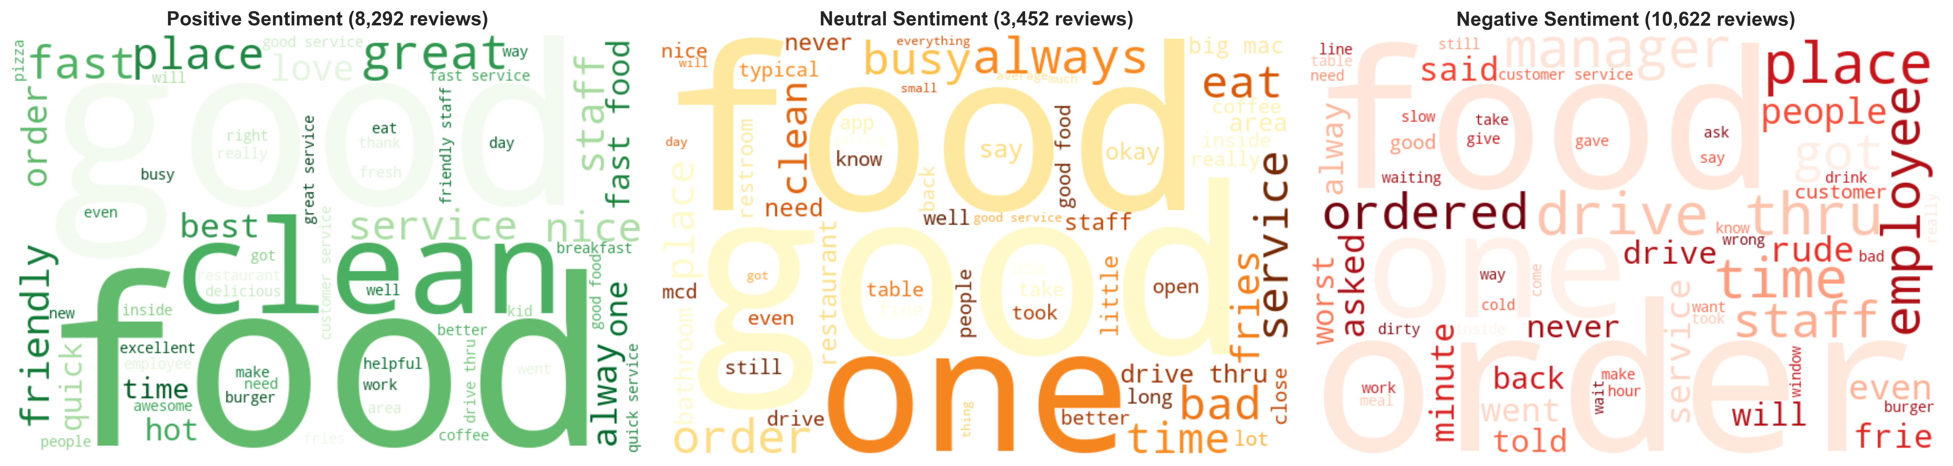
Figure B: Word clouds by sentiment class after preprocessing.
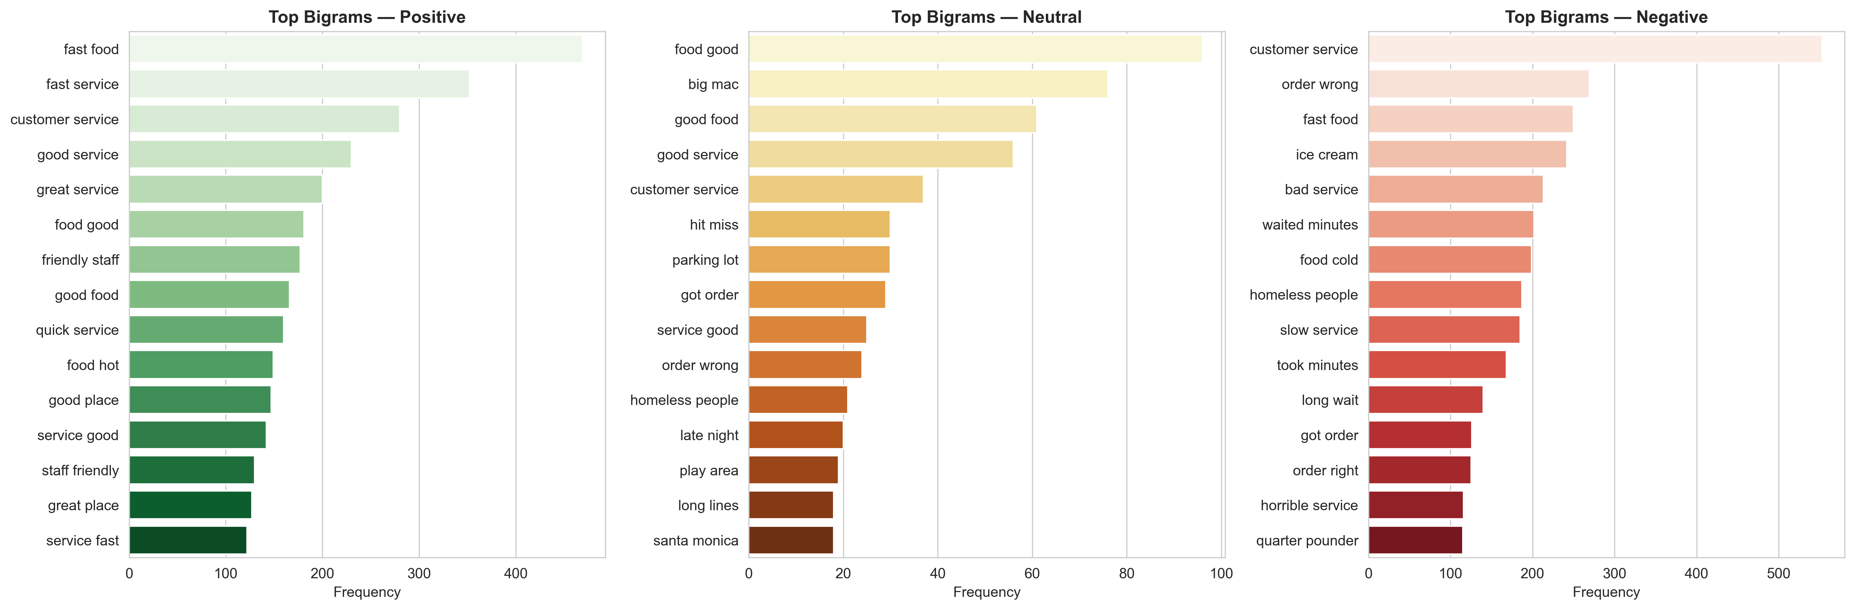
Figure C: Most frequent bigrams by sentiment class.

3.4 Feature Engineering & Models
Review text was cleaned (lower-casing, URL/punctuation handling, negation-preserving tokenisation) and vectorised with TF-IDF (unigrams–trigrams, 20,000 features, min_df=3, sublinear TF). Three supervised classifiers were trained with class_weight='balanced' to counteract Neutral-class under-representation: multinomial Logistic Regression, Linear SVM (LinearSVC), and Multinomial Naive Bayes. An unsupervised VADER lexicon baseline was run on an 8,000-review sample for comparison, requiring no training data.

3.4b Train / Test Split
Stratified 80/20 split (17,892 train / 4,474 test) on the full labelled pool, preserving class proportions; the same split was used to evaluate all four approaches for comparability.

3.5 Evaluation Metrics
Metric | Definition
Accuracy | Proportion of all test reviews correctly classified
Macro Precision | Unweighted mean of per-class precision
Macro Recall | Unweighted mean of per-class recall
Macro F1 | Unweighted mean of per-class F1; primary model-selection metric under class imbalance

Chapter 4: Results, Insights and Discussion

4.1 Model Comparison
Champion model: Linear SVM, selected as the model with the highest macro-F1 (0.839), also achieving the highest accuracy (87.2%).
Model | Accuracy | Macro Prec. | Macro Rec. | Macro F1
Linear SVM (best) | 0.8722 | 0.8370 | 0.8414 | 0.8391
Logistic Regression | 0.8663 | 0.8279 | 0.8544 | 0.8369
Multinomial Naive Bayes | 0.7827 | 0.8303 | 0.6318 | 0.6114
VADER (unsupervised) | 0.6305 | 0.5843 | 0.5847 | 0.5699
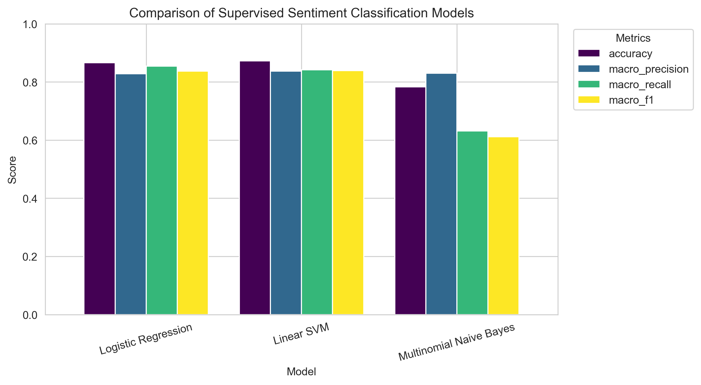
Figure 1: Accuracy, macro-precision, macro-recall and macro-F1 across all four approaches.

4.2 Per-Class Performance — Linear SVM
Class | Precision | Recall | F1-score | Support
Negative | 0.90 | 0.90 | 0.90 | 2,125
Neutral | 0.70 | 0.73 | 0.71 | 690
Positive | 0.91 | 0.89 | 0.90 | 1,659
Naive Bayes reaches the highest macro-precision (0.830) but the lowest macro-recall (0.632) and macro-F1 (0.611): it almost never predicts "Neutral", defaulting to the majority classes — the reason raw accuracy alone is a misleading selection criterion here. Linear SVM and Logistic Regression track each other closely on every metric (within 0.005), with SVM ahead on all four; Neutral remains the hardest class for both, consistent with its smaller support (690 of 4,474 test reviews) and its semantic overlap with mild positive/negative language.
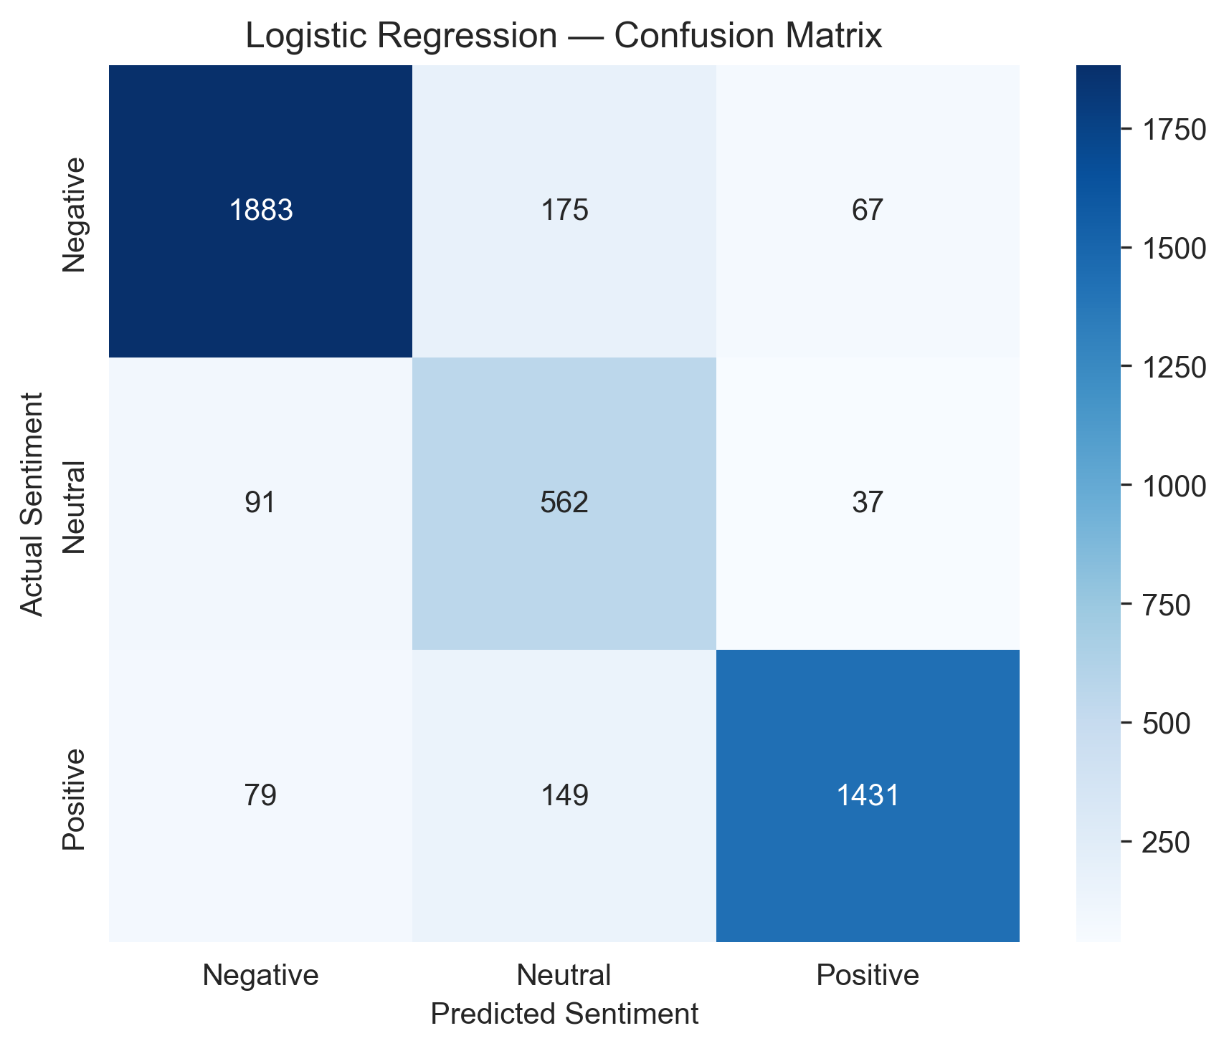
Figure 2: Confusion matrix, Logistic Regression (retained for coefficient interpretability alongside the SVM champion).
Actual \ Predicted | Negative | Neutral | Positive
Negative | 1,893 | 175 | 67
Neutral | 91 | 562 | 37
Positive | 79 | 149 | 1,431
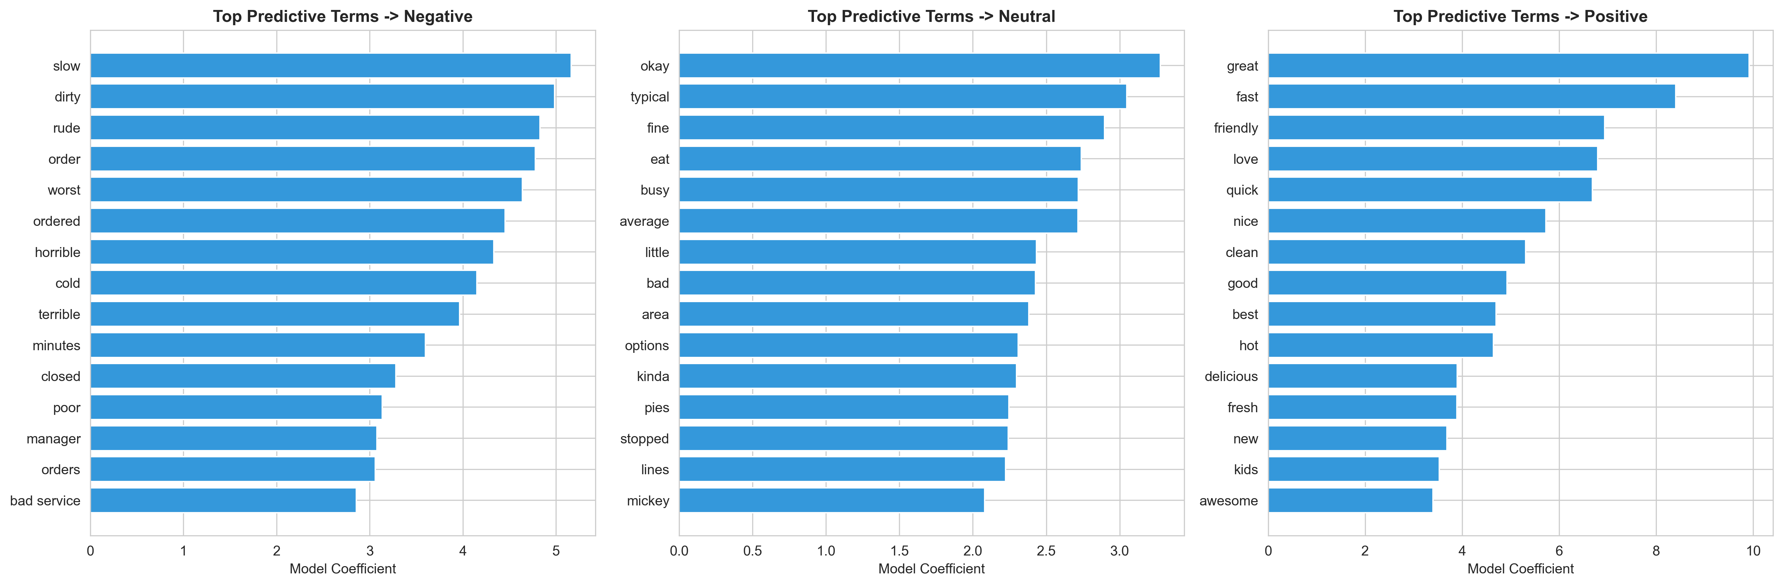
Figure 3: Top TF-IDF-coefficient words per sentiment class (Logistic Regression).

4.3 Human-Labeling Validation (Gold Test, n=150)
Metric | Value
Accuracy | 0.7067
Macro F1 | 0.5986
Fleiss' κ (pilot IAA) | 0.6287
This is the only fully human-verified evaluation in the project; it is markedly lower than the pseudo-label-based test accuracy in Section 2.1, consistent with the caveat in Section 1.2.

4.4 VADER Lexicon Baseline
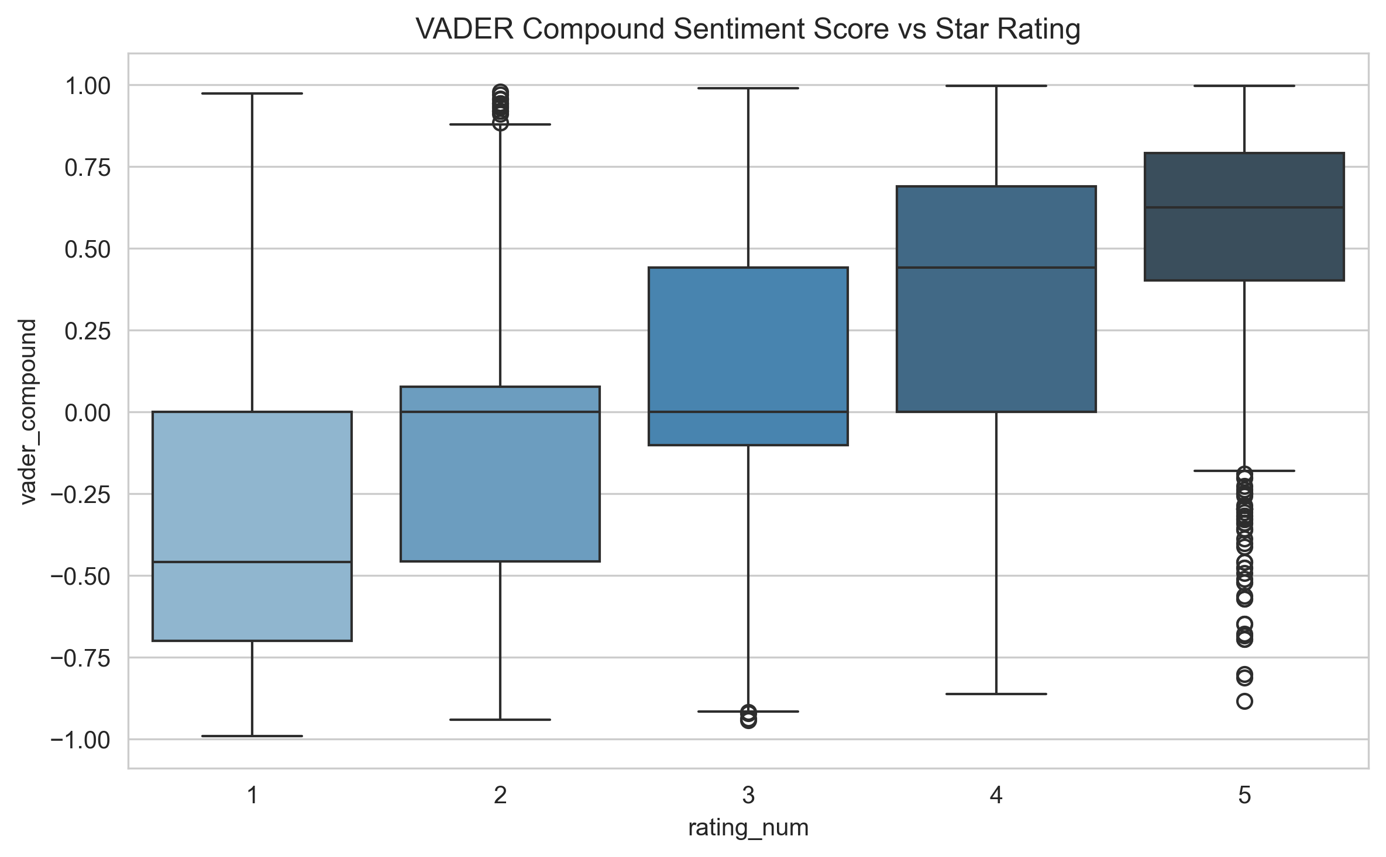
Figure 4: VADER compound score vs. star rating — monotonic trend supports the rating-derived labelling scheme.
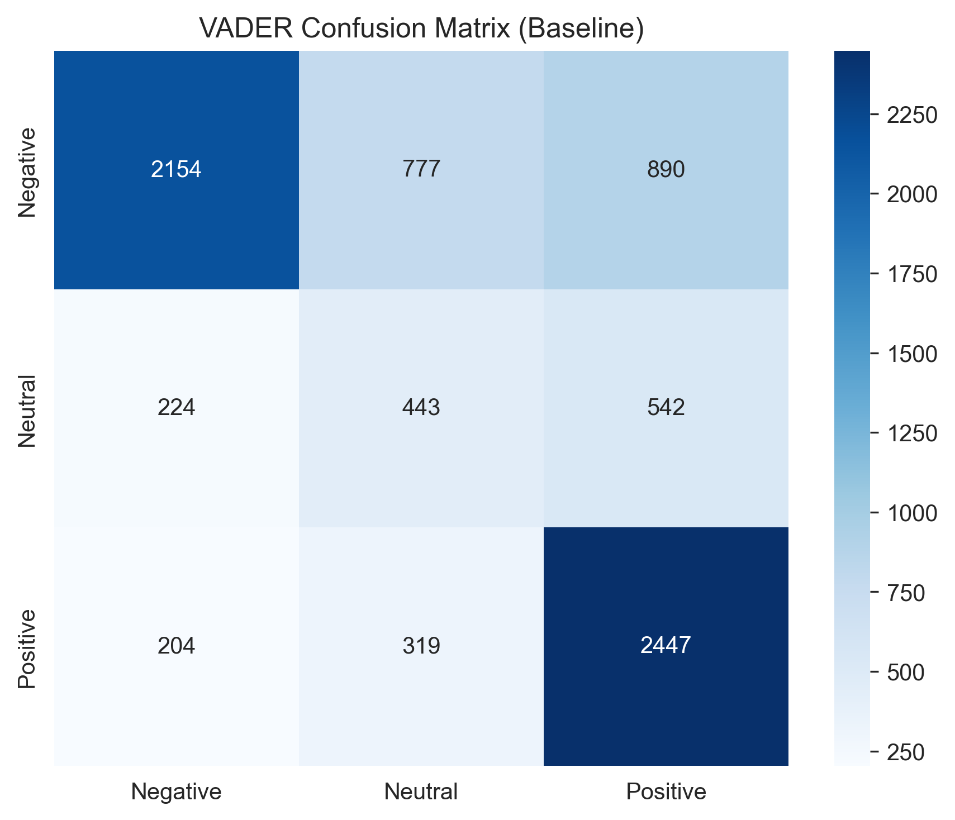
Figure 5: VADER confusion matrix (8,000-review sample).
VADER reached 63.1% accuracy / 0.570 macro-F1 with zero training data, versus the champion Linear SVM's 87.2% / 0.839 — quantifying the value of labelled training data, though noting the SVM figure includes the pseudo-label caveat above.

4.5 Full Per-Class Metrics — All Supervised Models
Model | Class | Precision | Recall | F1
Linear SVM | Negative | 0.90 | 0.90 | 0.90
Linear SVM | Neutral | 0.70 | 0.73 | 0.71
Linear SVM | Positive | 0.91 | 0.89 | 0.90
Logistic Regression | Negative | 0.90 | 0.89 | 0.90
Logistic Regression | Neutral | 0.64 | 0.81 | 0.72
Logistic Regression | Positive | 0.92 | 0.87 | 0.89
Multinomial NB | Negative | 0.79 | 0.94 | 0.86
Multinomial NB | Neutral | 0.85 | 0.03 | 0.06
Multinomial NB | Positive | 0.78 | 0.87 | 0.82
Logistic Regression's higher Neutral recall (0.81 vs. SVM's 0.73) comes at the cost of lower Neutral precision (0.64 vs. 0.70) — it over-predicts Neutral. SVM's more balanced precision/recall trade-off across all three classes is the main reason its macro-F1 edges out Logistic Regression despite similar accuracy. Naive Bayes' near-zero Neutral recall (0.03) confirms it is unsuitable for this three-class problem despite its high overall accuracy.

Chapter 5: Limitations and Future Work
- Test-set circularity: ≈95% of the evaluation labels used in Section 2.1 are model-generated pseudo-labels rather than independent human judgments (Section 1.2); the Section 2.3 gold-test figures are the more conservative, fully human-verified estimate.
- Neutral-class difficulty: smallest class by support (15.4% of test data) and semantically closest to mild Positive/Negative language, driving most residual error for every model.
- Confidence-flagged pseudo-labels: 44.5% of pseudo-labelled rows fell below the 0.60 confidence threshold and were never reviewed by a human, so their true label accuracy is unverified.
- Single-domain scope: all reviews are for one restaurant chain; generalisation to other domains is untested.

5.1 Future Enhancements
- Extend human annotation beyond the 1,000-review pilot to reduce reliance on pseudo-labels.
- Add geographic/outlet-level sentiment breakdowns for operational use.
- Explore transformer-based embeddings (e.g., DistilBERT) as a higher-capacity alternative to TF-IDF.

5.2 Deployment Note
The champion model (Linear SVM) and its TF-IDF vectoriser were packaged for batch inference; Logistic Regression is retained alongside it for coefficient-level interpretability of predictive terms.

Chapter 6: Conclusion
This project delivered a validated sentiment-labelling pipeline and a comparative evaluation of three supervised classifiers against a lexicon baseline. Linear SVM was selected as the champion model on macro-F1 (0.839) and accuracy (87.2%), narrowly ahead of Logistic Regression, with both far ahead of Naive Bayes and VADER. The human-labeling pilot (gold-test accuracy 70.7%, macro-F1 0.599) is retained as the project's most trustworthy evaluation and should be read alongside the headline pseudo-label-based figures, per the limitation noted in Chapter 5.

References
- NLTK VADER Sentiment Analysis Tool — Hutto, C.J. & Gilbert, E. (2014).
- Scikit-learn: Machine Learning in Python — Pedregosa et al. (2011), JMLR.
- TF-IDF and n-gram feature engineering — standard scikit-learn text feature extraction documentation.

