FINAL REPORT
Capstone Project in Data Science II (DS3206)
Sentiment Analysis of Customer Reviews: A Comparative Study of Supervised Machine Learning and Lexicon-Based Methods on McDonald's Google Maps Reviews

Submitted by
Pooja Anbalagan
Index No: 22CDS0412
Internal Supervisor: Ms. Sweshthika Sureshkumar

DEPARTMENT OF DATA SCIENCE
FACULTY OF COMPUTING
SABARAGAMUWA UNIVERSITY OF SRI LANKA

August, 2026

Declaration
I declare that this report does not incorporate, without acknowledgement, any material previously submitted for a Degree or a Diploma in any University, and that, to the best of my knowledge and belief, it does not contain any material previously published or written by another person, except where due reference is made in the text.

Index Number | Name of Student | Date | Signature of Student
22CDS0412 | Pooja Anbalagan

Certificate of Approval
We hereby declare that this thesis is from the student's own work and effort, and that all other sources of information used have been acknowledged. This thesis has been submitted with our approval.

Index Number | Name of Student | Date | Signature of Student
22CDS0412 | Pooja Anbalagan
Name of Internal Supervisor: Ms. Sweshthika Sureshkumar
Signature of Internal Supervisor: ______________________________
Date: ______________________________
Signature of Head of the Department: ______________________________
Date: ______________________________

Acknowledgement
I would like to express my sincere gratitude to my supervisor, Ms. Sweshthika Sureshkumar, for the invaluable guidance and constructive feedback provided throughout the course of this Capstone Project. Their expertise in data science and machine learning greatly shaped the direction and quality of this work.
I am also thankful to the Head of the Department of Data Science and the academic staff of the Faculty of Computing, Sabaragamuwa University of Sri Lanka, for providing the resources and academic environment necessary to complete this Capstone Project. Finally, I extend my appreciation to my friends and colleagues for their unwavering support and encouragement during this endeavour.

Abstract
Online customer reviews are one of the richest sources of unfiltered feedback available to service businesses, yet the sheer volume of free-text opinion makes manual analysis impractical at scale. This project builds and evaluates an automated sentiment classification pipeline for 33,396 customer reviews of McDonald's outlets scraped from Google Maps, spanning the reviewer's free-text comment, 1-5 star rating, review recency, and store metadata. After cleaning encoding artefacts, removing 10,741 duplicate entries and 179 unusable rows, and identifying 5,167 reviews that were in fact Google's auto-generated rating tags rather than genuine free text (which were excluded from text modelling to avoid label leakage), a ground-truth sentiment label (Negative, Neutral, Positive) was derived from the star rating for 22,366 free-text reviews. Reviews were vectorised using TF-IDF (unigrams to trigrams, 20,000 features) and three supervised classifiers - Logistic Regression, Multinomial Naive Bayes, and Linear Support Vector Machine - were trained on an 80/20 stratified split and benchmarked against VADER, an unsupervised lexicon-based baseline that requires no labelled training data. Logistic Regression achieved the best balance across classes with a macro-F1 of 0.670 and 74.1% accuracy, outperforming Naive Bayes' higher raw accuracy (76.6%) once class imbalance is accounted for, since Naive Bayes almost never predicts the minority Neutral class. VADER reached 64.3% accuracy without any training data, confirming that the review text carries a genuine, learnable sentiment signal independent of the labelling scheme. Lexical analysis of the model's most predictive features shows that negative reviews are dominated by service-speed and order-accuracy language ("worst", "rude", "minutes", "dirty"), while positive reviews centre on staff friendliness and food quality ("great", "love", "friendly", "delicious") - an actionable insight for operational decision-making. The trained model and vectoriser were packaged into an interactive web application, built with a FastAPI backend and a React frontend, the McDonald's Sentiment Intelligence Platform, providing live prediction, exploratory dashboards, and model-performance views. The project concludes that a TF-IDF plus Logistic Regression pipeline offers a strong, interpretable, and deployable baseline for review sentiment analysis, while identifying the ambiguous Neutral class as the primary remaining challenge for future work.
Keywords: sentiment analysis; natural language processing; TF-IDF; text classification; Logistic Regression; VADER; customer reviews; opinion mining

Table of Contents
Declaration 2
Certificate of Approval 3
Acknowledgement 4
Abstract 5
Table of Contents 6
Chapter 1: Introduction 8
1.1 Overview 8
1.2 Motivation for Selecting the Topic 8
1.3 Objectives 8
1.4 Scope of the Project 8
1.5 Methodology and Approach (Summary) 9
1.6 Summary of Results 9
Chapter 2: Background and Problem Domain 9
2.1 Description of the Domain 9
2.2 Justification for the Project Topic 9
2.3 Review of Existing Solutions and Limitations 9
Chapter 3: Data Acquisition and Preparation 10
3.1 Data Source and Acquisition Method 10
3.2 Dataset Description 10
3.3 Data Cleaning and Preprocessing 10
3.3.1 Key Data-Quality Finding: Auto-Generated Rating Tags 11
3.3.2 Sentiment Labelling 11
3.4 Exploratory Data Analysis 11
3.5 Sentiment-Aware Text Preprocessing and Lexical Exploration 13
3.6 Feature Engineering 14
3.7 Train / Test Split Strategy 14
Chapter 4: Modelling and Analysis 14
4.1 Analytical Pipeline 14
4.2 Model 1: Logistic Regression 14
4.3 Model 2: Multinomial Naive Bayes 14
4.4 Model 3: Linear Support Vector Machine 15
4.5 Baseline: VADER Lexicon-Based Sentiment Analyser 15
4.6 Evaluation Metrics 15
Chapter 5: Results, Insights, and Discussion 15
5.1 Full Evaluation Results 15
5.2 Why Logistic Regression Was Selected Despite Lower Raw Accuracy 16
5.3 Confusion Matrix and Most Predictive Words 16
5.4 Lexicon-Based Baseline Validation (VADER) 17
5.5 Key Findings 18
5.6 Deployment: The McDonald's Sentiment Intelligence Platform 19
5.7 Limitations 19
Chapter 6: Future Enhancements 19
6.1 Human-Annotated Validation Set 19
6.2 Transformer-Based Modelling 19
6.3 Cross-Domain Generalisation 20
6.4 Geographic Sentiment Analysis 20
6.5 Automated Neutral-Class Rebalancing 20
6.6 Expanded Dashboard Features 20
Chapter 7: Conclusion 20
References 21
Glossary 22
Appendix A: Repository and Artefact Structure 23

Figures
Figure 1: Sentiment class distribution (left) and raw star-rating distribution (right) 12
Figure 2 : Free-text reviews vs. Google's auto-generated rating-tag reviews. 12
Figure 3: Distribution of review length (characters) by sentiment class. 13
Figure 4: Sentiment composition by review recency. 13
Figure 5:Word clouds by sentiment class. 14
Figure 6: Word clouds by sentiment class. 14
Figure 7: Full evaluation results across all four sentiment-scoring approaches. 16
Figure 8: Confusion matrix for the Logistic Regression model. 17
Figure 9: Top predictive words per sentiment class 17
Figure 10: VADER compound sentiment score distribution across each star rating. 18
Figure 11: Confusion matrix for the VADER lexicon-based baseline. 18

Tables
Table 1: Fields of the cleaned review dataset. 10
Table 2: Evaluation metrics used for model comparison. 16
Table 3:Full evaluation results across all four sentiment-scoring approaches. 16
Table 4: Per-class classification report for the Logistic Regression model. 16

Chapter 1: Introduction

1.1 Overview
Customer reviews posted to public platforms such as Google Maps have become one of the most direct and abundant channels through which consumers express satisfaction or dissatisfaction with a service. For a high-volume, multi-outlet business such as McDonald's, thousands of such reviews accumulate continuously, containing a mixture of star ratings and free-text commentary. Manually reading and categorising this volume of feedback is impractical, which motivates an automated approach: sentiment analysis, the task of algorithmically classifying a piece of text as expressing a Positive, Neutral, or Negative opinion.
This project, undertaken as the Capstone Project in Data Science II (DS3206) at the Department of Data Science, Sabaragamuwa University of Sri Lanka, builds a complete sentiment analysis pipeline for a real-world dataset of 33,396 McDonald's customer reviews scraped from Google Maps, covering data cleaning, exploratory analysis, supervised and lexicon-based sentiment classification, model comparison, and deployment as an interactive web application.

1.2 Motivation for Selecting the Topic
Review sentiment analysis sits at the intersection of natural language processing and practical business analytics, making it an ideal capstone topic: it requires the full data science lifecycle, from messy, real-world scraped data through to a deployed, user-facing system. The McDonald's review dataset is particularly well suited to this because it combines a numeric rating (a natural, if imperfect, ground-truth signal) with free text, allowing supervised model performance to be benchmarked directly against an unsupervised lexicon baseline. The project is further motivated by a genuine data-quality finding uncovered during cleaning - that a meaningful share of "reviews" are in fact auto-generated placeholder text rather than authentic customer opinion - which demonstrates the importance of careful data auditing before any modelling is attempted.

1.3 Objectives
- Acquire, clean, and validate a large, real-world dataset of McDonald's customer reviews scraped from Google Maps, resolving encoding artefacts, duplicate records, and data-quality anomalies.
- Derive a ground-truth sentiment label (Negative, Neutral, Positive) from the star rating and identify and exclude non-genuine, auto-generated review text to prevent label leakage.
- Explore the dataset through visual analysis of sentiment distribution, review length, temporal trends, and lexical patterns (word clouds and bigrams) by sentiment class.
- Engineer TF-IDF text features and train and compare three supervised classification algorithms - Logistic Regression, Multinomial Naive Bayes, and Linear SVM.
- Benchmark the supervised models against VADER, an unsupervised, lexicon-based sentiment analyser, to assess how much value labelled training data adds.
- Interpret model results, identify the linguistic drivers of each sentiment class, and translate the findings into actionable business insight.
- Deploy the best-performing model and vectoriser as an interactive web application - a FastAPI backend serving predictions to a React frontend for live sentiment prediction and result exploration.

1.4 Scope of the Project
The project analyses text-based sentiment for McDonald's outlet reviews only, using rating-derived labels rather than manually annotated ground truth. It compares three classical supervised machine-learning classifiers and one unsupervised lexicon baseline; transformer-based deep learning models (e.g. BERT-family models) are discussed as future work but not implemented in this phase. The project produces a documented, reproducible set of Jupyter notebooks, saved model artefacts, a comparative evaluation of four sentiment-scoring approaches, a deployed web dashboard (React frontend with a FastAPI backend), and this final report; it does not include geographic or per-outlet drill-down analysis beyond what the available metadata supports.

1.5 Methodology and Approach (Summary)
The project follows a standard applied data-science workflow:
- Raw data acquisition and cleaning.
- Exploratory data analysis.
- Sentiment-aware text preprocessing and lexical exploration.
- Tf-idf feature extraction and supervised model training.
- Comparison against the vader lexicon baseline.
- Interpretation of results and deployment.
Each stage is implemented in a dedicated, numbered Jupyter notebook and produces reusable artefacts (cleaned CSV files, saved model and vectoriser objects, evaluation tables, and figures) consumed by the next stage and by the final web application (FastAPI backend and React frontend).

1.6 Summary of Results
Logistic Regression was selected as the best-performing supervised model, achieving 74.1% accuracy and a macro-F1 of 0.670 on a held-out test set of 4,474 reviews, ahead of Linear SVM (macro-F1 0.643) and Multinomial Naive Bayes (macro-F1 0.558, despite its higher raw accuracy of 76.6%). The unsupervised VADER baseline reached 64.3% accuracy and a macro-F1 of 0.563 with no training data at all. All models perform strongly on the clear-cut Negative and Positive classes but struggle with the linguistically ambiguous Neutral class, which is the project's central and most actionable finding.

Chapter 2: Background and Problem Domain

2.1 Description of the Domain
Sentiment analysis, also called opinion mining, is a well-established subfield of natural language processing concerned with automatically determining the emotional polarity expressed in a piece of text. Approaches broadly fall into two families: lexicon-based methods, which score text using a pre-built dictionary of words with assigned sentiment weights (e.g. VADER, TextBlob), and machine-learning methods, which learn to associate textual patterns with sentiment labels from a labelled training corpus (e.g. Logistic Regression or Naive Bayes over TF-IDF features, or more recently, fine-tuned transformer models). Customer-review sentiment analysis is one of the most common applied settings for this task, since review platforms provide an abundant, naturally-occurring source of opinionated text, frequently paired with a numeric star rating that can serve as a weak, if imperfect, ground-truth label.

2.2 Justification for the Project Topic
For a multi-outlet fast-food business, the ability to automatically and continuously monitor customer sentiment at scale has direct operational value: it allows operational issues such as slow drive-thru service, order inaccuracy, or food quality problems to be surfaced from free-text complaints far faster than manual review reading would allow. The McDonald's Google Maps review dataset, containing over 33,000 real customer reviews with associated star ratings, provides a realistic and sufficiently large corpus to build and rigorously evaluate such a system, while also exposing the practical data-quality challenges (encoding errors, duplicate scrapes, auto-generated placeholder text) that any real-world NLP project must handle before modelling can begin.

2.3 Review of Existing Solutions and Limitations
Lexicon-based sentiment tools such as VADER (Valence Aware Dictionary and sEntiment Reasoner) are widely used for their simplicity and zero training-data requirement, and are particularly well tuned to short, informal social-media-style text. However, they cannot adapt to domain-specific vocabulary or sarcasm and typically underperform supervised models when labelled data is available, as this project's own VADER benchmark confirms. Classical supervised approaches using TF-IDF features with Logistic Regression, Naive Bayes, or Support Vector Machines remain strong, interpretable, and computationally cheap baselines, and are still widely used in industry when a fully labelled dataset is available, as is the case here via the star-rating proxy. More recent transformer-based language models (e.g. BERT, DistilBERT) can capture context and negation more effectively than bag-of-words TF-IDF representations, particularly for ambiguous, mixed-sentiment text, but require significantly more computational resources to fine-tune and deploy; this trade-off motivates this project's choice of classical, TF-IDF-based models as the primary approach, with transformer fine-tuning identified as a natural extension in Chapter 6.

Chapter 3: Data Acquisition and Preparation

3.1 Data Source and Acquisition Method
The dataset consists of 33,396 customer reviews of McDonald's outlets scraped from Google Maps, previously acquired prior to this implementation phase. Each raw record contains a reviewer identifier, store name, store category and address, latitude/longitude, the store's aggregate rating count, the review's star rating (recorded as text, e.g. "5 stars"), a relative review timestamp (e.g. "3 months ago"), and the free-text review body. The raw file was read using the cp1252 encoding to correctly recover characters that had been mis-encoded during the original scrape.

3.2 Dataset Description
The raw dataset spans 40 distinct McDonald's store locations (identified by address) across the United States, all recorded under the category "Fast food restaurant". Table 1 summarises the structure of the cleaned dataset.
Field | Description
reviewer_id | Anonymised identifier for the reviewer
store_name / category / store_address | Outlet metadata (McDonald's, Fast food restaurant, full address)
latitude / longitude | Geographic coordinates of the outlet
rating_count_num | Total number of ratings the outlet has received (aggregate, not per-review)
review_time / days_ago | Original relative timestamp and its parsed approximate numeric age in days
review_clean | Cleaned free-text review body
rating_num | Star rating given by the reviewer (1-5)
sentiment | Derived ground-truth label: Negative / Neutral / Positive
is_autotag | Flag marking Google's auto-generated placeholder reviews (see Section 3.3.1)
Table 1: Fields of the cleaned review dataset.

3.3 Data Cleaning and Preprocessing
The raw dataset required several cleaning steps before it was analysis-ready:
- Fixed a mis-encoded store-name variant (a corrupted, symbol-prefixed "McDonald's") caused by a character-encoding artefact during scraping, merging it back into a single canonical "McDonald's" entity.
- Converted the textual star rating ("1 star" / "5 stars") into a numeric 1-5 scale, and the comma-formatted rating_count field into an integer.
- Parsed the relative review_time field (e.g. "3 months ago", "a year ago") into an approximate numeric "days since posting" value to enable time-based trend analysis.
- Cleaned mojibake / replacement-character artefacts left over from a text-encoding mismatch during scraping, and normalised whitespace.
- Removed 179 rows with empty or unusable review text (fewer than 3 characters).
- Removed 10,741 exact duplicate reviews (identical text and rating pairs), most of which were repeated scrape artefacts.

3.3.1 Key Data-Quality Finding: Auto-Generated Rating Tags
Inspection of the most frequent review texts revealed that when a Google Maps reviewer leaves a star rating with no written comment, Google auto-fills the review field with a generic placeholder tag that simply mirrors the star rating: "Excellent" (5★), "Good" (4★), "Neutral" (3★), "Poor" (2★), "Terrible" (1★). These are not genuine free-text opinions - using them for NLP modelling would trivially leak the label and artificially inflate model performance. 5,167 such rows were flagged during cleaning; the great majority were also exact duplicates of one another and were removed during deduplication, leaving 28 unique auto-tag rows in the final cleaned file, all of which are excluded from text modelling via the is_autotag flag while remaining available for rating-based statistics.

3.3.2 Sentiment Labelling
Since the dataset has no explicit sentiment column, ground-truth sentiment labels were derived from the star rating, a standard and widely-used proxy in review sentiment analysis: 1-2 stars map to Negative, 3 stars map to Neutral, and 4-5 stars map to Positive. After cleaning, the final analysis-ready dataset contains 22,476 reviews, of which 22,448 include genuine free text usable for NLP modelling (excluding the flagged auto-tag rows).

3.4 Exploratory Data Analysis
Figure 1 shows the resulting sentiment class distribution alongside the raw star-rating distribution. Reviews are notably polarised: strong positive (5★, 9,819 reviews) and strong negative (1★, 7,192 reviews) dominate, a pattern commonly seen in online consumer reviews, while the Neutral class (3,194 reviews, roughly 14% of the dataset) is comparatively under-represented - a class imbalance that shapes model performance throughout Chapters 4 and 5.
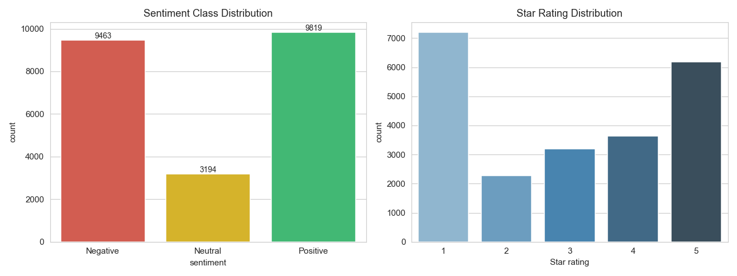
Figure 1: Sentiment class distribution (left) and raw star-rating distribution (right)

Figure 2 confirms that the great majority of the dataset (22,448 of 22,476 rows) consists of genuine free-text reviews, with only a small residual share of Google's auto-generated placeholder tags remaining after deduplication.
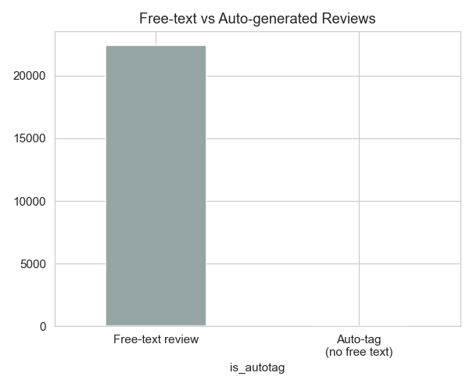
Figure 2 : Free-text reviews vs. Google's auto-generated rating-tag reviews.

Figure 3 compares review length (in characters) across the three sentiment classes. Negative reviews are noticeably longer on average than positive ones, suggesting that dissatisfied customers tend to write more to explain what specifically went wrong with their visit.
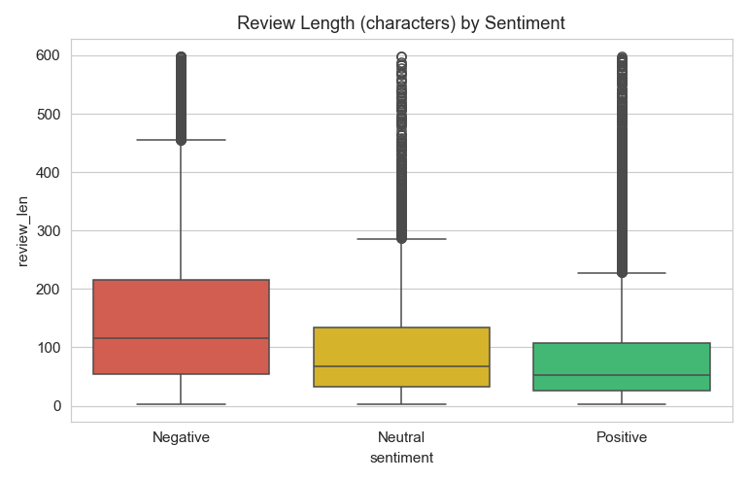
Figure 3: Distribution of review length (characters) by sentiment class.
Figure 4 shows the sentiment composition of reviews grouped by how long ago they were posted. Negative reviews make up a consistently large share of feedback across all time periods, indicating that service-quality complaints are a persistent rather than transient pattern in the data.
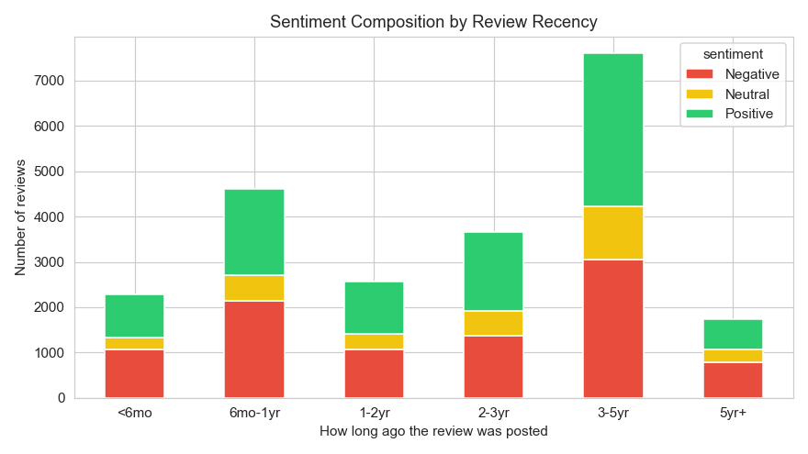
Figure 4: Sentiment composition by review recency.

3.5 Sentiment-Aware Text Preprocessing and Lexical Exploration
Prior to feature extraction, free-text reviews (excluding auto-generated tags) were normalised for NLP modelling: lower-casing, removal of URLs and non-alphabetic characters, whitespace normalisation, and removal of English stop-words plus a small set of domain-specific noise terms ("mcdonalds", "mcdonald", "mc", "donalds", "location", "store") that carry no sentiment signal in this dataset. Critically, negation words ("not", "no", "never", "neither", "nor", "cannot", "without") were deliberately preserved rather than removed, since they can reverse the sentiment of a sentence and are highly informative features, as confirmed later by their appearance among the model's top predictive terms (Section 5.3).
Figure 5 shows word clouds generated separately for each sentiment class. Positive reviews centre on terms such as "great", "love", "clean", and "fast service"; negative reviews centre on "time", "drive", "rude", and "cold"; neutral reviews reflect mixed or mediocre experiences ("okay", "slow", "average").
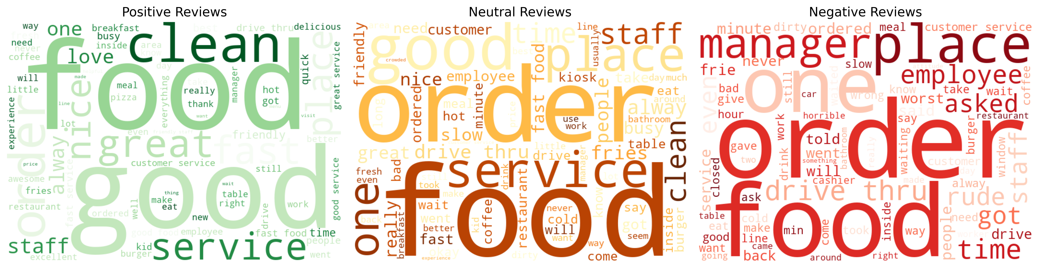
Figure 5:Word clouds by sentiment class.

Figure 6 shows the most frequent two-word phrases (bigrams) per sentiment class, reinforcing the same operational themes identified in the word clouds - drive-thru speed and order accuracy for negative reviews, and staff friendliness and food freshness for positive reviews.
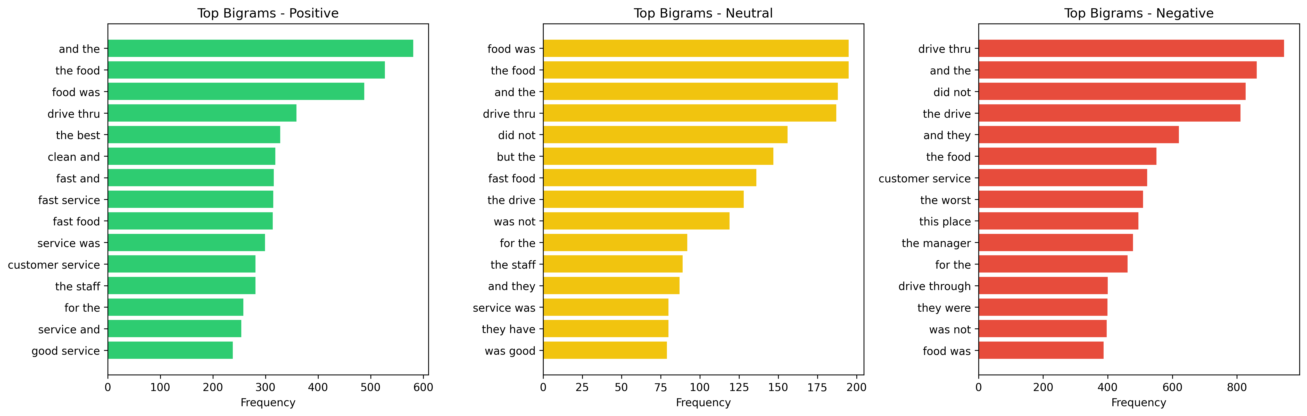
Figure 6: Word clouds by sentiment class.

3.6 Feature Engineering
Preprocessed review text was converted into numeric features using Term Frequency-Inverse Document Frequency (TF-IDF) vectorisation with the following configuration: unigrams through trigrams (ngram_range = (1,3)), a maximum vocabulary of 20,000 terms, a minimum document frequency of 3 (terms appearing in fewer than 3 reviews are discarded), and sublinear term-frequency scaling to dampen the effect of very frequently repeated words within a single review. This configuration allows the models to capture short, sentiment-bearing phrases (e.g. "not bad", "fast service") in addition to individual words.

3.7 Train / Test Split Strategy
The 22,366 reviews with usable processed text were split into training and test sets using an 80/20 stratified split (test_size = 0.20, random_state = 42), preserving the relative proportion of Negative, Neutral, and Positive classes in both sets. This produced 17,892 training reviews and 4,474 held-out test reviews, on which all supervised models in Chapter 4 are evaluated identically.

Chapter 4: Modelling and Analysis

4.1 Analytical Pipeline
The end-to-end pipeline proceeds through four notebooks:
- Data cleaning and preprocessing, producing the cleaned review dataset,
- Exploratory data analysis, producing the distribution and trend figures in chapter 3,
- Sentiment-aware text preprocessing and lexical exploration, producing the model-ready processed text plus word-cloud and bigram figures,
- Supervised model training, VADER benchmarking, and artefact saving, producing the trained model, tf-idf vectoriser, and all evaluation outputs used in chapter 5.
The best-performing model and its vectoriser are subsequently loaded by the FastAPI backend of the deployed web application described in Section 5.6.

4.2 Model 1: Logistic Regression
A multinomial Logistic Regression classifier was trained on the TF-IDF feature matrix with class_weight = "balanced" (to counteract the under-representation of the Neutral class) and a maximum of 1,000 solver iterations. Logistic Regression is a linear model whose per-class coefficients are directly interpretable as the strength and direction with which each TF-IDF feature pushes a prediction toward that class, which is exploited in Section 5.3 to extract the most sentiment-predictive words.

4.3 Model 2: Multinomial Naive Bayes
A Multinomial Naive Bayes classifier, a standard probabilistic baseline for text classification that assumes conditional independence between features given the class, was trained on the same TF-IDF matrix with default hyperparameters. Naive Bayes is fast to train and often performs well on raw accuracy for imbalanced text data, but as Section 5.1 shows, this can mask very poor performance on minority classes.

4.4 Model 3: Linear Support Vector Machine
A Linear Support Vector Machine (LinearSVC) was trained with class_weight = "balanced", providing a maximum-margin linear alternative to Logistic Regression that is often competitive on high-dimensional, sparse TF-IDF representations.

4.5 Baseline: VADER Lexicon-Based Sentiment Analyser
As an unsupervised benchmark requiring no training data, the VADER (Valence Aware Dictionary and sEntiment Reasoner) lexicon-based analyser was applied to a random sample of 8,000 reviews. Each review's compound polarity score (ranging from -1 to +1) was mapped to a discrete label using standard VADER thresholds: compound ≤ -0.05 → Negative, compound ≥ 0.05 → Positive, otherwise Neutral. This label was then compared against the same rating-derived ground truth used for the supervised models.

4.6 Evaluation Metrics
Because the dataset is class-imbalanced (the Neutral class makes up only around 14% of reviews), all models are evaluated using both overall accuracy and macro-averaged precision, recall, and F1-score, the latter computed by averaging each metric across the three classes without weighting by class size. Macro-F1 was used as the primary model-selection criterion, since it penalises a model that performs well only on the majority classes while ignoring the minority Neutral class - exactly the failure mode observed for Naive Bayes in Section 5.1.
Metric | Definition
Accuracy | Proportion of all test reviews correctly classified
Macro Precision | Unweighted mean of per-class precision (TP / (TP+FP))
Macro Recall | Unweighted mean of per-class recall (TP / (TP+FN))
Macro F1 | Unweighted mean of per-class F1-score; primary model-selection metric
Table 2: Evaluation metrics used for model comparison.

Chapter 5: Results, Insights, and Discussion

5.1 Full Evaluation Results
Table 3 reports all four evaluation metrics for the three supervised classifiers and the VADER baseline on their respective held-out test sets (4,474 reviews for the supervised models; the 8,000-review VADER sample).
Model | Accuracy | Macro Precision | Macro Recall | Macro F1
Logistic Regression (best) | 0.7405 | 0.6711 | 0.6780 | 0.6701
Linear SVM | 0.7456 | 0.6434 | 0.6423 | 0.6426
Multinomial Naive Bayes | 0.7664 | 0.7535 | 0.5982 | 0.5576
VADER (unsupervised) | 0.6434 | 0.5752 | 0.5628 | 0.5627
Table 3: Full evaluation results across all four sentiment-scoring approaches.
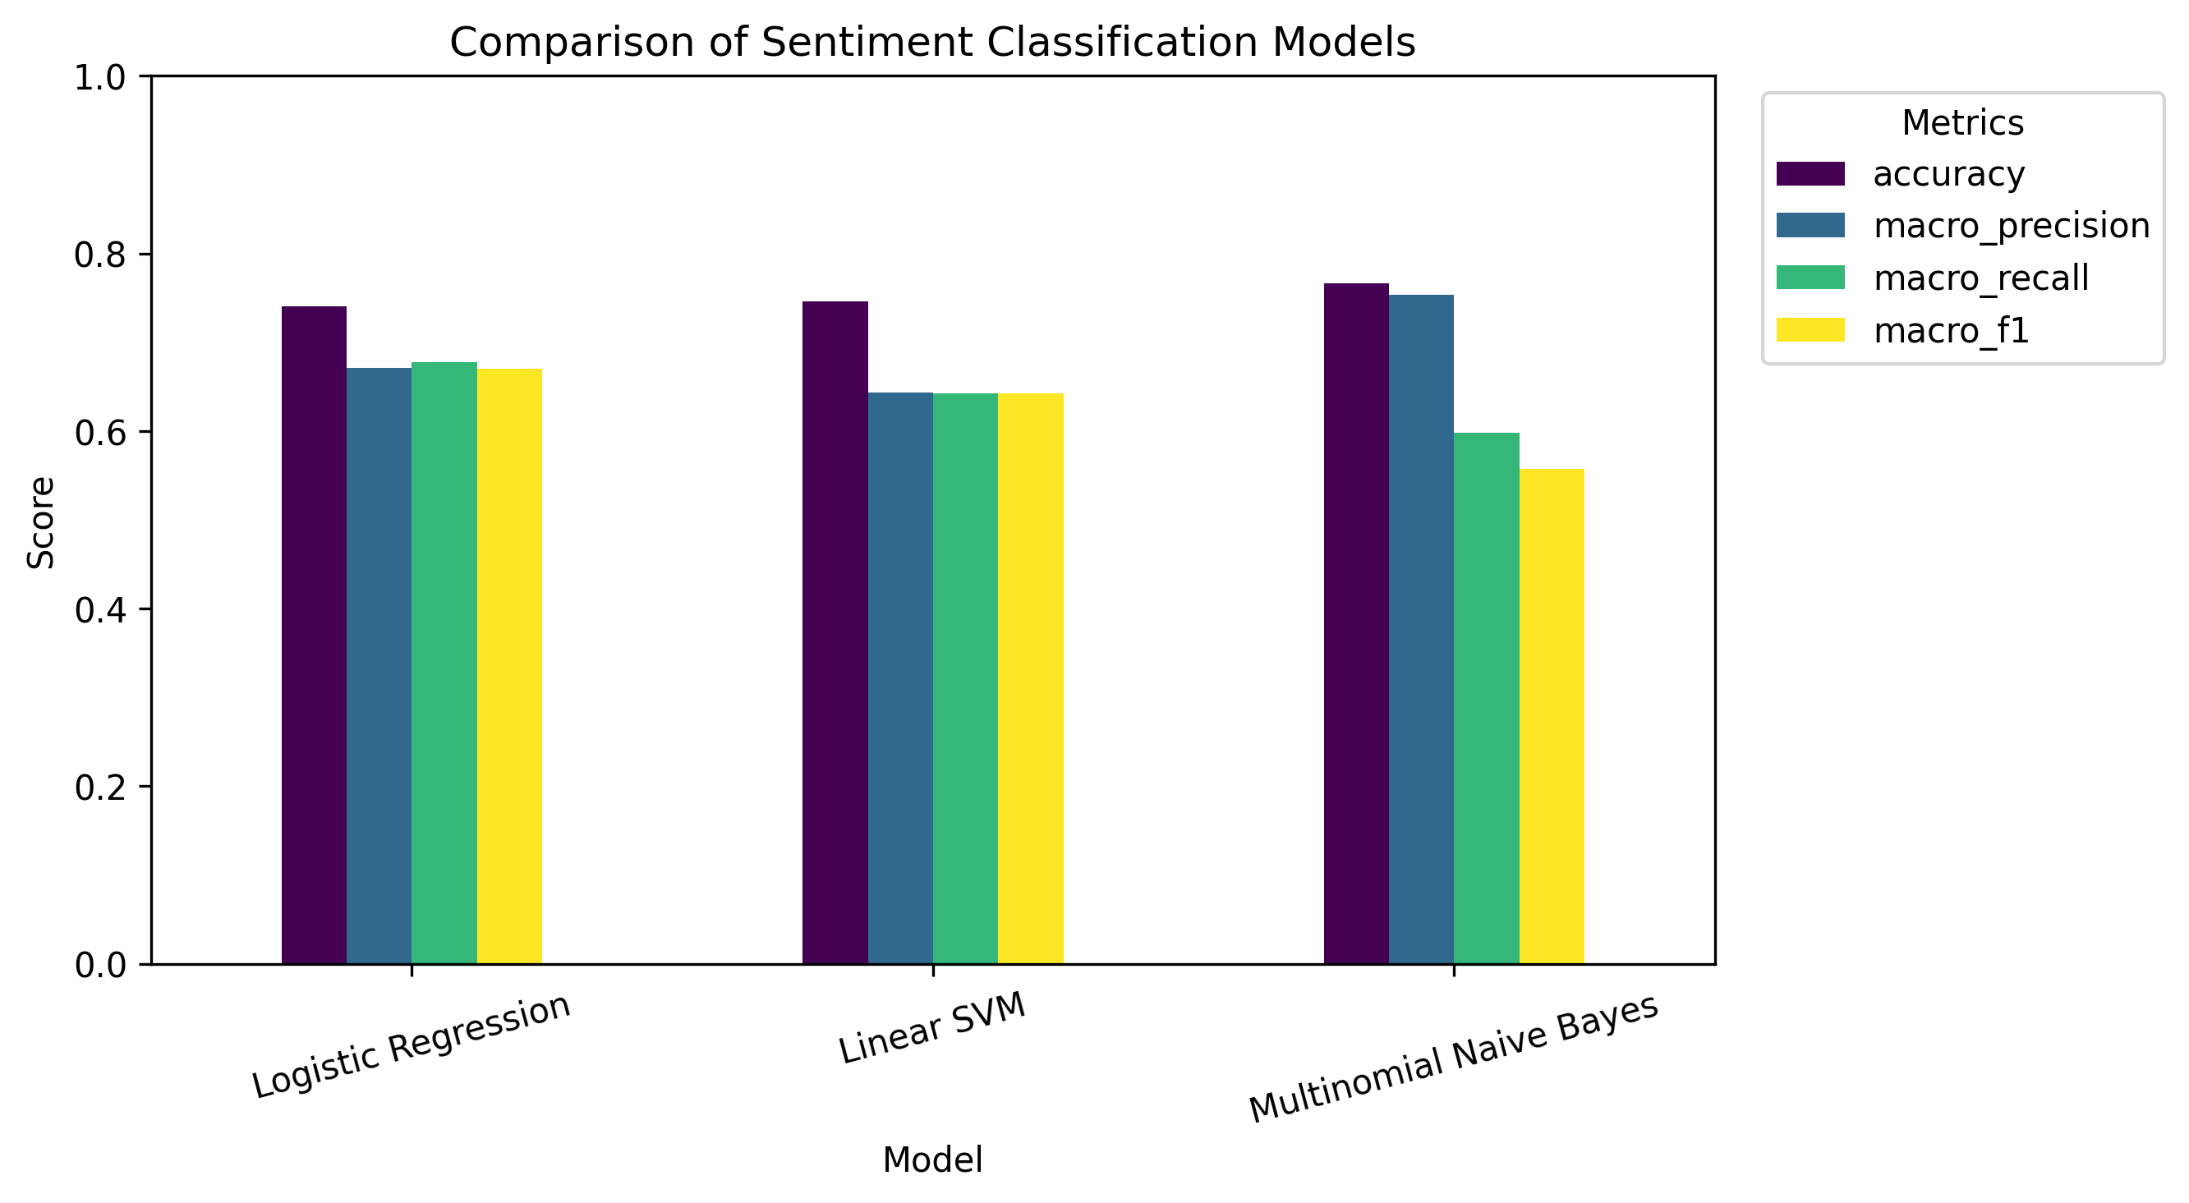
Figure 7: Full evaluation results across all four sentiment-scoring approaches.

5.2 Why Logistic Regression Was Selected Despite Lower Raw Accuracy
Multinomial Naive Bayes achieves the highest raw accuracy (76.6%) and macro precision (0.754), which might suggest it is the strongest model. However, its macro-recall (0.598) and macro-F1 (0.558) are the lowest of the three supervised models, because it performs very poorly on the minority Neutral class - the per-class classification report shows Naive Bayes' Neutral F1-score is close to zero, meaning it almost never predicts "Neutral" at all and instead defaults to the majority classes. Logistic Regression, by contrast, achieves the best macro-F1 (0.670), balancing performance more fairly across all three classes, and was therefore selected as the primary deployed model. Table 4 presents the full per-class breakdown for Logistic Regression.
Class | Precision | Recall | F1-score | Support
Negative | 0.83 | 0.81 | 0.82 | 1,888
Neutral | 0.33 | 0.46 | 0.38 | 633
Positive | 0.85 | 0.76 | 0.80 | 1,953
Table 4: Per-class classification report for the Logistic Regression model (test set, n = 4,474).

5.3 Confusion Matrix and Most Predictive Words
Figure 8 shows the confusion matrix for the Logistic Regression model. The great majority of confusion occurs between the Neutral class and its neighbouring Negative/Positive classes - an expected outcome, since 3-star reviews are inherently ambiguous and frequently contain a mix of positive and negative statements within the same sentence.
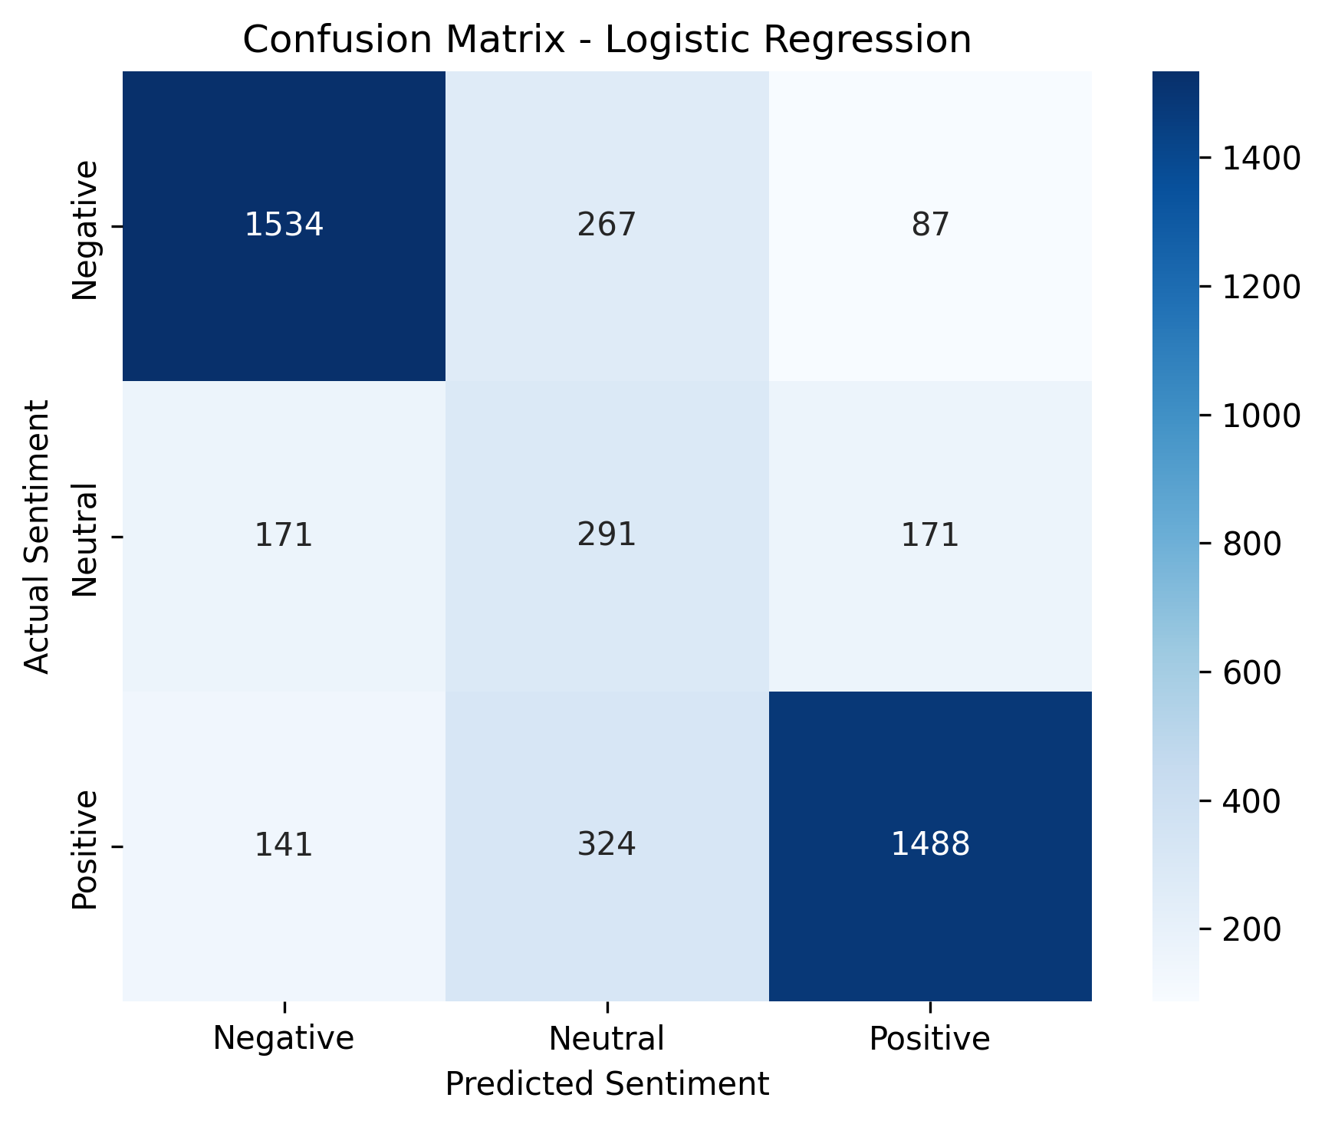
Figure 8: Confusion matrix for the Logistic Regression model.

Figure 9 shows the words with the strongest positive coefficient for each class - i.e. the words most predictive of that sentiment - extracted directly from the trained Logistic Regression model. Negative reviews are dominated by service-failure language ("worst", "rude", "horrible", "minutes", "dirty"); Positive reviews centre on staff and food-quality language ("great", "love", "friendly", "delicious", "fast service"); and Neutral reviews are characterised by hedging and contrast language ("okay", "but", "average", "however"), consistent with the mixed-sentiment nature of 3-star reviews. Notably, negation words such as "not" appear among the strongest Negative predictors ("not good", the phrase "not" alone), confirming the value of preserving negation terms during preprocessing (Section 3.5).
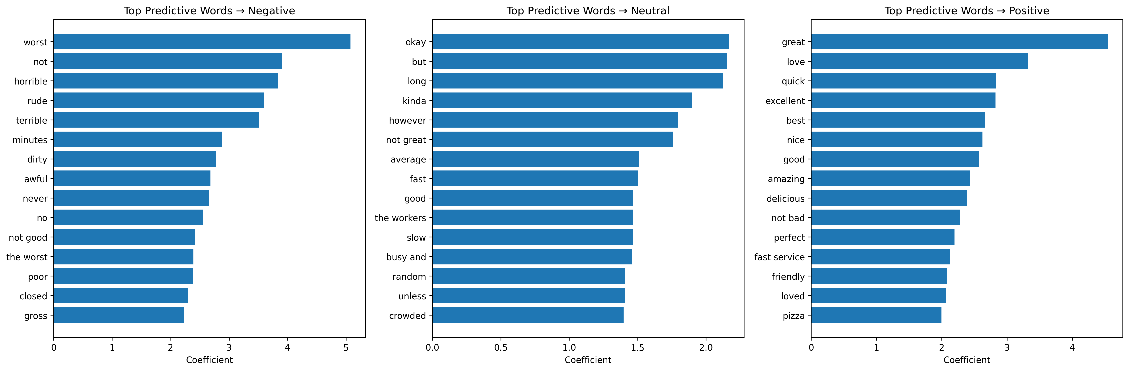
Figure 9: Top predictive words per sentiment class, from the Logistic Regression model coefficients.

5.4 Lexicon-Based Baseline Validation (VADER)
VADER scored each review's polarity without any training. Figure 10 shows its compound score plotted against the actual star rating: the clear, monotonic relationship between the two confirms that the review text carries genuine sentiment signal consistent with the star ratings, independently validating the rating-derived labelling scheme used throughout this project. VADER's 64.3% agreement with the rating-derived label is respectable given it required no labelled training data at all, though it remains well below the supervised Logistic Regression model's 74.1% accuracy - quantifying the value that a modest amount of labelled training data adds over a general-purpose sentiment lexicon.
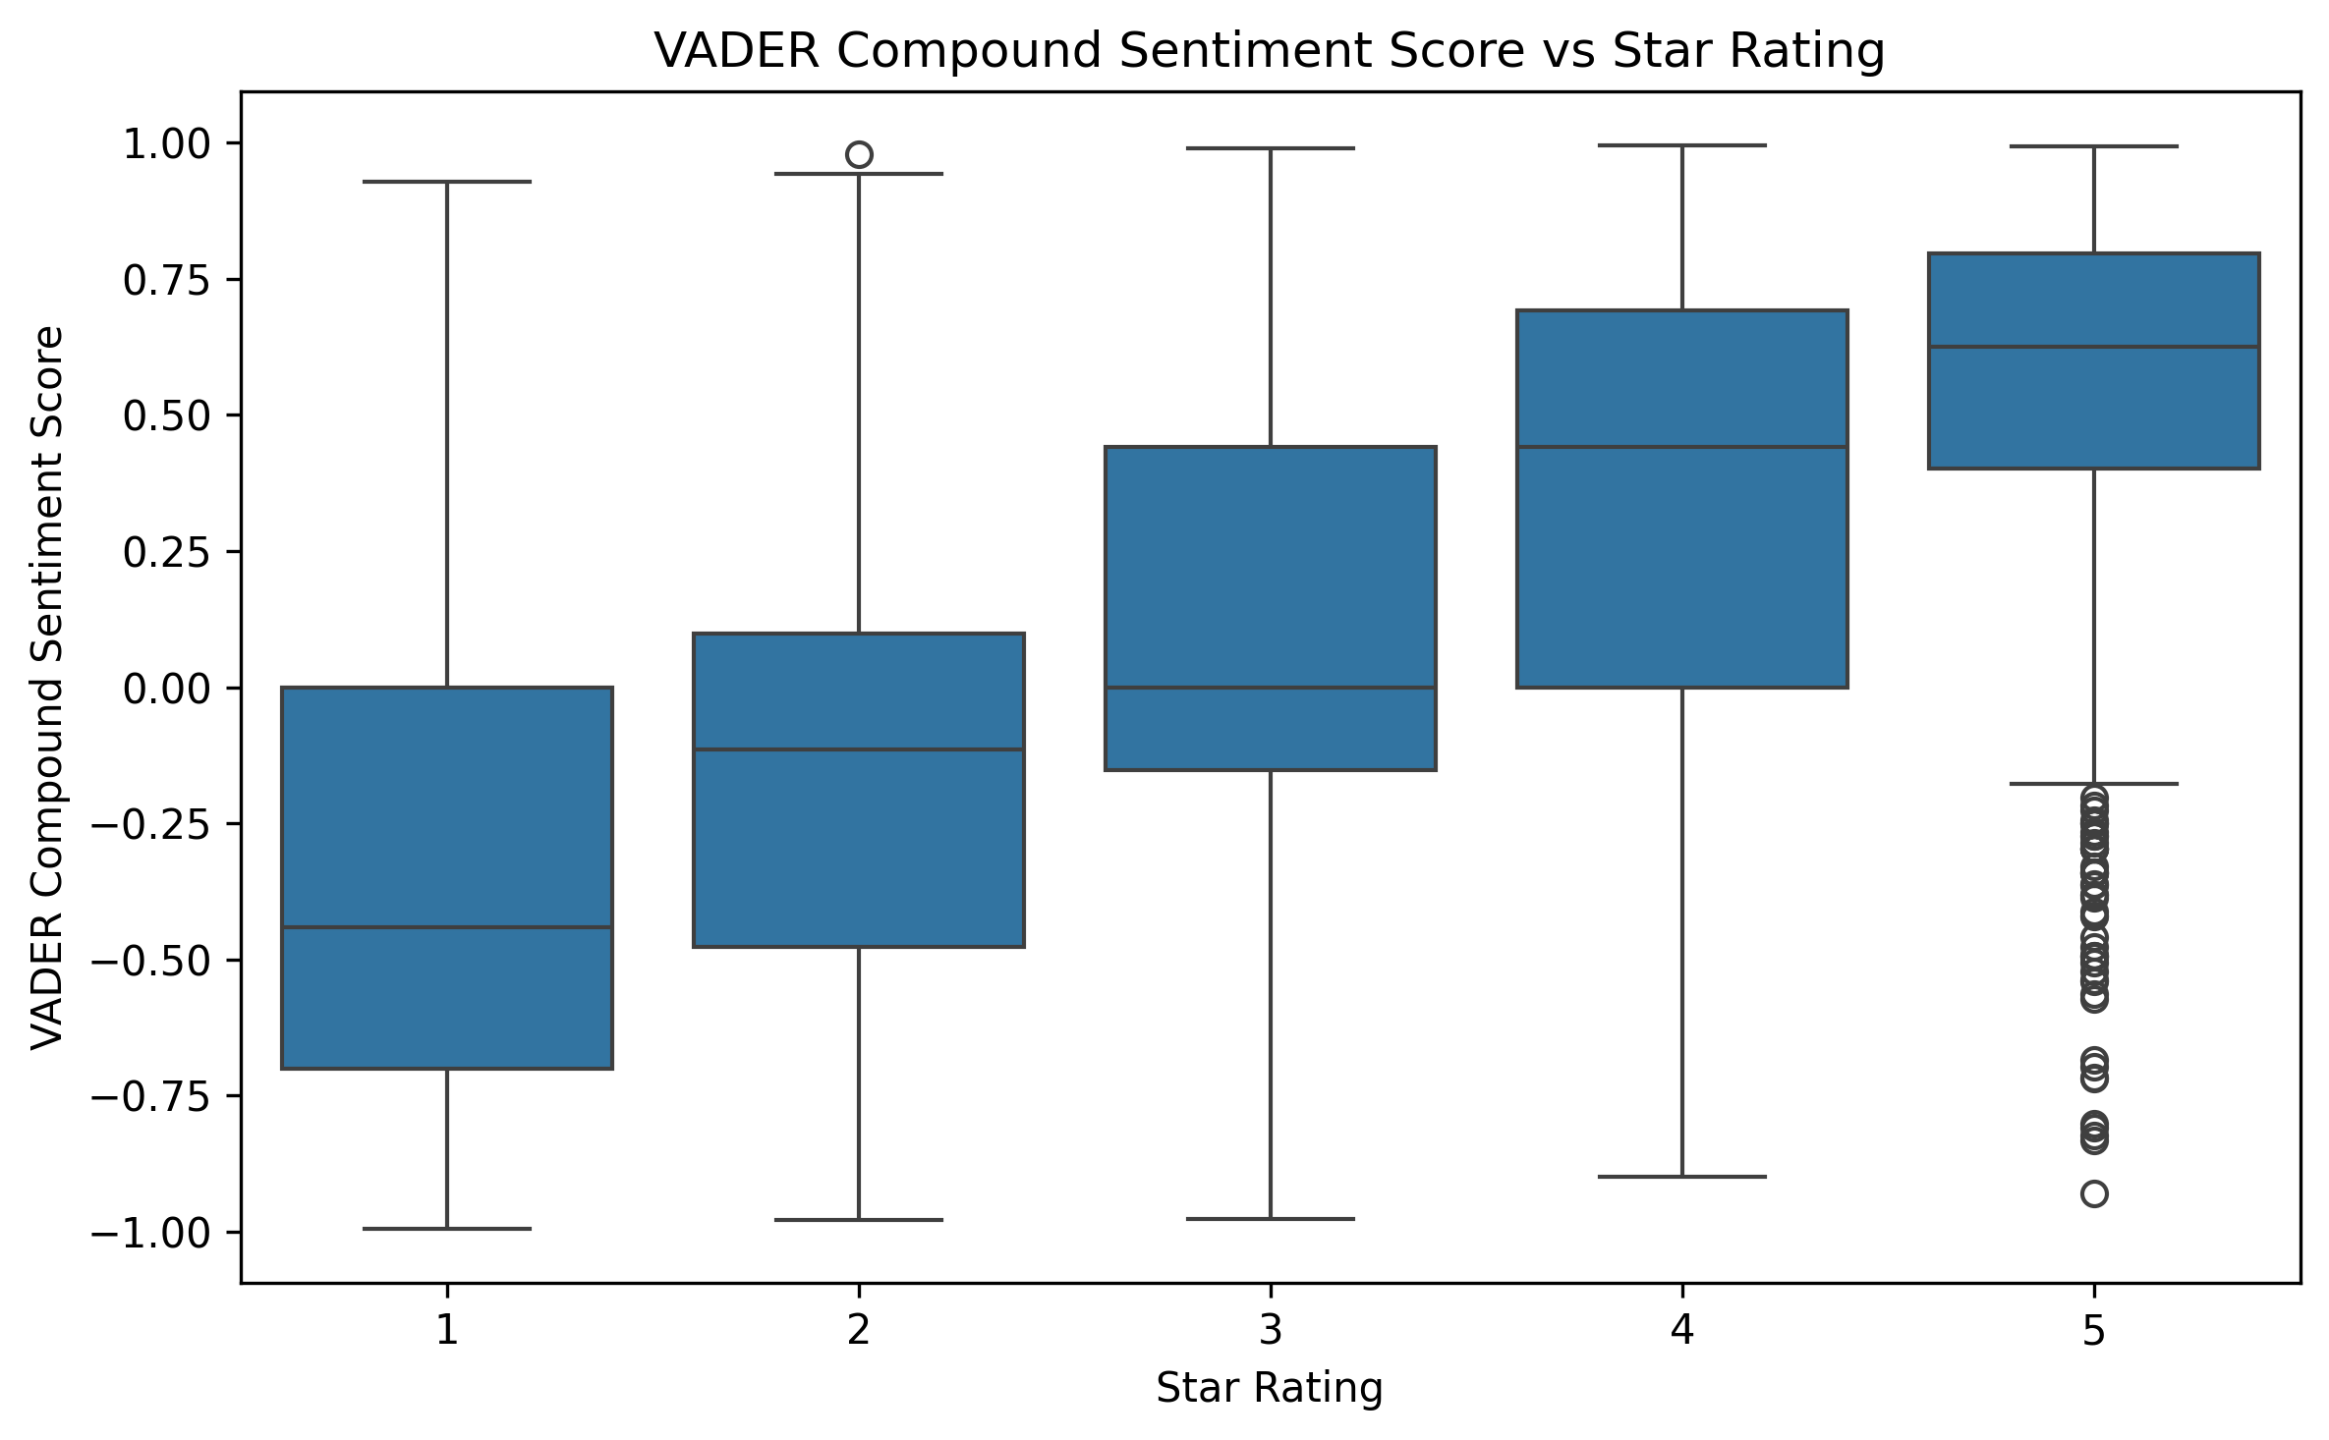
Figure 10: VADER compound sentiment score distribution across each star rating.
Figure 11 shows VADER's own confusion matrix; like the supervised models, its largest source of error is the Neutral class, which it frequently confuses with the adjacent Negative and Positive classes, reflecting the same underlying linguistic ambiguity rather than a weakness specific to any one modelling approach.
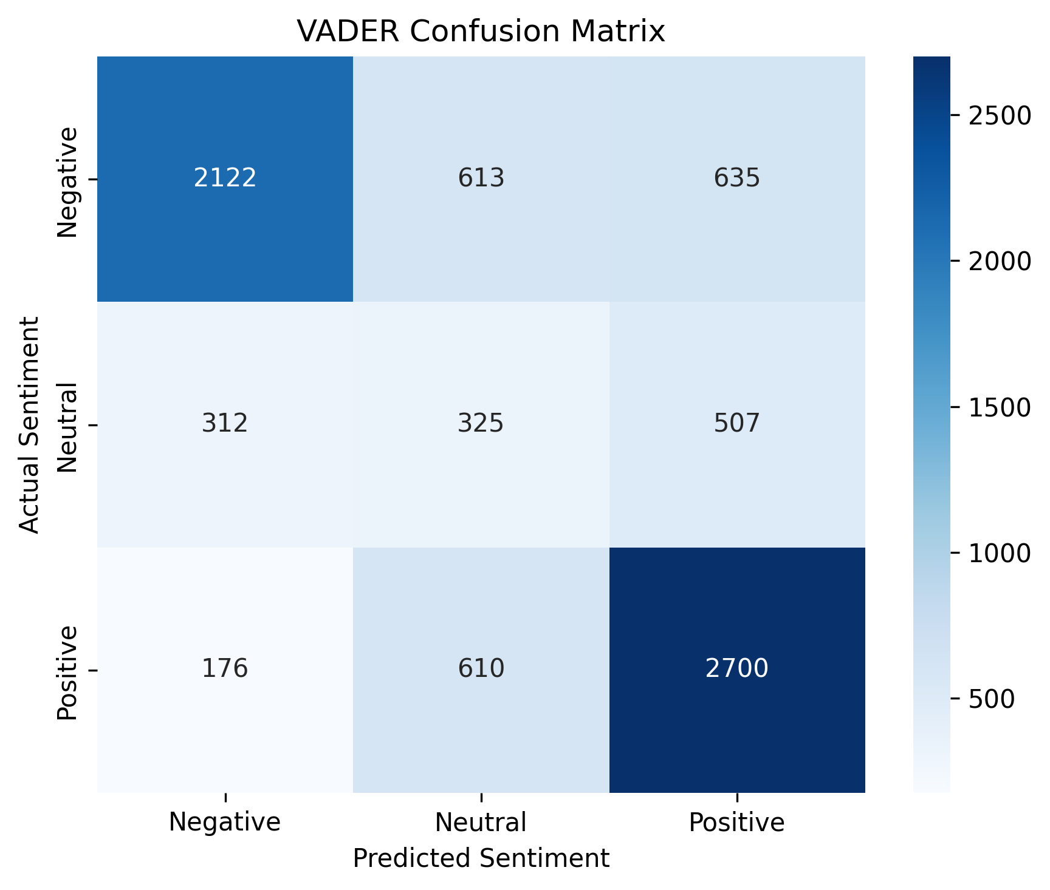
Figure 11: Confusion matrix for the VADER lexicon-based baseline.

5.5 Key Findings
- Customer sentiment is strongly and consistently expressed in review language: the Logistic Regression model correctly classifies clear-cut Positive and Negative reviews with 75-85% precision/recall.
- All four approaches - three supervised models and VADER - struggle with the Neutral class specifically, confirming this is a property of the data (mixed-sentiment 3-star reviews) rather than a weakness of any single algorithm.
- Raw accuracy is a misleading model-selection metric under class imbalance: Naive Bayes' higher accuracy conceals its near-total failure on the Neutral class, which macro-F1 correctly penalises.
- The close agreement between the unsupervised VADER baseline and the star ratings confirms the sentiment signal is robust and not an artefact of the rating-derived labelling scheme.
- Speed and drive-thru experience dominate negative reviews ("drive", "time", "minutes") - operational delays and order accuracy are primary drivers of dissatisfaction, more so than food quality itself.
- Staff friendliness and cleanliness dominate positive reviews ("clean", "friendly", "fast service") - service quality, not just the product, appears to drive customer loyalty.
- Negative reviews are systematically longer than positive ones, meaning dissatisfied customers invest more effort describing specific incidents - a valuable, detailed signal for operational root-cause analysis.
- A meaningful share of raw "reviews" (5,167 of 33,396, before deduplication) are Google's auto-generated rating tags rather than genuine free text, a data-quality trap that must be identified and excluded to avoid trivial label leakage in any similar review-scraping project.

5.6 Deployment: The McDonald's Sentiment Intelligence Platform
The trained Logistic Regression model and its TF-IDF vectoriser were packaged into an interactive the FastAPI backend handles text preprocessing, TF-IDF vectorisation, and model inference, while the React frontend handles presentation, state management, and data visualisation, the "McDonald's Sentiment Intelligence Platform", allowing a non-technical user to enter or select a sample review and receive a live, cached-inference sentiment prediction alongside its most influential words. The application additionally provides an interactive exploratory-data-analysis dashboard, a model-performance comparison view, a raw dataset explorer, and a capstone-details page summarising the project's objectives and pipeline, turning the offline analysis in Chapters 3-5 into a reusable, demonstrable artefact.

5.7 Limitations
- Ratings are used as a sentiment proxy rather than human-annotated ground truth; some 3-star reviews may be mislabelled Neutral when the text itself leans clearly positive or negative.
- The dataset covers only McDonald's outlets, so language patterns (e.g. "drive-thru") are fast-food specific and may not generalise to other review domains without re-training.
- Approximate "days ago" values, derived from relative time text such as "3 months ago", are estimates rather than exact timestamps.
- The VADER benchmark was evaluated on an 8,000-review random sample rather than the full dataset, for computational efficiency; results may shift marginally on the full corpus.

Chapter 6: Future Enhancements

6.1 Human-Annotated Validation Set
Collecting a human-annotated subset of reviews, particularly for the Neutral class, would allow the rating-derived sentiment labels to be validated directly and would quantify how much of the current model's Neutral-class error is attributable to label noise versus genuine model limitation.

6.2 Transformer-Based Modelling
Fine-tuning a transformer-based language model such as DistilBERT on this dataset would likely better capture the mixed-sentiment, context-dependent nature of Neutral reviews than a bag-of-words TF-IDF representation, at the cost of significantly higher training and inference compute requirements.

6.3 Cross-Domain Generalisation
Extending the pipeline to an originally-considered second dataset (e.g. Amazon product reviews) would test whether the trained model and its learned vocabulary generalise beyond fast-food-specific language, or whether domain-specific re-training is required.

6.4 Geographic Sentiment Analysis
The cleaned dataset retains store-level latitude and longitude for each of the 40 outlets represented. Incorporating this into an interactive map view would allow sentiment to be analysed geographically, surfacing whether specific outlets or regions systematically under- or out-perform the network average.

6.5 Automated Neutral-Class Rebalancing
Applying targeted class-balancing techniques beyond simple class weighting - such as SMOTE-style oversampling of Neutral reviews, or a two-stage classifier that first separates clear-cut from ambiguous reviews - is a promising direction for directly addressing the project's central remaining weakness.

6.6 Expanded Dashboard Features
The deployed web application could be extended with scheduled batch scoring of newly scraped reviews, alerting when negative-sentiment volume spikes for a given outlet, and an authenticated multi-user view for operational teams, moving the platform from an analytical demonstration toward an operational early-warning tool for customer-experience management.

Chapter 7: Conclusion
This project set out to build and rigorously compare supervised and unsupervised approaches to sentiment classification of McDonald's customer reviews, with a specific focus on how model choice interacts with class imbalance and the inherent ambiguity of neutral opinion. A real-world dataset of 33,396 scraped reviews was cleaned, an important data-quality finding regarding auto-generated placeholder reviews was identified and corrected, and 22,366 genuine free-text reviews were used to train and evaluate three TF-IDF-based supervised classifiers alongside the unsupervised VADER lexicon baseline.
The results confirm the project's central finding: raw accuracy alone is an unreliable model-selection criterion under class imbalance, since it can conceal near-total failure on a minority class, as observed for Multinomial Naive Bayes on the Neutral class. Logistic Regression, selected using macro-F1 as the primary criterion, offers the best balance of performance across all three sentiment classes (74.1% accuracy, 0.670 macro-F1) and was deployed as the production model behind an interactive web application with a FastAPI backend and React frontend. The unsupervised VADER baseline, requiring no labelled training data, reached a respectable 64.3% accuracy, both validating the rating-derived labelling scheme through its monotonic relationship with star ratings and quantifying the tangible benefit that labelled training data provides over a general-purpose sentiment lexicon.
Taken together, this report has met its stated objectives: a large, real-world review dataset was acquired, audited, and cleaned; a ground-truth sentiment label was derived and a subtle label-leakage risk was identified and corrected; four distinct sentiment-scoring approaches were implemented, evaluated with imbalance-aware metrics, and compared; the linguistic drivers of each sentiment class were interpreted and translated into actionable operational insight; and the best-performing model was deployed as a live, interactive application. The resulting pipeline, together with the future enhancements identified in Chapter 6, provides a solid and extensible foundation for further work on customer-review sentiment analysis at McDonald's and comparable multi-outlet service businesses.

References
[1] B. Pang and L. Lee, "Opinion mining and sentiment analysis," Foundations and Trends in Information Retrieval, vol. 2, no. 1-2, pp. 1-135, 2008.
[2] C. J. Hutto and E. Gilbert, "VADER: A parsimonious rule-based model for sentiment analysis of social media text," in Proc. 8th Int. AAAI Conf. Weblogs and Social Media, 2014.
[3] F. Pedregosa et al., "Scikit-learn: Machine learning in Python," Journal of Machine Learning Research, vol. 12, pp. 2825-2830, 2011.
[4] G. Salton and C. Buckley, "Term-weighting approaches in automatic text retrieval," Information Processing & Management, vol. 24, no. 5, pp. 513-523, 1988.
[5] A. McCallum and K. Nigam, "A comparison of event models for Naive Bayes text classification," in AAAI-98 Workshop on Learning for Text Categorization, 1998.
[6] C. Cortes and V. Vapnik, "Support-vector networks," Machine Learning, vol. 20, no. 3, pp. 273-297, 1995.
[7] J. D. M.-W. Chang, K. Lee, and K. Toutanova, "BERT: Pre-training of deep bidirectional transformers for language understanding," in Proc. NAACL-HLT, 2019.
[8] Google Maps, McDonald's outlet customer reviews (scraped dataset), 2025-2026.

Glossary
Accuracy: The proportion of test reviews for which the predicted sentiment label matches the true label.
Bigram: A sequence of two consecutive words treated as a single text feature.
Class imbalance: A situation where one or more target classes (here, Neutral) are substantially under-represented relative to others.
Confusion matrix: A table showing, for each true class, how many test instances were predicted into each class.
Lexicon-based sentiment analysis: Scoring text sentiment using a pre-built dictionary of words with assigned polarity weights, without any model training (e.g. VADER).
Logistic Regression: A linear classification model estimating class probabilities from a weighted sum of input features; the best-performing model in this project.
Macro-F1: The unweighted mean of the F1-score computed separately for each class; the primary model-selection metric used in this report.
Multinomial Naive Bayes: A probabilistic text classifier assuming conditional feature independence given the class.
Sentiment analysis: The automated classification of text as expressing a positive, negative, or neutral opinion.
Stratified split: A train/test split that preserves the relative proportion of each class in both resulting subsets.
TF-IDF: Term Frequency-Inverse Document Frequency: a numeric text-vectorisation scheme that weights terms by their frequency in a document, discounted by how common they are across all documents.
VADER: Valence Aware Dictionary and sEntiment Reasoner: a rule-based, lexicon-driven sentiment analysis tool used in this report as an unsupervised baseline.

Appendix A: Repository and Artefact Structure
The project’s codebase is organised as follows, reflecting the notebook-driven pipeline described in Chapter 4:
- notebooks/01 Data Cleaning & Preprocessing.ipynb - raw data cleaning, producing data/cleaned_reviews.csv
- notebooks/02 Exploratory Data Analysis.ipynb - distribution and trend figures (Figures 3.1-3.4)
- notebooks/03 Text Preprocessing & Lexical Exploration.ipynb - text normalisation, word clouds, bigrams (Figures 3.5-3.6)
- notebooks/04 Modelling.ipynb - TF-IDF, model training, VADER benchmarking, artefact and figure saving
- models/ - saved best_sentiment_model.pkl, tfidf_vectorizer.pkl, and logistic_regression_model.pkl
- results/ - summary.json, model_results.csv, classification_reports.txt, vader_classification_report.txt, supervised_vs_vader.csv
- Figures/ - all 11 exported figures used throughout this report
- server.py - FastAPI application exposing the model and vectoriser via a REST API
- frontend/ - React application consuming the FastAPI backend

