Sentiment Analysis of Customer Reviews
McDonald's Google Maps Reviews Dataset
Capstone Project II (DS3206) — Implementation Phase A12 (A12_ii - A12_iv)
Pooja | Department of Data Science, Sabaragamuwa University of Sri Lanka

1. Introduction & Objective
This report documents the implementation phase (A12) of the Capstone Project II sentiment analysis study, covering data cleaning and preprocessing (A12_ii), the application of analytical and modelling techniques (A12_iii), and the interpretation of results with generated insights (A12_iv).
The dataset (A12_i, previously acquired) contains 33,396 customer reviews of McDonald's outlets scraped from Google Maps, including the reviewer's star rating (1-5), the free-text review, review recency, and store metadata. The objective of this phase is to classify each review's sentiment (Positive / Neutral / Negative), understand what language distinguishes each sentiment class, and generate insights that could support business decision-making.

2. A12_ii — Data Cleaning & Preprocessing
The raw dataset required several cleaning steps before it was analysis-ready:
- Fixed a mis-encoded store name variant ("ýýýMcDonald's") caused by a character-encoding artifact during scraping, merging it back into a single "McDonald's" entity.
- Converted the textual star rating ("1 star" / "5 stars") into a numeric 1-5 scale, and the comma-formatted rating_count into an integer.
- Parsed the relative review_time field (e.g. "3 months ago", "a year ago") into an approximate numeric "days since posting" value to enable time-based trend analysis.
- Cleaned mojibake / replacement-character artifacts (ï¿½, ý) left over from a text-encoding mismatch during scraping, and normalised whitespace.
- Removed 179 rows with empty or unusable review text (fewer than 3 characters).
- Removed 10,741 exact duplicate reviews (identical text + rating pairs), most of which were repeated scrape artifacts.

2.1 Key Data-Quality Finding: Auto-Generated Rating Tags
Inspection of the most frequent review texts revealed that when a Google Maps reviewer leaves a star rating with no written comment, Google auto-fills the review field with a generic tag that simply mirrors the star rating: "Excellent" (5★), "Good" (4★), "Neutral" (3★), "Poor" (2★), "Terrible" (1★). These are not genuine free-text opinions — using them for NLP modelling would trivially leak the label and inflate model performance artificially. 5,167 such rows were flagged and excluded from the text-modelling dataset (they remain in the file for rating-based statistics).

2.2 Sentiment Labelling
Since the dataset has no explicit sentiment column, ground-truth sentiment labels were derived from the star rating, a standard and widely-used proxy in review sentiment analysis:
- 1-2 stars → Negative
- 3 stars → Neutral
- 4-5 stars → Positive
After cleaning, the final analysis-ready dataset contains 22,476 reviews (22,448 of which include genuine free text used for NLP modelling).

3. Exploratory Data Analysis
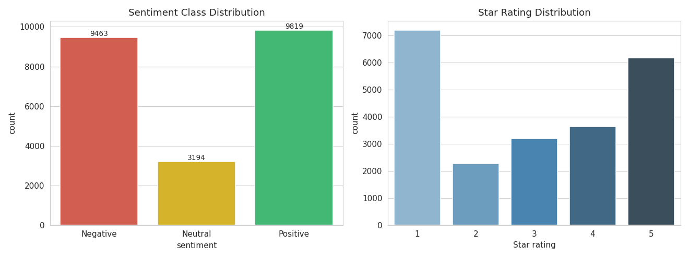
Figure 1. Sentiment class distribution (left) and raw star-rating distribution (right). Reviews are polarised: strong positive (5★) and strong negative (1★) dominate, a common pattern in online reviews.
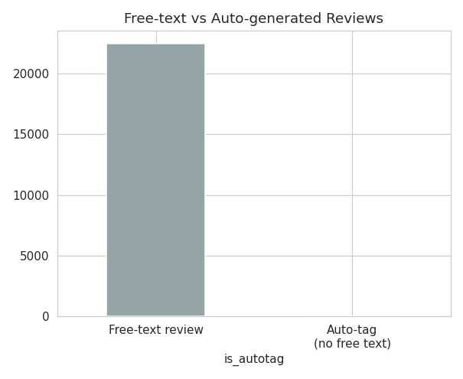
Figure 2. Share of reviews that are genuine free text vs Google's auto-generated rating tags.
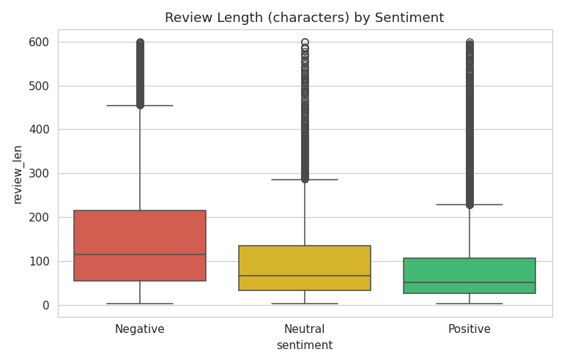
Figure 3. Review length (characters) by sentiment. Negative reviews tend to be noticeably longer than positive ones — dissatisfied customers write more to explain what went wrong.
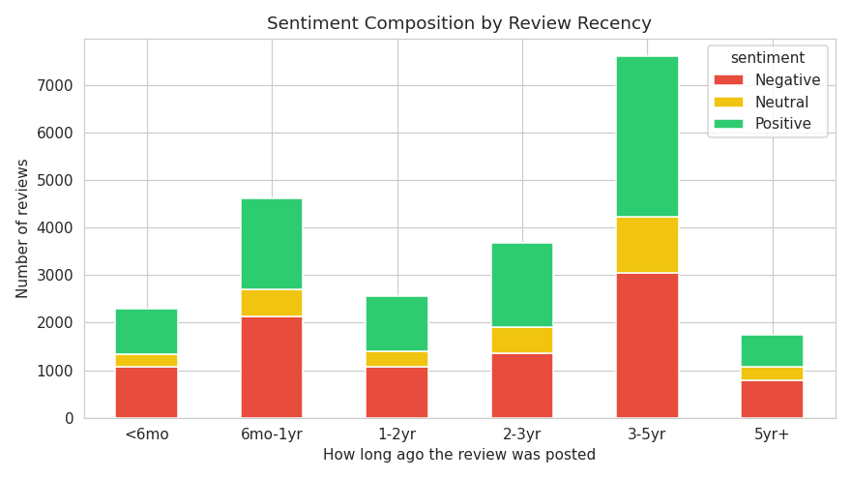
Figure 4. Sentiment composition by how long ago the review was posted. Negative reviews make up a consistently large share across all time periods.

4. A12_iii — Application of Analytical & Modelling Techniques

4.1 Text Preprocessing
Free-text reviews (excluding auto-generated tags) were preprocessed for NLP modelling: lower-casing, removal of URLs and non-alphabetic characters, removal of English stop-words plus domain-specific noise terms (e.g. "mcdonalds", "food", "place"), and filtering of very short tokens.

4.2 Lexical Exploration
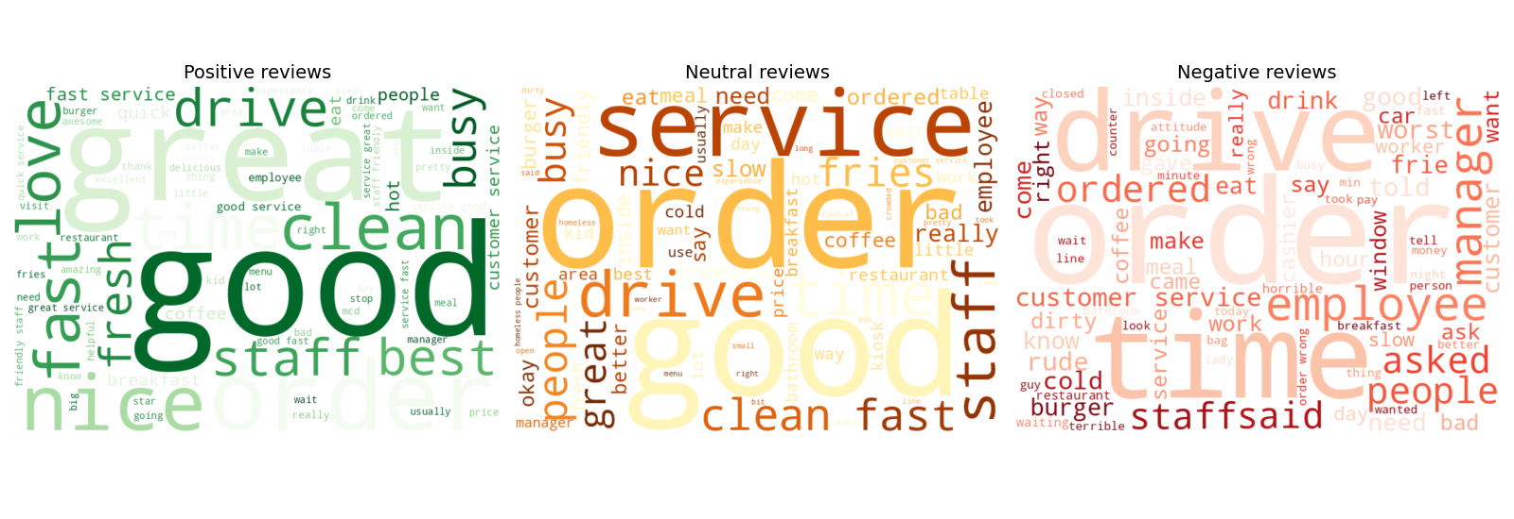
Figure 5. Word clouds by sentiment class. Positive reviews center on "great", "love", "clean", "fast service"; negative reviews center on "time", "drive", "rude", "cold"; neutral reviews reflect mixed/mediocre experiences ("okay", "slow", "average").
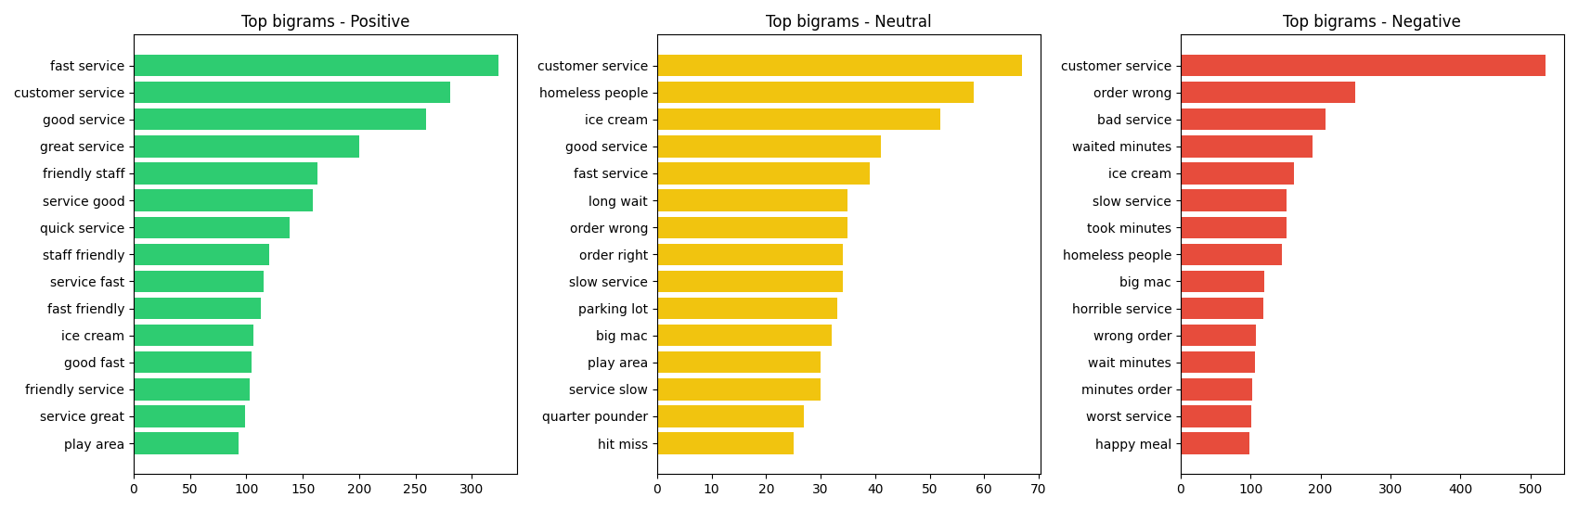
Figure 6. Most frequent two-word phrases (bigrams) per sentiment class.

4.3 Supervised Classification Models
Reviews were vectorised using TF-IDF (unigrams + bigrams, 8,000 features) and split 80/20 into train/test sets (stratified by sentiment). Three supervised classifiers were trained and compared:
- Logistic Regression (class-balanced)
- Multinomial Naive Bayes
- Linear Support Vector Machine (class-balanced)
As an unsupervised benchmark, the VADER lexicon-based sentiment analyzer (which requires no training data) was also applied and its output compared against the rating-derived labels.

Model | Accuracy | Macro Precision | Macro Recall | Macro F1
Logistic Regression (TF-IDF) | 0.717 | 0.649 | 0.653 | 0.646 (best)
Multinomial Naive Bayes | 0.759 | 0.728 | 0.592 | 0.554
Linear SVM | 0.733 | 0.638 | 0.636 | 0.637
VADER lexicon baseline (unsupervised) | 0.647 | - | - | -
Table 1. Model performance on the held-out test set (4,434 reviews).
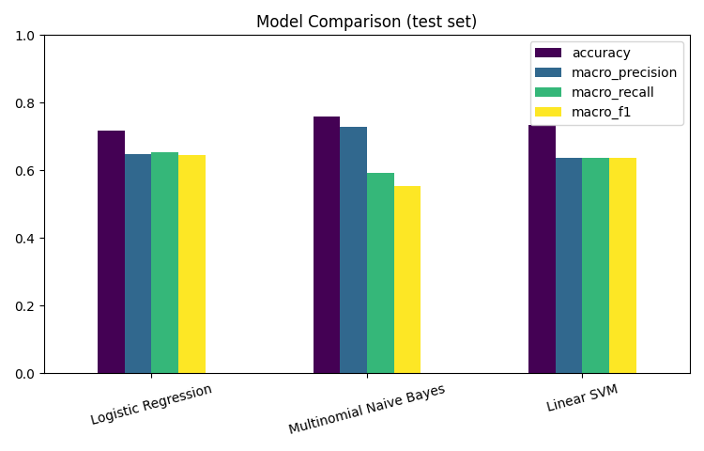
Figure 7. Visual comparison of model performance metrics.
Naive Bayes achieves the highest raw accuracy (75.9%) but performs poorly on the minority Neutral class (F1 ≈ 0.03 — it almost never predicts "Neutral"), which is reflected in its low macro-F1. Logistic Regression gives the best macro-F1 (0.646), balancing performance more fairly across all three classes, and was selected as the primary model.
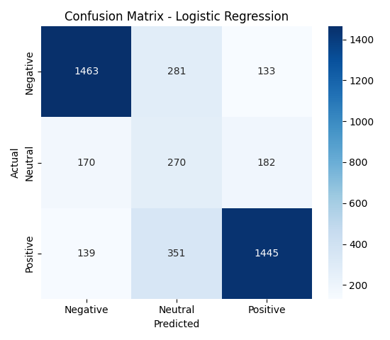
Figure 8. Confusion matrix for the Logistic Regression model. Most confusion occurs between the Neutral class and its neighbouring classes (Positive/Negative) — expected, since 3-star reviews are inherently ambiguous.
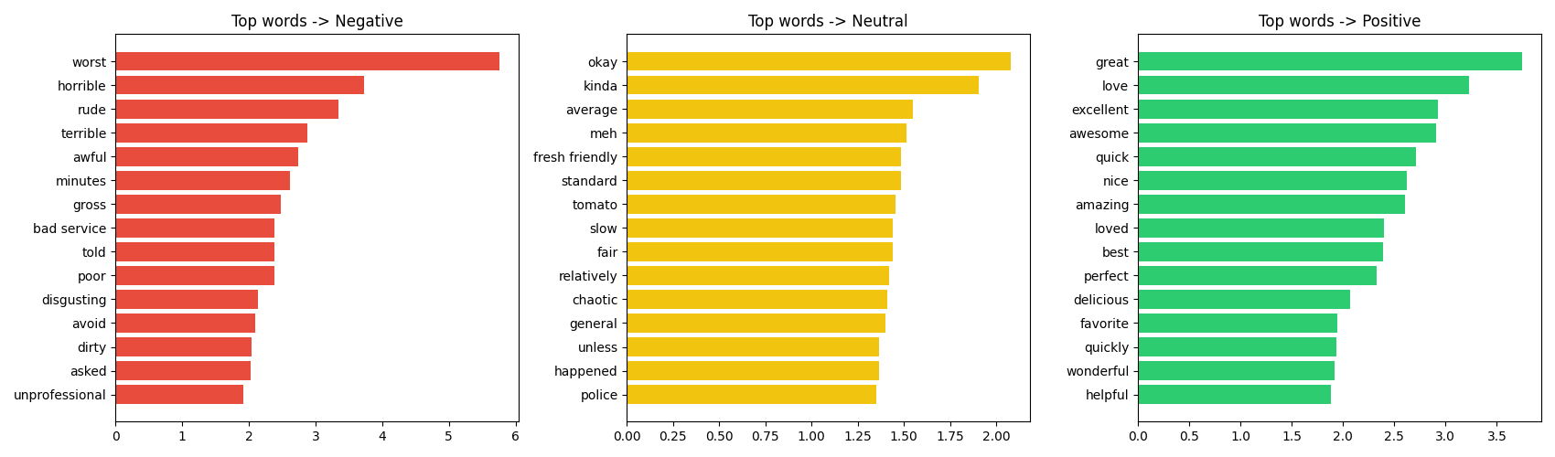
Figure 9. Words with the strongest positive coefficient (i.e. most predictive) for each sentiment class, from the Logistic Regression model.

4.4 Lexicon-Based Baseline (VADER)
VADER, a rule-based sentiment lexicon, scored each review's polarity without any training. Its compound score shows a clear, monotonic relationship with the star rating, validating that the review text does carry genuine sentiment signal consistent with the ratings — and giving 64.7% agreement with the rating-derived label, close to the supervised Logistic Regression's 71.7% accuracy despite needing no labelled training data.
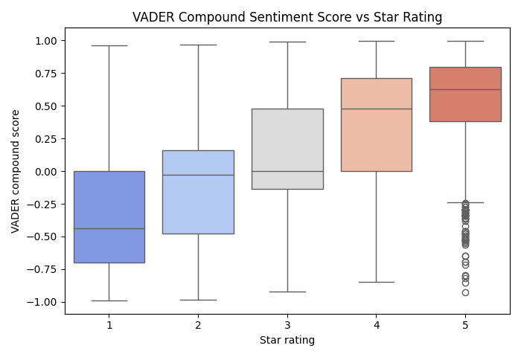
Figure 10. VADER compound sentiment score distribution across each star rating.

5. A12_iv — Interpretation of Results & Insights

5.1 Model Performance Interpretation
- The Logistic Regression model correctly classifies clear-cut Positive and Negative reviews with 75-83% precision/recall, confirming that customer sentiment is strongly and consistently expressed in review language.
- All models struggle with the Neutral class (3-star reviews). This is expected: 3-star reviews often contain a mix of positive and negative statements ("food was good but service was slow"), making them linguistically closer to either extreme than to a distinct "neutral" style.
- The close agreement between the unsupervised VADER baseline and the star ratings (and its similarity to the supervised model's accuracy) confirms the sentiment signal is robust and not an artifact of the labelling scheme.

5.2 Business / Domain Insights
- Speed and drive-thru experience dominate negative reviews ("drive", "time", "minutes", "order wrong") — operational delays and order accuracy are the primary drivers of dissatisfaction, more so than food quality itself.
- Staff friendliness and cleanliness dominate positive reviews ("clean", "friendly staff", "fast service") — service quality, not just the product, drives loyalty.
- Negative reviews are systematically longer than positive ones, meaning dissatisfied customers invest more effort describing specific incidents — valuable, detailed signal for operational root-cause analysis.
- Roughly 1 in 4 reviews (23%) have no free text at all (Google's auto-generated tags), a common phenomenon that data teams working with this kind of scraped review data should account for to avoid label leakage.

5.3 Limitations
- Ratings are used as a sentiment proxy rather than human-annotated ground truth; some 3-star reviews may be mislabelled Neutral when the text itself leans positive or negative.
- The dataset covers only McDonald's outlets, so language patterns (e.g. "drive-thru") are fast-food specific and may not generalise to other review domains.
- Approximate "days ago" values (derived from relative time text) are estimates, not exact timestamps.

5.4 Recommendations for Future Work
- Collect a human-annotated subset to validate the rating-derived sentiment labels, particularly for the Neutral class.
- Experiment with a fine-tuned transformer model (e.g. DistilBERT) to better capture the mixed-sentiment nature of Neutral reviews.
- Extend the pipeline to the originally-planned Amazon product review dataset to test cross-domain generalisation of the sentiment model.
- Incorporate store location (latitude/longitude) to analyse whether sentiment varies geographically across outlets.

