Sabaragamuwa University of Sri Lanka

Assignment
Title | Design and Representation of a University Academic Knowledge Graph Using RDF
Course Title | Semantic Web
Course Code | DS5103
Student Name | Pooja Anbalagan
Index Number | 22CDS0412
DEPARTMENT OF DATA SCIENCE
FACULTY OF COMPUTING
18th October 2026

Table of Contents

List of Images
Figure 1: University knowledge graph (generated from university.ttl with Graphviz, so it always matches the data). Resource nodes are ellipses coloured by class, literals are rounded boxes, and the dashed ellipse is the blank node.
List of Tables
Table 1: Submitted Files details
Table 2: Database Design
Table 3: Prefix and Namespace
Table 4: RDF triple

Overview
The aim of this assignment is to take the kind of information that earlier weeks kept in separate XML documents (students, lecturers, courses, programmes, departments and research areas) and express it as a single RDF graph. Instead of nesting everything under one parent, each entity gets its own IRI and the relationships between entities become explicit triples. All data is fictional.
Submitted file | Content
university.ttl | Full dataset (118 triples) in Turtle, hand-written and commented
university.rdf | The same graph serialized as RDF/XML
university.nt | The same graph serialized as N-Triples
knowledge_graph.png / .svg | Graph diagram (Part C)
report.pdf | This report (Parts A–E)
Table 1: Submitted Files details

Part A — Dataset Design
The dataset describes a fictional “Hill Country University”. Every entity type meets or exceeds the required minimum:
Entity | Required | In my dataset | Resources (IRI local names)
Students | 5 | 5 | S001 – S005
Lecturers | 3 | 3 | L01, L02, L03
Courses | 5 | 5 | DS5103, DS4101, DS3105, SE8111, IS4210
Academic programmes | 2 | 3 | DS, SE, IS
Departments | 2 | 2 | Computing, InfoSystems
Research areas | 3 | 3 | AI, SemanticWeb, DataMining
University | – | 1 | HCU
Table 2: Database Design
Identifier design. Each entity type gets its own namespace, so an IRI tells you what kind of thing it is at a glance. Classes and properties live in a separate vocabulary namespace (ex:).
Prefix | Namespace | Example
ex: | https://example.org/vocab/ | ex:Student, ex:takes, ex:gpa
stu: | https://example.org/student/ | stu:S001
lec: | https://example.org/lecturer/ | lec:L01
crs: | https://example.org/course/ | crs:DS5103
prog: | https://example.org/programme/ | prog:DS
dept: | https://example.org/department/ | dept:Computing
area: | https://example.org/research/ | area:AI
uni: | https://example.org/university/ | uni:HCU
Table 3: Prefix and Namespace
Resource or literal? Programmes, departments and research areas are resources rather than strings, because many statements point to them (three courses belong to prog:DS, two lecturers share an interest in area:DataMining). Names, course codes, GPA, year and credits are literals, since they are plain values nobody needs to link to.

Part B — RDF Triple Construction
university.ttl contains 118 triples, well above the required 30. The table shows how they cover each feature the assignment asks for.
Feature | Count | Example (Turtle)
rdf:type | 23 | stu:S001 a ex:Student .
Resource-to-resource | 46 | stu:S001 ex:takes crs:DS5103 .
String literals | 15 | lec:L01 ex:name "Dr. Kavinda Silva" .
Numeric typed literals | 16 | stu:S001 ex:gpa "3.67"^^xsd:decimal .
Date literal (extra) | 1 | stu:S001 ex:enrolledOn "2023-02-01"^^xsd:date .
Language-tagged literals | 17 | crs:DS5103 ex:title "Semantic Web"@en .
Blank node | 1 node, 4 triples | stu:S001 ex:hasAddress _:addr1 .
Table 4: RDF triple
The language-tagged literals include English labels throughout, plus Sinhala and Tamil labels for the class ex:University, so the data could support a multilingual portal. Here is the full description of one student, including the blank node used for the address:
stu:S001
a ex:Student ;
ex:name "Kamal Perera" ;
ex:enrolledIn prog:DS ;
ex:academicYear "3"^^xsd:integer ;
ex:gpa "3.67"^^xsd:decimal ;
ex:enrolledOn "2023-02-01"^^xsd:date ;
ex:takes crs:DS5103 , crs:DS4101 ;
ex:supervisedBy lec:L01 ;
ex:interestedIn area:AI ;
ex:hasAddress _:addr1 .

_:addr1 a ex:Address ; ex:city "Ratnapura" ; ex:country "Sri Lanka" .

Part C — RDF Graph
The diagram below shows a representative slice of the dataset: 16 resource nodes (15 IRIs plus the blank node), 7 literal nodes and 33 labelled directed edges (26 between resources, 7 to literals). That comfortably exceeds the minimum of 12 resource nodes, 15 relationships and 3 literal nodes. The remaining students, courses and lecturers follow exactly the same pattern and are in university.ttl.
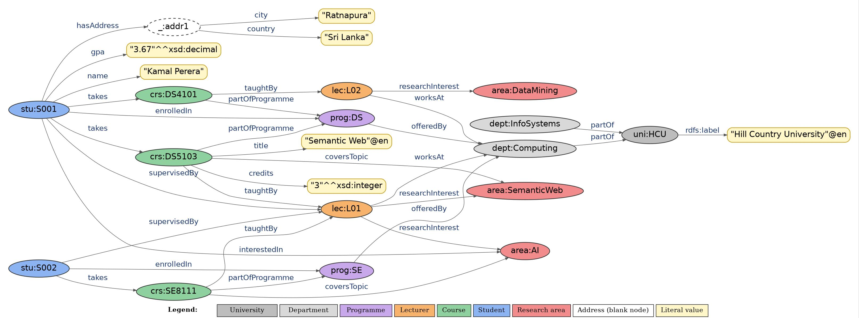
Figure 1: University knowledge graph (generated from university.ttl with Graphviz, so it always matches the data). Resource nodes are ellipses coloured by class, literals are rounded boxes, and the dashed ellipse is the blank node.

Part D — RDF Serialization
The same statement, that student S001 has a GPA of 3.67, looks like this in each format:
Turtle
stu:S001 ex:gpa "3.67"^^xsd:decimal .

RDF/XML
<rdf:Description rdf:about="https://example.org/student/S001">
<ex:gpa rdf:datatype="http://www.w3.org/2001/XMLSchema#decimal">3.67</ex:gpa>
</rdf:Description>

N-Triples
<https://example.org/student/S001> <https://example.org/vocab/gpa>
"3.67"^^<http://www.w3.org/2001/XMLSchema#decimal> .

The assignment asks for a selected subgraph of at least 10 triples in all three formats. I serialized the whole 118-triple dataset in all three files, which satisfies that minimum and makes the equivalence check stronger. I wrote university.ttl by hand, generated university.rdf and university.nt from it with the rdflib library, and then re-parsed all three files independently:
All three parse without errors, contain 118 triples, and are isomorphic as graphs (rdflib's graph comparison returned true for every pair). Isomorphism is the right test because blank node labels are local: the blank node appears as _:addr1 in N-Triples and rdf:nodeID="addr1" in RDF/XML, and the comparison correctly treats them as the same node. Non-ASCII labels, such as the Sinhala and Tamil ones, are preserved in every format.

Part E — Analytical Questions
Q1. Why is RDF more suitable than a purely hierarchical XML representation for linking academic entities?
A university's information does not form a tree. A lecturer works in a department, teaches several courses, supervises students and researches topics that colleagues also study, while a course belongs to a programme but is taken by many students. XML forces each element to have one parent, so everything else must be copied or linked through ID attributes that the XML language itself does not understand. RDF models the data as a graph instead: every entity is a node with its own IRI, and any number of relationships can point to it without nesting. In my dataset, Dr. Kavinda Silva (lec:L01) is described once but referenced by two courses and two supervised students. Graphs from different systems can also be merged simply by combining their triples, because shared IRIs line up automatically.
Q2. What is the difference between an IRI and a literal?
An IRI is a global name for a thing: a student, a course, a department, or even a property such as ex:takes. Anything that other data might want to refer to needs an IRI, and two statements using the same IRI are automatically about the same thing. A literal is not something to refer to; it is a value, such as "Kamal Perera", "3.67"^^xsd:decimal or "Semantic Web"@en, optionally carrying a datatype or a language tag. This also affects where each can appear: literals can only be the object of a triple, while IRIs can be subjects, predicates or objects. That is why I used crs:DS5103 as an IRI, since many statements point to the course, but kept its code "DS5103" as a plain literal.
Q3. When is a blank node appropriate?
A blank node is appropriate when we need to describe something that has structure but no identity worth sharing outside the document. A student's address is a good example: it groups a city and a country together, but nobody will need to link to that address from another dataset. In my graph, stu:S001 ex:hasAddress _:addr1, and the blank node carries ex:city and ex:country. Blank nodes also suit intermediate structures that exist only to connect other nodes. They are a poor choice for things that must be referenced consistently, such as students, courses or lecturers, because a blank node label is only meaningful inside one file. Once graphs are merged or updated, there is no reliable way to point back to it, so those entities should get stable IRIs.
Q4. Why do RDF serializations use namespaces or prefixes?
Full IRIs are long, and writing https://example.org/vocab/takes in every statement would make a file hard to read and easy to mistype. A prefix is just a short label for the start of an IRI, so ex:takes expands to the full IRI; the meaning does not change, only the readability. Prefixes also keep vocabularies apart: ex:name from my own vocabulary and foaf:name from the FOAF vocabulary are different properties because their namespaces differ, even though the local name is the same. They also make it easy to reuse standard vocabularies such as rdf:, rdfs: and xsd: without retyping their long IRIs. Turtle declares prefixes with @prefix and RDF/XML with xmlns attributes, while N-Triples has no prefixes and writes every IRI in full.
Q5. What are the differences between RDF/XML, Turtle and N-Triples?
All three express exactly the same triples; only the syntax differs. RDF/XML is the original W3C format and encodes triples as XML elements using rdf:about and rdf:resource. It works well with XML tools, but it is verbose and its nesting hides the graph, so beginners often find it hard to read. Turtle is compact and designed for people: it has @prefix declarations, a semicolon to reuse a subject, a comma to repeat a predicate, and the shorthand "a" for rdf:type, which is why I authored the master dataset in Turtle. N-Triples is the simplest: one complete triple per line, full IRIs, no prefixes and no shorthand. That makes it easy for programs to parse, sort and stream, but long and repetitive for humans. Their usual extensions are .rdf, .ttl and .nt.

