Sabaragamuwa University of Sri Lanka



Assignment

Title | Preventing Cascading Failures in Urban Drainage Networks Using Graph Theory
Course Title | Graph Theory
Course Code | DS5106
Student Name | Pooja Anbalagan
Index Number | 22CDS0412

DEPARTMENT OF DATA SCIENCE
FACULTY OF COMPUTING

October 2026

Table of Contents
Table of Contents 1
List of Figures 3
List of Tables 3
Abstract 4
1. Introduction 4
1.1. The drainage problem and why cascades matter 4
1.2. Graph theory as a tool for infrastructure dependencies 5
1.3. Research problem, question, aim and objectives 5
1.4. Scope and distinction from network visualisation 6
1.5. Structure of the report 6
2. Literature Review 6
2.1. Cascading failures and load-capacity models 6
2.2. Graph-theoretic assessment of drainage and water networks 7
2.3. Edge betweenness and flow-based importance 7
2.4. Risk-based maintenance and intervention optimisation 8
2.5. Simulation-based evaluation 8
2.6. Comparative summary 8
2.7. Synthesis 9
3. Research Gap and Proposed Problem 9
3.1. Existing approaches and the remaining limitation 9
3.2. Refined research gap 9
3.3. Proposed problem 9
3.4. Contribution and non-claims 10
4. Methodology 10
4.1. Overview 10
4.2. Graph model 11
4.3. Synthetic network generation 11
4.4. Load generation, rainfall and capacities 11
4.5. Flow redistribution and the cascade algorithm 12
4.6. Structural importance 13
4.7. Intervention strategies 13
4.8. Experimental design 13
4.9. Evaluation metrics 14
4.10. Statistical analysis 15
4.11. Validation 15
5. Findings and Results 15
5.1. Example network and cascade 16
5.2. Overall comparison of strategies 18
5.3. Effect of rainfall intensity and budget 19
5.4. Choosing λ on the tuning set 21
5.5. Paired comparison of graph-based and risk-based maintenance 21
5.6. Consistency across trials 23
5.7. Stress tests 24
5.8. Which graph property identifies critical pipes? 24
5.9. Summary of findings 26
6. Discussion 26
6.1. Why the strategies behaved as they did 26
6.2. Graph structure and cascading failures 26
6.3. Is centrality a useful proxy for hydraulic importance? 27
6.4. Rainfall, budget and initial failures 27
6.5. Practical significance 27
6.6. Limitations and threats to validity 27
6.7. Simulated resilience versus real flood prevention 28
7. Conclusion and Future Work 28
7.1. Answer to the research question 28
7.2. Contribution and limitations 28
7.3. Future work 28
References 29

List of Figures
Figure 1. Experimental design flow: 12
Figure 2. Synthetic drainage network 101 18
Figure 3. Pipes selected by Strategy B 19
Figure 4. Failure propagation in network 101 at θ = 1.6 with no intervention 19
Figure 5. Mean failure rate and unmet demand by strategy and rainfall at a 10% budget. 20
Figure 6.Failure rate (top) and unmet demand (bottom) against rainfall multiplier for three budgets; bands are 95% CIs. 22
Figure 7. Effect of the reinforcement budget on failure rate and unmet demand. 22
Figure 8. Tuning-set sweep of λ at a 10% budget; the dashed line marks the chosen λ*. 23
Figure 9. Percentage reduction of B relative to A. 25
Figure 10. Trial-by-trial comparison of B with A 25
Figure 11. Reduction in failure rate of B relative to A 26
Figure 12. Correlation between candidate scores (left) and share of the true top-10% critical pipes captured by each strategy (right). 27
Figure 13. Summary of findings 28

List of Tables
Table 1. Comparison of the reviewed studies and their relevance to this project. 9
Table 2. Model parameters and distributions. All values are illustrative assumptions, not calibrated to a real network. 13
Table 3. The five strategies compared. 15
Table 4. Evaluation metrics. 16
Table 5. Mean results at a 10% budget (5 networks × 100 test trials) 21
Table 6. Paired comparison of B and A on failure rate R_{f}. 24
Table 7. Paired comparison of B and A on unmet demand U 24
Table 8. Stress tests of Strategy B against A (θ ≥ 1.0, 10% budget, pooled). 26
Table 9. Mean Spearman rank correlation between candidate scores across the five networks. 27

Abstract
Urban drainage networks can fail progressively: when a blocked or overloaded pipe can no longer carry its flow, the water is pushed onto other routes and may overload them in turn. This project asks whether a graph-based maintenance rule that combines each pipe's individual failure risk with its structural importance can reduce such cascades more effectively than ranking pipes by risk alone, when the number of pipes that can be reinforced is limited. Drainage is modelled as a directed, weighted, gravity-oriented graph with demand nodes and outlets. Cascades are simulated with a flow-aware routing rule in which overloaded pipes fail and flow is redistributed in proportion to the capacity of the surviving downstream pipes. This is a simplified steady-state approximation, not a validated hydraulic simulator. Five strategies (risk-based, graph-based with directed edge betweenness, random, load-based and no intervention) were compared on five synthetic networks of 86 to 88 pipes, with 100 test trials per network, four rainfall multipliers (0.7 to 1.6) and three reinforcement budgets (5%, 10% and 20% of pipes), using common random failure scenarios, paired tests, Holm correction and bootstrap confidence intervals.
The graph-based strategy did not significantly reduce the proportion of failed pipes relative to risk-based maintenance in any of the 12 rainfall-budget cells (changes of -0.5% to +2.9%). It did significantly reduce unmet demand, the share of demand that cannot reach an outlet, in 11 of 12 cells (2.1% to 18.6%), with the largest gain at moderate rainfall and a 10% budget. The advantage shrank as rainfall increased. Betweenness correlated moderately with single-pipe impact (ρ = 0.42), whereas risk and load did not. The unmet-demand result is partly built into the model and should not be read as evidence of real-world flood prevention. The findings are limited to synthetic networks and illustrative parameters.
Keywords: cascading failure, urban drainage, graph theory, edge betweenness, risk-based maintenance, simulation.

Introduction

The drainage problem and why cascades matter
Urban drainage systems collect rainfall runoff at inlets and convey it through pipes and junctions to discharge outlets. Their performance depends on every component carrying its share of flow. Rajabi et al. note that conduit blockage, commonly caused by sediment transported during runoff, can lead to flooding even in low-intensity rainfall and can disrupt urban traffic and infrastructure [1]. When network capacity is inadequate during intense rainfall, runoff can also flood from manholes and affect other infrastructure such as roads [2].
A single failure is not always the end of the story. A blocked or overloaded pipe cannot deliver its flow, so water is pushed onto other routes or accumulates upstream. Where those routes lack spare capacity they become overloaded and fail, and the process repeats. This chain reaction, known as a cascading failure, can reduce the effective capacity of the whole system far beyond the first fault. Preventing failure propagation is therefore more valuable than reacting to it, because each additional failed pipe removes capacity exactly when rainfall demand is highest.

Graph theory as a tool for infrastructure dependencies
Graph theory represents a drainage system as a directed, weighted graph G=(V,E,W). Vertices are junctions, inlets and outlets, directed edges are pipes that carry water downhill, and edge weights store attributes such as capacity and flow. This representation makes dependencies explicit: which pipes lie on the routes between inlets and outlets, which have alternatives, and which carry the largest share of upstream demand. Graph measures such as edge betweenness centrality can therefore rank pipes by their structural role, and hydraulically informed variants have been proposed for water networks [3]. Cascade models from network science add a dynamic rule: loads are redistributed after a failure and elements fail when load exceeds capacity [4].

Research problem, question, aim and objectives
Conventional maintenance often ranks components by individual failure probability or condition-based risk, as in risk-based sewer prioritisation [5]. However, a pipe's importance to the wider network also depends on its position and its role in transporting water to outlets. When only a few pipes can be strengthened, selecting them by risk alone may protect pipes that are likely to fail but matter little to the network, while overlooking pipes that are less likely to fail but whose loss would isolate large areas.
Main research question. Can a graph-based intervention strategy that combines component failure risk with network structural importance reduce cascading failures in urban drainage networks more effectively than a strategy based only on individual component failure risk?
Supporting questions. (RQ1) Does the proposed strategy reduce the proportion of failed pipes? (RQ2) Does it preserve more usable drainage capacity and deliver more water to outlets? (RQ3) How does its effectiveness change with rainfall intensity and maintenance budget? (RQ4) Which graph-theoretical properties are most useful for identifying critical pipes? (RQ5) Under what conditions does the proposed strategy fail to outperform the baselines?
Aim. To develop and test a budgeted, graph-based pipe-reinforcement strategy in a controlled cascading-failure simulation, and to determine honestly whether it outperforms risk-only maintenance.
Objectives.
- Formulate a directed, weighted graph model of a gravity-driven drainage network with a flow-aware cascade rule.
- Implement five strategies (risk-based, graph-based, random, load-based and no intervention) under an identical budget and identical reinforcement effect.
- Evaluate them under varied rainfall, budget, initial failures and random selections using several metrics.
- Quantify differences with paired statistics and identify where the proposed strategy fails.

Scope and distinction from network visualisation
The scope is deliberately limited: pipes are the only components that fail; junction and pump failures, storage, hydraulic head loss and time-varying rainfall are excluded; the networks are synthetic. The project is not a visualisation exercise. The graph is used as a model on which a decision rule is defined, simulated and statistically compared against baselines, following the sequence existing research, research gap, proposed problem, graph-theoretical model, algorithm, simulation, comparison and findings.

Structure of the report
Section 2 reviews the literature, Section 3 develops the research gap and the proposed problem, Section 4 describes the model, algorithms and experiments, Section 5 presents results, Section 6 discusses them and their limits, and Section 7 concludes. Code listings and validation details are in the appendices.

Literature Review
Only sources whose bibliographic details were checked against publisher or repository pages are cited. Where a paper concerns pressurised water distribution rather than gravity drainage, it is used for method only.

Cascading failures and load-capacity models
Motter and Lai introduced a load-capacity model in which each node carries a load, has a capacity proportional to its initial load, and fails when overloaded; load is then redistributed to the surviving nodes [4]. They showed that disabling a single key node can trigger a large-scale cascade in networks with heterogeneous loads. Crucitti, Latora and Marchiori modelled cascades through the dynamic redistribution of flow and found that the breakdown of a single high-load node can collapse system efficiency [6]. Motter later studied control of cascades and showed that a costless defence strategy, removing selected nodes and edges right after the initial failure, can drastically reduce the cascade [7]. Buldyrev et al. showed that failures can cascade between interdependent networks and that broader degree distributions make them more vulnerable to random failure [8].
These works establish the overload-and-redistribute mechanism used here. Their limitations for this project are that they treat generic networks without drainage physics, define load through shortest-path counts, and, in the case of [7], act after the initial failure by removing elements, whereas drainage maintenance acts beforehand by reinforcing pipes. Reinforcement under a budget is therefore a different intervention from the defence studied in [7].

Graph-theoretic assessment of drainage and water networks
Several recent studies apply graph theory to urban drainage. Rajabi et al. convert a drainage network into a topology-based graph model, compute flood volume and runoff for single-pipe failures, and find high consistency with the Storm Water Management Model (SWMM) in one real case study [1]. In a companion study they calculate flood volume with modified graph metrics and report strong consistency with SWMM dynamic-wave results for an alpine city area [2]. Hajibabaei et al. represent failure consequences from hydrodynamic modelling as a directed, weighted "impact network" that identifies the most influential and most affected nodes for junction failures [9]. For pressurised water distribution networks, Ulusoy et al. proposed Water Flow Edge Betweenness Centrality, a hydraulically informed surrogate for pipe criticality [3]; Hajibabaei et al. proposed a hydraulically inspired complex network approach that needs no hydraulic simulation, identifies critical and impacted pipes through flow redistribution after a failure, and resizes the impacted pipes [10]; and Satish et al. ranked multiple-pipe failure combinations with a graph-based method, reporting a Spearman correlation above 0.75 with hydraulic-based ranking and a computational gain factor above 30 [11].
Taken together, these studies support using graph measures as fast surrogates for hydraulic importance. Their common pattern is diagnosis, that is, identifying critical pipes or quantifying consequences and validating the ranking against a hydraulic model, with single-pipe failure as the dominant scenario. Only [10] closes the loop by resizing pipes, and it does so for water distribution and for single failures, without comparing a risk-only budgeted rule.

Edge betweenness and flow-based importance
Girvan and Newman used betweenness-based centrality to find boundaries in networks [12], and Brandes gave an algorithm that computes betweenness in O(n+m) space and O(nm) time on unweighted networks [13], which makes it practical for sparse infrastructure graphs. Plain betweenness assumes that flow is spread over all shortest paths between all vertex pairs, which is a poor description of drainage, where water originates at demand nodes and flows only toward outlets. Ulusoy et al. addressed this for water supply by weighting betweenness by customer demand [3]. This project follows the same idea by using directed subset edge betweenness with demand nodes as sources and outlets as targets.

Risk-based maintenance and intervention optimisation
Berardi et al. formulated sewer inspection prioritisation as a risk-based, multi-objective optimisation that trades the cost of a survey programme against the expected cost of emergency repairs after blockages and collapses, solved with a genetic algorithm and demonstrated on a real UK sewer system [5]. The approach is risk-based and budget-aware, which matches the baseline used here, but, as described in its abstract, its objectives are cost terms for individual conduits and do not use network connectivity. It also concerns inspection rather than reinforcement.

Simulation-based evaluation
Most graph-based drainage studies validate against one hydraulic model on one or a few real networks [1], [2], [10], [11]. This strengthens realism but gives limited information on how a decision rule performs across many random failure scenarios. Monte Carlo simulation with common random numbers, paired non-parametric tests and bootstrap intervals provides that information at low cost, at the price of a simplified physical model. This project adopts the second approach and states its simplifications explicitly.

Comparative summary
Table 1. Comparison of the reviewed studies and their relevance to this project.
Ref. | Graph model and method | Main finding | Limitation | Relevance here
[4] | Generic networks; load-capacity cascade with load = betweenness | One key node can trigger a large cascade | No drainage physics; no budgeted prevention | Overload rule L_{e}>C_{e}
[6] | Generic networks; dynamic flow redistribution | One high-load failure can collapse efficiency | Generic; no maintenance | Flow-aware redistribution
[7] | Cascade control by removing elements | Costless defence reduces cascade size | Acts after failure; no reinforcement | Contrast with prevention
[3] | Water supply; flow- and demand-weighted edge betweenness | Hydraulically informed pipe criticality | Pressurised network; single-pipe focus | Motivates demand-to-outlet betweenness
[10] | Water supply; hydraulically inspired graph approach | Identifies critical and impacted pipes; resizing without simulation | Single failure; supply network | Closest intervention analogue
[11] | Water supply; graph ranking of multi-pipe failures | Spearman > 0.75 vs hydraulic ranking; > 30x faster | Supply network; ranking only | Supports surrogate use
[1] | Drainage; topology-based graph, single-pipe failure | Consistent with SWMM in one case | One real case; no intervention | Drainage graph proxy
[9] | Drainage; directed impact network from hydrodynamic runs | Finds influential and affected nodes | Needs hydrodynamic modelling; junctions | Directed failure-consequence graph
[5] | Sewers; risk-based multi-objective inspection | Pareto-optimal inspection programmes | No network structure; inspection only | Risk-based baseline logic

Synthesis
Three points follow from the review. First, graph measures are credible surrogates for hydraulic importance in water networks, but this has been checked mainly for single-pipe failures. Second, cascade theory supplies the overload-and-redistribute mechanism but not a maintenance decision problem. Third, risk-based maintenance supplies the decision framing but, in the work reviewed, does not use the network structure. The assumptions that carry over to this project are the overload condition, flow-aware redistribution, demand-to-outlet betweenness and budget-constrained selection. The evaluation approach differs: repeated paired simulations rather than a single hydraulic comparison.

Research Gap and Proposed Problem

Existing approaches and the remaining limitation
What existing approaches do. Graph-theoretic studies identify critical pipes and quantify single-failure consequences [1], [2], [3], [9]; one resizes pipes after such an analysis [10]; cascade models describe how overloads propagate [4], [6]; and risk-based studies prioritise components by failure risk and cost [5].
Limitation that remains relevant. Among the sources reviewed for this project, none compared, under an equal budget and identical failure scenarios, a risk-only reinforcement rule with a rule that combines risk and structural importance in a cascading-failure setting. This statement describes the evidence collected here. It does not prove that no such study exists, and a wider search could change it.

Refined research gap
The project investigates whether a combined risk-and-network-importance intervention strategy can outperform risk-only maintenance under controlled cascading-failure simulations that use equivalent intervention budgets, rainfall conditions and initial failure scenarios. The combination is treated as a hypothesis to be tested, not as a result.

Proposed problem
Given a drainage graph G, estimated pipe risks r_{e} and a budget of K pipes, choose a set R⊆ E with |R|=K to be reinforced before failures occur so that the expected damage E[Φ(R)] is as small as possible, where Φ is the final failure rate R_{f} or the unmet demand U after the cascade. Because exact optimisation would require evaluating a very large number of subsets, the project studies priority-score heuristics, namely rank by r_{e}, by a blend of r_{e} and structural importance b_{e}, by load, or at random.

Contribution and non-claims
The contribution is a transparent, reproducible budgeted-reinforcement experiment: a flow-aware cascade model on gravity-oriented graphs, five strategies compared under common random scenarios, several metrics, pre-specified paired statistics with a held-out test set, and stress tests of the proposed rule. The project does not claim to solve drainage design, to provide a validated hydraulic model, to represent any real city, or to show that centrality is a general substitute for hydraulic analysis.

Methodology

Overview
Figure 1 summarises the workflow. Synthetic networks are generated and calibrated using the no-intervention strategy only. For each trial one set of random failure draws is created and shared by all strategies. Each strategy selects pipes under the same budget, the cascade engine produces a final state, and metrics and paired statistics are computed. All code is in Python with NetworkX [14], NumPy, pandas, SciPy and Matplotlib.
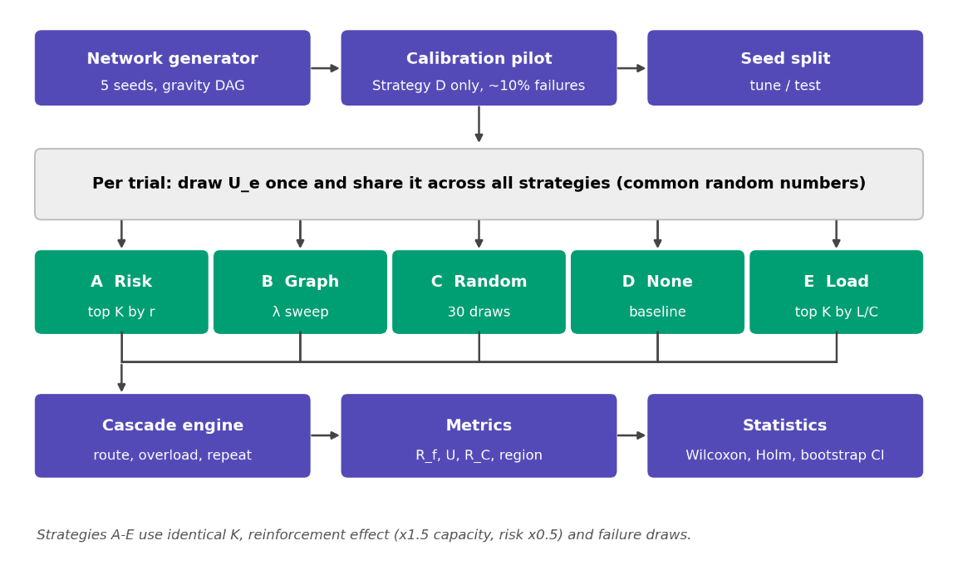
Figure 1. Experimental design flow: setup, common random draws, five strategies, cascade engine, metrics and statistics.

Graph model
The network is the directed weighted graph G=(V,E,W) with V=V_{D}∪ V_{J}∪ V_{O} (demand nodes, plain junctions and outlets). Each node has an elevation z_{v}, and a pipe e=(u,v) exists only if z_{u}>z_{v}, so water flows downhill and G is a directed acyclic graph. Alternative routes exist because a node may have several downhill pipes. Outlets have no outgoing pipes. Pipes carry the attributes in Table 2. Only pipes can fail.
Table 2. Model parameters and distributions. All values are illustrative assumptions, not calibrated to a real network.
Symbol | Meaning | Value or distribution | Units
d_{v} | Base demand at demand node v | 2.0 × LogNormal(0, 0.5²); about 60% of non-outlet nodes, plus all source nodes | L/s
θ | Rainfall multiplier (demand scaling) | 0.7, 1.0, 1.3, 1.6 (illustrative) | –
g_{e} | Nominal conveyance (routing weight) | LogNormal(0, 0.4²) | –
L_{e}⁰ | Load at θ=1, no failures | From routing with weights g_{e} | L/s
C_{e} | Pipe capacity | max{(1+sα_{e})L_{e}⁰, 0.5}, α_{e}~ U(0.5,1.5), s calibrated | L/s
r_{e} | Individual failure (blockage) risk | Beta(2, 30), mean 0.0625, independent of position | –
k, δ | Reinforcement: capacity multiplier, risk reduction | k=1.5, δ=0.5 (illustrative, identical for all strategies) | –
β, K | Budget fraction; number of reinforced pipes | β∈{5,10,20}\%, K=⌈ β|E|⌉ (5, 9, 18 pipes for 87 pipes) | –
λ | Weight on risk in the priority score | 0, 0.25, 0.5, 0.75; λ=1 equals Strategy A | –

Synthetic network generation
Each network is built on a 7 × 8 grid of 56 nodes. Elevation is z=10×(rows below the top) plus Gaussian noise (standard deviation 3), three outlets are chosen at random on the bottom row and lowered by 15, and local pits are filled so that every node has a downhill neighbour. Grid links are oriented downhill, about 10% are removed at random while every node keeps at least one outgoing pipe, and source nodes receive demand. The five networks (seeds 101 to 105) have 86 to 88 pipes. The generator checks that the graph is acyclic and that every node can reach an outlet. These networks are plausible in structure (a mesh core, branches and several outlets) but are not validated representations of any real city.

Load generation, rainfall and capacities
Rainfall acts through demand scaling: the demand at each node is θd_{v}. Loads follow from the routing rule in Section 4.5. Capacity is set from the design load L_{e}⁰ computed at θ=1 with all pipes intact, with a random margin, so that the intact network is just feasible at θ=1. The margin scale s is calibrated for each network, using Strategy D only, so that the mean failure rate with no intervention at θ=1 is close to 10%; this avoids tuning the network in favour of any strategy. The calibrated values of s were 2.78, 1.77, 2.78, 2.05 and 1.52 for networks 101 to 105, and the realised no-intervention failure rate was within 0.007 of the target in each (Appendix B).
Initial failures are blockages. Pipe e is initially failed if a random draw U_{e}~ U(0,1) falls below
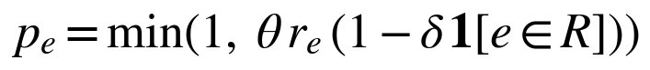
where R is the set of reinforced pipes. Rainfall therefore raises the blockage probability, an assumption made for illustration.

Flow redistribution and the cascade algorithm
When pipes fail, water is rerouted by a consistent, direction-aware rule. Let F be the failed set. A node can reach an outlet if a path of surviving pipes leads to one. A node that can reach an outlet sends its entire inflow q_{v} (its own demand plus water received from upstream) only along surviving pipes whose downstream end can still reach an outlet. The split is proportional to the routing weights of those pipes, so that more capable pipes take more water. A node that can no longer reach any outlet cannot discharge, and its own demand is counted as unmet. The failed pipe's load is therefore not shared equally among neighbours; it is redirected only along downstream paths that exist and in proportion to pipe size.
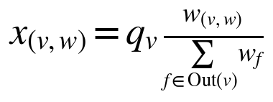
Capacity is deliberately not enforced during routing, otherwise no overload could ever occur. A pipe is overloaded when
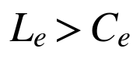
The routing weight of a reinforced pipe is multiplied by k, because larger pipes attract more flow. This can push extra water onto reinforced pipes and away from neighbours, so reinforcement is not guaranteed to help in every trial.
Algorithm 1 (cascade).
Input: graph G, capacities C, weights w, rainfall theta, initial failed set F0
F <- F0
repeat
route demand over surviving pipes (reachability, then proportional split)
N <- { e not in F : load(e) > C(e) } # newly overloaded pipes
F <- F union N # failures within a round are simultaneous
until N is empty
output: F, final loads, unmet demand
Because F only grows, the loop stops after at most |E| rounds, and each round costs O(|V|+|E|). This is an explicit approximation: it is a steady-state routing model with proportional splitting, not a physically validated hydraulic simulator, and it ignores storage, head loss, surcharge and timing.

Structural importance
The proposed score uses directed subset edge betweenness b_{e}: the fraction of shortest paths from demand nodes to outlets that pass through pipe e (path length = pipe length), computed with NetworkX [14] using Brandes' algorithm [13]. It suits the directed, many-to-few structure of drainage better than all-pairs betweenness. Three comparison measures are also computed: the upstream catchment demand of the pipe, the baseline utilisation L_{e}⁰/C_{e} (Strategy E), and an oracle equal to the unmet demand when that pipe alone fails. The oracle is a benchmark for how well each score finds truly critical pipes under this model, not a deployable rule.

Intervention strategies
Table 3. The five strategies compared. All use the same budget K and the same reinforcement effect.
ID | Strategy | Selection rule (top K pipes) | Purpose
A | Risk-based | Highest individual risk r_{e} | Conventional baseline to beat
B | Graph-based (proposed) | Highest S_{e}=λr̂_{e}+(1-λ)b̂_{e} | Tests the combined hypothesis
C | Random | K pipes at random; 30 draws averaged per trial | Checks results against chance
D | No intervention | None | Reference damage
E | Load-based | Highest utilisation L_{e}⁰/C_{e} | Tests whether betweenness adds more than load

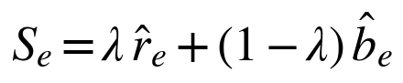 (4)
Hats denote min-max normalised values. Reinforcement is preventive: it changes capacity and initial failure probability before any failure occurs; repair after failure is not modelled. The value of λ is treated as a hypothesis to test, not a guaranteed improvement.

Experimental design
Every experiment uses the same five networks (seeds 101 to 105), rainfall multipliers θ∈{0.7,1.0,1.3,1.6} and budgets 5%, 10% and 20%. The 12 rainfall-budget combinations are called cells.
- Common random numbers. For each network and trial, one vector of uniform draws U_{e} is generated from a seeded generator and used for every strategy, rainfall level and budget. Strategies are therefore compared on identical failure scenarios, and a reinforced pipe can only avoid failures that the baseline also faced.
- Tune and test sets. Trials 0 to 99 form the tuning set, used only to choose λ*. Trials 1000 to 1099 form the test set used for all headline results. This gives 500 paired trials per cell (5 networks × 100 trials).
- Choosing λ*. λ* is the value with the lowest mean R_{f} pooled over all 12 cells of the tuning set.
- Stress tests. (i) Noisy risk estimates: strategies see r_{e} e^{σZ} with Z standard normal and σ∈{0.5,1.0}, while true risk drives failures. (ii) Risk correlated with structure: true risk is a blend, with weight ρ∈{0.5,1.0}, of independent values and the same values reassigned in order of b_{e}. (iii) Alternative importance measures: catchment and oracle replace b_{e}.
- Reproducibility. Seeds are derived from (base seed 2026, network seed, trial); results were verified to be identical on repeated runs. Library versions: NumPy 2.4.4, pandas 3.0.2, NetworkX 3.6.1, SciPy 1.17.1, Matplotlib 3.10.8.

Evaluation metrics
Table 4. Evaluation metrics.
Metric | Definition | Better | Relates to
Failure rate R_{f} | Share of pipes failed at the end | Lower | RQ1
Retained capacity R_{C} | Original capacity of surviving pipes over total; installed capacity does not guarantee delivery to an outlet | Higher | RQ2
Unmet demand U | Share of demand at nodes with no surviving path to an outlet | Lower | RQ2
Secondary failures | Failures beyond the initial set | Lower | Cascade size
Largest affected region | Size of the largest connected group of cut-off nodes | Lower | Spread of impact
Delivered flow | 1-U | Higher | RQ2

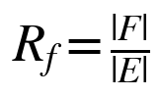
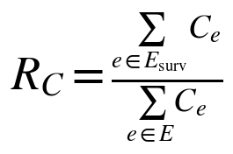
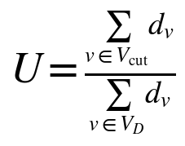
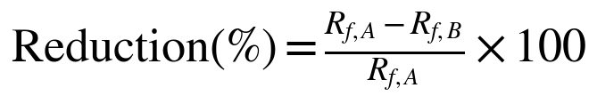
Reductions are computed on cell means, and are reported as not defined when the baseline mean is zero (the absolute paired difference is reported instead). R_{C} uses original, pre-reinforcement capacities so that reinforcement alone cannot raise it.

Statistical analysis
For each cell and metric, the per-trial difference between Strategy A and Strategy B is analysed as a paired sample. Significance uses the two-sided Wilcoxon signed-rank test [15], with Holm correction [16] across the 12 cells. Uncertainty uses a percentile bootstrap with 2,000 resamples [17] for the mean paired difference, and error bars on means are 95% normal-approximation intervals. Tests were specified before the test-set run. Figures use a colour-blind-safe palette [18] and also encode meaning through markers and hatching.

Validation
Eight automated checks were run before any experiment (Appendix B): acyclicity and reachability, flow conservation (maximum error 2.8×10⁻¹⁴), no overload at θ=1 with intact pipes, cascade termination with a monotone failed set, equivalence of λ=1 with Strategy A, identical results under identical seeds, calibration accuracy, and a sanity check that no intervention is not better than the strategies at high rainfall. One calibration bug, a search grid that was too narrow, was found by these checks and corrected before the experiments.

Findings and Results
All results below are from the test set (5 networks × 100 trials per cell). Results for the synthetic networks must not be read as predictions for real systems.

Example network and cascade
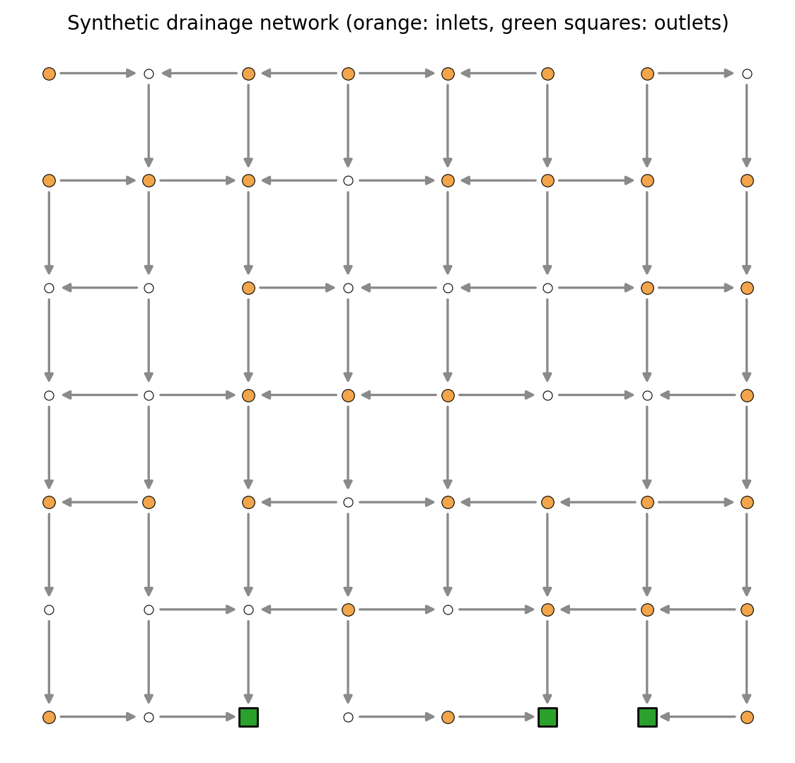
Figure 2. Synthetic drainage network 101 (56 nodes, 87 pipes, 3 outlets, 34 demand nodes). Arrows show downhill flow direction.
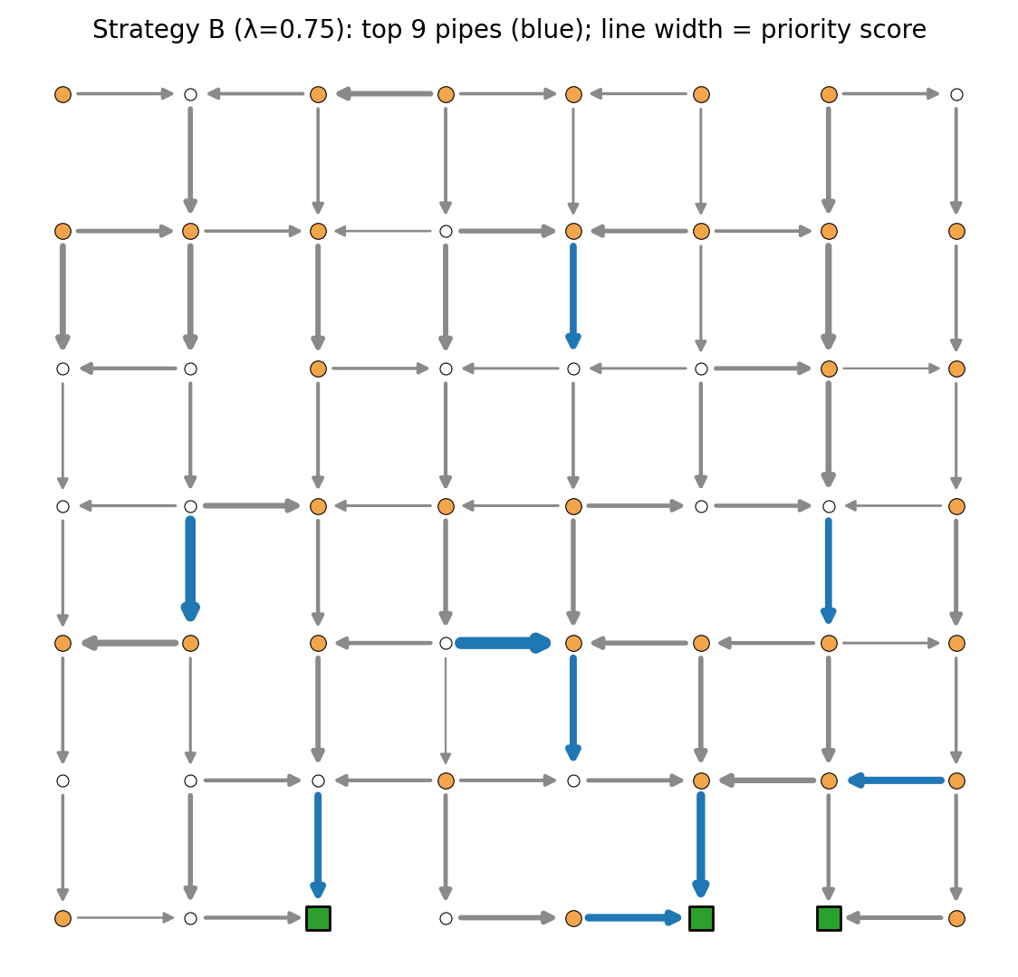
Figure 3. Pipes selected by Strategy B (λ = 0.75, 10% budget) for network 101, in blue; line width shows priority score.
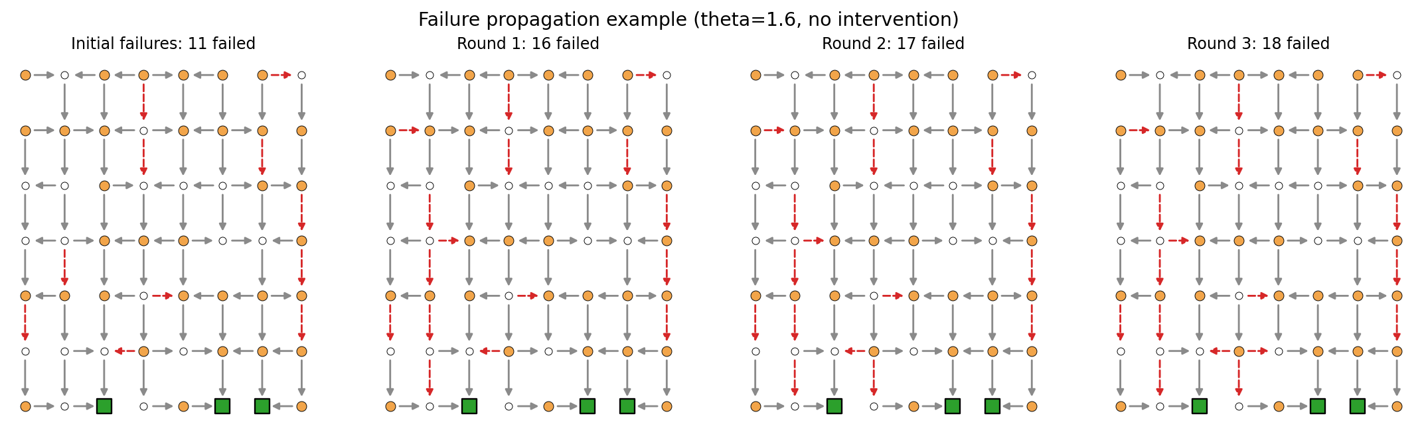
Figure 4. Failure propagation in network 101 at θ = 1.6 with no intervention: initial failures and the first three rounds of overload.
Figures 2 and 3 show the illustration network and the pipes that the proposed rule selects. In the cascade example (Figure 4), 11 initial blockages grow to 18 failed pipes over three further rounds, with failures spreading along downstream routes. This illustrates the propagation that the strategies try to limit.

Overall comparison of strategies
Averaged over all 12 cells, mean R_{f} was 0.151 with no intervention (D), 0.138 for random (C), 0.134 for load-based (E), 0.128 for risk-based (A) and 0.128 for graph-based (B). Mean U was 0.292 (D), 0.267 (C), 0.254 (E), 0.247 (A) and 0.232 (B). All targeted strategies beat random selection and no intervention, and A and B are very close on R_{f} but separated on U (Figure 5 and Table 5).
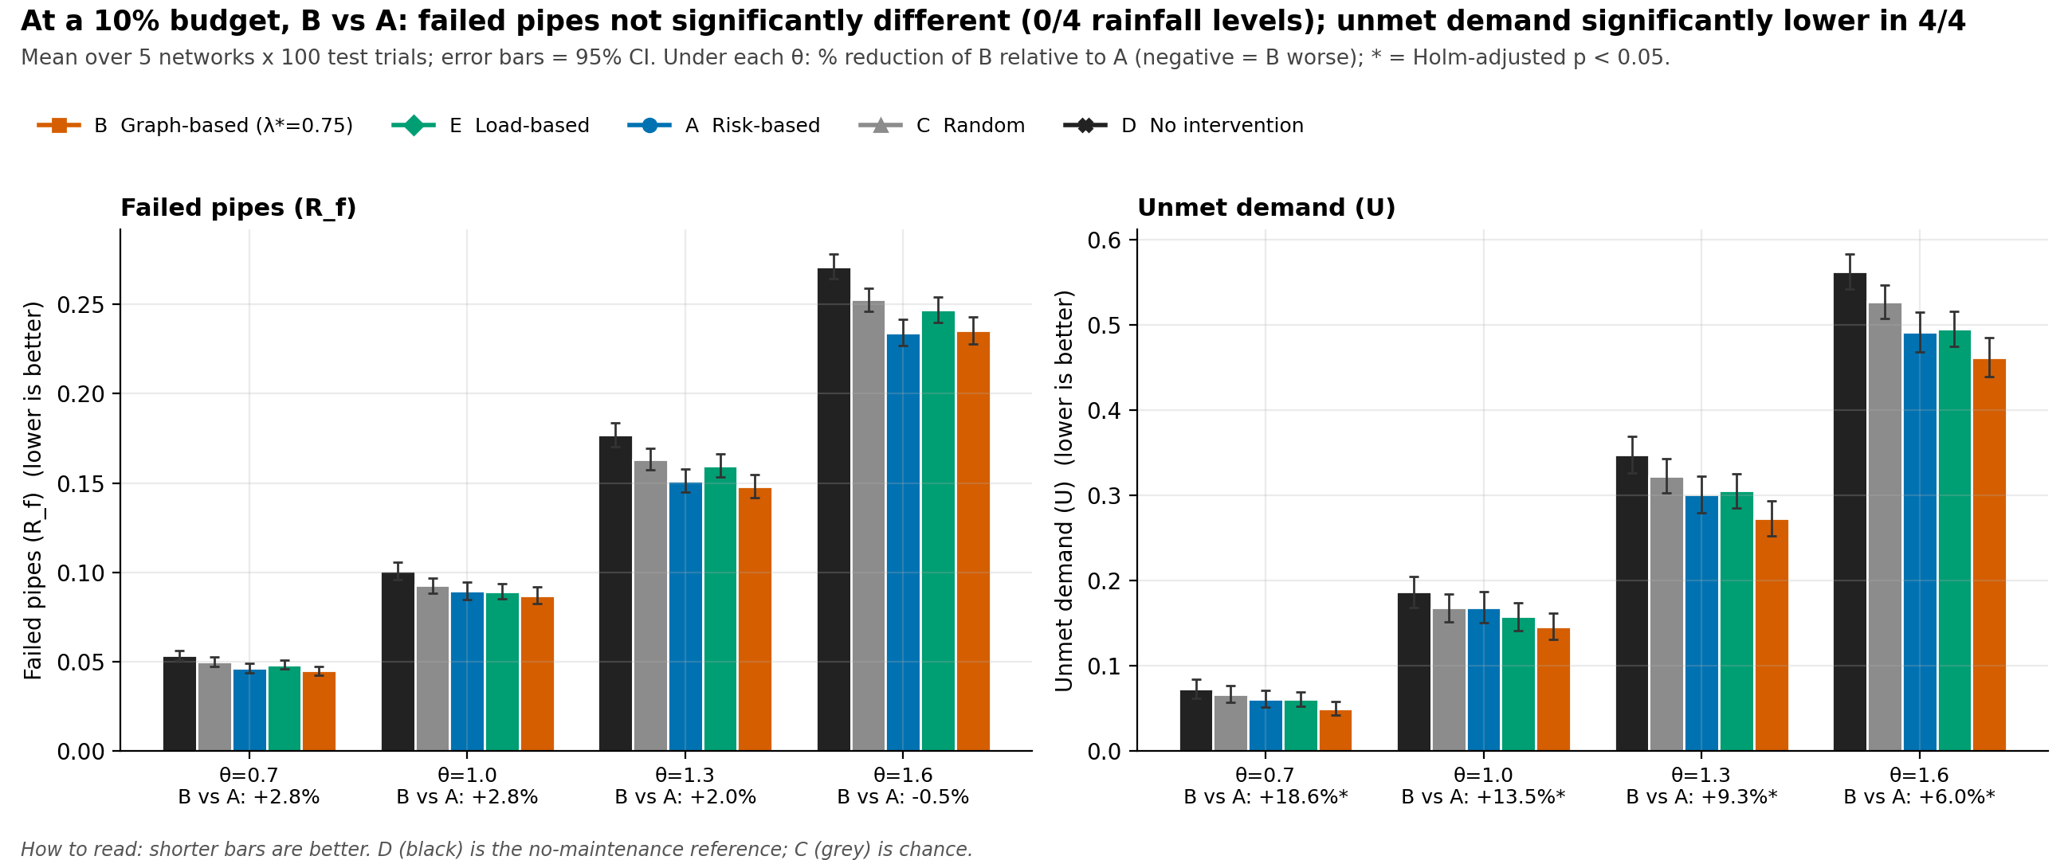
Figure 5. Mean failure rate and unmet demand by strategy and rainfall at a 10% budget (95% CI). The label under each rainfall level gives the change of B relative to A; * marks Holm-adjusted p < 0.05.
Table 5. Mean results at a 10% budget (5 networks × 100 test trials). SD is across trials.
θ | Strategy | R_{f} mean (SD) | U mean (SD) | R_{C} | Secondary failures | Largest region
0.7 | D No intervention | 0.054 (0.032) | 0.073 (0.126) | 0.958 | 0.8 | 3.8
 | C Random | 0.050 (0.029) | 0.067 (0.114) | 0.960 | 0.7 | 3.5
 | A Risk-based | 0.046 (0.030) | 0.061 (0.113) | 0.962 | 0.7 | 3.3
 | E Load-based | 0.048 (0.029) | 0.061 (0.101) | 0.960 | 0.6 | 3.1
 | B Graph-based (λ*=0.75) | 0.045 (0.028) | 0.050 (0.091) | 0.966 | 0.6 | 2.8
1.0 | D No intervention | 0.101 (0.056) | 0.187 (0.208) | 0.928 | 3.2 | 9.4
 | C Random | 0.093 (0.049) | 0.168 (0.185) | 0.933 | 2.8 | 8.5
 | A Risk-based | 0.090 (0.055) | 0.169 (0.207) | 0.936 | 3.0 | 8.6
 | E Load-based | 0.089 (0.050) | 0.158 (0.185) | 0.934 | 2.6 | 8.0
 | B Graph-based (λ*=0.75) | 0.087 (0.052) | 0.146 (0.176) | 0.942 | 2.8 | 7.6
1.3 | D No intervention | 0.177 (0.077) | 0.347 (0.247) | 0.883 | 8.3 | 17.6
 | C Random | 0.163 (0.069) | 0.323 (0.228) | 0.891 | 7.5 | 16.3
 | A Risk-based | 0.151 (0.074) | 0.301 (0.248) | 0.899 | 6.9 | 15.1
 | E Load-based | 0.160 (0.074) | 0.305 (0.229) | 0.893 | 7.2 | 15.2
 | B Graph-based (λ*=0.75) | 0.148 (0.074) | 0.273 (0.234) | 0.907 | 6.7 | 13.8
1.6 | D No intervention | 0.271 (0.079) | 0.562 (0.236) | 0.812 | 14.8 | 28.7
 | C Random | 0.253 (0.073) | 0.527 (0.223) | 0.826 | 13.6 | 26.9
 | A Risk-based | 0.234 (0.085) | 0.491 (0.266) | 0.838 | 12.7 | 24.9
 | E Load-based | 0.247 (0.080) | 0.495 (0.233) | 0.833 | 13.2 | 25.3
 | B Graph-based (λ*=0.75) | 0.235 (0.088) | 0.462 (0.256) | 0.850 | 12.9 | 23.3

Effect of rainfall intensity and budget
Damage rises steeply with rainfall for every strategy (Figure 6): with no intervention the mean R_{f} at a 10% budget grows from 0.054 at θ=0.7 to 0.271 at θ=1.6. The gaps between strategies are small compared with that rise. Increasing the budget lowers damage for all targeted strategies (Figure 7); at θ=1.6 and a 20% budget the mean R_{f} of both A and B is well below its no-intervention value.
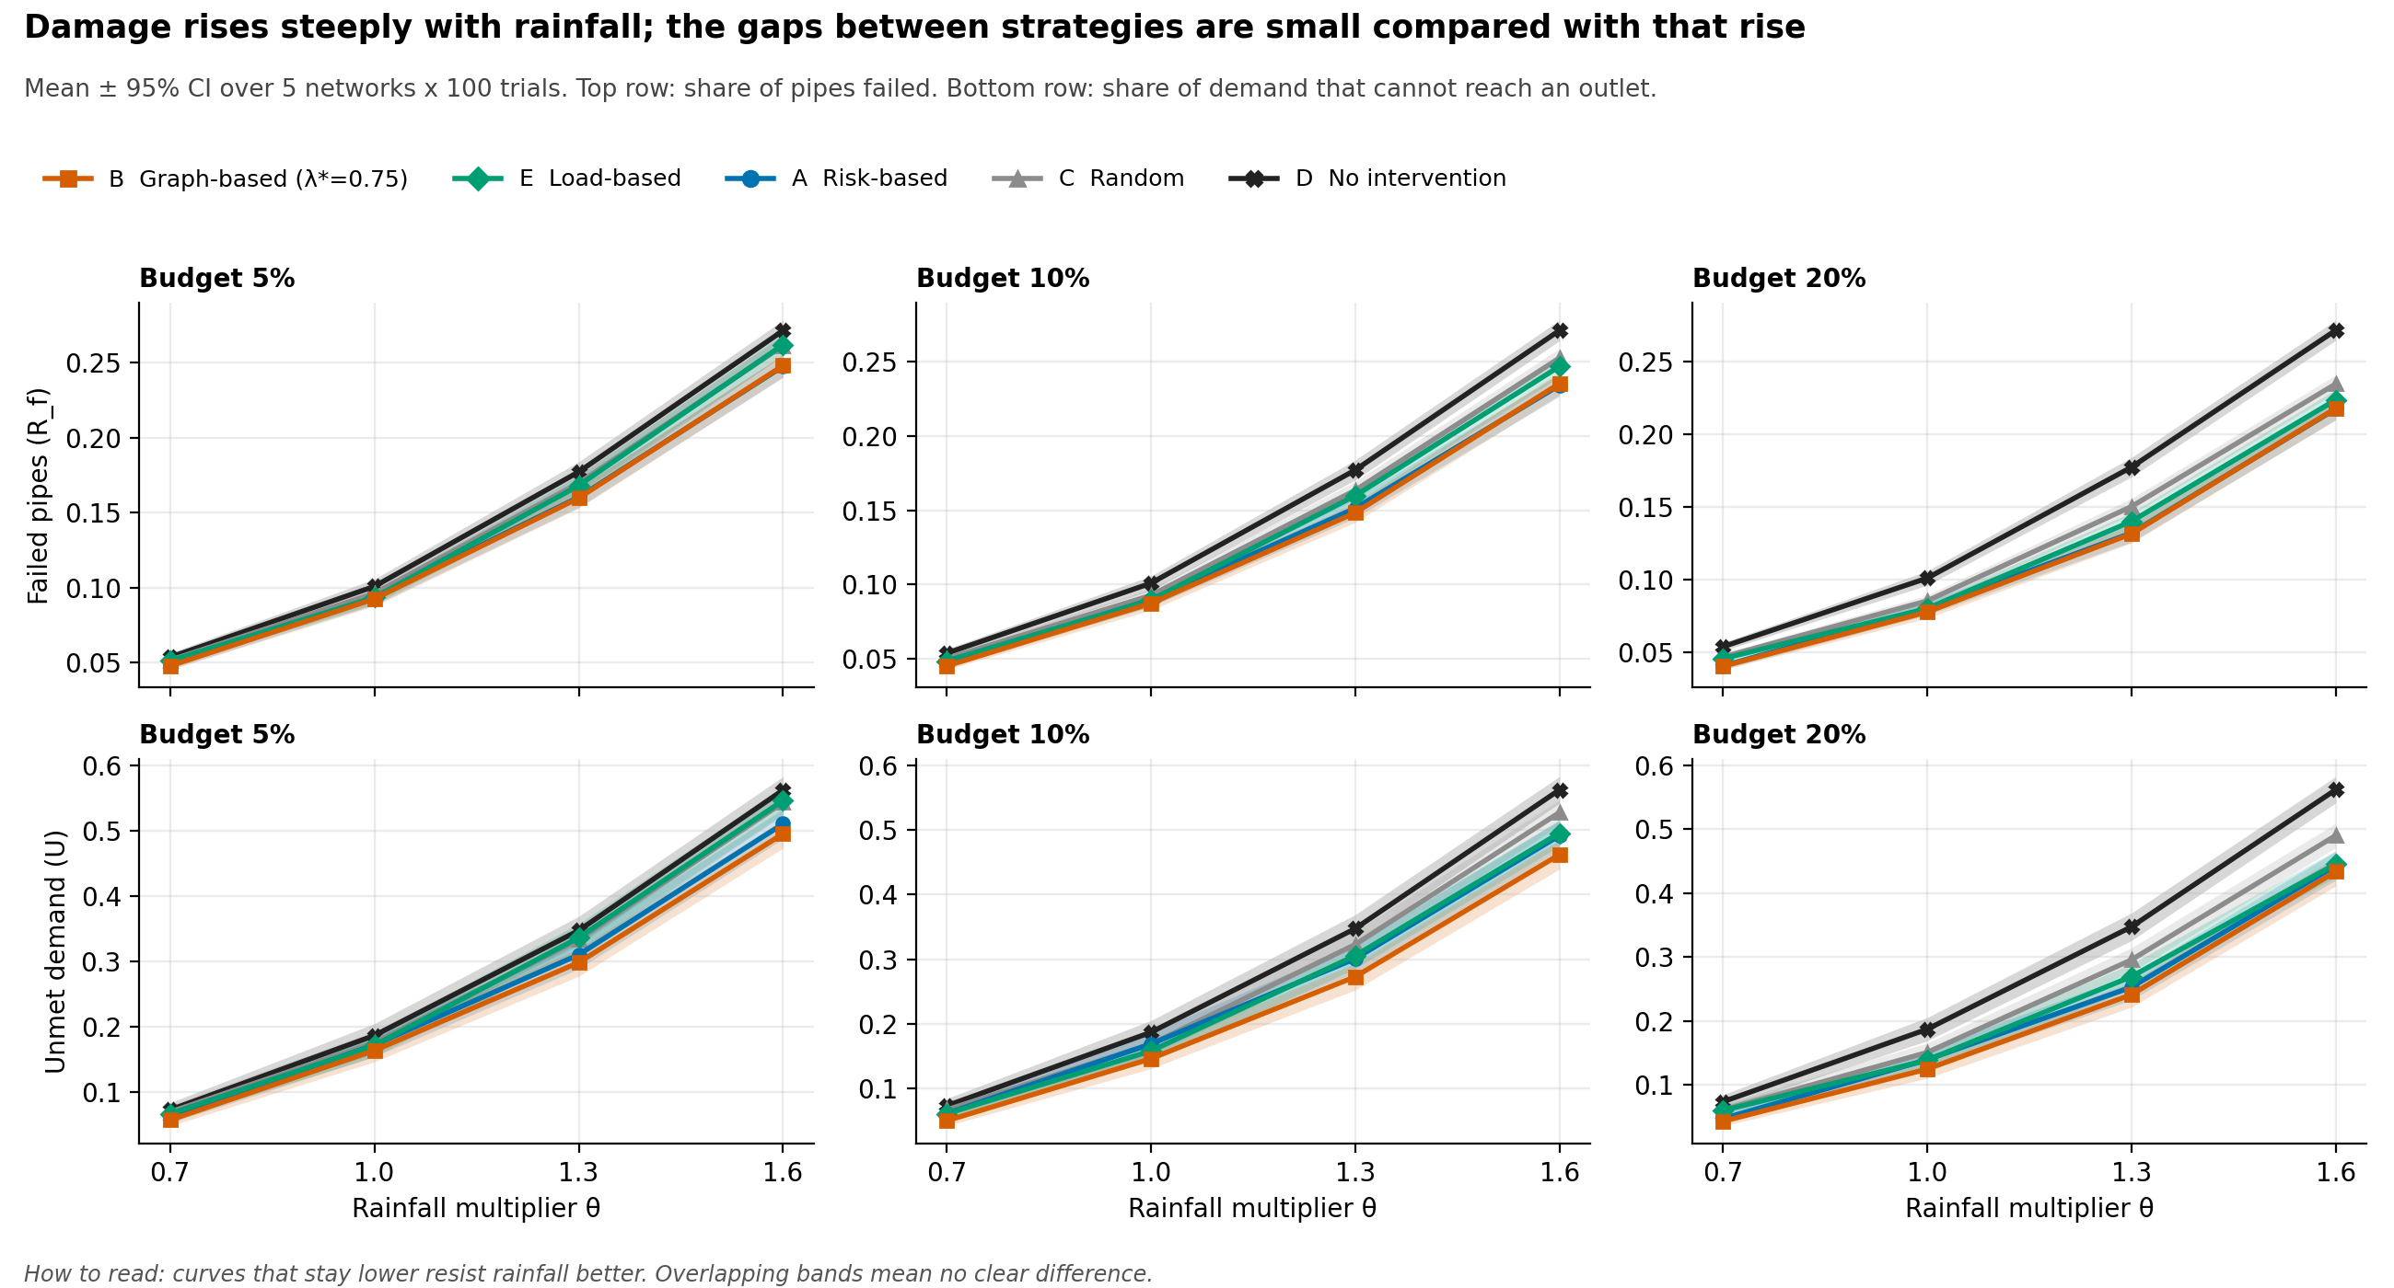
Figure 6. Failure rate (top) and unmet demand (bottom) against rainfall multiplier for three budgets; bands are 95% CIs.
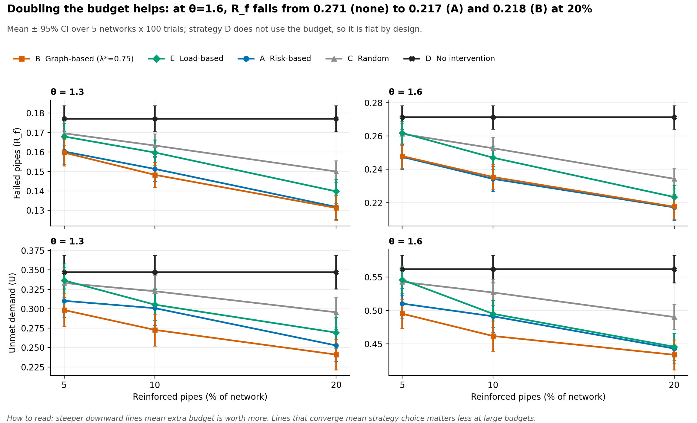
Figure 7. Effect of the reinforcement budget on failure rate and unmet demand at θ = 1.3 and θ = 1.6.

Choosing λ on the tuning set
On the tuning set, pooled mean R_{f} was 0.1336 for λ=0, 0.1308 for λ=0.25, 0.1277 for λ=0.5, 0.1273 for λ=0.75 and 0.1276 for λ=1 (Strategy A). The pre-specified rule therefore selected λ*=0.75, but the curve is almost flat between 0.5 and 1 (Figure 8). Unmet demand showed the opposite tendency: it was lowest at λ=0.25 (0.2169) and highest for Strategy A (0.2441). The parameter λ thus trades pipe survival against delivery. Tuning on U instead would have chosen a lower λ, but this was not evaluated on the test set, to avoid post-hoc selection.
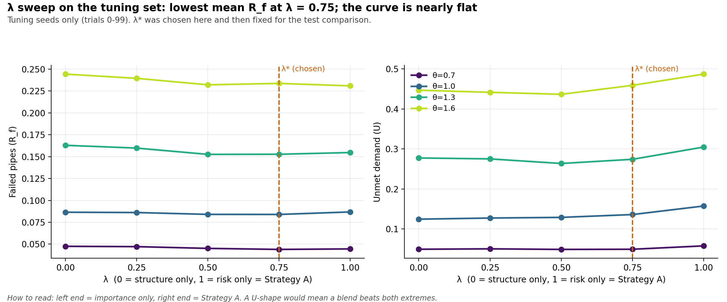
Figure 8. Tuning-set sweep of λ at a 10% budget; the dashed line marks the chosen λ*.

Paired comparison of graph-based and risk-based maintenance
Failure rate (RQ1). B was not significantly different from A in any cell after Holm correction (Table 6 and Figure 9). Mean reductions ranged from -0.5% (θ = 1.6, 10% budget) to +2.9% (θ = 1.0, 20% budget), and were slightly negative at θ = 1.6. In 4 cells the bootstrap interval for the mean difference excluded zero, but the rank-based test did not survive correction. The two disagree because many trial pairs tie, so the small mean gain comes from a minority of trials. The evidence is best described as a possible small gain at moderate rainfall and a 10% budget, not robust to multiplicity correction.
Table 6. Paired comparison of B and A on failure rate R_{f} (lower is better; positive Δ favours B).
θ | Budget | A mean | B mean | Δ = A − B [95% CI] | Reduction | p (Holm)
0.7 | 5% | 0.0483 | 0.0478 | +0.0005 [-0.0003, +0.0015] | +1.0% | 1.000
0.7 | 10% | 0.0463 | 0.0450 | +0.0013 [+0.0003, +0.0024] | +2.8% | 1.000
0.7 | 20% | 0.0403 | 0.0402 | +0.0002 [-0.0004, +0.0008] | +0.4% | 1.000
1.0 | 5% | 0.0933 | 0.0924 | +0.0009 [-0.0003, +0.0023] | +1.0% | 1.000
1.0 | 10% | 0.0897 | 0.0872 | +0.0026 [+0.0009, +0.0043] | +2.8% | 0.737
1.0 | 20% | 0.0799 | 0.0775 | +0.0024 [+0.0009, +0.0039] | +2.9% | 0.156
1.3 | 5% | 0.1603 | 0.1597 | +0.0006 [-0.0008, +0.0022] | +0.4% | 1.000
1.3 | 10% | 0.1513 | 0.1483 | +0.0030 [+0.0004, +0.0059] | +2.0% | 1.000
1.3 | 20% | 0.1318 | 0.1313 | +0.0005 [-0.0015, +0.0026] | +0.4% | 1.000
1.6 | 5% | 0.2474 | 0.2479 | -0.0005 [-0.0025, +0.0018] | -0.2% | 0.660
1.6 | 10% | 0.2343 | 0.2354 | -0.0011 [-0.0050, +0.0029] | -0.5% | 1.000
1.6 | 20% | 0.2172 | 0.2176 | -0.0004 [-0.0029, +0.0024] | -0.2% | 1.000

Unmet demand and capacity (RQ2). B significantly reduced unmet demand in 11 of 12 cells and was never significantly worse (Table 7). Reductions ranged from 2.1% to 18.6%, with the largest gain at θ = 0.7 and a 10% budget; the only cell without a significant gain was θ = 1.6 with a 20% budget (2.1%, p = 0.134). Retained capacity R_{C} was higher for B in all 12 cells, but the differences were small (0.2% to 1.4%) and significant in 8 cells. B had significantly fewer secondary failures in 3 cells (Appendix C).
Table 7. Paired comparison of B and A on unmet demand U (lower is better; positive Δ favours B).
θ | Budget | A mean | B mean | Δ = A − B [95% CI] | Reduction | p (Holm)
0.7 | 5% | 0.0631 | 0.0576 | +0.0055 [+0.0016, +0.0107] | +8.7% | 0.009*
0.7 | 10% | 0.0613 | 0.0499 | +0.0114 [+0.0068, +0.0173] | +18.6% | <0.001*
0.7 | 20% | 0.0466 | 0.0425 | +0.0040 [+0.0016, +0.0069] | +8.7% | <0.001*
1.0 | 5% | 0.1725 | 0.1638 | +0.0086 [+0.0036, +0.0149] | +5.0% | <0.001*
1.0 | 10% | 0.1687 | 0.1460 | +0.0227 [+0.0149, +0.0312] | +13.5% | <0.001*
1.0 | 20% | 0.1391 | 0.1243 | +0.0148 [+0.0082, +0.0218] | +10.6% | <0.001*
1.3 | 5% | 0.3103 | 0.2984 | +0.0119 [+0.0060, +0.0189] | +3.8% | <0.001*
1.3 | 10% | 0.3008 | 0.2728 | +0.0280 [+0.0183, +0.0376] | +9.3% | <0.001*
1.3 | 20% | 0.2527 | 0.2410 | +0.0117 [+0.0046, +0.0196] | +4.6% | 0.009*
1.6 | 5% | 0.5104 | 0.4953 | +0.0152 [+0.0092, +0.0219] | +3.0% | <0.001*
1.6 | 10% | 0.4914 | 0.4619 | +0.0295 [+0.0181, +0.0405] | +6.0% | <0.001*
1.6 | 20% | 0.4431 | 0.4338 | +0.0093 [+0.0026, +0.0169] | +2.1% | 0.134

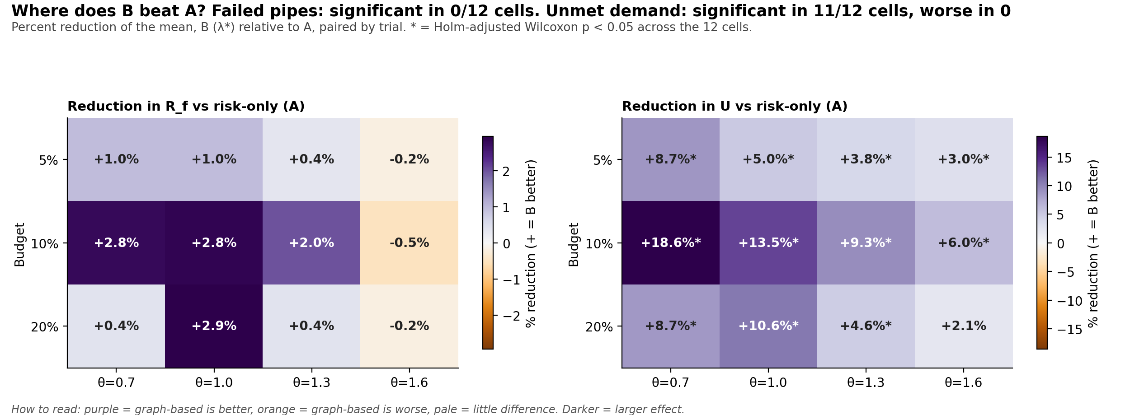
Figure 9. Percentage reduction of B relative to A across rainfall and budget cells; * marks Holm-adjusted p < 0.05.
Comparison with load-based selection. Against Strategy E, B had significantly lower R_{f} in 8 of 12 cells and significantly lower U in 8 of 12 cells, the exceptions being mainly at θ = 1.0 and at the largest budget under heavy rain. Betweenness therefore added information beyond baseline utilisation in most cells.

Consistency across trials
At a 10% budget, B beat A on R_{f} in 9% of trials at θ = 0.7, 13% at θ = 1.0, 17% at θ = 1.3 and 21% at θ = 1.6; the strategies tied in 82%, 75%, 62% and 53%, and B lost in 9%, 12%, 21% and 26% respectively (Figure 10). Ties dominate at low rainfall, where few cascades occur, and wins and losses become more balanced as rainfall rises.
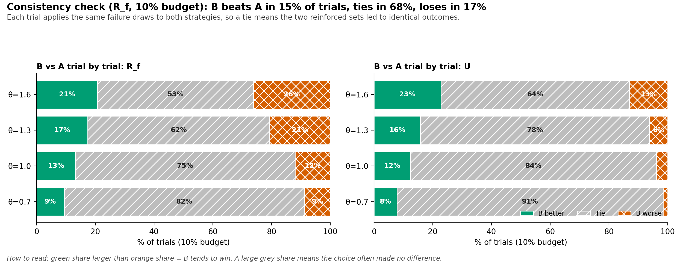
Figure 10. Trial-by-trial comparison of B with A on failure rate and unmet demand (10% budget).

Stress tests
B's advantage over A on R_{f}, pooled over θ ≥ 1.0 at a 10% budget, was +0.9% with accurate risk (interval including zero). It was clearly positive only when risk estimates were noisy (+2.0% and +2.1%) or partly correlated with structure (+2.9%). Replacing betweenness with catchment gave +0.6% and with the oracle −0.4%, neither distinguishable from zero. At ρ = 1.0 risk and structure rank pipes identically, so A and B select the same pipes and coincide by construction (Table 8 and Figure 11).
Table 8. Stress tests of Strategy B against A (θ ≥ 1.0, 10% budget, pooled).
Condition | Reduction in R_{f} (B vs A) | 95% CI
Base: betweenness, accurate risk | +0.9% | [-0.1, +2.0]
Importance = upstream catchment | +0.6% | [-0.3, +1.5]
Importance = oracle (single-pipe impact) | -0.4% | [-1.4, +0.6]
Noisy risk estimates (σ=0.5) | +2.0% | [+1.2, +2.8]
Noisy risk estimates (σ=1.0) | +2.1% | [+1.2, +3.0]
Risk correlated with structure (ρ=0.5) | +2.9% | [+2.0, +4.0]
Risk correlated with structure (ρ=1.0) | +0.0% | identical picks

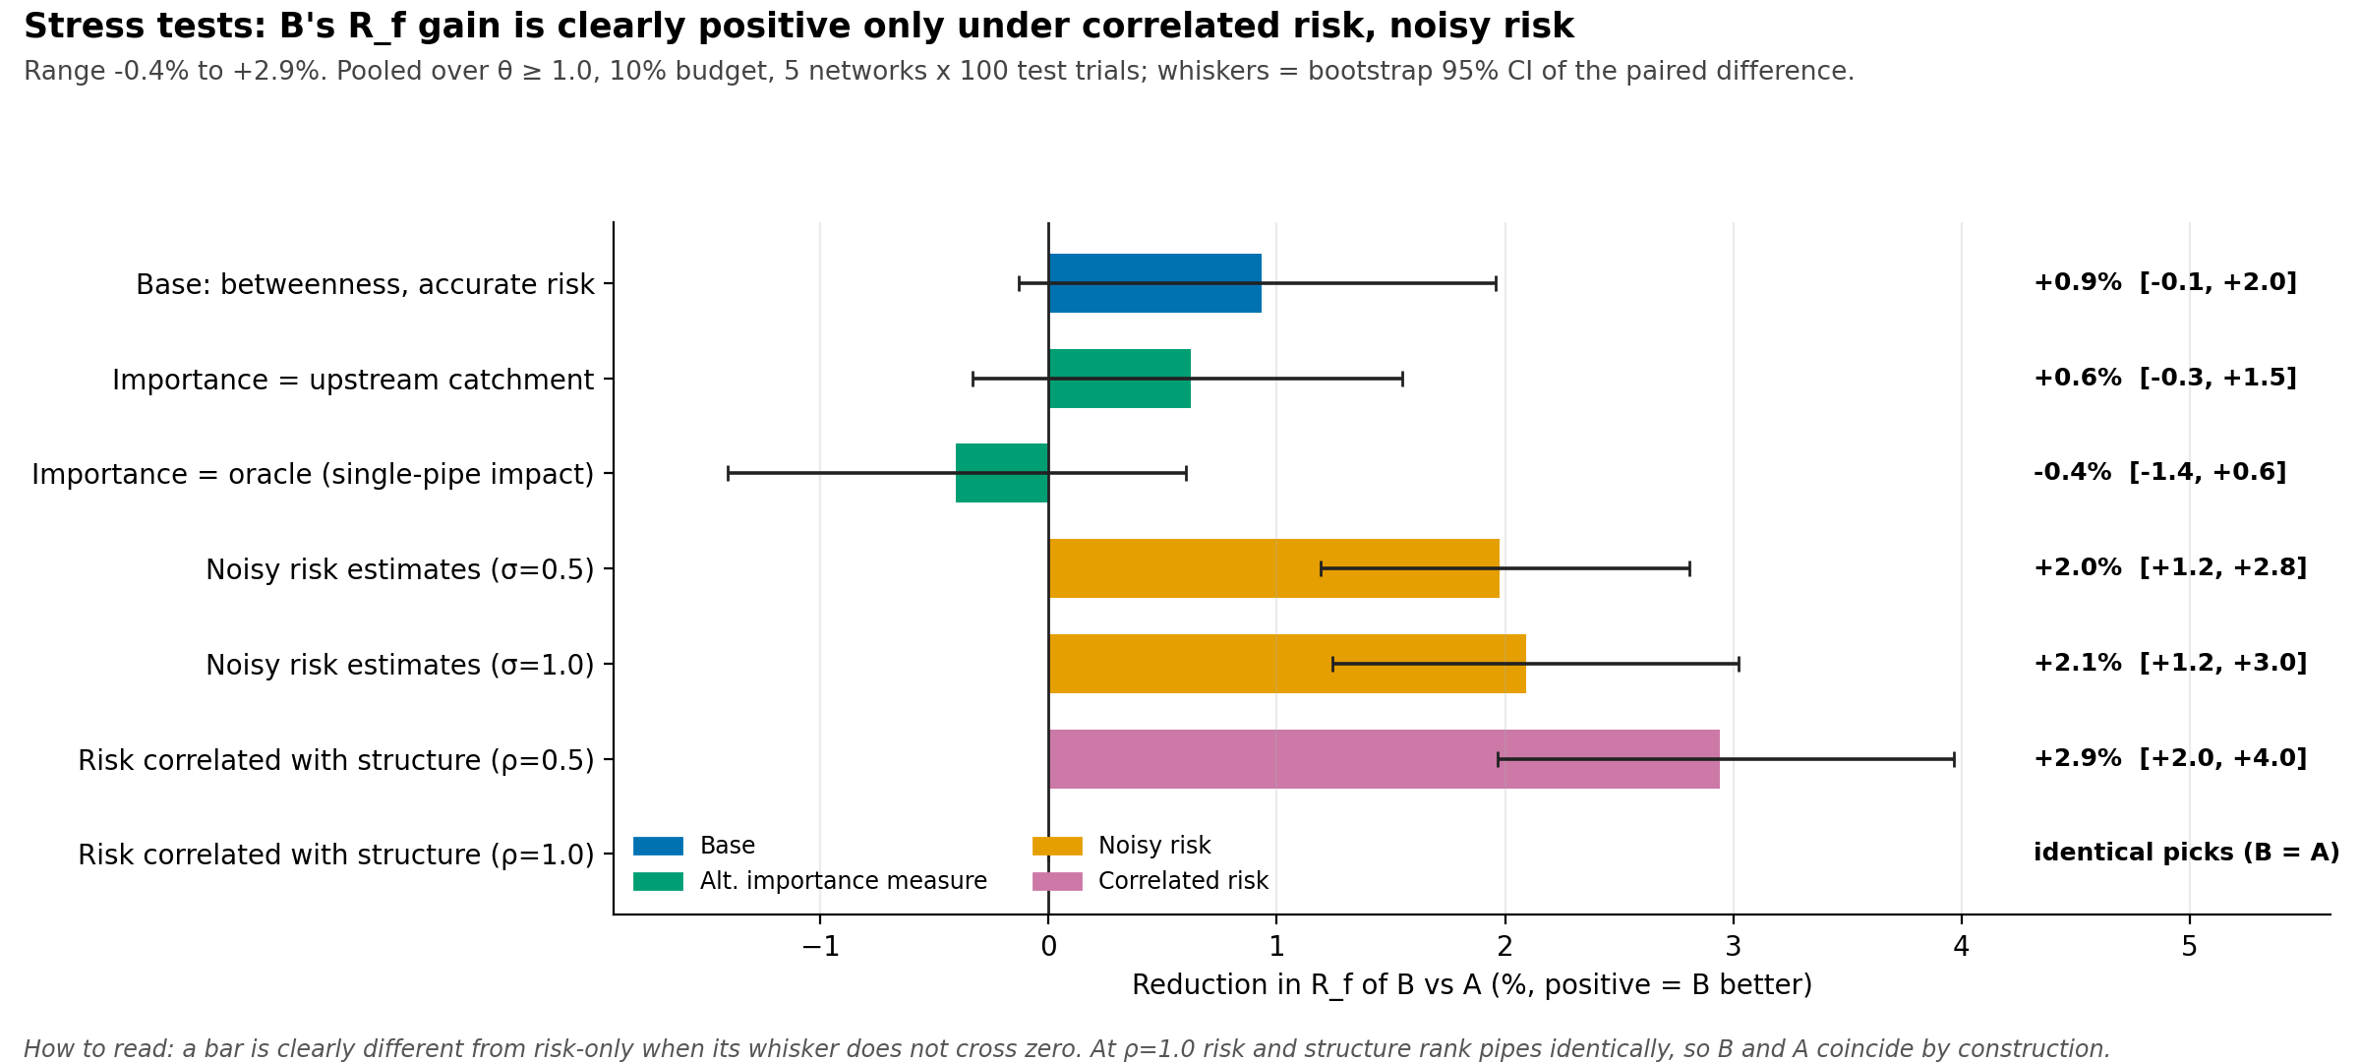
Figure 11. Reduction in failure rate of B relative to A under alternative importance measures, noisy risk and correlated risk.

Which graph property identifies critical pipes?
Across the five networks, betweenness correlated with oracle single-pipe impact at ρ = 0.42 and catchment at 0.26, whereas load (-0.01) and risk (-0.00) were uncorrelated with it (Table 9 and Figure 12). Of the true top-10% critical pipes, the strategies selected about 7% (A), 13% (E) and 20% (B) at a 10% budget, against 10% expected by chance. Betweenness and catchment were themselves moderately correlated (0.41), and neither was related to risk or load.
Table 9. Mean Spearman rank correlation between candidate scores across the five networks.
Spearman ρ | risk r | betweenness b | catchment | load L/C | oracle impact
risk r | 1.00 | 0.04 | -0.03 | 0.07 | -0.00
betweenness b | 0.04 | 1.00 | 0.41 | -0.01 | 0.42
catchment | -0.03 | 0.41 | 1.00 | -0.09 | 0.26
load L/C | 0.07 | -0.01 | -0.09 | 1.00 | -0.01
oracle impact | -0.00 | 0.42 | 0.26 | -0.01 | 1.00

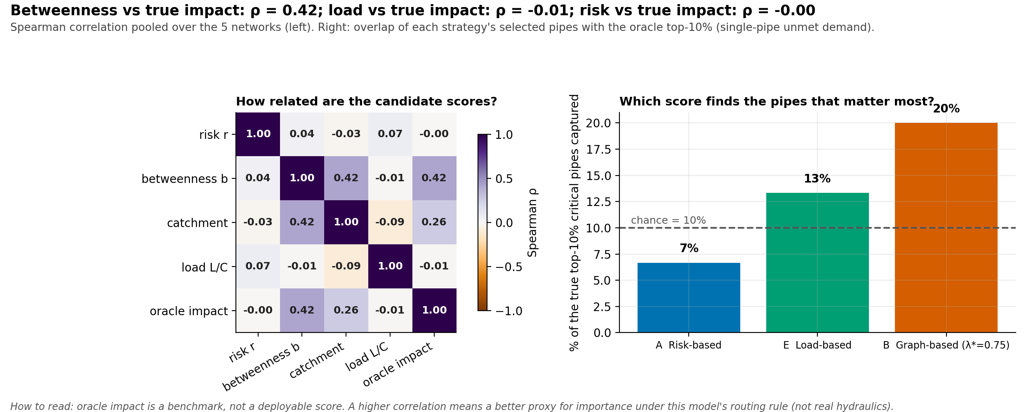
Figure 12. Correlation between candidate scores (left) and share of the true top-10% critical pipes captured by each strategy (right).

Summary of findings
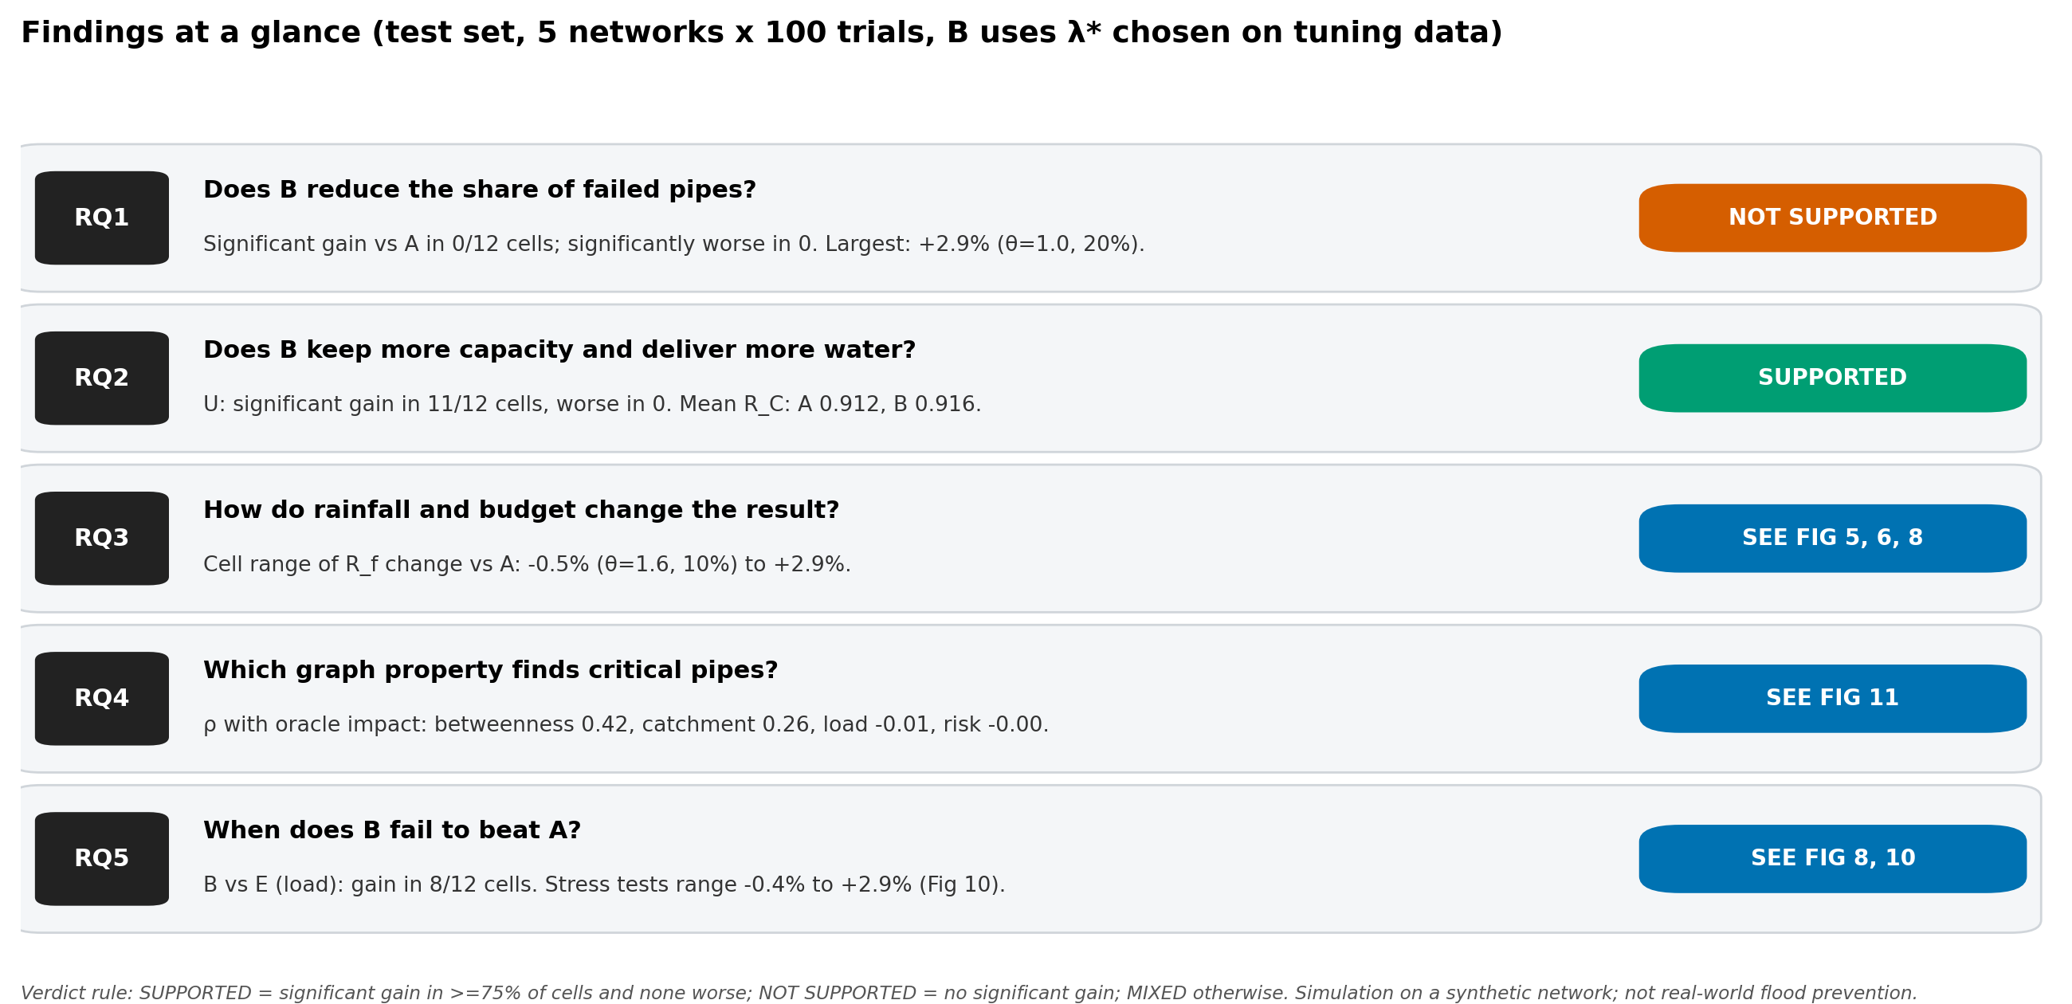
Figure 13. Summary of findings by research question, with verdicts determined by the stated rule.

Discussion

Why the strategies behaved as they did
The main result is mixed. Strategy A directly targets the quantity that drives most failures in this model: random initial blockages. Halving the risk of the K riskiest pipes removes the largest expected number of initial failures, which makes risk-only selection a strong baseline for R_{f}. Strategy B gives up some of that reduction by choosing pipes with high structural importance but lower risk. Those pipes matter more for delivery, because their loss cuts off more demand, which explains why B improved U in almost every cell without significantly changing R_{f}. This explanation is consistent with the results (including the λ trade-off in Section 5.4) but was not isolated by a dedicated experiment.

Graph structure and cascading failures
Because flow in the model moves only downhill through a directed acyclic graph, failures propagate downstream through redistribution and isolate upstream areas, so a pipe's position strongly shapes its consequence. The weak correlation between betweenness and the oracle (ρ = 0.42) shows that position explains part, but not most, of single-pipe impact; local capacity margins and neighbouring failures also matter. Load and risk were essentially unrelated to impact, which is why Strategy E and Strategy A captured few of the truly critical pipes.

Is centrality a useful proxy for hydraulic importance?
Within this model, betweenness is a moderately useful proxy for importance and a better one than load or risk. This does not show that it is a good proxy for real hydraulics. The oracle is computed with the same simplified routing rule, so the comparison is partly circular. Studies that compare graph measures with hydraulic models report encouraging agreement for real networks [1], [2], [11], which supports the idea, but they concern different failure scenarios and models. Whether betweenness tracks hydraulic importance in the cascade setting would need validation against a hydraulic simulator.

Rainfall, budget and initial failures
The advantage of B on unmet demand decreased as rainfall increased, from 18.6% at θ = 0.7 to 6.0% at θ = 1.6 for a 10% budget. Under heavy rain the network is overloaded widely, and a handful of reinforced pipes cannot prevent most overload failures. The 10% budget showed the largest gains. At 5% there are few pipes to place, and at 20% a large share of the important pipes is probably selected by both strategies, although overlap between selected sets was not measured. The stress tests suggest that the structural component is most useful when risk information is poor: with noisy risk estimates, B retained a clear advantage because betweenness is computed from the network and not affected by the noise. This is a plausible, not a proven, practical implication.

Practical significance
At θ = 1.0 and a 10% budget, unmet demand fell from 0.169 to 0.146, about 2.3 percentage points of demand or 13.5% in relative terms. Differences in R_{f} and R_{C} were small (under 3% and 1.4% relative). Whether such gains justify using a structural score would depend on the cost of data and analysis, and the importance of delivery over pipe survival to a utility.

Limitations and threats to validity
- Synthetic networks. Five generated networks of 86 to 88 pipes are small and regular. They do not reproduce the layout, age or heterogeneity of real systems, and results may not transfer.
- Simplified flow redistribution. Steady-state proportional routing ignores storage, head loss, surcharge and timing. It is a modelling approximation, not a hydraulic simulator.
- Assumed parameters. Capacities, risk distribution, rainfall multipliers, reinforcement effect and the rain-to-risk link are illustrative. Findings could change with other values.
- Partial circularity of the unmet-demand result. Betweenness and the unmet-demand metric are both defined by paths to outlets, so a gain in U is partly expected by construction and is weaker evidence than an independent measure.
- Selection of λ*. It was tuned on R_{f}; tuning on U would have given a different value.
- Independent risk. Base risk was generated independently of position. The correlated-risk stress test shows that conclusions are sensitive to this assumption.
- Pipe-only failures and unit costs. Junction and pump failures are excluded, and every pipe costs the same to reinforce.

Simulated resilience versus real flood prevention
A lower simulated unmet-demand share is not the same as fewer floods. Real flooding depends on rainfall timing, surface storage, hydraulic head, blockages that evolve over time and operational response. The results indicate how a decision rule behaves inside a simplified model and should be treated as hypotheses for validation, not as evidence of real-world effectiveness.

Conclusion and Future Work

Answer to the research question
In these simulations, combining individual failure risk with directed edge betweenness did not produce a reliable reduction in the proportion of failed pipes relative to risk-only maintenance (0 of 12 cells significant after correction; mean changes between -0.5% and +2.9%). It did produce a consistent reduction in unmet demand (significant in 11 of 12 cells, 2.1% to 18.6%), a small increase in retained capacity, and a better ability to identify critical pipes than risk or load. The advantage was largest at moderate rainfall with a 10% budget, shrank under heavy rain, and was most robust when risk estimates were noisy or correlated with structure. The answer to the main question is therefore partly: the structural score helps protect water delivery but not pipe survival.

Contribution and limitations
The contribution is a reproducible, budgeted-reinforcement experiment with common random scenarios, a held-out test set, honest reporting of a mixed outcome, and stress tests that show where the proposed rule helps and where it does not. The main limitations are the synthetic networks, the simplified routing, assumed parameters and the partial circularity of the unmet-demand metric.

Future work
- Replace synthetic networks with real drainage data and validate rankings and cascades against a hydraulic simulator such as SWMM.
- Use calibrated rainfall-runoff inputs and time-varying storms instead of demand multipliers.
- Include junction and pump failures, storage and surcharge.
- Optimise selection directly (for example, greedy or integer programming on simulated outcomes) rather than ranking by a score, and test a multi-objective rule that balances R_{f} and U.
- Study uncertainty-aware optimisation and alternative graph measures, such as flow-weighted betweenness variants.

References
[1] M. Rajabi, M. Hajibabaei, A. Dastgir, and R. Sitzenfrei, "A graph-based approach for structural resilience assessment in the urban drainage network," in Proc. 13th Urban Drainage Modelling Conf., Innsbruck, Austria, Sep. 2025, doi: 10.71573/9vfsbz30.
[2] M. Rajabi, M. Hajibabaei, and R. Sitzenfrei, "Flood resilience assessment of urban drainage systems: A graph theory perspective," in Proc. 13th Urban Drainage Modelling Conf., Innsbruck, Austria, Sep. 2025, doi: 10.71573/pme9gf12.
[3] A.-J. Ulusoy, I. Stoianov, and A. Chazerain, "Hydraulically informed graph theoretic measure of link criticality for the resilience analysis of water distribution networks," Appl. Netw. Sci., vol. 3, no. 1, Art. no. 31, 2018, doi: 10.1007/s41109-018-0079-y.
[4] A. E. Motter and Y.-C. Lai, "Cascade-based attacks on complex networks," Phys. Rev. E, vol. 66, no. 6, Art. no. 065102, 2002, doi: 10.1103/PhysRevE.66.065102.
[5] L. Berardi, O. Giustolisi, D. A. Savic, and Z. Kapelan, "An effective multi-objective approach to prioritisation of sewer pipe inspection," Water Sci. Technol., vol. 60, no. 4, pp. 841–850, 2009.
[6] P. Crucitti, V. Latora, and M. Marchiori, "Model for cascading failures in complex networks," Phys. Rev. E, vol. 69, no. 4, Art. no. 045104, 2004, doi: 10.1103/PhysRevE.69.045104.
[7] A. E. Motter, "Cascade control and defense in complex networks," Phys. Rev. Lett., vol. 93, no. 9, Art. no. 098701, 2004, doi: 10.1103/PhysRevLett.93.098701.
[8] S. V. Buldyrev, R. Parshani, G. Paul, H. E. Stanley, and S. Havlin, "Catastrophic cascade of failures in interdependent networks," Nature, vol. 464, no. 7291, pp. 1025–1028, 2010, doi: 10.1038/nature08932.
[9] M. Hajibabaei, M. Rajabi, G. Fu, D. Butler, and R. Sitzenfrei, "Graph-theoretical representation of impact propagation in urban stormwater networks," in Proc. 13th Urban Drainage Modelling Conf., Innsbruck, Austria, Sep. 2025, doi: 10.71573/m613y775.
[10] M. Hajibabaei et al., "Resilience enhancement of water distribution networks under pipe failures: A hydraulically inspired complex network approach," Aqua Water Infrastruct. Ecosyst. Soc., Dec. 2023, doi: 10.2166/aqua.2023.180.
[11] R. Satish, M. Hajibabaei, et al., "A graph-based method for identifying critical pipe failure combinations in water distribution networks," Water Supply, Jul. 2024, doi: 10.2166/ws.2024.146.
[12] M. Girvan and M. E. J. Newman, "Community structure in social and biological networks," Proc. Natl. Acad. Sci. U.S.A., vol. 99, no. 12, pp. 7821–7826, 2002, doi: 10.1073/pnas.122653799.
[13] U. Brandes, "A faster algorithm for betweenness centrality," J. Math. Sociol., vol. 25, no. 2, pp. 163–177, 2001, doi: 10.1080/0022250X.2001.9990249.
[14] A. A. Hagberg, D. A. Schult, and P. J. Swart, "Exploring network structure, dynamics, and function using NetworkX," in Proc. 7th Python in Science Conf. (SciPy), Pasadena, CA, USA, 2008, pp. 11–15.
[15] F. Wilcoxon, "Individual comparisons by ranking methods," Biometrics Bull., vol. 1, no. 6, pp. 80–83, 1945.
[16] S. Holm, "A simple sequentially rejective multiple test procedure," Scand. J. Statist., vol. 6, no. 2, pp. 65–70, 1979.
[17] B. Efron, "Bootstrap methods: Another look at the jackknife," Ann. Statist., vol. 7, no. 1, pp. 1–26, 1979.
[18] B. Wong, "Points of view: Color blindness," Nat. Methods, vol. 8, no. 6, p. 441, 2011.

