# If else Switch case Ternary Assignment

1. Using ternary operator compare 3 numbers and display the smallest number

1. WAP to read a designation code and display his designation as a string. Use the following mapping.
2. – Software Developerw
3. – Senior Software Developer
4. – Team Lead
5. – Senior Team Lead

anyother value – incorrect designation code

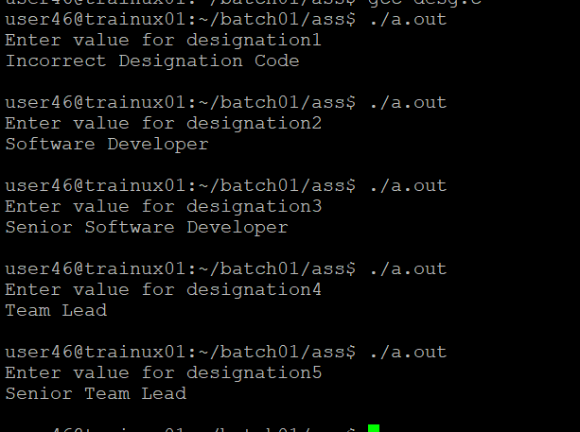

1. WAP to test the eligibility for deployment post training. Need to fulfill all the 4 conditions. Read the score inputs from user at runtime. (Use if else and switch together).
   * 1. Test1 Score >= 75%
     2. Test2 Score >= 75%
     3. Test3 Score >= 70%
     4. Project Score >=75%

