**Pooja Bahuguna**

**8085**

**Introduction to Database**

1. **Create Database**



1. **Design Schema**

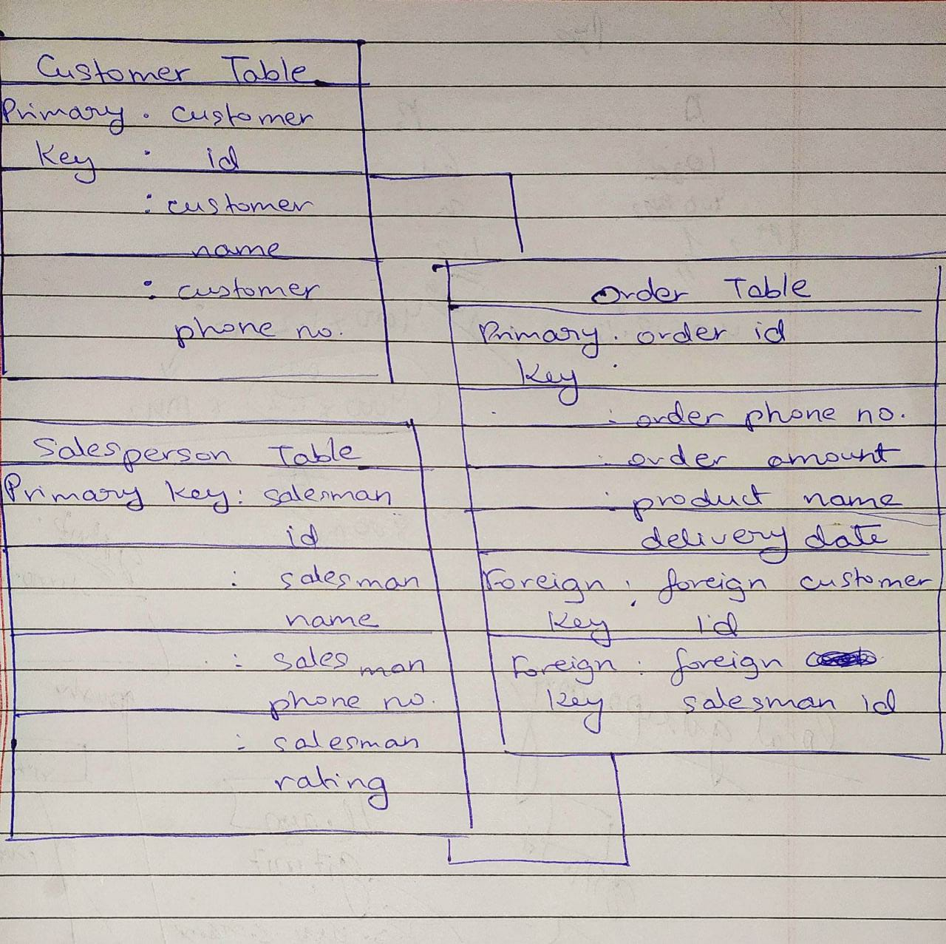

1. **Create tables**

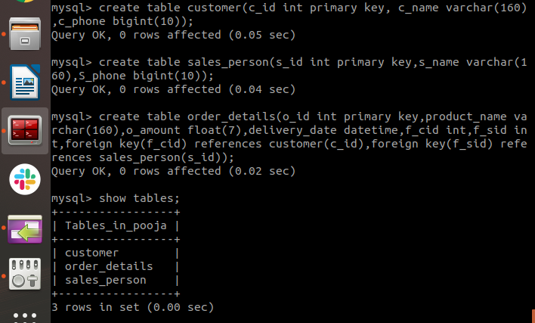

1. **Insert sample data**

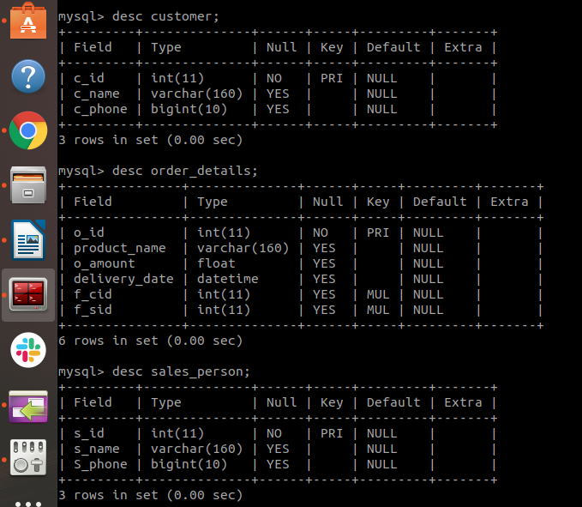

1. **Find the sales person have multiple orders.**

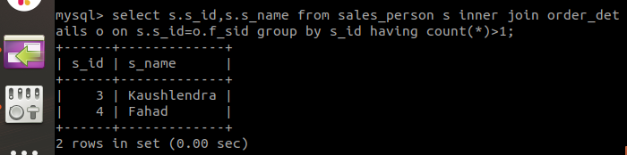

1. **Find the all sales person details along with order details**

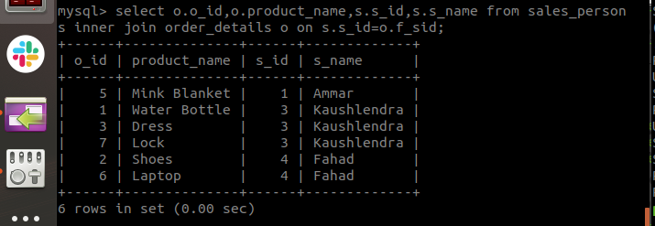

1. **Create index**

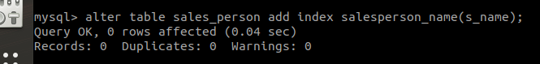

1. **How to show index on a table**

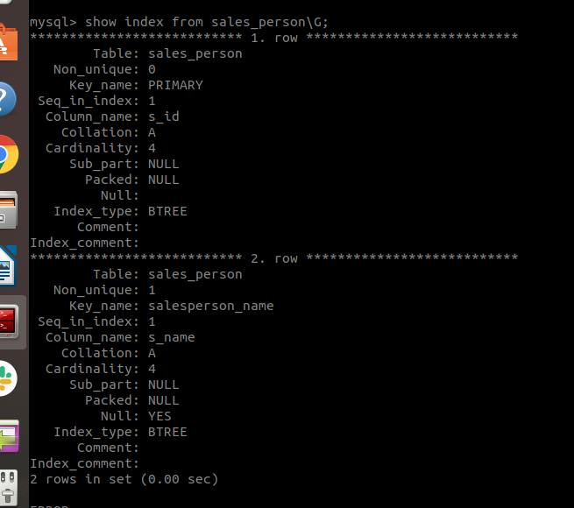

1. **Find the order number, sales person name, along with the customer to whom that order belongs to**

