MONGODB

Install latest version of MongoDB from apt-get repository and Create a database student
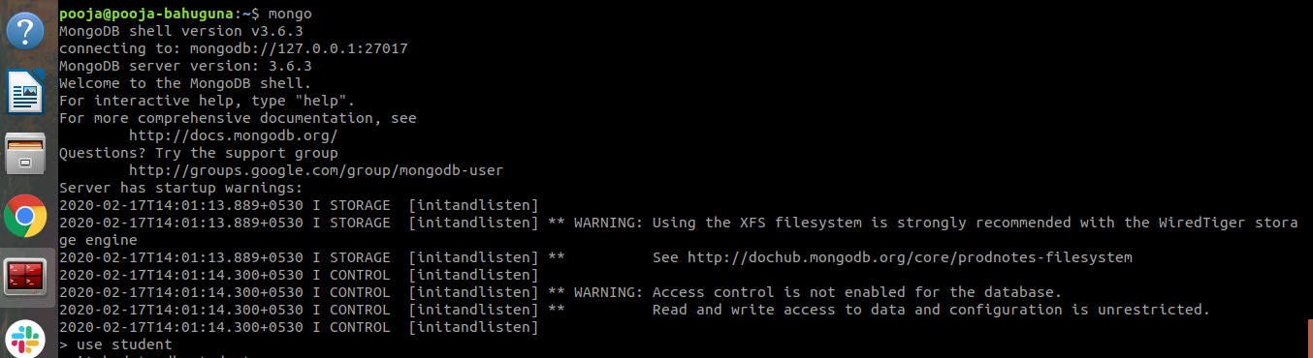

Insert operation : 5 students data (Name, Contact, City, Roll No, Branch)

Read operation : All the students belong to a particular city

Update operation : Update the branch of all the students to CSE
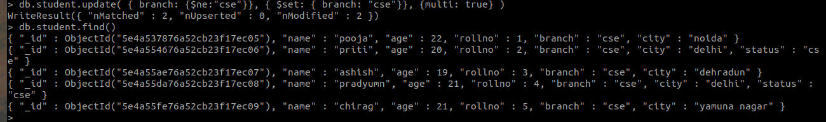
Or we can do
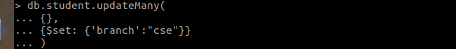

Take dump of the database

Delete operation : Delete the record of last 2 students according to the roll number
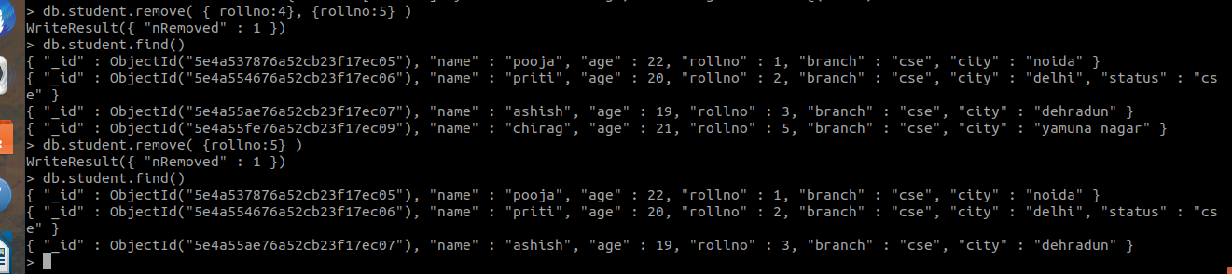

Drop the database
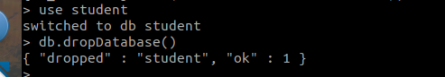

Restore the database again to have the full data
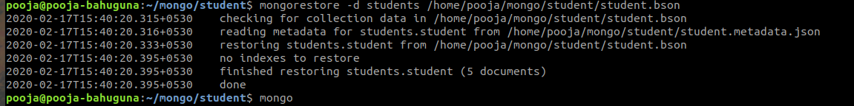
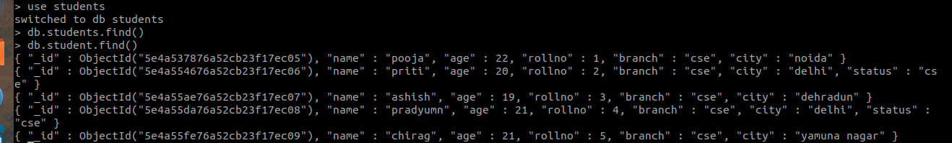
Enable authentication on the Mongo
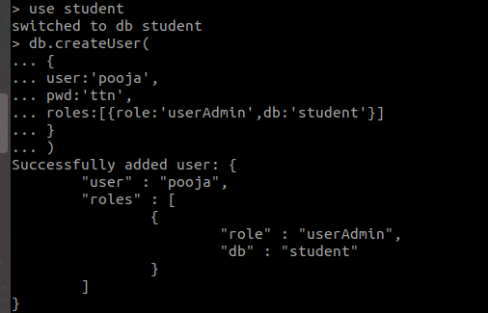
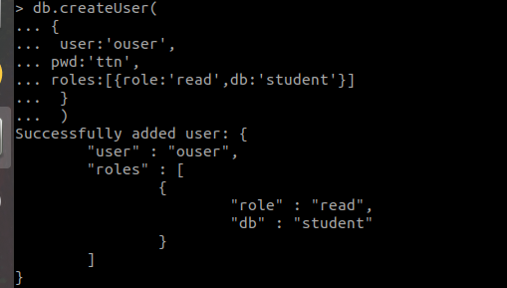
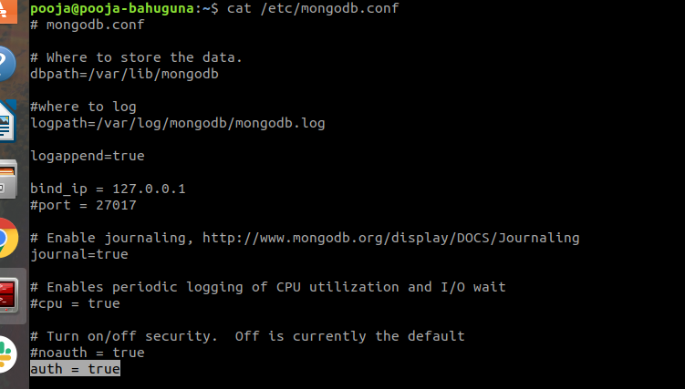

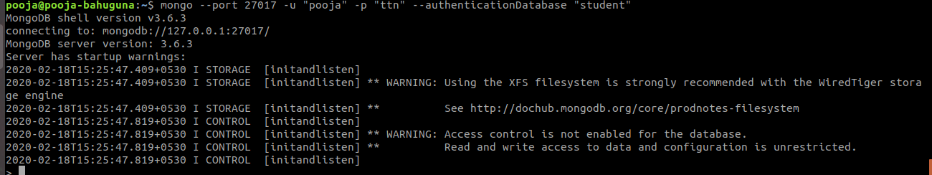
I

nstall another version of MongoDB from source (Version 2.6.3) and run it on port 27009
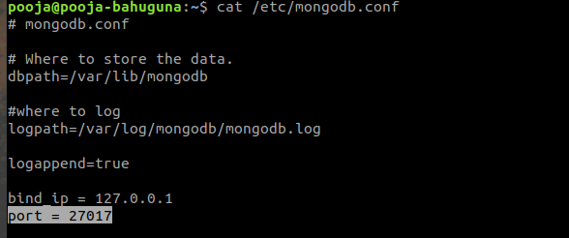
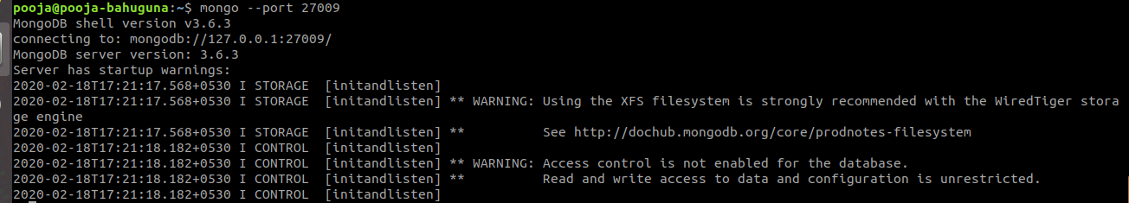

Create init service of Mongo installed later*
Create a file /etc/init.d/mongodb
In below script the path is "/opt/mongo/bin/mongod"
Code:
#!/bin/bash
#
# mongodb Startup script for the mongodb server
#
# chkconfig: - 64 36
# description: MongoDB Database Server
#
# processname: mongodb
#

# Source function library
. /etc/rc.d/init.d/functions

if [ -f /etc/sysconfig/mongodb ]; then
. /etc/sysconfig/mongodb
fi

prog="mongod"
mongod="/opt/mongo/bin/mongod"
mongodb_user="mongo"
RETVAL=0

start() {
echo -n $"Starting $prog: "
#daemon $mongod "--fork --logpath /var/log/mongodb.log --logappend 2>&1 >>/var/log/mongodb.log"
daemon --user=$mongodb_user $mongod "--config /etc/mongodb.conf"
RETVAL=$?
echo
[ $RETVAL -eq 0 ] && touch /var/lock/subsys/$prog
return $RETVAL
}

stop() {
echo -n $"Stopping $prog: "
killproc $prog
RETVAL=$?
echo
[ $RETVAL -eq 0 ] && rm -f /var/lock/subsys/$prog
return $RETVAL
}
reload() {
echo -n $"Reloading $prog: "
killproc $prog -HUP
RETVAL=$?
echo
return $RETVAL
}

case "$1" in
start)
start
;;
stop)
stop
;;
restart)
stop
start
;;
condrestart)
if [ -f /var/lock/subsys/$prog ]; then
stop
start
fi
;;
reload)
reload
;;
status)
status $mongod
RETVAL=$?
;;
*)
echo $"Usage: $0 {start|stop|restart|condrestart|reload|status}"
RETVAL=1
esac

exit $RETVAL

MySQL
- Install latest version of MongoDB from apt-get repository
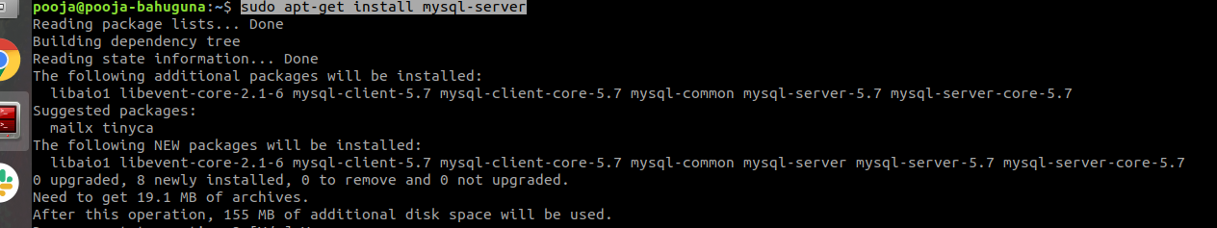
- Create a database student
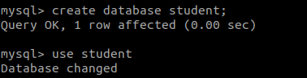
- Insert operation : 5 students data (Name, Contact, City, Roll No, Branch)
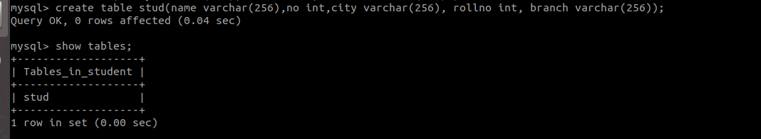
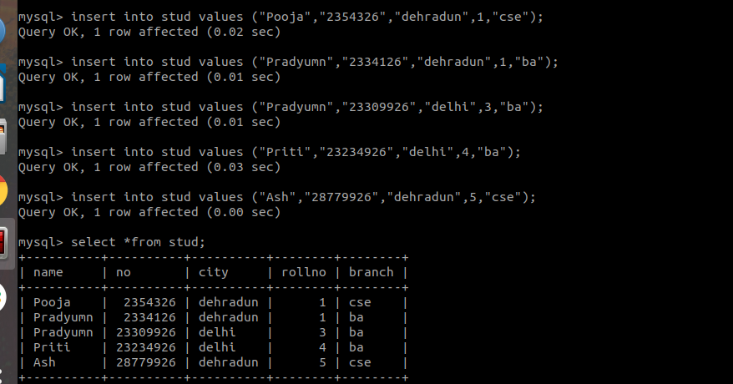
- Read operation : All the students belong to a particular city
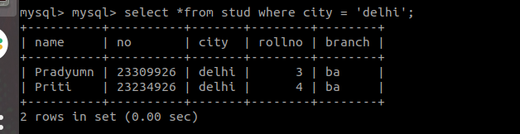

- Update operation : Update the branch of all the students to CSE
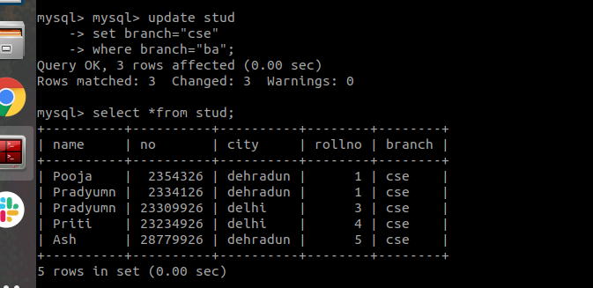
- Take dump of the database
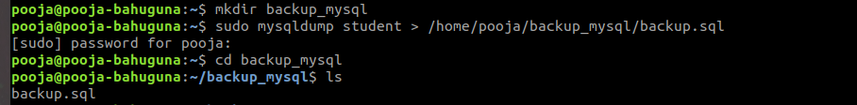

- Delete operation : Delete the record of last 2 students according to the roll number
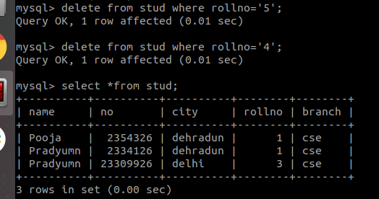

- Drop the database
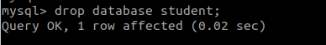
- Restore the database again to have the full data
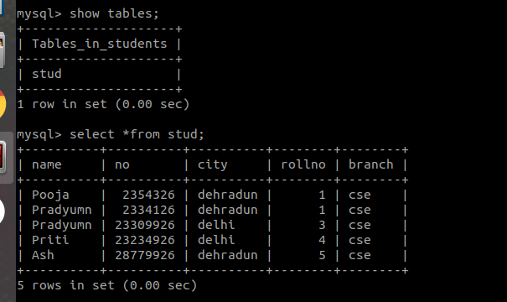

- Enable authentication on the Mysql
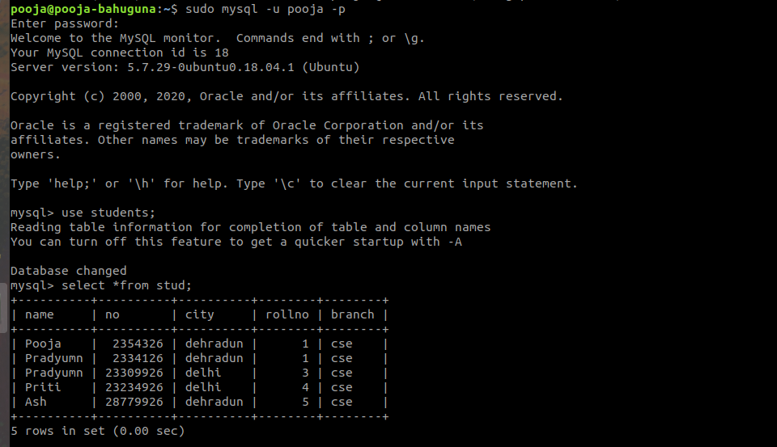
- Install another version of MongoDB from source (Version 2.6.3) and run it on port 27009
