- What is the size of MBR and what does it contains.

The master boot record is a small program that is executed when a computer is booting in order to find the operating system and load it into memory.
During the first stage of the boot process, the BIOS searches for the MBR and then loads it into memory, after which the MBR takes over.
Its size is 512 bytes.

- In which file you can write commands which you want to run whenever Linux system starts/restarts?
.bashrc
- Reboot the system using runlevel.
init 6
- Restart cron service.

- Create an ext4 filesystem
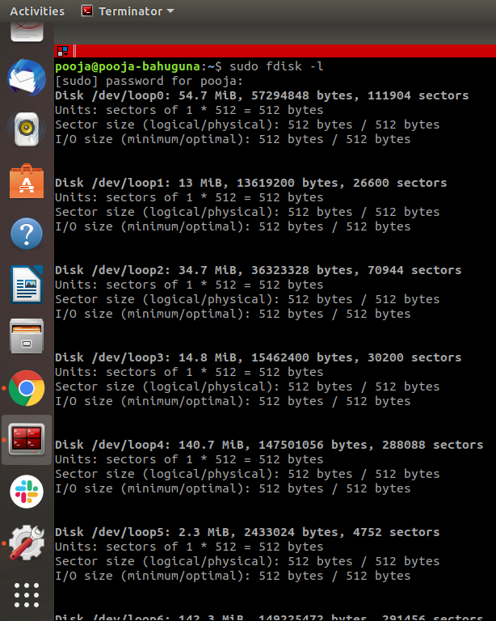
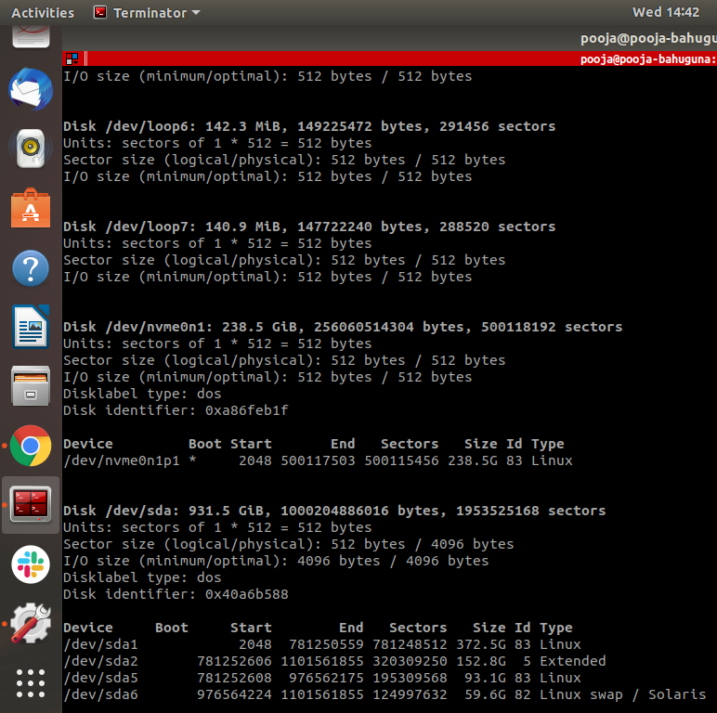

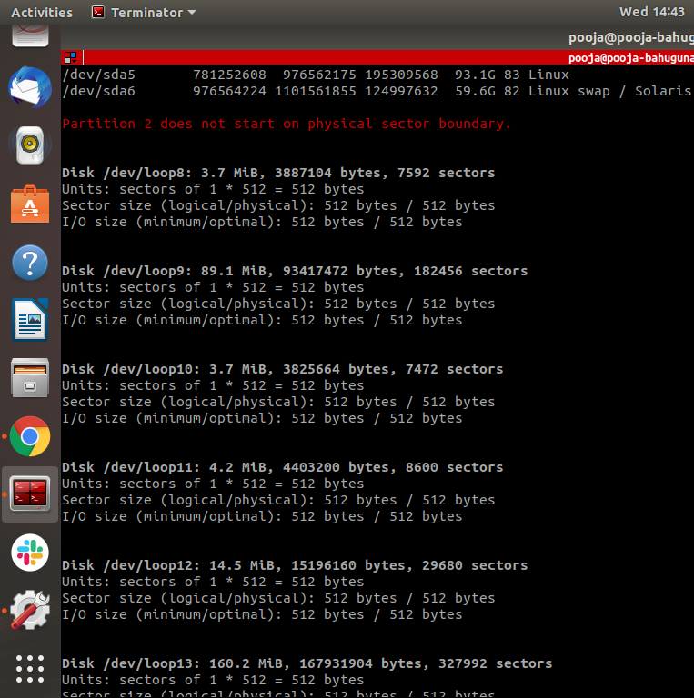
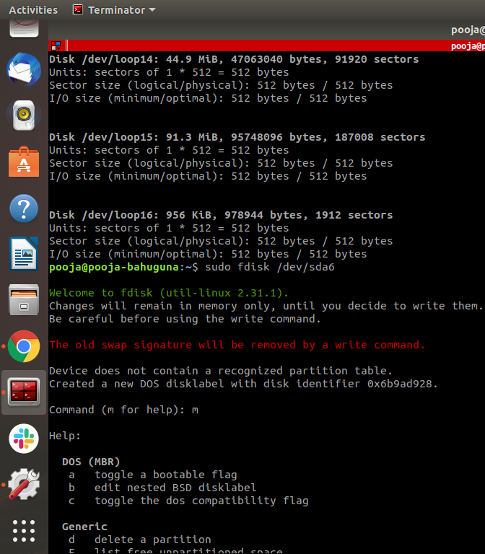
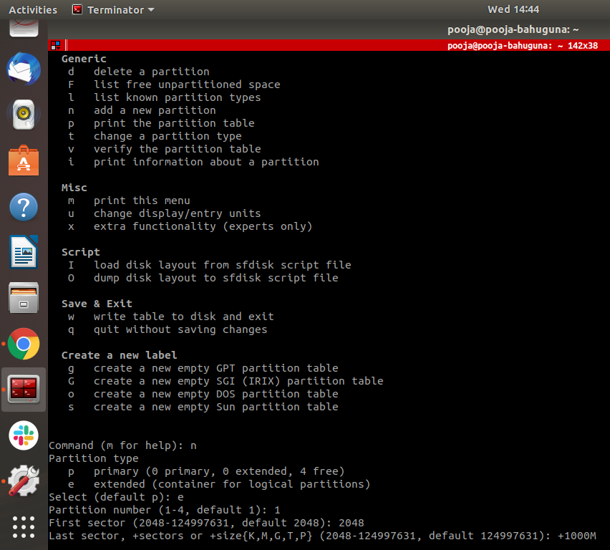
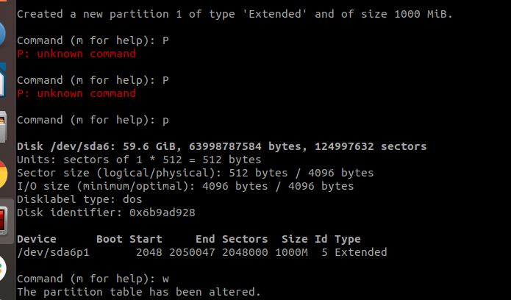

- Mount the created filesystem on /partition directory.

- Difference between LVM and RAID.
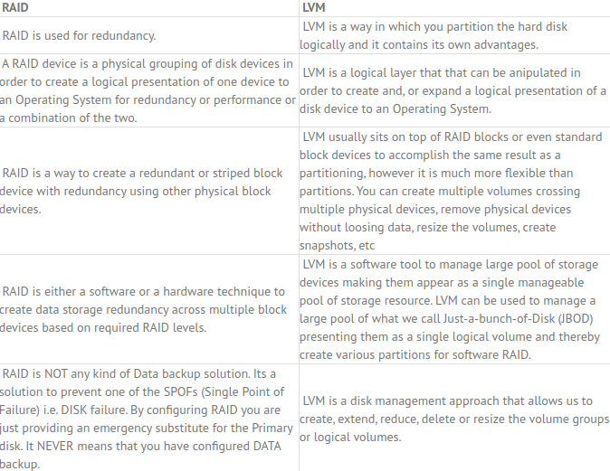

- Create a LVM(Slide 13)

- Create a RAID1 device(Slide 19)

- Create a swapfile of 500Mb(slide20)
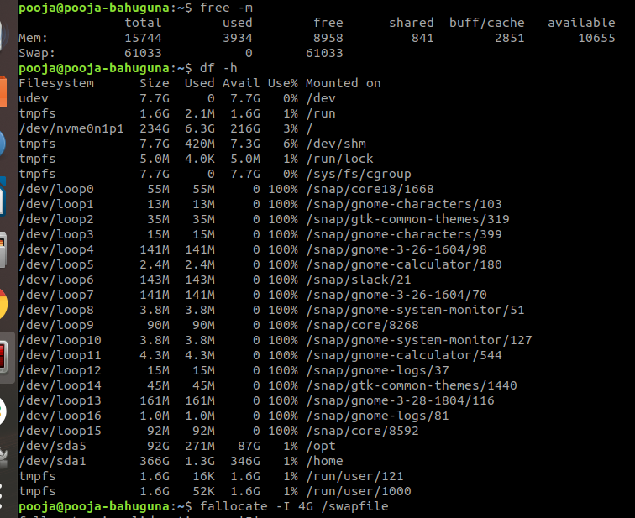
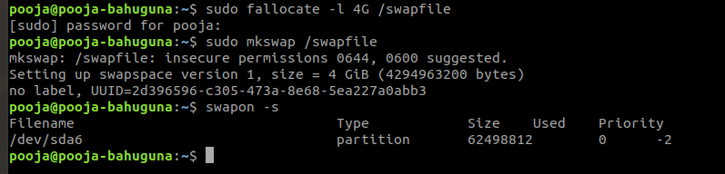

- Set setuid and setgid on two different file.
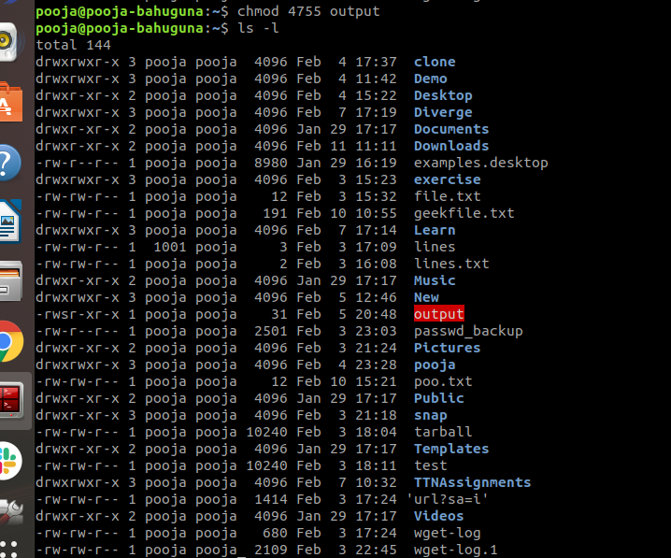
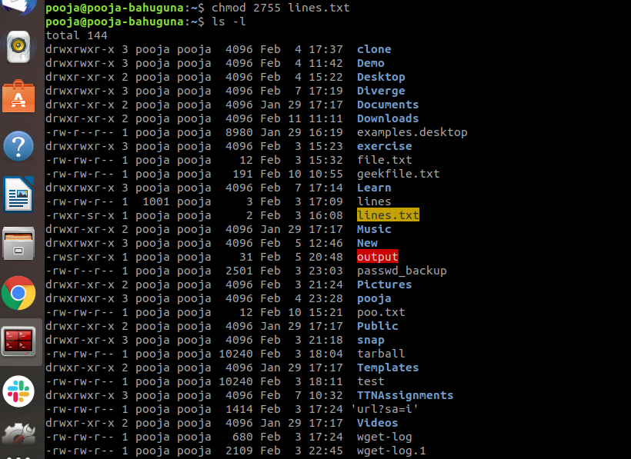
- What is the use of Sticky bit.
Sticky Bit is mainly used on folders in order to avoid deletion of a folder and it’s content by other users who have write permissions on the folder contents.

- Create a user and add it to one secondary group.
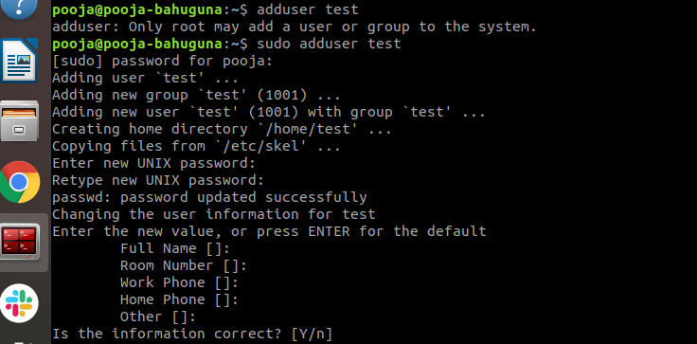

- Lock this user.

- Give this user full access (without password).
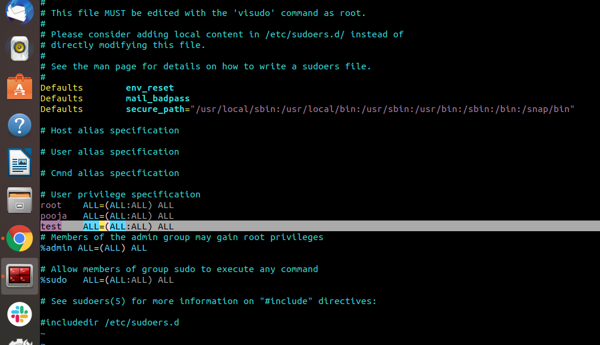
- Delete the create user after taking backup of it home directory.
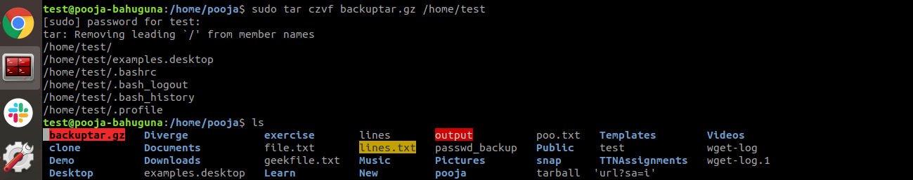
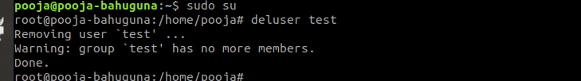

- Create a file with some content. Change all lower case letter to upper case letters and save output to another file using redirections.

tr:Truncate is used to translate or delete characters
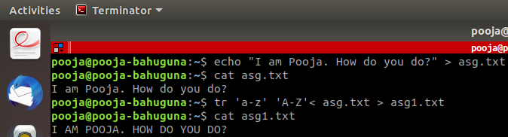

- Set nice value of a process to -1.
nice - run a program with modified scheduling priority
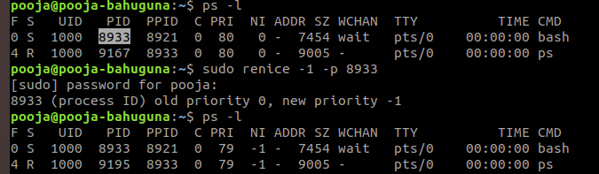

- Get a list of all files used by “telnet”.
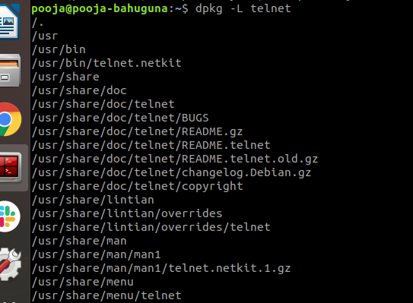

- Check if port 22 is listening using netstat and telnet command.
The telnet command is used for interactive communication with another host
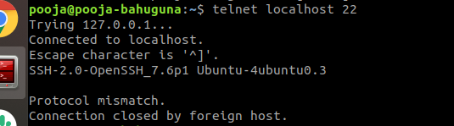

netstat - Print network connections, routing tables, interface statistics, masquerade connections, and multicast memberships
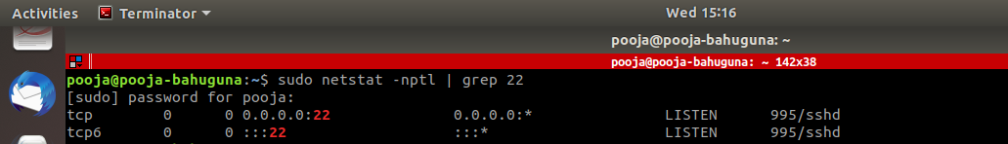

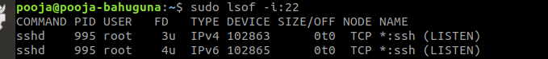

- Create a cron job which runs once a week at 23:45.

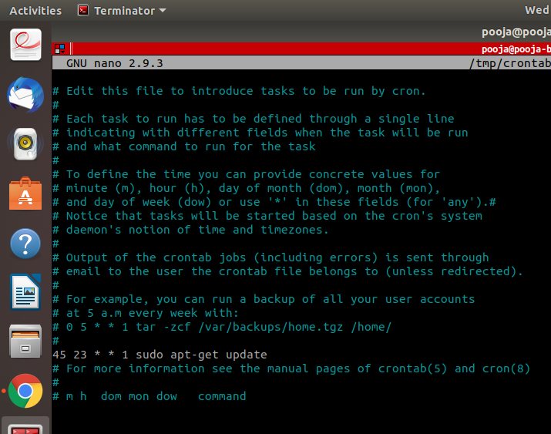

- Difference between dig and traceroute

DIG | TRACEROUTE
DNS lookup utility | Print the route packets trace to the network host.

