MONGODB

Install latest version of MongoDB from apt-get repository and Create a database student
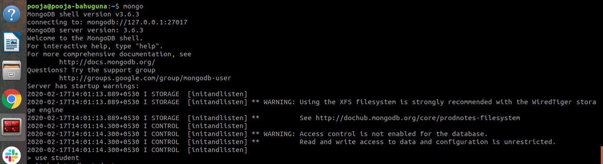

Insert operation : 5 students data (Name, Contact, City, Roll No, Branch)

Read operation : All the students belong to a particular city

Update operation : Update the branch of all the students to CSE
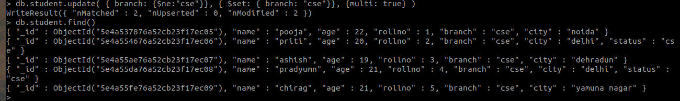
Or we can do
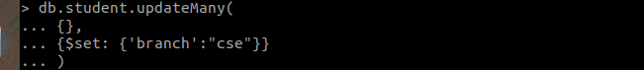

Take dump of the database

Delete operation : Delete the record of last 2 students according to the roll number
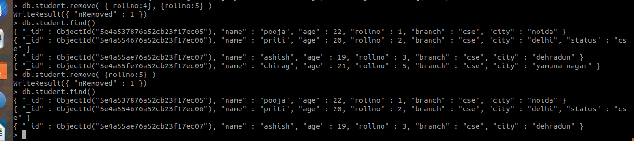

Drop the database
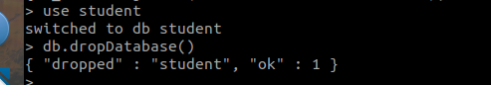

Restore the database again to have the full data
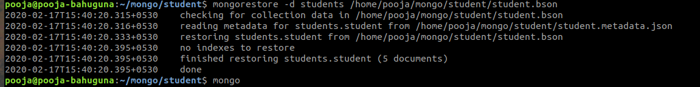
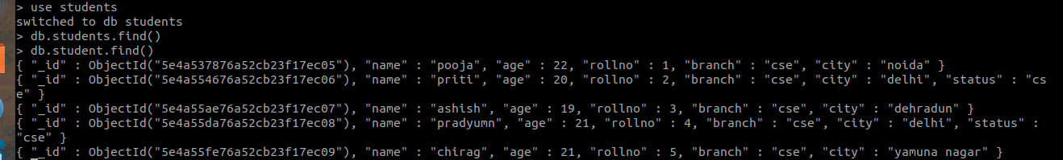

Enable authentication on the Mongo
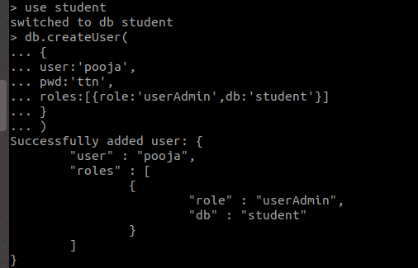
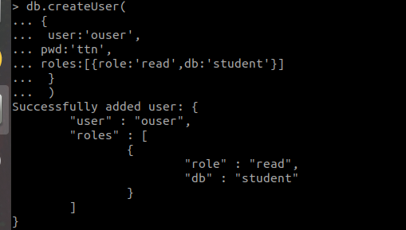
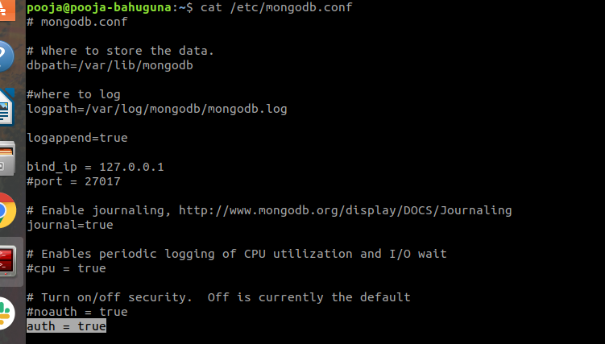

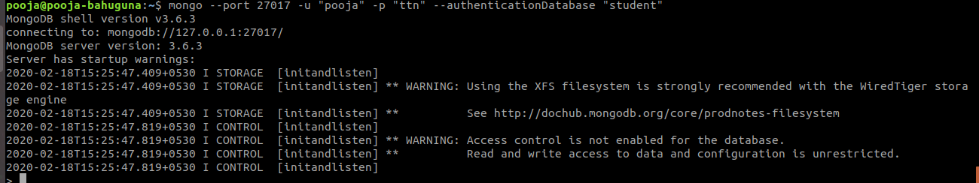
Install another version of MongoDB from source (Version 2.6.3) and run it on port 27009
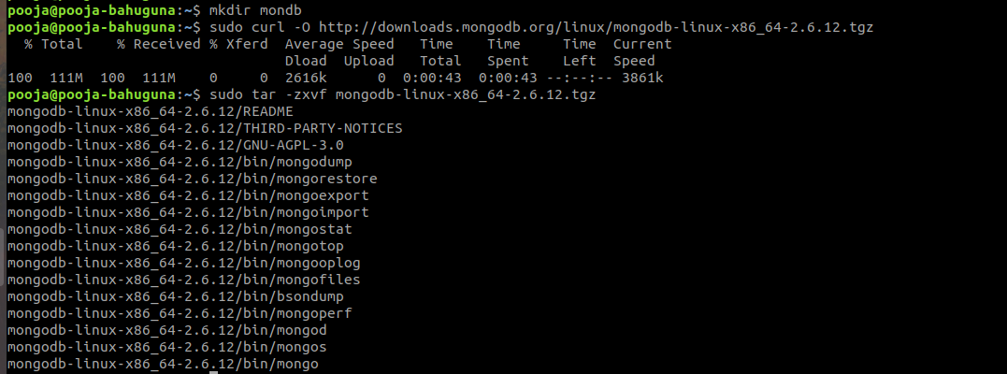

Create init service of Mongo installed later*
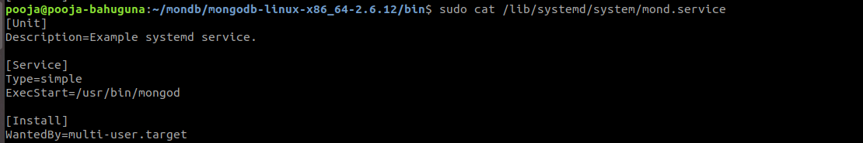

MySQL
- Install latest version of MongoDB from apt-get repository
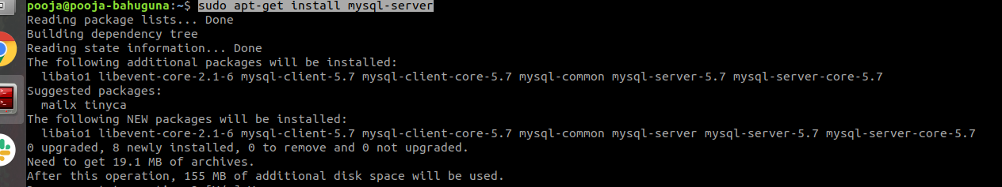
- Create a database student
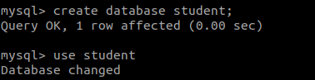
- Insert operation : 5 students data (Name, Contact, City, Roll No, Branch)
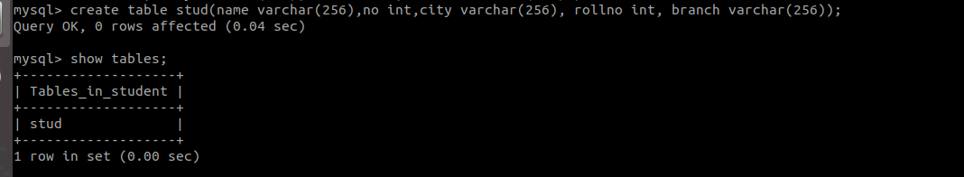
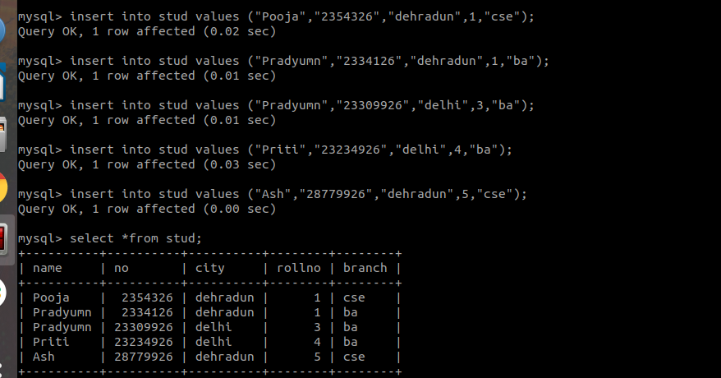
- Read operation : All the students belong to a particular city
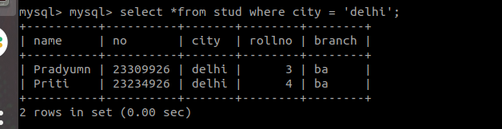
- Update operation : Update the branch of all the students to CSE
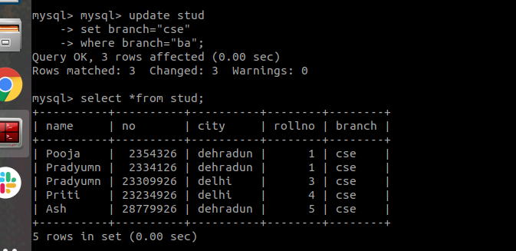
- Take dump of the database
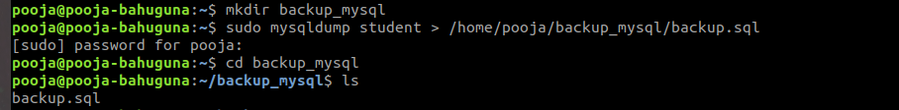

- Delete operation : Delete the record of last 2 students according to the roll number
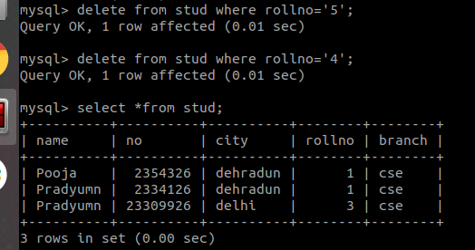
- Drop the database

- Restore the database again to have the full data
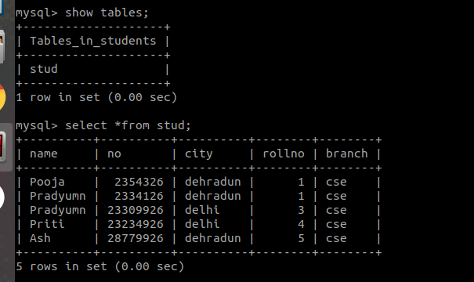

- Enable authentication on the Mysql
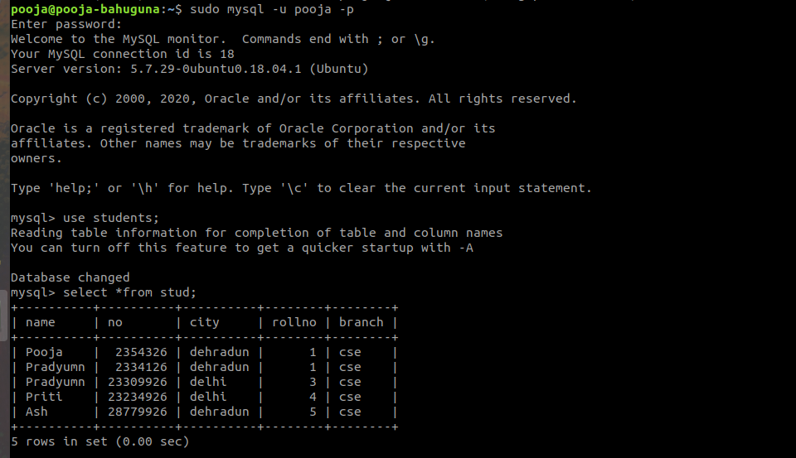
- Install another version of MongoDB from source (Version 2.6.3) and run it on port 27009
